Rational
The unit start starts of with a slow paced intro to different forms of figures and formulas. It allows for the students to grasp the simple concepts of geometry by working through what is length, width and height in a given figure. Once the student become familiar with the new terms and concepts. I apply application techniques where the lessons become hands on. The students can see the difference between height and width. They can also put into perspective what items might be a trapezoid.
The students are then asked to apply the formulas to objects in the room. I allow them to use a calculator as long as they have the formulas correctly written down. The students use this knowledge to lead into squaring numbers. They know what 2 times 2 is but have not heard of the term 2 squared. Breaking down the terminology is the biggest battle. Once the students have bridged the Language barrier we can start in the Formula of Pythagorean theorem.
The Theorem wraps up the entire unit of formulas. It allows them to identify right triangles. It adds Problem-solving skills for missing part of the Triangle and adds to their vocabulary acquisition by adding squared, squared roots, and hypotenuse to their previous knowledge of formulas such as perimeter and area.
In my class, I have a variety of students with disabilities. The student’s disabilities range from E.D, S.L.D. and C.D. Throughout my lesson, I try to incorporate Marcia Tate’s Brain Based learning process. The students in my class need to be active in the classroom. I start almost everyday with math ball. This may engage the students in the learning process. This also shifts their minds from Language to math functions. I also embrace the use of technology in my class. I allow the students to view web-sites that will aid in their understanding of new concepts. I have included in my lessons an enrichment activity. I plan on implementing this activity next year. Some of the activities may have to be modified but this activity allows the students to see Pythagorean theorem used in everyday life.

Unit outcomes

Unit: Differentiated Instruction Strategies

I will be able to analyze whole group strategies by utilizing research materials. (Analysis)

I will research additional strategies that are appropriate for 8th grade special needs math to help with reinforcement/enrichment activities. (Comprehension)

I will use the E.L.M.O to give the students a hands-on/visual representation of the new concepts that we will cover. (Synthesis)

Using various strategies modeling, video presentation, color- coded- models, Internet games, I will survey the students as to what method gave them the clearest picture of the concepts. I will review the information and adjust my unit as needed. (Application)

I will review the information and adjust my unit as needed. (Analysis)
Instructional design plan day one
Opening Activity
We will start the period off with a five- minute round of math ball. I will toss a soft basketball to a student. Once they catch the ball, they will be asked a math question from one of the four basic operations. (5 min)
Front Loading of Information
The students will view video on unitedstreaming.com. This video will show the application of formulas into real life situations. (5 min.)

Integrated review We will then move into a review round. The students will find the value of each expression. This will be a teacher lead review.
The students will have their own dry erase boards. On their dry-erase boards, the students will solve six equations. They will use the values w=2 and t=-3.
(5 min.)
BACKGROUND INFORMATION
I will use structures in the classroom to see if the students can tell me if the shape is square, rectangle, trapezoid or triangle. Once we have discovered all items, we will discuss the number of sides each object has. (10 min.)

Instruction Of New Concept
The students will view video on unitedstreaming.com. This video will show the application of formulas into real life situations. (5 min.)
I will then throw a Kleenex box out into the class. Hopefully one student will catch the box. I will ask him/her what side they are touching. The response I am looking for is the surface. With this answer, I can go into my explanations of formula for the area of a rectangle.
I will be in the middle of the classroom using the ELMO. The ELMO is a video image of three- dimensional items. This allows for students to be interactive with the notes and to work through the problems for everyone to see. When all the students are watching the notes, the can point out what the student is doing write or wrong.
This becomes a collaborative effort to solve the problem. The notes will take a minimum of 15 minutes. I will explain the formulas for rectangles, trapezoids and triangles.
Reflection on New Concept
With the few remaining minutes of class, I will ask the students to think about what applications they could use area formula of rectangles, trapezoids and triangles in everyday life. Their homework assignment will be to come up with five everyday formulas. (whatever time is remaining)
Materials
E.L.M.O/dry-erase boards/ notebooks/prentice hall math books/unitedstreaming.com/
DAY 2

Opening Activity
We will start the period off with a five- minute round of math ball. I will toss a soft basketball to a student. Once they catch the ball, they will be asked a math question from one of the four basic operations. (5 min)
Reflection Review
I will ask the class for volunteers to discuss the reflection assignment.
What I’m looking for is discussion with parents. Some answers I hope to hear are carpeting, buying paint, drywall and folding a flag. (5min)
Review of Formulas
I will have students come up to the dry-erase and give the formula for each figure (trapezoid, triangle, and rectangle). They will be able to ask anyone for help if they are stuck with the formula. I will then walk them through the formulas again using different colors to represent length, width, height and base. They students will also be encourage to use colored pencils in their notes to represent my presentation on the board. (10 min.)

Hands on Activity
In this activity the students, the students will be using paper, pencil and rulers. They will be asked to move around the room and find ten shapes
In the classroom. The shapes must be rectangular, triangular or trapezoidal. Once the students have found an object in the classroom, they will measure it. On the piece of paper they will create a scale of the object and label their measurements accordingly. The students will do this for all ten items they find. When they are finished, they will turn the paper in to me for a final check. They will have bonus points if they can find a trapezoidal figure in the classroom. (20 min)

Materials
E.L.M.O/dry-erase boards/ notebooks/prentice hall math books/unitedstreaming.com/

DAY 3
Opening Activity
We will start the period off with a five- minute round of math ball. I will toss a soft basketball to a student. Once they catch the ball, they will be asked a math question from one of the four basic operations. (5 min)

Wrap-up of hands on activity.
I will hand back the papers from yesterday. If anyone was absent, I will have them work with the para-professional to catch up with the rest of the class. With the remainder of the class, I will hand them back another students paper. The students will then find the area of each shape that the student recorded. (10 min.)

Introduction of new concept
Exploring square roots and irrational numbers

Quick Intro
The students will evaluate the expression X² for each value of x
a. 2 b. -2 c. -6 d. 10
Once they show me that they understand that x², represents a number times the same number. The student will be able to use calculators.
I will show them how to use the calculator functions to ease the process. (10 min.)
The students will then define perfect square, square root, irrational numbers and real numbers. They may use their books, internet or dictionaries.(10 min)
Instruction
To demonstrate a perfect square I will use the ELMO and tile squares.
I will start out by using two tiles. When I combine two tiles with two more tiles I will create a perfect square.
I will also demonstrate with the 4². I will show that 4 x 4 =16
I will then have students come up to the ELMO and demonstrate with the tiles. ( 5 min carry over to day 4)
Materials
E.L.M.O/dry-erase boards/ notebooks/prentice hall math books/unitedstreaming.com/

DAY 4
Opening Activity
We will start the period off with a five- minute round of math ball. I will toss a soft basketball to a student. Once they catch the ball, they will be asked a math question dealing with multiplication only. (5 min)
Instruction
To demonstrate a perfect square I will use the ELMO and tile squares.
I will start out by using two tiles. When I combine two tiles with two more tiles I will create a perfect square.
I will also demonstrate with the 4² . I will show that 4 x 4 =16
I will then have students come up to the ELMO and demonstrate with the tiles. ( 5 min carry over to day 4)

Next I will introduce the inverse of squaring a number. The students will be led through the steps of finding the square roots with a calculator. They will be asked to write down all necessary steps so they can do it on their on without assistance. The students will also be asked to describe what the difference is between squaring a number and the square root of a number. I am looking for the students to describe that inverse is a form of division that divides a number into an equal quantity. (10-15 min)

IN CLASS PRACTICE
The remainder of the time the students will be working on practice problems. I will walk around the room to check for understanding of concepts. I also will check for the correct usage of the calculator

REFLECTION OF TOPIC
I will take the last five minutes of class to review any problems that the students may have encountered. I will also use this time to have the students think about how they can solve for unknown distances by using squares and square roots. Their homework assignment will be to try and figure out the height of a kite with the hypotenuse of 30 and the distance from the person to where the kite landed 10 ft away. The students will be confused at first but this is a way to have them prepared for the following lesson.

Materials
E.L.M.O/dry-erase boards/ notebooks/prentice hall math books/unitedstreaming.com/

INSTRUCTIONAL DESIGN PLAN DAY 5-6
Opening Activity
We will start the period off with a five- minute round of math ball. I will toss a soft basketball to a student. Once they catch the ball, they will be asked a math question dealing with multiplication only. (5 min)
FRONTLOADING OF NEW CONCEPTS
The students will watch a video on unitedstreaming.com. This video will introduce Pythagorean theorem and how it is applied in everyday concepts. This video will take about 5 minutes.
INVESTIGATION
The students will be given a diagram containing many squares and right triangles. I will have one of the triangles shaded red. What I want the students to do is explain why the area of the larger square is equal to the sum of the areas of the two smaller squares. (The larger square has 4 triangles and the smaller squares each have 2. 2+2 = 4
Then I want them to find the area of the large square. They will have the information that each side of the smaller squares is equal to one. The area of the large square is 4. (10 min.)

INTODUCTION OF NEW CONCEPT
The students will be given three new vocabulary words to identify
Leg= the shortest two sides of right triangle. Hypotenuse= the longest side in a right triangle it is located opposite of the right angle. The Pythagorean theorem shows how the legs and hypotenuse are related. A² + B² = C² (5-10 min)

The students will then grab their own dry erase boards and recreate the triangles that are on the E.L.M.O. I will then ask the students to identify the hypotenuse in each of the triangles. I will ask them why they are picking each number to represent the hypotenuse. I am looking for the students to see that the hypotenuse is always the largest of the three numbers. (10-15 min)
DAY 6
Opening Activity
We will start the period off with a five- minute round of math ball. I will toss a soft basketball to a student. Once they catch the ball, they will be asked a math question dealing with multiplication only. (5 min)
QUICK REVIEW
I quickly review identifying the hypotenuse. I will have triangles drawn on the board and simply ask the students to tell me which one is the hypotenuse and why. I will also have just a set of numbers on the board and students again identify the hypotenuse and explain why. (5min)

PYTHAGOREAN THEOREM
We will work together to solve Pythagorean theorem. The students will first determine what the legs and hypotenuse are for given triangles. Then I will walk through the formula with the students A and B are the legs. C is the variable for the hypotenuse. The students will then substitute the numbers into the formulas. We will then walk through how to solve the missing hypotenuse. The student will be asked to square both legs using a calculator then they will add the two squares together. Once they have combined squares, they will be asked to find the square root of the number. This will give them their hypotenuse. We will use dry erase boards, E.L.M.O., pencil and paper to do numerous examples.
To check their work they must note that the hypotenuse must be the biggest number. If the number is smaller, then they did the process incorrectly.
We will then switch to solving for a given leg. This will be the same process as solving for a hypotenuse. The only difference will be that instead of adding the two squares they must subtract. Once they have subtracted the two squares, they will find the square root of the number. If the number is larger than the hypotenuse, they have incorrectly done the process.
Materials
E.L.M.O/dry-erase boards/ notebooks/prentice hall math books/unitedstreaming.com/

Web resources
www.ohiotreasurechest.com
www.Aplusmath.com
www.mathwarehouse.com
www.yourteacher.com

Authentic assessments for area of rectangles and squares
- The students will use a ruler, the classroom, pencil and paper.
- They will find ten rectangles or squares in the classroom
- They will then draw the shape onto the piece of paper. They will include the measured lengths on the piece of each side of their drawings.
- The students will then trade papers
- The students will then find the area of each square.
- Students should score 80% for mastery
If not met re-teach with more visual aides and guidance

Authentic assessment for triangles
- Students will draw 5 squares on paper various sizes
- They will then be asked to see if they can make two triangles out of each shape.
- Then I will raise the question if they can tell me the comparison between a rectangle/square and triangle. I’m hoping that I hear the answer ½ a rectangle may become a triangle.
- This will allow seeing the relationship between formulas of rectangles and triangles.
- The students will then take the newly formed triangles and give the area of each

Authentic assessments for Pythagorean theorem

Satellites that relay TV signals to earth maintain a distance of about 22,200 miles above Earth’s surface. Assume that the radius of the Earth is 4,000 miles. Find the distance from the satellite to the Earth’s horizon.

The students will be aided on creating a diagram. Then they will walk through the formula to plug in the information.
They may use a calculator to aid in squaring and square roots of numbers
State Standards
Solve and determine the reasonableness of the results for problems involving rates and derived measurements, such as velocity and density, using formulas, models and graphs.

Find the square root of perfect squares, and approximate the square root of non perfect squares as consecutive integers between which the root lies.

ENRICHMENT ACTIVITY BUILDING A ONE- ROOM SCHOOL HOUSE

Materials you will need: 0 basswood or wooden strips 0 battery 0 electrical bell wire 0 flashlight bulbs and holders 0 glue 0 oaktag
o switch

State what the design challenge is:

- Clarify the Design Specifications and Constraints

What are the specifications and constraints the design must meet?

- 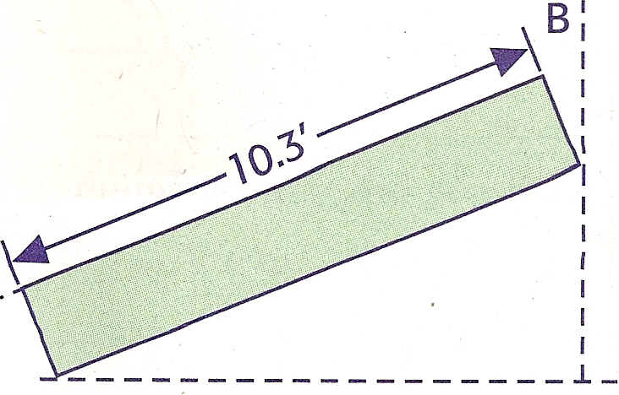
The larger the rise (A), the steeper the roof will be. The run (B) is approximately half the width of the building. By knowing the rise and run, you can make a small triangle and then extend it to meet the scale size of your building. For instance, if the rise is 3 inches per foot of run, then for a building with a width of 20 ft, the run is half the distance, or
10 ft, as shown in the illustration. /

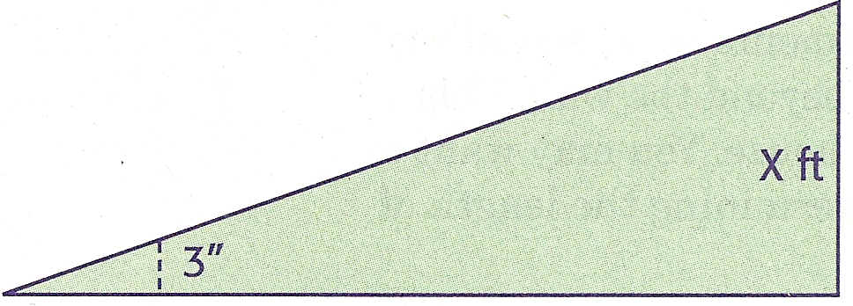
~12"~ <

For similar triangles, the proportion is shown in this equation:

3
-
12 10

30 = 12 x 30/12 =x
x = 2.5 ft

The length of the rafter may be determined from the Pythagorean theorem, a² + b² = c²:
10² + 2.5² = (2

100 + 6.25 = (2 106.25 = (2 10.3 ft = (

Is this the length of lumber that you will need? Let's take a closer look. Make a drawing of the rafter at the rise indicated.

A .... · .... ·
.....
- 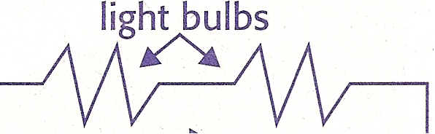The rafter must be extended by length A plus length B so that it can be attached to the top plate at point A and the ridge board at point B.
Now, use the equation above to figure the length of the rafter for a building 20' wide if the rise is 5 inches per foot.
What is the length of the rafter? _
The illustration in your text (Chapter 9, page 244) shows
the rafters, ridge beam, and other elements of an actual roof truss. Notice that the rafters extend beyond the wall. This allows the rain to fall away from the house. You may want to take this into consideration when determining the length of the rafters on your schoolhouse.
Knowledge and Skill Builder 3: Framing Doors and Windows Walls serve two purposes: they carry the load of the roof and
ceiling, and they serve as partitions for the rooms. The vertical supports of the wall are called studs. Studs are made from 2" x 4" lumber for internal walls and 2" x 4" or 2" x 6" lumber for
external walls. When there is an opening in the wall for a window
or for a door, a header is used to transfer the weight that the
removed studs otherwise would have carried to the window or
door frame. Additional studs (jack studs) are used to support the internal and external wall. The studs are located 16" on center
for 2" x 4" studs and 24" on center for 2" x 6" studs. The studs ate secured to the top and bottom by nailing them into boards of the same width, called the top plate and the bottom plate.
Take a piece of paper measuring 20" x 30". Using the scale
specified for the model schoolhouse, make a scale drawing of a
wall with two windows and a door. The windows will be 36" x 60"
and 36" x 78" before scaling. Show the appropriate framing.
Knowledge and Skill Builder 4: Electrical Circuits
A series circuit has the lights connected one to another and then to a battery in one path, as shown schematically below.
5₁ _
lIlIl electron flow Series Circuit

U sing a battery, wire, a switch, and three flashlight bulbs with holders, create a series circuit and then a parallel circuit, which has more than one path through which electricity can flow. Draw your circuits below. Explain how you connected the battery, lights, and wire in each case. ==========================.
() Generate Alternative Designs
Describe two of your possible solutions to the problem. Remember to consider the specifications and constraints. What are each solution's strengths and weaknesses? Include such considerations as the overall size, roof angle, and types of windows. Use a photocopy of the template at the back of the Guide to describe two alternative solutions to improve your design. If you need an extra copy of the template, ask your teacher.
e Choose and Justify the Optimal Solution
Choose your preferred solution. Explain how your solution meets the specifications and constraints. Why is this the better alternative?
What trade-offs, if any, did you make in selecting this alternative?

Prentice hall “Technology Education” Michael hacker and David Burghardt
Upper saddle River, New Jersey 2008

