Instructional Design
(American History: Progressive Reforms Unit)

By: Kevin O’Shea

American History
Progressive Reforms Unit
General/Unit Outcomes

Unit Length: app. 1 1/2 weeks

General Outcomes:

- Students will identify effects of Industrialization on various people and places throughout America.
- Students will understand what the Progressive movement was and how it impacted and changed America.

- Students will understand how the Progressives eased the suffering of the urban poor.

- Students will be able to identify conditions and improvements in the workplace.

- Students will be able to identify and explain changes made in Government.

- Students will understand the struggle and fight for Women’s rights.

- Students will recognize the presidencies of Roosevelt, Taft, and Wilson and how these pushed for progressive reforms

- Students will know how individual citizens interact with their own government and understand how each can help reform it.

- Students will connect past events with present situations in economics, government, and big business

Unit Outcomes:

- Explain the effects of industrialization in the United States in the 19th century

- Explain the goals and outcomes of the late 19th and early 20th century reform movements of Populism and Progressivism with emphasis on Urban reforms

- Explain the effects of immigration on society in the United States including Housing patterns

- Explain how perceptions and characteristics of geographic regions in the United States have changed over time including urban areas.

- Analyze the geographic processes that contributed to changes in American society including Industrialization and post-industrialization; Urbanization and suburbanization; Immigration.
- Explain the goals and outcomes of the late 19th and early 20th century reform movements of Populism and Progressivism with emphasis on urban reforms.

- Explain the effects of immigration on society in the United States Political affiliations.

- Demonstrate how U.S. governmental policies, including taxes, antitrust legislation and environmental regulations affect individuals and businesses.

- Describe the ways in which government policy has been shaped and set by the influence of political parties, interest groups, lobbyists, the media and public opinion.
- Describe how the perspectives of cultural groups helped to create political action groups such as The National Association for the Advancement of Colored People (NAACP); & National Organization for Women (NOW)

- Analyze the perspectives that are evident in African-American art, music, literature and media and how these contributions reflect and shape culture in the United States.

- Analyze the struggle for racial and gender equality and its impact on the changing status of minorities since the late 19th century.

- Explain why the 19th and 26th Amendments were enacted and how they affected individuals and groups.

- Describe the ways in which government policy has been shaped and set by the influence of political parties, interest groups, lobbyists, the media and public opinion with emphasis on the Extension of suffrage and Civil rights legislation;

- Explain how civil disobedience differs from other forms of dissent and evaluate its application and consequences including Women's suffrage movement of the late 1800s.

- Describe the ways in which government policy has been shaped and set by the influence of political parties, interest groups, lobbyists, the media and public opinion with emphasis on Labor legislation.

- Analyze the development and impacts of labor unions, farm organizations and business organizations on the U.S. economy.

- Explain the effects of immigration on society in the United States on Labor practices.

- Explain the goals and outcomes of the late 19th and early 20th century reform movements of Populism and Progressivism with emphasis on Business regulation and antitrust legislation and the regulation of child labor.

- Analyze the reasons for the rise and growth of labor organizations in the United States (i.e., Knights of Labor, American Federation of Labor and Congress of Industrial Organizations) including Unregulated working conditions; Laissez-faire policies toward big business; Violence toward supporters of organized labor.

- Analyze the impact of industrialization and the modern corporation in the United States on economic and political practices with emphasis on Laissez-faire policies and Monopolies.

- Explain the effects of industrialization in the United States in the 19th century including Changes in work and the workplace.

American History
Progressive Reforms Unit
Pre-assessment

The Progressive reform unit is correlated with and in connection to the previously learned industrialization unit. One must make the connections of industrialization with that of the reform movement created as a result of the effects of industrialization.
The goals of this particular pre-assessment will be multifaceted in that it will be used to determine the level of comprehension and understanding of the students in the previous unit as well as their current level of knowledge for the various reforms during the progressive era. In doing this the students will complete two activities. The first, an anticipation guide (Appendix A1), requires students to answer direct statements with either a true or false response but more importantly explain how and why they came to their conclusion about each statement. Secondly, students will complete a KWL chart (Appendix A2) listing the things about the progressive movement that they already know or think that they know and what they would like to learn about the movement or what they would like clarified or elaborated on. They will fill out the rest of the KWL charts during the post assessment portion of the unit.
The pre-assessment will be given one day before the beginning of the unit to give me a chance to look over the assessments and to determine any variations or changes that need to be made in the lesson. The pre-assessment will take approximately 65-75 minutes to complete. I will pass out a copy of the pre-assessment to each student in the class and will read each statement to the class and give them time to respond to each. After they have responded to the statement we will allow for a couple of students to present their answers and discuss as a class their responses with one another. Other students will have the opportunity to build on what each has said. After each of the pre-assessments have been completed they will be collected, graded, and handed back to them the following day to be discussed once more and give closure to any loose ends that need to be tied up.
As stated before the pre-assessment will determine if any supplemental lessons will need modifications before the start of the actual lesson. Copies of the pre-assessment are attached in the appendix.

American History
Progressive Reforms Unit
Lesson One: Effects of Industrialization

General Outcomes: 1, 8, 9
Unit Outcomes: 1, 2, 3, 4, 5, 6, 7
Objectives:
- Students will analyze the effects of industrialization, immigration, and expansion in American during the early 20th century.
- Students will compare and contrast issues concerning industrialization today with that of the events during the late 19th and early 20th century in America.
- Students will understand that American society needed major reforms to fix the problems created by the rapid industrialization and expansion of America.
- Analyze the connections of past issues to that of issues concerning America today
Materials:
- Pre-assessment anticipation guides and KWL Charts
- Industrialization Worksheet
Procedures:
Before Lesson: Watch CNN Student news and discuss any connections made with content in class. Return the pre-assessment Anticipation guides and KWL Charts and tie up looses ends or questions students may have.
Introduction/Activity: With pre-assessment in hand pass out industrialization worksheets and have students begin listing areas that were affected by industrialization. I will write the areas on the board. In each area listed by students have them reflect on problems that were created as a result of industrialization and list them under there respective area. Have each student pair with another and share the ideas that each has come up with and record each others ideas. After a period of time have them pair with another member until each has paired with someone different and shared their new ideas. Have the class get back into their desks and write the summation of all the groups on the board. Identify any key vocabulary that has been listed and add any necessary vocabulary that you feel has maybe been left out. Write the vocabulary list on the board and have each student copy the list.

Activity/Summary/Closure/Evaluation: Have students take out their worksheet that was created during their pairings with other classmates and their vocabulary list. Using that list they are to assume the identity of someone from this time period and write a letter, journal entry, ect. Whatever they choose to write must include each of the vocabulary term listed as a class in telling their story. They must underline each word used and use each word in the appropriate context without simply defining the word.
Evaluation: Using rubric students will be critiqued in the appropriate use of each vocabulary term and the length of their work.

American History
Progressive Reforms Unit
Lesson Two: Progressivism

General Outcomes: 2, 3, 4, 5, 9
Unit Outcomes: 2, 6, 9, 10, 11, 12, 14
Objectives:
- Understand the effects of progressive reforms on the Urban Poor
- Understand the effects of the progressive reforms on improving working conditions
- Understand the effect hat progressives had on reforming corrupt government
- Analyze how issues of the past are similar to many of today
Materials:
- Textbook
- Internet/Computer
Procedures:
Before Lesson: Watch Cnn Students News make connections from in class discussions.
Introduction/Activity: Ask Students Critical questions to focus thoughts on topics. What is a social movement, Political movement, economic movement? When do these type of movements occur? What are the goals and results of these movements? Explain to students how their answers relate to what the progressive movement was all about. Explain that the problems caused by urbanization created the need for these types of movements and that they became known as the progressive movements. Have students discuss organizations or movements that do the same today for many of the issues that we face.
Activity/Summary/Closure/Evaluation:
Have the students go to the computer lab and research the progressives in three major areas (urban poor, working conditions, and government) using ohiohistorycentral.org. Then, from the viewpoint of a city manager living in a major city during the late 1800s and early 1900s write a report. Your report should address the problems found in the city and propose solutions. Use standard grammar, spelling, sentence structure, and punctuation.
Evaluation: Using rubric students will be critiqued in the appropriate use of each vocabulary term and the length of their work. Creativity and amount of city problems will be taken into consideration in their grades.

American History
Progressive Reforms Unit
Lesson Three: Women and Public Life

General Outcomes: 2, 6, 9
Unit Outcomes: 2, 6, 10, 12, 13, 14, 15
Objectives:
- Analyze opportunities that women had for education and work outside the home
- Understand how women gained political experience through participation in reform movements
- Understand how the women’s suffrage movement progressed.
Materials:
- Notebook paper
Procedures:
Before Lesson: Watch Cnn Students News make connections from in class discussions.
Introduction/Discussion: Guide students in a discussion about the reform issues of each group and organization formed by women. Discuses obstacles which blocked women in their efforts to achieve reform in these areas. Have groups distinguish between white and black women and their attempts at reform.
Activity/Summary/Closure/Evaluation:
Have students break into groups of three and have each group read an assigned reading from textbook. Each group member will draw three ladders on their own notebook paper and label the tops of the ladders with Opportunities for women, gaining political experience, and the suffrage movement. As they read their section they should fill out the appropriate portion of their ladder. When finished they will switch with other group members and help each other fill out their ladders until all ladders are completely filled out. Lastly, students will write letters to the editor from the perspective of either a suffragist or someone who opposes suffrage. They should argue either for or against and give examples that defend their positions.
Evaluation: Using rubric students will be critiqued in the appropriate use of each vocabulary term and the length of their work. Creativity and amount of city problems will be taken into consideration in their grades.

American History
Progressive Reforms Unit
Lesson Four: Roosevelt and Progressivism

General Outcomes: 2, 6, 8, 9
Unit Outcomes: 17, 16, 19, 20, 21
Objectives:
- Understand how Roosevelt used the power of the presidency to push for progressive reforms
- Understand the role that government plays in reforming American society
- Understand how people and their government interact with one another.
Materials:
- Reading Materials
Procedures:
Before Lesson: Watch Cnn Students News make connections from in class discussions.
Introduction/Discussion:
Discuss with students the personality and opinions of Roosevelt. List key terms and evemt of his presidency. Guide students in a discussion about the “bully pulpit and the “Square deal”
Activity/Summary/Closure/Evaluation:
Have students break into two groups one that represents and defends workers rights and union activists and the other that represents and defend the rights and needs of business owners and leaders. Have each side create a list of demands and why they need these things and why they are reasonable. Have one group member read and list their demands and allow them to debate one another for their rights. Then discuss how the government could help resolve their conflicts and compare to how Roosevelt responded to labor strife.
Evaluation: Have students write reflections about the demand form each side and why each side demanded each. Include a section about unions and labor today and how the government gets involved in any specific events today.

American History
Progressive Reforms Unit
Lesson Five: Taft and Wilson Reforms

General Outcomes: 2, 6, 8, 9
Unit Outcomes: 17, 16, 19, 20, 21
Objectives:
- Understand how President’s Taft and Wilson used the power of the presidency to push for progressive reforms
- Understand the role that government plays in reforming American society
- Understand how people and their government interact with one another.
Materials:
Procedures:
Before Lesson: Watch Cnn Students News make connections from in class discussions.
Introduction/Discussion: Lead class in discussion about Taft’s approach to progressivism, Wilson’s New Freedom, and their role in advancing the rights of minorities. While discussing these topics have students create a detailed time line and chart that outline all of the major laws and key terms from the discussion.
Activity/Summary/Closure/Evaluation:
Have students write ten questions for both President Taft and Wilson that they think a journalist might ask. They will then pair up with another student in class and create the appropriate answers to each others questions. In front of the class they will present their questions and have classmate try and predict their answers. They will then read their answers and justify why they responded like they did.
Evaluation: Have them write a paragraph in which they compare and contrast the two president’s reforms initiated. In their conclusions they should indicate which president they feel achieved the most and why.

American History
Progressive Reforms Unit
Post-Assessment

The Post Assessment covers all of the five subunits. The test consists of all of the following question formats (multiple choice, Matching, Completion, short answer, and extended responses). The post-assessment will be given two days after the last subunit is completed with one full day of review and rap up.

The previously completed Anticipation guide will be re-filled out and measured for growth as well as the KWL chart will be completed and checked for growth

The day following the post-assessment the teacher will go over question that multiple students missed and if necessary re-teach any material that the post assessment reveals was not taught effectively or not retained well by students.

APPENDIX A

A1: Pre/Post-Assessment
Anticipation Guide: The Progressive Era 1890-1920
1. T/F The Progressive Movement was exactly like the Populist Movement.
________________________________________________________________________________________________________________________________________________________________________________________________________________________________________________________________________________________________________________________

2. T/F The term “muckraker” was a positive label describing writers during the early 19th Century.
________________________________________________________________________________________________________________________________________________________________________________________________________________________________________________________________________________________________________________________

3. T/F The Progressive movement’s goal was to reform the poor and education, but not industry.
________________________________________________________________________________________________________________________________________________________________________________________________________________________________________________________________________________________________________________________

4. T/F The direct primary, initiative, and recall gave individuals more power.
_______________________________________________________________________________________________________________________________________________________________________________________________________________________________________________________________________________________________________________________

5. T/F The “Jungle” is a novel about the struggles of an immigrant family working in Chicago..
________________________________________________________________________________________________________________________________________________________________________________________________________________________________________________________________________________________________________________________

6. T/F The National American Woman Suffrage Association was successful in achieving their goal during this period.
________________________________________________________________________________________________________________________________________________________________________________________________________________________________________________________________________________________________________________________
7. T/F Congress passed an Amendment to ensure women had the right to vote.
__________________________________________________________________________________________________________________________________________________________________________________________________________________________________________

8. Americanization was an attempt by individuals to restrict immigrants from becoming American.
________________________________________________________________________________________________________________________________________________________________________________________________________________________________________________________________________________________________________________________
9. T/F . W.E.B. Du Bois and Booker T. Washington settled their differences during the Niagara Movement.
__________________________________________________________________________________________________________________________________________________________________________________________________________________________________________
10. T/F T.R.’s Square Deal attempted to help the wealthy and powerful.
_______________________________________________________________________________________________________________________________________________________________________________________________________________________________________________________________________________________________________________________
11. T/F Teddy Roosevelt was a trust buster.
________________________________________________________________________________________________________________________________________________________________________________________________________________________________________________

12. T/F The Meat and Inspection Act wand Pure Food and Drug Act had a positive effect on the food industry.
________________________________________________________________________________________________________________________________________________________________________________________________________________________________________________________________________________________________________________________

13. T/F Roosevelt and Taft had similar views on government.
__________________________________________________________________________________________________________________________________________________________________
______________________________________________________________________________

14. T/F The Presidential Election of 1912 was a close race. _______________________________________________________________________________________________________________________________________________________________________________________________________________________________________________

15. T/F Progressivism had little impact on America.
________________________________________________________________________________________________________________________________________________________________________________________________________________________________________________________________________________________________________________________

A2: Pre/post-Assessment
K W L

Post-Assessment

Progressivism

Multiple Choice
Identify the choice that best completes the statement or answers the question.

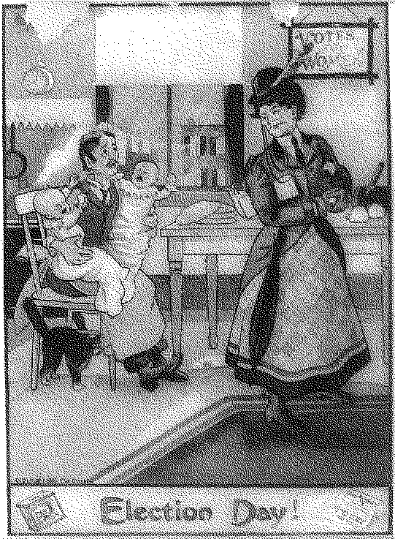

____ 1. Anti-suffragists feared that if women got the right to vote, they would
a. | demand in-home childcare while they went to the polls.
b. | repeal alcohol taxes since they used alcohol for many medicinal purposes.
c. | ignore their duties at home.
d. | vote for passage of more healthcare measures and thus have more babies.

____ 2. The foundation of the Progressive movement was laid by the
a. | politicians.
b. | muckrakers.
c. | Civil War veterans.
d. | Redeemers.

____ 3. This book by Jacob Riis presented visual images of desperate urban poverty.
a. | How the Other Half Lives
b. | Shame of the Cities
c. | The Octopus
d. | Tortilla Flats

____ 4. In the case of Muller v. Oregon, the Brandeis brief convinced the Supreme Court to uphold
a. | property rights of business owners.
b. | state anti-smoking laws.
c. | a law establishing a 10-hour work day.
d. | laws against racial discrimination.

____ 5. This event was a turning point for reform in workplace safety.
a. | the IWW textile workers strike in Lawrence, Massachusetts
b. | Lochner v. New York
c. | the Teapot Dome scandal
d. | Triangle Shirtwaist Company fire

____ 6. This governor pushed through reforms on campaign spending, railroad regulation, and civil service in Wisconsin.
a. | Robert M. La Follette
b. | Samuel M. Jones
c. | Tom Johnson
d. | Charles Evans Hughes

On the killing-floor you might easily freeze, if the gang for any reason had to stop for a time. You were apt to be covered with blood, and it would freeze solid; if you leaned against a pillar you would freeze to that . . .
—Upton Sinclair, The Jungle

____ 7. This novel prompted an investigation into the
a. | railroad industry.
b. | meatpacking industry.
c. | mining industry.
d. | Department of Labor.

____ 8. By 1900 more than 2,000 women had found employment in this field in which only 35 women worked in 1870.
a. | nursing
b. | teaching
c. | journalism
d. | medicine

____ 9. In the Progressive Era, women reformers campaigned for civil rights, children’s health and welfare, and
a. | pacifism.
b. | the spoils system.
c. | prohibition.
d. | retirement benefits.

____ 10. She was arrested for “knowingly, wrongfully, and unlawfully” voting in 1872.
a. | Carrie Nation.
b. | Susan B. Anthony
c. | Harriet Tubman
d. | Lucy Hayes

____ 11. Soon after he took office as president, Teddy Roosevelt intervened in the
a. | prohibition movement.
b. | suffrage movement.
c. | Spanish American War.
d. | coal strike.

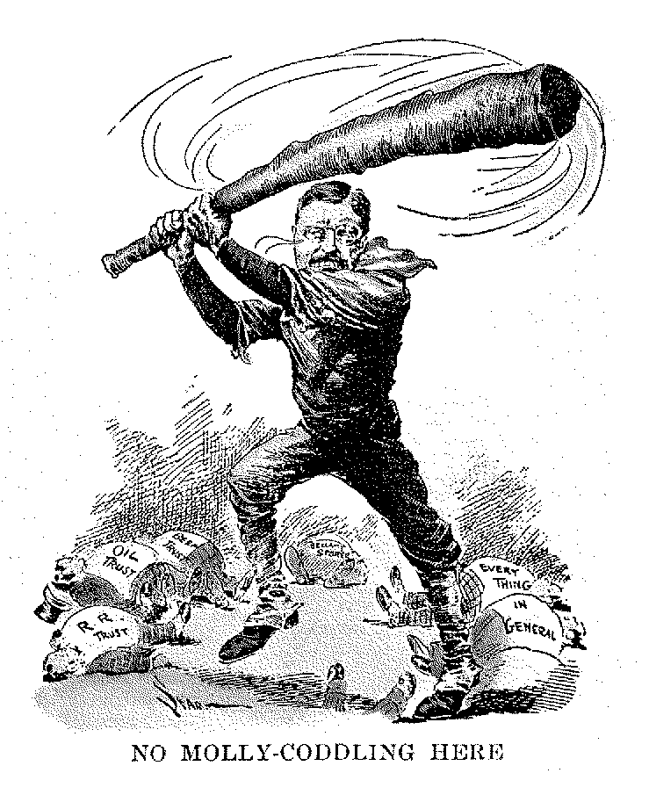

____ 12. This cartoon illustrates President Roosevelt’s national reputation as a
a. | conservationist.
b. | trust buster.
c. | rough rider.
d. | negotiator.

____ 13. Theodore Roosevelt refused to support President Taft’s reelection, and the Republican Party split after the
a. | Sixteenth Amendment passed.
b. | Democrats nominated Wilson.
c. | Ballinger-Pinchot affair.
d. | Payne-Aldrich Tariff.

____ 14. When President Wilson succeeded in reducing tariffs, the government made up the shortfall by a graduated
a. | income tax.
b. | sales tax.
c. | property tax.
d. | park service fee.

____ 15. This government agency, created under President Wilson, enforces antitrust laws and unfair business practices like deceptive advertising.
a. | Federal Reserve Board
b. | Interstate Commerce Commission
c. | Federal Trade Commission
d. | Small Business Administration

____ 16. The struggle for women’s suffrage resulted in a final victory with the ratification of the
a. | NAWSA.
b. | Nineteenth Amendment.
c. | Constitution.
d. | Suffrage Act.

____ 17. How did muckrakers prepare the way for political reforms?
a. | They organized labor strikes.
b. | They exposed corruption by writing about it.
c. | They testified in Senate hearings.
d. | They hired lawyers to settle disputes about safety.

____ 18. In the 15 years immediately following the passage of the New York Tenement Act of 1901, what evidence showed that the environment for residents was healthier?
a. | The amount of nutritious food sold by New York grocers increased.
b. | The number of wrongful death lawsuits went down.
c. | Landlords’ insurance rates dropped.
d. | Death rates in New York dropped dramatically.

____ 19. Which aims did the NAACP and the ADL share?
a. | insuring the rights of the disabled
b. | demanding increased safety at work
c. | fighting negative stereotyping of a minority
d. | increasing the availability of safe housing

____ 20. What improvements in working conditions was Florence Kelley instrumental in promoting?
a. | prohibiting child labor and limiting the number of hours women could work
b. | setting higher standards of hygiene in factories
c. | serving more nutritious food in factory cafeterias
d. | improving factory ventilation systems

____ 21. What was important about the “Uprising of the 20,000”?
a. | The uprising failed because of disputes among its leaders.
b. | The uprising resulted in court cases that dragged on for years.
c. | The uprising resulted in a shorter workweek and higher wages.
d. | Workers advocated for industrial sabotage.

____ 22. How did the lawyer for the state of Oregon convince the Supreme Court to uphold a law that limited women to a 10-hour workday?
a. | He took the justices to visit a factory.
b. | He created media interest in the women’s stories.
c. | He cited concrete evidence linking working long hours with poor health.
d. | He forced a laundry owner to admit that women workers were shackled to their workstations.

____ 23. Why was the Triangle Shirtwaist Company fire a landmark in labor history?
a. | Owners and families went to court to determine the amount of damages owed.
b. | The tragedy gave labor an edge in contract negotiations.
c. | The fire set off strikes across the nation.
d. | The tragedy led to New York State reforms of safety measures, factory inspections, and sanitation standards that became a nationwide model.

____ 24. What was the difference between the AFL and ILGWU?
a. | The AFL was only for women.
b. | The ILGWU won no victories by striking.
c. | The ILGWU’s members were mostly radicals.
d. | The ILGWU included unskilled workers.

____ 25. After winning some important victories, why did the Wobblies lose power?
a. | The government cracked down because of the group’s radicalism.
b. | Union leaders decided to focus on strengthening the AFL instead.
c. | Having achieved their goals, there was little reason for the group to continue.
d. | By 1912 all those who had held leadership positions were jailed.

____ 26. What political reform was enacted through the ratification of the Seventeenth Amendment?
a. | the creation of the posts of city commissioners
b. | the elimination of the position of city manager
c. | the direct election of senators
d. | the abolishment of jail time for failure to pay debts

____ 27. In the garment industry, why were women paid less than men?
a. | It took more time to train women for garment industry jobs than it did to train men.
b. | Women were usually less well educated than men were.
c. | Employers assumed women were supported by fathers or husbands.
d. | The work required more strength than most women had.

Group 1 |  |  |  | Group 2
Opposed Women’s Right to Vote

____ 28. Which of the following pairs best completes the chart above?
a. | Liquor industry, church leaders
b. | Suffragists, business leaders
c. | NACW, business leaders
d. | Business leaders, supporters of Susan B. Anthony

____ 29. Ohio’s Oberlin College is noted for its role in
a. | crafting the wording used in the Seventeenth Amendment.
b. | writing landmark labor legislation.
c. | opening its doors to women decades before most colleges did.
d. | helping pass fire safety laws that were used as models in other states.

____ 30. Reformers called for prohibition because they believed that alcohol
a. | was responsible for crime, poverty, and violence against women.
b. | was produced under unsanitary conditions.
c. | caused health problems.
d. | production lines were liable to burst into flames under the right conditions.

____ 31. What were main concerns of the NACW?
a. | organizing labor strikes
b. | improving safety conditions in minority-owned businesses
c. | fighting segregation and lynchings
d. | abolishing stereotypes about Jews

____ 32. What is one reason it took 72 years from the Seneca Falls Convention in 1848 for women to be granted the right to vote?
a. | The NWSA became distracted with other issues, like prohibition.
b. | The Fourteenth Amendment said women did not have the right to vote.
c. | The Supreme Court ruled that the right to vote was up to individual states to decide.
d. | Male politicians were afraid that women would only vote for women candidates.

____ 33. States in which area of the country were first to give women the right to vote?
a. | the South
b. | the West
c. | the East
d. | the North

____ 34. Susan B. Anthony was arrested for
a. | using a hatchet to destroy saloons.
b. | voting on election day in Rochester, New York.
c. | distributing pamphlets to a lynch mob in Fayetteville, Tennessee.
d. | barring the factory door to business owners during a strike.

____ 35. Why did the Republican Party’s plan to control Teddy Roosevelt backfire?
a. | President William McKinley was assassinated.
b. | Roosevelt was too young to listen to party bosses.
c. | Roosevelt’s health kept him from pushing through reforms.
d. | He refused to use the “bully pulpit,” even after he became president.

____ 36. What groups’ needs did Theodore Roosevelt feel should be balanced in the “Square Deal”?
a. | workers, women, and bankers
b. | women, farmers, and reformers
c. | religion, business, and art
d. | workers, business, and consumers

____ 37. Roosevelt formed the “Bull Moose” party because
a. | he thought that President Taft had failed to continue his policies of progressive reform.
b. | he believed that President Taft was ignoring the interests of big business at a critical point in the nation’s history.
c. | he thought President Taft’s conservation legislation was effective but poorly timed.
d. | he saw that President Taft focused on anti-trust legislation to the exclusion of other reforms.

____ 38. Why did Gifford Pinchot accuse Richard Ballinger of sabotaging the government’s efforts at conservation?
a. | He was angry that Ballinger had refused to support the conservation of the prairies of the Midwest.
b. | Ballinger had ignored industrial waste in the Mississippi River.
c. | Ballinger made a speech proclaiming that America needed to promote business more than it needed to “save a few trees.”
d. | Ballinger allowed businessmen to purchase protected land in Alaska.

____ 39. Upton Sinclair’s shocking novel The Jungle sparked an investigation that led to
a. | the creation of the Interstate Commerce Commission.
b. | anti-trust legislation.
c. | the passage of the Meat Inspection Act.
d. | the passage of the Elkins Act.

____ 40. Theodore Roosevelt created the U.S. Forest Service and the National Park Service because
a. | he recognized that natural resources were limited and believed that their use needed to be controlled.
b. | he thought the land could be developed more efficiently and profitably by government.
c. | he feared the consequences for industry if the open forests were under the care of only conservationists.
d. | he realized that lumber was too valuable a commodity to be kept inaccessible to business.

Completion
Complete each statement.

41. Theodore Roosevelt’s administration filed hundreds of lawsuits against ____. (monopolies/arbitrators)

42. The ____ caused Roosevelt to withdraw his support of President Taft. (Brownsville Incident/Ballinger-Pinchot affair)

43. The Federal Trade Commission was tough on companies that used ____. (deceptive advertising/impure ingredients)

44. The 1905 Antiquities Act created 18 national ____. (monuments/museums)

45. The split within the Republican Party in the 1912 presidential election allowed ____ to win. (William Howard Taft/Woodrow Wilson)

46. Journalists who exposed the dark side of society were called ____. (tabloid writers/muckrakers)

47. Florence Kelly led a successful effort in Oregon to limit women’s workdays to ____. (eight hours/ten hours)

48. Carrie Nation attacked saloons with a hatchet in one hand and in the other a ____ . (Bible/gun)

49. Teddy Roosevelt saw the White House as a ____. (bully pulpit/safe haven)

50. Wilson’s campaign slogan was the New ____. (Freedom/Deal)

True/False
Indicate whether the statement is true or false.

____ 51. In 1910 one third of U.S. workers lived in poverty.

____ 52. African American soldiers wrongly accused in the Brownsville incident were honorably discharged in 1906.

____ 53. President Woodrow Wilson called for higher tariffs and the repeal of most anti-trust legislation.

____ 54. The Roosevelt administration pursued and dissolved trusts that competed unfairly.

____ 55. By 1912 most states had laws prohibiting children from fulltime work.

Short Answer

56. Describe at least two accomplishments of President Theodore Roosevelt in the field of environmental conservation.

57. What was Oberlin College in Ohio the first to do in 1833?

58. What was the goal of the Women’s Christian Temperance Union?

“One half of the people of this nation to-day are utterly powerless . . . The women, dissatisfied as they are with this form of government, that enforces taxation without representation . . . are this half of the people left wholly at the mercy of the other half, in direct violation of the spirit and letter of the declarations of the framers of this government, every one of which was based on the immutable principle of equal rights to all.”
—Susan B. Anthony, 1872

59. On what founding principles of American government did Susan B. Anthony base her claim to women’s rights?

60. Describe the misuse of natural resources that led to the conservation movement.

Matching

a. | Alice Paul | h. | Square Deal
b. | John Muir | i. | ILGWU
c. | New Freedom | j. | Susan B. Anthony
d. | Ida Tarbell | k. | Sixteenth Amendment
e. | Jacob Riis | l. | Eighteenth Amendment
f. | IWW | m. | Nineteenth Amendment
g. | Richard Ballinger

____ 61. Journalist who exposed Rockefeller’s underhanded tactics at Standard Oil

____ 62. Plan that called for tariff reductions, banking reforms, and stronger anti-trust laws

____ 63. Roosevelt’s plan to limit the power of trusts and promote public health and safety

____ 64. Cabinet member who allowed business leaders to purchase public land in Alaska

____ 65. Union that organized unskilled laborers

____ 66. Naturalist who wanted the entire wilderness preserved in its natural state

____ 67. Women’s suffrage activist arrested for voting

____ 68. Amendment giving women the right to vote

____ 69. Helped found the National Woman’s Party

____ 70. Amendment that allowed Congress to levy taxes based on an individual’s income

a. | Elizabeth Cady Stanton | h. | John Muir
b. | Gifford Pinchot | i. | Francis Willard
c. | Alice Paul | j. | Leon Czolgosz
d. | Lincoln Steffens | k. | “Big Bill” Haywood
e. | Upton Sinclair | l. | Theodore Roosevelt
f. | Woodrow Wilson | m. | Otella Cromwell
g. | Robert La Follette

____ 71. Led progressive movement in Wisconsin

____ 72. Assassinated President McKinley

____ 73. Led National Women’s Party in picketing the White House

____ 74. President of the International Workers of the World

____ 75. Helped Susan B. Anthony form the National Woman Suffrage Association

____ 76. Exposed corruption of city governments

____ 77. President of the Women’s Christian Temperance Union

____ 78. Chief of the U.S. Forest Service

____ 79. Earned a Ph.D. from Yale and wrote a biography of Lucretia Mott

____ 80. Won all but eight states in the 1912 election

