Area, Volume, and Surface Area
Name_________________________________________

1. Carson wanted to make a cylindrical pillow for his mother’s birthday. The pillow was to be 15 inches long, with a diameter of 6 inches and would be filled with stuffing. Determine how many cubic inches of stuffing Carson will need to make the pillow. Show your work. Before he started making the pillow, Carson decided he wanted to make it bigger. Compare the amount of stuffing needed when he doubles the length to the amount of stuffing needed when he doubles the diameter. Show work or provide an explanation to support your comparison.

2. A tabletop in the shape of a trapezoid is made up of a rectangle and two congruent right triangles. The bases of the trapezoid are 70 cm and 130 cm, and the height is 80 cm. What is the area of the tabletop?

A. 240 sq cm
B. 5,600 sq cm
C. 8,000 sq cm
D. 10,400 sq cm
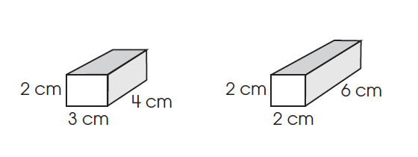
3. How do the volumes and surface areas of these rectangular prisms compare?

A. The volumes are the same, but the surface areas are different.
B. The volumes and surface areas are the same.
C. The volumes are different, but the surface areas are the same.
D. The volumes and surface areas are both different.
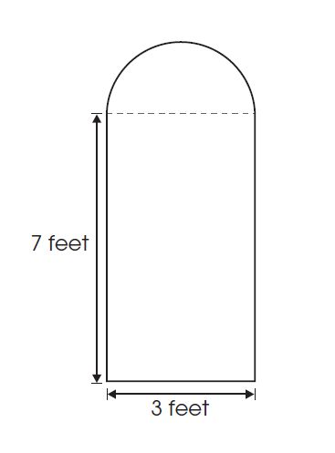
4. A window consists of a semicircle and a rectangle, as shown.
What is the approximate area of the window?
A. 21 square feet
B. 24 ½ square feet
C. 28 square feet
D. 35 ½ square feet

5. The Burton Company produces cylindrical barrels. If the height of a cylindrical barrel is reduced from 12 feet to 4 feet, what will happen to the volume of the barrel?

A. The volume triples.
B. The volume doubles.
C. The volume is reduced to one half of the original.
D. The volume is reduced to one third of the original.

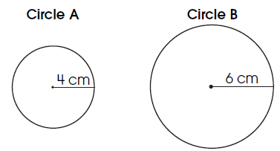
6. Two circles are shown. Find the ratio of the circumference of Circle A to the circumference of Circle B. Show your work or provide an explanation to support your answer.

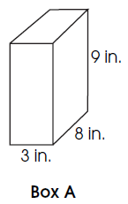
7. A company needs to create a box shaped like a rectangular prism. The volume must be 216 cubic inches, but the surface area needs to be as small as possible. One possible box is shown. Sketch or describe a different box that has the same volume as Box A, and a surface area less than that of Box A. Show work or provide an explanation to verify that the new box meets the criteria.

8. Tina created a display as shown below. What is the total area of her display?
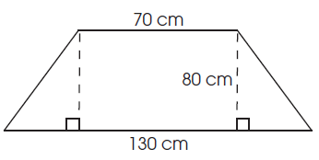
A. 1,152 square inches
B. 1,440 square inches
C. 2,016 square inches
D. 2,880 square inches

9. A packing company is changing the size of a shipping carton.
The carton is in the shape of a rectangular prism. The height of the carton will be doubled and the width will be tripled. By what scale factor will the volume of the original carton increase?
A. 5
B. 6
C. 9
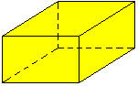
D. 36

10. If L = 8 cm, W = 5 cm, and H = 4 cm, what is the surface area of the rectangular prism?
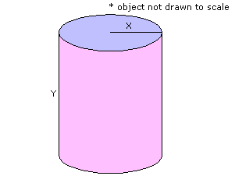
11. If X=4 inches and Y=8 inches, what is the volume of the cylinder to the nearest cubic inch?
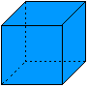
12. If the cube has a side length of 3 cm, what is the surface area of the cube?

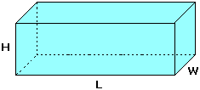
13. If L = 12 inches, W = 3 inches, and H = 4 inches, what is the surface area of the rectangular box?

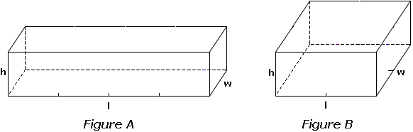
14. Figure A has length l = 12 cm, width w = 3 cm, and height h = 3 cm. The volume of Figure A is 108 cm³. The surface area of Figure A is 162 cm².
Figure B has length l = 6 cm, width w = 6 cm, and height h = 3 cm. The volume of Figure B is also 108 cm³. What is the surface area of Figure B?
 | A. | 180 cm²
 | B. | 162 cm²
 | C. | 144 cm²
 | D. | 81 cm²

15. A worker at a fast food restaurant looked in the dumpster and saw that trash only filled the dumpster about 2 feet high. About what portion of the dumpster is still available for trash?
- 80 cubic feet
- 120 cubic feet
- ⅓
- ⅔

