C:\Users\User\Pictures\Microsoft Clip Organizer\en00505_.wmf

By: Jodie Rominski

EDTL 2100

Summer 2009

**Rationale**

Art education is more than just coloring and drawing. Art education is an elective subject that enriches students’ lives with exploration and creative problem solving skills. In this course students’ will be involved in art education were they are encouraged to express their thoughts and ideas creatively while challenging their imagination, fostering reflective thinking, and developing disciplined effort and critical thinking skills (Mittler & Ragans, 2007). Art education has many standards and the state and national levels but does not have a set curriculum in our district. My objective is to create a starting point for a set curriculum for Swanton middle school. This unit is designed to introduce students to the elements of art. The elements of art are the basic visual components an artist uses to create art (Mittler & Ragans, 2007). There are seven total elements of art that need to be covered. They are line, color, value, shape, form, space, and texture.

“When you first learned how to read, you did not start with an entire book. You began by learning one word at a time. That is how you will learn the language of art: one element at a time” (Mittler & Ragans, 2007).

Going through each element students will begin to understand how artists use these elements to create artwork. Then students will work with these concepts and they will be able to identify and compare the elements of art in their work, artwork, and the world around them. This is why the elements of art are the foundation for teaching art standards to middle school students.

This instructional design is going to focus on the subunit of Line. Chiarelott states that “common cognitive activities such as problem solving, communicating thoughts and feelings, and organizing daily activities would be virtually impossible without concepts” (Chiarelott, 2005). With this being said, line is an important concept to grasp in this the element of art unit because it has a strong presence in all visual artwork and the world around us. In this subunit students will gain an understanding of the term line, how to use it, and how it is carried out in all types of artwork. Each of the lessons is created around the project based lesson plan format because this is an art education class, where students create a piece of artwork of their own to show understanding of the concept learned. This lesson plan format allows the learning process to extend over a several day period to get to the final outcome. Once the lessons are complete students will be able to recognize the different types of line in their own artwork, artist’s artwork and the world around them. The completion of this subunit will also provide the students with what they need to proceed to the other elements of art subunits.

**References:**

Chiarelott, Leigh. (2005). *Curriculum in context*. Bowling Green: Wadsworth

Publishing.

Mittler, G., & Ragans, R. (2007). Exploring art. Woodland Hills, CA: Glencoe /

McGraw-Hill.

**Subunit: Line**

Subunit learner outcomes are based off of the

Gagne` and Briggs’s Learned Capabilities.

* Students will be able to define the term Line.

(Intellectual Skills)

* Be able to name the different types of lines.

(Verbal Information)

* Create a drawing using the different types of lines.

(Motor Skills)

* Students will be able to describe and discuss types of moods that lines portray. (Cognitive Strategies)
* Identify different types of lines in an artwork.

(Intellectual Skills)

**Pre-Assessment Of Line**

Name: \_\_\_\_\_\_\_\_\_\_\_\_\_\_\_\_\_\_\_\_\_\_\_\_\_\_\_\_\_\_ Class: \_\_\_\_\_\_\_\_Date:\_\_\_\_\_\_\_\_\_

Directions: Answer the following questions the best you can and do not leave any of them blank. This is to see what you already know about the term Line.

1. Define the term LINE. \_\_\_\_\_\_\_\_\_\_\_\_\_\_\_\_\_\_\_\_\_\_\_\_\_\_\_\_\_\_\_\_\_\_\_\_\_\_\_\_\_\_\_\_\_\_\_\_\_\_\_\_\_\_\_\_\_\_\_\_\_\_\_\_\_\_\_\_\_\_\_\_\_\_\_\_\_\_\_\_\_\_\_\_\_\_\_\_\_\_\_\_\_\_\_\_\_\_\_\_\_\_\_\_\_\_\_\_\_\_\_\_\_\_\_\_\_\_\_\_\_\_\_\_\_\_\_\_\_\_\_\_\_\_\_\_\_\_\_\_\_\_\_\_\_\_\_\_\_\_\_\_\_\_\_\_\_\_\_\_\_\_\_\_\_
2. Name two different types of lines.

\_\_\_\_\_\_\_\_\_\_\_\_\_\_\_\_\_\_\_\_\_\_\_\_\_\_&\_\_\_\_\_\_\_\_\_\_\_\_\_\_\_\_\_\_\_\_\_\_\_\_\_\_

1. Can types of lines describe a type of mood? If so describe a line and the mood it portrays.

\_\_\_\_\_\_\_\_\_\_\_\_\_\_\_\_\_\_\_\_\_\_\_\_\_\_\_\_\_\_\_\_\_\_\_\_\_\_\_\_\_\_\_\_\_\_\_\_\_\_\_\_\_\_\_\_\_\_\_\_\_\_\_\_\_\_\_\_\_\_\_\_\_\_\_\_\_\_\_\_\_\_\_\_\_\_\_\_\_\_\_\_\_\_\_\_\_\_\_\_\_\_\_\_\_\_\_\_\_\_\_\_\_\_\_\_\_\_\_\_\_\_\_\_\_\_\_\_\_\_\_\_\_\_\_\_\_\_\_\_\_\_\_\_\_\_\_\_\_\_\_\_\_\_\_\_\_\_\_\_\_\_\_\_\_

1. Describe and list the types of lines that you see in the picture below.

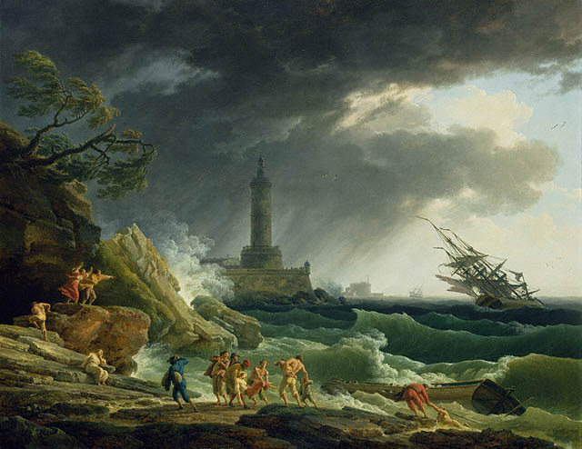\_\_\_\_\_\_\_\_\_\_\_\_\_\_\_\_\_\_\_\_\_\_\_\_\_\_\_\_\_\_\_\_\_\_\_\_\_\_\_\_\_\_\_\_\_\_\_\_\_\_\_\_\_\_\_\_\_\_\_\_\_\_\_\_\_\_\_\_\_\_\_\_\_\_\_\_\_\_\_\_\_\_\_\_\_\_\_\_\_\_\_\_\_\_\_\_\_\_\_\_\_\_\_\_\_\_\_\_\_\_\_\_\_\_\_\_\_\_\_\_\_\_\_\_\_\_\_\_\_\_\_\_\_\_\_\_\_\_\_\_\_\_\_\_\_\_\_\_\_\_\_\_\_\_\_\_\_\_\_\_\_\_\_\_\_\_\_\_\_\_\_\_\_\_\_\_\_\_\_\_\_\_\_\_\_\_\_\_\_\_\_\_\_\_\_\_\_\_\_\_\_\_\_\_\_\_\_\_\_\_\_\_\_\_\_\_\_\_\_\_\_\_\_\_\_\_\_\_\_\_\_\_\_\_\_\_\_\_\_\_\_\_\_\_\_\_\_\_\_\_\_\_\_\_\_\_\_\_\_\_\_\_\_\_\_\_\_\_\_\_

Picture from: http://www.getty.edu/art/gettyguide/artObjectDetails?artobj=144721&handle=li

**Pre-Assessment Of Line**

Name: \_\_\_\_Teacher Key\_\_\_\_\_\_\_\_\_\_\_\_\_\_ Class: \_\_\_\_\_\_\_\_Date:\_\_\_\_\_\_\_\_\_

Directions: Answer the following questions the best you can and do not leave any of them blank. This is to see what you already know about the term Line.

1. Define the term LINE.

\_\_A continuous mark made on a surface by a moving point \_\_\_\_

1. Name two different types of lines. (any of the following will work)

\_\_\_\_CURVED, HORIZONTAL, VERTICAL, DIAGNOL, & ZIGZAG\_\_\_

1. Can types of lines describe a type of mood? If so describe a line and the mood it portrays.

\_\_YES, Zigzag lines can create confusion, suggest action and nervous excitement\_\_\_\_\_\_\_\_\_\_\_\_\_\_\_\_\_\_\_\_\_\_\_\_\_\_\_\_\_\_\_\_\_\_\_

1. Describe and list the types of lines that you see in the picture below.

\_\_Answers will vary. Example: Diagnol lines of the clouds and ship suggest movement \_\_\_\_\_\_\_\_\_\_\_\_\_\_\_\_\_\_\_\_\_\_\_\_\_\_\_\_\_\_\_\_\_\_\_\_\_\_\_

**Lesson Plan #1**

**Overview of Lesson:**

This lesson is where the term line is defined and the different types of line are discovered. This lesson will lead into the following lessons of this subunit.

**Lesson Objectives:**

1. Students will be able to define the term Line. (Intellectual Skills)
2. Be able to name the different types of lines. (Verbal Information)

**Class Period Objectives:** (47 minute class period)

1. Students will complete the pre-assessment handout.
2. Class will discuss the pre-assessment.
3. Students will read and discuss pages 24-27 in their textbooks.
4. Students will define and demonstrate the different types of lines on their worksheet.

**Materials:**

1. Pre-assessment for each student
2. Types of lines worksheet for each student
3. Classroom textbook
4. Pencil
5. Dry erase board

**Procedure:**

Beginning of the Lesson**:**

Students will complete the line pre-assessment to see what they already know and need to know about the concept of line. (10 minutes)

Once students have completed the pre-assessment then there will be a teacher guided discussion about their answers. Teacher will encourage students to share their answers so that they right and wrong answers can be discussed. The teacher should write out each answer on the board for the students to see the new concepts.

(10 minutes)

Activity:

Once the pre-assessment is completed then students will begin to read pages 24 through 27 in the Exploring Art textbook. As students read the teacher should stop at every new type of line to reinforce the importance of them and have the students write down definition and mood of each type of line on the worksheet that is provided. Once the reading and definitions are completed have the students complete the back side of the handout. Here the students will draw out the different types of line to practice the skill. (25 minutes)

Lesson Closure:

Ask students to pass forward their worksheet and verbally ask the students a series of questions to check understanding. (2 minutes)

1. What does the term line mean?
2. Name the five types of line?

Evaluation:

The pre-assessment will be graded as participation points (10 points). The types of line worksheet will be graded based on completing all the definitions and types of moods (15 points) and if they completed the drawing different types of line exercise (15 points). The amount of points possible for this lesson is 40.

References:

Mittler, G., & Ragans, R. (2007). Exploring art. Woodland Hills, CA: Glencoe /

McGraw-Hill.

**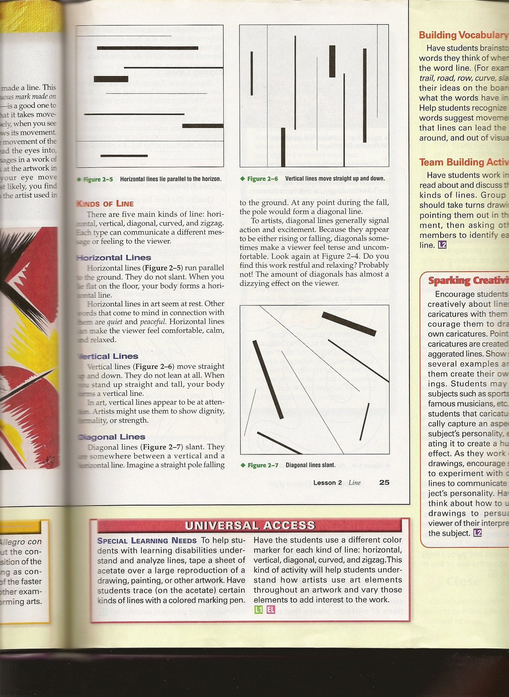**

**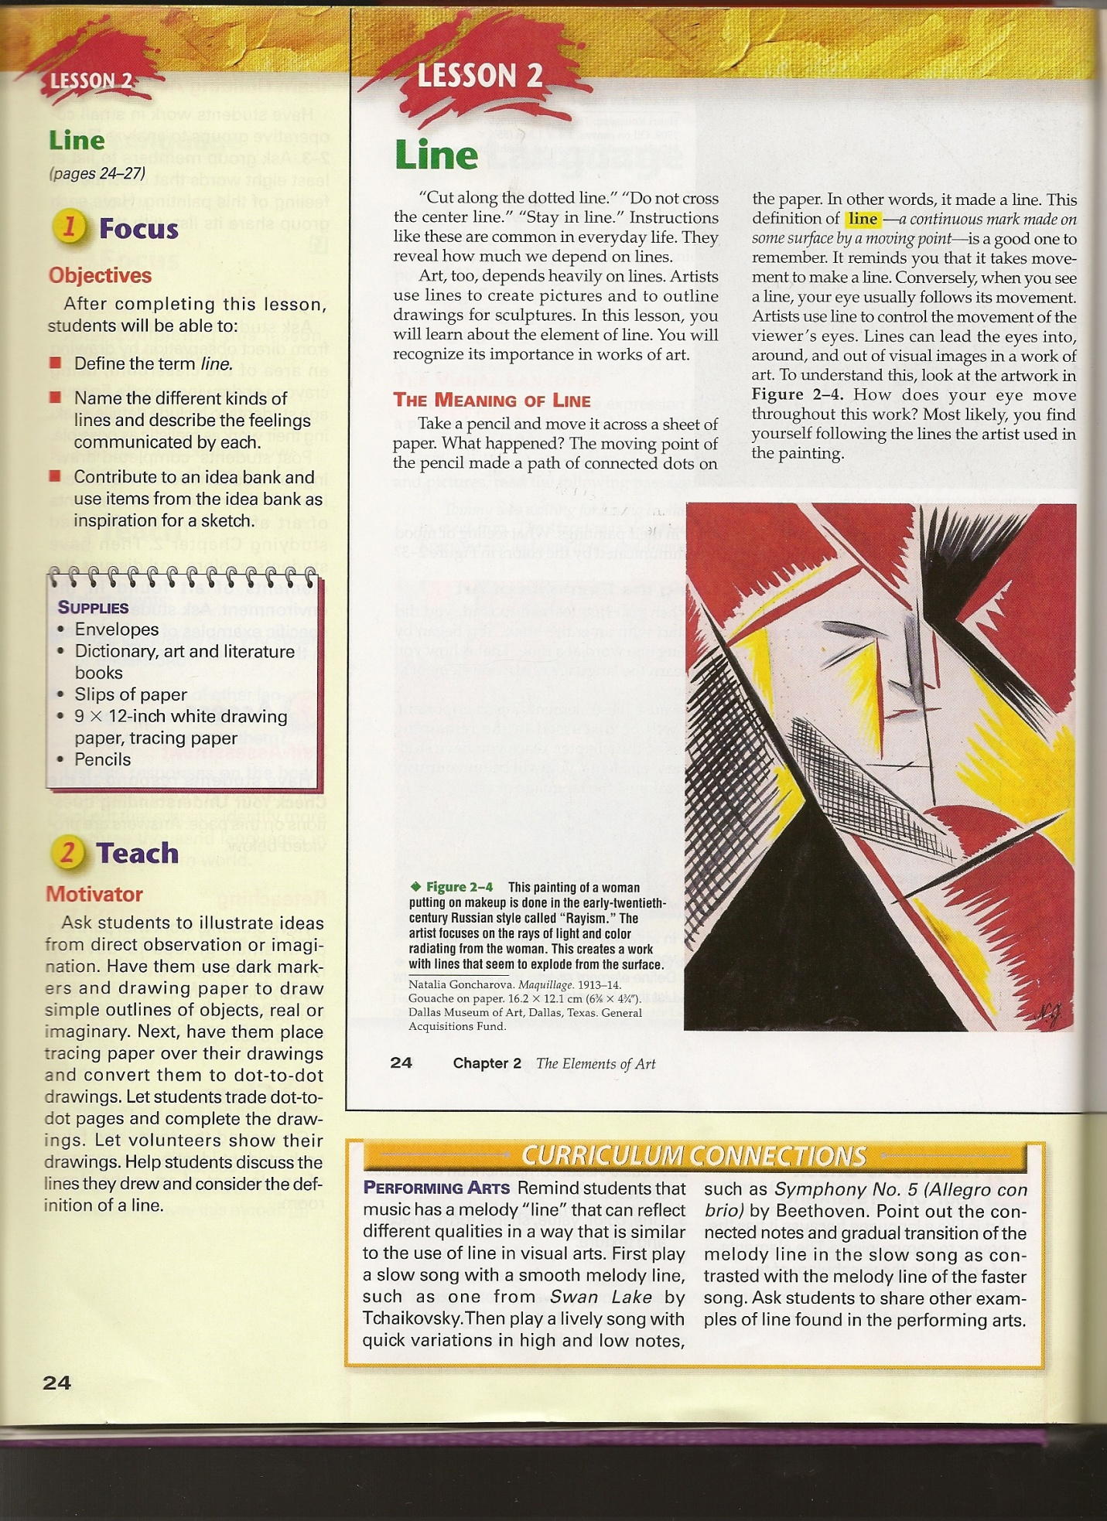**

**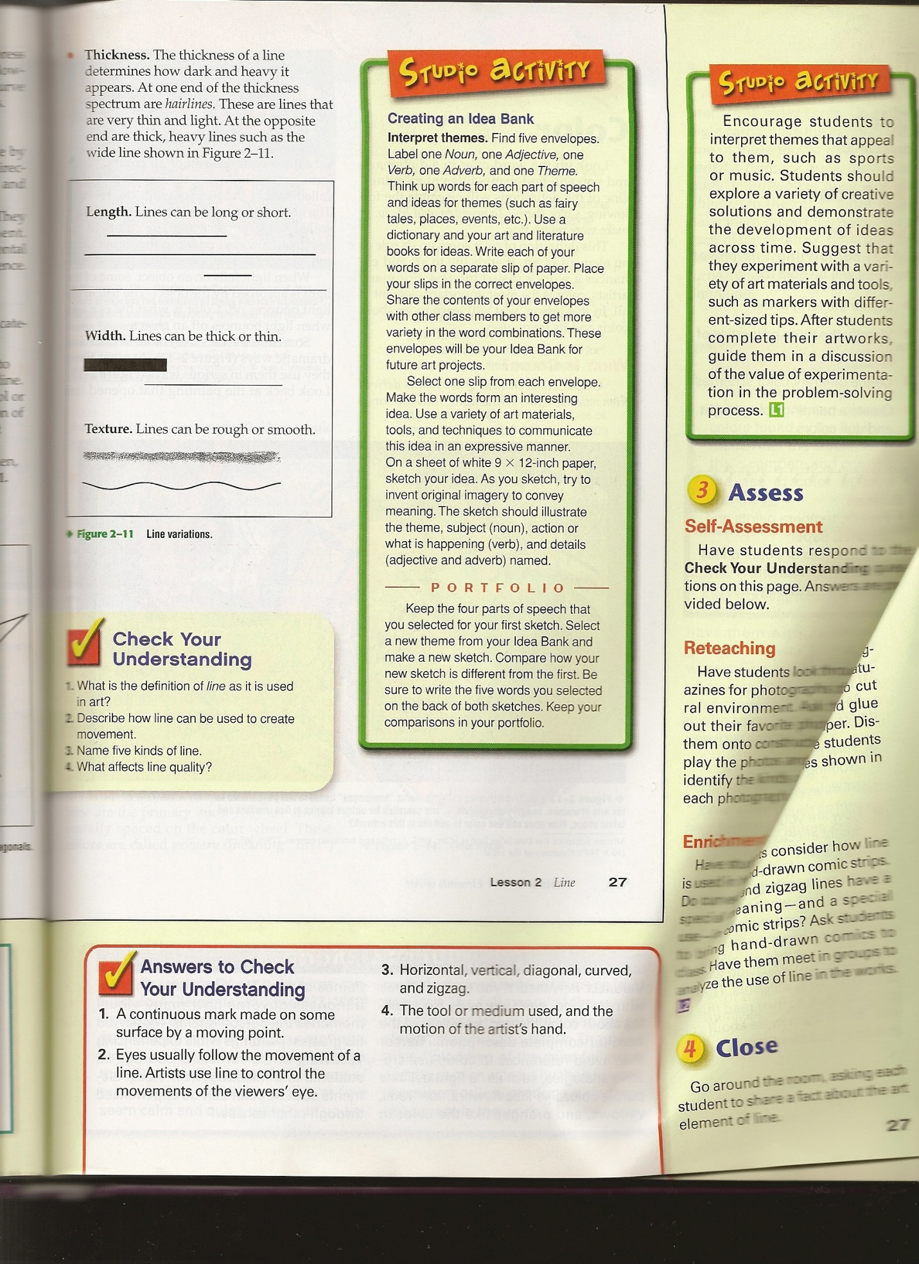**

**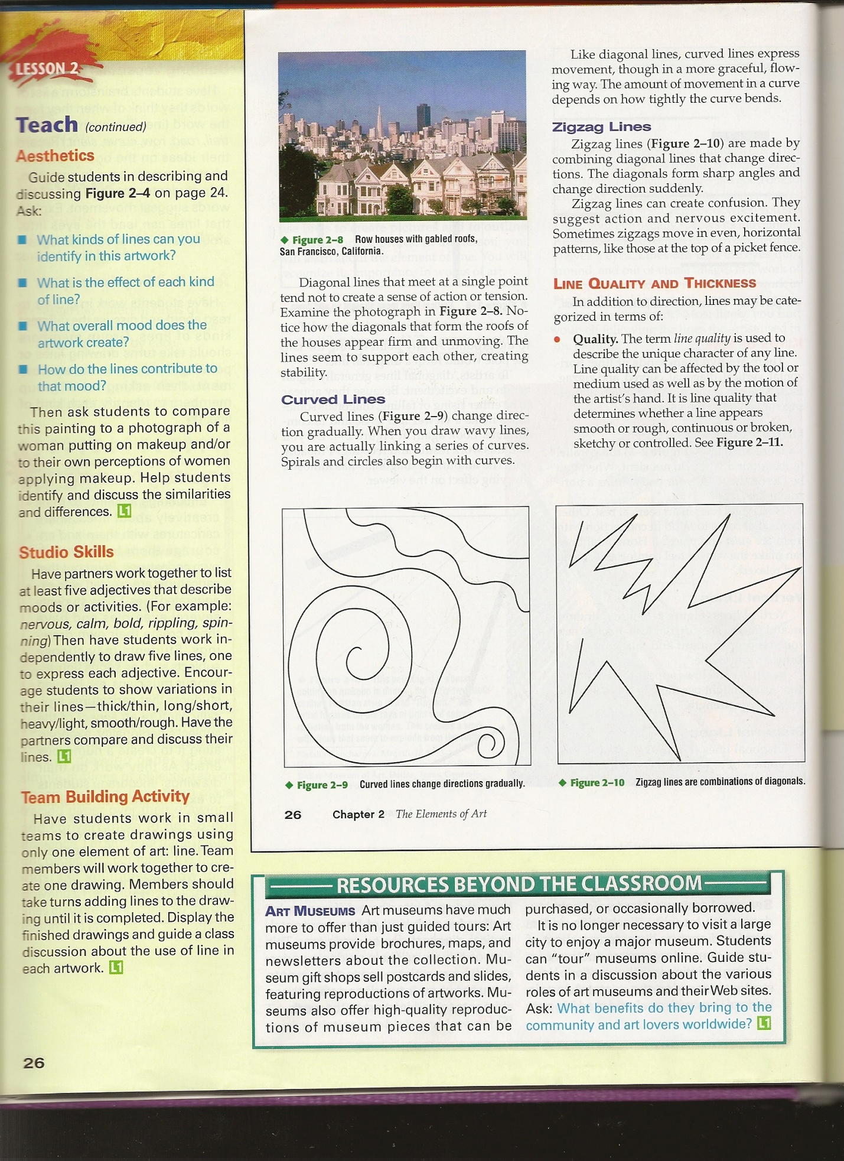**

**Different Types of Lines**

Name: \_\_\_\_\_\_\_\_\_\_\_\_\_\_\_\_\_\_\_\_\_\_\_\_\_\_\_\_\_\_ Class: \_\_\_\_\_\_\_\_Date:\_\_\_\_\_\_\_\_\_

Directions: As you read along with pages 24-27 in the Exploring Art textbook fill in the definitions and different moods that the lines portray.

1. Line: \_\_\_\_\_\_\_\_\_\_\_\_\_\_\_\_\_\_\_\_\_\_\_\_\_\_\_\_\_\_\_\_\_\_\_\_\_\_\_\_\_\_\_\_\_\_\_\_\_\_\_\_\_\_\_\_\_\_\_

\_\_\_\_\_\_\_\_\_\_\_\_\_\_\_\_\_\_\_\_\_\_\_\_\_\_\_\_\_\_\_\_\_\_\_\_\_\_\_\_\_\_\_\_\_\_\_\_\_\_\_\_\_\_\_\_\_\_\_\_\_\_\_\_

1. List the 5 different types of lines: \_\_\_\_\_\_\_\_\_\_\_\_\_\_\_\_\_\_\_, \_\_\_\_\_\_\_\_\_\_\_\_\_\_\_\_\_,

\_\_\_\_\_\_\_\_\_\_\_\_\_\_\_\_\_\_\_\_, \_\_\_\_\_\_\_\_\_\_\_\_\_\_\_\_\_\_\_, & \_\_\_\_\_\_\_\_\_\_\_\_\_\_\_\_\_\_\_\_\_.

1. Horizontal: \_\_\_\_\_\_\_\_\_\_\_\_\_\_\_\_\_\_\_\_\_\_\_\_\_\_\_\_\_\_\_\_\_\_\_\_\_\_\_\_\_\_\_\_\_\_\_\_\_\_\_\_\_\_

Mood: \_\_\_\_\_\_\_\_\_\_\_\_\_\_\_\_\_\_\_\_\_\_\_\_\_\_\_\_\_\_\_\_\_\_\_\_\_\_\_\_\_\_\_\_\_\_\_\_\_\_\_\_\_\_\_\_\_\_

1. Vertical: \_\_\_\_\_\_\_\_\_\_\_\_\_\_\_\_\_\_\_\_\_\_\_\_\_\_\_\_\_\_\_\_\_\_\_\_\_\_\_\_\_\_\_\_\_\_\_\_\_\_\_\_\_\_\_\_\_

Mood: \_\_\_\_\_\_\_\_\_\_\_\_\_\_\_\_\_\_\_\_\_\_\_\_\_\_\_\_\_\_\_\_\_\_\_\_\_\_\_\_\_\_\_\_\_\_\_\_\_\_\_\_\_\_\_\_\_\_

1. Diagonal: \_\_\_\_\_\_\_\_\_\_\_\_\_\_\_\_\_\_\_\_\_\_\_\_\_\_\_\_\_\_\_\_\_\_\_\_\_\_\_\_\_\_\_\_\_\_\_\_\_\_\_\_\_\_\_\_

Mood: \_\_\_\_\_\_\_\_\_\_\_\_\_\_\_\_\_\_\_\_\_\_\_\_\_\_\_\_\_\_\_\_\_\_\_\_\_\_\_\_\_\_\_\_\_\_\_\_\_\_\_\_\_\_\_\_\_\_

1. Curved: \_\_\_\_\_\_\_\_\_\_\_\_\_\_\_\_\_\_\_\_\_\_\_\_\_\_\_\_\_\_\_\_\_\_\_\_\_\_\_\_\_\_\_\_\_\_\_\_\_\_\_\_\_\_\_\_\_

Mood: \_\_\_\_\_\_\_\_\_\_\_\_\_\_\_\_\_\_\_\_\_\_\_\_\_\_\_\_\_\_\_\_\_\_\_\_\_\_\_\_\_\_\_\_\_\_\_\_\_\_\_\_\_\_\_\_\_\_

1. Zigzag: \_\_\_\_\_\_\_\_\_\_\_\_\_\_\_\_\_\_\_\_\_\_\_\_\_\_\_\_\_\_\_\_\_\_\_\_\_\_\_\_\_\_\_\_\_\_\_\_\_\_\_\_\_\_\_\_\_

Mood: \_\_\_\_\_\_\_\_\_\_\_\_\_\_\_\_\_\_\_\_\_\_\_\_\_\_\_\_\_\_\_\_\_\_\_\_\_\_\_\_\_\_\_\_\_\_\_\_\_\_\_\_\_\_\_\_\_\_

1. Quality of a line: \_\_\_\_\_\_\_\_\_\_\_\_\_\_\_\_\_\_\_\_\_\_\_\_\_\_\_\_\_\_\_\_\_\_\_\_\_\_\_\_\_\_\_\_\_\_\_\_\_\_\_

\_\_\_\_\_\_\_\_\_\_\_\_\_\_\_\_\_\_\_\_\_\_\_\_\_\_\_\_\_\_\_\_\_\_\_\_\_\_\_\_\_\_\_\_\_\_\_\_\_\_\_\_\_\_\_\_\_\_\_\_\_\_\_\_\_\_\_\_\_\_\_\_\_\_\_\_\_\_\_\_\_\_\_\_\_\_\_\_\_\_\_\_\_\_\_\_\_\_\_\_\_\_\_\_\_\_\_\_\_\_\_\_\_\_\_\_\_\_\_\_\_\_\_\_\_\_\_\_

1. Thickness of a line: \_\_\_\_\_\_\_\_\_\_\_\_\_\_\_\_\_\_\_\_\_\_\_\_\_\_\_\_\_\_\_\_\_\_\_\_\_\_\_\_\_\_\_\_\_\_\_\_

\_\_\_\_\_\_\_\_\_\_\_\_\_\_\_\_\_\_\_\_\_\_\_\_\_\_\_\_\_\_\_\_\_\_\_\_\_\_\_\_\_\_\_\_\_\_\_\_\_\_\_\_\_\_\_\_\_\_\_\_\_\_\_\_\_\_\_\_\_\_\_\_\_\_\_\_\_\_\_\_\_\_\_\_\_\_\_\_\_\_\_\_\_\_\_\_\_\_\_\_\_\_\_\_\_\_\_\_\_\_\_\_\_\_\_\_\_\_\_\_\_\_\_\_\_\_\_\_

**Different Types of Lines**

Name: \_\_\_\_Teacher Key\_\_\_\_\_\_\_\_\_\_\_\_\_ Class: \_\_\_\_\_\_\_\_Date:\_\_\_\_\_\_\_\_\_

Directions: As you read along with pages 24-27 in the Exploring Art textbook fill in the definitions and different moods that the lines portray.

1. Line: \_\_\_ continuous mark made on a surface by a moving point \_\_\_
2. List the 5 different types of lines: \_\_\_Horizontal\_\_\_, \_\_\_\_Vertical\_\_\_\_\_,

\_\_\_Diagonal\_\_\_\_, \_\_\_Curved\_\_\_\_, & \_\_\_Zigzag\_\_\_\_.

1. Horizontal: \_lines that run parallel to the horizon\_\_\_\_\_\_\_\_\_\_\_\_\_\_\_\_\_\_\_\_\_\_\_\_\_

Mood: \_\_\_quiet, peaceful, comfortable, calm, and relaxed\_\_\_\_\_\_\_\_\_\_\_\_\_\_\_\_\_\_

1. Vertical: \_lines that move straight up and down \_\_\_\_\_\_\_\_\_\_\_\_\_\_\_\_\_\_\_\_\_\_\_\_\_\_

Mood: \_\_dignity, formality, and strength \_\_\_\_\_\_\_\_\_\_\_\_\_\_\_\_\_\_\_\_\_\_\_\_\_\_\_\_\_\_\_\_

1. Diagonal: \_\_lines that are slanted \_\_\_\_\_\_\_\_\_\_\_\_\_\_\_\_\_\_\_\_\_\_\_\_\_\_\_\_\_\_\_\_\_\_\_\_\_

Mood: \_\_\_action, excitement, tense, and uncomfortable\_\_\_\_\_\_\_\_\_\_\_\_\_\_\_\_\_\_\_

1. Curved: \_\_lines that change directions gradually \_\_\_\_\_\_\_\_\_\_\_\_\_\_\_\_\_\_\_\_\_\_\_\_\_

Mood: \_\_\_movement and graceful\_\_\_\_\_\_\_\_\_\_\_\_\_\_\_\_\_\_\_\_\_\_\_\_\_\_\_\_\_\_\_\_\_\_\_\_

1. Zigzag: \_\_lines that are cominations of diagonals\_\_\_\_\_\_\_\_\_\_\_\_\_\_\_\_\_\_\_\_\_\_\_\_\_

Mood: \_\_\_action, nervousness, and excitement \_\_\_\_\_\_\_\_\_\_\_\_\_\_\_\_\_\_\_\_\_\_\_\_\_\_

1. Quality of a line: \_used to describe the unique character of any line, determines whether a line appears smooth or rough, continuous or broken, sketchy or contolled\_\_\_\_\_\_\_\_\_\_\_\_\_\_\_\_\_\_\_\_\_\_\_\_\_\_\_\_\_\_\_\_\_\_\_\_\_\_\_\_\_\_\_\_\_\_\_\_\_\_\_\_\_\_\_\_\_
2. Thickness of a line: \_\_determines how dark and heavy the line appears\_\_\_\_\_\_\_\_\_\_\_\_\_\_\_\_\_\_\_\_\_\_\_\_\_\_\_\_\_\_\_\_\_\_\_\_\_\_\_\_\_\_\_\_\_\_\_\_\_\_\_\_\_\_\_\_\_\_

|  |  |
| --- | --- |
| Different  Types of Lines | Directions: Practice drawing the  different types of lines in the spaces provided. Remember to use good craftsmanship skills when creating your lines. \*Hint: use a ruler\* |
| Horizontal |  |
| Vertical |  |
| Diagonal |  |
| Curved |  |
| Zigzag |  |
| Thick |  |

**Lesson Plan #2**

**Overview of Lesson**:

This lesson is to reinforce and show students how lines show different emotions and portray different moods. This lesson needs 4 days to complete, ensuring students that they will have enough time to do their best work.

**Lesson Objectives**:

1. Create a drawing using the different types of lines. (Motor Skills)
2. Students will be able to describe and discuss types of moods that lines portray. (Cognitive Strategies)

**Class Period Objectives**: (47 minute class period)

1. Students will work in table groups to complete tasks. (4 people to a group)
2. Students will complete the adjective and line handout.
3. Class will discuss different moods or emotions that lines portray.
4. Listen to a music clip and discuss what mood or emotion is it trying to portray and how they would visualize what it looks like in lines.
5. Students will prepare for line project.

**Materials**:

1. Pencil
2. Music Clips
3. 2 sheets of newsprint
4. Adjective and line worksheet
5. Dry erase board
6. Construction paper
7. 4, 6x6 white square sheets

**Procedures**:

Beginning of Lesson:

Return student’s papers from lesson 1 so that they have a review sheet of what lines go with what moods. (2 minutes)

Motivation:

A question to ask the students before activity begins: Can a line drawing be a representation of a mood or emotion in a song?

The answer is Yes, because lines can describe a type of mood or emotion and this motivation activity will prove how this can be done.

Pass out two sheets of newsprint to each student, have them put their name and class period in the lower right hand corner. They should also write the name of the activity, which is Lines with Music. Pick 2 songs to play for the students, explain that music portrays different emotions as do different types of lines. First have them just listen to part of the 1st song and discuss with them what they hear and how the song could be drawn into different line patterns. During the discussion draw examples on the board that show how lines can represent a sound that displays a mood. Then play the song through and have them listen and have their hand draw the lines that they hear. This is going to be a freeform drawing that shows the students how they interpret music into lines. (10 minutes)

(Examples of 2 different types of music: Canon ID and My Girl)

Activity:

Once the motivation activity is completed now they are going to work with the students at their tables (they sit in groups of four). Now pass out the adjective and line handout. Have them fill out the top of the worksheet with their name, date, and class period. With their groups they will pick out 5 adjectives each that describe a mood or activity. They can discuss with their groups different moods and activities so that the group does not repeat an adjective on any of their worksheets. Once they have completed the worksheet, then they will circle one adjective that they want to work with. (15 minutes)

Now pass out the 4 white 6x6 sheets of paper to each student. First they need to put their name on the back of each square. Once that is completed have them write down the adjective that they wanted to work with from their handout and have the write it on the back of one of the squares. Now they are going to trade their worksheet with the person to the right of them and choose one of the adjectives from one of their group member’s worksheet. Once they have chosen one then they need to write that on one of their other squares. They are going to continue to do this until all of their squares have an adjective on them. (15 minutes)

Lesson Closure:

Have students put their adjective and line worksheet in the blue class period folder located in the front of the classroom. Then put their definition and line practice worksheet and their 4 squares into their personal art folder and return it to the red box located in the front of the room, next to the blue class period folder box.

Explain to students that the next part of the project will continue the next day. (5 minutes)

**Following Next 3 Days of Lesson Plan #2**

**The Next 3 Class Period Objectives**: (3 - 47 minute classes)

1. Students will plan for their final project.
2. Students will draw out different types of lines to represent different adjectives.
3. Students will construct their four different square designs.
4. Students will follow/use rubric to make sure that they have all the requirements for the project.

**Materials**:

1. 4 Previously written on 6x6 white paper squares
2. Scissors
3. Glue
4. Construction Paper
5. Pencil
6. Notebook Paper

**Procedures**:

Beginning of Lesson:

As students are walking in to the classroom have them get out their folders and their pencils so that class can begin. Once class has begun, have an open discussion about lines and the different moods, emotions, and activities that they can portray. Once discussion is over then it is time to start the rest of the activity. (10 minutes)

Activity:

Have the students take out their folders and remove the 4 white squares. Now it is time to explain the rest of the project and how they will be working independently to finish the assignment. Each adjective that is written on the back of the squares needs to be drawn out in lines. Students can draw and map out their ideas on notebook paper so they have a good understanding of what they want each square to look like. Once they have chosen how each one will look, then they need to get their supplies, construction paper, glue, and scissors. Each line that they want displayed on the white paper needs to be cut out of construction paper. Once all the pieces are cut out for one square design then it is time to arrange the cut outs and then glue them down. Students will repeat this process until each one of the squares is complete. Students will receive a rubric to follow for their designs to make sure that they include everything that is required.

Daily Closure:

The days that the students are working on their projects allow them 5 minutes at the end of the class period to clean up materials and put their projects away for the next day.

**Evaluation**:

Students will complete the lines with music activity and they will receive participation points for having two different freeform drawings (20 points). Then students will be graded on how well they worked with their group on the adjective and line worksheet (25 points) as well as the completion of the worksheet (25 points). Students will also be assessed on the 4 line designs that explain an adjective. The grading for this project will follow the rubric and it will be out of 100 points. The amount of points possible for this lesson is 170.

Adjective and Line Design Rubric

|  |  |  |  |  |
| --- | --- | --- | --- | --- |
| Requirements | Great  (25 pts) | Good  (20 pts) | Fair  (15 pts) | Needs Improvement  (10 pts) |
| 4 Square Designs |  |  |  |  |
| Craftsmanship |  |  |  |  |
| Uses Entire Space for Design |  |  |  |  |
| Shows Different Lines for Each Adjective |  |  |  |  |
| Total Points  (100 pts Possible) |  |  |  |  |

Adjective and Line Design Rubric

|  |  |  |  |  |
| --- | --- | --- | --- | --- |
| Requirements | Great  (25 pts) | Good  (20 pts) | Fair  (15 pts) | Needs Improvement  (10 pts) |
| 4 Square Designs |  |  |  |  |
| Craftsmanship |  |  |  |  |
| Uses Entire Space for Design |  |  |  |  |
| Shows Different Lines for Each Adjective |  |  |  |  |
| Total Points  (100 pts Possible) |  |  |  |  |

**Lines & Adjectives**

Name: \_\_\_\_\_\_\_\_\_\_\_\_\_\_\_\_\_\_\_\_\_\_\_\_\_\_\_\_\_\_ Class: \_\_\_\_\_\_\_\_Date:\_\_\_\_\_\_\_\_\_

Directions: Discuss with your group different types of adjectives that describe a mood or activity. Write down 4 adjectives in the spaces provided and make sure that you have different answers than the people in your group. Then come up with a few line patterns to go with each adjective.

|  |  |
| --- | --- |
| Adjectives | Lines |
|  |  |
|  |  |
|  |  |
|  |  |

**Lesson Plan #3**

**Overview of Lesson**:

In this lesson students are going to look at different artist’s works and pick out the different types of line that they see. Then students will also put their work up to have the class decide what the adjective goes with what line design.

**Lesson Plan Objective**:

Identify different types of lines in an artwork. (Intellectual Skills)

**Class Period Objectives:**

(47 minute class period, with the possibility of taking the first 20 minutes of the following day’s class period)

1. Class discussion identifying different lines in artist’s work.
2. Class discussion on the different moods/emotions that the artist’s works portray.
3. Students hang up one of their squares on the dry erase board.
4. Students pick out the adjectives that go with the different student line designs.

**Materials**:

1. Artist works
2. Projector
3. Dry erase board
4. Tape
5. Dry erase markers
6. Computer

**Procedure**:

Beginning of Lesson:

Have students choose one of the four line designs that they created and set it to the side. Then have the students clear off their space leaving only their one work that they chose to leave out. (5 minutes) This time allows the teacher to make sure the Power Point is ready to go.

Activity:

Have the computer and projector with the Power Point presentation up and ready to go. (the power point presentation is linked to the c-map) Once everyone has settled have them face where the screen is in the room. Review with the students that they have the proper knowledge now to pick out the different types of lines, properly name the lines, and describe what mood/emotion that each artwork portrays. Slowly go through each slide and discuss each piece having the students pick out the lines and moods/emotions. (20 minutes)

Once the Power Point is over choose 15 students take their artwork that they have chosen to leave out and tape it to the board in an orderly fashion. The next set of 15 might have to be reviewed the following day. Once they are all up have the students look at each one on the board and think about what adjective could go with one. Once they have figured out that they know what adjective goes with what design then have them go to the board and write the adjective under the design. When all the adjectives have been filled out, discuss as a class the answers that are on the board.

(20 minutes)

The board with student work should look similar to the example below:

**Closure of Lesson**:

The last two minutes of class have the students take their artwork down and put it in their folders. Then explain to the class that we will get to the next set of 15 students tomorrow/the next day. Have students place their folders in the red folder box.

**Evaluation**:

Students will be graded on how well they followed directions and on their participation in the class discussion. The amount of points possible for this lesson is 20.

**Post Assessment Lesson**

**Overview of Lesson**:

This lesson will follow lesson three, with the continuation of the 15 students that need to put up their artwork and the class guessing the adjectives. Once that is complete the students will do a brief review of everything they have learned. Then the students will take the quiz to close the subunit of line.

**Class Period Objectives**:

1. The next 15 students will hang up their artwork.
2. Students will continue the guessing adjectives of student artwork.
3. Class will review in an open discussion what they have learned about line.
4. Students will complete the post assessment quiz.

**Procedure**:

Beginning of Lesson:

Have the 15 students hang up their artwork and have students guess the adjectives that go with each. This is a continuation of the previous day’s lesson.

Activity:

After the discussion of the last group’s artwork then it is time to move onto the review session. Here is where the teacher asks the students questions in an open forum so that the entire class can respond, hear, and observe the answers.

Teacher Questions:

What is the definition of line?

Name the 5 different types of line?

What type of line is a combination of diagonals?

What type of line changes directions gradually?

Now the teacher needs to draw the following lines on the board and have the students guess which term goes with the drawn line. Horizontal, Diagonal, and Vertical.

Explain to the students that the last lesson they explored different types of moods/emotions that they see in artwork and ask if they have any questions about that.

Now it is time for students to take the quiz which will wrap up this subunit. This quiz will addresses all of the learner outcomes for topic of line:

* Students will be able to define the term Line. (Intellectual Skills)
* Be able to name the different types of lines. (Verbal Information)
* Create a drawing using the different types of lines. (Motor Skills)
* Students will be able to describe and discuss types of moods that lines portray. (Cognitive Strategies)
* Identify different types of lines in an artwork. (Intellectual Skills)

Students will have the remainder of the class period to complete the quiz. Once they are done they need to turn it into the blue class period folder and sit quietly until the entire class is finished.

**Evaluation**:

The students will get 10 points for the participating in the beginning class discussion. Students will also be graded on the amount of correct answers they get on their quiz. The quiz will be out of 40 points.

Line Quiz

Name: \_\_\_\_\_\_\_\_\_\_\_\_\_\_\_\_\_\_\_\_\_\_\_\_\_\_\_\_\_Class:\_\_\_\_\_\_\_\_ Date: \_\_\_\_\_\_\_\_\_\_

Directions: Write the correct response in the spaces provided.

1. What is the definition of the term Line?

\_\_\_\_\_\_\_\_\_\_\_\_\_\_\_\_\_\_\_\_\_\_\_\_\_\_\_\_\_\_\_\_\_\_\_\_\_\_\_\_\_\_\_\_\_\_\_\_\_\_\_\_\_\_\_\_\_\_\_\_\_\_\_\_\_\_\_\_\_\_\_\_\_\_\_\_\_\_\_\_\_\_\_\_\_\_\_\_\_\_\_\_\_\_\_\_\_\_\_\_\_\_\_\_\_\_\_\_\_\_

Name the five different types of lines in the table below. Then draw the correct type of line next to the term.

|  |  |
| --- | --- |
| **Type of Line** | **Drawing of Type of Line** |
| 2. | 7. |
| 3. | 8. |
| 4. | 9. |
| 5. | 10. |
| 6. | 11. |

1. What type of line is a combination of diagonals? \_\_\_\_\_\_\_\_\_\_\_\_\_\_\_\_
2. What type of line is parallel to the horizon? \_\_\_\_\_\_\_\_\_\_\_\_\_\_\_\_\_
3. What type of line moves straight up and down? \_\_\_\_\_\_\_\_\_\_\_\_\_\_\_\_\_
4. What type of line slants to one side? \_\_\_\_\_\_\_\_\_\_\_\_\_\_\_\_\_
5. What type of line changes directions gradually? \_\_\_\_\_\_\_\_\_\_\_\_\_\_\_\_\_

Directions: Next to the following pictures write down the types of lines that you see and the mood/emotion or adjective that each image portrays.

1. C:\Users\User\Pictures\Microsoft Clip Organizer\j0415216.wmf List the types of lines that you see in this picture. Then choose the mood/emotion or adjective that goes with that line in this image.

\_\_\_\_\_\_\_\_\_\_\_\_\_\_\_\_\_\_\_\_\_\_\_\_\_\_\_\_\_\_\_\_\_\_\_\_\_\_\_\_\_\_\_\_\_\_\_\_\_\_\_\_\_\_\_\_\_\_\_\_\_\_\_\_\_\_\_\_\_\_\_\_\_\_\_\_\_\_\_\_\_\_\_\_\_\_\_\_\_\_\_\_\_\_\_\_\_\_\_\_\_\_\_\_\_\_\_\_\_\_\_\_\_\_\_\_\_\_\_\_\_\_\_\_\_\_\_\_\_\_\_\_\_\_\_\_\_\_\_\_\_\_\_\_\_\_\_\_\_\_\_\_\_\_\_\_\_\_\_\_\_\_\_\_\_\_\_\_\_\_\_\_\_\_\_\_\_\_\_\_\_\_\_\_\_\_\_\_\_\_\_\_\_\_\_\_\_\_\_\_\_\_\_\_\_\_\_\_\_\_\_\_\_\_\_\_\_\_\_\_\_\_\_\_\_\_\_\_\_\_\_\_\_\_\_\_\_\_\_\_\_\_\_\_\_\_\_\_\_\_\_\_\_\_\_\_\_\_\_\_\_\_\_\_\_\_\_\_\_\_\_\_\_\_\_\_\_\_\_\_\_\_\_\_\_\_\_\_\_\_\_\_\_\_\_\_\_\_\_\_\_\_\_\_\_\_\_\_\_\_\_\_\_\_\_\_\_\_\_\_\_\_\_\_\_\_\_\_\_\_\_\_\_\_\_\_\_\_\_\_\_\_\_\_\_\_\_\_\_\_\_\_\_\_\_\_\_\_\_\_\_\_\_\_\_\_\_\_\_\_\_\_\_\_\_\_\_\_\_\_\_\_\_\_\_\_\_\_\_\_\_\_\_\_\_\_\_\_\_\_\_\_\_\_\_\_\_\_\_\_\_\_\_\_\_\_\_\_\_\_\_\_\_\_\_\_\_\_\_\_\_\_\_\_\_\_\_\_\_\_\_\_\_\_\_\_\_\_\_\_\_\_\_\_\_\_\_\_\_\_\_\_\_\_\_\_\_\_\_\_\_\_\_\_\_\_\_\_\_\_\_\_\_\_\_\_\_\_\_\_\_\_\_\_\_\_\_\_\_\_\_\_\_\_\_\_\_\_\_\_\_\_\_\_\_\_\_\_\_\_\_\_\_\_\_\_\_\_\_\_\_\_\_\_\_\_\_\_\_\_\_\_\_\_\_\_\_\_\_\_\_\_\_\_\_\_\_\_\_\_\_\_\_\_\_\_\_\_\_\_\_\_\_\_\_\_\_\_\_\_\_\_\_\_\_\_\_\_\_\_\_\_\_\_\_\_\_\_\_\_\_\_\_\_\_

1. List the types of lines that you see in this picture. Then choose the mood/emotion or adjective that goes with that line in this image.



\_\_\_\_\_\_\_\_\_\_\_\_\_\_\_\_\_\_\_\_\_\_\_\_\_\_\_\_\_\_\_\_\_\_\_\_\_\_\_\_\_\_\_\_\_\_\_\_\_\_\_\_\_\_\_\_\_\_\_\_\_\_\_\_\_\_\_\_\_\_\_\_\_\_\_\_\_\_\_\_\_\_\_\_\_\_\_\_\_\_\_\_\_\_\_\_\_\_\_\_\_\_\_\_\_\_\_\_\_\_\_\_\_\_\_\_\_\_\_\_\_\_\_\_\_\_\_\_\_\_\_\_\_\_\_\_\_\_\_\_\_\_\_\_\_\_\_\_\_\_\_\_\_\_\_\_\_\_\_\_\_\_\_\_\_\_\_\_\_\_\_\_\_\_\_\_\_\_\_\_\_\_\_\_\_\_\_\_\_\_\_\_\_\_\_\_\_\_\_\_\_\_\_\_\_\_\_\_\_\_\_\_\_\_\_\_\_\_\_\_\_\_\_\_\_\_\_\_\_\_\_\_\_\_\_\_\_\_\_\_\_\_\_\_\_\_\_\_\_\_\_\_\_\_\_\_\_\_\_\_\_\_\_\_\_\_\_\_\_\_\_\_\_\_\_\_\_\_\_\_\_\_\_\_\_\_\_\_\_\_\_\_\_\_\_\_\_\_\_\_\_\_\_\_\_\_\_\_\_\_\_\_\_\_\_\_\_\_\_\_\_\_\_\_\_\_\_\_\_\_\_\_\_\_\_\_\_\_\_\_\_\_\_\_\_\_\_\_\_\_\_\_\_\_\_\_\_\_\_\_\_\_\_\_\_\_\_\_\_\_\_\_\_\_\_\_\_\_\_\_\_\_\_\_\_\_\_\_\_\_\_\_\_\_\_\_\_\_\_\_\_\_\_\_\_\_\_\_\_\_\_\_\_\_\_\_\_\_\_\_\_\_\_\_\_\_\_\_\_\_\_\_\_\_\_\_\_\_\_\_\_\_\_\_\_\_\_\_\_\_\_\_\_\_\_\_\_\_\_\_\_\_\_\_\_\_\_\_\_\_\_\_\_\_\_\_\_\_\_\_\_\_\_\_\_\_\_\_\_\_\_\_\_\_\_\_\_\_\_\_\_\_\_\_\_\_\_\_\_\_\_\_\_\_\_\_\_\_\_\_\_\_\_\_\_\_\_\_\_\_\_\_\_\_\_\_\_\_\_\_\_\_\_\_\_\_\_\_\_\_\_\_\_\_\_\_\_\_\_\_\_\_\_\_\_\_\_\_\_\_\_\_\_\_\_\_\_\_\_\_\_\_\_\_\_\_\_\_\_\_\_\_\_\_\_\_\_\_\_\_\_\_\_\_\_

Line Quiz

Name: \_\_Teacher Key \_\_\_\_\_\_\_\_\_\_\_\_\_\_Class:\_\_\_\_\_\_\_\_ Date: \_\_\_\_\_\_\_\_\_\_

Directions: Write the correct response in the spaces provided.

Questions 1-16 are 2 points each and 17-18 are 4 points each making the 40 total points possible on this quiz.

1. What is the definition of the term Line?

\_Line is a continuous mark made on a surface by a moving point. \_\_

Name the five different types of lines in the table below. Then draw the correct type of line next to the term.

|  |  |
| --- | --- |
| **Type of Line** | **Drawing of Type of Line** |
| 2. horizontal | 7. |
| 3. vertical | 8. |
| 4. diagonal | 9. |
| 5. curved | 10. |
| 6. zigzag | 11. |

1. What type of line is a combination of diagonals? \_\_\_zigzag\_\_\_\_\_\_\_\_
2. What type of line is parallel to the horizon? \_\_\_\_horizontal\_\_\_\_\_
3. What type of line moves straight up and down? \_\_\_\_vertical\_\_\_\_\_\_\_
4. What type of line slants to one side? \_\_\_\_diagonal\_\_\_\_\_\_
5. What type of line changes directions gradually? \_\_\_\_curved\_\_\_\_\_\_\_

Directions: Next to the following pictures write down the types of lines that you see and the mood/emotion or adjective that each image portrays.

1. C:\Users\User\Pictures\Microsoft Clip Organizer\j0415216.wmf List the types of lines that you see in this picture. Then choose the mood/emotion or adjective that goes with that line in this image.

\_\_\_\_\_\_\_\_\_\_\_\_\_\_\_\_\_\_\_\_\_\_\_\_\_\_\_\_\_\_\_\_\_\_\_\_\_\_\_\_\_\_\_\_\_\_\_\_\_\_\_\_\_\_\_\_\_Answers may vary but should include: curved & diagonal lines, an example of the type of response to be looking for: this images shows gradual movement with curved lines, the moon was created with curved lines that gives the feeling that it is night time. The diagonal lines help develop the background giving the image depth. \_\_\_\_\_\_\_\_\_\_\_\_\_\_\_\_\_\_\_\_\_\_\_\_\_\_\_\_\_\_\_\_\_\_\_\_\_\_\_\_\_\_\_\_\_\_\_\_\_\_\_\_\_\_\_\_\_\_\_\_\_\_\_\_\_\_\_\_\_\_\_\_\_\_\_\_\_\_\_\_\_\_\_\_\_\_\_\_\_\_\_\_\_\_\_\_\_\_\_\_\_\_\_\_\_\_\_\_\_\_\_\_\_\_\_\_\_\_\_\_\_\_\_\_\_\_\_\_\_\_\_\_\_\_\_\_\_\_\_\_\_\_\_\_\_\_\_\_\_\_\_\_\_\_\_\_\_\_\_\_\_\_\_\_\_\_\_\_\_\_\_\_\_\_\_\_\_\_\_\_\_\_\_\_\_\_\_\_\_\_\_\_\_\_\_\_\_\_\_\_\_\_\_\_\_\_\_\_\_\_\_\_\_\_\_\_\_\_\_\_

1. List the types of lines that you see in this picture. Then choose the mood/emotion or adjective that goes with that line in this image.



\_\_\_\_\_\_\_\_\_\_\_\_\_\_\_\_\_\_\_\_\_\_\_\_\_\_\_\_\_\_\_\_\_\_\_\_\_\_\_\_\_\_\_\_\_\_\_\_\_\_\_\_\_\_\_Answers may vary but should include: zigzags, curved, and diagonal. Written responses should include the type of line and the moods that they portray. Zigzags: strong, action

Curved: dominant movement

Diagonals: strong and forceful position

\_\_\_\_\_\_\_\_\_\_\_\_\_\_\_\_\_\_\_\_\_\_\_\_\_\_\_\_\_\_\_\_\_\_\_\_\_\_\_\_\_\_\_\_\_\_\_\_\_\_\_\_\_\_\_\_\_\_\_\_\_\_\_\_\_\_\_\_\_\_\_\_\_\_\_\_\_\_\_\_\_\_\_\_\_\_\_\_\_\_\_\_\_\_\_\_\_\_\_\_\_\_\_\_\_\_\_\_\_\_\_\_\_\_\_\_\_\_\_\_\_\_\_\_\_\_\_\_\_\_\_\_\_\_\_\_\_\_\_\_\_\_\_\_\_\_\_\_\_\_\_\_\_\_\_\_\_\_\_\_\_\_\_\_\_\_\_\_\_\_\_\_\_\_\_\_\_\_\_\_\_\_\_\_\_\_\_\_\_\_\_\_\_\_\_\_\_\_\_\_\_\_\_\_\_\_\_\_\_\_\_\_\_\_\_\_\_\_\_\_\_\_\_\_\_\_\_\_\_\_\_\_\_\_\_\_\_\_\_\_\_\_\_\_\_\_\_\_\_\_\_\_\_\_\_\_\_\_\_\_\_\_\_\_\_\_\_\_\_\_\_\_\_\_\_\_\_\_\_\_\_\_\_\_\_\_\_\_\_\_\_\_\_\_\_\_\_\_\_\_\_\_\_\_\_\_\_\_\_\_\_\_\_\_\_\_\_\_\_\_\_\_\_\_\_\_\_\_\_\_