Instructional Design
5th Grade Phonics
Candace Meyers
Lake Elementary
Rationale
The concept of reading can be a difficult process. A good understanding of phonics is the foundation of a successful reading career. The more practice a student has with phonics, the easier reading will become.
Once students enter 5th grade, teachers overlook phonics. At this point, students should know their phonics skills but this is not always the case. As a 5th grade Intervention Specialist, I want to make sure my students are still getting basic phonics instruction on a daily basis. This will help each student’s fluency which then correlates to their comprehension.
This subunit focuses on the short vowels. These lessons are designed for a mini review that last 15-20 minutes. These lessons focus on the multiple intelligence, getting students to understand the importance of reading, and recognizing items/words they use in their everyday life. I used the basic lesson plan model and the 5-E learning cycle model to guide my lessons. The 5-E model allowed my students to take ownership in their work. This model let students explore on their own along with explaining what they have explored. This allowed student to work on expressing their ideas and work, and it gave them a sense of ownership. When students feel ownership they become more motivated in the activity or what they are learning.

Unit Outcomes
Short Vowel
- Students will identify all the vowels. (comprehension)

- Students will identify the sound of each short vowel: a, e, i, o, and u. (comprehension)

- Students will identify the pattern CVC (constant vowel constant),CVCC, CCVC or CCVCC as a short vowel pattern. (application)

- Students will demonstrate they know their letter and short vowel sounds by reading short vowel words with the CVC, CVCC, CCVC, or CCVCC patterns. (application)

- Students will create a poster, song, writing activity, or list to show they understand the short vowels, their sounds and the patterns. (synthesis)

Preassessment
(The preassessment will be given to each student while they are working on their introductory assignment the first week of school. Students can work independently on this assignment while I give the preassessment to each student.)
C. Meyers Informal Word Analysis Inventory – Level I
Learner Copy
(Please read down each column.)

fan thin hung

hag wham brag

Sal rum slot

Ban cup snap

tad log held

rig mod sprig

Sid fen runt

shin met Fisk

chat sod kong

pitch bed fill

latch rank bath

sack link smell

C. Meyers Informal Word Analysis Inventory
Teacher Copy

Name________________________
Date____________________

 | Reading | Spelling |  | Reading | Spelling
fan |  |  | fen
hag |  |  | met
sal |  |  | sod
ban |  |  | bed
tad |  |  | rank
rig |  |  | link
sid |  |  | hung
shin |  |  | brag
chat |  |  | slot
pitch |  |  | snap
latch |  |  | held
sack |  |  | sprig
thin |  |  | runt
wham |  |  | fisk
rum |  |  | kong
cup |  |  | fill
log |  |  | bath
mod |  |  | smell
What are the vowels? _______________________
Do you know the patterns that make up a short vowel sound?_________________________________________________

Day 1
Short Vowel ‘A’
I. Concept or skill to be learned
Short vowel ‘A’ sound and patterns
II. Objective
Students will be able to state all the vowels.
Students will be able to pronounce the short vowel ‘A’.
Students will be able to recognize words that have a short vowel ‘A’ in them.
Students will be able to recognize short vowel patterns.
III. Procedure
Engagement: (1 minute)
We will listen to the phonics dance to get students moving and singing.
Introductory Activity: (4 minutes)
- (2 minutes) I need five volunteers. Each of the five volunteers needs to pick a popsicle stick. The student who has #1 please tell me a vowel. The student who has #2 please tell me another vowel. The student who has #3 please tell me another vowel. The student who has #4 please tell me another vowel. The student who has #5 please tell me the last vowel.
- Now as a class let’s say all the vowels together. “A, E, I, O, U”.
- (2 minute) I will hold up the letter ‘a’ along with a picture that goes with the letter ‘a’ for the class to see. What vowel am I holding up? What does a short ‘a’ say?
- As a class, we will then sing the vowel sound for ‘a’. For example, short ‘a’ says ah, ah, ah, apple.
Today we will be concentrating on the short vowel ‘a’.
Developmental Activity: (14 minutes)
- (2 minutes) Give students a plastic bag full of words that have short vowel ‘a’ sound with constant vowel constant, CVCC, CCVC, and CCVCC.
  - Everyone needs to lay out all the words in their bags, once you are done laying out all your words face up put your hands on top of your hand.
- (3 minutes) Pick a partner to read all the words on your desk. Once one of you is done reading your words, go to your partners desks and he/she will read the words to you now. (I will move on once everyone knows all the words.)
- (4 minutes) Does anyone know a pattern that makes up a word with a short vowel sound? If you don’t look at the words I gave you. What type of pattern do you see in some of the words. Discuss the patterns. Once everyone understands the patterns I move on.
- (2 minutes) Now that you know the patterns, I would like for you to put each word under the correct pattern: CVC, CCVC, CVCC or CCVCC. When you are done please raise your hand.
- (3 minutes) Once I check over their work they receive a colored piece of paper to glue their words on to post on the bulletin board.
Concluding Activity: (2 minutes)
- What are the vowels again?
- I will hold up the ‘a’ vowel and each student has to tell me the short vowel sound.
IV. Assessment/Evaluation
- I assess the students by checking over their activity they completed and by observations throughout the lesson.
V. Materials
-phonics dance cd
-poster of the ‘a’ vowel with a picture on it
-short ‘a’ words in a bag for each student
-colored paper

Short ‘A’ List

rat last pass

sat fast small

cat flag brag

tag drag bag

can back jack

bat lamb gas

rag mask crab

Day 2
Short Vowel ‘E’
I. Concept or skill to be learned
Short vowel ‘E’ sound and patterns
II. Objective
Students will be able to state all the vowels.
Students will be able to pronounce the short vowel ‘E’.
Students will be able to recognize words that have a short vowel ‘A’ in them.
Students will be able to recognize short vowel patterns.
III. Procedure
Engagement: (2 minutes)
We will listen to the phonics dance to get students moving and singing.
Introductory Activity: (4 minutes)
- (1 minute) THINK-Everyone has a sticky note on their desk. I would like for you to write all the vowels on the sticky note.
- (1 minute) PAIR-Now pick a partner and go over your list and make sure you have 5 vowels.
- (1 minute) SHARE-Who is brave enough to say all five of the vowels? Is there another person who would like to share?
Now as a class let’s say all the vowels together. “A, E, I, O, U”.
- (1 minute) I need two more volunteers. Each student will be given a sign with an ‘a’ and ‘e’ vowel on it. When we say the vowel you are holding please hold it up for the class to see.
  - As a class, we will sing the vowel sound the vowel makes. For example, short ‘a’ says ah, ah, ah, apple.
  - Today we will be concentrating on the short vowel ‘e’. And what does the short vowel ‘e’ say? Short ‘e’ says e, e, e, elephant.
- Yesterday we talked about the patterns that make up a short vowel sound. Can anyone give me one pattern? Does anyone know another pattern? Does anyone know the last pattern?

Developmental Activity: (6 minutes)
- (2 minutes) Before I split you up into two groups and explain the activity, I want to go over words with the short ‘e’ sound. (Pass out the a list) Let’s go over all the words on the list and make sure everyone knows them.
- (1 minute) Each student will pick a popsicle stick. Students who have #1-3 are in a group in the front of the room. Students who have #4-7 are in a group in the back of the room.
- (3 minutes) As a group, you will take these words (from the list) and write them under the correct pattern: CVC, CVCC, CCVC, CCVCC. After your group is done, each one of you has to read all the words to your group members. Everyone has to participate!
Concluding Activity: (1 minute)
- What are the vowels again?
- I will hold up the ‘a’ and ‘e’ vowel and each student has to tell me the short vowel sound.
IV. Assessment/Evaluation (4 minutes)
- I assess the students by checking over their activity they completed and by observations throughout the lesson.
- Students will have to draw a picture of something they see around their house, community or school that has a short ‘e’ sound, along with writing the word out.
V. Materials
-phonics dance cd
-sticky notes for each student
-poster of the ‘a’ & ‘e’ vowel with a picture on it
-short ‘e’ words in a bag for each group along with a list of them for each student
-chart paper for each group

Short ‘E’ List

fell fled shell

ten sled smell

red tent vest

bell swell cell

met bend den

felt kept chest

bed net bet

held blend spell

web bench melt

Day 3
Short Vowel ‘I’
I. Concept or skill to be learned
Short vowel ‘I’ sound and patterns
II. Objective
Students will be able to state all the vowels.
Students will be able to pronounce the short vowel ‘I’.
Students will be able to recognize words that have a short vowel ‘I’ in them.
Students will be able to recognize short vowel patterns.
III. Procedure
Engagement/Introductory: (10 minutes)
- ( 2 minutes) We will listen to the phonics dance to get students moving and singing.
- (1 minute) In the front and the back of the room I have the vowel ‘I’ on chart paper. I am going to split the class into two groups. I will give each group 3 minutes to see how many words you can come up with that has a short vowel ‘I’ (put the words inside the ‘I’). Remember what we have learned about short vowels and their patterns.
- (2 minutes) Split the class up into two groups. The group who comes up with the most words will get bonus points! Ready…GO!
(While the groups are writing their words, I will place a dry erase board and marker on each of their desk.)
- (2 minutes) Have one person from each group say all their words and count up their words. Discuss if all the words have short ‘I’ sound.
- (1 minute) Students will then go back to their desk. I would like you to write down all the vowels on your dry erase board. When you are done hold it up so I can see it.
- Now as a class let’s say all the vowels together. “A, E, I, O, U”.
- (2 minute) I need three volunteers. Each student will be given a sign with an ‘a’, ‘e’, and ‘I’ vowel on it. When we say the vowel you are holding please hold it up for the class to see.
- As a class, we will sing the vowel sound the vowel makes. For example, short ‘a’ says ah, ah, ah, apple. Short ‘e’ says e, e, e, for elephant. Short ‘I’ says I, I, I, for igloo.
- Today we will be concentrating on the short vowel ‘i’. And what does the short vowel ‘i’ say? Before we start I would like someone to tell me a short vowel pattern. What is another pattern? What is the last two patterns?
Developmental Activity: (5 minutes)
- You are getting so good at this. I would like to see what you can do on your own. Today we are going to work on spelling. The worksheet shows you a picture and you have to write the spelling next to it. If you have a question, ask three before me! (I encourage students to ask three other students their question before asking me.)
Circle any picture that relates to you in any way.
Concluding Activity: (3 minute)
- Go over the worksheet and let students share how the picture they circled relates to them.
- What are the vowels again?
- I will hold up the ‘a’, ‘e’ and ‘I’ vowel and each student has to tell me the short vowel sound for each.
IV. Assessment/Evaluation
- I assess the students by checking over their activity they completed and by observations throughout the lesson.
- Students will turn in the worksheet they completed.
V. Materials
-phonics dance cd
-dry erase board and marker for each student
- worksheet
Squires, L. L. (2006). Short Vowels. Westminster, CA: Teacher Created Resources, Inc.
-poster of the ‘a’, ‘e’, and ‘I’ vowel with a picture on it
-chart paper with a big ‘I’ on it for each group

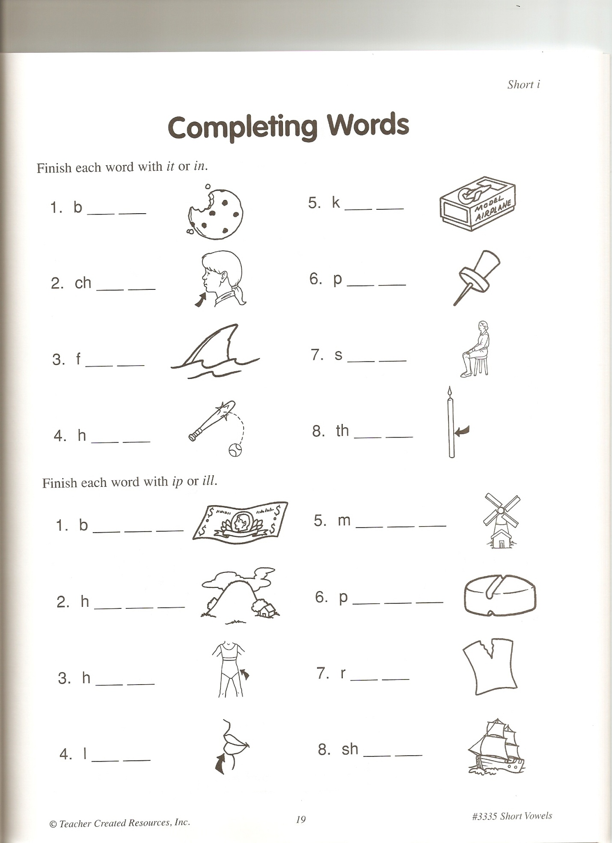
Day 4
Short Vowel ‘O’
I. Concept or skill to be learned
Short vowel ‘o’ sound and patterns
II. Objective
Students will be able to state all the vowels.
Students will be able to pronounce the short vowel ‘o’.
Students will be able to recognize words that have a short vowel ‘0’ in them.
Students will be able to recognize short vowel patterns.
III. Procedure
Engagement/Introductory: (4 minutes)
- (2 minutes) Who can tell me all the vowels? “A, E, I, O, U”.
- We are going to concentrate on the short vowel ‘o’. What does the short vowel ‘o’ say? I will hold up the poster for ‘o’ and the picture that goes with it. ‘O’ is for octopus. O, O, O is for octopus. Lets say it as a class now, O, O, O is for octopus.
- (2 minutes) Before we start the activity I have planned we need to review the short vowel patterns. Can someone come up to the board and write down a short vowel patter? Does anyone else know a short vowel pattern? Come up to the board and write it down. Who knows the last two short vowel patterns? Please come write it on the board.
Now that we have review the short vowel patterns and the short vowel ‘o’ we are going to play bingo!
Developmental Activity: (8 minutes)
(Pass out blank bingo sheet) As you can see the words are not written on your bingo sheet. I am going to tell you the words I would like you to put on your bingo sheet. You can put the words anywhere on your bingo sheet. I am doing it this way so you can practice your spelling using the short vowel patterns you have learned. If you forget, they are on the board for you.
- (3 minutes) I will say each of the words below and the students can place the word anywhere on their bingo sheet. I will make sure everyone has spelled them correctly.
WORDS:
-stop -flock -lock -fox
-job -flop -rock -rod
-top -frog -sob -dock
-hot -shot -pot -clock
-block -mop -nod -box
- (5 minutes) We are now going to play bingo. Once you get a bingo horizontal, vertical or diagonal shout out BINGO! To spice things up I am going to use M &Ms or skittles instead of bingo chips.
After two students (depending on the time) get bingo we will clean up. Students will be able to eat their skittles or M &Ms once they are done putting away all their material. (A bingo sheet will go up on the bulletin board.) Students will sit quietly when they are done putting everything away.
Concluding Activity: (4 minute)
- What are the vowels again?
- I will hold up the ‘a’, ‘e’ and ‘I’ and ‘o’ vowels and each student has to tell me the short vowel sound for each.
- Go back through the ‘a’ worksheet the students completed and place on the bulletin board, go over the ‘e’ words from day 2 activity, go over all the words they came up with for the letter ‘I’ and maybe add more, and then go over their bingo sheet words to practice each of the vowel sounds we have went over throughout the week.
IV. Assessment/Evaluation
- I assess the students by checking over their BINGO sheet they completed and by observations throughout the lesson.
V. Materials
-phonics dance cd
-BINGO sheet
-M&Ms or Skittles
-List of short ‘o’ words
-poster of the ‘a’, ‘e’, ‘I’ and ‘o’ vowel with a picture on it

Day 5
Short Vowel ‘U’
I. Concept or skill to be learned
Short vowel ‘u’ sound and patterns
II. Objective
Students will be able to state all the vowels.
Students will be able to pronounce the short vowel ‘u’.
Students will be able to recognize words that have a short vowel ‘u’ in them.
Students will be able to recognize short vowel patterns.
III. Procedure
Engagement/Introductory: (3 minutes)
- (2 minutes) We will listen to the phonics dance to get students moving and singing.
- (1 minute) Who can tell me all the vowels? “A, E, I, O, U”.
- We are going to concentrate on the short vowel ‘u’. What does the short vowel ‘u’ say? I will hold up the poster for ‘u’ and the picture that goes with it. ‘U’ is for umbrella. Uh, Uh, Uh is for umbrella. Let’s sing it as a class now, uh, uh, uh is for umbrella.
Developmental Activity: (10-12 minutes)
- (3 minutes) I am going to explain the activity you will be completing before splitting you up into partners. I have books on the back table. You and your partner will pick a book and “hunt” for words containing the short ‘u’ vowel sound. I would like you and your partner to read and enjoy the book you have chosen, and then go back and find words that have a short ‘u’ sound, write them down, and then you will share them with the class.
- Does anyone have any questions on the activity you will be completing?
- ( 1 minute) Now I would like you to line up in the front of the room by your first name without talking. I will then pair them off.
- (9 minutes) Student will complete the activity with their partner.
Concluding Activity: (2-3 minute)
- Students will share the words they found that have a short ‘u’ vowel.
- I will hold up the ‘a’, ‘e’ and ‘I’, ‘o’ and ‘u’ vowels and each student has to tell me the short vowel sound for each.
IV. Assessment/Evaluation
- I will assess the students by listening to each of them read and by looking over the list they generated.
V. Materials
-phonics dance cd
-children books
-scrap paper
-poster of the ‘a’, ‘e’, ‘I’, ‘o’ and ‘u’ vowel with a picture on it

Day 6
Review Short Vowels
I. Concept or skill to be learned
Review short vowel sounds and patterns.
II. Objective
Students will be able to state all the vowels.
Students will be able to pronounce all the short vowels.
Students will be able to recognize words that have a short vowel a, e, I, o and u in them.
Students will be able to recognize short vowel patterns.
III. Procedure
Engagement/Introductory: (3 minutes)
- (3 minutes) We will listen to the phonics dance to get students moving and singing.
Today we are going to play a game to review short vowels. I am going to split you up into two groups. This side (right) of the classroom will be on one team and this side (left) will be on a team.
Developmental Activity: (13-15 minutes)
- (3 minutes) You will each get a piece of chart paper that have five categories listed for you, short a, short e, short I, short o and short u. Each team has 15-20 sticky notes that have words on them. You need to take those words and place them under the correct short vowel. Once your team is done, sit down on the floor. BUT, before you sit down make sure everyone knows all the words, because whoever sits down first, their team has to tell me all the words on the sticky notes in order to win. If your team can’t read all the words the other team has a chance to win.
Does everyone understand? The right side of the room, please go to the front of the room. The left side of the room, please go to the back of the room.
Ready…GO!

(Extension)
- (5-7 minutes)You have learned about the short vowels. Now you are going to apply what you know. This worksheets has several pictures on it. You must color all the pictures that have a short vowel.

Concluding Activity: (2-3 minute)
- Students will share the pictures they colored.
- I will hold up the ‘a’, ‘e’ and ‘I’, ‘o’ and ‘u’ vowels and each student has to tell me the short vowel sound for each.
IV. Assessment/Evaluation
- I will assess the students by collecting the worksheet they completed (Identification) along with observing each student during the game.
V. Materials
-phonics dance cd
-chart paper that have the short vowels written on it
- sticky notes with short vowel words
-identification worksheet
Squires, L. L. (2006). Short Vowels. Westminster, CA: Teacher Created Resources, Inc.
-crayons or markers
-poster of the ‘a’, ‘e’, ‘I’, ‘o’ and ‘u’ vowel with a picture on it

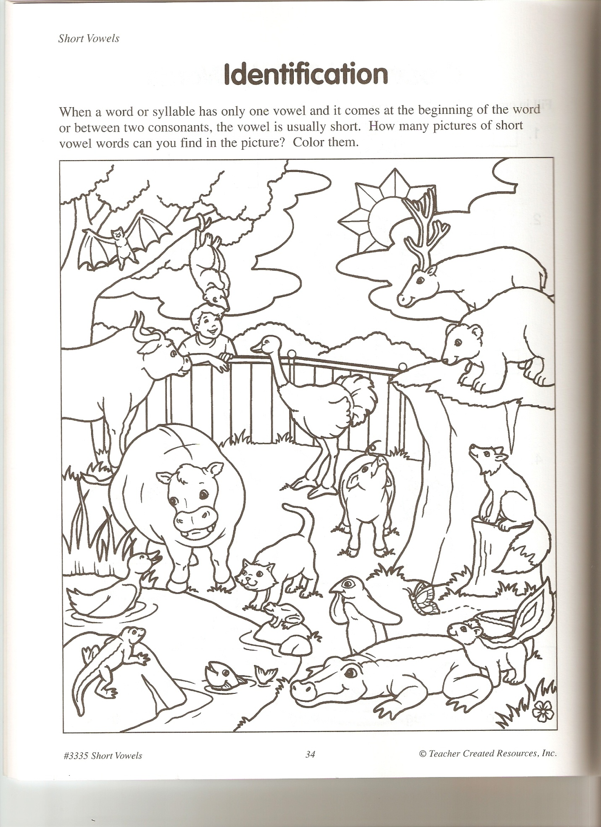

Day 7
Review Short Vowels
I. Concept or skill to be learned
Review short vowel sounds and patterns.
II. Objective
Students will be able to state all the vowels.
Students will be able to pronounce all the short vowels.
Students will be able to recognize words that have a short vowel a, e, I, o and u in them.
Students will be able to recognize short vowel patterns.
III. Procedure
Engagement/Introductory: (2 minutes)
We will listen to the phonics dance to get students moving and singing.
Today we are going to play a game with a partner to review short vowels.
Developmental Activity: (20 minutes)
- (1 minute) This game is called connect a word. I have 4 different stations set up throughout the room. You and your partner will start at one station. After a couple of minutes you will change stations and partners.
- (6 minutes) This is how the game works. (place the game on the over head using the vowel a) *See worksheets below.*
- (13 minutes) Once I complete the example and all the students understand, students will pick a station and complete connect a word. I will give the students 3 minutes to write down as many words as they can. After 3 minutes, students will share their words with their partner. Afterwards students will pick a different partner and a new station. This will continue until all the students have completed each station for e, I, o, and u..
Concluding Activity: (1 minute)
- I will hold up the ‘a’, ‘e’ and ‘I’, ‘o’ and ‘u’ vowels and each student has to tell me the short vowel sound for each.
IV. Assessment/Evaluation
- I will assess the students by observing each student during the game along with collecting their work.
V. Materials
-phonics dance cd
-connect a word (*see worksheets below)
Jacobson, J. (2003). Great Games for the Overhead, Reading. New York, NY: Scholastic Inc.
-poster of the ‘a’, ‘e’, ‘I’, ‘o’ and ‘u’ vowel with a picture on it

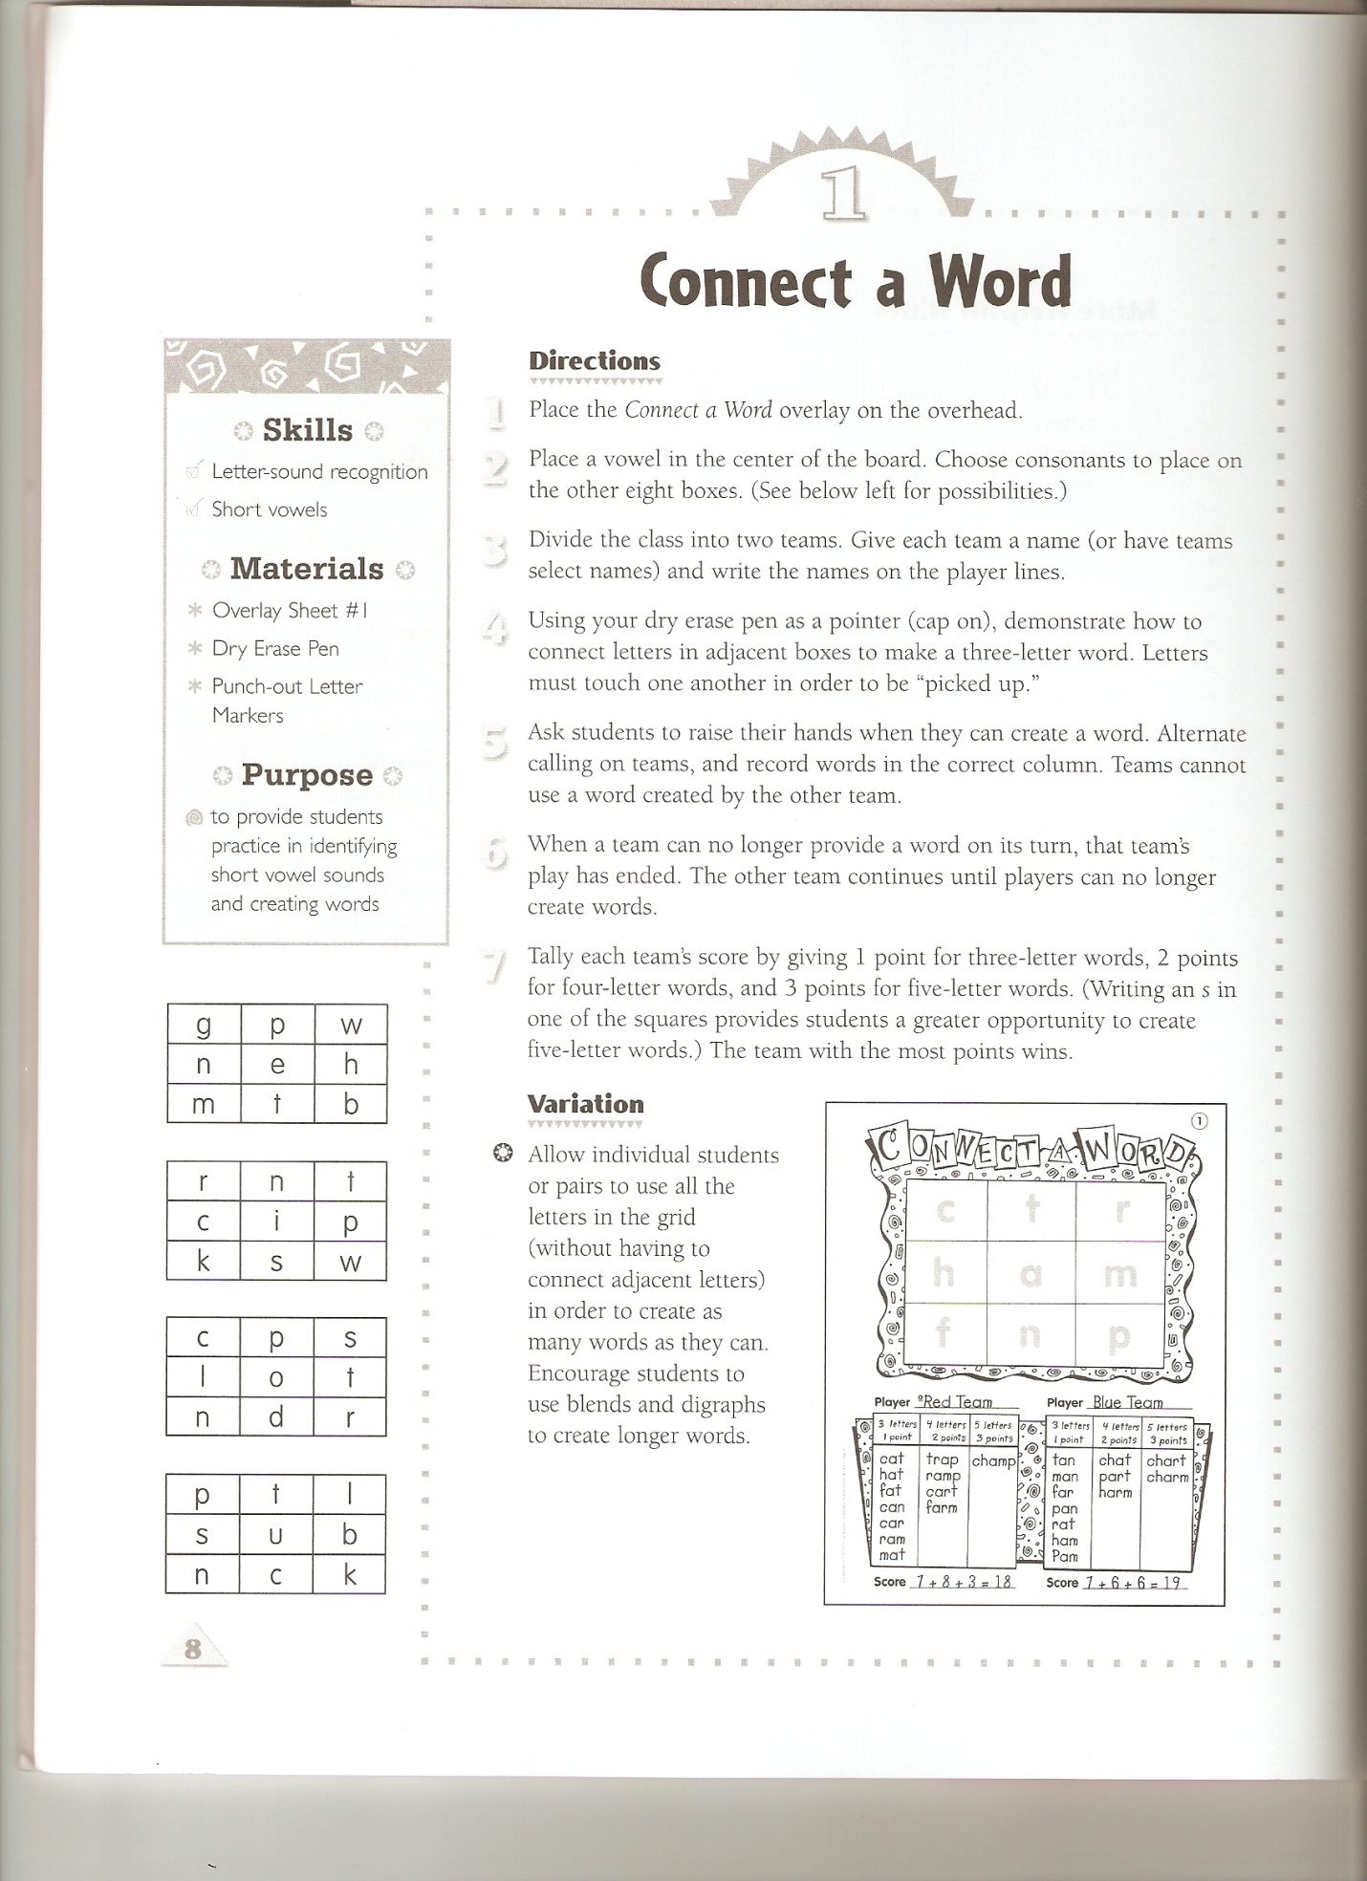
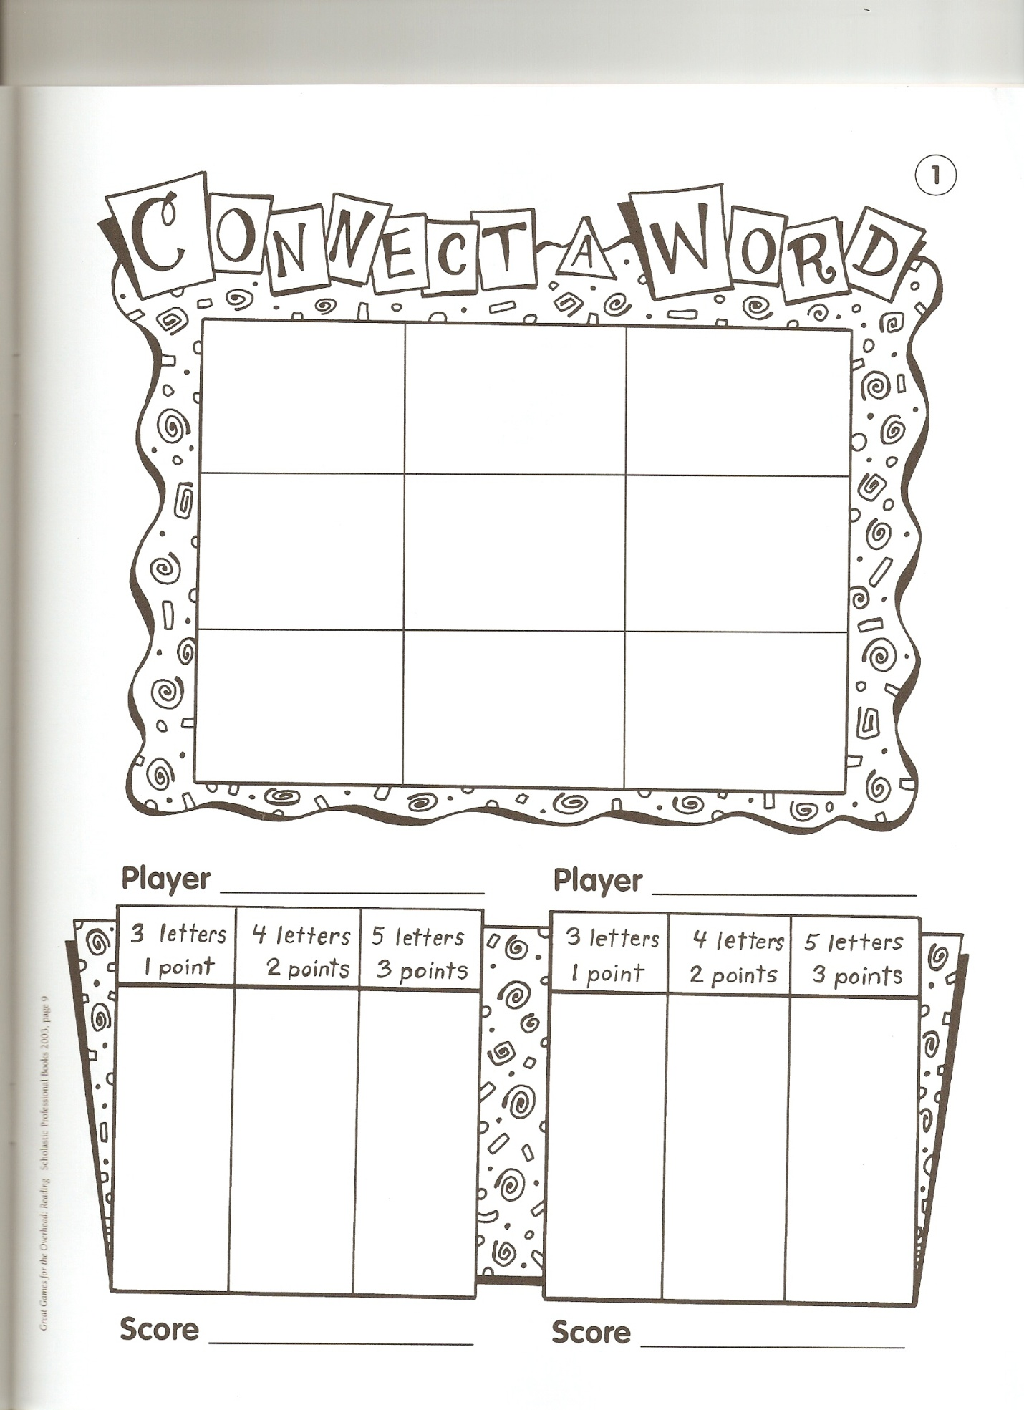

Day 8
Name_____________________________
Date_____________
*Pick ______ activities from the TIC-TAC-TOE board.*

Create a rap or song to teach others about the vowels, their sound and short vowel patterns.  (musical) | Design a poster that shows all the vowels, examples of each vowel and short vowel patterns.  (visual) | With a partner or small group create a list of as many words that have a short a, short e, short I, short o and short u for your classmates.  (interpersonal)
Create a play or presentation on all the vowels, their sound and short vowel pattern.  (kinesthetic) | Create a mobile that shows all the vowels and a picture or name that goes with each vowel.  (visual) | Write a poem to help students remember the vowels, the sounds and/or patterns.  (intrapersonal)
Create a word web for each short vowel.  (verbal) | Write in your journal what you have learned about vowels. You should have at least 6-10 sentences.  (intrapersonal) | Look for ideas in nature that has a short vowel. Come up with 5 things from nature for the 5 short vowels. You can draw, list or write a story for these items you find in nature.  (naturalist)
Please list all the vowels we have went over.
_________________
Please list all the short vowel patterns.
________________________________________________________
Day 8
Postassessment
(The postassessment will be given to each student while they are working on a written post test.)
C. Meyers Informal Word Analysis Inventory – Level I
Learner Copy
(Please read down each column.)

fan thin hung

hag wham brag

Sal rum slot

Ban cup snap

tad log held

rig mod sprig

Sid fen runt

shin met Fisk

chat sod kong

pitch bed fill

latch rank bath

sack link smell

C. Meyers Informal Word Analysis Inventory
Teacher Copy

Name________________________
Date____________________

 | Reading | Spelling |  | Reading | Spelling
fan |  |  | fen
hag |  |  | met
sal |  |  | sod
ban |  |  | bed
tad |  |  | rank
rig |  |  | link
sid |  |  | hung
shin |  |  | brag
chat |  |  | slot
pitch |  |  | snap
latch |  |  | held
sack |  |  | sprig
thin |  |  | runt
wham |  |  | fisk
rum |  |  | kong
cup |  |  | fill
log |  |  | bath
mod |  |  | smell

