Attachment C

- A simple, ________________ figure formed by _______________ or more ____________________ lines.
- 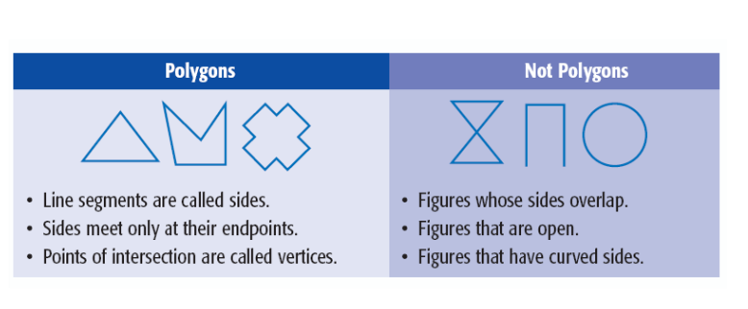 Does NOT have any lines that ____________ each other.

Words
(prefix)
Number of Sides | 5 | 6 | 7 | 8 | 9 | 10
Models

Regular Polygons
- A polygon that has ________ sides congruent and all ________ congruent.

- Two Examples: ____________________________ and ___________________________

