 | Pentagon | Hexagon | Heptagon | Octagon
Number of Sides

 |  |  | 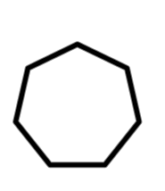 | 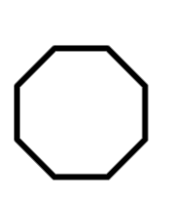
Number of triangles formed
Sum of ALL angles
Measure of EACH angle in the polygon
Angle Measure of a Regular Polygon
Attachment D
Step 1: Draw all the diagonals from one vertex and count the number of triangles formed. Step 2: Using properties of triangles, find the sum of the angle measures in the polygon. Step 3: Find the measure of each angle of the polygon.

Attachment D (cont’d)
Looking at the chart, can you find a pattern that will help to find the sum of the angles in a nonagon (a nine sided figure)?

Can you figure what the formula is for finding the sum of the angles of a regular polygon? (HINT: Let n represent the number of sides of the polygon.)

1. Find the measure of an angle of a regular polygon with 20 sides.

2. Find the measure of an angle of a regular polygon with 100 sides.

