Geometry – Post Assessment Name ___________________________

Use the diagram of the circle to answer the following questions.
C
B

D
A
F
Radius = 4 inches

E

Name a radius ___________
Name the diameter __________
Name the center point ___________
Name a chord __________
What is the length of the diameter? _____________

Name the following shapes.

Compare and contrast the properties of a rectangle and a square.

______________________________________________________________________
______________________________________________________________________
______________________________________________________________________
______________________________________________________________________
______________________________________________________________________
Place the following coordinates on the coordinate plane. Be sure to plot the points and label with the correct letter.

A = (2,6) B = (-5,7) C = (8, -4) 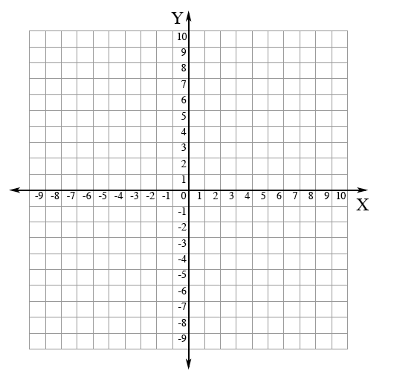
Use the diagrams to answer questions.

A B

C E F

G D

List a pair of intersecting lines. ___________________

List a pair of perpendicular lines. ____________________

List a pair of parallel lines. ____________________

What is the measure of the missing angle? Show your work.

85⁰

55⁰

?

Jay made a cardboard sign to announce an after-school picnic. He is looking for a congruent piece of cardboard so that he can make a second sign.

Which piece of cardboard could Jay use?

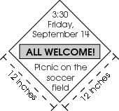

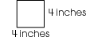
A.

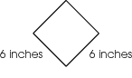
B.

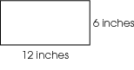
C.

D.
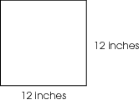

A circle is shown.

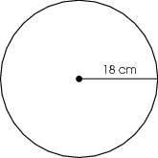

Which statement about the circle is true?

A. The diameter is 9 cm.
B. The diameter is 36 cm.
C. The radius is 9 cm.
D. The radius is 36 cm.

A triangle has one right angle and one acute angle.
What kind of angle must its third angle be?

A. acute
B. obtuse
C. right
D. straight

Which figure represents a line?

A.

B.

C.

D.
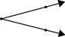

Four points are shown on the coordinate plane.

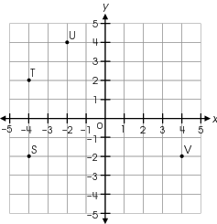

Which point is located at (4, –2)?

A. S
B. T
C. U
D. V

Stan is making a triangular desk to fit in a corner. One angle needs to measure 90°. He wants the other two angles to be congruent to each other. Draw Stan’s desk and determine the measure of the other two angles. Explain how you found the measures of the other two angles.

Which statement describes the relationship between the diameter and the radius of a circle?

A. The radius is half of the diameter.
B. The radius is two times the diameter.
C. The radius is three times the diameter.
D. The radius is one-third of the diameter.

Two rectangular windows on the front of a store are congruent. One window measures 10 feet wide and 8 feet tall. Which could be the measurements of the other window?

A. 5 feet wide and 4 feet tall
B. 10 feet wide and 8 feet tall
C. 10 feet wide and 10 feet tall
D. 20 feet wide and 16 feet tall

Four points are shown on a grid.

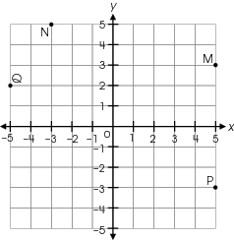

Which point is located at (–3, 5)?

A. point M
B. point N
C. point P
D. point
Pentagon FGHJK is congruent to pentagon LMNPQ

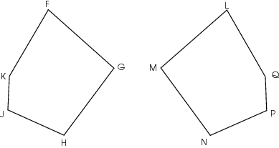

Which statement must be true?

A.
B.
C.
D.

Geometry – Post Assessment Name KEY

Use the diagram of the circle to answer the following questions.
C
B

D
A
F
Radius = 4 inches

E

Name a radius FA or FC or FE
Name the diameter CE
Name the center point F
Name a chord DB
What is the length of the diameter?
8 inches

Name the following shapes.

Trapezoid Isosceles Triangle Parallelogram

Compare and contrast the properties of a rectangle and a square.

A rectangle and square are similar and different. First, both have four right angles that are 90 degrees each. Next, both have 2 sets of parallel lines so they are parallelograms. A square is always a rectangle, but a rectangle is not always a square. A rectangle can have one set of sides that are longer than the other set, while a square must have 4 equal sides.
Place the following coordinates on the coordinate plane. Be sure to plot the points and label with the correct letter.

A = (2,6) B = (-5,7) C = (8, -4)

Use the diagrams to answer questions.

A B

C E F

G D

List a pair of intersecting lines: AG and CD or BD and CD (accept all appropriate answers)

List a pair of perpendicular lines: BD and EF

List a pair of parallel lines. AG and BD

What is the measure of the missing angle? Show your work.

85⁰

55⁰

?

85+55=140 180-140=40 The missing angle is 40 degrees. First, I added to find the total of the two listed angles. Then I subtracted to find the missing angle. I used 180 because the sum of the angles of a triangle equals 180 degrees

Jay made a cardboard sign to announce an after-school picnic. He is looking for a congruent piece of cardboard so that he can make a second sign.

Which piece of cardboard could Jay use?

A.

B.

C.

D.

A circle is shown.

Which statement about the circle is true?

A. The diameter is 9 cm.
B. The diameter is 36 cm.
C. The radius is 9 cm.
D. The radius is 36 cm.

A triangle has one right angle and one acute angle.
What kind of angle must its third angle be?

A. acute
B. obtuse
C. right
D. straight

Which figure represents a line?

A.

B.

C.

D.

Four points are shown on the coordinate plane.

Which point is located at (4, –2)?

A. S
B. T
C. U
D. V

Stan is making a triangular desk to fit in a corner. One angle needs to measure 90°. He wants the other two angles to be congruent to each other. Draw Stan’s desk and determine the measure of the other two angles. Explain how you found the measures of the other two angles.

180-90=90
90/2=45

I drew the desk with a 90 degree angle. I know the sum of the angles in a triangle equals 180 so I subtracted 90 from 180. I knew the other angles and sides had to be the same size because congruent means the same size and shape, so I divided 90 by 2 to get 45 degrees. The two angles are 45 degrees each.

Which statement describes the relationship between the diameter and the radius of a circle?

A. The radius is half of the diameter.
B. The radius is two times the diameter.
C. The radius is three times the diameter.
D. The radius is one-third of the diameter.

Two rectangular windows on the front of a store are congruent. One window measures 10 feet wide and 8 feet tall. Which could be the measurements of the other window?

A. 5 feet wide and 4 feet tall
B. 10 feet wide and 8 feet tall
C. 10 feet wide and 10 feet tall
D. 20 feet wide and 16 feet tall

Four points are shown on a grid.

Which point is located at (–3, 5)?

A. point M
B. point N
C. point P
D. point
Pentagon FGHJK is congruent to pentagon LMNPQ

Which statement must be true?

A.
B.
C.
D.

The last 11 questions are released questions taken from the 5th grade OAA from 2009 and 2010

