Instructional Design- Family Unit
Samantha Hnizdil
Bowling Green State University

Rationale
The following unit, written for a families and friends, unit is an important aspect of the kindergarten curriculum for a variety of reasons. First, these lessons introduce multiculturalism to children in a way that relates to them. They learn more about the different types of families, different characteristics of their friends and more about the community that they live in. This unit is being taught as an introduction to differences and similarities between people and the understanding that it is okay to be different because in some ways we are all the same. As most of the students in kindergarten are five and six years old, they are gaining experiences that are more social with children than before, and they need to be aware of these differences. These differences are important because the world that we live in is only going to continue to become more diverse. Teaching this unit to preschoolers builds a strong foundation for children to grow up to be a positive influence of society. Through a variety of stories, individual, group, and class activities students engage in lessons that are designed to give first hand experiences with friends and family and the many ideas and differences that follow with each.
This unit is driven by teaching and learning that acknowledges learning environments that exist in and outside of the school, also known as contextual teaching and learning, (CTL). Driving factors in this lesson is exposing children to diversity in school, but understanding that exists everywhere in the world and exposing students to this is school will create an understanding and empathy towards others. It gives an opportunity to understand a wider variety of people than what they might see at home or just in school. This unit allows for the content, objectives, and content standards to connect with real life experiences and necessary skills.
There is a curriculum design model that was designed by Grant Wiggins and Jay McTighe called the “backward design approach”. (Chiarelott 31) This approach identifies three major components and they are outcomes, assessment and learning experiences. These three components are major driving factors to this unit. When designing this large unit for students, the outcomes were looked at closely. There are many objectives that need to be met when teaching this unit. Therefore, I identified the outcomes and then how I was going to assess the learning objectives. Finally once I decided the outcomes, and assessment, I thought about how to teach the lesson and relate the outcomes to real life experiences.
This unit and the lessons developed to complete the learning objectives follows the 5-E learning Cycle Model. This model is strategically designed and the procedures are separated into five steps. The five steps are engagement, exploration, explanation, extension and evaluation. The engagement step is when the teacher brings in an object or makes an attempt to get the students attention and stimulate thinking. The exploration stage gives students time to gather their thoughts and understand information. The explanation stage is when the students analyze what they have discovered through activities. The extension part is allowing the students to apply all learning and prior knowledge to real life situations. The final stage is evaluation which is where students take an assessment or complete an assignment that can be grades based on a rubric to evaluate levels of understanding. (Chiarelott 90-91)

Social Studies Benchmarks for this unit
K, 1, 2
History:
- Place events in correct order on a time line
- Recognize that the actions of individuals make a difference, and relate the stories of people from diverse backgrounds who have contributed to the heritage of the United States
People in Societies:
- Identify practices and produces of diverse cultures
- Identify ways that different cultures within the United States and the world have shaped out national heritage.
Citizenship Rights and Responsibilities:
- Describe the results of cooperation in group settings and demonstrate the necessary skills
Demonstrate personal accountability, including making choices and taking responsibility for personal action
Science Benchmarks for this unit
K, 1, 2
Physical Science:
- Discover that many objects are made of parts that have different characteristics and recognize ways an object may change.
Scientific Inquiry:
- Gather and communicate information from careful observations and simple investigations and simple investigation through a variety of methods.

Math Benchmarks in this unit
K, 1, 2
Measurement:
- Select appropriate units for length, weight, volume, and time
Patterns, Functions and Algebra:
- Sort, classify and order objects by size number and other properties and describe the attributes used
- Describe and compare qualitative and quantitative changes
Data Analysis:
- Sort and classify objects by attributes, and organize data into categories in a simple table or chart.
- Represent data using objects, picture graphs and bar graphs
Language Arts Benchmarks in this unit
K, 1, 2
Writing Process:
- Generate ideas for written compositions
- Develop audience purpose for self-selected and assigned writing tasks
- Use organizers to clarify ideas for writing assignments
- Publish writing samples for display or sharing with others
Writing Applications:
- Compose writings that convey a clear message and include well-chosen details
Writing Conventions:
- Print legibly using appropriate spacing
- Spell grade appropriate words correctly
- Use conventions of punctuation and capitalization in written word
- Use grammatical structures in written work
Communication; Oral and Visual:
- Connect prior experiences insights and ideas to those of a speaker
Reading Process:
- Establish a purpose for reading and use a range of reading comprehension strategies to understand literary passages and text

Unit Outcomes
- Students will be able to name which students have the most of least number of family members through a class created graph. (Application)
- Students will be able to verbally name two different types of families such as living with grandparents, aunts, uncles, single parent or adopted families. (Application)
- Students will be able to identify through illustrations characteristics that make their families such as traditions, celebrations, food, hobbies and interest. (Synthesis)
- Students will be able to verbally identify characteristics that make them the same or different than their classmates, such as hair color, eye color, straight or curly hair, glasses, freckles, and skin and hair length. (Comprehension)
- Students will be able to identify ways in which their partners’ physical features and clothes are alike or different from them. (Application)
- Students will be able to identify members of the family through a web. (Comprehension)
- Students will be able to write a sentence explaining their families. (Application)
- Students will be able to identify words that describe friends through a class web. (Comprehension)
- Students will identify different traditions and celebrations that families follow.(Comprehension)
- Students will be able to identify characteristics that make them similar and different from a classmate through an interview and present their findings orally to the class. (Analysis)
Pre-assessment
This unit will be taught in the beginning of the school year due to importance of building a foundation of diversity to Kindergarteners. Kindergarten is when many children have their first social experiences with many different cultures, races, etc. Therefore due to the lack of experience and understanding it is important to begin this lesson at the beginning of the year. The assessment for this friends and family unit will be done as a group discussion. As a class students will give responses to this question and I will write the responses on graph paper. As students give responses, we will talk about them and I will document what each student says. The discussion prompt will be how are people alike and different? This prompt and type of open ended pre-assessment will allow for teachers to identify areas and objectives that students may need more information or exposure to and plan lessons accordingly. It allows for this kindergarten assessment to not put the pressure of an assessment of the students who are new to school because it is more like a discussion.

Lesson Plan 1 / Math & Social Studies
Ohio Academic Content Standards:
Social Studies
Benchmark A: Identify practices and products of diverse cultures. People in Societies #1: Identify ways that individuals in the family, school, and community are unique and ways that they are the same. Benchmark C: Communicate information orally, visually, or in writing. Social Studies Skills and Methods #3: Compare similarities and Differences among objects or pictures.
Mathematics:
Benchmark C: Represent date using objects, picture graphs, and bar graphs. Data Analysis and Probability Standard #3: Select the category or categories that have the most or fewest objects in a floor or table graph
Objectives:
Students will be able to name which students have the most number of family members through a class created graph.
Lesson Summary:
After reading a story about families, and the different people that can be in a family, the class will make a family graph. After creating the graph, the class will have a discussion on who has the most, least and same amount of family members
Resources:
All families are special by Norma Simon
Graph paper/ or chart paper made into a graph
Markers
Crayons
Sticky Tack or tape
Pictures of two different sized families
Unit Introduction:
During this unit, we are going to trace our bodies, make self-portraits, a Family photo album, and a class book. We are going to learn more about. Different types of families in our classroom and the community, and learn more about our friends that we might not have known before. We are going to have a lot of fun getting to know each other better than we did before!

Procedures:
Discuss what makes up different types of families. Allow students to discuss their families. (Celebrations they have, brothers, sisters, step sisters, step mom, etc.) What makes your family different than the friends in your class, baseball or dance team? (7-10min)
Discuss basic graphing concepts. Talk with students about how to read a graph. Provide an example on the Smartboard. Allow for students to practice reading it, ask questions and have class discussion. (10min)
Create a class graph based on families (size, makeup..) Use chart paper to create a large graph for students. Have students sit at carpet and teacher model how to graph the information that they have provided. (5-6 min)
Discuss graph results. Talk to students about what the graph tells us. Prompt the discussion with questions and allow time for discussion about families or the data provided on the graph. (6-7 min) Which has the most, the least, or the same? Who can put the findings from the graph into a sentence?
Collect data as a class on a different topic about family then have students create their own graph with similar data (10-13 min)
Assessment:
Have a checklist with students’ names on it and after graphing individually ask
- Child who has more, less, or the same amount of people in your families. Another
- Possibility, if students cannot identify others names have point to the graph to
- Identify their answer. Mark off the throughout the day students who were able to identify in each category someone who has more, less or the same.
Differentiation
Have a teacher working with students at each table. Have them help the student’s count the people that are in their families. Have teachers help the students who have difficulty with the number recognition. Have a number chart on the table for them to look off of when they are writing the number on their cutout.
Enrichment:
Have students take a family tree home with them to fill out with their families. Then day by day have children share their family tree with the class and display them around the room.

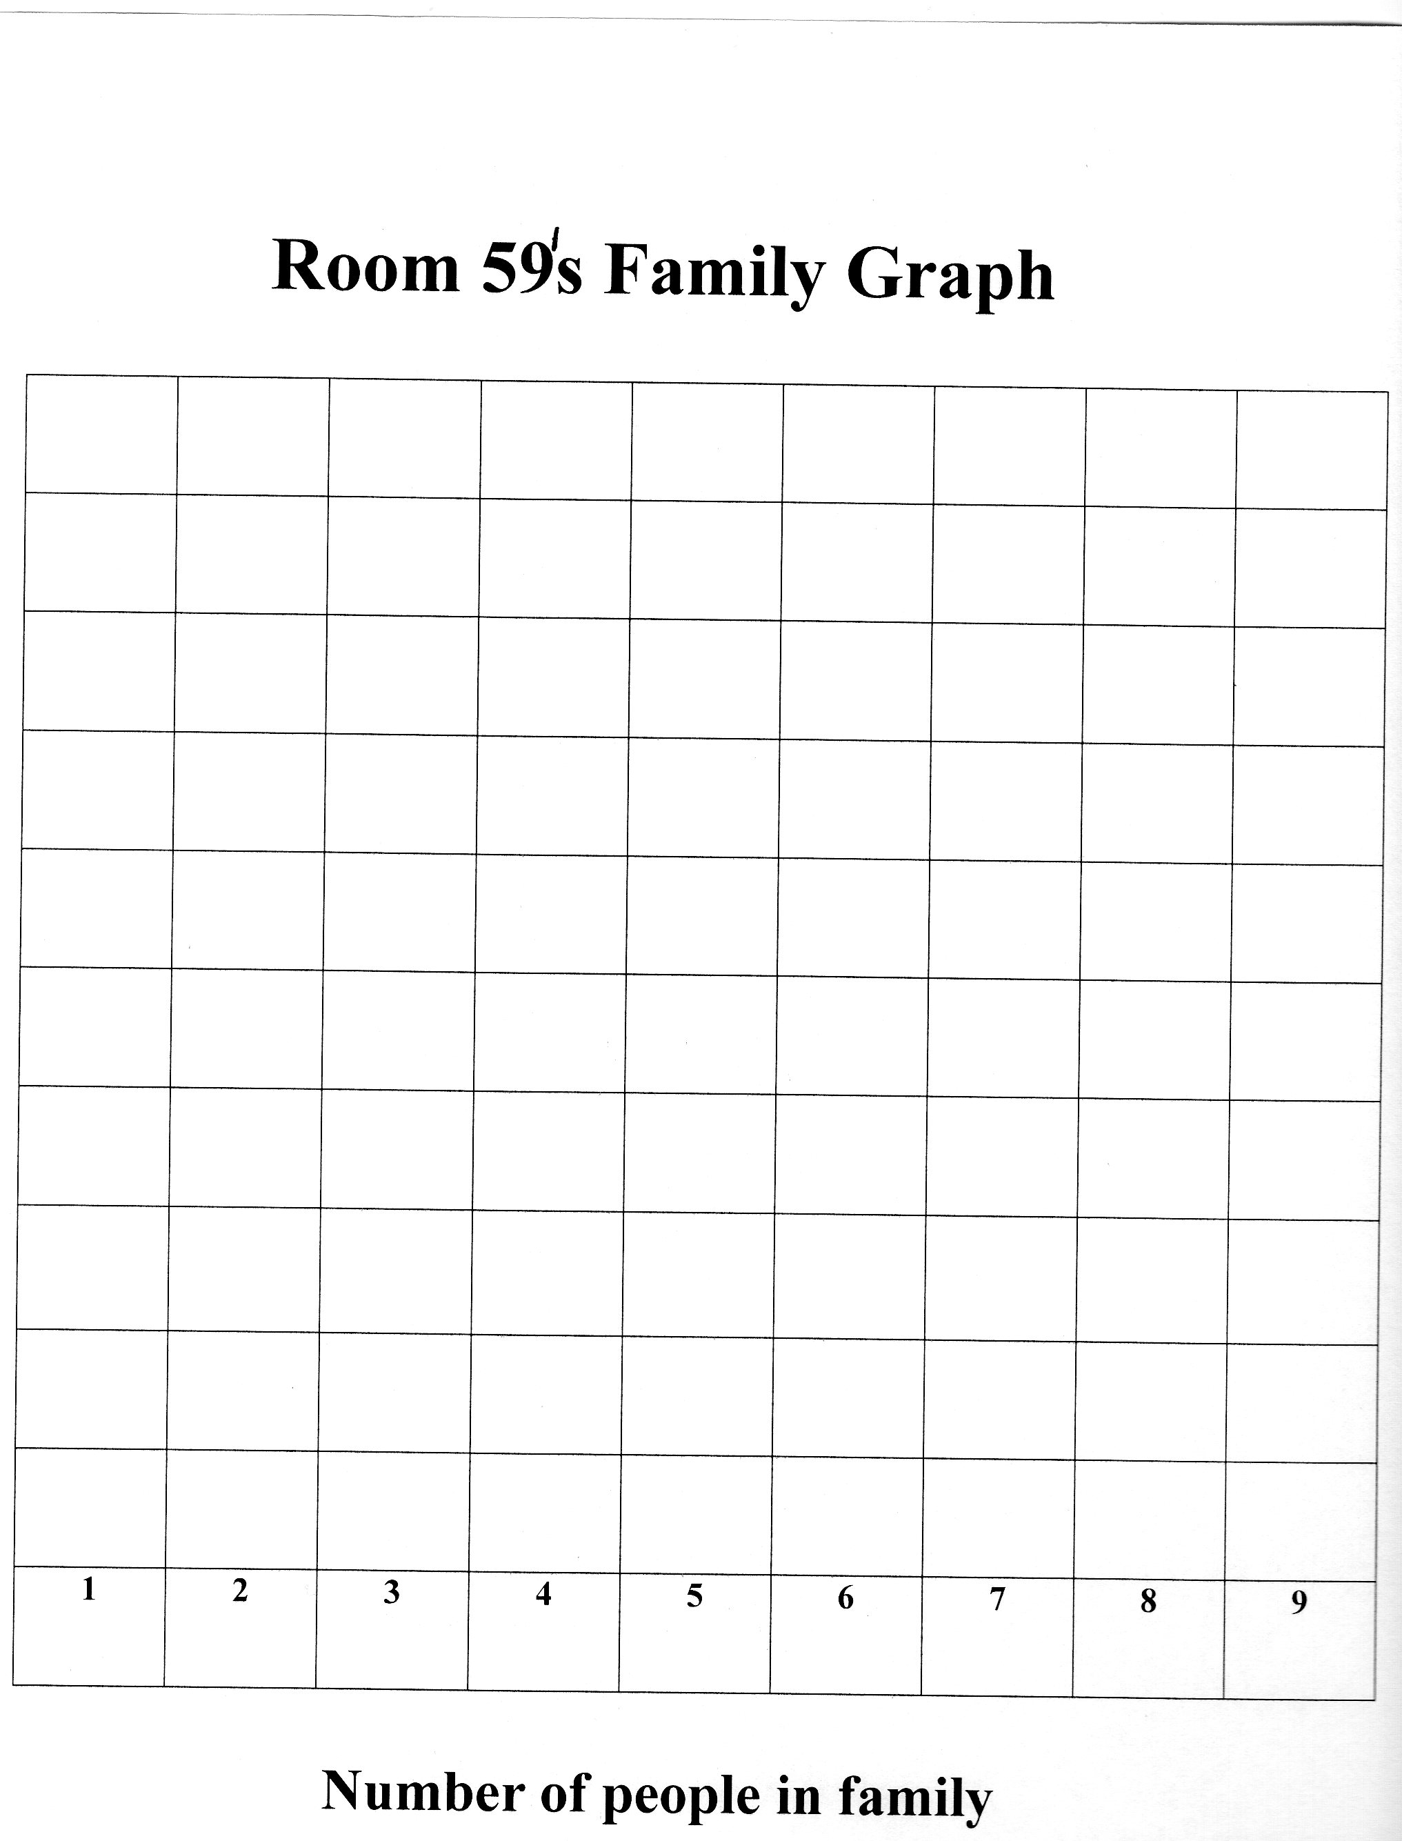

** Example of Graph completed in class, similar format for individual work.
Lesson Plan 2 / Language Arts
Topic: How we are alike and different
1. Ohio Academic Content Standards:
Language Arts: Reading Process: Concepts of Print, Comprehension Strategies, and Self- Monitoring Strategies #4: Visualize the information in texts, and demonstrate this by drawing pictures, discussing images in texts or dictating simple descriptions.
Benchmark A: Apply reading comprehension strategies to understand grade appropriate texts. Writing Applications #1 Dictate or write simple stores, using letters, Words, or pictures.
Benchmark B: Write responses to literature that provide an interpretation, Recognize ambiguities, nuances, complexities, and that understand the Author’s use of stylistic devices and effects created.
Social Studies:
People in Societies #1: Identify ways that individuals in the family, School, and community are unique and ways that they are the same.
Benchmark A: Identify practices and products of diverse cultures.
2. Objectives:
Students will identify different traditions and celebrations that families follow.
3. Lesson Summary:
After reading Children Just like Me: Celebrations, students are going to draw a picture of a celebration from the story and write about it. This celebration may be one that they can or cannot relate to. Students will be able to explain this holiday in detail.
4. Resources:
Children Just Like Me: Celebrations! By Anabel Kindersley
Celebrations worksheet
Pencils
Crayons
Pictures of different celebrations
Thanksgiving
Birthday Parties
Halloween
Hanukkah
Celebrations PowerPoint
5. Procedures:
Use Power Point presentation on different celebrations shown on the Smartboard, allow for students to discuss what they see. Prompt with open ended questions. (6-7min) How are these celebrations similar or different than celebrations you have with your family?
Read book as a class, ask questions throughout. At the end of the story, talk about main idea, character, etc. (4-5min)
Discuss family celebrations, what you do when you are there and why. Write their answers on large chart paper. Make a web of the information that the students talk about, prompt them with ideas from the book or power point presentation. (6-7 min)
Create a Celebrations book. Pass out to students lined paper and talk about directions. Put name on top. Write a sentence or two with detail. Draw a picture and include details about the celebration that you do with your family or learned about throughout the story or PowerPoint. (10 min)
6. Differentiation:
For an extension to this lesson, the students who are more advanced writers have them write more sentences about the certain celebrations paying more attention to specific detail of the celebration. To make this lesson a bit easier, teacher can help children spell out the words or write the words they tell them.
7. Enrichment/Optional:
Have a parent or grandparent come into the classroom and talk to the students about a certain celebration that their family has. Allow children to talk to them and ask questions. Have children draw a self-portrait for their All about Me Book.

** Following page is the celebrations worksheet given to students. Write a sentence about a celebration and draw a picture, including detail about the holiday.

______________________________________________________________________________
Lesson Plan 3 / Language Arts & Social Studies
1. Ohio Academic Content Standards:
Language Arts: Reading Process Concepts of Print, Comprehension Strategies, and Self-Monitoring Strategies #9: Monitor comprehension of orally read texts by asking and answering questions.
Benchmark A: Apply reading comprehension strategies to understand grade appropriate texts.
Social Studies: People in Societies #12: Identify ways that individuals in the family, School, and community are unique and ways that they are the same. Benchmark A; Identify practices and products of diverse cultures.
2. Objectives:
Students will be able to identify words that describe family through a class Web.
3. Lesson Summary:
After reading The Family Book, by Todd Parr the class will create a web that identifies words that are related to family.
4. Resources:
The Family Book by Todd Parr
Chart paper
Markers
Graphic Organizer
5. Procedures:
Picture walk through story talking about what they see on each page and what is happening in the pictures. Talk about how the pictures may relate to their lives or experiences. (6-7 min) Throughout this story you may have seen something that relates to your life or something that you do not understand. What is a detail from the story that stood out to you?
Discuss story and how it relates to them. (3-4 min)
Talk about webbing. Show students an example of webbing and talk about how to read it and the information that it shares. Write on a separate chart paper the ideas that students have about families and just write the words in columns. (8-10 min)
Create a family web. Give students a blank piece of paper and have them use the words that the class came up with during the discussion to create a family web. (6-7 min)
6. Differentiation:
Have students work individually and write down the words or draw pictures instead of making the class web. Have them make family collages with things they like to do with their friends.
7. Enrichment/Optional:
Students can make an all about me book. When they are finished with activities in class, they can work on a different sheet each day. Make cover page for an All about Me Book, decorate it with name and things that child likes to do. Other ideas for other pages throughout the week for students to use: Where I live/ Family Tree/ Favorite Activities/ Friends/ My Phone Number is/my birthday is in.

** Following two pages show handouts that will be used during this lesson.

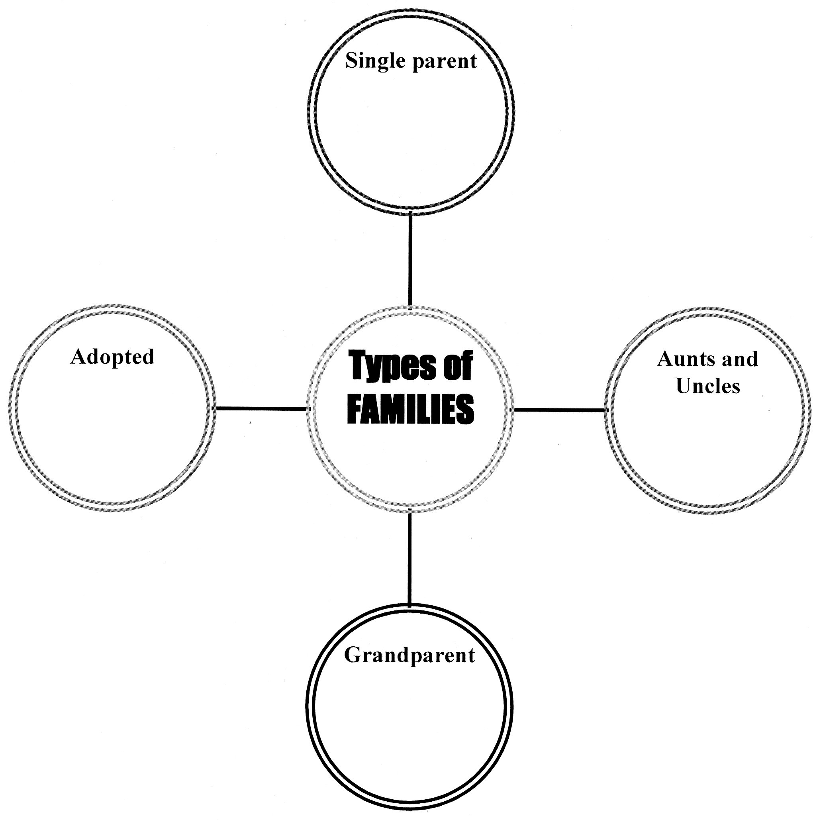

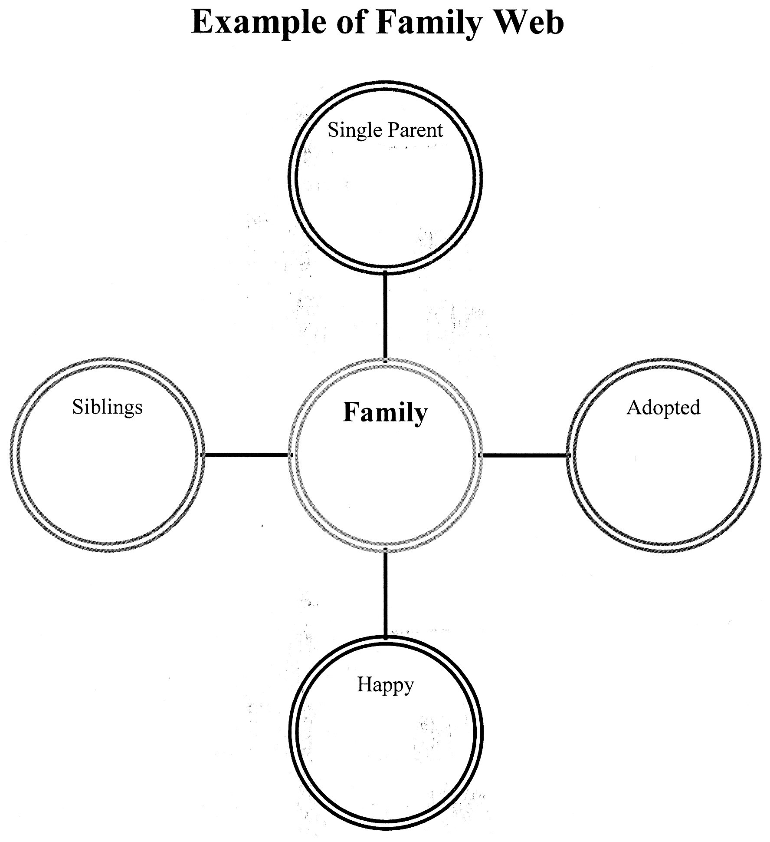

Lesson Plan 4 / Social Studies
1. Ohio Academic Content Standards:
Social Studies:
Benchmark A: Identify practices and products of diverse cultures.
People in Societies #1: Identify ways that individuals in the family, school, and community are unique and ways that they are the same.
Benchmark C: Communicate information orally, visually or in writing.
Social Studies Skills and Methods #4: Compare similarities and difference among objects or pictures.
Science: Scientific Inquiry: Gather and communicate information from careful observations and simple investigations and simple investigation through a variety of methods.
2. Objectives:
Students will be able to verbally identify characteristics that make them the same or different than their classmates, such as hair color, eye color, straight or curly hair, glasses, freckles, and skin and hair length.
3. Lesson Summary:
After students look in a mirror to identify certain characteristics that make them unique, students will create a self-portrait using paper plates and yarn.
4. Resources:
Class set of large white paper plates
Yarn variety of colors (red, brown, yellow, black)
Crayons
Glue
Mirror
5. Procedures:
Have 2 students come to front of room. Ask questions to get students to get students thinking about similarities and differences. Provide prompts or examples if students are struggling and not understanding what you are asking. (3-4min) Student A has curly hair, while students B has straight short hair. What are some other ways that they look different or the same?
Pass around mirror and discuss ways we look different, be sure to allow each child to give their response. (10-12 min)
Students create self-portrait at their desks and present to class their findings. (13-15 min)
6. Differentiation:
Have this lesson as center to allow for smaller groups and more individualized instruction with children. Allow more time for children to finish their picture. Have mirrors at each table to allow for children having difficulty remembering what color their hair and eyes are.

Post Assessment
This friends and family unit is a large unit and can be used across the content areas. Rather than just assessing what the students learned simply at the end of the unit. Teachers can assess the objectives of the lessons after each one of before they move on to another objective. This would allow for teachers to identify areas of need before the end of the lesson when it is too late. Throughout this unit suggestions to assess the objectives are, monitor worksheets, graphs, grading rubrics and individually assess students through questions.
Examples of post unit questions to ask students:
~ What makes people different?
~ What makes people the same?
~ What makes your family different/ same than others?
~ What are examples of celebrations that some families celebrate?
~ What are words that explain your friends?
The assessments will give teachers an understanding of what objectives were learned and which students learned or did not learn them. When the unit is over, the class will gather around and be presented the same prompt as the pre-assessment. Teachers will compare the answers from the pre-assessment to the post.

**Following page is an example of a rubric that can be used to complete the post assessment.

