ACS560
Microblog 911
Software Design Description

Version 3.0
Prepared by Kassie M. Bowman
December 6, 2011

Revision History
Date | Version | Description | Author
11/1/2011 | 1.0 | Initial creation | Kassie Bowman
11/29/2011 | 2.0 | Updates to entire document; completed sections 1, 2, 3, 7, & 8 | Kassie Bowman
12/6/2011 | 3.0 | Completed sections 4, 5, & 6 | Kassie Bowman
Table of Contents
1. Introduction 5
1.1 Purpose 5
1.2 Scope 5
1.3 References 5
1.4 Overview 5
2. System Overview 6
3. System Architecture 6
3.1 Architectural Description 6
3.2 Decomposition Description 7
3.3 Design Rationale 8
4. Data Design 8
4.1 Database Description 8
4.2 Global Data Structures 8
5. Component Design 10
5.1 Component Identification 11
5.2 Mobile Application Client (CMAC) 12
5.2.1 Purpose 12
5.2.2 Dependencies 12
5.2.3 Interfaces 12
5.3 Web Browser Client (CWBC) 12
5.4 Emergency Detection Service (CEDS) 12
5.4.1 Purpose 12
5.4.2 Function 12
5.4.3 Subordinates 13
5.4.4 Dependencies 14
5.4.5 Interfaces 14
5.5 Data Access Manager (CDAM) 15
5.5.1 Purpose 15
5.5.2 Function 15
5.5.3 Subordinates 15
5.5.4 Dependencies 15
5.5.5 Interfaces 15
6. Human Interface Design 16
6.1 Overview of the User Interface 16
6.2 Screen Images 16
6.3 Screen Objects and Actions 16
7. Requirements Matrix 16
8. Resource Estimates 18
9. Definitions, Acronyms and Abbreviations 18

Table of Figures
Figure 1: Microblog 911 Application Architecture 7
Figure 2: Emergency Class Diagram 8
Figure 3: Post Class Diagram 9
Figure 4: Post Group Class Diagram 9
Figure 5: User Class Diagram 10
Figure 6: Microblog 911 Component Diagram 11
Figure 7: Emergency Detection Activity Diagram 13
Figure 8: Microblog Data Manager Class Diagram 13
Figure 9: Emergency Manager Class Diagram 14
Figure 10: User Manager Class Diagram 14
Figure 11: Mobile App Service API Class Diagram 15
Figure 12: Data Store API Class Diagram 16
Figure 13: Microblog Data API Class Diagram 16

Introduction
The Software Design Description provides a description of how the software will be implemented for Microblog 911, an emergency detection and notification application that will allow emergency services personnel and application subscribers to receive real-time information about emergency situations.

Purpose
The purpose of this document is to provide a detailed description of how the software for Microblog 911 should be implemented in order to fulfill the requirements specified in the Software Requirements Specification (SRS). The intended audience for this document includes project stakeholders and developers.

Scope
The scope of this document is all software necessary for the Microblog 911 emergency detection application. This includes software for interfacing with users, both public subscribers and emergency services personnel, as well as software for collecting and processing microblog data.
The objective of this application is to detect emergency situations in real time by analyzing microblog data. The application will notify users of detected situations, allowing them to respond appropriately.

References
Document | Availability
Application Architecture | http://www.students.ipfw.edu/~kbowma
Software Requirements Specification | http://www.students.ipfw.edu/~kbowma
Vision Document | http://www.students.ipfw.edu/~kbowma

Overview
This document provides descriptions of the system architecture, data design, component design, and human interface design. In the component design section, each of the major components of the application are discussed in detail, including interfaces with other components and the functionality performed by the sub-components. Finally, the requirements matrix will provide traceability between the system functional requirements and the design.

System Overview
The system will analyze microblog data through public APIs in order to determine when an emergency situation is occurring or has occurred. Such an emergency could be weather-related (storms, hurricanes, tornados, etc.), traffic-related (such as accidents which impede traffic), or acts of violence/terrorism (including shootings, bombings, etc.) Once the system has detected one of these situations, a notification will be sent to emergency services personnel in the affected area so they could respond to alleviate the situation. Notification will also be sent to members of the public who subscribe to the service, allowing them to respond appropriately. The system will depend on the existing microblogging applications in order to provide real-time information about events of interest.

System Architecture

Architectural Description
The Microblog 911 application is constructed as shown in Figure 1. The main components are the presentation layer, the business layer, and the data layer. The presentation layer will provide the user interface to the application via two methods: mobile application and web browser. The data layer will provide a means to access the data store for the system as well as communicating with external services to obtain microblog data. The business layer will provide all of the actual processing for the system. Additionally, security, operational management, and communication apply to the entire system. The latter elements will not be an area of focus for this project, as illustrated in Figure 1.
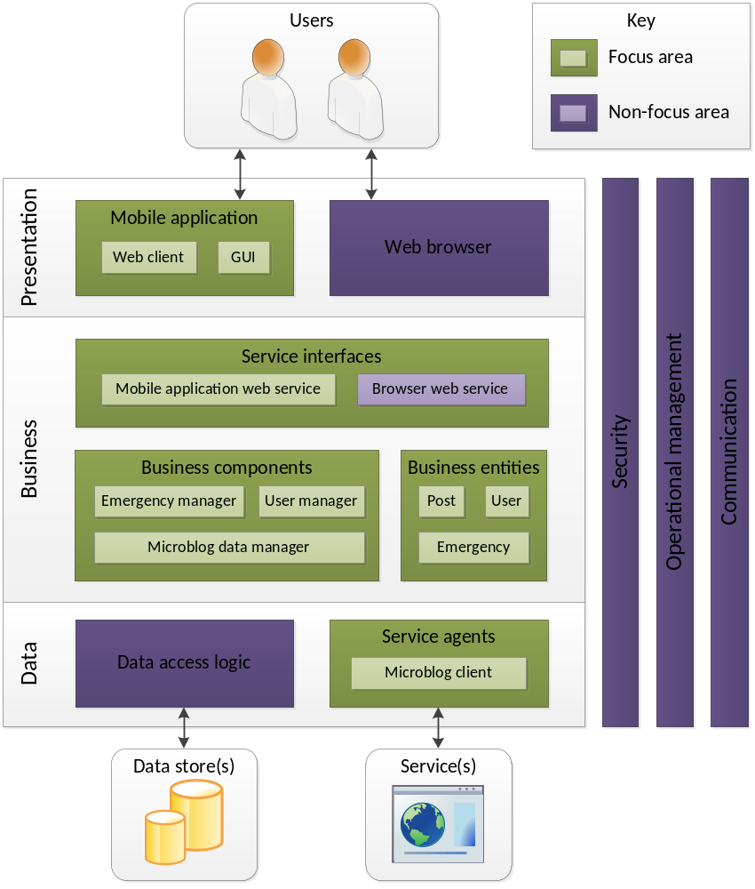
Figure 1: Microblog 911 Application Architecture

Decomposition Description
All of the main processing for the Microblog 911 application will occur in the business layer. The business layer contains the service interfaces, which are responsible for communicating with the presentation layer and isolating any business logic from the remote clients. This layer also contains the business components and entities. The business components are responsible for performing all of the main processing of the application, and the business entities serve as containers for moving data around.

Design Rationale
The selected architecture is based on the Microsoft Application Architecture for .Net. This architecture is a proven approach for distributed systems similar to the Microblog 911 application.
One of the design alternatives considered was to have more of the application logic allocated to the remote clients for the mobile application and web browser. While there are some benefits of this approach, one of the negatives is the need to send more information to the remote application than is actually needed for displaying to the user. This can consume user resources unnecessarily and result in a system that performs in a less than optimal manner.

Data Design

Database Description
The database will be used to maintain user information settings, including login, password, and notification preferences. It will also be used to persist microblog data acquired from the Twitter API so that it can be processed and analyzed. Finally, it will store any on-going emergencies, along with information about where the emergency has occurred and the current status of the emergency.

Global Data Structures
The application will use the following data structures to pass data between components. The Emergency class, shown in Figure 2, will contain all information associated with an emergency situation. The emergency will be given a unique id and will be associated with the post group that provided the initial indication of the emergency. It will also provide the emergency type, the detection time, and the location. When the situation is confirmed to have ended, the inProgress indicator and timeEnded attributes will be updated.
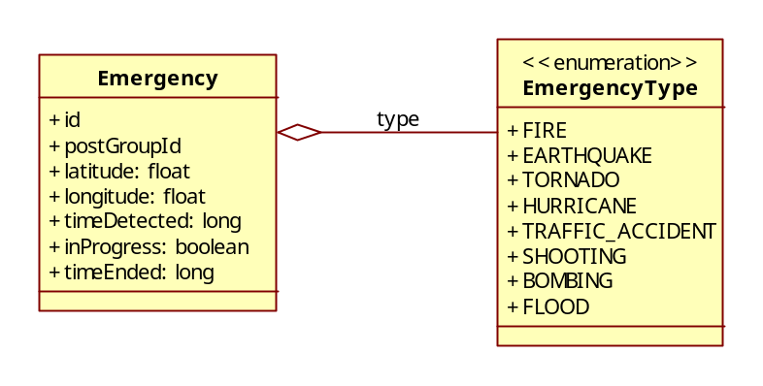
Figure 2: Emergency Class Diagram
The Post class will be used as a container for a microblog post. Each post will have a unique id, as well as an author and the actual post text. The time and location of the post will be monitored along with the number of reposts. Once pre-processing has been done, the keywords will be added to the post.
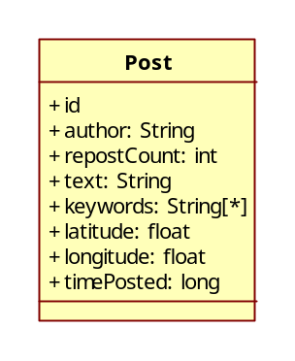
Figure 3: Post Class Diagram
The PostGroup class will be used to group the posts that are determined to have similar keywords and location. The group will be scored by tracking the cumulative followers of all post authors and cumulative reposts of all posts.
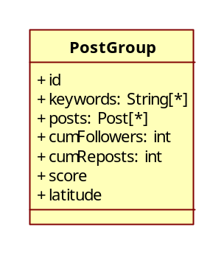
Figure 4: Post Group Class Diagram
Finally, the User class will be used as the container for the users of the application. The class will track the user login and name, as well as his/her password. The user preferences for notification method, location, and emergency types will also be stored by the structure.
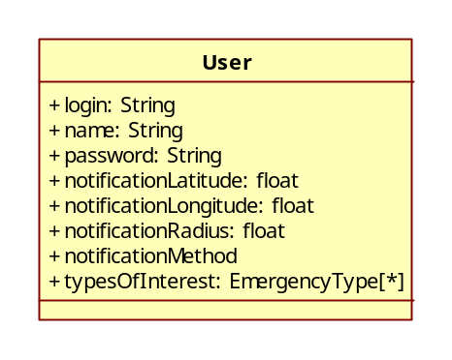
Figure 5: User Class Diagram

Component Design
The Microblog 911 application will be composed of four major components: the Mobile Application Client, the Web Browser Client, the Emergency Detection Service, and the Data Access Manager.
The Mobile Application Client (CMAC) is responsible for providing access to the main application to users of mobile devices. The client will provide a GUI which allows the user to updated their preferences as well as check on the status of existing emergency situations that are of interest to them.
The Web Browser Client (CWBC) is responsible for providing access to the main application to users via a web browser. It will provide the same capabilities as the CMAC, but will be targeted to a different platform and communication protocols.
The Emergency Detection Service (CEDS) provides the main business logic of the application. It is responsible for processing microblog data, detecting emergency situations, and notifying users of emergency situations which satisfy their preferences.
The Data Access Manager (CDAM) is the part of the application responsible for interfacing with an external data store to maintain system data. It is also responsible for interfacing with the Twitter API in order to retrieve microblog data for use by the CEDS.
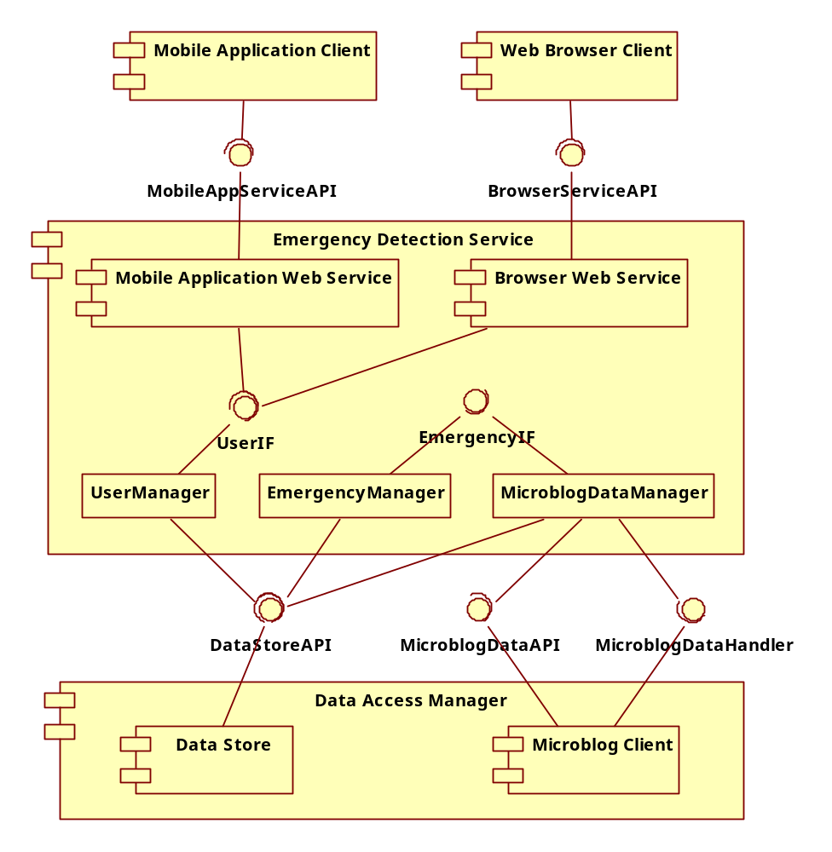
Figure 6: Microblog 911 Component Diagram

Component Identification
The system has been broken into four high-level components. Each component has been assigned a unique identifier, as shown in below. Each identifier begins with the letter ‘C’ to denote that the item is a component.
Identifier | Component
CMAC | Mobile Application Client
CWBC | Web Browser Client
CEDS | Emergency Detection Service
CDAM | Data Access Manager

Mobile Application Client (CMAC)

Purpose
The purpose of the CMAC is to interface with the user via an application on a mobile device. It provides the ability to updates user information, such as login and password, as well as modifying user preferences such as notification method, emergency types of interest, and location of interest.

Dependencies
The CMAC is dependent on the CEDS, which provides the Mobile Application Web Service. The service will provide user authentication as well as methods to update user preferences. It will also provide information for relevant emergency situations.

Interfaces
The CMAC will interface with the CEDS via the MobileAppServiceAPI. This interface is provided by the CEDS and will be covered in detail in section 5.4.5.

Web Browser Client (CWBC)
This component is not an area of focus for this course. As such, it will not be addressed in further detail.

Emergency Detection Service (CEDS)

Purpose
The purpose of the CEDS is to perform the business logic for the Microblog 911 application. It processes microblog data from the CDAM to detect and monitor emergency situations. It also manages interactions with the user and provides notification of detected emergency situations.

Function
The most important function of the CEDS is the detection of emergency situations. The process for doing so is depicted in Figure 7. As posts are received from the CDAM, each one is processed in order to extract the key words. If a group with similar key words and a similar location exists, the post will be added to the group. Otherwise a new group will be created. The group score will then be updated using the cumulative number of followers for all posts in the group and the total number of reposts for all posts in the group. If the new group score exceeds the threshold for declaration as an emergency, a new emergency is created.
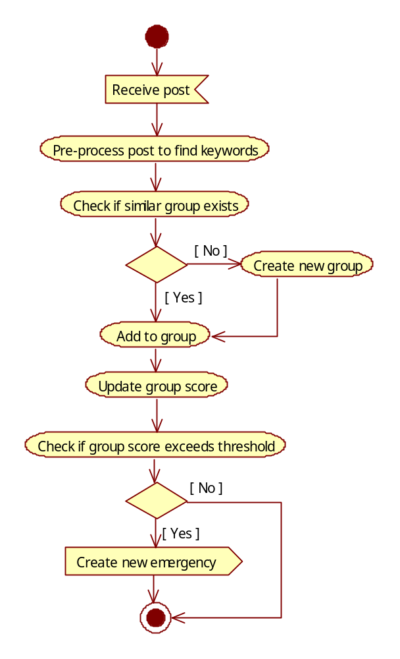
Figure 7: Emergency Detection Activity Diagram

Subordinates
There are three main components used within the CEDS. The first is the MicroblogDataManager, shown in Figure 8. This class is responsible for processing microblog posts as they are received from the CDAM. The processing of the posts and effort to group them is performed by this class.
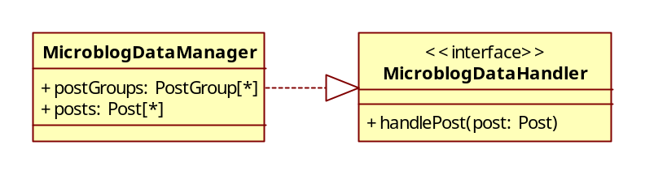
Figure 8: Microblog Data Manager Class Diagram
The EmergencyManager class is responsible for managing emergencies that have been detected by the MicroblogDataManager. When an emergency has been detected, the MicroblogDataManager will create a new emergency via the createEmergency method. Updates to emergencies will be initiated via the updateEmergency method.
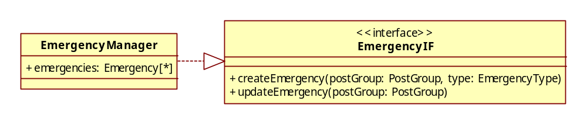
Figure 9: Emergency Manager Class Diagram
The UserManager class is depicted in Figure 10. This class is responsible for managing all aspects related to users, including creating new users, user authentication, and updating user preferences. It will interact with the EmergencyManager in order to determine which emergencies of which the user should be informed.
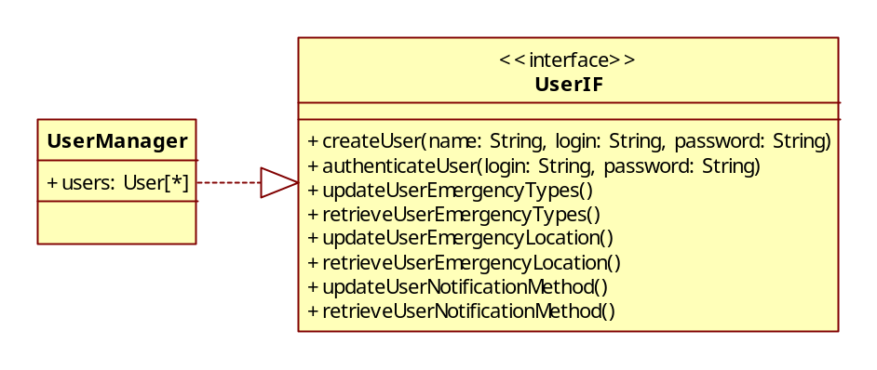
Figure 10: User Manager Class Diagram

Dependencies
The CEDS is dependent on the CDAM for data store operations as well as for obtaining microblog data from the Twitter API. The CMAC and CWBS are both dependent on the CEDS for their respective web services.

Interfaces
The CEDS interfaces with the CMAC via the MobileAppServiceAPI. This interface, which is provided by the CEDS, is shown in Figure 11. The interface provides methods for user registration and logging in and out. It also provides methods to retrieve and update the various user preferences, including emergency types, emergency location, and notification method.
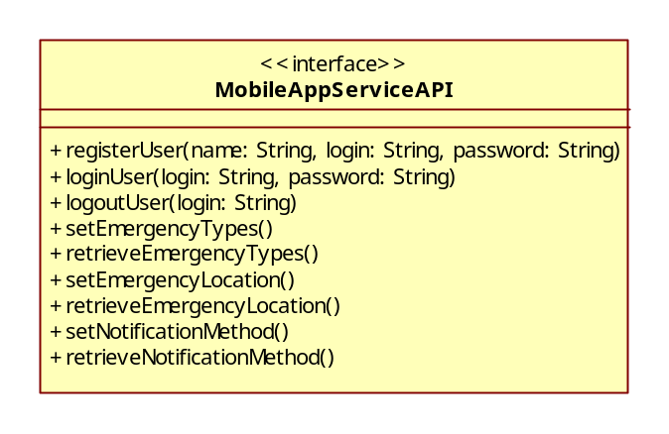
Figure 11: Mobile App Service API Class Diagram

Data Access Manager (CDAM)

Purpose
The purpose of the CDAM is to manage the interface with the external data store and to manage the interface with the Twitter API.

Dependencies
This component is dependent on the external data store, as well as the Twitter API. Any changes to these two elements would cause changes to the CDAM. The CEDS is dependent on the CDAM to provide access to the data store and to provide microblog data from Twitter.

Interfaces
The CDAM interfaces with the CEDS via the DataStoreAPI. This interface, which is provided by the CDAM, is shown in Figure 12. The interface provides methods for storing data to and retrieving data from the data store.
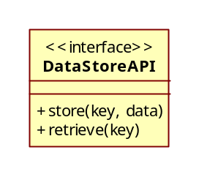
Figure 12: Data Store API Class Diagram
The CDAM also interfaces with the CEDS via the MicroblogDataAPI. This interface, which is provided by the CDAM, is shown in Figure 13. The interface provides methods for registering a MicroblogDataHandler. The class which is registered as the handler will be called for each new post that is received via the handlePost method of the MicroblogDataHandler interface.

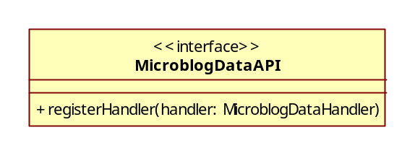
Figure 13: Microblog Data API Class Diagram

Human Interface Design

Overview of the User Interface
There will be two methods for interfacing with the user. A mobile application interface will be provided for use with mobile devices, and a web browser interface will be provided for use with standard computers. Both interfaces will provide the same functionality. The user will be able to update his/her personnel data, including username and password. The user will also be able to set notification preferences. One setting will control the notification method, with choices of text message, email, and voicemail. Another setting will allow the user to select for which of the supported emergency types they wish to be notified. Finally, the user will be able to select an area of interest, allowing them to specify the location for which they wish to be notified of emergencies.

Screen Images
Development of a detailed user interface is not a focus area of this project.

Screen Objects and Actions
Development of a detailed user interface is not a focus area of this project.

Requirements Matrix
FR ID | Functional Requirements | Component
FR1 | The system shall have a presentation layer. | CMAC, CWBC
FR1.1 | The presentation layer shall provide a mobile user interface. | CMAC
FR1.1.1 | The mobile user interface shall provide a method for a user to register. | CMAC
FR1.1.2 | The mobile user interface shall provide a method for a user to login. | CMAC
FR1.1.3 | The mobile user interface shall provide a method for a user to logout. | CMAC
FR1.1.4 | The mobile user interface shall provide a method for a user to set preferences. | CMAC
FR1.1.4.1 | The mobile user interface shall provide a method for a user to set emergency types for which to be notified. | CMAC
FR1.1.4.2 | The mobile user interface shall provide a method for a user to set the notification area. | CMAC
FR1.1.4.3 | The mobile user interface shall provide a method for a user to set the notification method. | CMAC
FR1.1.5 | The mobile user interface shall provide a method to notify a user of an emergency. | CMAC
FR1.2 | The presentation layer shall provide a web user interface. | CWBC
FR2 | The system shall have a business layer. | CEDS
FR2.1 | The business layer shall provide service interfaces. | CEDS
FR2.1.1 | The business layer shall provide a service interface for mobile applications. | CEDS
FR2.1.2 | The business layer shall provide a service interface for web browsers. | CEDS
FR2.2 | The business layer shall provide business components. | CEDS
FR2.2.1 | The business layer shall perform emergency management. | CEDS
FR2.2.1.1 | The business layer shall provide the ability to create new emergencies. | CEDS
FR2.2.1.2 | The business layer shall provide the ability to monitor the status of emergencies. | CEDS
FR2.2.1.3 | The business layer shall provide the ability to update the status of emergencies. | CEDS
FR2.2.2 | The business layer shall perform user management. | CEDS
FR2.2.2.1 | The business layer shall provide the ability to create new users. | CEDS
FR2.2.2.2 | The business layer shall provide the ability to authenticate a user. | CEDS
FR2.2.2.3 | The business layer shall provide the ability to update user preferences. | CEDS
FR2.2.2.4 | The business layer shall provide the ability to notify a user of an emergency. | CEDS
FR2.2.3 | The business layer shall perform microblog data management. | CEDS
FR2.2.3.1 | The business layer shall provide the ability to collect microblog data. | CEDS
FR2.2.3.2 | The business layer shall provide the ability to store microblog data. | CEDS
FR2.2.3.3 | The business layer shall provide the ability to pre-process microblog data. | CEDS
FR2.2.3.4 | The business layer shall provide the ability to group microblog data. | CEDS
FR2.2.3.5 | The business layer shall provide the ability to score microblog data groups. | CEDS
FR2.2.3.6 | The business layer shall provide the ability to identify high scoring groups as emergencies. | CEDS
FR3 | The system shall have a data layer. | CDAM
FR3.1 | The data layer shall provide data access logic. | CDAM
FR3.2 | The data layer shall provide service agents. | CDAM
FR3.2.1 | The data layer shall provide the ability to request microblog data. | CDAM
FR3.2.2 | The data layer shall provide the ability to request followers of an author. | CDAM
FR3.2.3 | The data layer shall provide the ability to request reposts of a message. | CDAM
FR4 | The system shall provide security. | N/A
FR5 | The system shall provide operational management. | N/A
FR6 | The system shall provide communication. | N/A

Resource Estimates
Computer resource estimates are outside of the scope of this project as it is only concerned with the early stages of design.

Definitions, Acronyms and Abbreviations
Term | Definition
emergency services | Public organizations that respond to and deal with emergencies when they occur, esp. those that provide police, ambulance, and firefighting services
ES | Emergency Services
ESP | Emergency Services Personnel
GUI | Graphical User Interface
microblog | Web service that allows the subscriber to broadcast short messages to other subscribers of the service
PS | Public Subscribers
public subscribers | Members of the general public who subscribe to the service provided by the application
SDD | Software Design Description
SRS | Software Requirements Specification

