Bitácora 0
I have to be honest here: I had no idea this course would deal with ITCs. I didn’t even know what ICTs were until you said what it meant. Even then, I imagined only things like PowerPoint, audios, videos, etc. So, when you gave us the outline of the course, I was a little surprised by the variety of things we are going to see. However, I was surprised even more by how familiar and common most of them are.
Even if I have never used ITCs in my classes, I feel like I kind of know a bit about them since I’ve been in so many online worlds. Ever since I was little, I loved videogames, and I became almost addicted to some of them, especially Diablo 2.
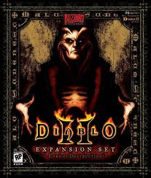
This game is especially significant because it had a semi-constant world in which characters had to complete several quests over and over to get the best gear. This gave the game a sense of community like no other and I feel like it was am very helpful tool for my English learning process. The only flaw was that the world is kind of limited and cheating was rampant, so there wasn’t a real incentive to keep playing after a certain point. Then, WoW came out:
http://www.youtube.com/watch?v=uv_b1-bsN5o&feature=related
An example of a dungeon fight which required lots of coordination and really knowing your team.
Now, WoW had a huge continuous world with tons of stuff to do. There were thousands of people in a single world, split in two opposing factions. This game really had everything needed to make an immersive world work and I spent many hours in it. Leveling a character for the first time is incredibly fun, in part thanks to the NPCs who litter the world and give you quests. After you achieved the maximum level, there were a ton of dungeons that required extensive teamwork and dedication to complete. Finally, there were professions that required a lot of time to perfect.
To me, WoW’s world is the best example that I have experienced of an ICT that can be used as an effective teaching platform. I say this because the game really encouraged you to form bonds with other players and cooperate in order to succeed. Learning to use tools like this to help me teach is something I’m really looking forward to and I hope to be able to successfully incorporate them to my classes in the future.
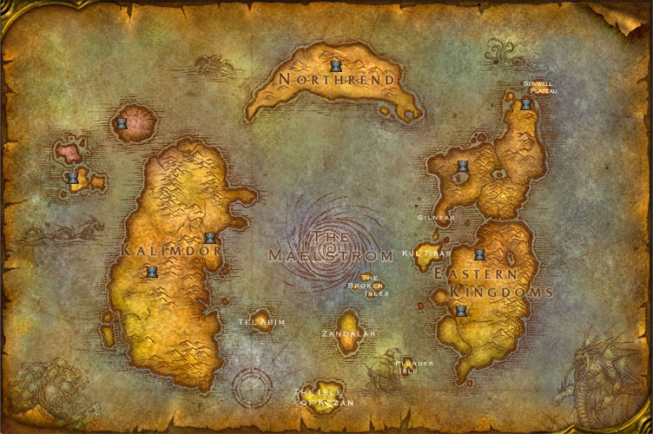
The world is larger than it looks.

Dear David,
This is a fantastic bitácora 0. I really enjoyed reading it. Hope you gain a lot from this!!!
4.5/5.0
Harold

