NERVE BLOCK OF THE CORNUAL BRANCH OF THE LACRIMAL NERVE

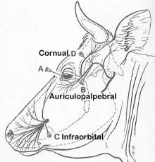

Uses: Used for disbudding or dehorning of cattle.

Materials Used: 20 gauge 1.5 inch needle, 20mL

Procedure:
- Palpate the frontal ridge of the animal (palpate between the lateral canthus of the eye and the base of the horn)
- Insert a needle into the upper third of the frontal ridge (area demonstrated in the picture), immediately behind the ridge and about 2.5 cm below the base of the horn, to a depth of 0. 5 to 0.75 inch deep)
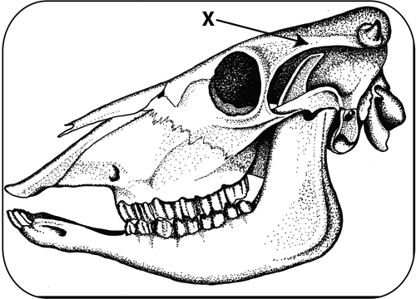
- Draw back on the plunger to check that the needle is not placed intravascularly.
- Inject 5 to10 ml of 2% lidocaine hydrochloride (the amount required depends on the size of the animal)
- After approximately 10 minutes use a needle and lightly stick the skin around the base of the horn to test cow reaction.
  - If the block worked: cow should not react to the stick of the needle.
  - If the block did not work: Cow will react to the stick of the needle. In this case the block can be repeated (as long as this does not cross the toxic dose of lidocaine calculated!)

Something to Note:
In individuals with well-developed horns an additional injection may be required, caudal to the horn or as an elliptical ring block around the horn base.

