When?
Some Examples:
Morning Afternoon Evening

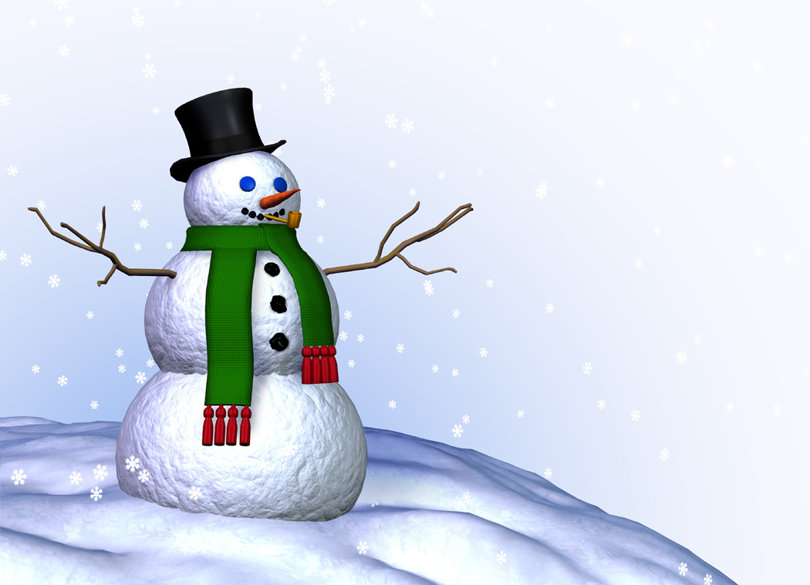
Autumn Winter
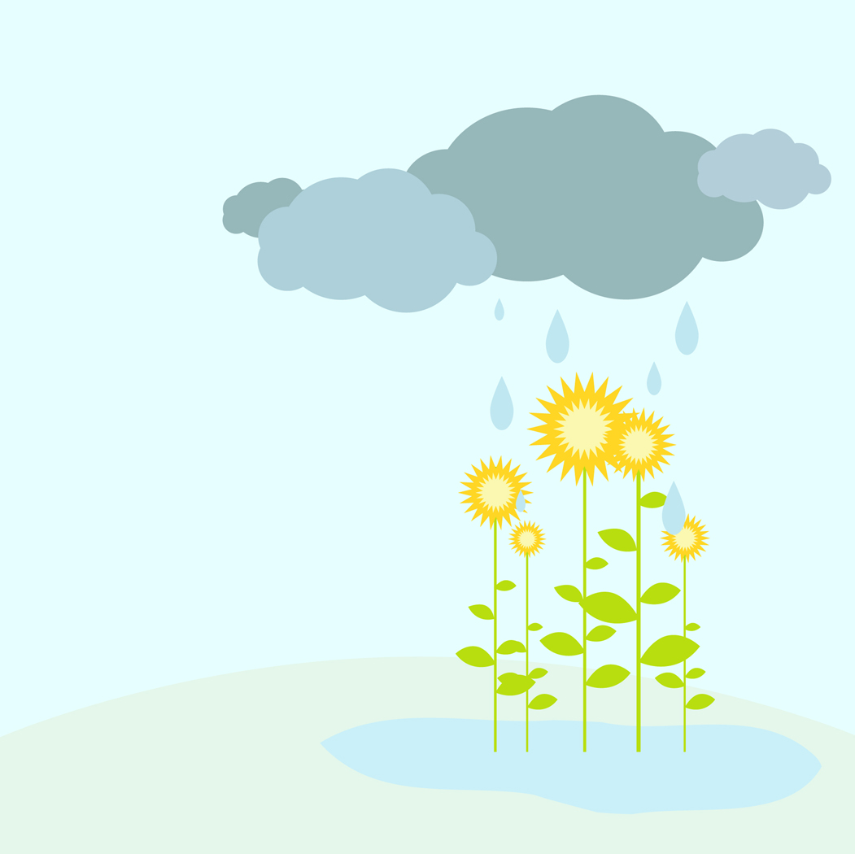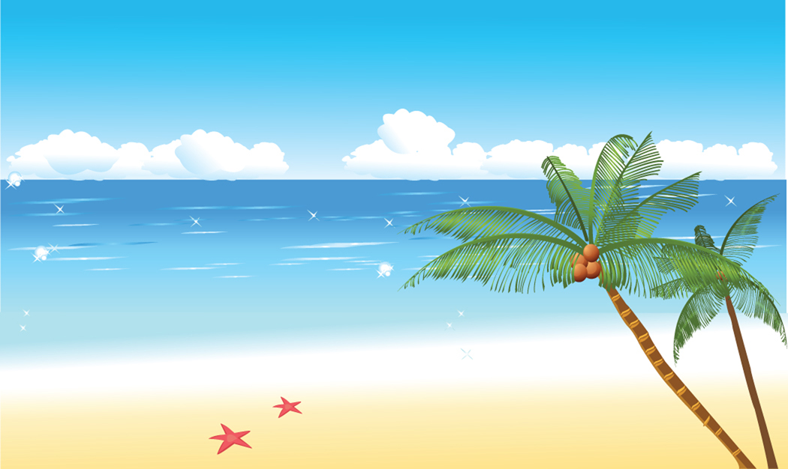
Spring Summer
Where?
Some Examples:
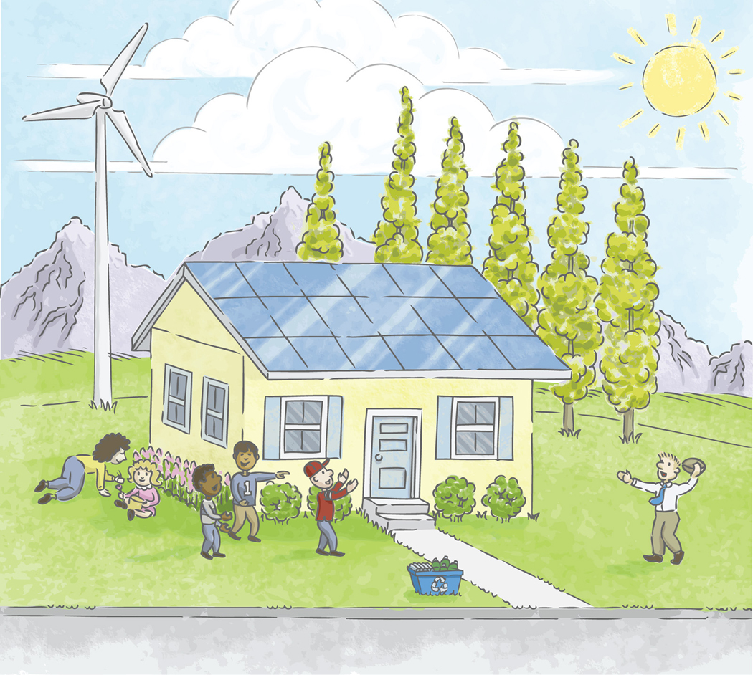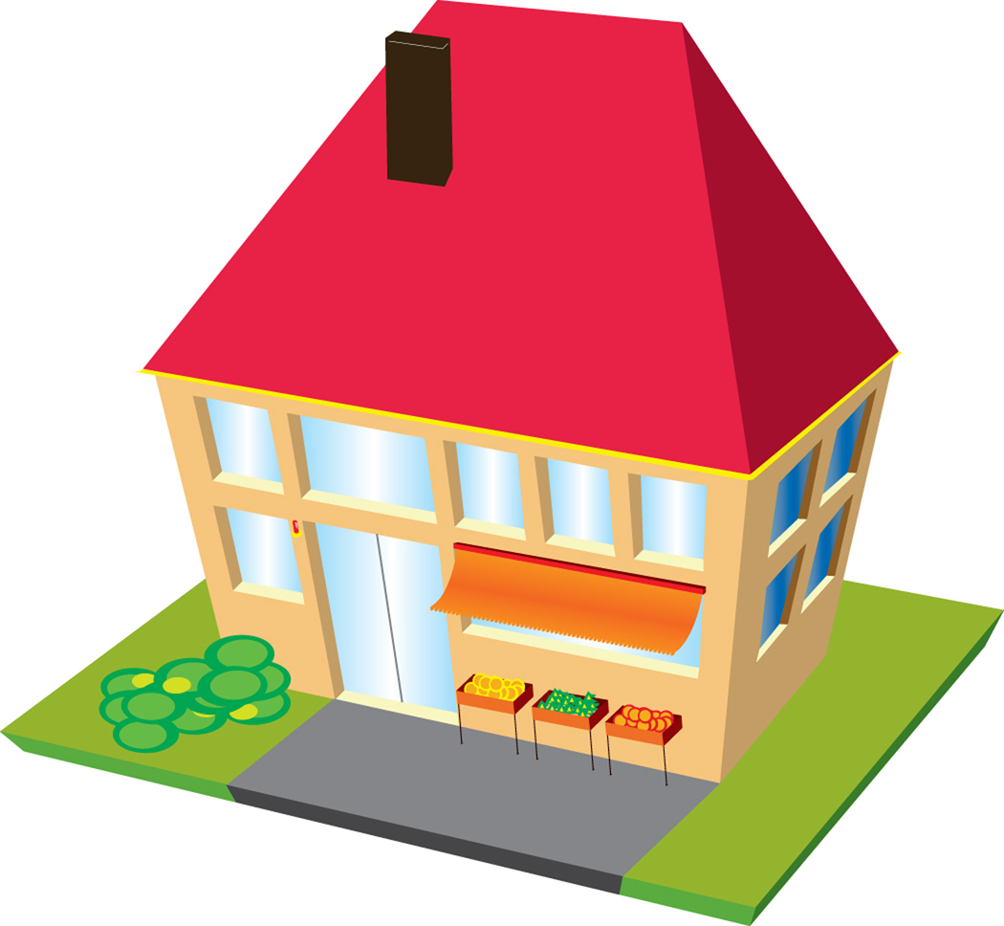
Home School Store or Restaurant
Setting Quiz Name:_______________________

- What is the setting of your story? ________________________________________________________________________________________________________________________________________________________________________________________________________________________________________________________________________

- Where does it take place? ______________________________________________________________________________________________________________________________________________________________________________________________________

- When does it take place? ______________________________________________________________________________________________________________________________________________________________________________________________________

- How do you know when it takes place? ______________________________________________________________________________________________________________________________________________________________________________________________________

- How do you know where it takes place? ______________________________________________________________________________________________________________________________________________________________________________________________________

- If your story doesn’t tell you where or when exactly how can you infer (or guess) where or when? ________________________________________________________________________________________________________________________________________________________________________________________________________________________________________________________________________

