Instructional Design
EDTL 7100-Summer 2009
First Grade Gingerbread man Thematic Unit
Language Arts Focus
Karrie Jimenez

Rationale

I am looking to extend what my Language Arts curriculum offers. The typical first grade Language Arts curriculum generally fails to integrate other subjects, appeal to the multiple intelligences in the classroom, and engage the students. I want to make sure the required content standards are met in a fun, interactive, hands-on approach. Research indicates it is important that teachers have a variety of approaches supported by research to teach these important skills. Each child has unique learning needs and one approach in a classroom will probably not address all student needs. (Rule, Dockstader, Stewart, 2006) This is important so every child can access, learn, and participate in the Language Arts curriculum.
Modifications should enable each student to make progress toward identified standards and gain awareness and the necessary skills required to meet first grade Language Arts benchmarks. My educational goal is to assist students with different learning styles by providing a variety of opportunities for success in Language Arts. A focus on balanced reading instruction that includes phonological awareness, phonics, fluency, and comprehension has evolved out of recent discussions and research reviews focused on research-based best practices in early literacy instruction (International Reading Association, 2003, NICHD News Release, April 13, 2000).
When teaching Language Arts to young children it is important that the students are engaged and actively participating in the learning at their developmental level. This
will be accomplished by using The Basic Lesson Planning Model. This model is generally used for a one-day lesson of 45-90 minutes, but it can be expanded by extending the activities to additional days. These lessons will be behavioral, problem solving, or expressive, depending on the content, the experiential background of the learner, and the context in which learning will occur (Chiarelott, 2006).
Throughout this unit, students will have the opportunity to increase their vocabulary, phonological awareness, comprehension, and fluency, by reading numerous Gingerbread man stories and completing various activities that are linked to First grade content standards and connect to our Language Arts curriculum. To make further connections, students will then begin to create and write letters that describe a gingerbread man depicting their state. After several versions of the story have been introduced and examined, each student will create their own ending to the story. This will be compiled into a class book and placed in the class library to be shared by everyone. The unit will end with a choral reading of a class play of the Gingerbread Baby to improve their reading fluency. This will bring the unit all together and will enrich their learning experience overall by bringing the story to life.
A gingerbread man themed unit is based on the student’s strengths and challenges and is created to provide each student meaningful, relevant, purposeful, useful and functional experiences. It incorporates Social Studies, Math, Science, and Language Arts. It is important that the skills are not taught in isolation but in conjunction with one another. Integrating Language Arts with other subjects replicates real life literacy, which
leads to a child’s overall understanding and purpose of learning. According to research, teachers need to look at what ought to be taught, what can be taught, how best to help
children learn it, and how best to help children apply it. (Johnson and Baumann)
A gingerbread man themed unit focuses on how we are alike and the differences of people as well. The unit allows for a tolerance of others and the acceptance of being different in a society. It also exposes children to many levels of Bloom’s Taxonomy and requires higher-level thinking skills. All of this combined, engages students in the learning process, helps them to retain necessary skills, and helps them to apply these experiences to real-life situations. Connecting the material to the student’s experiences and interest also make the learning more meaningful and relevant (Chiarelott, 2006).

References

Graham, Steve and Harris, Karen. (2006). Preventing Writing Difficulties: Providing Additional Handwriting and Spelling Instruction to At-Risk Children in First Grade Teaching Exceptional Children. Vol. 38, No. 5, p. 63-67

Johnson, Dale and Baumann, James. Word Identification Handbook of Reading Research Ch. 19

Rule, Audrey; Dockstader, Jolene; Stewart, Roger. (2006). Hands-On and Kinesthetic Activities for Teaching Phonological Awareness Early Childhood Education Journal. Vol. 34, No.3, p. 195-201

Chairlott, L. (2006). Curriculum in Context: Designing Curriculum for Teaching and Learning in Context. Belmont: CA: Wadworth

Ohio Department of Education. (2004) Academic Content Standards: K-12 Language Arts. Columbus, OH: Ohio Department of Education.

Sub-Unit Learner Outcomes

Word Recognition
- Students will identify and say the beginning and ending sounds in words. (analysis)
- Students will demonstrate an understanding of letter-sound correspondence by saying the sounds from all letters and from a variety of letter patterns, such as consonant blends and long-and-short-vowel patterns, and by matching sounds to the corresponding letters. (comprehension)
- Students will decode by using letter-sound matches. (knowledge)
- Students will use knowledge of common word families (e.g., -ite or –ate) to sound out unfamiliar words. (knowledge)
- Students will blend two to four phonemes (sounds) into words. (knowledge)
- Students will add, delete or change sounds in a given word to create new or rhyming words. (synthesis)

Acquisition of Vocabulary
- Students will use knowledge of word order and in-sentence context clues to support word identification and to define unknown words while reading. (knowledge)
- Students will classify words into categories (e.g., colors, fruits, vegetables). (analysis)

Comprehension Strategies
- Students will establish a purpose for reading (e.g., to be informed, to follow directions or to be entertained). (knowledge)
- Students will visualize the information in texts and demonstrate this by drawing pictures, discussing images in texts or writing simple descriptions. (comprehension)
- Students will make predictions while reading and support predictions with information from the text or prior experience. (application)
- Students will compare information (e.g., recognize similarities) in texts with prior knowledge and experience. (comprehension)
- Students will recall the important ideas in fictional and non-fictional texts. (comprehension)
- Students will create and use graphic organizers such as Venn diagrams or webs, with teacher assistance, to demonstrate comprehension. (synthesis)
- Students will answer literal, simple inferential and evaluative questions to demonstrate comprehension of grade-appropriate print texts and electronic and visual media. (evaluate)
- Students will monitor comprehension of independently-or group-read texts by asking and answering questions. (knowledge)

Writing
Writing Processes-prewriting, drafting, revising and editing, publishing
- Students will generate writing ideas through discussions with others. (synthesis)
- Students will develop a main idea for writing. (application)
- Students will determine purpose and audience. (synthesis)
- Students will use organizational strategies (e.g., brainstorming, lists, webs and Venn diagrams) to plan writing. (application)
- Students will organize writing to include a beginning, middle, and end. (application)
- Students will construct complete sentences with subjects and verbs. (application)
- Students will mimic language from literature when appropriate. (comprehension)
- Students will add descriptive words and details. (comprehension)
- Students will use resources (e.g., a word wall, beginner’s dictionary, word bank) to select effective vocabulary. (knowledge)
- Students will proofread writing to improve conventions (e.g., grammar, spelling, punctuation and capitalization). (Knowledge)
- Students will rewrite and illustrate writing samples for display and for sharing with others. (comprehension)
Writing applications
- Students will write friendly letters or invitations that follow a simple letter format. (application)
- Students will produce informal writings (e.g., messages, journals, notes and poems) for various purposes. (application)
Writing conventions
- Students will print legibly, and space letters, words, and sentences appropriately. (application)
- Students will create phonetically-spelled written work that can usually be read by the writer and others. (synthesis)
- Students will use end punctuation correctly, including question marks, exclamation points and periods. (application)
- Students will use correct capitalization (e.g., the first word in a sentence, names and the pronoun I). (application)
- Students will use nouns, verbs and adjectives (descriptive words). (application)

Fluency
- Students will read text using fluid and automatic decoding skills, including knowledge of patterns, onsets and rimes. (application)
- Students will read aloud with changes in emphasis, voice, timing and expression that show recognition of punctuation and an understanding of meaning (application).

*Unit outcomes are categorized by using Bloom’s Taxonomy*

Pre-assessment

The pre-assessments for this particular unit will be informal. Two activities will be utilized to determine prior knowledge. The first activity is to introduce a KWL chart during a whole group setting using large chart paper. We will fill in only the first two columns. The second activity allows the students to fill in any vocabulary words that they are able to connect with about the Gingerbread man. A majority of the assessing will take place throughout the lessons. I will ask questions, students will ask questions, and observations will be taken as well. Work samples will also be used as assessment pieces. Below you will find a sample KWL chart and the boxes that student’s fill in with vocabulary words pertaining to the Gingerbread man.
For these types of informal pre-assessments, I am looking for prior knowledge and will later re-assess to see the amount of knowledge gained after completing the lessons. There are not any particular right or wrong answers at this stage of the learning process. First grade students have all year to meet content standards therefore, formal assessments will be given during each quarter of the school year. These lessons are to prepare for the formal assessments and to track progress made towards meeting each standard.

KWL Chart-Gingerbread man 

What I already know about the Gingerbread Man | What I want to know about the Gingerbread Man | What I learned about the Gingerbread Man

*Filled out on large chart paper in a whole group setting. Answers will vary depending on the prior knowledge of the students in the class.*

Fill in as many Gingerbread man related
words as you can think of!

A | B | C  Ex: cookie | D  Ex: decorate | E
F  Ex: fast | G  Ex: Gingerbread house | H | I | J
K | L | M | N | O
P | Q | R  Ex: runs | S | T
U | V | W | X | Y
Z

Gingerbread man Lesson 1

- Concept or the skills to be learned
- Word recognition and rhyming

- Lesson objective(s)
- The students will increase their knowledge of blends and vowel combinations in words and recognize both rhyming and patterns found in those words.

- Procedures

Engagement: (5 minutes)
- Sing the Gingerbread children poem to get their attention and to introduce the Gingerbread man. Spend a few minutes to review what they filled in on the pre-assessment alphabet chart.

Exploration: (15 minutes)
- Read a version of the story The Gingerbread Man to the class. Allow students to respond to the events in the story. Encourage them to chime in during the refrain. Make sure to stop at several words for the opportunity to sound out and decode any unfamiliar words. Focus on adding new words to their vocabulary. Have students prompt questions about the story to encourage higher level thinking skills.

Explanation: (10 minutes)
- Take parts of the story and create rhyming words in small groups of 2-3 students each that are associated with the story. They can use white drawing paper to write the “poem” and draw a picture to go with it.
- For example: Skate, skate, as fast as you can
Skate right past the gate but don’t be late.

Extension: (5-10 minutes)
- Each group shares with the class the rhymes they came up with.
- Give students a few minutes to add any new words to their alphabet chart about the Gingerbread man.

Evaluation: (5-10 minutes long)
- Students will be evaluated on their word recognition skills and rhyming by the completeness and accuracy of their handout. This will help determine their ability to decode unfamiliar words by using blends and word families they are familiar with.

- Materials and Resources
- A version of the Gingerbread man story
- White drawing paper to create poems and drawings to go with the poem
- Each student’s alphabet fill-in chart about Gingerbread man words
- Rhyming Gingerbread man house worksheet
- Gingerbread Children poem retrieved June 8, 2009, from http://www.kinderkorner.com/gingerbread.htm
- Gingerbread house rhyming sheet retrieved June 8, 2009, from http://www.geocities.com/teachingwithheart/gingerbreadhact.html


Gingerbread Children
Gingerbread children
Stand in a row.
Very good children
Always you know.
They never will jump
Or kick or leap,
Or start to cry when
It's time to sleep.
They never run off
Or look around.
And no one has heard
Them make a sound.
Gingerbread children
Are fine to meet,
But, much better still,
They're good to eat!

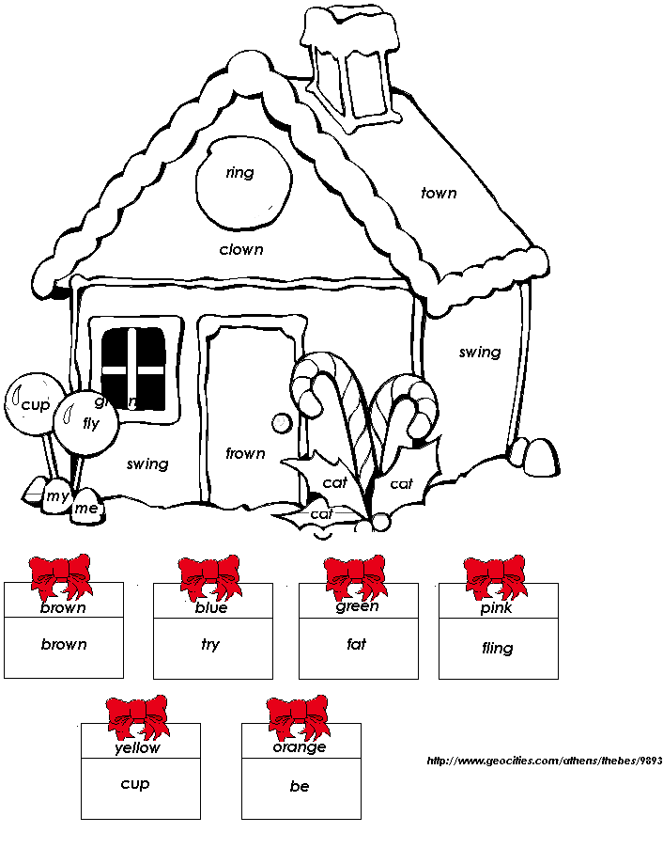

Gingerbread man Lesson 2

- Concept or the skills to be learned
- Using context clues and completing a story map

- Lesson objective(s)
- The students will fill in a story map independently to show comprehension and will use context clues to figure out unknown words.

- Procedures

Engagement: (5 minutes)
  - Gather students together to discuss what they do when they come across words that are difficult to read even though they sound them out. End the discussion by telling the class that the Gingerbread man left them a note. (act very surprised!)

Exploration: (20 minutes)
  - After reading the first note, explain to the class that we will be going on a scavenger hunt to try to find the Gingerbread man.
  - Make sure the Gingerbread men have been placed throughout the school with clues attached.
  - Have students recall from the story how fast the Gingerbread man ran and how quiet we will have to be in the hallways so he doesn’t hear us coming. (Make this fun by tip-toeing throughout the school.)
  - Follow each clue until you reach the end.
  - Students enjoy a snack of Gingerbread man cookies and juice while the teacher procedes to the explanation part of the lesson and reads another version of the story.

Explanation: (15 minutes)
- After completing the scavenger hunt, explain in more detail how the context clues helped to find the Gingerbread man. Allow time for any questions about using context clues.
- Read another version of the Gingerbread man and stop for any words that can be figured out by using context clues.

Extension: (5 minutes)
- Allow students to look at books in the class library or in their baggy books (these are books at each child’s desk that are at their appropriate reading levels) to try and use context clues to determine unfamiliar words.

Evaluation: (5 minutes)
- Each student will be evaluated on their comprehension of what we read by completing a story map with a partner.
- While students are reading books in the class library or their baggy books, walk around and jot down any notes regarding a child’s knowledge of using context clues to keep track of progress being made toward meeting that content standard.

- Materials and Resources
- A version of the Gingerbread man story
- Baggy books and books in the class library to review context clues.
- Gingerbread man clues already placed throughout the school
- A story map for each child to complete
- A box of Gingerbread cookies
- Juice
- Napkins
- Gingerbread man scavenger hunt was changed to meet my classroom needs. The original was retrieved on June 8, 2009 from http://www.kinderkorner.com/gingerbread.htm
- Gingerbread man story map retrieved on June 8, 2009 from http://www.teachingheart.net/gingerbreadman.htm


Note found on top of KWL chart
Dear Boys and Girls,
Tomorrow look for me around a shelf.
And inside of books,
I'm famous for running away
And for my delicious looks!

School Office
The office is a busy place.
The secretary has a friendly face.
She types with her left,
Writes notes with her right.
When the phone rings,
She takes the call
Without using any hands at all!
Principal's Office
This is the Principal's office.
Mrs. C is nice you know.
She told me not to run anymore,
But to walk wherever I go!
Nurse's Office
The nurse is our friend
And I'll tell you why.
She'll check your ears
And she'll check your eyes.
She'll fix the hurt that makes you cry.
I have to run now -- can't say good-bye!
Custodian
This is Miss Rita’s room.
Do you see the mop and broom?
SHe empties the basket
And locks the door.
She is kind and good.
Can we help her?
We should!
Cafeteria
This is the lunch room.
They like us a bunch!
They always makes sure
We have a good lunch.
If we're very polite and
help keep it clean,
And use soft voices
Our school will be keen!
Classroom
Dear Boys and Girls,
I've run and run
I need some rest
I think this room is the best!
Love, The Gingerbread Man
(Gingerbread cookies, juice and napkins are waiting for the class.)

Fill in the Story Map For the Gingerbread Man
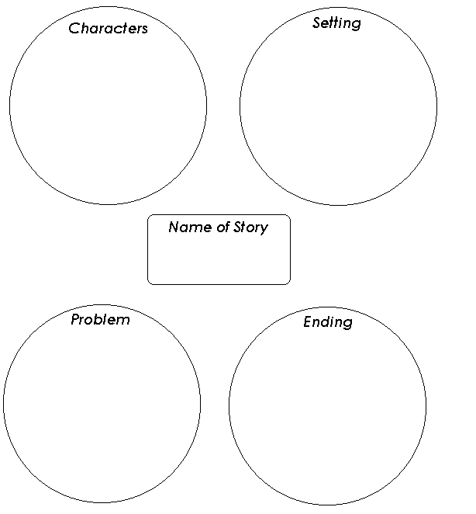

Gingerbread man Lesson 3

- Concept or the skills to be learned
- Creative writing

- Lesson objective(s)
  - The students will be able to create a Gingerbread man about their state and write a new ending to the traditional story.

- Procedures

Engagement: (5 minutes)
- Teach the class a Gingerbread man finger play and chant.

Exploration: (20 minutes)
- Read another version of the Gingerbread man story. Discuss how each story has had similar endings. (The Gingerbread man is tricked by the fox and is eaten.)
- Give each child a white piece of drawing paper.
- Have them write how the Gingerbread man escaped the fox. Make sure they draw a picture to go with it.
- Collect each story ending and put it together to create a class book.

Explanation: (5 minutes)
- Discuss how the Gingerbread man is chased all over and encounters many different obstacles. Then discuss the setting if he came to Ohio today.

Extension: (15 minutes)
- Give out two pre-cut Gingerbread men and provide a variety of art materials for each student to decorate. They must represent what Ohio looks like at this time of the year.
(I would do this unit in December so students could draw bare trees with snow and snowmen, etc..)
- Collect these Gingerbread men and send home the attached letters to their parents along with the two Gingerbread men and two blank Gingerbread men.
(Parents are asked to send a letter, one of their child’s Gingerbread man, and a blank one to a family member. The family member uses the Gingerbread man to re-create facts about their state. They send the new one back to school and the class gets to track on the map where all the Gingerbread men travel to and also receive notes about his travels.)

Evaluation:
- Review at each child’s ending they created to make sure they understand the necessary parts of a sentence.
- Look for correct punctuation, capitalization, correctly spelled high frequency words, and phonetically spelled words.

- Materials and Resources
- A version of the Gingerbread man story
- A copy of the Gingerbread man finger play and chant
- A piece of white drawing paper for every child
- Two pre-cut Gingerbread men for each child
- Variety of art materials
- One parent letter for each child
- A letter to send to relatives in another state (Two letters per child)
- Two blank Gingerbread men
- Gingerbread man finger play and chant was retrieved on June 8, 209 from http://www.kinderkorner.com/gingerbread.htm

Gingerbread Men Finger play & Chant
Five little gingerbread men lying on a tray,
One jumped up and ran away.
Shouting "Catch me, catch me, catch me if you can ...
I run really fast, I'm a gingerbread man!"
Four little gingerbread men lying on a tray,
One jumped up and ran away.
Shouting "Catch me, catch me, catch me if you can ...
I run really fast, I'm a gingerbread man!"
Three little gingerbread men lying on a tray,
One jumped up and ran away.
Shouting "Catch me, catch me, catch me if you can ...
I run really fast, I'm a gingerbread man!"
Two little gingerbread men lying on a tray,
One jumped up and ran away.
Shouting "Catch me, catch me, catch me if you can ...
I run really fast, I'm a gingerbread man!"
One little gingerbread man lying on a tray,
He jumped up and ran away.
Shouting "Catch me, catch me, catch me if you can ...
I run really fast, I'm a gingerbread man!"
No more gingerbread men lying on a tray,
They all jumped up and ran away.
Oh, how I wish they had stayed with me to play.
Next time I'll eat them before they run away.
It's fun to do this finger play using the left hand open, plam up, as the "tray," and lying the other fingers on the tray until each runs away.

Letter to parents

Dear Parents,

I would like to ask your help with a special project for our Gingerbread Man Unit. In addition to reading, writing, and math, I am hoping to tie this unit in with social studies and learn some interesting facts about our country. Your child has prepared two gingerbread men representing Ohio. You are also receiving two letters to be sent to someone you know that lives preferably outside of Ohio. With your child’s help, please decide who should receive this letter, and then send it on to them. Grandparents, aunts, cousins, and friends, are all good examples of people that would love to help. I am asking that person to send us a gingerbread man representing where they live. (I am sending two of each in hopes of covering as many states as possible.) For each one, please send the letter, your child’s Ohio gingerbread man, a blank gingerbread man, and a return Crissey address label. (They get to keep your child’s gingerbread man as a special keepsake.) Please send these out as soon a possible so that we may start receiving the gingerbread men within the next couple of weeks. This can be a lot of fun so please find someone that you feel will be able to respond back. If you need someone with an address other than the state of Ohio, please let me know and I can get that to you. The returned gingerbread men will be displayed for everyone to see where they traveled.

Thank you! I appreciate your help!

Mrs. Jimenez

Letter to family members

Hi,

I am the Gingerbread Man. A teacher named Mrs. Jimenez, was reading a story about me in First Grade. She told the children about how fast I can run. I was so excited that a decided to jump out of the storybook and come to visit you! _________________ thought you would be the perfect person. I know my friends back at Crissey Elementary are curious as to where I have run to. I was wondering if you could help them by sending a newly decorated "me" depicting something about the state where you live. As a matter of fact, _________________ decorated me to show you an intersting fact about Ohio. Please keep this as a thank you for your help. (Feel free to drop in a little note about today's weather, any holiday traditions in your area, interesting facts, etc.) I have included a return address label to attach to your envelope to ensure I make it back home safely. This will be a unique opportunity to help the children with their study of other states. As soon as I return, I will be put on display for everyone to see where I have traveled. I know my friends will enjoy hearing from you and learning about where I have been running! Please send me back as soon as possible because I know the class is anxiously waiting for my safe return. Thank you for your help.
Got to go!

-The Gingerbread Man

Gingerbread man Lesson 4

- Concept or the skills to be learned
- Increasing Fluency

- Lesson objective(s)
- Students will be able to recall important events from a story and perform in a class play for their peers.

III. Procedures

Engagement: (5 minutes)
- Remind the class that every story so far has been about a Gingerbread man or boy. Introduce the story Gingerbread Baby by: Jan Brett and do a picture walk to discuss what they predict will happen in this version. (Do not show the last couple of pages until later because he actually escapes!)

Exploration: (10-15 minutes)
- Watch the online video of Jan Brett making real gingerbread cookies and reading the story.

Explanation: (5 minutes)
- Recall the characters in the Gingerbread Baby story and what role they had in the story as a whole group.

Extension: (20 minutes)
- Break the class up into groups to make sure each character is represented.
- Allow the class to use the pre-made character puppets and retell the story.
- To help with classroom management, allow 5-10 minutes to review and then 5-10 minutes for any group that wishes to perform to the class using the props and what they remember from the story.

Evaluation: (10 minutes)
- Students work in groups of 3-4 to complete a beginning, middle, and ending activity worksheet.
- The worksheet will be used to assess their ability to comprehend what they have read and it they are able to recall those events in sequential order.

- Materials and Resources
  - Copy of the Gingerbread Baby by: Jan Brett
  - Internet access
  - Character puppets from the Gingerbread Baby story
  - A worksheet for each student to assess their knowledge of beginning, middle, and end.
  - Jan Brett’s storytelling of the Gingerbread Baby online can be found at http://www.janbrett.com/index.html
  - Gingerbread baby beginning, middle, and ending worksheet was retrieved on June 8, 2009 from http://www.teachingheart.net/gingerbreadman.html
  - Gingerbread puppets for story re-telling was retrieved on June 8, 2009 from http://www.janbrett.com/index.html

Tell About the Beginning, Middle, and End of the Gingerbread Baby
What happened in the beginning of the story?
___________________________________________________________________________
___________________________________________________________________________
___________________________________________________________________________
___________________________________________________________________________
What happened in the middle of the story?
___________________________________________________________________________
___________________________________________________________________________
___________________________________________________________________________
___________________________________________________________________________
What happened at the end of the story?
___________________________________________________________________________
___________________________________________________________________________
___________________________________________________________________________
___________________________________________________________________________
http://www.geocities.com/athens/thebes/9893

Gingerbread Baby Animals
You can print these masks and use them for a play.
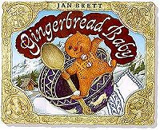
This is a great project to use with my book The Gingerbread Baby
These files are quite large and download slowly, but I hope that you'll be pleased by the quality.
Click on each animal to display the full sized mask artwork.
Printing Suggestions
Free PDF reader
Top of Form

Bottom of Form
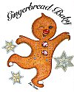
Baby
Click here for PDF
"I am the Gingerbread Baby
fresh from the pan.
If you want me
catch me if you can."
  The Dog  Click here for PDF  "Sniff, sniff, Gingerbread!  Sniff, Sniff, Gingerbread!  I'll try and find you now.  I'll track you through the snow,  Bow Wow Wow! |   The Goat  Click here for PDF  "Thumpity, thumpity what do we feel?  That Gingerbread Baby would make a good meal  (Clippity clop, clippity clop)  - with wood blocks."
  The Mountain Dog  Click here for PDF  Gingerbread Baby you're as  naughty as can be.  First you tweaked my masters' nose  now you run away from me.  Woof, Woof Woof! |   The Fox  Click here for PDF  "Smack, smack, I'm licking my chops  I'm a fox and I'm fast, I'll catch you at last!"  Grrrrrr."
  The Cat  Click here for PDF  "Meow, meow, meow  I twitch my tail and my whiskers too,  Gingerbread Baby, I'm going to catch you" |   The Pig  Click here for PDF  "I tossed the baby high, and he jumped right  on my snout, Oink, Oink, Oink  a cookie with bad manners, what's this all about?  Gingerbread Baby, come back!  Gingerbread Baby, come back!
Home Page
Post-Assessment
The post-assessments are a follow up to what was assessed during the pre-assessments. As a class we will review our KWL chart and add to the final column (What we learned about). We will also review what we wanted to know and see if we are able to answer those questions as a whole group. I will be completing additional assessments throughout each lesson in order to determine if particular goals were met. This data will be used to determine my future lesson plan goals.
The final post-assessment will be to ask each child to fill in their alphabet chart about Gingerbread man words to see how well they are able recall facts from the stories, comprehend what they have been read, and also to see if their vocabulary has increased. I will obtain that information by totaling the number of words they knew prior to the unit. That data will by used to compare the amount of words they had at the end of the unit. All of the assessments will be combined to make an overall decision as to what each child’s strengths and weaknesses are. It is important to note that each child will progress differently. Each lesson plan and assessment is varied in order to make sure numerous opportunities to be successful were provided.

*Please review the KWL and alphabet chart found on the pre-assessment pages because they are also used as part of the post-assessment.*

