Name:________________________________ Class:_____ #_____ Date:_________________

Ecosystems and Change – Answer Document

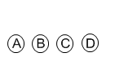

1. 2. 3. 4.



5. 6. 7. 8.

9. Write your response to question 9 in the space below.



10. 11.

12. Write your response to question 12 in the space below.



13. 14.

15. Write your response to question 15 in the space below.



16. 17. 18.