Ohio Standards Connection:

Scientific Inquiry

Benchmark B
Analyze and interpret data from scientific investigations using appropriate mathematical skill in order to draw valid conclusions.

Indicator 3
Distinguish between observation and inference.
Lesson Summary:
This lesson introduces the skill of inference to students. Students will rotate through six stations that challenge them to make observations and then draw inferences from their observations.

Estimated Duration: One hour and 30 minutes
Commentary:
Prior to sixth grade, students have had many opportunities to learn about and make observations. This lesson helps students understand how observations can be used to make inferences about their world. The lesson uses activities at stations that are positioned around the classroom. Use of stations encourages students to actively participate in the learning experience.

Pre-Assessment:
See Attachment A, Pre-Assessment, for a weather chart from the Web site for the National Oceanic and Atmospheric Association (www.noaa.gov). Copy and give to students.

Scoring Guidelines:
The purpose of the pre-assessment is to determine if students know the difference between an observation and an inference and if they can make these given a data table.
Proficient students will be able to make observations about the weather from the table and infer or predict weather phenomena, or causes of the weather observations, based on this. Less-proficient students may confuse observation and inference or make an inference that does not lead from an observation.
The pre-assessment will serve as a point of discussion to begin the lesson.

Post-Assessment:
- See Attachment B, Post-Assessment, for a weather chart and a set of questions.
- Copy and provide the chart and the questions for students to answer.

Scoring Guidelines:
- Use Attachment C, Post-Assessment Answers, to assess student work. This attachment includes a rubric to grade the observations and inferences that students make from the weather chart and answers to the questions students completed after their observations and inferences.

Instructional Procedures:
1. Set up six stations with activities that students will carry out in class. See Attachment D, Teacher Instructions, for instructions on how to set up the stations.
2. Conduct the pre-assessment.
3. Ask the students to define “observation.” Be sure to question the students in a way that will lead to a definition. An observation is any information which is obtained by using one’s senses. Write the definition on the blackboard.
4. Ask the students why it is important to make observations in science. Write these reasons on the board. Ask the students to develop a working definition that explains why observations are important.
5. Define the term “inference”. Write the definition on the blackboard. Give the students several examples that distinguish between observation and inference and then ask them to provide their own examples of observations and inferences. Use the following two examples to prompt the students.

Observation Inference
Sean is not in school today. Sean must be sick.
Mr. Newton is wearing a coat. It must be cold outside.

6. Explain the procedure for using the lab stations. At each station, the students are to perform the task indicated on their handouts and answer the questions.
7. Hand out Attachment E, Student Worksheet, and have students complete the stations in teams. Make sure that students are aware that they are each responsible for completing their own worksheet.
8. Circulate around the room while students complete their worksheets to make sure that they understand what they are supposed to be doing.
9. After completing the stations, have each team share one observation that they had and an inference that they made which they thought was the most interesting.
10. Revisit the definitions that students made at the beginning of the lesson. Ask if any revisions need to be made.
11. Proceed to the post-assessment.
Differentiated Instructional Support:
Instruction is differentiated according to learner needs, to help all learners either meet the intent of the specified indicator(s) or, if the indicator is already met, to advance beyond the specified indicator(s).
- Provide a scribe. Make sure students can maneuver the items at the tables.
- Read a mystery story and identify observations and inferences.

Extension:
- Ask students to make a list of observations and inferences throughout the school day.
- Challenge students to find inferences in their local newspaper. Highlight observations and inferences with different colors.

Homework Options and Home Connections:
Have students make a list of inferences at home. Have them discuss the difference between an observation and inference, and see if their parents can relate some of the inferences that they have to make during the day.

Materials and Resources:
The inclusion of a specific resource in any lesson formulated by the Ohio Department of Education should not be interpreted as an endorsement of that particular resource, or any of its contents, by the Ohio Department of Education. The Ohio Department of Education does not endorse any particular resource. The Web addresses listed are for a given site’s main page, therefore, it may be necessary to search within that site to find the specific information required for a given lesson. Please note that information published on the Internet changes over time, therefore the links provided may no longer contain the specific information related to a given lesson. Teachers are advised to preview all sites before using them with students.

For the teacher: tables

For the students: audio tape, beans, corn starch, film canisters, flour, iodine, margarine container, cans of food, powdered sugar, ramp, rice, seeds, sock, tape recorder with headphones

Vocabulary:
• inference
• observation
Research Connections:
Marzano, Robert J., Peckering, Debra J., and Pollock, Jane E. Classroom Instruction that Works Research-Based Strategies for Increasing Student Achievement, ASCD, 2001.

Nonlinguistic representations help students think about and recall knowledge. This includes the following:
- Creating graphic representations (organizers);
- Making physical models;
- Generating mental pictures;
- Drawing pictures and pictographs;
- Engaging in kinesthetic activity.

Generating and testing hypotheses engages students in one of the most powerful and analytic of cognitive operations. It deepens students’ knowledge and understanding. Any of the following structured tasks can guide students through this process:
- Systems analysis;
- Problem solving;
- Historical investigation;
- Invention;
- Experimental inquiry;
- Decision making.

General Tips:
Distinguishing between an observation and an inference is difficult at this age. Therefore, this topic needs to be incorporated into every lesson. The students are not cognizant that they do this naturally. If you point this out in all lessons, it will reinforce the skill.

Attachments:
Attachment A, Pre-Assessment
Attachment B, Post-Assessment
Attachment C, Post-Assessment Answers
Attachment D, Teacher Instructions
Attachment E, Student Worksheet

Attachment A
Pre-Assessment

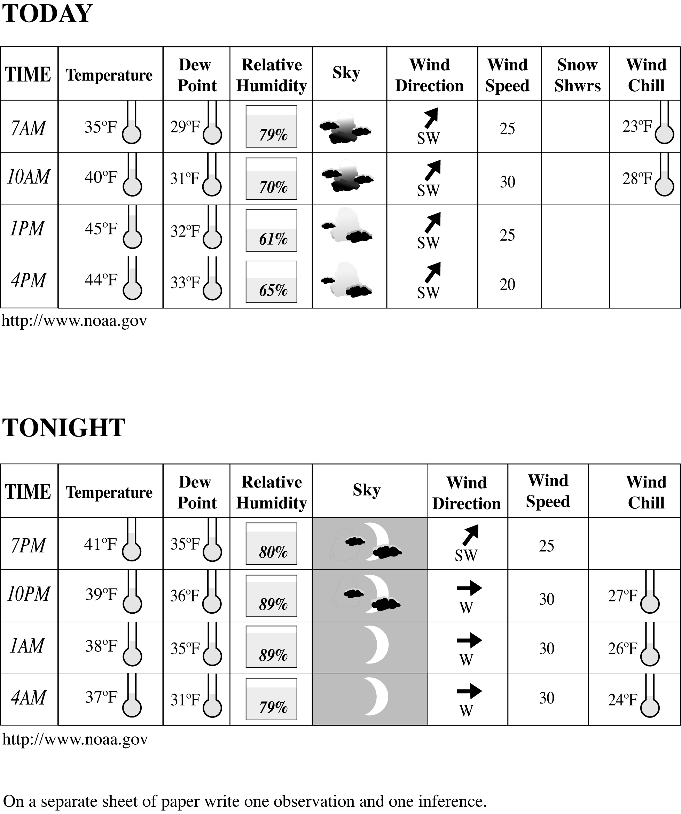
Attachment B
Post-Assessment

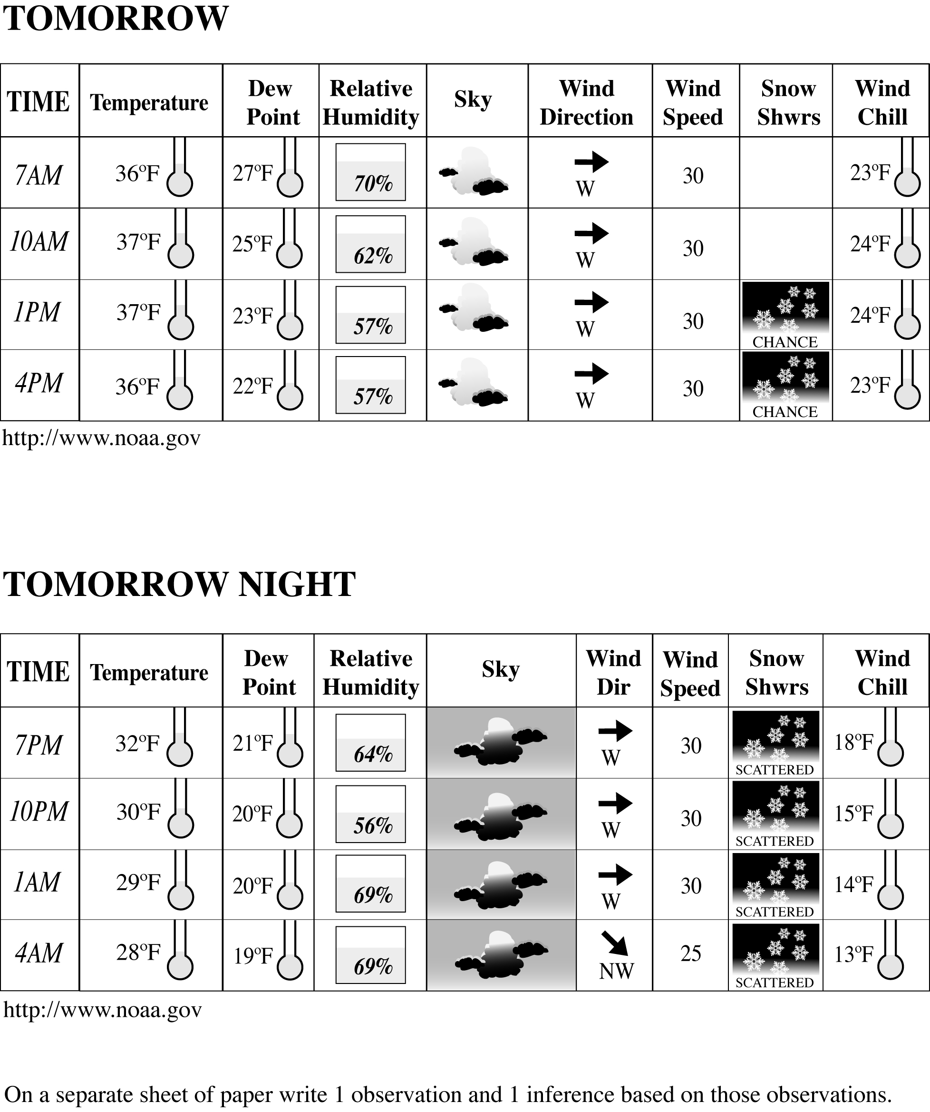

Attachment B (cont'd)

Directions: Label the following statements as either observation (O) or inference (I).

1. When I rang the doorbell, no one answered. ___________

2. The hamburger was hot. ___________

3. Jamal must be very popular. ___________

4. The rabbit uses fur from her stomach to build her nest. ___________

5. That sounded like a mean dog. ___________

6. The rock feels like an ice cube. ___________

7. Those clouds look like a mountain. ___________

8. The beaker contains 250 ML of water. ___________

9. The bark on the birch tree was white. ___________

10. A gas was formed when I mixed the liquid and solid. ___________

Attachment C
Post-Assessment Answers

Use the following rubric to assess student choice and description of an observation and an inference.

 | 3 | 2 | 1
Observation and inference | Makes one clearly stated observation and one clearly stated inference. | Makes a clearly stated observation or inference. | Observation and inference are unclear or incorrect.
Relationship of inference to observation | The inference is directly tied to the observation | Inference is loosely tied to the observation. | Inference does not follow from the observation.

The answers to the Post-Assessment questions are listed below.

1. When I rang the doorbell, no one answered. ______O____

2. The hamburger was hot. ______O____

3. Jamal must be very popular. ______I_____

4. The rabbit uses fur from her stomach to build her nest. ______O____

5. That sounded like a mean dog. ______I_____

6. The rock feels like an ice cube. ______I_____

7. Those clouds look like a mountain. ______I_____

8. The beaker contains 250 ml of water. ______O____

9. The bark on the birch tree was white. ______O____

10. A gas was formed when I mixed the liquid and solid. ______O____
Attachment D
Teacher Instructions

Instructions for setting up six stations are shown below. Run through all stations and try the experiments that students will try before the students actually use the materials. You may catch mistakes or find ways to streamline the stations by testing the procedures.

Station One: Place three containers of white powders labeled A, B and C on the table. Use flour, powder sugar and cornstarch to fill the containers. Place a dropper bottle containing iodine and several small pieces of foil on the table

Station Two: Place a stopwatch and at least four canned food items at the table. Construct a ramp: A board propped on textbooks works fine. Do not use a can with a lip on it, because it will not roll straight down the ramp.

Station Three: Place different sized seeds, rice or macaroni in three film canisters, one in each canister, and seal the lids with tape. Label the canisters A, B and C. Make a matching set but label with the contents.

Station Four: Make an audio tape of familiar sounds such as a class bell, fire alarm, etc. Place the tape at a listening station with headphones

Station Five: Cut a hole large enough for student to put his/her hand in the top of a large margarine container. Cut the top off an old athletic sock and tape it to the inside of the lid so that students will put their hands through the hole and into the sock inside the container. Place several different shaped items inside the container and seal. Make a list of the contents.

Station Six: No preparation is needed. Students will only require a table on which to complete their worksheets.

Attachment E
Student Worksheet

Name: ___________________________________

Fill out the following worksheet as you circulate among stations in your classroom.

Station One
Task: Place a small sampling of Powder A on the foil. Record what you see. Now add three drops of iodine and record what you see. Repeat the procedure with samples B and C.

 | Before iodine observations | After iodine observations
A
B
C

Fact: Iodine will change to a dark purplish color when it is mixed with cornstarch.
Based on your observations make at least one inference.

Attachment E (cont'd)

Station Two
Task: Choose four cans to roll down the ramp. Roll each can down the ramp, one at a time. Record the time for the can to go from the top of the ramp to the bottom.

TIME
Can 1
Can 2
Can 3
Can 4
Make an observation based on this activity.

Station Three
Task: Shake each canister with contents labeled and make observations about the sound and record the results in the chart. Shake the containers labeled A,B, and C and listen to the sound. Try to match the contents by making an inference from your observations. Check to see if you were correct.
Container with contents labeled | Observations | Letter of the matching sound | Place a check if you are correct.
Attachment E (cont'd)

Station Four
Task: Listen to the sounds and make an inference about what the sound is and what it means.

Sound | What is the sound used for or what does it mean?

Station Five
Task: Place your hand inside the sock. Feel around and try to identify each object in the container. Then look at the list to see if you correctly identified the objects.

Did you infer correctly?

Attachment E (cont'd)

