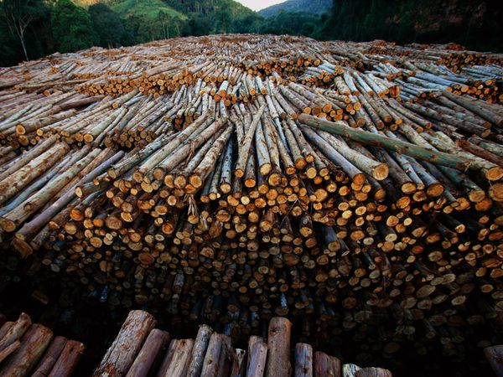
ESS Analysis of Brazilian Deforestation
Cycle A – Biosphere Group

Problem Statement:
The Amazon rainforest is considered the “lungs” of planet earth. This forest system breathes in vast quantities of carbon dioxide, storing it in its trees, plants, and upper 1 m of soil. It plays a major role in the stabilization of the Earth’s climate. However, since the 1940’s, Brazil has experienced accelerated rates of deforestation in order to meet local, national, and global economic needs. It is noted as the highest area of deforestation in the world with a total loss of 600,000 km² of rainforest since 1970. There are three main contributing factors to deforestation: agricultural expansion, wood extraction and infrastructure expansion.
Rainforests are second to the ocean for absorbing human-induced carbon dioxide. How will Brazilian deforestation affect this carbon sink and ultimately affect climate change?

Event to Sphere Interactions:
E>B: Brazilian deforestation will lead to a major loss of tree and plant species. There are thousands of species of plants and animals that have been identified in the Brazilian rainforest and there are still thousands yet to be identified. Many of the species are endemic to the rainforest and will become vulnerable to extinction as they loose their habitat. This will have a domino effect on the remaining biota. Also with loss of biodiversity will come loss of genetic diversity.

E>B: Deforestation will greatly diminish soil quality. Rainforest soils are very thin and poor in nutrients. Farmers typically engage in “slash and burn” practices to create a fertilizing layer of ash. Nutrients in the soil are quickly lost by erosion or consumed by the crops. Farmers unfortunately discover that soil fertility only last a few years.

E>B: Deforestation of the Brazilian rainforest also has many societal impacts. Indigenous tribes are loosing their homes and way of life. There is constant threat of armed conflict over logging, ranching, and farming rights.

E>B: Brazilian deforestation will release large quantities of carbon dioxide to the atmosphere, thus accelerating or amplifying climate change both locally and globally. Trees and plants are vital to stabilization of the climate. Also, the vegetation removes carbon dioxide from the atmosphere by storing it in the leaves, wood, roots and soils of the plants. Deforestation removes these plants, leaving more carbon dioxide in the atmosphere.

Sphere to Event Interactions:
B>E: Deforestation itself can lead to more deforestation as animals and people migrate to other locations as land and habitat is lost. Once relocated, the cycle begins where the land is cleared for farming, the soil quickly looses is nutrient load, and people move on to yet another location.

Sources:
- Tropical Deforestation, NASA Earth Observatory

- Human Impact: Deforestation and Desertification - http://environment.nationalgeographic.com/environment/habitats/rio-rain-forest/#page=2

- Tropical Deforestation and Climate Change - http://www.edf.org/documents/4930_TropicalDeforestation_and_ClimateChange.pdf

- Deforestation in the Amazon, Rhett A Butler, Mongabay.com.

- ScienceDaily 11 May 2007. 18 March 2010 <http://www.sciencedaily.com /releases/2007/05/070511100918.htm>.

- Pilot Analysis of Global Ecosystems: Forest Ecosystems http://pdf.wri.org/page_forests.pdf

