Wilkes University
Center for Environmental Quality
Environmental Engineering and
Earth Sciences

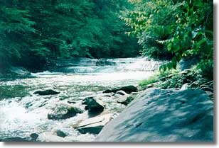

Why Temperature Is Important
Temperature is a critical water quality and environmental parameter because it governs the kinds and types of aquatic life, regulates the maximum dissolved oxygen concentration of the water, and influences the rate of chemical and biological reactions. The organisms within the ecosystem have preferred temperature regimes that change as a function of season, organism age or life stage, and other environmental factors. With respect to chemical and biological reactions, the higher the water temperature the higher the rate of chemical and metabolic reactions.
Seasonal variations in stream temperature may be caused by changing air temperature, solar angle, meteorological events, and a number of physical aspects related to the stream and watershed. These physical features include stream origin, velocity, vegetation types and coverage, stream configuration, land-use, and percentage of impervious area. For example, a narrow, deep well-shaded shoreline reduces the impact of warming by the sun; whereas, a wide shallow stream would be more impacted by solar heating.
In a warm water streams, the temperatures should not exceed 89 degrees Fahrenheit). Cold water streams should not exceed 68 degrees (Fahrenheit). Often summer heat can cause fish kills in ponds because high temperatures reduce available oxygen in the water.

Temperature (Water Quality Index Calculator)
Based On Temperature Change from a Reference Site
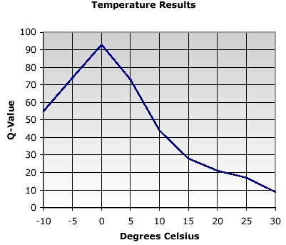
Source of Image: http://www.nsf.org/consumer/just_for_kids/wqi.asp
Great Site !
- At the control site place the thermometer about 0.5 inches from the bottom or a few inches below the water surface. Keep the thermometer in the water until a constant reading is attained (approximately two minutes). These try to collect temperature in a portion of the stream that is shaded.
- Record your measurement in Celsius. (To convert from Fahrenheit to Celsius, subtract 32 and multiply by 5/9.)
- Repeat the test temperature at your test site. Subtract the upstream temperature from the reference site from the temperature downstream and record the result as temperature change (C). Try to collect temperature data under similar conditions and using the same thermometer- thermometer should be readable to 0.1 C.
- Input the Temperature Change in to the Javascript Calculator or interpret from the graph.

Temperature change: (C)

Water quality index:

Source of Java Calculator: http://www.fivecreeks.org/monitor/tc.html
Return to Water Quality Index Page
For More information about the Environmental Quality Center, please contact:
Attn: Mr. Brian Oram, Professional Geologist (PG)
Laboratory Director
Wilkes University
Environmental Engineering and Earth Science Department
PO Box 111
84 West South Street
Wilkes-Barre, PA 18766
Home | Technology Outreach Program | Drinking Water Help Guides | Contact Us
Available Test Parameters
Research Interests, Funded Research and Applied Research
Homeowner Information Water Testing
Environmental Topics - Infiltration, Soils,
Wellhead Protection, Groundwater, Watersheds
PowerPoint Presentations
Watershed Monitoring, Research, Training,
Lake and Watershed Studies, Volunteer Monitoring Programs
The Water Library - Pdf files on Water Issues and Topics
Tools for Undergraduate Students
Field Training and Workshops in Earth Science
Affiliations and Hot Links
| Search Our Site|

Website Design by:
Web Design Pros.Net

