Instructional Design

Rationale

In the field of English as a second language education, resources for programming are certainly not unlimited. Often times, schools and other education programs have little funding to put toward ESL programs. This curriculum design addresses the need for high-quality ESL curriculum that can be used for low-resourced schools/learners/programs/etc. This means that most materials required for the course are accessible to anyone for free, and that overall the course uses little to no special technology such as textbooks, workbooks, computers, or projectors.
In order to have a successful curriculum in an ESL classroom, a carefully planned out instructional design must also be included. The following instructional design utilized project- and problem-based lesson plans in order to effectively work in an ESL classroom.
Project- and problem-based lesson plans are effective in a communicative classroom because they allow for flexibility, which is important in a language classroom. Though the lessons have a tendency to exemplify ambiguity, the “considerable fluidity in the daily activities” (Chiarelott, 2006) is a necessary element in a language class that aims to help students gain the necessary communicative skills to function in an English-speaking society.
Central to the purpose of communicative language teaching, language should be meaningful to the students studying the language (Brown, 2007). With project- and problem-based designs, “projects and problems can address either social issues or personal issues relevant to that individual’s life” (Chiarelott, 2006). Using problems or issues in the lives of the students is a very sensible way to design instructional materials for a community ESL classroom because they will be more likely to care about the material since it directly relates to their lives.

References

Brown, H. (2007). Teaching by principles: An integrative approach to language pedagogy. White Plains, NY: Pearson Education.
Chiarelott, L. (2006) Curriculum in context: Designing curriculum and instruction for teaching and learning in context. Belmont, CA: Thomson Wadsworth.

Schedules Subunit Learner Outcomes

- Knowledge
  - Students will use authentic materials, such as props or bus schedules to read examples of different schedules.
  - Students will learn vocabulary that they would see in a coffee shop
  - Student will learn vocabulary related to sports
- Comprehension/Application
  - Students will learn about and discuss activities that they would like to add to their daily schedules.
  - Students will practice fluent speech
  - Students will gain functional skills that are important while living in English-speaking countries
  - Students will be prepared for end of the unit field trip to Starbucks

- Synthesis
  - Students will describe to each other their daily schedules using common “schedule” expressions.
  - Students will learn how to ask what time is it and answer correctly when asked questions about the time
  - Students will learn the appropriate times to use certain frequency adverbs

- Evaluation
  - Students will write a copy of their daily schedule in paragraph form and in bulleted list form.
Pre-Assessment

Like most community English classes, the chances that a wide variety of skills levels being in one class is very likely. Therefore, a pre-assessment is necessary in order to group the students within the class by proficiency level.
This pre-assessment task is a communicative activity rather than a paper and pen test. All students should be seated at desks or tables where they have flat space to work on. Each student has blank paper and art supplies to draw with. Everyone in the class (including the teacher) is then instructed to draw a picture of something they like to do in the summer. Allow five to ten minutes for students and teachers to draw their pictures (it is a good idea for the teacher to draw his or her picture in front of the class incase some students need a model to start from). After all drawings are completed, students take turns describing their picture and explaining as much information about the picture as they can. The teacher listens carefully during this oral evaluation. Using the American Council on the Teaching of Foreign Languages Guidelines (ACTFL), the teacher evaluates the proficiency levels of the students and adjusts lesson plans for the unit accordingly. Most adjustments deal with level of vocabulary and grammatical forms, which can be easily adjusted. See the ACTFL Proficiency Speaking Guidelines below.

SUPERIOR
Speakers at the Superior level are able to communicate in the language with accuracy and fluency in order to participate fully and effectively in conversations on a variety of topics in formal and informal settings from both concrete and abstract perspectives. They discuss their interests and special fields of competence, explain complex matters in detail, and provide lengthy and coherent narrations, all with ease, fluency, and accuracy. They explain their opinions on a number of topics of importance to them, such as social and political issues, and provide structured argument to support their opinions. They are able to construct and develop hypotheses to explore alternative possibilities. When appropriate, they use extended discourse without unnaturally lengthy hesitation to make their point, even when engaged in abstract elaborations. Such discourse, while coherent, may still be influenced by the Superior speakers own language patterns, rather than those of the target language.

Superior speakers command a variety of interactive and discourse strategies, such as turn-taking and separating main ideas from supporting information through the use of syntactic and lexical devices, as well as intonational features such as pitch, stress and tone. They demonstrate virtually no pattern of error in the use of basic structures. However, they may make sporadic errors, particularly in low-frequency structures and in some complex high-frequency structures more common to formal speech and writing. Such errors, if they do occur, do not distract the native interlocutor or interfere with communication.

ADVANCED HIGH
Speakers at the Advanced-High level perform all Advanced-level tasks with linguistic ease, confidence and competence. They are able to consistently explain in detail and narrate fully and accurately in all time frames. In addition, Advanced-High speakers handle the tasks pertaining to the Superior level but cannot sustain performance at that level across a variety of topics. They can provide a structured argument to support their opinions, and they may construct hypotheses, but patterns of error appear. They can discuss some topics abstractly, especially those relating to their particular interests and special fields of expertise, but in general, they are more comfortable discussing a variety of topics concretely.

Advanced-High speakers may demonstrate a well-developed ability to compensate for an imperfect grasp of some forms or for limitations in vocabulary by the confident use of communicative strategies, such as paraphrasing, circumlocution, and illustration. They use precise vocabulary and intonation to express meaning and often show great fluency and ease of speech. However, when called on to perform the complex tasks associated with the Superior level over a variety of topics, their language will at times break down or prove inadequate, or they may avoid the task altogether, for example, by resorting to simplification through the use of description or narration in place of argument or hypothesis.

ADVANCED MID
Speakers at the Advanced-Mid level are able to handle with ease and confidence a large number of communicative tasks. They participate actively in most informal and some formal exchanges on a variety of concrete topics relating to work, school, home, and leisure activities, as well as to events of current, public, and personal interest or individual relevance.

Advanced-Mid speakers demonstrate the ability to narrate and describe in all major time frames (past, present, and future) by providing a full account, with good control of aspect, as they adapt flexibly to the demands of the conversation. Narration and description tend to be combined and interwoven to relate relevant and supporting facts in connected, paragraph-length discourse.

Advanced-Mid speakers can handle successfully and with relative ease the linguistic challenges presented by a complication or unexpected turn of events that occurs within the context of a routine situation or communicative task with which they are otherwise familiar.

Communicative strategies such as circumlocution or rephrasing are often employed for this purpose. The speech of Advanced-Mid speakers performing Advanced-level tasks is marked by substantial flow. Their vocabulary is fairly extensive although primarily generic in nature, except in the case of a particular area of specialization or interest. Dominant language discourse structures tend to recede, although discourse may still reflect the oral paragraph structure of their own language rather than that of the target language.

Advanced-Mid speakers contribute to conversations on a variety of familiar topics, dealt with concretely, with much accuracy, clarity and precision, and they convey their intended message without misrepresentation or confusion. They are readily understood by native speakers unaccustomed to dealing with non-natives. When called on to perform functions or handle topics associated with the Superior level, the quality and/or quantity of their speech will generally decline. Advanced-Mid speakers are often able to state an opinion or cite conditions; however, they lack the ability to consistently provide a structured argument in extended discourse. Advanced-Mid speakers may use a number of delaying strategies, resort to narration, description, explanation or anecdote, or simply attempt to avoid the linguistic demands of Superior-level tasks.

ADVANCED LOW
Speakers at the Advanced-Low level are able to handle a variety of communicative tasks, although somewhat haltingly at times. They participate actively in most informal and a limited number of formal conversations on activities related to school, home, and leisure activities and, to a lesser degree, those related to events of work, current, public, and personal interest or individual relevance.

Advanced-Low speakers demonstrate the ability to narrate and describe in all major time frames (past, present and future) in paragraph length discourse, but control of aspect may be lacking at times. They can handle appropriately the linguistic challenges presented by a complication or unexpected turn of events that occurs within the context of a routine situation or communicative task with which they are otherwise familiar, though at times their discourse may be minimal for the level and strained. Communicative strategies such as rephrasing and circumlocution may be employed in such instances. In their narrations and descriptions, they combine and link sentences into connected discourse of paragraph length. When pressed for a fuller account, they tend to grope and rely on minimal discourse. Their utterances are typically not longer than a single paragraph. Structure of the dominant language is still evident in the use of false cognates, literal translations, or the oral paragraph structure of the speaker's own language rather than that of the target language.

While the language of Advanced-Low speakers may be marked by substantial, albeit irregular flow, it is typically somewhat strained and tentative, with noticeable self-correction and a certain grammatical roughness. The vocabulary of Advanced-Low speakers is primarily generic in nature.

Advanced-Low speakers contribute to the conversation with sufficient accuracy, clarity, and precision to convey their intended message without misrepresentation or confusion, and it can be understood by native speakers unaccustomed to dealing with non-natives, even though this may be achieved through repetition and restatement. When attempting to perform functions or handle topics associated with the Superior level, the linguistic quality and quantity of their speech will deteriorate significantly.

INTERMEDIATE HIGH
Intermediate-High speakers are able to converse with ease and confidence when dealing with most routine tasks and social situations of the Intermediate level. They are able to handle successfully many uncomplicated tasks and social situations requiring an exchange of basic information related to work, school, recreation, particular interests and areas of competence, though hesitation and errors may be evident.

Intermediate-High speakers handle the tasks pertaining to the Advanced level, but they are unable to sustain performance at that level over a variety of topics. With some consistency, speakers at the Intermediate High level narrate and describe in major time frames using connected discourse of paragraph length. However, their performance of these Advanced-level tasks will exhibit one or more features of breakdown, such as the failure to maintain the narration or description semantically or syntactically in the appropriate major time frame, the disintegration of connected discourse, the misuse of cohesive devises, a reduction in breadth and appropriateness of vocabulary, the failure to successfully circumlocute, or a significant amount of hesitation.

Intermediate-High speakers can generally be understood by native speakers unaccustomed to dealing with non-natives, although the dominant language is still evident (e.g. use of code-switching, false cognates, literal translations, etc.), and gaps in
communication may occur.

INTERMEDIATE MID
Speakers at the Intermediate-Mid level are able to handle successfully a variety of uncomplicated communicative tasks in straightforward social situations. Conversation is generally limited to those predictable and concrete exchanges necessary for survival in the target culture; these include personal information covering self, family, home, daily activities, interests and personal preferences, as well as physical and social needs, such as food, shopping, travel and lodging.

Intermediate-Mid speakers tend to function reactively, for example, by responding to direct questions or requests for information. However, they are capable of asking a variety of questions when necessary to obtain simple information to satisfy basic needs, such as directions, prices and services. When called on to perform functions or handle topics at the Advanced level, they provide some information but have difficulty linking ideas, manipulating time and aspect, and using communicative strategies, such as circumlocution.

Intermediate-Mid speakers are able to express personal meaning by creating with the language, in part by combining and recombining known elements and conversational input to make utterances of sentence length and some strings of sentences. Their speech may contain pauses, reformulations and self-corrections as they search for adequate vocabulary and appropriate language forms to express themselves. Because of inaccuracies in their vocabulary and/or pronunciation and/or grammar and/or syntax, misunderstandings can occur, but Intermediate-Mid speakers are generally understood by sympathetic interlocutors accustomed to dealing with non-natives.

INTERMEDIATE LOW
Speakers at the Intermediate-Low level are able to handle successfully a limited number of uncomplicated communicative tasks by creating with the language in straightforward social situations. Conversation is restricted to some of the concrete exchanges and predictable topics necessary for survival in the target language culture. These topics relate to basic personal information covering, for example, self and family, some daily activities and personal preferences, as well as to some immediate needs, such as ordering food and making simple purchases. At the Intermediate-Low level, speakers are primarily reactive and struggle to answer direct questions or requests for information, but they are also able to ask a few appropriate questions.

Intermediate-Low speakers express personal meaning by combining and recombining into short statements what they know and what they hear from their interlocutors. Their utterances are often filled with hesitancy and inaccuracies as they search for appropriate linguistic forms and vocabulary while attempting to give form to the message. Their speech is characterized by frequent pauses, ineffective reformulations and self-corrections. Their pronunciation, vocabulary and syntax are strongly influenced by their first language but, in spite of frequent misunderstandings that require repetition or rephrasing, Intermediate-

Low speakers can generally be understood by sympathetic interlocutors, particularly by those accustomed to dealing with non-natives.

NOVICE HIGH
Speakers at the Novice-High level are able to handle a variety of tasks pertaining to the Intermediate level, but are unable to sustain performance at that level. They are able to manage successfully a number of uncomplicated communicative tasks in straightforward social situations. Conversation is restricted to a few of the predictable topics necessary for survival in the target language culture, such as basic personal information, basic objects and a limited number of activities, preferences and immediate needs. Novice-High speakers respond to simple, direct questions or requests for information; they are able to ask only a very few formulaic questions when asked to do so.

Novice-High speakers are able to express personal meaning by relying heavily on learned phrases or recombinations of these and what they hear from their interlocutor. Their utterances, which consist mostly of short and sometimes incomplete sentences in the present, may be hesitant or inaccurate. On the other hand, since these utterances are frequently only expansions of learned material and stock phrases, they may sometimes appear surprisingly fluent and accurate. These speakers= first language may strongly influence their pronunciation, as well as their vocabulary and syntax when they attempt to personalize their utterances. Frequent misunderstandings may arise but, with repetition or rephrasing, Novice-High speakers can generally be understood by sympathetic interlocutors used to non-natives. When called on to handle simply a variety of topics and perform functions pertaining to the Intermediate level, a Novice-High speaker can sometimes respond in intelligible sentences, but will not be able to sustain sentence level discourse.

NOVICE MID
Speakers at the Novice-Mid level communicate minimally and with difficulty by using a number of isolated words and memorized phrases limited by the particular context in which the language has been learned. When responding to direct questions, they may utter only two or three words at a time or an occasional stock answer. They pause frequently as they search for simple vocabulary or attempt to recycle their own and their interlocutor=s words. Because of hesitations, lack of vocabulary, inaccuracy, or failure to respond appropriately, Novice-Mid speakers may be understood with great difficulty even by sympathetic interlocutors accustomed to dealing with non-natives. When called on to handle topics by performing functions associated with the Intermediate level, they frequently resort to repetition, words from their native language, or silence.

NOVICE LOW
Speakers at the Novice-Low level have no real functional ability and, because of their pronunciation, they may be unintelligible. Given adequate time and familiar cues, they may be able to exchange greetings, give their identity, and name a number of familiar objects from their immediate environment. They are unable to perform functions or handle topics pertaining to the Intermediate level, and cannot therefore participate in a true conversational exchange.

American Council on the Teaching of Foreign Languages. (1999). ACTFL proficiency guidelines speaking 1999. Retrieved from http://www.actfl.org/files/public/Guidelinesspeak.pdf

Lesson Plans

Lesson Plan 1—Telling Time

Background Information:  Course/ level: Novice, Family English Class  Description of students: Intermediate-low  Goals: To have students be able to know how to tell the time and use language to get information about time to incorporate into their daily scheduels.  Objectives:  Terminal  - Students will learn how to ask what time is it and answer correctly when asked questions about the time  Enabling  - Students will practice fluent speech  - Students will gain functional skills that are important while living in English-speaking countries  Materials: Clock handout, Event handout  Skills focus/ grammar/ vocabulary: listening and speaking  New vocabulary: watch, “quarter after…”, “quarter till…”, exhibit, event  Previous class work: Grammar lesson about when to use –ing and when to use the infinitive form of the verb  Materials: Listening CD, textbook  Work to be collected: N/A |  | To do before class:  -make photocopies of handouts  Bring to class:  -Extra photocopies of handouts  -Chart for final activity  -flashcards
Timeframe:  (in minutes) | Procedures: | Notes:  Seating plans: Ss sit in desks of first row  Transitions:  Contingencies: If Ss do not formulate many answers from Step 2 during previous lesson, this first activity will be much shorter and less interesting. T will prepare extra sentences just incase there are not enough statements
5 | T informs students about class topic of time. Asks Ss questions as an introduction to class.  - What do we use to tell time? (clock, watch, cell phone)  - Do you use a watch?  - Do you use a cell phone?
5 | T brings Ss’ attention a.m. and p.m. T asks Ss questions about what they do and what time during the day using the time plus a.m. or p.m.  - What time do you eat dinner?  - What time do you eat breakfast?  - What time do you go to bed?  - What time do you wake up?
10 | T writes “two-fifteen” and “a quarter after two” on board. T asks Ss which one is more common by a show of hands. T asks Ss to explain their answers.  T explains that times that are 15 minutes before the hour or after the hour are often expressed using “a quarter after” or “a quarter till”.  Give Ss clock handout (from http://www.teachnet-lab.org/miami/2004/garcia2/images/Analog%20clock.JPG) and tell Ss to draw times on all of the clocks. This is done individually. T then pairs off Ss and tells them to take turns saying the different times on the clocks from handout. One S asks “what time is it?” and the other responds with “it’s quarter after two” or “ it’s two-fifteen”.  After students interview each other, T asks Ss if they can think of other ways to ask, “what time is it?” (Do you have the time? Do you know what time it is? Have you got the time?)
10 | Next activity T writes on chalkboard, “club, movie theater and zoo” all in different columns. T asks if students understand what all of these events are. T then asks what information the Ss would need to know before going to one of these events (time, place, ticket price). T then asks where the Ss could find this information (Internet, newspaper, radio, TV commercial, flier, poster, friends). Then T asks Ss how often they go to these types of events. What are other events that they might go to? Art exhibit, soccer match, concert, etc.
15 | T gives Ss event handout. In pairs, Ss fill in chart with their own information. Each pair must think of four different events and fill in the names of these events on the blank chart that I provide. They must also decide details about the event such as what time the event starts, where the event is, or how much the event costs. Each pair writes down these details. Then each pair will take turns reading their information out loud to the other pair. The pair that is listening must fill in the details that they hear about each event. Then the pairs switch roles as listener and speaker.  Extra activity: Around the World card game with different times as they would appear on a digital clock. The student who says the time that he or she sees on the card first and correctly moves on to face the next competitor in the class. Student moves “around the world” by moving from desk to desk.

Comments/ Evaluation:
Plan before the lesson:
- I will assess their progress through their ability to use the different ways to tell and ask about the time while talking about their daily schedules

Clock Handout (from http://www.teachnetlab.org/miami/2004/garcia2/images/Analog%20clock.JPG)

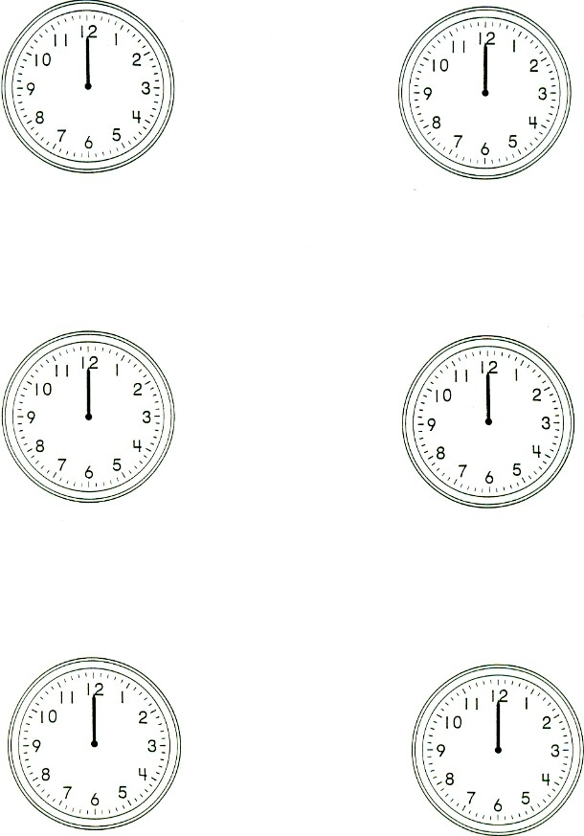
Event Handout

Event ______________________ ______________________

1. _____________ ______________________ ______________________
2. _____________ ______________________ ______________________
3. _____________ ______________________ ______________________
4. _____________ ______________________ ______________________

Event ______________________ ______________________

1. _____________ ______________________ ______________________
2. _____________ ______________________ ______________________
3. _____________ ______________________ ______________________
4. _____________ ______________________ ______________________

Event ______________________ ______________________

1. _____________ ______________________ ______________________
2. _____________ ______________________ ______________________
3. _____________ ______________________ ______________________
4. _____________ ______________________ ______________________

Lesson Plan 2—At the Coffee Shop

Background Information:  Course/ level: Novice, Family English Class  Description of students: Novice-high  Goals: To have students be able to use vocabulary surrounding coffee shops  Objectives:  Terminal  -Students will learn vocabulary that they might see in a coffee shop  Enabling  -Students will be prepared for end of the unit field trip to Starbucks  Materials: crossword puzzle, props, pictures with notecards  Skills focus/ grammar/ vocabulary: new vocabulary  New vocabulary: coffee, coffee shop, decaf, small, medium, large, milk, sugar, cream, iced, latte, mocha, muffin, bagel, whipped cream  Previous class work: Lesson about telling time to use in daily schedules  Work to be collected: N/A |  | To do before class:  -print crossword  -print slides  -gather props  Bring to class:  -crossword worksheet  -slides  -vocab props  - To go coffee mug  - Small, medium and large coffee cups from coffee shop  - Milk carton  - Sugar packet  - Stirrer  - Chocolate  - Tea packet
Timeframe:  (in minutes) | Procedures: | Notes:  Seating plans:  Transitions: Use props during PPT show to reiterate what the different words mean  Contingencies: This vocabulary may be too easy. If it is, give Ss crossword earlier to challenge them.  I also hope that these Ss have had coffee before. Explaining caffeine and energy may be difficult if they have never had coffee before.
20 | If technology is available, present PPT to Ss to introduce vocabulary. If not, give Ss slide printouts .T encourages Ss to take notes on vocabulary  At the Coffee Shop  T shows starbucks slide. Who knows what this is?  Next slide-Does anyone know what this store sells?  Next- Coffee! Coffee is a drink. T takes coffee cup and pretends to sip from it.  T → Ss- does anyone here drink coffee? Today we are going to learn about coffee words  -Coffee drinks are different sizes. T shows different sized cups, S, M, L saying the words. Ss repeat. When T holds up different cups, Ss say what size it is.  T → Ss- people put different things in their coffee to change the taste. Some people put milk in their coffee. Hold up milk carton. T asks Ss if they like milk. If they like milk in their coffee?  T → Ss- Some people put sugar in their coffee. Hold up sugar packets. T asks Ss if they like sugar. If they like sugar in their coffee?  T → Ss- Some people put cream in their coffee. Hold up cream packets. T asks Ss if they like cream in their coffee?  T → Ss- Some people don’t like hot coffee so they put ice in their coffee. Point to ice picture. T asks Ss if they like ice in their coffee? Iced coffee.  T → Ss- Note that the heading says ON your coffee instead of IN your coffee. Some people like whipped cream on their coffee. Point to whipped cream. T asks Ss if they like whipped cream? In their coffee?  T → Ss- Tells Ss that there are different kinds of coffee and they taste different. There is decaf. Decaf does not give you energy. You can drink decaf before going to bed (going to sleep at night), but you can’t do that with regular coffee.  There is a latte. A latte is coffee with a lot of milk. Use PPT pictures and props to help illustrate this.  There is mocha. Mocha is coffee with chocolate. Use PPT pictures and props to help illustrate this.  Coffee shops also sell food. Does anyone know any foods that are sold at a coffee house?  There are bagels. Bagels are similar to bread. They are round and have a hole in the middle. Use pictures and props to illustrate bagels. Have you ever eaten a bagel? Have you ever eaten a bagel in a coffee shop?  There are muffins. Muffins are sweet and have many different flavors. Muffins are like a dessert. Use pictures and props to illustrate muffins. Have you ever eaten a muffin? Have you ever eaten a muffin in a coffee shop?
5 | T performs comprehension check using different props.  T holds up an item and Ss must say what it is. T may ask S if he or she likes to eat or drink this item or if he or she has had the item in a coffee shop before.
15 | T gives Ss crossword puzzle. Helps Ss complete first question in case not everyone has seen one before.  Ss finish crossword on own. T should circulate because this vocab is new and may be difficult to remember. However, T encourages Ss to reference their notes
10 | T reviews crossword answers with Ss. Answers any final qs.
 | Extra activity: Charades with notecards
Comments/ Evaluation:
- I will assess their progress through their ability to use the different types of coffee shop vocabulary

Crossword Puzzle (made from www.puzzle-maker.com/CW)

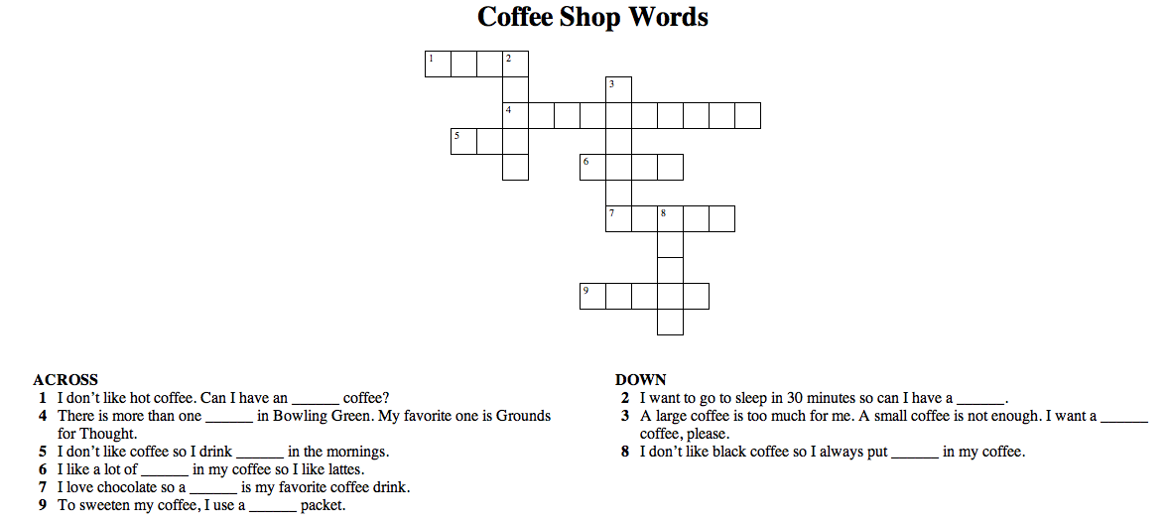

Coffee Shop Powerpoint Presentation
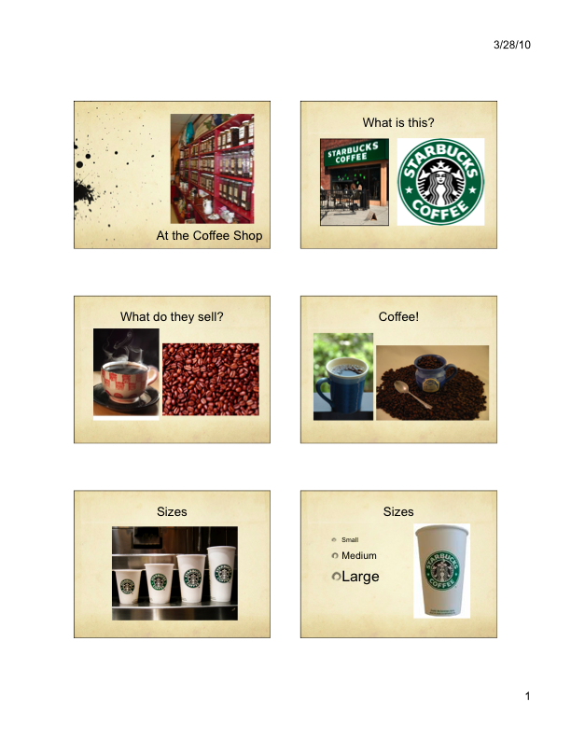

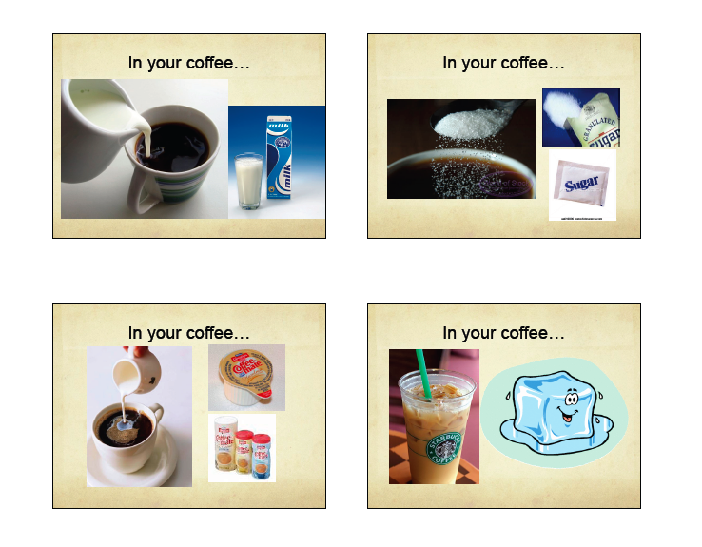

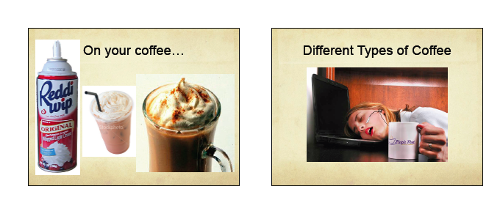
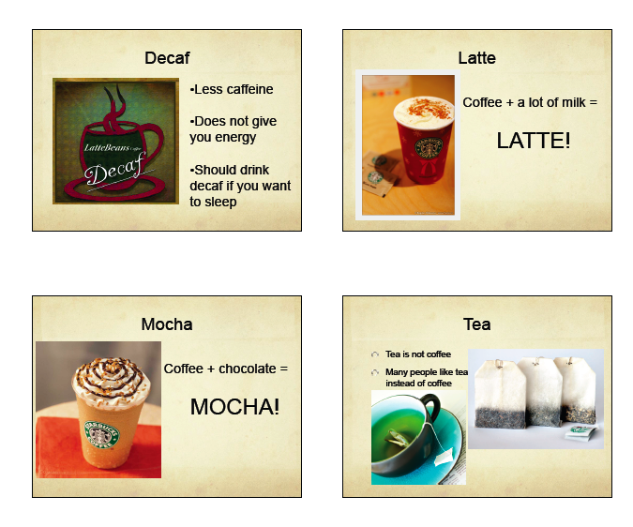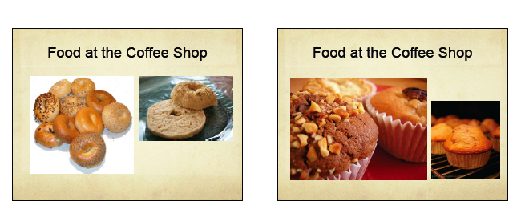

Lesson Plan 3—Frequency in Daily Schedules

Background Information:  Course/ level: Novice, English Family Class  Description of students: Intermediate-low  Goals: To have students know how to use frequency adverbs while discussing sports that they do/watch in their daily schedules  Objectives:  Terminal  -Students will learn the appropriate times to use certain frequency adverbs  -Students will learn vocabulary related to sports  Enabling  -Students will practice reading comprehension and fluent speech using frequency adverbs  Materials: Adverbs WS  Skills focus/ grammar/ vocabulary: reading comprehension, listening & speaking, grammar (frequency adverbs)  New vocabulary: frequency  Previous class work: Vocabulary that revolves around going to the coffee shop  Work to be collected: N/A |  | To do before class:  -Make copies of Adverb WS  Bring to class:  -Adverb WS
Timeframe:  (in minutes) | Procedures: | Notes:  Seating plans: Ss sit in desks of first row  Transitions: Use frequency adverbs to express how often Ss notice different types of advertising  Contingencies: If WS is too hard to do individually, Ss may work in pairs
10 | T writes lists of words on chalkboard.  - Never  - Sometimes  - Rarely  - Seldom  - Always  T draws a continuum on chalkboard with never on one side and always on the other. T gives examples of sentences with “never” and “always” (I always wear flip-flops during spring. I never come to class without a pen or pencil). Asks Ss to give example sentences of something that they always or never do. T asks Ss if they can place the remaining words on the continuum based on how often something is done.
18-20 | T gives Ss Adverb WS to practice using different frequency adverbs correctly. Ss complete WS individually and T reviews answers after.
5 | T writes the following words on chalkboard:  - Run  - Swim  - Bike  - Bowl  - Ski  - Windsurf  T tells Ss that these verbs often are used with “go + -ing” (ex. I go running). T calls on Ss to use the same structure for the other verbs.  T writes “I’m running right now” and “I go running twice a week”. T asks Ss which statement is referring to an action that is happening at this moment.
10 | T tells Ss to comment on sports that they play, don’t play, and watch on TV and how often they do these things. This is a pair activity.
Comments/ Evaluation:
- I will assess their progress through their ability to complete all activities using sports vocabulary and frequency adverbs.

Adverb Worksheet

How often…?

- Greg is an excellent student. He ___________ goes to class.
  - Always
  - Seldom
  - Rarely
  - Never

- I hate vegetables. I ___________ eat carrots.
  - Always
  - Sometimes
  - Usually
  - Never

- Adam goes to the gym only two or three times a year. He ___________ goes to the gym.
  - Never
  - Always
  - Usually
  - Seldom

- Julie never leaves the college on Friday. She ___________ eats at the cafeteria on Fridays.
  - Always
  - Never
  - Seldom
  - Sometimes

- Ms. Logar is always in a good mood. She is ____________ sad.
  - Always
  - Usually
  - Sometimes
  - Never

- Mikey is not a pleasant person. He is ___________ in a bad mood.
  - Never
  - Seldom
  - Always

- My brother usually drives to work with a friend. He ___________ drives alone.
  - Never
  - Usually
  - Always
  - Rarely

- I never lend money to Jess. She ___________ pays me back.
  - Always
  - Never
  - Usually
  - Sometimes

- Jake goes to the beach whenever he can. He ___________ misses a chance to go to the ocean.
  - Never
  - Always
  - Usually

- It almost always rains in Seattle. The sun ___________ shines there.
  - Always
  - Usually
  - Seldom

Post Assessment

As mentioned in the evaluation strategy, due to the nature of this course (most likely out of a public school PreK-12 setting), evaluation is a bit non-traditional. For example, while a common type of formative assessment would be to administer quizzes and tests to measure, assess, and evaluate students’ learning outcomes, this is not the case for this course. Because this course is focused on gaining communicative skills over academic skills, per se, there are no quizzes or tests for grades. Short-term and other forms of formative evaluation should be judged by the teacher by gauging the level of comprehension, completion, and understanding of the course subunits of the students in regards to the intended learner outcomes. During this course, the teacher needs to be very aware of the students’ comprehension of the content matter in order to have a successful class.
Summative assessment will evaluate the overall effectiveness of the course as it compares to other similar ESL courses with the same intention of teaching students English communicative skills they may need to function in an English-speaking country. In order to have an effective summative assessment, this course must be evaluated over a period of at least three to five years. Often times in community or family ESL classes, students return to take the class again because their past experiences in the class were both beneficial for learning language skills and an overall fun experience. A more short term form of summative assessment could be gauged by the number of returning students or the number of students who were referred to the class by a former student.

