JH Band/Building Performance skills
Instructional Design
**** Note: I have only included the conductors score for the exercises in this instructional design anyone who would like the individual parts please contact me at paul_s@treca.org and I will be happy to mail you a set.

Pre assessment
Pre assessment for this unit will take place at both the individual and group level and will assess the students knowledge and expertise of each skill. Various assessment ideas are included in this plan. These sub units are not aimed to last for the duration of the class period they are designed to be used in conjunction with daily rehearsal of other music. The concepts and skills learned through these sub units should be reinforced in the rehearsal of other music so students can associate the relevancy of the lessons.
Sub unit 1: Theory
Learning outcomes
- Students will identify note and rest values and demonstrate them on their various instruments (knowledge, application).
- Students will analyze rhythms and subdivide them by counts (analysis).
- Students will identify note names according to the staff of their instrument and demonstrate them on their instruments (identify, application)
- Students will recognize and explain the meaning of various key signatures (comprehension, analysis).
- Students will identify and demonstrate major scales (Concert B flat, E flat, A flat, F, & C) (knowledge, application).
- Students will identify and demonstrate a chromatic scale beginning on concert B flat (knowledge, application).
- Students will identify and demonstrate various intervals (Major 2nd, Major 3rd, etc..) (knowledge, application).

Lesson Plan 1
Introduction to unit and pre assessment of knowledge and skill level
Objectives:
- To assess the knowledge of basic theory of each of the students
- To realize the attitude of the students about learning theory
Materials: Pencils and copies of the pre assessment
Procedure:
- Open up a discussion on why the students like to play their instrument. This can be done in a full band situation or the band could be divided into groups. Each group could come up with answers to a few simple questions and then the groups could present their answers.
- Possible Questions:
  - Why do I like band
  - Why do I like to play my instrument
  - What is the difference between a great musician and an average musician
  - Is it important to understand what you are playing on your instrument
  - How important is individual skills to the quality of the full band
  - Do you feel that by understanding how music is constructed helps musicians enjoy performing music even more

- Explain to student what theory is and the importance of applying these skills and concepts while playing their instrument as an individual or with a group.
- To find out what everyone knows about music theory you are going fill out a short questionnaire so we will know where to start as a class. Pass out pre assessment
Summary/ Closure:
Explain to the students that for us to be a better band as a full group we need to be better individual musicians. The better we get as a band the more interesting music we will be able to play and the more fun you will have playing your instrument.
Evaluation:
Teacher will evaluate the pre-assessments and determine the level of understanding that students have in the various areas.

The following is a pre assessment for the first sub unit and then materials to be used in the first two weeks of class.
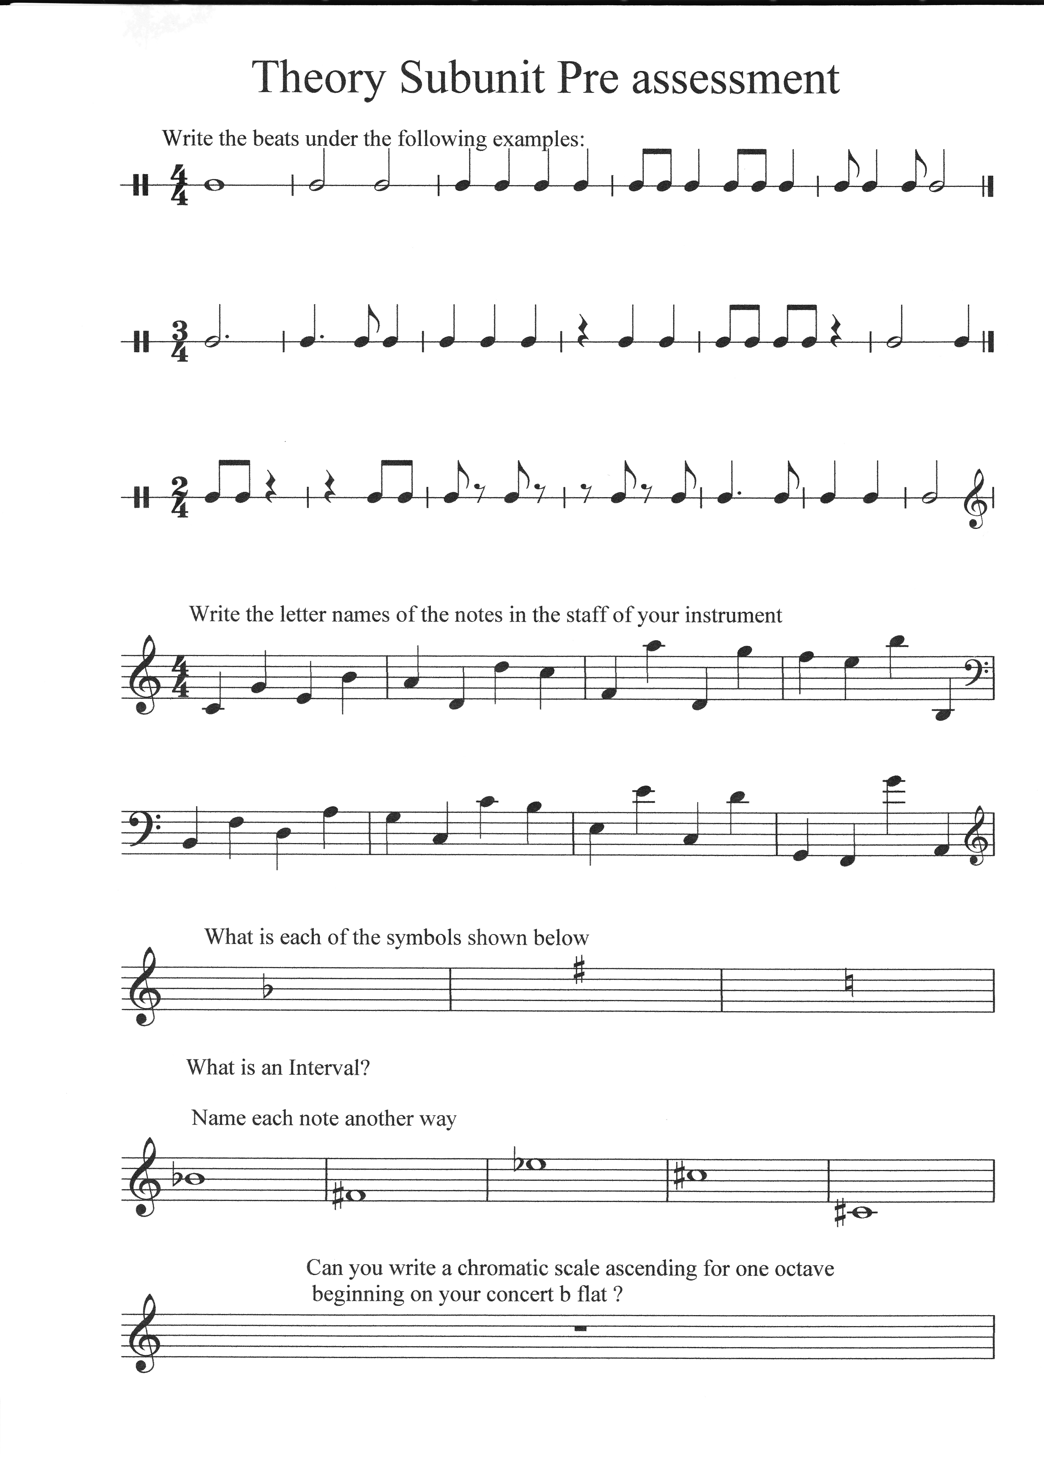
The following are worksheets to be used to strengthen note and rest values. They can be used at the beginning of daily rehearsal. Clapping and counting the Rhythm Studies is an effective way to reinforce the understanding of note length.
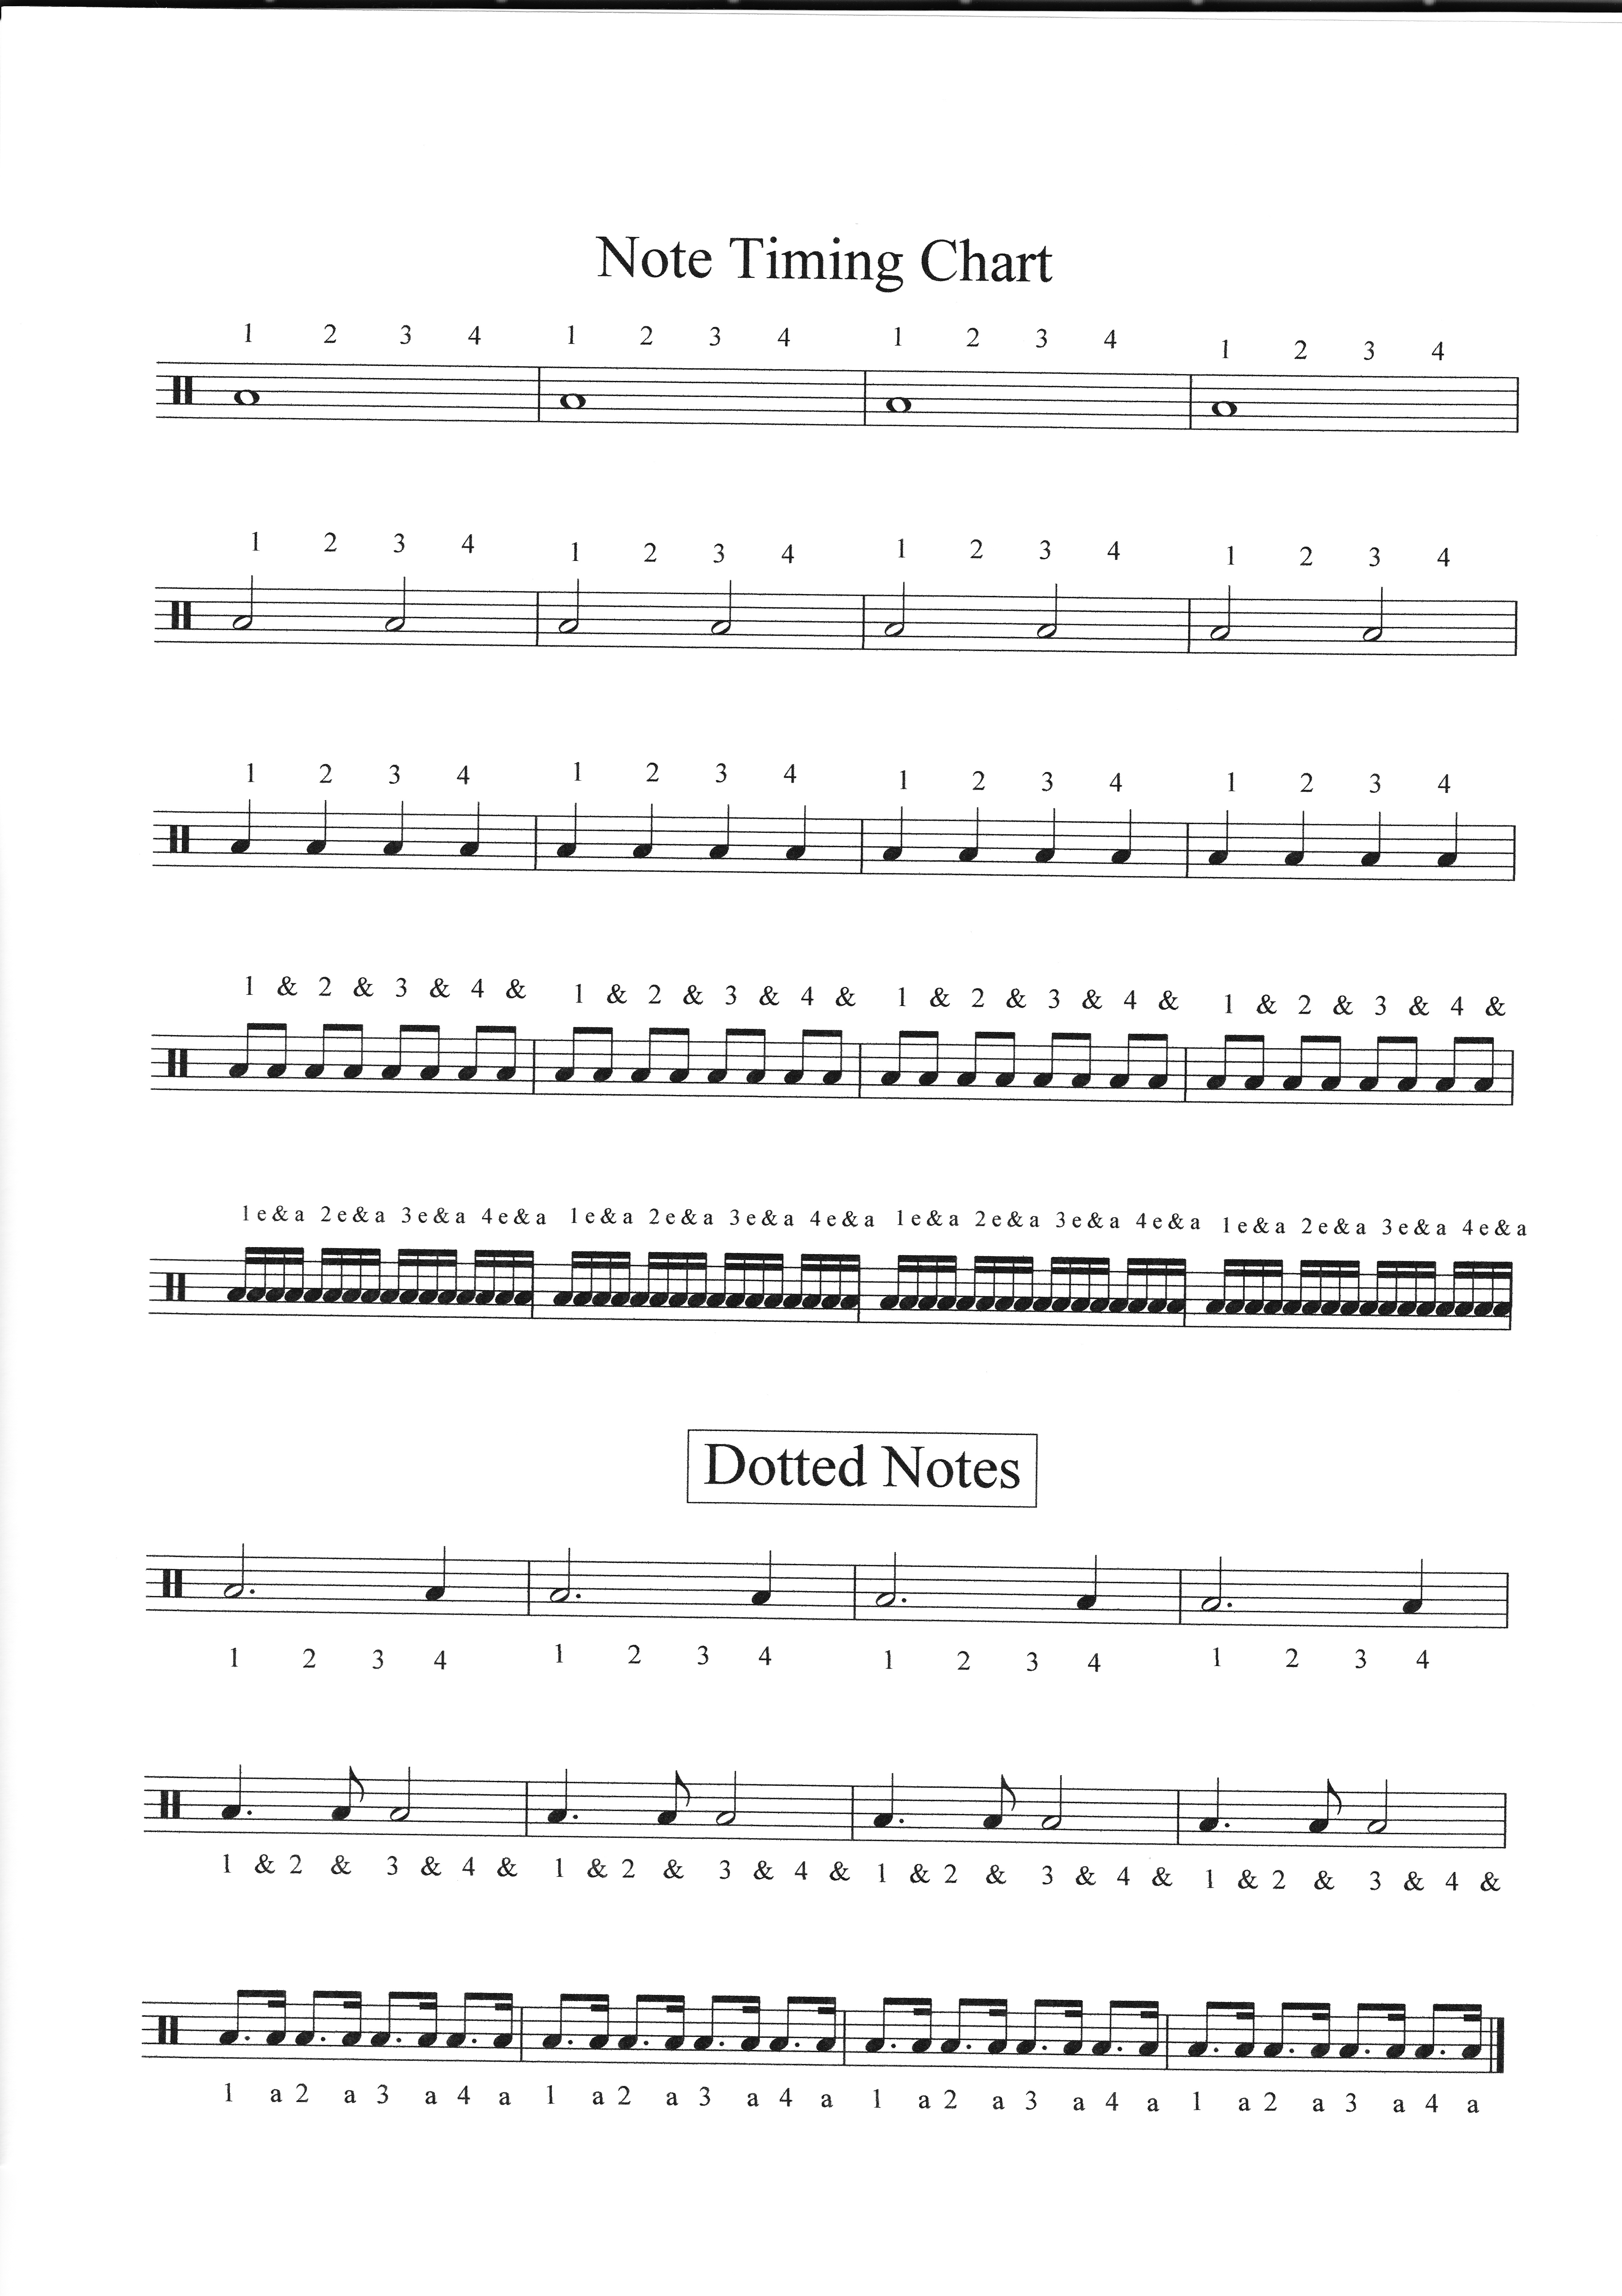
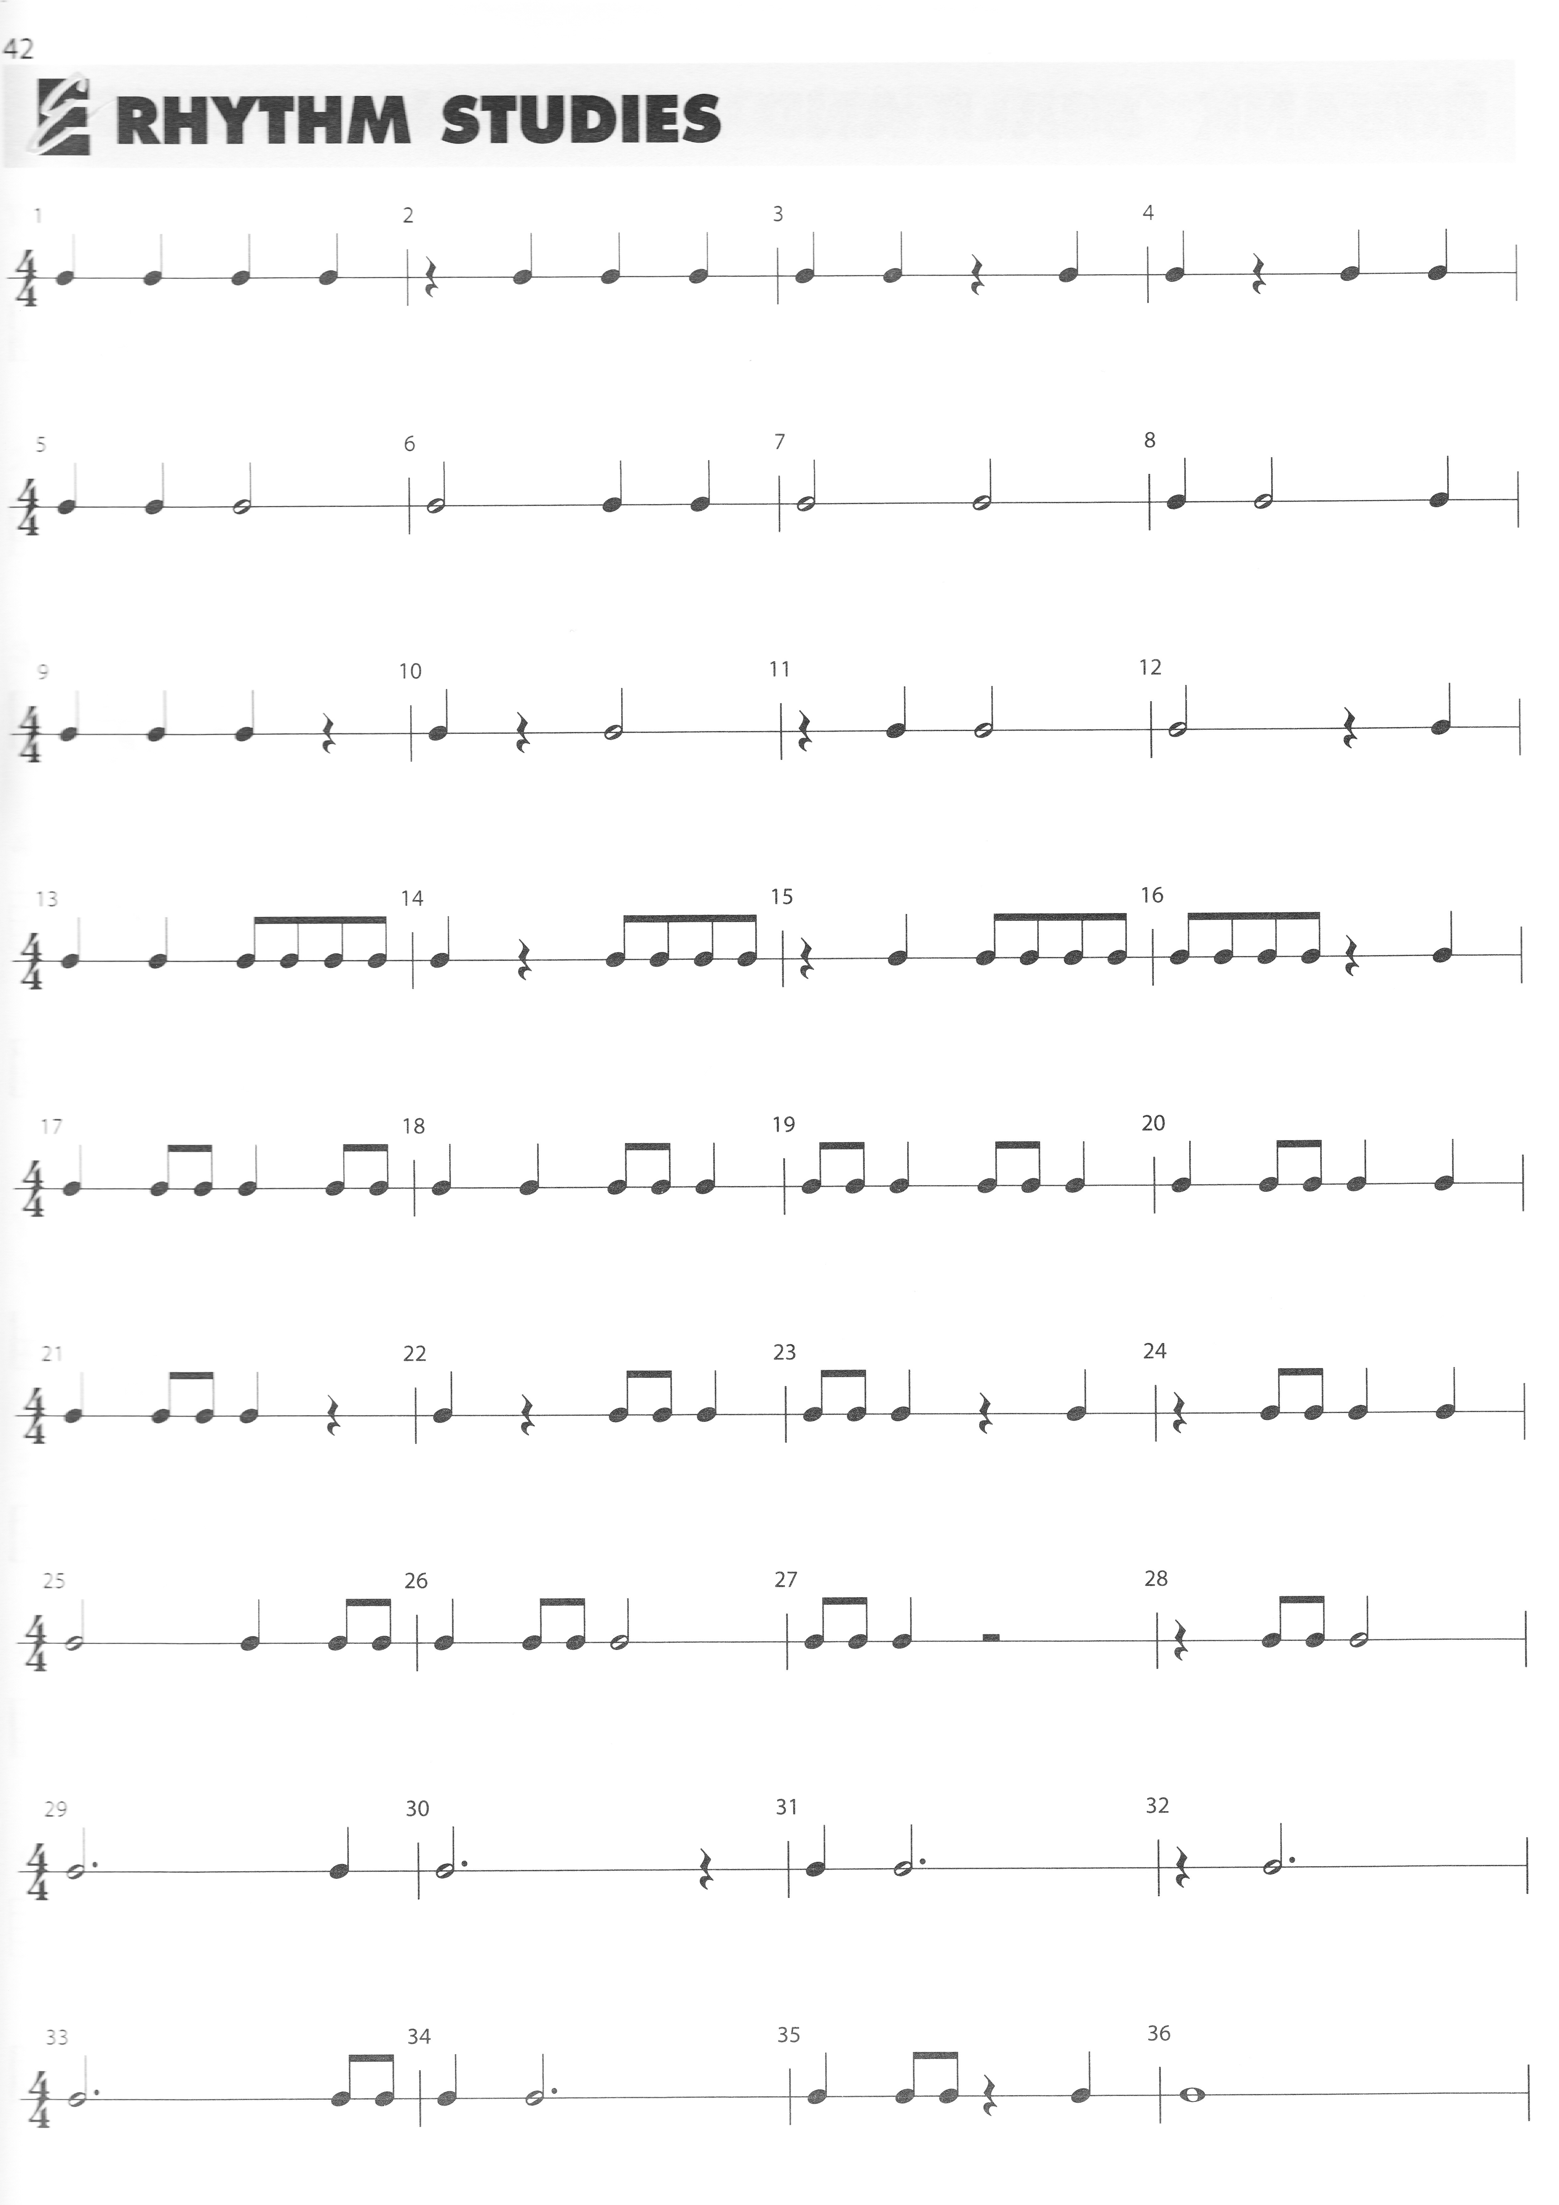
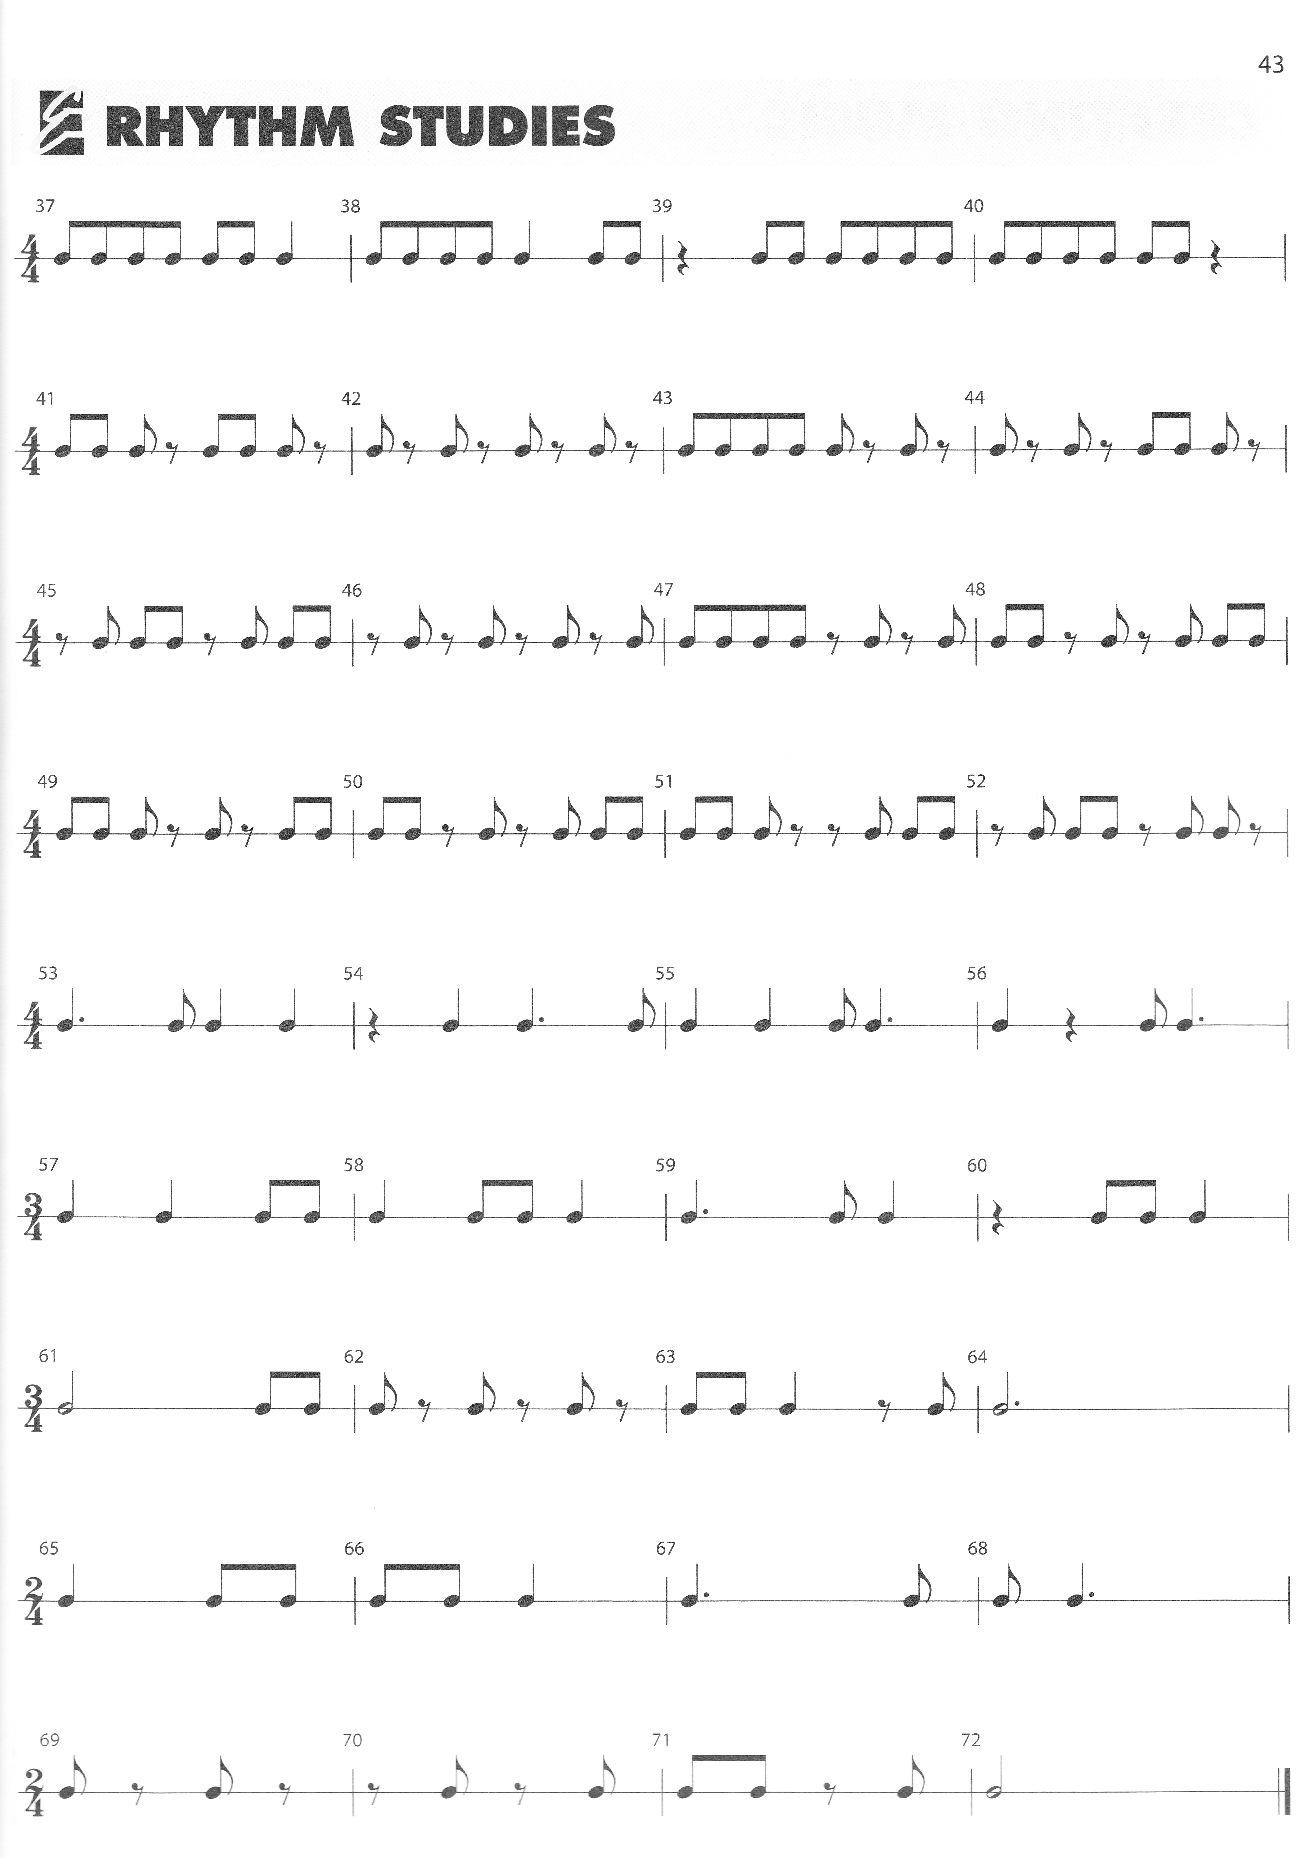

Note Names:
Most young musicians learn note names a few at a time using pneumonic devices such as for the lines of the treble clef-every, good, boy, does, fine and for the spaces f-a-c-e. As students get older some do not retain the names of the notes because they have began to associate fingerings on their instruments with to where the notes are on the staff. Using flash cards in small groups is a great way for students to reinforce the names of notes. This can be done in small groups
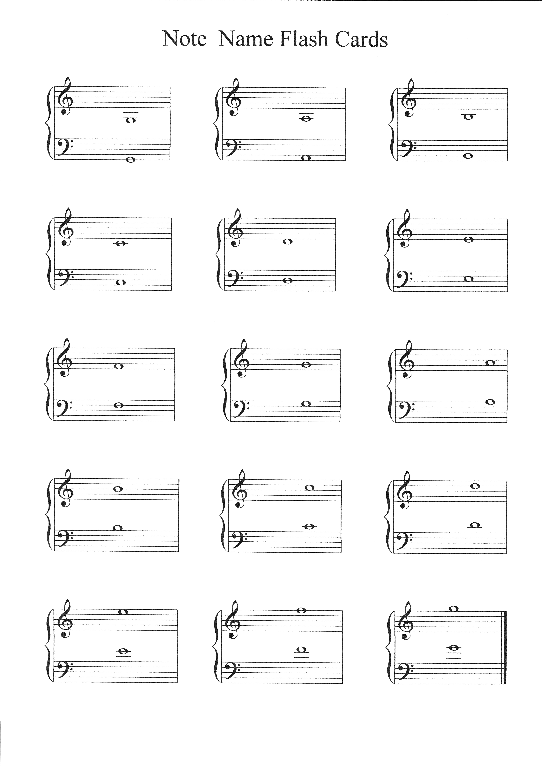

Below is a picture of a piano keyboard. It can be used to explain the difference between flats and sharps and how notes can have multiple names/enharmonic tones. Visual learners do much better when they can relate the notes to a piano keyboard.
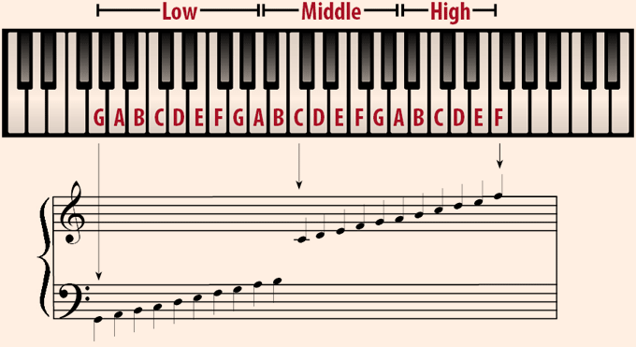

Scales are very important in developing many areas of musicianship a few of which are
- An understanding of the various keys that music is written in
- Teaches our fingers how to move in certain keys
- As we learn our scales, we learn how to play in keys that would otherwise be difficult to play. Having to remember the sharps and flats becomes much easier when your fingers "just know" how to play the scale of the key signature that you are in.
- Scales need to be practiced daily which doesn’t take much time after the students learn them.
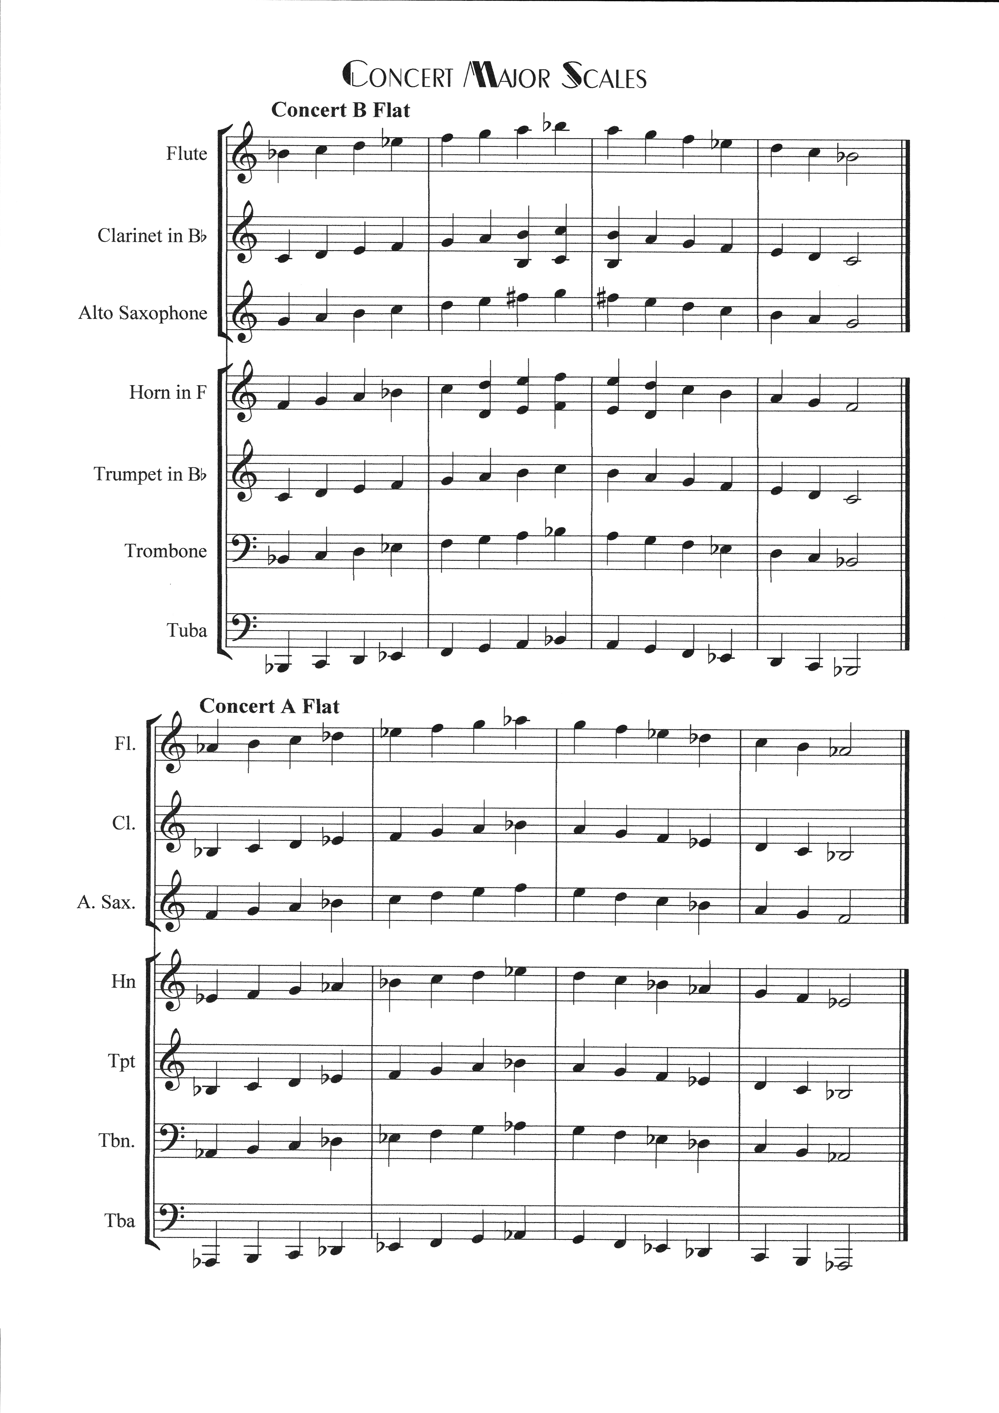
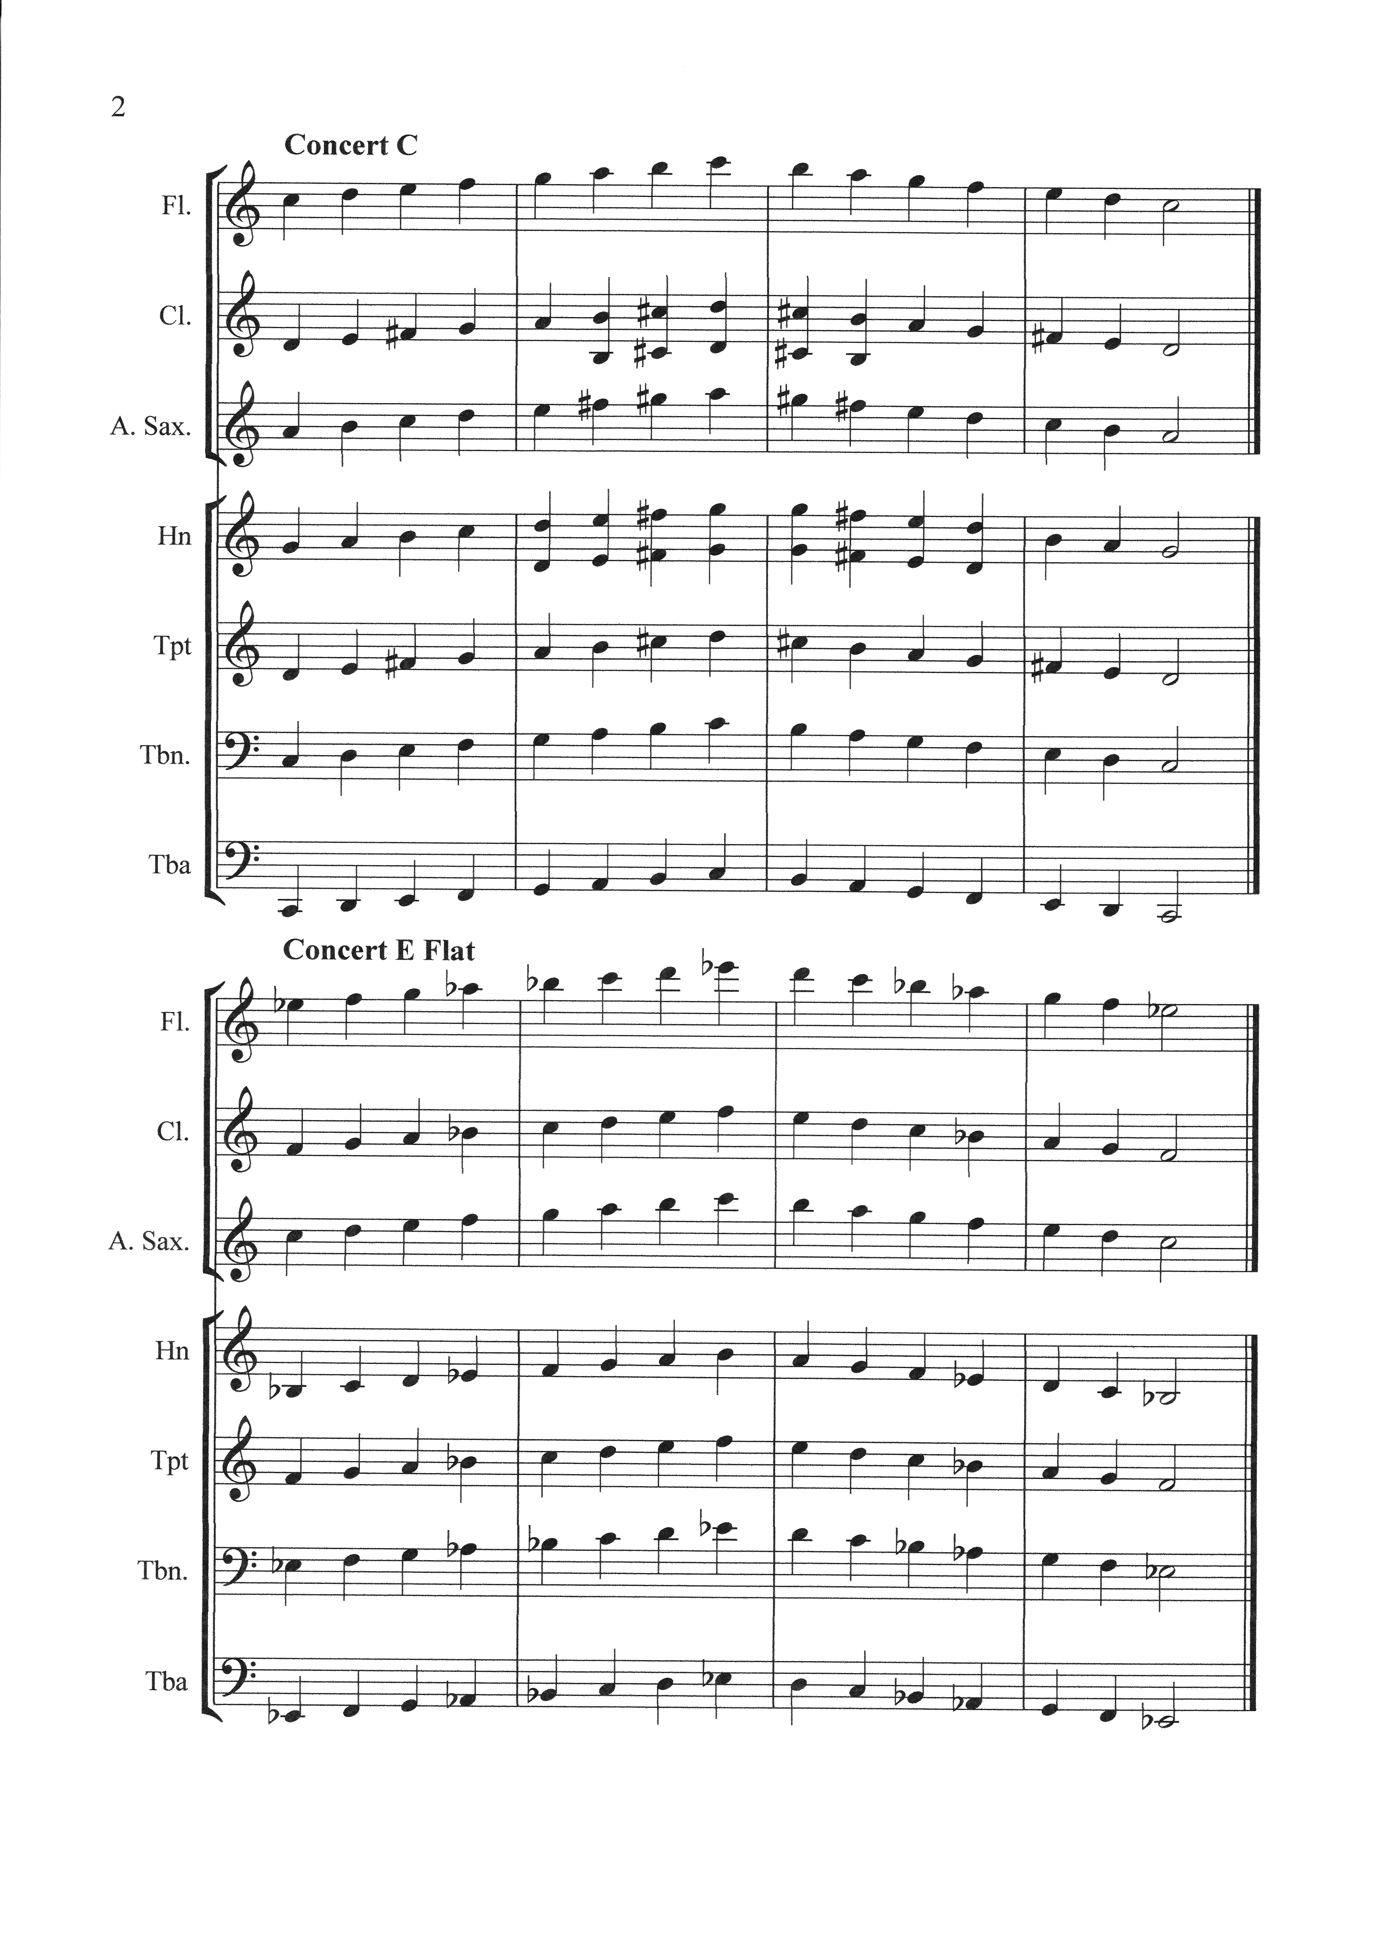
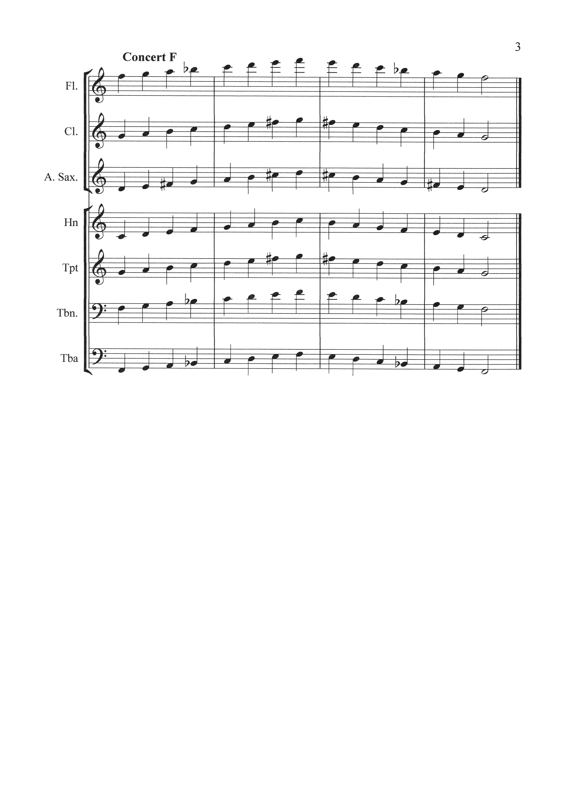
The Chromatic Scale
This scale is often overlooked and is one of the most important to learn, especially for woodwind and brass instruments. Learning it and practicing it helps you become more agile on your instrument.
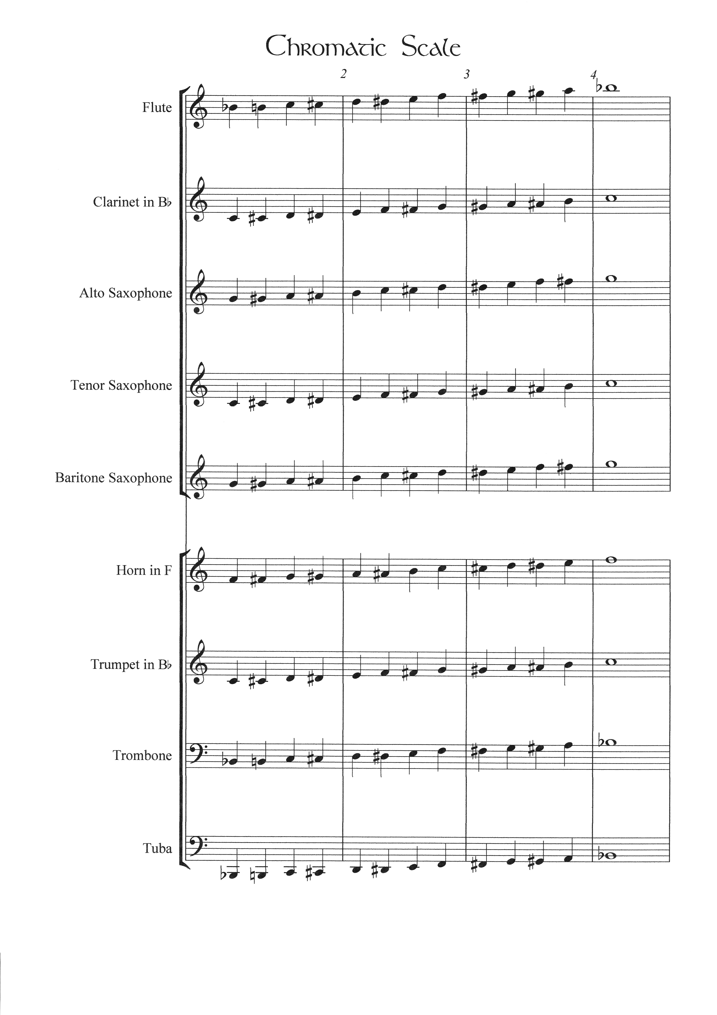

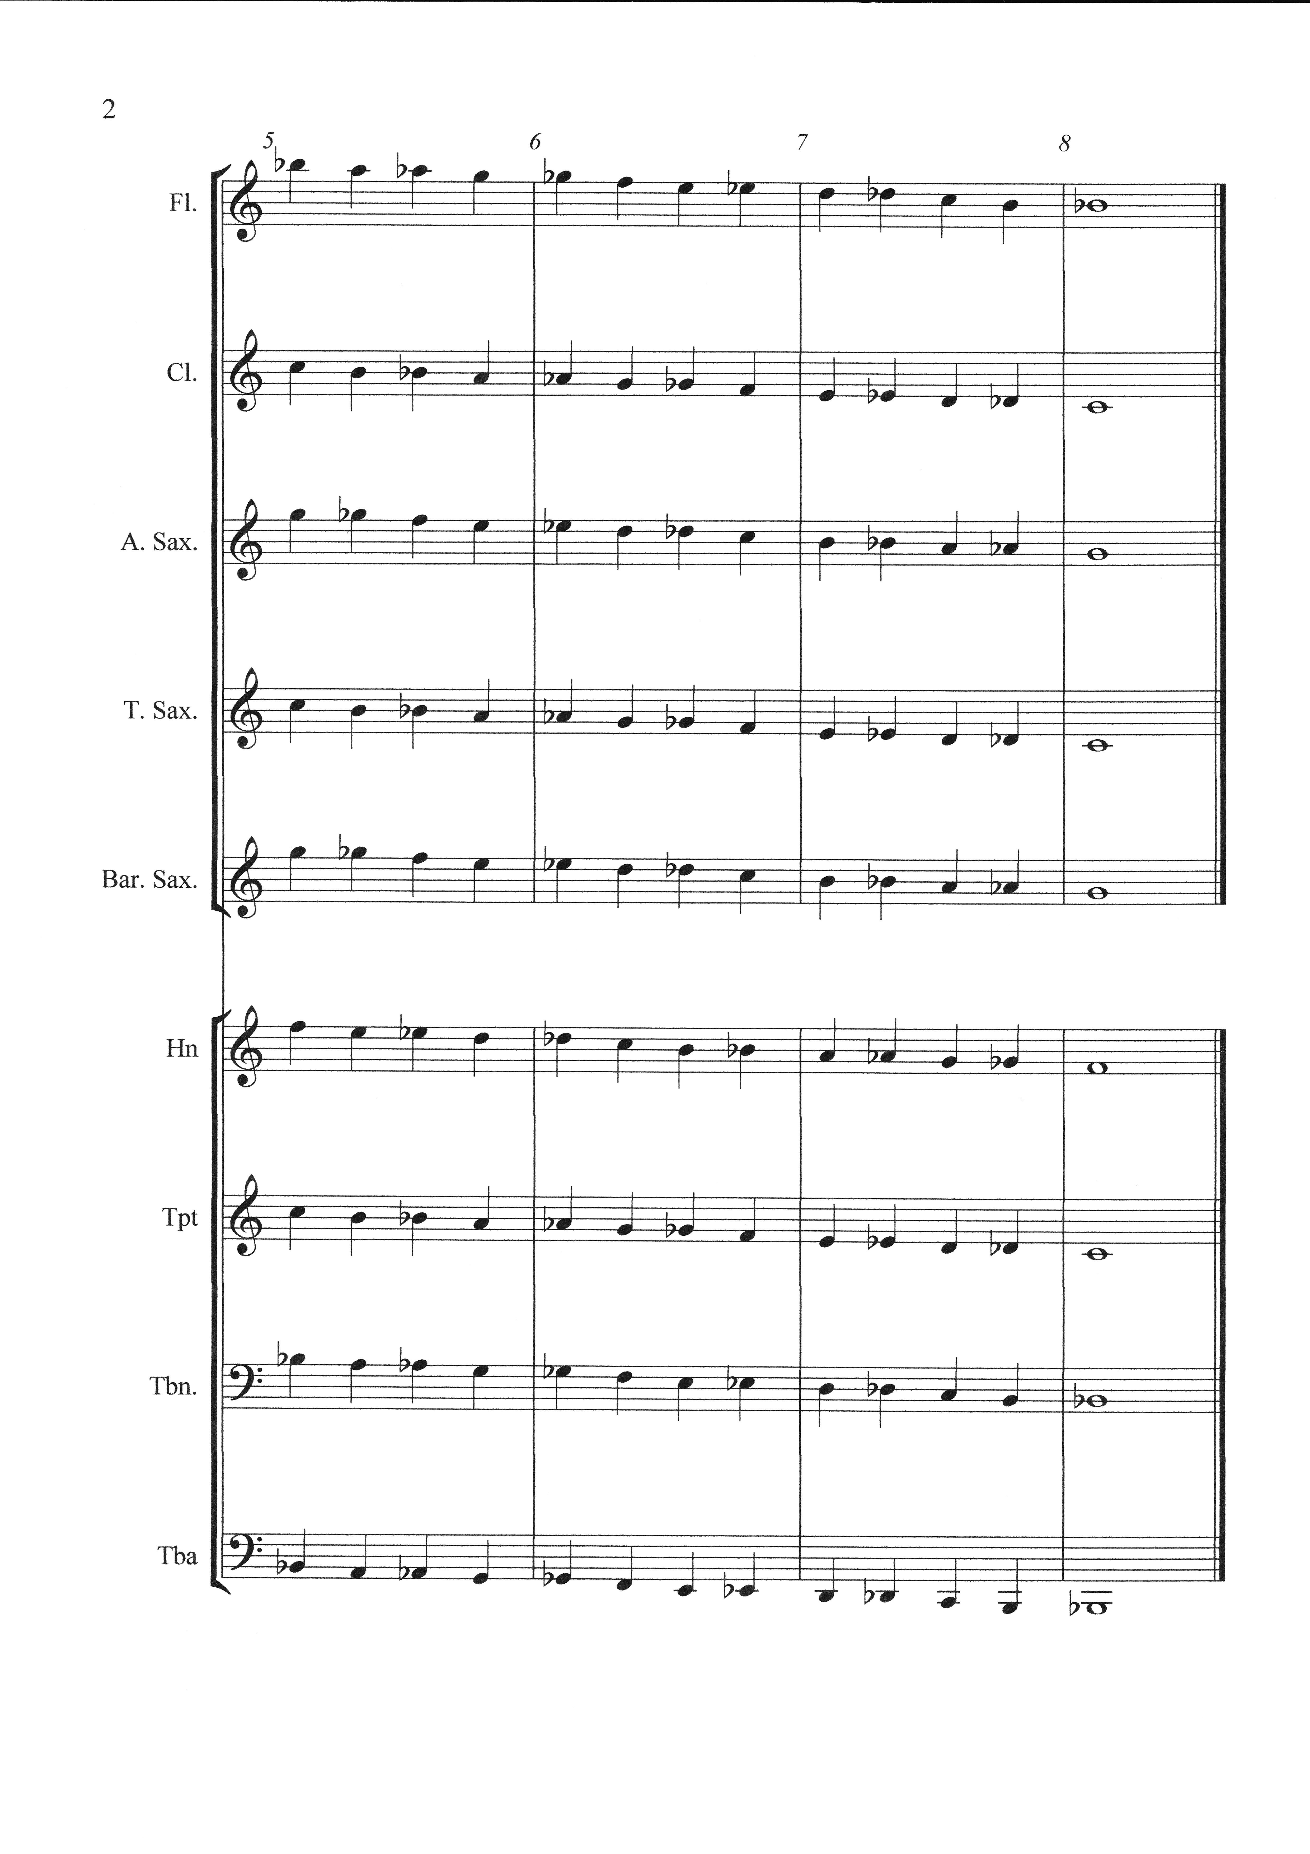
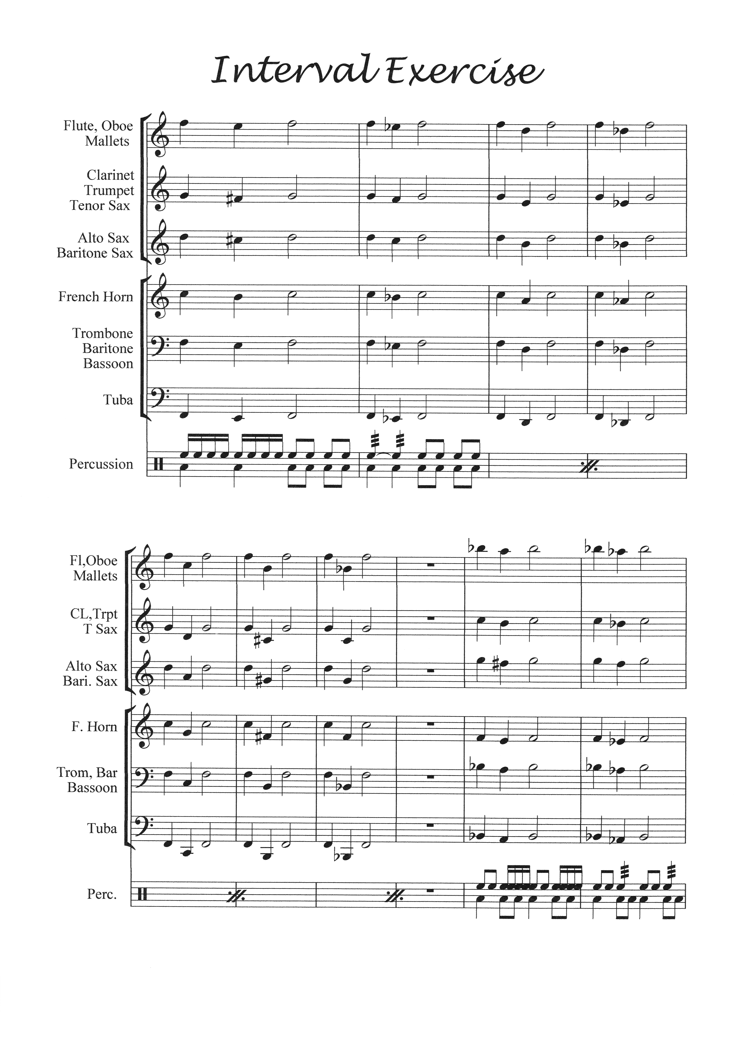
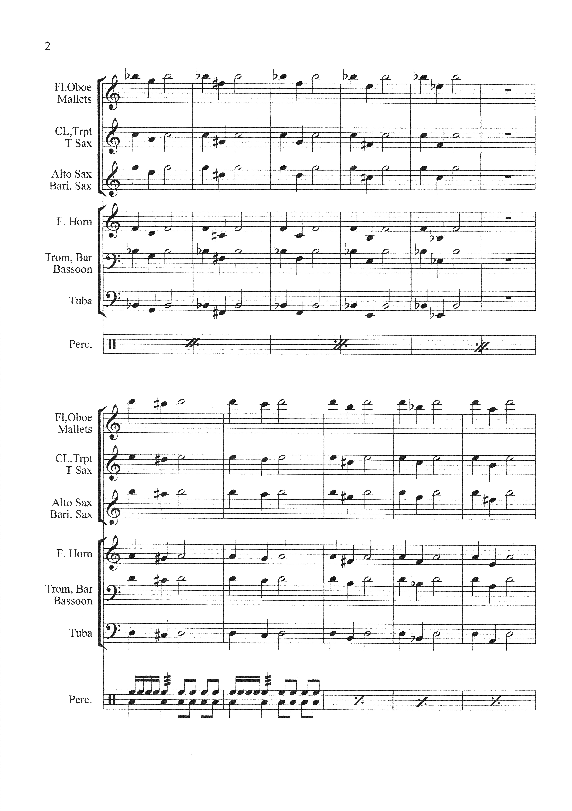
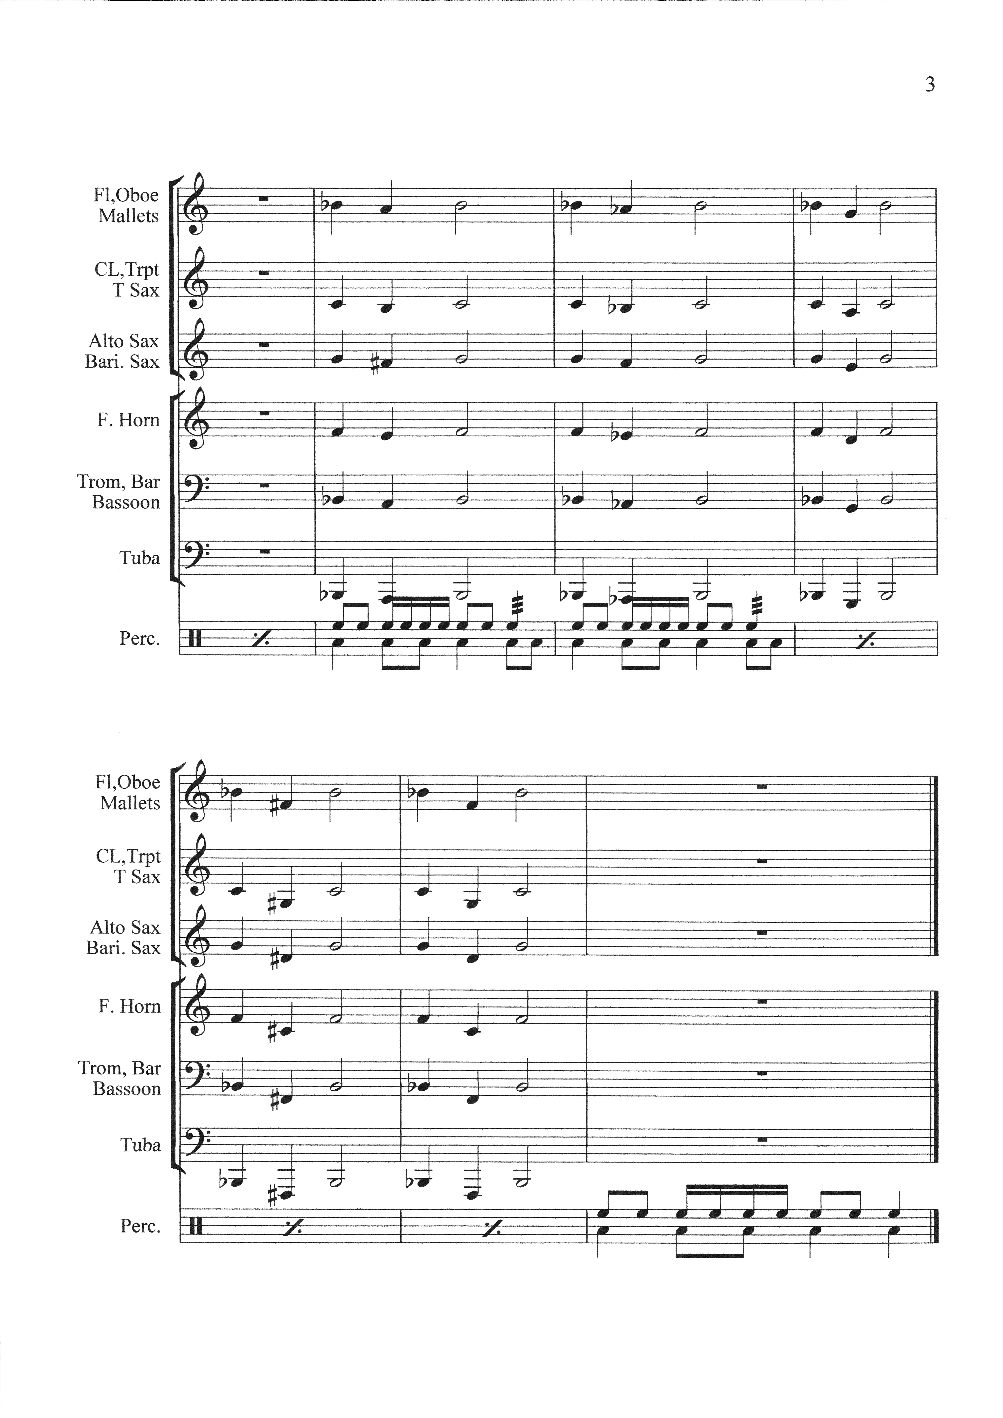

Week 1
Materials:
Make copies of the Note Timing Chart, about 10 sets of Note flash Cards, Concert Major Scale Sheet for the different instruments

Daily Student Learning Objectives: Students will-
- Review basic note values and counting
- Learn Concert B Flat Scale
- Rehearsal music

Procedure:
Pass out note timing chart to students
- Discuss the different types of notes and their counts
- Compare notes in mathematical terms
- Clap notes and count out loud the counting

Make available the note name flash cards for any student who feels they need to improve in that area

Explain that learning Scales are very important in developing many areas of musicianship a few of which are:
- An understanding of the various keys that music is written in
- Teaches our fingers how to move in certain keys
- As we learn our scales, we learn how to play in keys that would otherwise be difficult to play. Having to remember the sharps and flats becomes much easier when your fingers "just know" how to play the scale of the key signature that you are in.
- Scales need to be practiced daily which doesn’t take much time after the students learn them.
Pass out Concert Major scale sheet and the sheet with the piano keyboard on it
- Discuss the key signature of the scale for the various instruments
- Make visual note of the flats and sharps on the piano keyboard(before class if you want to draw a large scale piano key board on the dry erase board this might be helpful)
- Rehearsal the Concert B flat scale.

Other rehearsal music(note: choose a piece for rehearsal that is in the key of b flat to make the learning of the scale relevant the students. Also tie in the note timing chart to rhythms in the music)

Week 1 Day 2
Materials:
Make copies of the first Rhythm Studies Sheet (this is taken from Essential Elements Book 1) and the chromatic scale sheet

Daily Student Learning Objectives: Students will-
- Analyze, Count and Clap the first four lines of the Rhythm Studies Sheet
- Review and play the concert b flat scale
- Understand the chromatic scale sheet and learn first 7 notes
- Other rehearsal music

Procedure
Quick review of note timing chart

Pass out and analyze the first four lines of the Rhythm Studies Sheet. Count and clap rhythms as a class
Rehearse the concert b flat scale that was learned yesterday

Pass out chromatic scale sheet discuss the difference between a major and chromatic scale and use the piano keyboard to visually show the students.

Learn the first 7 notes of the chromatic scale

Other rehearsal music(continue to tie in rhythms, scales, flats and sharps to show relevancy)

Week 1 Day 3
Materials: no additional materials

Daily Student Learning Objectives: Students will-
- Analyze, Count and Clap lines 5 through 9 of the Rhythm Studies Sheet
- Play the concert b flat scale
- Learn the rest of the chromatic scale
- Rehearse songs

Procedure
Begin rehearsal with the concert b flat scale. Challenge students to do it by memory if they can

Divide lines 5 through 9 between the sections of the band and have them clap and count them for each other.

Review the first 7 notes of the chromatic scale then teach the remainder of the scale. Use the piano keyboard to visually show the students.

Other rehearsal music(continue to tie in rhythms, scales, flats and sharps to show relevancy)

Week 1 Day 4
Materials: The 2nd Rhythm Study Sheet

Daily Student Learning Objectives: Students will-
- Learn about syncopation
- Analyze Clap and Count the first four lines of rhythm sheet number 2
- Play the concert b flat scale by memory if possible
- Review and play the chromatic scale
- Rehearse Songs

Procedure
Begin rehearsal with the concert b flat scale-challenge the students to play it by memory. Instruct the students to use the rhythm of the first two lines of the Rhythm Studies Sheet ascending then stop and use lines three and four descending.

Review and play the chromatic scale ascending

Ask students if anyone has ever heard of the word syncopation
Explain the difference between strong and weak beats in music and that syncopation is emphasizing the weak beats in music

Use the first four lines in the second Rhythm Sheet to demonstrate synchopation

Rehearse other music and point out the syncopated parts.

Week 1 day 5

After the first 4 days I usually reflect on the previous four days and concentrate rehearsal on the areas that need to be reinforced.

Week 2

Week 2 Day 1

Materials: Copy Interval Exercise for each of the different instruments

Daily Student Learning Objectives: Students will-
- Learn the concert A flat scale
- Analyze Clap and Count lines 5 through 9 of rhythm sheet number 2
- Play the concert b flat scale by memory if possible
- Review and play the chromatic scale ascending and descending
- Learn what enharmonic tones are

Procedure:

Begin rehearsal with the chromatic scale ascending then descending- explain enharmonic tones

Next play the concert b flat scale by memory. Instruct the students to use the rhythm of the first two lines of the Rhythm Studies Sheet ascending then stop and use lines three and four descending.

Instruct students to compare the concert A flat scale with the concert b flat scale. How far away from B flat is a flat and the difference in the number of accidentals. Now would be a good time to discuss the formula of whole steps and half steps when making a scale.

Have students play the concert A flat scale. Fix errors as you hear them

Analyze Clap and Count lines 5 through 9 of rhythm sheet number 2
Rehearse other music- try to use a piece of music that is in the key of A flat to reinforce the scale that was learned.

Week 2 day 2

Materials: Blank Staff paper

Daily Student Learning Objectives: Students will-
- Build a major scale using the given formula
- Rehearse Concert A flat, b flat , and chromatic scale
- Rehearse music

Procedure:

Pass out staff paper to all students. Instruct them that they can do this activity by themselves or with one or two other students. Show on the board a major scale starting on C then show the whole and half step formula that makes the scale: Steps-Whole, Whole, half, Whole, Whole, Whole, Half
Tell the students that they can begin on any note and by using this formula then can make a major scale. Draw and use a picture of a piano to help them see the steps. See if they can make some scales beginning on G, F and D.

After they finish work the scales out as a class and see how everyone did.

Rehearse Concert A flat, b flat , and chromatic scale

Rehearse music.

Week 2 day 3

Materials: Copy Interval Exercise for each instrument

Daily Student Learning Objectives: Students will-
- Learn what an interval is
- Build major scales using the given formula
- Rehearse concert A flat b flat and chromatic scales
- Rehearse music

Procedure:

Explain that and interval is the distance between two notes. The first note is counted as one.

Rehearse Interval Study Measures 1 through measures 15. This study is great for multiple reasons
- It introduces students to intervals
- Helps musicians work on leaps in their playing
- Helps reinforce accidentals and enharmonic tones
- Reinforces chromatics

To reinforce the past two lessons have a student come to the board and let the class help them build a major scale using the formula. Do this two or three times.
Rehearse the learned scales B and A Flat and Chromatic

Rehearse Music

****Reminder to tie learned concepts into music as much as possible

Week 2 Day 4
Materials: Review sheet of terminology or write them on the board and hold a class discussion
- Enharmonic tones
- Major scales and how to build them
- Chromatic scale
- Syncopation
- Enharmonic tones
- Interval

Daily Student Learning Objectives: Students will-
- Learn Concert E flat Scale- compare it to the other major scales
- Review the terms we have learned over the past two weeks
- Rehearse concert A flat b flat and chromatic scales
- Rehearse music

Procedure

Teach the concert E flat scale. Have students compare it to the other scales. Number of accidentals what note it starts on compared with the key of their instrument

Use this day to also reinforce the skills learned over the past two weeks
Review the terms learned
Review Scales B flat, A Flat, Chromatic

Rehearse Music

Week 2 day 5

After the first 4 days I usually reflect on the previous four days and concentrate rehearsal on the areas that need to be reinforced.
*****************************************************************************************
End of unit Formative Evaluation:

I could give a written test but the ultimate test is whether the students can use the skills that have been learned in class rehearsal and ultimately in a performance situation.

Except for a few of the scales this is the end of the first unit so I would use some form of formative evaluation. I would go through each area we covered and assess how well the students have mastered the concept or whether it needs more work now before we go on or possibly visit it again later.

I don’t believe that there is a summative evaluation for Instrumental Music. As musicians we are constantly using formative evaluations to improve ourselves and the groups we belong to and our ensembles and our individual students.

Sub Unit 2: Tone Quality/Balance and Blend
Learning Outcomes
- Students will demonstrate the use of good tone quality (application).
- Students will be able to explain the process of producing good tone quality and assess their own tone quality (analysis, evaluation).
- Students will recognize and explain good balance in an ensemble situation (comprehension, evaluation).

Improving the Tone Quality/ Balance and Blend of an ensemble is accomplished by improving the tone quality and the intonation of the individual student.

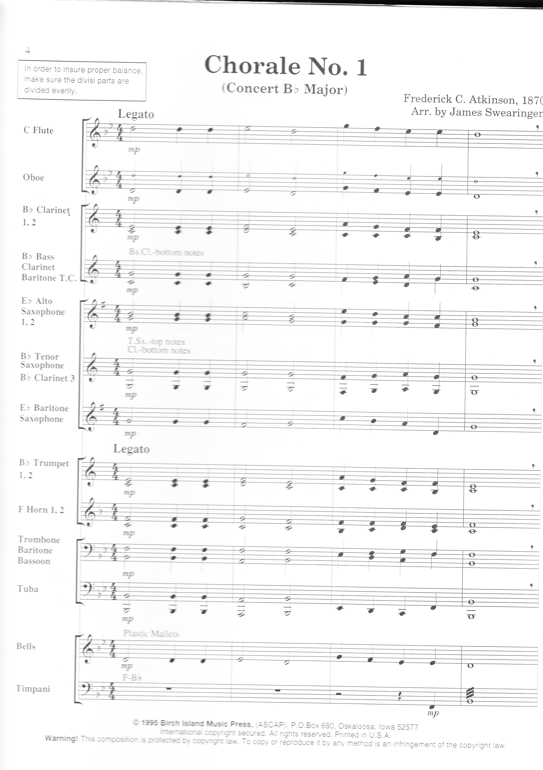

Week 3 day 1
Materials: Copy Chorale No. 1 for the various instruments ( shown above is page one of the conductors score)

Daily Student Learning Objectives: Students will-
- Recognize and explain good tone quality
- Learn the attributes and process of developing a good tone quality
- Learn Chorale No. 1 concentrating in tone quality
- Review Concert B, E, A flat and chromatic scales
- Interval Exercise

Procedure:

Begin with a demonstration of playing a phrase of music using good tone quality and musicality then demonstrate the same phrase using not so good tone quality and musicality

Ask students which they prefer and why.

Ask a student to make a list on the board of the things that contribute to a good tone quality. Have the rest of class help them.

While keeping in mind the things that make up a good tone quality teach Chorale No.1

Review Concert B, E, A flat and chromatic scales

Review Interval Exercise

Other Music- Emphasize the use of good tone quality

Week 3 day 2

Materials: nothing new

Daily Student Learning Objectives: Students will-
- Recognize and explain good balance and blend in an ensemble situation
- Learn Chorale No. 1 concentrating on balance, blend and good tone quality

Procedure:

Ask the class what they think the words balance and blend mean
Balance- equal volume by the different parts

Blend- How well the sound of the various instruments mix together.

Have groups of two or three students come forward at a time and play simple two and three part melodies that are written on the board.

Discuss the balance and blend of the groups that perform.
Discuss the importance of balance and blend in group situations.
Discuss how balance differs in various types of situations.

Rehearse various sections of music from the pieces the band is working on and have the students analyze the type of blend needed. Practice using this type of blend.

Week 3 day 3

Procedure:

Formative evaluation on Tone Quality/Balance and Blend.

Quick question answer session about tone production
- Posture, embouchure, horn position, breathing/support
- Embochure
Quick question answer session about balance and blend
- What is balance? and types of balance
- What is blend

Ask students to demonstrate good tone quality and play chorale No.1
Ask students to demonstrate good balance-explain and demonstrate it in various sections of pieces
Ask students to demonstrate blend and demonstrate it in various sections of pieces

Review Concert B, E, A, Flat scales and chromatic
Try them in half then quarter and eighth notes

********************************************************************************

Sub Unit 3: Pulse/Meter
Learning Outcomes
- Students will define and demonstrate what is meant by a steady beat or pulse (knowledge, application).
- Students will recognize and explain the meaning of various time signatures (comprehension, analysis).
- Students will analyze rhythms in various time signatures and demonstrate how they are played (analysis, application).

Week 3 day 4

Materials: Copy and pass out Pulse/Time signatures/ Rhythm Sheet

Daily Student Learning Objectives: Students will-
- Learn and demonstrate a steady beat in various times signatures
- Understand and demonstrate 4/4, 3/4, 6/8, 2/2, time signatures
- Understand simple rhythms in various time signatures

Procedure: Find examples of short songs in each of the time signatures. They can be found in any method book. Perform them for the students and have them list the differences. Talk about the time signature differences, the strong and weak beats, the feeling of each time signature.

Sub Unit 4: Expression/Articulation
Learning Outcomes
- Students will explain the meaning of and demonstrate various dynamic markings (pp,p,m,mf,ff)and (crescendo, decrescendo, sforzando) (analysis, application).
- Students will recognize and demonstrate various forms of articulation (staccato, marcato, tennuto, etc.) (comprehension, application).
- Students will compare examples of expression and integrate the appropriate technique in a given situation (evaluation, synthesis).

Sub Unit 5: Vocabulary/Reading
- Students will describe the meaning of various musical terminology (molto expressive, andante, d. c. al coda, etc…) (comprehension).

References:
www.rocketpiano.com/ free_course 2047newsletter2.htm

http://www.jagmmp.com/music_articles/why_practicing_scales_is_important.html

Swearingen, James (1995) Chorale No.1. First Chorales for Band

