Ohio Standards Connection

Data Analysis and Probability

Benchmark C
Evaluate interpretations and conclusions as additional data are collected, modify conclusions and predictions, and justify new findings.

Indicator 5
Modify initial conclusions, propose and justify new interpretations and predictions as additional data are collected.

Benchmark D
Compare increasingly complex displays of data, such as multiple sets of data on the same graph.

Indicator 3
Read and interpret increasingly complex displays of data such as double bar graphs.

Benchmark E
Collect, organize, display and interpret data for a specific purpose or need.

Indicator 4
Determine appropriate data to be collected to answer questions posed by students or teacher, collect and display data, and clearly communicate findings.

Lesson Summary:
In this lesson, students conduct a survey and represent the collected data in the form of a graph. Students examine the data and the graphs and analyze which graph corresponds to the proper heading. This lesson also involves collecting additional data and modifying initial conclusions and justifying new findings.

Estimated Duration: Three hours
Commentary:
Adding new data to information used to create a graph may have different effects on the graph and the interpretation is a new concept for students. Depending on how the original sample population represents the population as a whole (the entire school or the community that contains the school), will create different effects on the graph. If the initial sample is a good representative sample then general shape of the graph and conclusions should not vary. However, if the initial sample does not represent the total population then the graph of the data and the conclusion will change. For example, skewed data is possible, because of the limits placed on the initial sample. Helping students understand the graphs and conclusions can and will change based on the size and limits of the sample is paramount to interpreting and making predictions based on data and related graphs.
Pre-Assessment:
Distribute Attachment A, Matching Graphs to students.
Direct students to match the graphs, labeled 1, 2, 3 and 4 with the scenarios, labeled A, B, C and D. Have students write the reasons they chose to match the graph with the scenario.
Discuss the student responses and generate a list of information students know about graphs.

Scoring Guidelines:
Explanations should justify why the graph and the scenario match using similar ideas above. Provide intervention for those who were not able to match the graphs and explain the appropriateness of the graph. Allow for other justifications that are appropriate and with support. Such as, scenario A can also be paired with graph 2, 3 or 4, because the fifth and sixth graders were counted as a whole and not as individual groups or compare fifth and sixth graders.

Ohio Standards
Connection

Mathematical Processes

Benchmarks
G. Relate mathematical ideas to one another and to other content areas; e.g., use area models for adding fractions, interpret graphs in reading, science and social studies.
H.Use representations to organize and communicate mathematical thinking and problem solutions.
J.Communicate mathematical thinking to others and analyze the mathematical thinking and strategies of others.

Answer Key:
GraphScenarioExplanations could include these ideas but are not limited to them (see instructional tip):1BChange over time (trends)
Only five data points
The y-axis scale represents numbers that are temperature that are normal around the start of the school year2APart of a whole (a circle represents a whole and the subjects represent the parts)
Labels for the graph represent the percentage of students who like a particular subject and most students are graded in about five subject areas3DCompares the sales of each sixth grade class in the school
Scale represents the number of cases sold4CCompares more than one set of data
Scale used represents number of students who likes the different flavors of ice cream
The double bars represent the fifth and sixth grade and are used to compare the different grade levels
Post-Assessment:
The post-assessment is a continuation of part three in the lesson. Students present their data and conclusions to the class. Limit the number of questions asked to two or three. Initially limit the targeted population (sample size) to a specific group, e.g., class or grade.

Scoring Guidelines:

Score | Description
Exemplary | Chooses an appropriate graph to match the data.  Interprets the graph.  Collects additional data and modifies initial interpretations.  Presents the project in an organized method.
Good | Collects data and organizes the data into a table or chart.  Missing or minor errors in one of the following:  - Chooses an appropriate graph to match the data  - Draws conclusions relevant to the data  - Collects additional data and modifies initial conclusions  Presents the project in an organized method.
Intervention Needed | Collects data and organizes the data into a table or chart.  Errors in representing the data in two of the following areas:  - Appropriateness of graph to the data collected  - Conclusions or predictions relevant to the data  - Collects and graphs additional data and modifies initial conclusions or predictions  Presentation of the project was not organized, but complete.
Instruction Required | Collects data, but did not organize the data into a table or chart.  Graphs are not appropriate for the data collected.  Conclusions or predictions did not correspond with the data or graph.  Did not collect additional data and did not modify initial conclusions or predictions.  Presentation of the project is unorganized and incomplete.

Instructional Procedures:
Instructional Tip:
Complete the collection of data by one week before beginning the lesson. Keep the results from both collection samples separated copying the second set of data on different colored paper. Place the responses for each question in a separate envelope. The lesson begins with a small sample size and then is re-evaluated when combining additional data with the original data. The purpose is to draw conclusions based on initial collection of raw data and then to draw new conclusions on the collection of additional data and how this may change the graph and initial conclusions.

Part 1
1. Distribute Survey, Attachment B, to the class and to a class of a different grade level, keeping the results of each separate. Have each student respond to each question by circling the appropriate response. The line is for students to write in responses that are not included on the sheet.
2. Instruct students to cut the responses apart (along the dotted line) and place in the envelope that matches the question.

- Divide students into six groups and distribute to each group a sheet of chart paper and an envelope containing the response to one of the questions.
- Have groups create a table or chart, and a graph to organize and represent the data from the survey responses.
  - Have groups organize the data before they create the graph. Discuss how to organize the data, i.e., tally chart.
  - Describe the types of graphs that are most appropriate for this lesson, e.g., line plots, circle graphs and bar graphs. Discuss each type of these graphs before graphing the data.
  - Inform students to place the graph on one half of the sheet of chart paper. The other half of the sheet will be used later in the lesson.

Instruction Tip:
Have students construct graphs on a sheet of paper prior to transferring it to the chart paper. Use Attachment C, Circle Graph, a circle divided into 100 sections, to assist in making a circle graph.

5. Display the graphs constructed in the groups and discuss the appropriateness of the graphs the students chose.
- Why did you choose this graph to represent the data?
- How does this graph best represent the data?
- Are there other graphs that could represent the same set of data?
- Which one do you think is easier to read?
- What conclusions can you determine from your graph?
- Can you get the same conclusions from other types of graphs?
- Describe how the data is distributed.
6. Have students list the types of graphs and describe the nature of the data the graph represents in their journals. For example, a circle graph is used to represent and compare parts of a set of data.

Part 2
7. Distribute the responses from the other class surveyed to the appropriate group. Inform the students of the population surveyed, such as the grade level, club or teacher name.
8. Have students make predictions of how they think the new data is going to affect the shape of the graphs from part one.
- How is the additional data going to affect your initial conclusions?
- Why do you think the data may be similar or different? (If the population surveyed is of the same grade level, the shape of the data may stay consistent. If the population surveyed is a second grade class, the shape of the data may change. Students at second grade may not spend as much time on homework as fifth grade students.)
- How is your graph going to look with the addition of new data?
9. Discuss ways the additional data can be combined with the original data and graphed. Ask questions such as the following:
- How would you graph all of the data?
- Would you combine the data or keep the data separate for each grade level.

- How or when would you combine or separate the data sets?
- If you wanted to know which part of the group responded a certain way, which graph would you use?
- Have groups organize the data in the same manner as the first set and graph the combined data sets using their ideas based on the discussion. Use the other half of the chart paper to display the new graph.
- Bring groups back together and discuss the graphs. Use questions such as:
  - How does the new graph compare to the first graph?
  - How are they alike and how are they different?
  - What happened to the shape of the graph?
  - Why did they graph shape stay the same or change?
  - Did the new data change the graph in the way you predicted?
  - Do you need to change the conclusions that you made from the first graph?
  - Why do you think your conclusions changed or stayed the same?

Part 3
In this part, students begin the post-assessment task. Assist students with determining survey questions and collecting the data. When students are writing questions for the survey, discuss the types of questions asked, such as appropriateness for school use and questions match the topic chosen. Limit the number of questions asked to two or three and limit the audience to question.

12. Divide students into groups of three or four.
13. Have the groups choose a topic and design a survey to collect and organize data about something that interests them. For example, conduct a survey on the number of students who have a video game player and how many hours they play games each week, or collect data from the school office on attendance rates or bus riders versus walkers versus car riders. Develop survey questions that are frequency (tally survey) or categorical. These are the steps the student groups will follow:
- Develop survey questions and get approval from the teacher.
- Conduct the survey and collect the data from a specific group.
- Organize the data into a table or chart.
- Choose an appropriate graphical display to visually represent the data, interpret the data and graph and justify why that graph is appropriate for the set of data.
- Gather additional data from outside the original parameters. Collect data from one to two different audiences, such as different grade levels and/or adults.
- Organize and graph the combined data.
- Describe how the addition of data has affected the original interpretation.
- Prepare data for presentations.

Differentiated Instructional Support:
Instruction is differentiated according to learner needs, to help all learners either meet the intent of the specified indicator(s) or, if the indicator is already met, to advance beyond the specified indicator(s).
- Vary the sample size and demographics of the population.
- Focus on one type of graph at a time.

- Provide examples of what different types of graphs look like, identifying the key components of the graph.
- Provide grid paper or Attachment C, Circle Graph, to assist students with graph making.

Extensions:
- Use survey questions from newspapers and magazines to survey the class. Compare the class results to the published results. Analyze the appropriateness of the graph used.
- Use the results from the lesson and construct a different type of graph to represent the same data. Comparing the two graphs and discuss which graph better represents the data and explain why.
- Have students use the original set of data and create another graph by organizing the data by different demographics.

Home Connections:
Have students collect graphs from magazines, newspapers and other sources. Have them analyze the appropriateness of information on the graph and present their findings to the class.

Interdisciplinary Connections:
Content Area: Language Arts
Standard: Reading Applications: Informational, Technical and Persuasive Text
Benchmark: 5. Analyze information found in maps, charts, tables, graphs and diagrams.

Materials and Resources:
The inclusion of a specific resource in any lesson formulated by the Ohio Department of Education should not be interpreted as an endorsement of that particular resource, or any of its contents, by the Ohio Department of Education. The Ohio Department of Education does not endorse any particular resource. The Web addresses listed are for a given site’s main page, therefore, it may be necessary to search within that site to find the specific information required for a given lesson. Please note that information published on the Internet changes over time, therefore the links provided may no longer contain the specific information related to a given lesson. Teachers are advised to preview all sites before using them with students.

For the teacher: chart paper, markers, envelopes

For the student: chart paper, markers, and rulers

Vocabulary:
- circle graph
- data
- double bar graph
- line plot
- sample size
- survey

Technology Connections:
- Use software that has graphing capabilities to enter data and create a graph.
- Look for data from a survey on-line and create a graph to represent it.
- Have the class create on online survey using the original questions and post it on the web. Use the data generated from this survey to modify the original graphs.

Research Connections:

Arter, Judith and Jay McTighe. Scoring Rubrics in the Classroom: Using Performance Criteria for Assessing and Improving Student Performance. Thousand Oaks, CA: Corwin Press, 2001.

Marzano, Robert J., Jane E. Pollock and Debra Pickering. Classroom Instruction that Works: Research-Based Strategies for Increasing Student Achievement, Alexandria, VA: Association for Supervision and Curriculum Development, 2001.

Smutny, Joan F. Differentiation and Creativity (Content). A Professional Development Offering of Phi Delta Kappa International. 5 November 2003. Presentation materials.

Attachments:
Attachment A, Matching Graphs
Attachment B, Survey
Attachment C, Circle Graph

Attachment A
Matching Graphs Pre-Assessment

Name Date

Directions: Match the graph with the appropriate story.

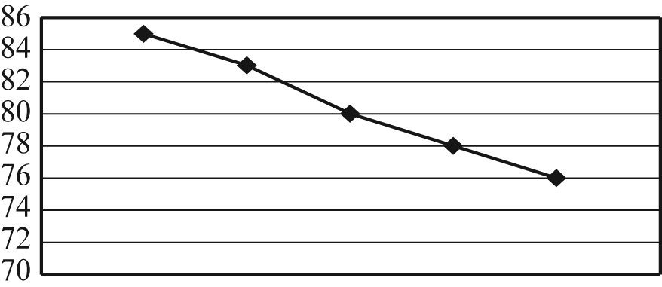  1. | A. A class was surveyed about their favorite subject in school.
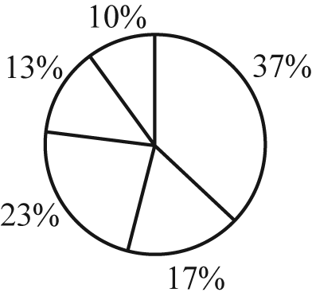  2. | B. This graph shows the high temperatures for the first five days of school
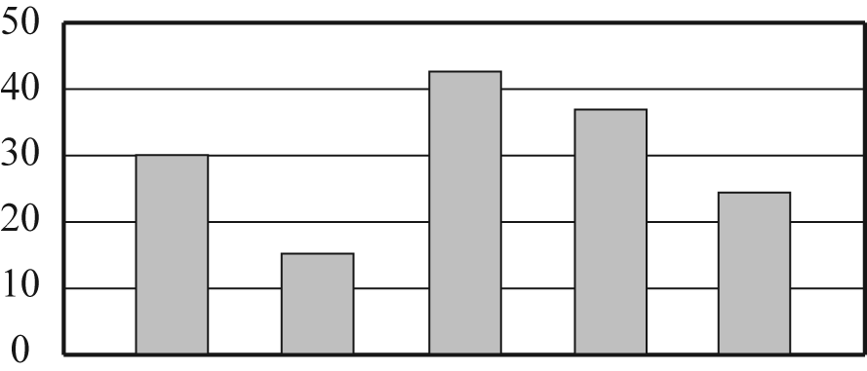  3. | C. A group of fifth and sixth graders were surveyed about flavors of ice cream.
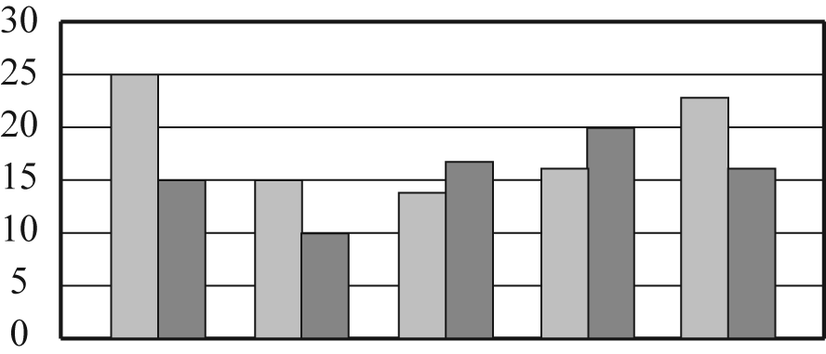  4. | D. This graph shows the number of cases of candy sold by each sixth-grade class.

Attachment B
Survey

Name Date

Directions: Respond to each question by circling your answer. The line is for a response that is not on the sheet. When finished cut apart the responses (along the dotted lines) and place them in the appropriate envelope.

The number of times you eat a school lunch per week. | 1 2 3 4 5
How many minutes have you read during the past week?
  10 | 20 | 30 | 40 | 50 | 60 | 70 | 80 | 90 | 100 | 110 | 120
  130 | 140 | 150 | 160 | 170 | 180 | 190 | 200
Do you like to ride roller coasters? | YES NO  Don’t know
How many minutes does it take you to complete your homework each night?
  5 | 10 | 15 | 20 | 25 | 30 | 35 | 40 | 45 | 50 | 55 | 60 | 65
  70 | 75 | 80 | 85 | 90 | 100
How many books you have read in the past month
  1 | 2 | 3 | 4 | 5 | 6 | 7 | 8 | 9 | 10
  11 | 12 | 13 | 14 | 15 | 16 | 17 | 18 | 19 | 20
  21 | 22 | 23 | 24 | 25 | 26 | 27 | 28 | 29 | 30
  31 | 32 | 33 | 34 | 35 | 36 | 37 | 38 | 39 | 40
  41 | 42 | 43 | 44 | 45 | 46 | 47 | 48 | 49 | 50
The number of hours you watch T.V. per week.
  1 | 2 | 3 | 4 | 5 | 6 | 7 | 8 | 9 | 10
  11 | 12 | 13 | 14 | 15 | 16 | 17 | 18 | 19 | 20
  21 | 22 | 23 | 24 | 25 | 26 | 27 | 28 | 29 | 30
  31 | 32 | 33 | 34 | 35 | 36 | 37 | 38 | 39 | 40
  41 | 42 | 43 | 44 | 45 | 46 | 47 | 48 | 49 | 50

Attachment C
Circle Graph

