**Hurricanes**

The weather in the tropics is hot and humid because the earth there receives more solar energy than it sends back to space. This over-heating makes weather that can affect any place in the world. It's this difference in energy that helps drive the flow of the atmosphere.

There is plenty of rainfall in the tropics because the heat of the sun causes air to rise. At certain times of year, showers and thunderstorms can occur every day. The high temperatures in the tropics (usually between 22° and 35°C) are steady throughout the year, with very little change. Therefore, tropical seasons aren't defined by periods of warm and cold as they are in Canada. Instead, the seasons in these warmer climates are distinguished by changes in rainfall and cloudiness.

These hot, humid conditions over tropical oceans are the main ingredients needed for tropical cyclones to form. A tropical cyclone is a storm system that has a low-pressure centre and thunderstorms that produce strong winds and flooding rain. These storm systems range in intensity from tropical depressions, which have winds below gale strength (less than 63 km/h), to intense hurricanes and typhoons, which can have winds exceeding 250 km/h. All of them can have devastating rainfall accumulations of hundreds of millimetres happening at fast rates; rainfall rates of 25-50 mm/hr are not uncommon. In addition to the wind and rain, tropical cyclones can also produce high waves and damaging storm surge. They can even spawn tornadoes.

The ferocity of these storms is behind the origin of the word hurricane. “Hurricane” stems from the word “hurican,” the Carib Indian god of evil, which itself comes from the Mayan god Hurikan, one of their creator gods. In essence then, “hurricane” means “evil wind” . Anyone who has experienced the wind, rain, storm surge and ocean waves in one of these storms will probably agree with the meaning behind the name.

It may be surprising to learn that hurricanes aren’t all bad. In fact, climate scientists have speculated that hurricanes may serve an important function of redistributing built-up heat energy in equatorial regions and shunting it toward the poles as the storms drift to higher latitudes. The degree to which these storms help the global heat budget is uncertain, but there are an average of 80-85% of them annually to perform this role.

# How and Where Hurricanes Form

A tropical cyclone is a storm system with a low-pressure centre. However, while typical Canadian lows and storm systems are fueled by a battle between cold and warm air, tropical cyclones are fueled by a different process.  This process involves water being converted to water vapour, which is then converted back to liquid water.

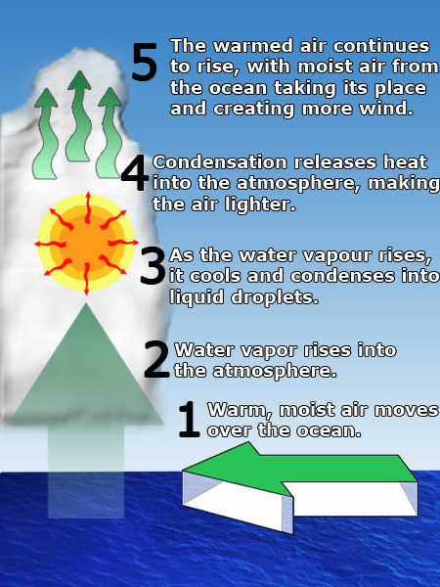

Most people know that heat is required to evaporate water. For example, a pot of water is put on a stove and heated. The heat is what evaporates the water, turning it into water vapour (steam) that gets trapped in the air. The water vapour just above the water in the pot is now hotter than the surrounding air, and it rises. The warm tropical atmosphere is like the stove: it heats up the water at the ocean surface and begins to evaporate it. And like the trapped water vapour in the air in the pot, the water from the ocean surface rises up through the atmosphere.  An atmospheric disturbance has begun! The rising air then meets lower pressures and temperatures at higher altitudes, and water vapour begins to condense back into liquid water. We see this as clouds. This is when the interesting physics of tropical cyclone formation really begins.

While most people know that it takes heat to evaporate water and turn it into water vapour, many don’t realize that when water vapour is cooled back into liquid water, the heat is released. Even more heat is given back if the process is continued to the point of freezing. The condensation process essentially extracts heat from the air as water vapour is condensed back into liquid water. This is referred to as the latent heat of condensation, where latent heat literally means “stored heat.”

The heat that was “stored” in the air at the ocean surface is released back into the atmosphere at higher altitudes when the rising air cools and the water vapour condenses into liquid water. This warming effect at higher altitudes causes the air to accelerate upward because it is now hotter than its surroundings. This then draws air up from below and speeds up the rate of rising air near the surface. Surface air around the growing disturbance rushes in to replace it. This motion of surface air is the wind we feel in a tropical cyclone. Rising columns of air quickly form tropical thunderstorms, and the result is a potential “seed” for a tropical cyclone. The eventual tropical cyclone that forms will be referred to as a warm-air or warm-core storm because of the process just described.

The term “cyclone” is a meteorological term and generally refers to any low-pressure area. In the Northern Hemisphere, cyclones rotate counterclockwise; in the Southern Hemisphere, they rotate clockwise. There are different kinds of cyclones, such as extratropical cyclones (referring more to the process of formation rather than geographic origin); mesocyclones (the large and intense thunderstorms that spawn tornadoes); and tropical cyclones.

**Conditions needed for tropical cyclones to form**

Warm ocean water is not the only ingredient needed for tropical cyclones to form. Each of the following conditions must be in place:

* **Warm ocean waters to fuel the tropical cyclone**. Studies have shown that sea surface temperature must be at least 26.5°C, and this temperature is actually required to a depth of at least 50 m. That’s why tropical cyclones can’t form outside of the tropics--water temperatures are too cold.
* **A warm, moist tropical atmosphere** that encourages thunderstorm development. Thunderstorm development is the foundation of the latent heat release process, the driving mechanism of tropical cyclones.
* **More than 500 km (about 5° latitude) away from the equator**. This is important because the Coriolis force--the apparent force of the rotating earth--is necessary to generate the rotation of the growing disturbance, and without it a low pressure cannot be maintained. The Coriolis force is slight near the equator and gets stronger towards the poles.
* **A pre-existing near-surface disturbance, low-pressure area or region of convergence.** This is necessary because tropical cyclones cannot generate spontaneously and they require a *trigger* mechanism to begin drawing air inwards at the lowest levels of the atmosphere.
* **Little to no vertical wind shear between the surface and the upper troposphere** (the upper part of the atmosphere where weather occurs, just below the stratosphere). Vertical wind shear is simply a change of wind speed or direction with increasing altitude. Large vertical wind shear disrupts a growing disturbance and can prevent a tropical cyclone from forming. If a tropical cyclone has already formed, large vertical wind shear can weaken or destroy it by interfering with the processes of deep convection (overturning air) around the cyclone centre by things such as *tilting them over* and *poking holes in the warm core*.

While these conditions are needed to create a tropical cyclone, it does not mean that they are enough to create one. Often all of these conditions exist, yet a tropical cyclone does not form. This is part of the challenge in forecasting when a tropical cyclone will develop--a process known as tropical cyclogenesis.

As well, while it is not required, a high-pressure area located at the top of the troposphere above the storm or growing disturbance can greatly help a tropical cyclone to form. This acts as a “chimney” for the storm, and it does at least two important things: 1) it takes the rising air away from the storm centre so that it doesn’t pile up above the storm and cause the storm to collapse on itself, and 2) it draws air up through the storm to help the air rise and keep the low pressure at the surface.

# Structure and Motion

The structure of tropical cyclones is determined by the latent-heat release mechanism that forms them. The graphic here does a better job than words in describing what these storms look like up close.

## ****Features of a tropical cyclone/Structure and Motion****

## 

**Eye** – The eye is the centre of the storm and is where the lowest pressure is found. The eye is roughly circular and is an area of warm subsiding air that is generally free of clouds and weather, although the sea surface will generally be an area of chaotic seas coming in from all directions toward the centre. The eye can become obscured and filled with cloud if the storm is embedded within a strong atmospheric flow. Higher up in the storm the eye can be 10°C warmer than the surrounding air. A hurricane eye averages 30-60 km in diameter but can be less than 10 km or as much as 200 km across.

**Eyewall** – The eyewall is the ring of deep convection surrounding the eye. This is where the highest surface winds are found. There are strong updrafts and downdrafts in the eyewall, but  overall the updrafts are stronger and more frequent.

**Spiral rain bands** – The convection in tropical cyclones organizes itself into long, narrow rain bands which spiral in towards the centre of the storm. The rain bands are oriented in the same direction as the horizontal wind.

**Surface winds** – In the Northern Hemisphere, the surface winds of a tropical cyclone rotate in a counter-clockwise direction. As shown in the diagram, the winds are zero at the centre of the eye, increase dramatically in the eyewall, then decrease gradually farther away from the storm. Any location over which the eye of a hurricane passes experiences the strongest winds twice, on each side of the eyewall. The first exposure to eyewall winds comes through a gradual building of the winds until the peak winds are experienced. Winds then drop to calm in the eye. When the eyewall at the other side of the storm arrives, the winds increase almost instantaneously to their maximum value, and from the opposite direction.

**What are Hurricanes?**

Most people associate twisters with tornadoes, but in fact tropical twisters come from hurricanes. Hurricanes are what scientists call "strong Tropical Cyclones". They are formed when large areas of the ocean become heated, and the air pressure over that area drops. This causes thunderstorms and strong surface winds. Cyclones develop over tropical or sub-tropical waters (for example, in the Atlantic off the coast of Africa, or in the Pacific). As they travel long distances gathering energy from the ocean, they are likely to be classified as strong Tropical Cyclones. When the winds of a tropical storm reach 74 mph, then the storm is classified as a hurricane.

A hurricane is a migratory tropical cyclone that originates over oceans near the equator. Usually, hurricanes form within a narrow equatorial belt with intermittent calms called doldrums. These doldrums have light variable breezes and frequent squalls, and they lie between the northeast and southeast trade winds. Hurricanes do not occur in the South Atlantic Ocean because the doldrums of the Atlantic are north of the equator. Hurricanes occur in both the North and South Pacific Oceans because the Pacific doldrums extend North and South of the equator. Hurricanes are made up of high-velocity winds blowing circularly around a low-pressure center called the eye of the storm. The eye develops when warm saturated air in the doldrums is forced upward by cooler, denser air. The atmospheric pressure drops sharply, and the wind velocity rises. Close to the point of lowest pressure, the winds will attain maximum force. The diameter of the area destructed by winds may exceed 240 km (150 mi). Gale winds may average 480km (300 mi) in diameter. Hurricanes are rated on strength from a scale of 1 to 5. Category 1 is the mildest with winds of at least 120 km/h (74 mph). Category 5 is the strongest and rarest with winds exceeding 250 km/h (155 mph). In the eye of the storm, with an average diameter of 24 km (15 mi), the winds cease and clouds lift, but the seas remain extremely violent.

http://www.ec.gc.ca/ouragans-hurricanes/default.asp?lang=En&n=77977664-1

**How are Hurricanes Created?**

The birth of a hurricane requires at least three conditions:

First, the ocean waters must be warm enough at the surface to put enough heat and moisture into the overlying atmosphere to provide the potential fuel for the thermodynamic engine that a hurricane becomes.

Second, atmospheric moisture from sea water evaporation must combine with that heat and energy to form the powerful engine needed to propel a hurricane.

Third, a wind pattern must be near the ocean surface to spirals air inward. Bands of thunderstorms form, allowing the air to warm further and rise higher into the atmosphere. If the winds at these higher levels are relatively light, this structure can remain intact and grow stronger: the beginnings of a hurricane!

Often, the feature that triggers the development of a hurricane is some pre-existing weather disturbance in the tropical circulation. For example, some of the largest and most destructive hurricanes originate from weather disturbances that form as squall lines over Western Africa and subsequently move westward off the coast and over warm water, where they gradually intensify into hurricanes.

Hurricane winds in the northern hemisphere circulate in a counterclockwise motion around the hurricane's center or "eye," while hurricane winds in the southern hemisphere circulate clockwise.

The eye of a hurricane is relatively calm. It is generally 20 to 30 miles wide (the hurricane istself may extend outward 400 miles). The most violent activity takes place in the area immediately around the eye, called the "eyewall". At the top of the eyewall (up to 50,000 feet), most of the air is propelled outward, increasing the air's upward motion. Some of the air, however, moves inward and sinks into the eye, creating a cloud-free area.

### Tropical Rainfall Measuring Mission

Hurricanes are huge heat engines, converting the warmth of the tropical oceans and atmosphere into wind and waves. The heat dissipates as the system moves toward the poles, sometimes causing a great deal of hardship for people living along the vulnerable coastlines.

NASA scientists are using the TRMM satellite to understand which parts of a hurricane produce rainfall and why. In addition, TRMM may answer the question of how much latent heat or "fuel" hurricanes release into the atmosphere and whether they affect global weather patterns.

Most importantly to people endangered by hurricanes, TRMM will add to the knowledge needed to improve computer-based weather modeling. With this data, meteorologists may be more able to precisely predict the path and intensity of these storms.

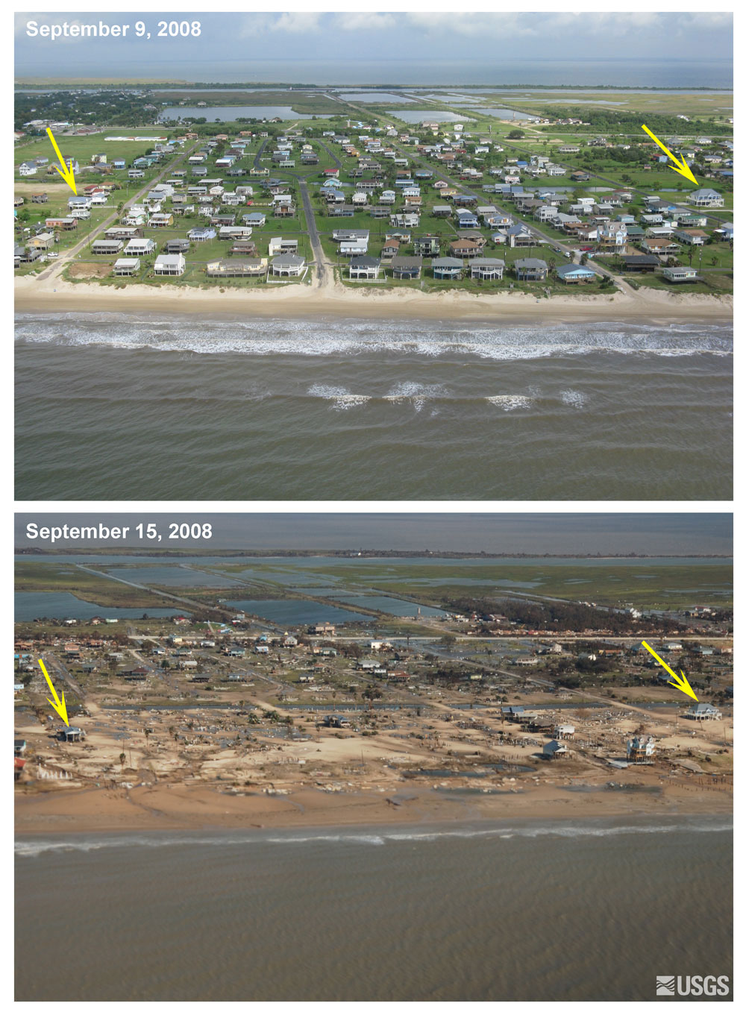

**How Dangerous are They?**

One of the most damaging, and deadly events that occur is the hurricane. When hurricanes move ashore, they bring with them a storm surge of ocean water along the coastline, high winds, tornadoes, and both torrential rains and flooding.

During a hurricane, homes, businesses, roads and bridges may be damaged or destroyed by high winds and/or high waves. Debris from the high winds can damage property. Roads and bridges can be washed away by flash flooding, or can be blocked by debris. In particularly large storms (such as Hurricane Andrew), the force of the wind alone can cause tremendous devastation. Trees and power lines topple and weak homes and buildings crumble. These losses are not just limited to the coastline -- often damage extends hundreds of miles inland.

Hurricanes and their potential for destruction are rated using a scale from 1 to 5 called the [Saffir-Simpson](http://kids.mtpe.hq.nasa.gov/archive/hurricane/saffir-simpson.html) scale. A Category 1 hurricane is the least destructive and a Category 5 hurricane is the most destructive. There are three types of damage caused by hurricanes:

* **Wind Damage**  
  Hurricane-force winds, 74 mph or more, can destroy poorly constructed buildings and mobile homes. Debris, such as signs, roofing material, siding, and small items left outside, become flying missiles in hurricanes. Winds often stay above hurricane strength well inland.
* **Storm Surge Damage**  
  Storm surge is a large dome of water often 50 to 100 miles wide that sweeps across the coastline near where a hurricane makes landfall. The surge of high water topped by waves is devastating. The stronger the hurricane and the shallower the offshore water, the higher the surge will be. Along the immediate coast, storm surge is the greatest threat to life and property.
* **Flood Damage**  
  Widespread torrential rains often in excess of 6 inches can produce deadly and destructive floods. This is the major threat to areas well inland.

Areas in the vulnerable to hurricanes include the Atlantic and Gulf coasts of the United States from Texas to Maine, the Caribbean, and tropical areas of the western Pacific, including Hawaii, Guam, American Samoa, and Saipan

Even Category 1 hurricanes can cause death, property damage and flooding and should be taken very seriously. Coastal areas are often evacuated by the police when a hurricane is approaching.

One of the most damaging, and deadly events that occur is the hurricane. When hurricanes move ashore, they bring with them a storm surge of ocean water along the coastline, high winds, tornadoes, and both torrential rains and flooding.

During a hurricane, homes, businesses, roads and bridges may be damaged or destroyed by high winds and/or high waves. Debris from the high winds can damage property. Roads and bridges can be washed away by flash flooding, or can be blocked by debris. In particularly large storms (such as Hurricane Andrew), the force of the wind alone can cause tremendous devastation. Trees and power lines topple and weak homes and buildings crumble. These losses are not just limited to the coastline -- often damage extends hundreds of miles inland.

Hurricanes and their potential for destruction are rated using a scale from 1 to 5 called the [Saffir-Simpson](http://kids.mtpe.hq.nasa.gov/archive/hurricane/saffir-simpson.html) scale. A Category 1 hurricane is the least destructive and a Category 5 hurricane is the most destructive. There are three types of damage caused by hurricanes:

* **Wind Damage**  
  Hurricane-force winds, 74 mph or more, can destroy poorly constructed buildings and mobile homes. Debris, such as signs, roofing material, siding, and small items left outside, become flying missiles in hurricanes. Winds often stay above hurricane strength well inland.
* **Storm Surge Damage**  
  Storm surge is a large dome of water often 50 to 100 miles wide that sweeps across the coastline near where a hurricane makes landfall. The surge of high water topped by waves is devastating. The stronger the hurricane and the shallower the offshore water, the higher the surge will be. Along the immediate coast, storm surge is the greatest threat to life and property.
* **Flood Damage**  
  Widespread torrential rains often in excess of 6 inches can produce deadly and destructive floods. This is the major threat to areas well inland.

Areas in the vulnerable to hurricanes include the Atlantic and Gulf coasts of the United States from Texas to Maine, the Caribbean, and tropical areas of the western Pacific, including Hawaii, Guam, American Samoa, and Saipan

Even Category 1 hurricanes can cause death, property damage and flooding and should be taken very seriously. Coastal areas are often evacuated by the police when a hurricane is approaching.

**Destructive Power Comparison:**

|  |  |
| --- | --- |
|  | **Category 1** |
| **Category 2** | 10 times |
| **Category 3** | 50 times |
| **Category 4** | 100 times |
| **Category 5** | 250 times |

**Why do Hurricanes Move?**

Hurricanes are "steered" by the prevailing wind currents that surround the storm from the surface to 50,000 feet or more. The storms move in the direction of these currents and with their average speed. The movement of a hurricane affects the speed of the winds that circulate about the center. On one side of the storm, where the circulating winds and the entire storm are moving in the same direction, the wind speed is increased by the forward movement of the storm. On the opposite side of the storm, the circulating wind speed is decreased by the forward motion. In the Northern Hemisphere, the right side of a hurricane, looking in the direction in which it is moving, has the higher wind speeds and thus is the more dangerous part of the storm. The average tropical cyclone moves from east to west in the tropical trade winds that blow near the equator. When a storm starts to move northward, it exchanges easterly winds for the westerly winds that dominate the temperate region. When the steering winds are strong, it is easier to predict where a hurricane will go. When the steering winds are weak, a storm seems to take on a mind of its own, following an erratic path that makes forecasting very difficult.

The major steering wind influence of most U.S. hurricanes is an area of high pressure known as the Bermuda High. This high pressure dome is over the eastern Atlantic Ocean in the winter, but shifts westward during the summer months. The clockwise rotation of air associated with high pressure zones is the driving force that causes many hurricanes to deviate from their east-to-west movement and start northward. Sometimes this is favorable: hurricanes never reaches the shore, and blow out into the Atlantic Ocean. Other times, hurricanes south of the U.S. are steered northward directly towards the coastline.

Because Hurricane movement can be very erratic, scientists have increasingly been called to track them. NASA has been on the forefront on the design, development and deployment of Earth remote sensing spacecraft design to do just this.

Resources

http://www.ec.gc.ca/ouragans-hurricanes/default.asp?lang=En&n=77977664-1

http://kids.mtpe.hq.nasa.gov/archive/hurricane/index.html