EVENT - ICE SHEET MELTING
ALL SPHERES
ESS Analysis

Resources:

NASA Goddard Space Flight Center
NG1 - http://www.gsfc.nasa.gov/topstory/20020606greenland.html
NG2 - http://www.nasa.gov/centers/goddard/news/topstory/2008/greenland_speedup.html
NG3 - http://www.nasa.gov/centers/goddard/news/topstory/2003/1023esuice.html

NASA
N1 - http://www.nasa.gov/vision/earth/environment/cryosphere.html
N2 - http://www.nasa.gov/topics/earth/features/greenland_temps.html

National Public Radio (NPR) – Science Friday
NPR - http://www.sciencefriday.com/pages/2006/Jun/hour1_060206.html

We are the Weathermakers
WATW - http://www.theweathermakers.org/

EHOW
EHOW - http://www.ehow.com/how-does_4741329_ice-affect-ocean-water-levels.html

GREENPEACE
GP - http://archive.greenpeace.org/climate/arctic99/reports/seaice3.html

ECOLOGY.COM
ECOL - http://ecology.com/featuresarchive/earthwarms/

GREENFACTS.ORG

GF - http://www.greenfacts.org/en/arctic-climate-change/l-2/3-sea-level-rise.htm

WOODS HOLE OCEANOGRAPHIC INSTITUTION
WO - http://www.whoi.edu/page.do?pid=12317

EPA
EPA - http://www.epa.gov/climatechange/effects/polarregions.html

LIVE SCIENCE
LIVE - http://www.livescience.com/environment/041222_permafrost.html

WORLD VIEW OF GLOBAL WARMING
WVGW - http://www.worldviewofglobalwarming.org/pages/glaciers.html

SCIENCEBLOG

SCIB - http://www.scienceblog.com/cms/climate_change_could_affect_tectonic_plates_10458.html

HEATISON
HIO - http://www.heatisonline.org/contentserver/objecthandlers/index.cfm?id=5966&method=full

RISING TIDE NORTH AMERICA
RTNA - http://www.risingtidenorthamerica.org/wordpress/2008/12/08/melting-ice-may-slow-global-warming/

NATIONAL GEOGRAPHIC
NG - http://news.nationalgeographic.com/news/2001/05/0509_penguindecline.html

EPA
EPA2 - http://www.epa.gov/climatechange/effects/polarregions.html

The cryosphere consists of those parts of the Earth's surface where water is found in solid form, including areas of snow, sea ice, glaciers, permafrost, ice sheets, and icebergs. In these regions, surface temperatures remain below freezing for a portion of each year. Since ice and snow exist relatively close to their melting point, they frequently change from solid to liquid and back again due to fluctuations in surface temperature. Although direct measurements of the cryosphere can be difficult to obtain due to the remote locations of many of these areas, using satellite observations scientists monitor changes in the global and regional climate by observing how regions of the Earth's cryosphere shrink and expand. (N1)
The cmap can be found on the public directory: cycle_B_ice_sheets_all_spheres_john

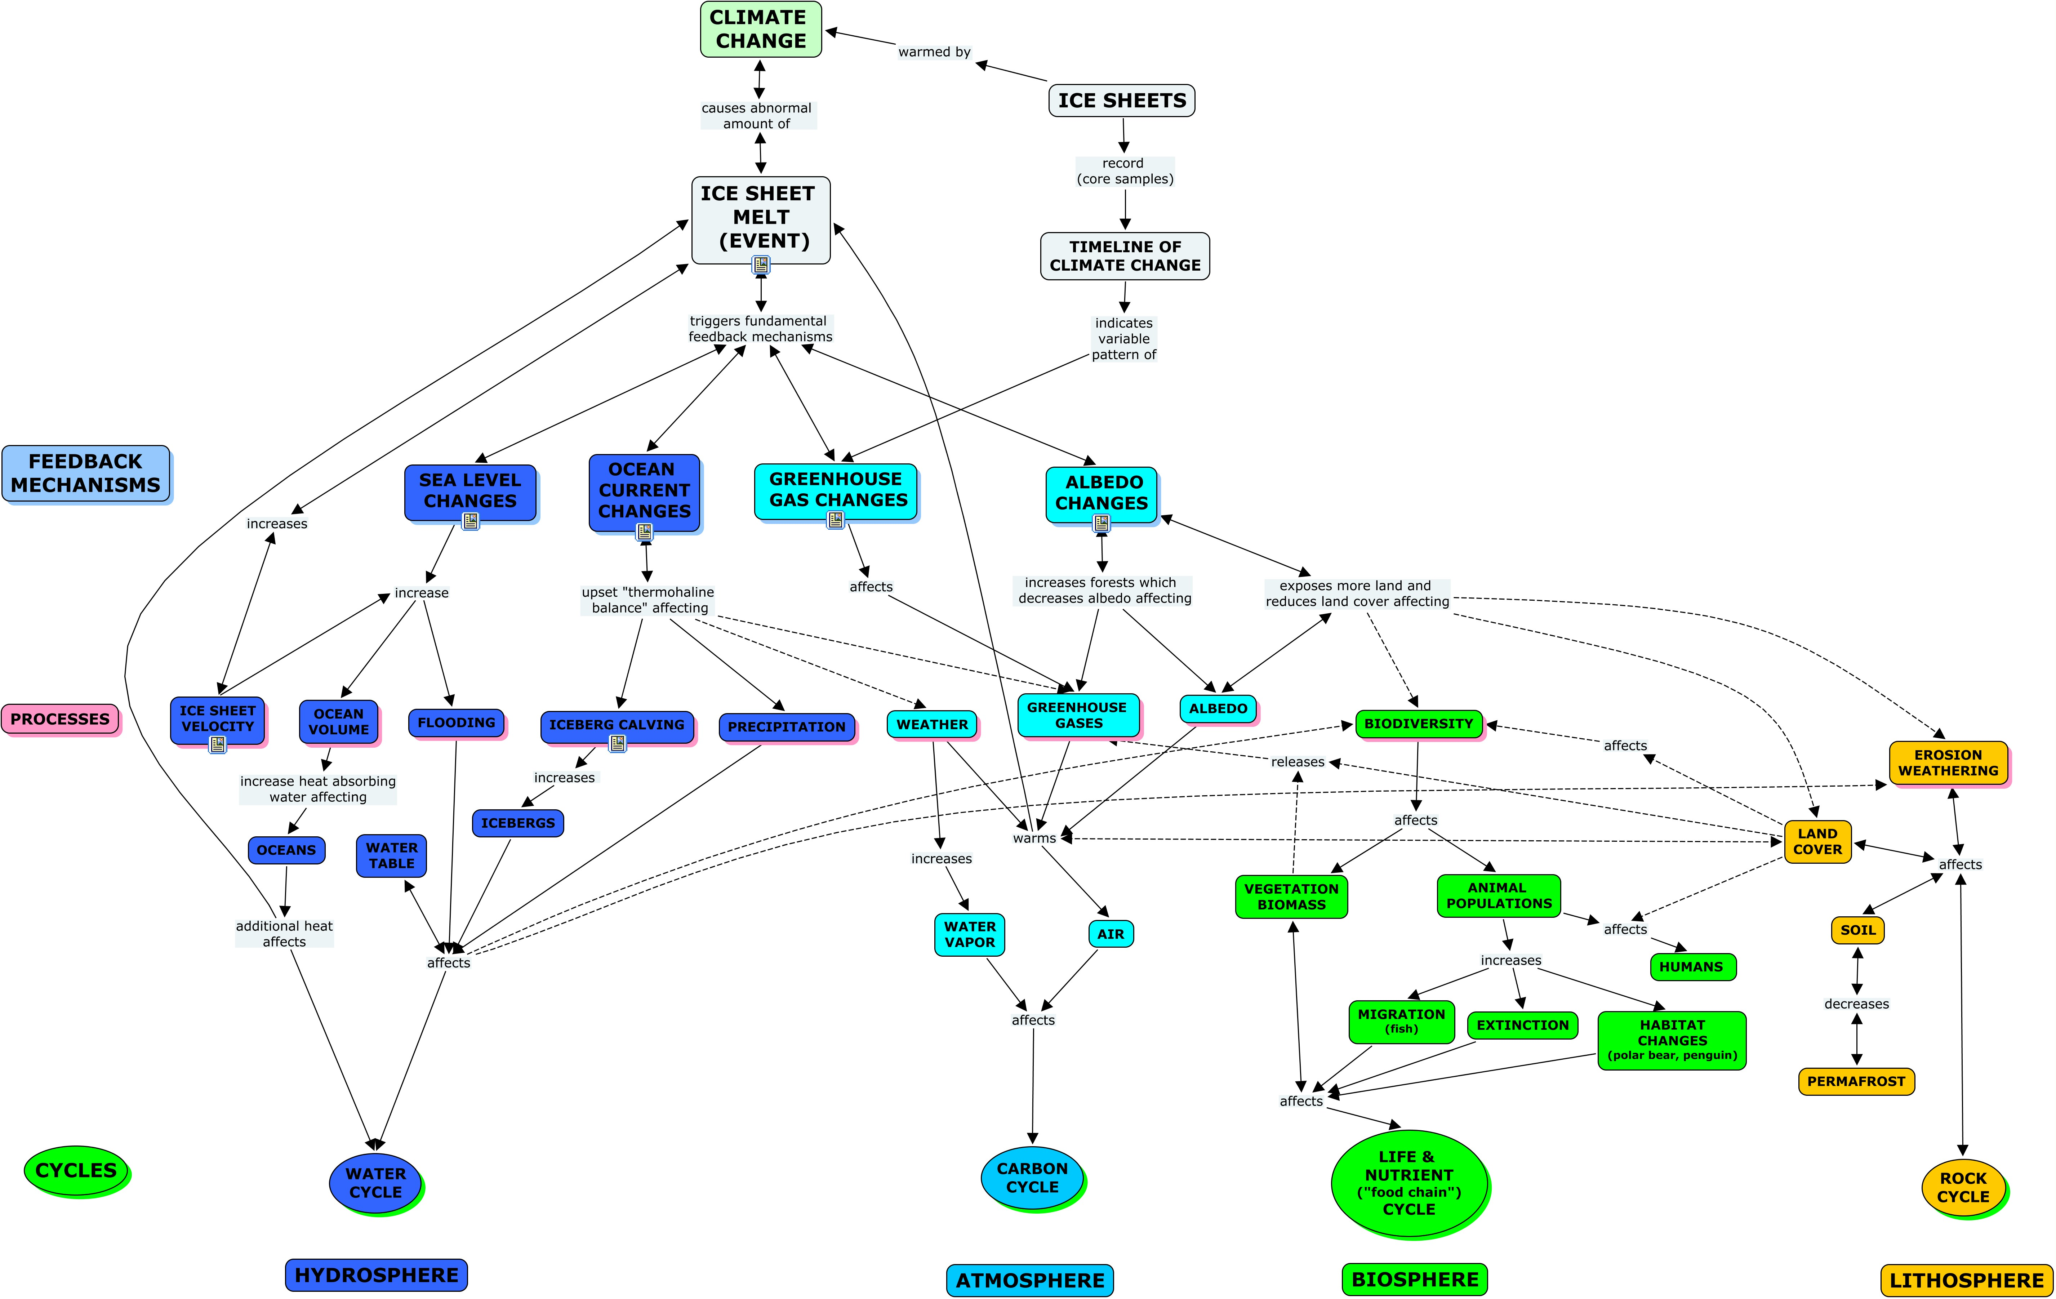

Event Feedback Loops
E > A > E
E > L > E
E > B > E
E > H > E
Arctic warming and its consequences have worldwide implications
The Arctic influences global climate through three major feedback mechanisms, all of which could be affected by global warming.
These mechanisms involve the reflection of sunlight, ocean currents, and greenhouse gas releases. (GF)

ALBEDO:
E > L > E (Ice melt exposes more heat absorbing land cover which in turn causes more ice melt)
As snow and ice are bright white, most of the solar energy that reaches them is reflected back to space. This is one reason why the Arctic remains so cold. As air temperatures are increasing, snow and ice now tend to form later in the autumn and melt earlier in the spring. The darker land and water surfaces, which absorb more of the sun's energy, are thus longer uncovered. This warms the surface further, which, in turn, causes faster melting, creating a ‘positive feedback loop’ that amplifies and accelerates the warming trend. This is one reason why climate change is particularly rapid in the Arctic. (GF)

E > B > E (Ice melt allows forests to move northward which decreases albedo and increases warming leading to even more ice melt)
With Arctic warming, forests are projected to expand northward into areas that are currently tundra. Forests are darker than tundra and mask snow cover on the ground, reducing the reflection of sunlight and further increasing warming. (GF)
E > A > E (Ice melt reduces ice sheet reflectivity reducing albedo leading to more warming that increases ice melt)
The polar caps not only hold much of the planet's total fresh water, but also play an important role in regulating the Earth's temperature. The relevant characteristic is called albedo. It's a measure of how much radiation, or light, is reflected from a body. Similar to how a white shirt helps keep a person cooler in the summer than a black shirt, the vast stretches of polar ice covering much of the planet's top and bottom reflect large amounts of solar radiation falling on the planet's surface. Were the ice caps to appreciably recede, sunlight that otherwise would have been reflected back into space would get absorbed by the darker, denser mass of ocean and land beneath. As light is absorbed, the environment is heated, thus intensifying a feedback loop: a warmer planet yields more ice melting thus an even warmer planet.
This animation provides a closer perspective of the relationship between ice and solar reflectivity. As glaciers, the polar caps, and in this case, icebergs melt, less sunlight gets reflected into space. It is instead absorbed into the oceans and land, thus raising the overall temperature, and adding energy to a vicious circle.
It comes down to a simple principle proved thousands of years ago by the Greek philosopher and scientist Archimedes. He showed that a body, in this case the floating ice of the North Pole, immersed in a fluid, is buoyed up by a force equal to the weight of the displaced fluid. In other words, since the northern pack ice is already floating its melting would not independently cause ocean levels to rise. However, the attending planetary conditions necessary to facilitate polar melting would likely have other enormous effects on the environment. These include the likely melting of the ice sheets covering Greenland and the vast reaches blanketing southern polar cap. As the ice over Greenland and Antarctica is NOT floating, a corresponding rise in the world's sea level would almost certainly result if it melted. (NG3)
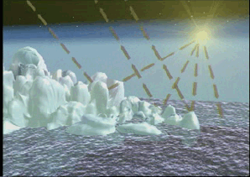
Click on image to view animation
This is a conceptual animation showing how melting ice on land and at sea, can affect the surrounding ocean water, changing both the chemistry and relative sea level. Credit: NASA

E > A: (Ice melt reduces “white blanket” - ice sheet albedo affect)

As albedo is reduced more heat is retained in lithosphere, hydrosphere, and atmosphere. The quick warming and cooling of the earth is regulated by atmosphere – the atmosphere’s sensitivity is a measure of the amount of change necessary to “tip” the warming and cooling balance in the atmosphere. (NPR)

OCEAN CURRENTS:
E > H > A > E (Ice melt can upset thermohaline circulation resulting in more CO2 in the atmosphere causing more ice melt
One of the ways the sun's energy is transported from the equator toward the poles is through the globally interconnected movement of ocean waters primarily driven by differences in heat and salt content, known as the thermohaline circulation (“thermo” for heat and “haline” for salt).
At present, the Gulf Stream current that flows from the Gulf of Mexico to the coasts of Europe warms the winds and provides much of the moisture that falls as precipitation over northwestern Europe. As the water moves northward, it becomes cooler, saltier and denser. As a result, surface water eventually becomes heavier than the water(s) below it and sinks deep into the ocean. This process drives the global seawater “thermohaline circulation” (sometimes referred to as the “conveyor belt”) which pulls warm waters northward. Part of this global circulation is known as the Gulf Stream, providing some of the heat that keeps Europe warmer in winter than regions of North America at the same latitude. Climate change could interfere with the formation of the cold, dense water that drives oceanic circulation and thus bring about further changes in climate.
Slowing the thermohaline circulation would have major global effects:
- The decreasing transport of CO₂, contained in water from the surface to the deep ocean. This would contribute to further increases in the level of CO₂ in the atmosphere and thus to further warming (due to CO₂).
- Regional cooling, for instance in Europe. This could result from the slowing of the northward transport of heat by Atlantic Ocean currents, even while the rest of the planet warms rapidly.
- Reduced sinking of cold, dense water in the Arctic. This would, in turn, reduce the amount of nutrients carried back toward the surface elsewhere in the world that sustain marine life living near the surface.
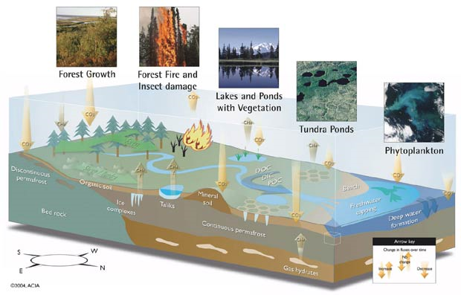

Greenhouse gases are exchanged between the atmosphere and Arctic soils and sediments. These processes can also be affected by global climate change and in turn affect it.
Ocean currents also affect global heat exchange by redistributing heat, especially in coastal regions. In fact, the oceans have the greatest impact on the Earth's climate. Scientists fear that continued melting of sea ice could weaken the North Atlantic Current, the northward continuation of the Gulf Stream. The Gulf Stream transports 25 times more water than all the Earth's rivers, and a diversion could result in extremely cold winters in the North Atlantic regions, especially in northern Europe (Source: US Geological Survey). (ECOL)
Less ice means more open water. More open water means greater absorption of solar energy. More absorption of solar energy means increased rates of warming in the ocean, which naturally tends to yield faster rates of ice loss. (NG3)
Continued warmth in June promoted early breakup and consistent winds in July pushed ice away from the Siberian coast and towards the North Pole. The significance of the physical and chemical processes taking place in the Arctic region extend far outside it. The polar area has been described as a "refrigerator in the equator to pole transport of energy". The NCAR model projects a 3.8 degree Celsius global temperature increase for greenhouse gas doubling, near the high end of typical projections, in part because of shrinking Arctic sea ice. As well as being an area where nutrients are recycled and released into the water, the Polar Front region in the North Atlantic plays a fundamental role in the driving of ocean currents. At the front near the Greenland, Iceland and Norwegian (GIN) seas and the Labrador Sea, warm salty water from the North Atlantic is cooled by Arctic waters and by intense heat loss to the atmosphere; it becomes more dense and sinks to deeper layers of the ocean. Salt rejected as sea ice forms also increases the density and contributes to the process. Although a slow process, this sinking takes place over a wide area and each winter several million cubic kilometres of water sink and begin moving slowly south along the bottom of the Atlantic Ocean. It is known as thermohaline circulation because it is driven in part by temperature and partly by salinity differences. (GP)
The dense, cooled water becomes part of what is termed the Ocean Conveyor and the water eventually returns to the surface in the Indian and Pacific Oceans. As warm water returns to the Atlantic, the current moves polewards as the Gulf Stream and North Atlantic Drift, warming northwestern Europe substantially. In addition, the formation of deep-water also dissolves carbon dioxide from the atmosphere and effectively removes it. This is of significance in the global cycling of carbon. The Arctic region, therefore, plays a fundamental role in ocean circulation patterns, which in turn determine climate patterns over the rest of the globe. (GP)
In 1968, a large area of unusually cold, fresh water appeared off the west coast of Greenland. Subsequent analysis suggests that this water was derived from melting sea ice which had broken off the Arctic ice pack and drifted south. This area of water, now called the Great Salinity Anomaly (GSA), significantly reduced deep water formation in the North Atlantic. Fresher water is less dense than saltier water, and the GSA made the GIN and Labrador seas more buoyant, reducing the deep water formation that drives global ocean circulation. (GP)
Cold temperatures and ice interact in polar oceans to give them distinct circulations that both affect—and are affected by—climate change. At the top of the globe, currents flows into, within, and out of the enclosed Arctic Ocean basin; at the bottom, they encircle the massive Antarctic continent.
In the Arctic, the formation of sea ice helps maintain a delicately balanced layer of cold, salty water, called the halocline, which acts as barrier protecting the sea ice cover from being melted by warmer, deeper waters entering from the Atlantic Ocean. The Arctic's freshwater outflow to the North Atlantic also affects the formation of cold, salty, dense waters, which sink to the depths to propel a climate-influencing global system of currents sometimes called the "Ocean Conveyor."
Antarctica is the only other region where ocean waters become cold and dense enough to sink to the abyss and pump up the Ocean Conveyor. The Antarctic Circumpolar Current is the most powerful current on the planet and the only one that flows completely around the globe, making it a key junction connecting the Atlantic, Indian, and Pacific Oceans. (WO)

However, the most likely source for increased freshwater in the far North Atlantic is increased precipitation. As the climate warms and the sea ice melts, scientists expect that more rain and snow will fall on the Arctic Ocean and the North Atlantic, reducing the saltiness and density of the water. But would this be enough to shut off thermohaline circulation?
Evidence for melting Arctic sea ice is available from many different sources. Warming Arctic landmasses; declining sea ice area, extent and thickness; decreasing salinity; and major changes in Arctic and North Atlantic air and ocean circulation all form part of the picture. Impacts have already been observed on many scales: to Arctic ice algae and other micro-organisms, to walrus and polar bear populations and to Arctic human inhabitants, such as the Inuit. Long term climate records suggest that most of this warming, especially after 1920, is driven by increasing levels of human-created greenhouse gases in the atmosphere.
Computer modeling suggests that, if warming and levels of greenhouse gases continue to increase, most of the permanent ice pack is likely to melt and be replaced by seasonal winter ice. This Arctic meltdown would threaten the productivity of the Arctic Ocean and the continued existence of many Arctic animals, including walrus, many seal species, and polar bears. It would also threaten the traditional lifestyle of the Inuit, the indigenous inhabitants of the Arctic coast.
The accelerated Arctic warming that would result from the removal of the permanent ice pack would significantly increase precipitation over the Arctic Ocean and far North Atlantic. This precipitation, combined with meltwater from sea ice and the Greenland ice sheet, would reduce the salinity of the North Atlantic. Computer models suggest that these changes in salinity, especially if they happen quickly, may severely reduce or completely switch off the North Atlantic Conveyor, which is the major driving force for the Gulf Stream and global ocean circulation. This may significantly cool the climate of northern Europe, and is likely to severely disrupt global marine life and fisheries, as well as reducing the ocean's ability to remove greenhouse gases from the atmosphere. (GP)

The same climatic conditions that created the glaciers, which are essentially great ice sheets formed on land, also formed the Arctic Ice Cap. Yet the ice sheet covering the Arctic Ocean rests directly on top of the ocean instead of land, and it has remained relatively stable and frozen since it was formed... until now.The Arctic Ice Cap is shrinking dramatically. Roughly the size of the United States, it has lost an area roughly the combined size of Massachusetts and Connecticut each year since the late 1970s. Since the 1950s, when data was first collected on the Arctic, the ice cap has lost nearly 22% of its volume. It is projected that in another 50 years, nearly half of the Arctic Ice Cap will be gone. (ECOL)
Global warming is real, and the melting of the Arctic Ice Cap is one of its symptoms.

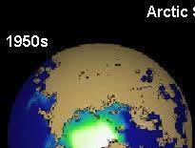 | 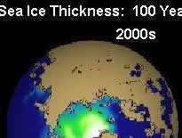 | 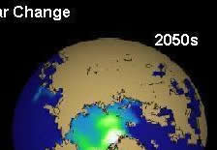
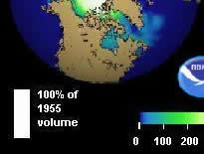 | 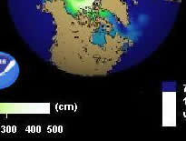 | 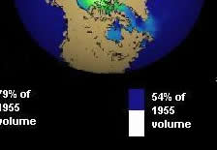
This chart compares the actual loss of Arctic Ice Cap volume between the 1950s and 2000, and the projected loss by 2050. The more ice that is lost, the faster the ice cap shrinks due to the loss of albedo, the amount of light energy that is normally reflected back out into space by the ice cap. (Image: NOAA)
Human activity, such as the burning of fossil fuels, is releasing enormous volumes of carbon dioxide and other greenhouse gases that are contributing to the Earth's natural greenhouse effect ? the Earth's natural process of trapping the sun's warmth. About 5-6 billion tons of carbon dioxide are emitted each year due to human activity (Source: Ohio State University Department of Mechanical Engineering, printed in Science Daily). This increase results in additional heat being trapped within the Earth's atmosphere; (ECOL)
The Polar Ice Cap itself reflects sunlight energy (heat) back into space, rather than the heat being absorbed by the Earth. This is called albedo, the amount of sunlight reflected by an object. As the Ice Cap melts however, the albedo is reduced and the Earth absorbs the energy that is not reflected. Thus, more heat is retained in the Arctic; (ECOL)

The Earth's natural carbon cycling process ? the amount of carbon dioxide that enters and leaves the atmosphere as a result of the natural cycle of water exchange from and back into the sea and plants ? accounts for about 95% of the carbon dioxide in the atmosphere which contributes to the greenhouse effect; (ECOL)
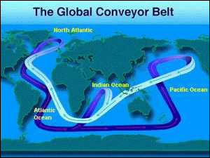
Ocean waters constantly move along a giant oceanic conveyer belt which travels from the North Atlantic to the Atlantic, Pacific and Indian Oceans. This circulation distributes warm tropical waters northward, which are then chilled and returned to the warmer southern oceans. This heat exchange also has a significant impact on global weather patterns. (Image: NASA)
Ocean waters are constantly on the move, carrying warmer waters north toward the Arctic and cooler waters south to the temperate and tropical zones. This ocean circulation is referred to as the great oceanic conveyer belt, which is a single continuous current that carries chilled water from the North Atlantic into the Atlantic, Indian and Pacific basins. The conveyer belt returns water warmed in the tropics back to the North Atlantic. (ECOL)
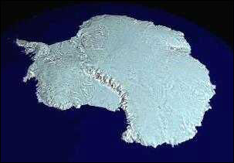
Antarctica is a continental land mass 98% covered by thick ice sheets. It contains 70% of Earth's fresh water and 90% of Earth's ice. The average ice thickness is 1.5 miles, reaching 3 miles deep in some regions. (Image: NASA)

E > H (Ice Melt affects salinity of the ocean currents)
However, with the first measurements of ocean temperature and salinity at the SHEBA site in early October, we found the upper ocean to be less saline and warmer than we had expected, and surmised that this indicated excessive melting." (GP)
By carefully examining the salinity and temperature of layers of ocean water up to 500 meters deep, the SHEBA scientists were able to construct a history of the 1997 melt season in the Beaufort Sea. They concluded that the equivalent of more than two meters of ice must have melted in the Beaufort Sea that year to explain the unusually low levels of salt. (GP)

E > H (Sea melt affects “caps” water convection affecting ocean circulation)

Excessive melting of sea ice, along with runoff from the Greenland Ice Sheet, also has the potential to "cap" deep water convection in the North Atlantic. This could profoundly impact global ocean circulation and climate, Serreze said. "In other studies, changes in the North Atlantic circulation have been implicated in starting and stopping Northern Hemisphere ice ages."
"The unusual conditions seen in 2002 are part of a larger pattern of recent Arctic change," said Serreze. This includes pronounced warming over sub-Arctic land areas. These changes are associated at least in part with a positive trend in the "Arctic Oscillation," characterized by reductions in atmospheric pressure over the Arctic and higher pressures in the mid-latitudes that are associated with more storms and warmer temperatures in the high Arctic.

For the past century, the world's ocean water level has risen at a rate of about .07 inches per year, primarily due to human-induced global warming, according to the United Nations-sponsored Intergovernmental Panel on Climate Change (IPCC). The rate of rise is increasing, measuring .12 inches annually between 1993 and 2003, and it will likely accelerate further as greater amounts of ice melt near the globe's northern and southern poles. (EHOW)

GREENHOUSE GASES:
E > H > L > B > A > E (Ice melt thaws permafrost exposing plant material that releases CO2 (greenhouse gases) that heat the Atmosphere resulting in more ice melt)
Carbon is currently trapped as organic matter in the permafrost (frozen soil) of the Arctic. During the summer, when the top layer of permafrost thaws, and plant material on dry land or ponds decomposes, methane – a very potent greenhouse gas – and CO₂ are released. Higher temperatures lead to an increase in the rate of decomposition and gas production, and possibly to a feedback loop with more warming that results in more releases, causing more warming, and so on.
In the Arctic, vast amounts of methane are trapped in permafrost and in cold ocean sediments in a solid icy form (as methane hydrates or clathrates). A rise in temperature within the soil could initiate the release of methane from permafrost to the atmosphere. This release is a less certain outcome of climate change than the other emissions discussed here because it would probably require greater warming and take more time to occur. If such releases were to take place, the climate impacts could be very large.
Currently, the direct effect of the Arctic Ocean on the level of CO₂ in the atmosphere is limited. This is due to the presence of sea ice that limits the absorption of CO₂ by the water and its uptake by organisms living near the water surface. A reduced ice cover could significantly increase the amount of carbon taken up by the Arctic Ocean. While these changes are likely to be important regionally, the total area affected is not large enough to significantly reduce global CO₂ concentrations in the atmosphere. (GF)

SEA LEVEL CHANGES:
E > H > E (Ice melt can increase oceans’ volume producing more energy absorbing water that warms and leads to more ice melt)
Warming trends like those found in these studies could greatly affect ocean processes, which, in turn, impact Arctic and global climate, said Michael Steele, senior oceanographer at the University of Washington, Seattle. Liquid water absorbs the Sun's energy rather than reflecting it into the atmosphere the way ice does. As the oceans warm and ice thins, more solar energy is absorbed by the water, creating positive feedbacks that lead to further melting. Such dynamics can change the temperature of ocean layers, impact ocean circulation and salinity, change marine habitats, and widen shipping lanes, Steele said. (NG3)

E > H (Ice melt increases oceans volumes raising sea-levels)

CU scientists estimate that a change in the Greenland climate toward warmer conditions would lead to an increase in the rate of sea-level rise mainly due to the dynamic response of the large ice sheet and not so much to the surface melting. (N2)
"For every degree (F) increase in the mean annual temperature near Greenland, the rate of sea level rise increases by about 10 percent," Steffen said. Currently the oceans are rising by a little more than half an inch per decade. In addition, melt water has been shown to directly affect the rate of ice flow off Greenland, penetrating the ice sheet and causing the glaciers to accelerate in speed as they slide over a thin film of melt water. (N2)

E > H > B (Ice melt increases sea level amounts harming coastal communities)
The Greenland Ice Sheet is the largest area of ice on Arctic lands. Part of the top layer of ice of this ice sheet is melting during summer and the area where this is happening increased by about 16% between 1979 and 2002, (which represents) an area roughly the size of Sweden.
Projections from global climate models suggest that the contribution of Arctic glaciers to global sea-level rise will accelerate over the next 100 years. By 2100, the melt of these glaciers will have contributed to a rise of roughly four to six centimeters or even more according to recent estimates. In the longer term, the Arctic contribution to global sea-level rise is projected to be much greater. Some climate models project that local warming over the Greenland Ice Sheet will eventually lead to its complete disappearance, with a resulting sea-level rise of about seven meters.
- First, and most significantly, water expands as it warms, and this is projected to be the largest component of sea-level rise over the next 100 years.
- Secondly, warming increases melting of glaciers and ice sheets, adding to the amount of water flowing into the oceans.
Global average sea level rose almost 3mm (0.12 inches) per year during the 1990s. This is about one millimeter (0.04 inches) more per year than during the decades before that. Global average sea level is projected to rise 10 to 90cm (4 to 36 inches) between 2000 and 2100, with the rise speeding up with time. Over the longer term, much larger increases in sea level are projected.
Sea-level rise is projected to have serious implications for coastal communities and industries, islands, rive deltas and harbors. A number of the world’s most populous cities such at Calcutta and Bangkok will be severely affected. (GF)

E > H > B: (As ocean water levels continue to rise as a result of melting ice, coastal cities around the world may face catastrophic consequences)
E > H > B (Ice melt increases sea-levels impacting biodiversity)
E > H >L (Ice melt increases sea-levels impacting erosion)
E > H >L (Ice melt increases sea-levels impacting land cover)

The bad news is that even relatively minor rises in ocean water levels can have dire impacts for vast numbers of people in low-lying coastal areas. These impacts could include more coastal erosion, increased flooding, reduced supplies of drinking water, losses of property and wildlife habitat, threats to transportation systems and declining incomes from agriculture and tourism.
Major cities like New Orleans and London already rely on man-made structures for protection from storm surges and these structures will need further strengthening as sea levels rise. It is estimated that a sea level rise of around 8 inches would displace 740,000 people in Nigeria. A 3-foot rise in ocean water levels could swamp cities along the U.S. eastern seaboard and 20-foot rise in sea levels would submerge a large portion of Florida. (EHOW)

E > H (Ice Sheet melt affects ocean temperatures)
The Atmosphere is the regulator – however, if compressed into liquid form it is 1/500 of the oceans’ volume. Ozone layer – very thin - When water – too hot – no coral reefs – What is best temp for earth? – oceans control the planet – ideal temp is 10 degrees – According to the Celestial cycles – we should be in cooling period – but are not - 70 meters rise if all ice melts. (WAWM)

================================================================

Event affects the Hydrosphere

E > H (Ice sheet melt creates more calving producing more icebergs)
Scientists know that Greenland is losing ice. Much of Greenland's ice sheet is slow moving, creeping toward the ocean where the ice can calve off as icebergs. The landscape is also dumps ice into the ocean through outlet glaciers – rivers of ice that channel through valleys of bedrock and move at least 10 times faster than the ice sheet. (NG2)
They found that the influence of the violent draining of the lakes had a short-lived influence on the local movement of the ice sheet. Speedup during periods of summer were widespread across Greenland, suggesting that the ice sheet's plumbing is composed of a drainage network that quickly distributes the lubricating meltwater throughout the base of the ice sheet, as opposed to the water remaining confined to a single isolated crack. (NG2)
"If you're really going to get a lot of ice out of Greenland, that would have to occur through outlet glaciers, but those are not being affected very much by seasonal melt," Joughin said. "The outlet glaciers are more affected by the removal of their shelves and grounded ice in their fjords, which decreases resistance to ice flow." (NG2)
Antarctica, which covers the geographic South Pole, is itself covered with thick ice sheets. The average ice thickness is about 1.5 miles with some parts reaching as deep as three miles. Antarctica's ice shelves are also melting, for the same reasons associated with the melting of the Arctic Ice Cap, but not as dramatic. The melting of the Antarctic ice shelves has resulted in the ¦calving² of some of the largest icebergs ever known to exist, such as the series of icebergs that broke off from the Ross Ice Shelf in the spring and summer of 2000 (see ecology.com story, "Largest Existing Iceberg is Born". (ECOL)

E > H > H (Ice sheet melting creates melt water which results in increased ice sheet velocity)

Using periodic Global Positioning Satellite measurements from 1996 through 1999, the researchers discovered that the ice flow speeds up from 31.3 cm (12.3 inches) per day in winter to a peak of 40 cm (15.7 inches) per day in the summer when surface melting is largest. "This study demonstrates that surface meltwater travels quickly through the 1200 meter (approx. 3/4 mile) thick ice to the bedrock to make the ice slide faster. This process was known for decades to enhance the flow of small mountain glaciers, but was not known to occur in the large ice sheets,"
The meltwater makes its way from the surface to the bedrock by draining into crevasses and large tunnels called moulins that may be as large as 10 meters (approx. 33 feet) in diameter. More meltwater underneath the ice sheet provides lubrication to allow the ice sheet to move faster toward the coastline of Greenland.
Over time, as ice melts from the top of the ice sheet, the ice thins and spreads out toward lower elevations closer to the coast.
The meltwater also carries heat (in the form of water) from the top of the ice to the base of the ice that sits on the bedrock.
A separate study by Abdalati and Konrad Steffen of the University of Colorado showed that the melting of the ice sheet surface has been increasing at a rate of nearly 20% over the last 21 years, while summer temperatures in that same period have increased by one quarter of a degree Celsius (.45º Fahrenheit). The link between ice sheet melt and ice flow suggest that the increasing melt may be more significant than previously believed.
The faster ice flow, ice thinning and consequent lowering of the surface elevation of the ice sheet can open a feedback to more melting that has not been considered in computer models that predict ice sheet response to climate change. (NG1)

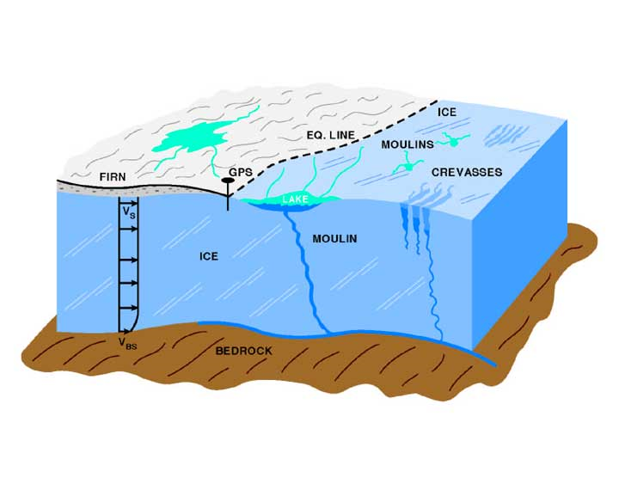
This schematic highlights glaciological features of the ice sheet including surface lakes, crevasses, and large openings called moulins, that stretch up to 10 meters in diameter and drain to the bedrock. Meltwater descends through the moulins, down to the bedrock, contributing to the movement of the ice sheet. The Equilibrium Line (EQ LINE), similar to a snow line on the glacier, is at about 1200 meters elevation in west-central Greenland. In the ablation zone below the EQ LINE, all the winter snow plus some of the ice flowing from higher elevations melts each summer. "GPS" is the marker where the "Global PositioningSystem" was located to observe the movement of the ice sheet. The "V" indicates the velocity of the movement of the ice, some of which is from sliding over the bedrock.
Their first-of-a-kind observations confirm the structure of the Greenland Ice Sheet plumbing, and go further to show that summertime melt indeed contributes to the speed up of ice loss. They also conclude, however, that summertime melt is not as critical a factor as other causes of ice loss. Research by Joughin and colleagues, published April 17 in Science Express, was funded in part by NASA and the National Science Foundation. (NG2)
Scientists have used computer models to show how melt could contribute to the observed speed up of the ice sheet. Meltwater travels through cracks in the ice down to the base of the mile-thick ice sheet where it forms a lubricating layer between the ice and the land. The fluid layer then makes it easier for the ice to slip away toward the ocean. The effect, however, had never been observed in Greenland on a large-scale, a fact that motivated Joughin and colleagues to get a closer look. (NG2)

Event affects the Other Spheres

E > L > A (Ice melt thaws soils releasing greenhouse gases into atmosphere)
If the high latitudes warm, and sea ice extent declines, thawing Arctic soils may release significant amounts of carbon dioxide and methane now trapped in permafrost, and slightly warmer ocean water could release frozen natural gases in the sea floor, all of which act as greenhouse gases in the atmosphere, said David Rind, a senior researcher at NASA's Goddard Institute of Space Studies, New York. "These feedbacks are complex and we are working to understand them," he added. (NG3)

E > A – (Ice melt affects global weather systems by altering albedo)
The Arctic's sea ice is a major driver of global weather systems. The light surface of the ice (which in scientific terms has a high "albedo") reflects solar energy away from the Earth and acts as a natural refrigerator for the planet. (GP)

E > H – (Ice melt affects global weather systems by altering ocean circulation)
Ice and melt water from the Arctic Ocean have profound affects on ocean circulation patterns on the North Atlantic, and from there to ocean and other climate systems over the entire planet. (GP)

E > B (Ice melt affects biodiversity by altering animal migration patterns and methods of transportation, as well as human (Inuit) hunting areas.)
The Arctic's sea ice is home to a wide variety of wildlife, including polar bears, arctic foxes, seals, walruses, and whales, fish species such as Arctic cod and char, and sea birds such as guillemots, auks, and eiders. The sea ice is also used as an important transportation route by caribou and muskox and a traditional hunting ground for the Inuit, that remarkable indigenous culture of the far north. (GP)
Walruses, which travel long distances on floating sea ice that allows them to feed over a wide area may be particularly vulnerable. In a greenhouse future, sea ice will likely melt rapidly in the spring, shrinking quickly over continental shelf areas and withdrawing to the deep ocean of the central Arctic. This could be devastating to walrus, which use sea ice as a platform from which to feed primarily on shellfish on the bottom of shallow continental shelf areas. Many species of seal are ice-dependent, including the spotted seal, which in the Bering Sea breeds exclusively at the ice edge in spring; the harp seal, which lives at the ice edge all year; the ringed seal, which give birth to and nurse their pups on sea ice; the ribbon seal and the bearded seal. (GP)
Climate-related changes in Arctic ecosystems will have consequences not only at local level but also on a global scale because of the many links between the Arctic and the rest of the planet. Many species from around the world migrate to the Arctic in summer and depend on it for breeding and feeding. Climate change will alter some of their habitats significantly. (GF)
E > B (Ice melt can alter the overall “food chain”)
Most Arctic marine species depend upon the presence of sea ice. The Arctic marine food chain begins with ice algae that cling to the underside of the dark ice pack all winter and creates a dense mat under the ice with the end of the long darkness in spring. About six weeks later, a phytoplankton bloom develops in the water beneath the ice. As the ice begins to break-up, the bloom spreads into a wide 20-80 kilometer belt surrounding the ice edge. This highly productive ice-edge ecosystem is home to numerous crustaceans and other invertebrates. These in turn are eaten by fish species such as Arctic cod. Organic material released from the ice algae mat and the phytoplankton bloom enriches the floor of the vast Arctic continental shelves, supporting a benthic (sea bottom) community of shellfish and other invertebrates. Unique among the world's ecosystems, the ice-edge zone moves thousands of kilometers each year, north in spring and south in fall. Walrus, numerous species of seals and cetaceans such as belugas and narwhals all follow the ice-edge, taking advantage of the ready access to food and (for the walrus and seals) the availability of ice to haul-out on for sunning, mating and raising pups. Seals are in turn preyed on by polar bears, humans and Arctic foxes. (GP)
The almost complete elimination of multiyear ice in the Arctic Ocean is likely to be immensely disruptive to ice-dependent microorganisms, which will lack a permanent habitat. Preliminary results from the SHEBA ice camp in the Beaufort Sea suggest that ice algae and other micro-organisms may have already been profoundly affected by warming over the last 20 years. Samples taken at the SHEBA site indicate that most of the larger marine algae have died out, and have been replaced with a much less productive community of microorganisms more usually associated with freshwater ecosystems. The nutrient level in the water under the ice has decreased significantly. (GP)
The major concern, however, would be the increase of fresh, cold water into the marine environment. This would alter ecosystems and the food chain dependent on the saline waters and would funnel more cold water into the oceanic conveyer belt. As a result, you would see a global climate change due to the introduction of the additional cold water into the southern oceans, and you would see a displacement of plant and animals species dependent on the more saline ecosystems. Some animal species will, of course, retreat to the land-based ecosystems.

E > L > B (Ice melt decreases tundra strength affecting human transportation and the world economy)
Moreover, the Arctic has significant oil and gas reserves, and the mineral reserves in parts of Russia and Canada provide large quantities of raw materials to the world economy. Marine access to resources is likely to be enhanced in many places in a warmer Arctic with less sea ice, but access by land is likely to be hampered due to a shortening of the season during which the ground is sufficiently frozen to drive on. (GF)

E > L > B > L > B (Ice melt exposes more land decreasing tundra areas and encouraging forest growth which will affect bird migration and breeding areas)
Expansion of the forests towards the North, for instance, may reduce the size of tundra areas, which are important breeding grounds for hundreds of millions of migratory birds. Indeed, a number of bird species are projected to lose more than 50% of their breeding area during this century, including several globally endangered seabird species. (GF)

LITHOSPHERE

E > L > B (Ice melt thaws permafrost affecting land use (infrastructures))
Community infrastructures will be harmed by the warming and thawing of permafrost. (EPA)

E > L (Ice melt transports rocks and rock debris, and can lead to mud/land slides)
A large block of rock moved by the collapse of a small glacier, Kluane Range, Yukon, Canada. The vertical fall of about half a million tons of glacier ice is calculated to have moved at about 125 mph (200 km/hour) and transported debris down-valley for nearly 1.2 miles (2 kilometers) (LIVE)
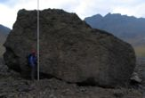

Shallow landslides produced by warm and sunny weather on Ellesmere Island, Canada. The seasonally thawed layer breaks away from the permafrost underneath due to rapid thawing of ice lenses in the soil.
As winters get milder, changes occur underfoot and go largely unnoticed until critical thresholds are reached. Railroad tracks are deformed. Rocky peaks crack apart and spill into ravines. Whole mountainsides lose footing, creating flows of ice and mud that move as fast as a BMW on the Autobahn.
Some 24 percent of land area in the Northern Hemisphere is underlain by perennially frozen ground. Scientists call this permafrost. Another 57 percent -- extending down into much of the United States and Europe -- freezes seasonally.
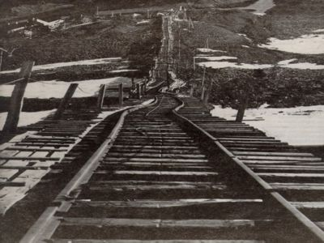
Thawing permafrost can render railroad tracks useless, as seen in this photo from the northern Tibetan Plateau taken in the early 1960s. Credit: Tingjun Zhang

Antoni Lewkowicz of the University of Ottawa has studied several northern landslides and rockslides that he says can be at least partially attributed to thinning and weakening of ice or permafrost caused by climate warming. In one case, an earthquake broke off a weakening glacier in the Yukon. About 500,000 tons of ice raced down a mountain.
"By the time it reached the bottom it would have been going about 140 mph," Lewkowicz said.
At other remote catastrophe sites, Lewkowicz has documented a bizarre situation in which thin permafrost sits atop unfrozen sand containing groundwater under pressure. The system is stable until the icy overlay gets slushy. The whole mess then gives way.
Some of these events expose a layer of earth -- perhaps a very salty layer -- on which nothing can grow for years, resulting in "profound ecological effects," Lewkowicz said.
And landslides like this could become common if the climate grows warmer, as many scientists expect it will.
Charles Harris of Cardiff University in the United Kingdom documented rockslides high in the Swiss Alps that, again, were related to thawing permafrost. During 2003, the warmest summer on record in the Alps, the slushy active layer of the permafrost moved down from its long-term average depth of 15 feet (4.5 meters) to 29 feet (9 meters).
"There is likely to be an increase in rockfalls and landslides" at high-altitude sites, Harris said.
More research is needed, the scientists agree, to understand exactly what is happening globally, what the future holds, and what might be done to mitigate certain problems. (LIVE)

E > L (Ice melt affects land cover by increasing thermokarsting and wet/marsh lands)

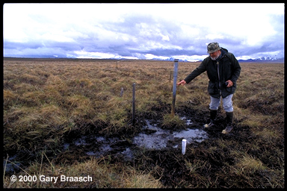
Geophysicist Tom Osterkamp indicates ground level when he installed this temperature probe pipe near Denali Park, 15 years ago. Alaska permafrost temperature has increased 0.5° to 1.5° C since 1980, when Osterkamp began measuring ground temperature at 30 sites. Many of those sites show thermokarsting like this. Serious effects include forest damage, sinking roads and buildings, eroding tundra riverbanks, changes in tundra vegetation, and increased carbon dioxide and methane emissions from thawed peat
Just how serious a threat thawing tundra can be is being measured in Northern Sweden. Rising atmospheric temperatures are causing the disappearance of permafrost and its replacement with marshland or open water. At Stordalen Mire near Abisko National Park, where careful records and aerial photos were available for comparison, the amount of wetland increased more than 50 % at the expense of higher dry land which had been underlain by permafrost. Study leader Patrick Crill reports this has increased the emission of methane from the mire, a powerful greenhouse gas, by as much as two-thirds over 1970 emissions. A 2004 study by Torben Christensen and others directly measured hydrocarbon emissions from the Mire, and found that almost all the emissions were methane. The scientists express concern that methane emissions seem to increase with temperature and could be a positive feedback creating even more atmospheric warming. (WVGW)

E > L (Ice melt leading to more rain-induced erosion could influence tectonic plates)
The erosion caused by rainfall directly affects the movement of continental plates beneath mountain ranges, says a University of Toronto geophysicist — the first time science has raised the possibility that human-induced climate change could affect the deep workings of the planet.
He found that when mountains are exposed to New Zealand-type rainfall (which causes one centimetre of erosion per year) compared to southern California-type rainfall (which erodes one-tenth of a centimetre or less), it profoundly changes the behavior of the tectonic plates beneath the mountains. “These are tiny, tiny changes on the surface, but integrating them over geologic time scales affects the roots of the mountains, as opposed to just the top of them,” says Pysklywec. “It goes right down to the mantle thermal engine — the thing that’s actually driving plate tectonics. It’s fairly surprising — it hasn’t been shown before.” (SCIB)

E > L (Ice melt reduces pressures in Earth’s crust resulting in earthquakes, tsunamis, and volcanic eruptions)

A number of geologists say glacial melting due to climate change will unleash pent-up pressures in the Earth's crust, causing extreme geological events such as earthquakes, tsunamis and volcanic eruptions. A cubic meter of ice weighs nearly a ton and some glaciers are more than a kilometer thick. When the weight is removed through melting, the suppressed strains and stresses of the underlying rock come to life. Because the earth is so viscous the rebound happens slowly, and the quakes that occasionally shake Eastern Canada are attributed to ongoing rebound from the last ice age more than 10,000 years ago. Melting of the ice that covers Antarctica or Greenland would have a similar impact, but the process would be accelerated due to the human-induced greenhouse effect. When a quake happens under water it can cause a tsunami. Wu said melting of the Antarctic ice is already causing earthquakes and underground landslides although they get little attention. He predicted climate warming will bring "lots of earthquakes."
When the glaciers melt, the re-liquefied water causes sea levels to rise and increases the weight on the ocean floor, which could also have an effect on the grinding tectonic plates deep below the surface. No one has claimed that the Christmas tsunami of 2004 was triggered by rising sea levels. But that event seems to have sparked new interest in the links between climate and geology.
"All over the world evidence is stacking up that changes in global climate can and do affect the frequencies of earthquakes, volcanic eruptions and catastrophic sea-floor landslides," says British geologist Bill McGuire, writing in New Scientist magazine.

The reason is that one cubic meter of ice weighs just over a ton, and glaciers can be hundreds of meters thick. When they melt and the water runs off, it is literally a weight off Earth's crust. The crust and mantle therefore bounce back, immediately as well as over thousands of years. That "isostatic rebound," according to studies of prehistoric and recent earthquakes and volcanoes, can make the planet's seismic plates slip catastrophically, and cause magma chambers that feed volcanoes to act like bottles of shaken seltzer. The world-wide melting of glaciers portends a seismically active future because of isostatic rebound and also because the meltwater from liquefying glaciers adds mass atop oceanic plates. That creates a teeter-totter effect, further destabilizing the planet's crust.
"The pressure of the ice sheet suppresses earthquakes, so removing that load triggers them," says Prof. Wu. That creates weakened zones that remain vulnerable to seismic activity to this day, including in northern Europe. "Present-day earthquakes may have their origin in postglacial rebound," he says.
In southwest Alaska, where the Pacific plate thrusts under the continental plate, the immense mass of glacial ice counters the tendency of the plates to slip catastrophically. As global warming melts the glaciers, however, the ice load is diminishing. As a result, Earth is springing back there, too, removing the check on seismic activity. The magnitude 7.2 temblor that shook the area in 1979 is linked to a bounce-back of the crust, conclude geoscientists Jeanne Sauber of NASA's Goddard Space Flight Center and Bruce Molina of the U.S. Geological Survey. (HIO)

BIOSPHERE
E > B > A (Ice melt can create more icebergs which can carry compounds that increase the growth of plankton which in turn could affect greenhouse gas levels)

As the icebergs drift northwards, they sprinkle the minerals through the ocean. Among these minerals, Raiswell’s research shows, are iron compounds that can fertilize large-scale growth of photosynthetic
plankton, which take in carbon dioxide from the air as they flourish.
A key question is how much of the carbon soaked up by the growing plankton is returned to the atmosphere. ‘We simply don’t know the answer to that,’ Raiswell said. Seeding the oceans with iron will only benefit the climate if the plankton sink to the bottom when they die, taking the carbon with them.
He said the number of icebergs in the Antarctic was expected to rise by about 20 per cent by the end of the century, which could remove an extra 500 million tonnes of carbon dioxide each year, if they all seeded plankton growth. (RTNA)

E > H > B (Ice melt influences ocean currents that affect penguin habitat)
Over the past 50 years, the population of Antarctic emperor penguins has declined by 50 percent. Using the longest series of data available, reseachers have shown that an abnormally long warm spell in the Southern Ocean during the late 1970s contributed to a decline in the population of emperor penguins at Terre Adelie, Antarctica. The warm spell of the late 1970s is related to the Antarctic circumpolar wave—huge masses of warm and cold water that circle Antarctica about once every eight years. In response to this cycle, Terre Adelie experiences a warming period every four or five years that generally lasts about a year. In the late 1970s, however, the warming continued for several years. Whether it was the result of natural climate variability in the Antarctic circumpolar wave cycle or an anomaly related to global warming is not possible to determine because air and sea surface temperature data from many years ago are not available. Weimerskirch thinks the unusually warm spell was probably the result of global warming. (NG)

A > E > B
H > E > B (Warmer air and sea temperatures reduce sea ice leading to a decline in krill that adversely affects the “food chain”)
Warmer air and sea surface temperatures in the Antarctic reduce the amount of ice in the sea. This, in turn, leads to smaller populations of krill, a shrimp-like crustacean that is a staple of the emperor penguin's diet. With less food to eat, emperor penguins die. (NG)

E > H > B (Ice melt contributes to greenhouse gases resulting in greater ocean acidification that adversely affects marine corals)
Ocean acidification will adversely affect marine calcifiers by making it more difficult for these organisms to form protective shells (NG)

E > B (Ice melt will probably have devastating affects on the “food chain” and biodiversity in general)

Reduction in sea ice is very likely to have devastating consequences for polar bears, ice-dependent seals, and local people for whom these animals are a primary food source. (NG)

Arctic impacts will have implications for biodiversity around the world because migratory species depend on breeding and feeding grounds in the Arctic.
Reduced sea ice is likely to increase marine access to the region’s resources, expanding opportunities for shipping and possibly for offshore oil extraction (although operations could be hampered initially by increasing movement of sea ice in some areas).
As frozen ground thaws, many existing buildings, roads, pipelines, airports, and industrial facilities are likely to be destabilized.
Increased areas of tree growth in the Arctic could serve to take up carbon dioxide (CO2, the principal greenhouse gas emitted by human activities) and supply more wood products and related employment, providing local and global benefits. However, tree growth would mean absorption of additional sunlight (as the land surface would become darker and less reflective) and add to regional warming.
Climate change is taking place within the context of many other ongoing changes in the Arctic, including observed increases in chemical contaminants entering the Arctic from other regions, overfishing, land use changes that result in habitat destruction and fragmentation, rapid growth in the human population, and cultural, governance and economic changes.
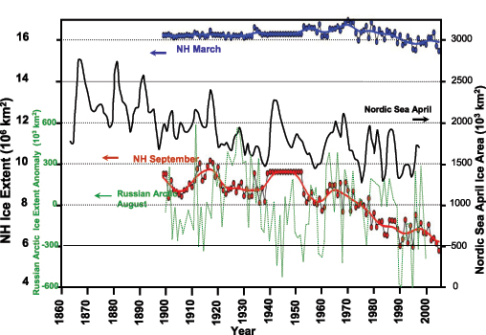

ATMOSPHERE

A > E (atmospheric circulation affects Ice melt)

The total area of surface melt on the Greenland Ice Sheet for 2002 broke all known records for the island and the extent of Arctic sea ice reached the lowest level in the satellite record, according to scientists at the University of Colorado at Boulder. Researchers from the CU-based Cooperative Institute for Research in Environmental Sciences, or CIRES, say the accelerated melting appears to be linked to shifts in Northern Hemisphere atmospheric circulation patterns. (N2)

A > E (Atmospheric pressure patterns can move sea ice)
A > E (Atmospheric temperature increases can cause sea ice to melt)
Researchers have suspected loss of Arctic sea ice may be caused by changing atmospheric pressure patterns over the Arctic that move sea ice around, and by warming Arctic temperatures that result from greenhouse gas buildup in the atmosphere. (NG3)

A > E (Warm air circulation in the atmosphere increases ice melt)
The second factor is a major change in Arctic air circulation patterns. Average sea level pressure has dropped over the central Arctic Ocean, and there has been an increase in high latitude storms. As a result of these changes, relatively warm spring and summer air masses from much of the Arctic coast are able to penetrate far over the Arctic Ocean, melting some sea ice and driving much of the remainder away from the shore and towards the central ice pack. (GP)
One of the major results of these changes has been a lengthening warm season during which sea ice can melt. The melt season has varied between 55 and 75 days between 1979 and 1996, and has lengthened at a rate of 5.3 days (8 percent) per decade during that time. Once areas of open water, called "leads", have opened in the ice, these darker areas of ocean (technically called areas of lower "albedo") reflect less sunlight, warming up and thus melting still more ice. (GP)

A > E: (Increase of greenhouse gases warms air leading to greater ice melt)
It is likely that greenhouse-gas-induced Arctic warming is one of the major factors for the significant decline in sea ice area and thickness observed in many Arctic seas over the past few decades. General circulation computer models of the atmosphere project that greenhouse warming will occur more intensely over the Arctic in the future than any other part of the planet… (GP)

