Tundra-Vegetation Biomass Changes
The tundra is a valuable biomass which takes in more carbon dioxide from the atmosphere than it releases. It is one of the Earth’s major CO2 sinks. The carbon dioxide from the remains of plants is trapped in the permafrost for long periods of time. Excess C02 can be kept from escaping into the atmosphere for thousands of years. As global warming warms and melts the tundra, the plant mass begins to decompose, releasing the trapped carbon dioxide into the atmosphere.
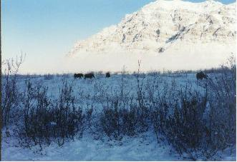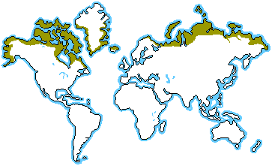

Any change in this fragile environment, will change the ecosystem, changing the plant and animal populations who depend on the tundra environment. In other areas of the world, the permafrost has been replaced by wet, marshy areas. Some of these areas have increased methane emissions, increasing greenhouse gases, causing the warming cycle to be accelerated.

The Marielandia Antarctic tundra depends on the sea for its resources. Mosses, lichens and algae are part of the limited plant life found on this tundra. Fear of global warming affecting this tundra as well will possibly change this “ecoregion”.

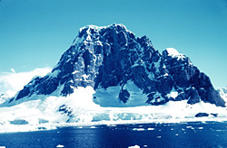
As the permafrost thaws, there is a fear that the tundra will be replaced by forests, changing the landscape. New plant species may be introduced, such as agrosstis stolonifera could be a threat as this species gets everywhere and overtakes other species of plants. New organisms can find their way to the tundra from tourists carrying seeds, spores and insect eggs. The unknown conclusion is whether this change will help change global warming for the better or worse.
E > B > E (Ice melt allows forests to move northward which decreases albedo and increases warming leading to even more ice melt)
With Arctic warming, forests are projected to expand northward into areas that are currently tundra. Forests are darker than tundra and mask snow cover on the ground, reducing the reflection of sunlight and further increasing warming. GF
E > H > L > B > A > E (Ice melt thaws permafrost exposing plant material that releases CO2 (greenhouse gases) that heat the Atmosphere resulting in more ice melt)
Carbon is currently trapped as organic matter in the permafrost (frozen soil) of the Arctic. During the summer, when the top layer of permafrost thaws, and plant material on dry land or ponds decomposes, methane – a very potent greenhouse gas – and CO₂ are released. Higher temperatures lead to an increase in the rate of decomposition and gas production, and possibly to a feedback loop with more warming that results in more releases, causing more warming, and so on.
In the Arctic, vast amounts of methane are trapped in permafrost and in cold ocean sediments in a solid icy form (as methane hydrates or clathrates). A rise in temperature within the soil could initiate the release of methane from permafrost to the atmosphere. This release is a less certain outcome of climate change than the other emissions discussed here because it would probably require greater warming and take more time to occur. If such releases were to take place, the climate impacts could be very large.
Currently, the direct effect of the Arctic Ocean on the level of CO₂ in the atmosphere is limited. This is due to the presence of sea ice that limits the absorption of CO₂ by the water and its uptake by organisms living near the water surface. A reduced ice cover could significantly increase the amount of carbon taken up by the Arctic Ocean. While these changes are likely to be important regionally, the total area affected is not large enough to significantly reduce global CO₂ concentrations in the atmosphere. GF

Resources:
http://archive.greenpeace.org/climate/arctic99/reports/seaice3.html GF
http://www.blueplanetbiomes.org/tundra.htm
http://www.nationalgeographic.com/wildworld/profiles/terrestrial/an/an1101.html
http://www.environmentalgraffiti.com/offbeat-news/global-warming-alien-invasion-antarctica/740

