Permafrost
Jamie Fryrear
How are the ice sheets melting connected to permafrost? Permafrost is where the ground has been frozen solid with water for more than a couple of years. There are different types of permafrost too, some permafrost that is seasonal which means it thaws in the warmer months and some permafrost that is more permanent and rarely thaws. Ice that melts in the ground can be very damaging to many things. First of all, ice, opposed to liquid water, takes up more space. So if ice that has been frozen in the ground melts, it is going to leave a hollow space. This will cause grounds to buckle or leave potholes. There are towns that have been built on permafrost. Some rural communities have been engineered to survive the thawing of the ground and some towns have not been so lucky.
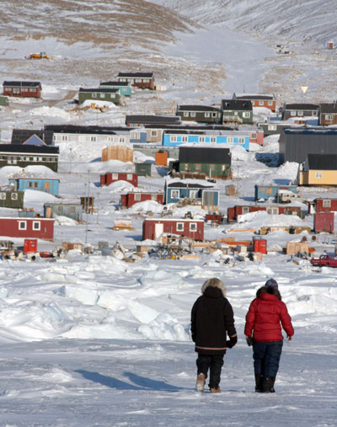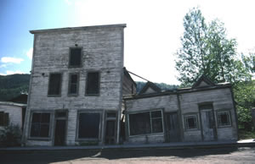

There are many other things that affect the grounds either freezing or thawing. The altitude affects the ground freezing. The higher the altitude, the colder the air is which means the grounds beneath will also be cold. Also the higher the altitude, the weaker the sun’s rays are which can melt the ice in the ground. The location of the permafrost can also be an advantage or disadvantage. If the permafrost is located at the poles then the chances of the ground thawing are less. Permafrost located at places other than the poles have a greater risk of melting due to warmer temperatures. Additionally, the amount of sunlight an area receives can also be an indicator of how much permafrost there is going to be. If the grounds receive lots of sunlight because the days are longer then that’s a disadvantage. But, if the grounds receive little sunlight then that is an advantage to permafrost not thawing as much. Also the amount of snow an area receives can be either helpful or harmful to permafrost. Snow can act as an insulator in the ground thus trapping all the heat in so more snow is not necessarily a good thing because it doesn’t allow the heat to escape thus thawing the grounds.
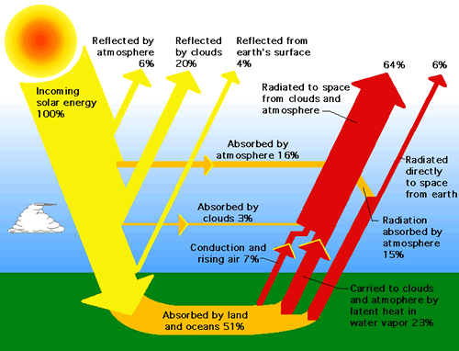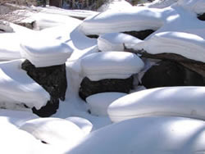

Additionally, the type of soil that surrounds permafrost can be either a good thing or a bad thing. Lighter colored soil freezes sooner as opposed to darker colored soil. Lighter colored soil also stays frozen longer than darker colored soil. The light colored soil reflects the sun’s rays, whereas, the darker colored soil absorbs the heat from the sun’s rays thus melting the frozen water found in the ground. Think about when a person wears a light colored shirt verses a dark colored shirt. The lighter colored one reflects the heat as the dark one absorbs the heat.

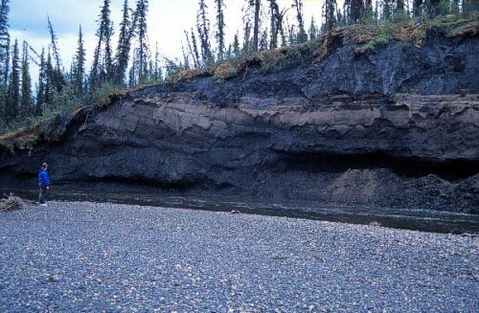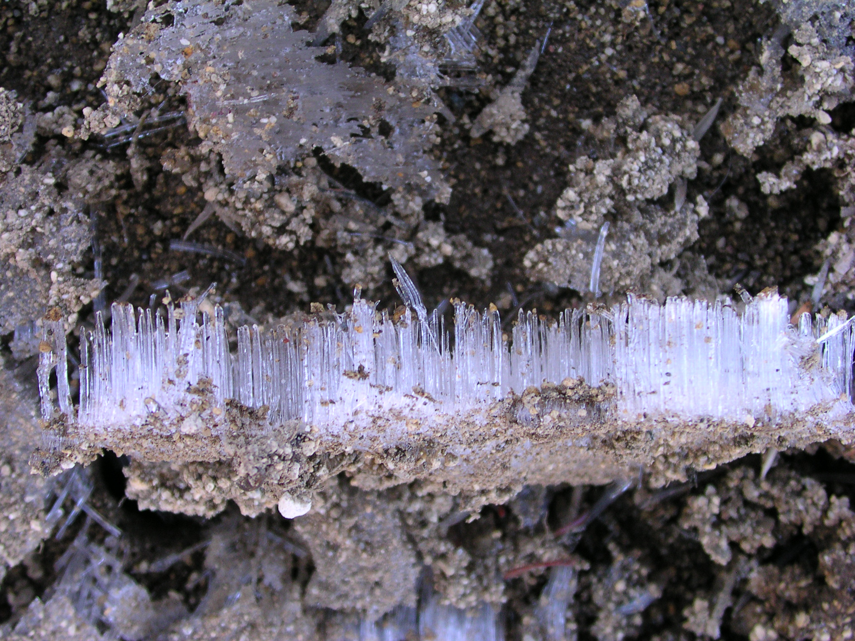

Warmer temperatures will cause the ice sheets to melt thus causing the ground to thaw. Thawing permafrost can cause landslides and “drunken forests.” Drunken forests are forests that have trees growing at an ankle. The roots of these trees are barely in the ground resulting in trees falling over easily. Trees help keep the soil cooler by blocking the sunlight. Branches can also block snow from hitting the ground and snow can act as an insulator of heat to the ground so if there are no branches from the tipsy trees then the grounds heat and the thawing begins.
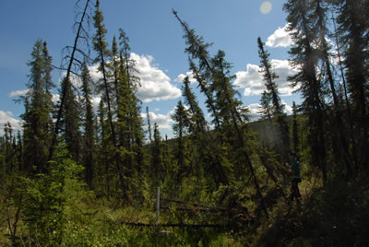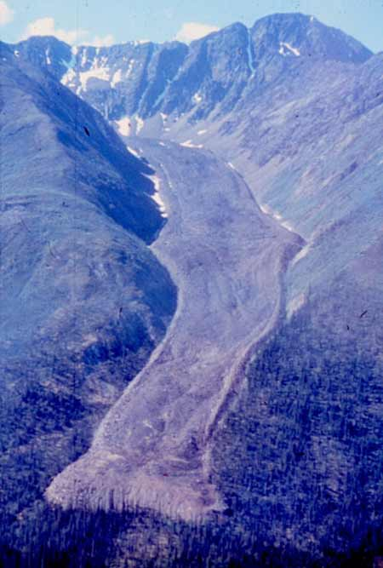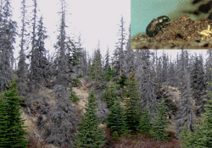

When the ice sheets melt thus causing the permafrost to thaw it ends up affecting the plants around the permafrost too. Plants absorb the sun’s energy and protect the permafrost from thawing. Permafrost, on the other hand, provides melted water for the plants. So, the plants and the permafrost have a great working relationship without the permafrost then the plants will suffer. Also, peat moss helps keep the ground cool. Peat moss is from plants. If plants are not able to grow andthrive then peat is not produced thus causing the grounds to heat and thawing the permafrost. Additionally, some thawing of the ground is expecting. When this happens it forms bogs which are bodies of water that are rich in soils and nutrients. Many types of animals and insects depend on these bogs for their survival.
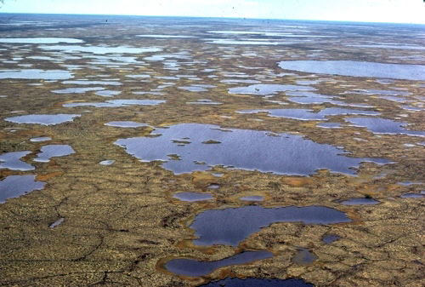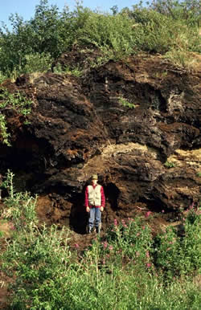

E>L: Ice sheets melting leads to permafrost below the ground thawing which leads to potholes, sub-surface hollows and landslides.
E>L>B: Ice sheets melting can cause the permafrost to thaw leading to structures collapsing or cracking plus leading to “drunken trees.”
E>A>H>L: Ice sheets melting causes weather patterns to change leading to more or less precipitation in the atmosphere which leads to the permafrost thawing because snow traps the heat in so more snow is not a good thing for permafrost.

Resources:
http://nsidc.org/frozenground/what_affects_fg.html
http://www.nasa.gov/centers/goddard/news/topstory/2008/greenland_speedup.html
http://www.eoearth.org/article/Impacts_of_global_warming_in_Alaska

