Tundra-Vegetation Biomass Changes
The tundra is a valuable biomass which takes in more carbon dioxide from the atmosphere than it releases. It is one of the Earth’s major CO2 sinks. The carbon dioxide from the remains of plants is trapped in the permafrost for long periods of time. Excess C02 can be kept from escaping into the atmosphere for thousands of years. As global warming warms and melts the tundra, the plant mass begins to decompose, releasing the trapped carbon dioxide into the atmosphere.
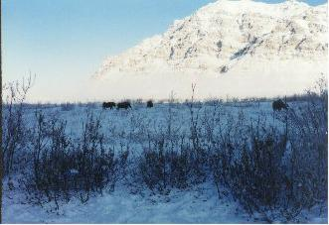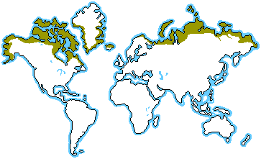

Any change in this fragile environment, will change the ecosystem, changing the plant and animal populations who depend on the tundra environment. In other areas of the world, the permafrost has been replaced by wet, marshy areas. Some of these areas have increased methane emissions, increasing greenhouse gases, causing the warming cycle to be accelerated.

The Marielandia Antarctic tundra depends on the sea for its resources. Mosses, lichens and algae are part of the limited plant life found on this tundra. Fear of global warming affecting this tundra as well will possibly change this “ecoregion”.

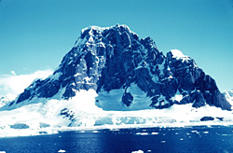
As the permafrost thaws, there is a fear that the tundra will be replaced by forests, changing the landscape. New plant species may be introduced, such as agrosstis stolonifera could be a threat as this species gets everywhere and overtakes other species of plants. New organisms can find their way to the tundra from tourists carrying seeds, spores and insect eggs. The unknown conclusion is whether this change will help change global warming for the better or worse.

Resources:
http://www.blueplanetbiomes.org/tundra.htm
http://www.nationalgeographic.com/wildworld/profiles/terrestrial/an/an1101.html
http://www.environmentalgraffiti.com/offbeat-news/global-warming-alien-invasion-antarctica/740

