Ingredients
- 2 Large Cans of Tuna in Water
- 2 Braeburn apples or Gala Apples
- 3 Stalks of Celery
- 1 Small Red Onion
- 1 Cup Golden Seedless Raisins
- 1/2 Cup Mayo
- 1/2 Cup Sweet Pickle Relish
- 1/2 Cup Crackers (I used Ritz Chips)
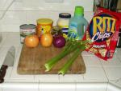

Step 1
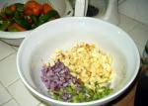\
Wash and chop the apples and celery coarsely, and mince the onion. If your apples start turning brown, you cut too slow.

Step 2
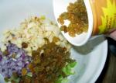
Add the raisins to the bowl and mix.

Step 3
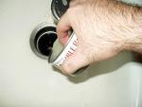
Open a can of tuna and strain.

Step 4
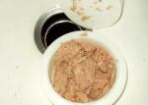
Strained tuna:

Step 5
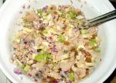
Stir the tuna loosely with the other ingredients in bowl.

Step 6
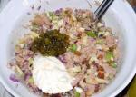
Add mayo and relish to taste.

Step 7
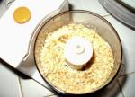
Take the crackers and crumble them into the tuna. You can crumble them by putting them into a zip loc bag and smashing them or use a food processor like I did.

Step 8
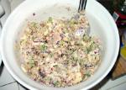
Mixing the cracker crumbs into the tuna:

Step 9
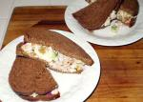
Serve tuna mixture on pita bread, crackers or my favorite: dark rye. Add sunflower seeds or sprouts if you are brave. Enjoy!

