Amy C. Bledsoe Follin
Anna Local Schools Art Education
September 20, 2010
bledsoe.curriculummap.contentpage.doc

Curriculum Design: Content Page

Sandy Skoglund was born in Quincy, Massachusetts in 1946. When she was a teenager, her family moved to southern California. This lifestyle was quite different from the east coast; the bright colors of the houses and flowers inspired her. After living in California for a few years, Sandy got a job working at Disneyland. It was there where she realized that fantasy applies to real life, and to people of all ages.

After high school graduation, Sandy attended Smith College in Northhampton from 1966-1968. Then from 1969-1972 she attended graduate school, studying art at the University of Iowa. During her studies she became fascinated with film, but eventually moved into photography as her main media. She has been a Professor of Art since 1973, and is currently teaching photography and installation art/multi-media at Rutgers University, New Jersey.

Sandy is interested in human behavior in suburban environments. Her experiences growing up in suburbia show through her fantastical installations, and photographs of these installations, depicting different realities. Her works question social norms, values, and practices in a surreal world gone seriously awry. Sandy approaches her artwork from an outrageous fantasy point of view, adding only human subjects as a means to connect her installations to real life. Sandy normally creates the animals by hand (ceramic goldfish, bubblegum “germs”), and poses actors into her photographs to add to these unusual scenes. She creates displays that everyone can relate too, yet her dream-like tableau gives the viewer an uneasy feeling. Sandy is known for her large, brightly colored Cibachrome photographs of her installations.

Sandy Skoglund’s 1981 installation, Revenge of the Goldfish, depicts a dream-like atmosphere that takes place in a couple’s all-blue bedroom. The oddity of fish floating in the room creates an uneasy feeling in the viewer. This piece is open up to the possibility of many interpretations, but generally reflects upon concerns and fantasies of a post-modern world. While viewing the work, one should question, “Why are these fish getting revenge? And if they are getting revenge, on whom, the subjects in the bedroom?” Sandy’s installations are mainly about the relationship between humans, suburban environments, and nature.

Another installation work done by Sandy is called The Green House, completed in 1990. Here, Sandy uses many dogs, a common American household pet, to fill a living room that is completely covered in Astroturf/grass! Her use of the bright, contrasting green and purple colors adds to the oddity of the fantastical environment. Another interesting detail to observe is that the real actors in the picture seem to be oblivious to their surroundings. This may be an additional comment on suburban living/social norms that Sandy is trying to portray through her work.

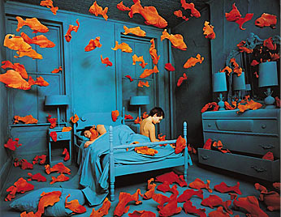
Revenge of the Goldfish, 1981. Cibachrome print, 30 x 40 inches.

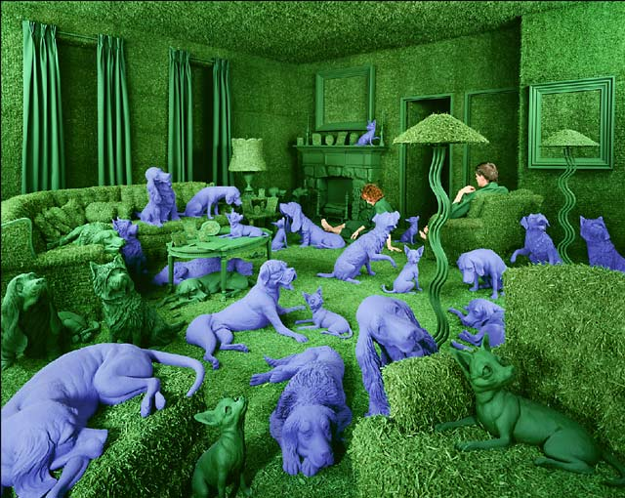
The Green House, 1990. Photo Cibachrome print, 134 x 164 cm.
References

A gallery for fine photography-Sandy Skoglund. (2001). Retrieved September 15, 2010, from http://www.agallery.com/Pages/photographers/skoglund.html

Art and music since 1945 and artist and musicians biographies. Art Education 160D Unit 22: Sandy Skoglund. Retrieved September 15, 2010, from http://accad.osu.edu/~rarnold/index.html

Beyond real: the art of Sandy Skoglund at the visual arts center of New Jersey. (2010). Retrieved September 15, 2010, from http://www.sandyskoglund.com/

Walker, S. R. (2001). Teaching meaning in artmaking. Worcester, Massachusetts: Davis Publications, Inc.

