Fermentation Lab Name:
All organisms need energy to live. Cellular respiration is the process they use to convert the energy stored in sugars into the quick energy of ATP. If oxygen is available, the mitochondria can perform their “energy generator” job and make a lot of ATP energy. This version of respiration is called aerobic respiration and it produces enough ATP energy to support large active, multicellular animals like you and me.
If oxygen is not available, large organisms cannot produce enough energy to survive. That’s why we die if we cannot breathe. But even though there is no oxygen, some one-celled organisms can still digest sugars and make enough ATP energy to live and grow. This version of respiration is called anaerobic respiration. Anaerobic means “without oxygen”. Anaerobic respiration is used by bacteria and fungi and is also referred to as fermentation. There are two types of fermentation:
lactic acid fermentation which is used by bacteria (and how we make yogurt) and also occurs in muscle cells when they are oxygen-deprived like during a sprint race:
glucose ATP + lactic acid

alcoholic fermentation, which is used by yeast (a one-celled fungus) and how we make beer, wine, bread, and many other foods:
glucose ATP + alcohol + CO₂
Complete the concept map using the following terms:
Cellular respiration, fermentation, ATP+lactic acid, ATP+alcohol+ CO₂ , lactic acid, alcoholic, CO₂ ₊ H₂O+ATP
Obtaining Energy(ATP)

Anaerobic
Aerobic
Process:
Process:

Produces

Produces
Produces

In this lab, we are going to explore alcoholic fermentation. Really? Yes, really! When yeast break down glucose to make ATP energy they also make two waste products: alcohol and CO₂. Unfortunately for the yeast, the alcohol eventually builds up and kills them. The CO₂ the yeast produces collects in the fermenting liquid and makes it fizzy. That’s why we use the terms “carbonation” or “carbonated beverage”. This is the old-fashioned way that soda was made, like root beer, birch beer, and sarsaparilla. And that’s what we are going to recreate in this lab: producing carbonated root beer through the fermentation of sugar.

MATERIALS
▪ empty 1 liter plastic bottle and cap ▪ spring water
▪ ½ c. sugar ▪ funnel
▪ 1/8 tsp. yeast ▪ ½ T. or1½ tsp. root beer extract

PROCEDURE:
The procedures listed below are measurements for one lab team of 2 people.
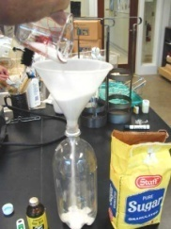
1. With a dry funnel, add in sequence:
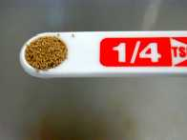
½ c. sugar
1/8 tsp. yeast

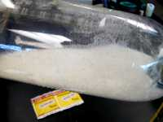
2. Shake to distribute the yeast in the sugar

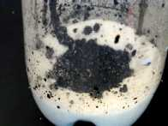
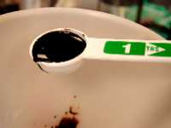
3. Add with funnel: ½ Tablespoon or 1 ½ tsp. of root beer extract on top of the dry sugar.

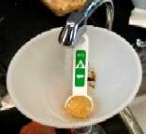
4. Half fill the bottle with fresh cool water.
5. Rinse in the extract which sticks to the tablespoon and funnel. Swirl to dissolve the ingredients.

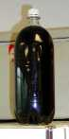
6. Leaving about an inch of space at the top, fill up the rest of the bottle with water. Screw on the top.
7. Invert the bottle until all the ingredients are mixed and dissolved.
8. Place at room temperature about three to four days until the bottle feels hard to a forceful squeeze. Move to a cool place (below 65 F).
9. Refrigerate overnight to thoroughly chill before serving. Crack the lid of the thoroughly chilled root beer just a little to release the pressure slowly.

SUMMARY QUESTIONS
1. Describe the appearance of the root beer before the fermentation process.

2. Describe the difference between anaerobic and aerobic:

3. What process are we using to create the rootbeer? Write the name and equation of the process.

4. Could we survive using this same process? If not, why not?

5.Why was the sugar necessary in this experiment?

6. Why do we have to leave the bottle for a few weeks before we drink it?

7. In step 8, why is it necessary to move the bottle to a cool place?

