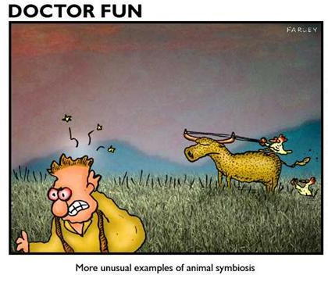
Symbiosis project Name:

You are to complete one of each type of project for the 3 types of symbiotic relationships: commensalism, mutualism, parasitism. You may pair any of the project types with any relationship type, but you must use them all.
- Bumper sticker: create a bumper sticker displaying a slogan, drawing, or both.
- Commercial/infomercial: create a short commercial (2-3 minutes) “selling” your relationship of choice. You may think of a product or service that will help solve “relationship” problems, etc. You must have a script and may use approved props from around the room.
- Biography: invent a biography (story of YOUR life as an animal or human) which describes one type of symbiotic relationship you have been in. You can make these up or use actual experiences. Be sure to include specific examples, feelings, etc.
Be creative!!!

