The Six Kingdom System Name:
Fill in the table below by selecting terms from the following list: multicellular, unicellular, autotrophic, heterotrophic, prokaryotic, eukaryotic

Kingdom | Archaebacteria | Eubacteria | Protista | Fungi | Plantae | Animalia
Example | 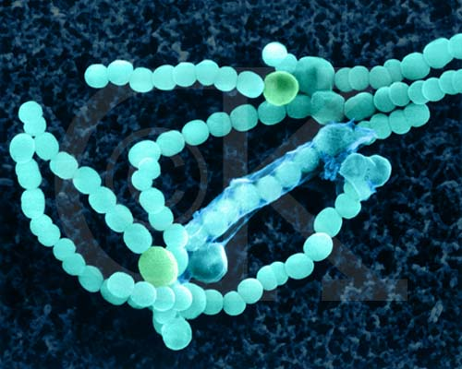 | 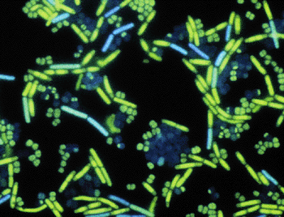 | 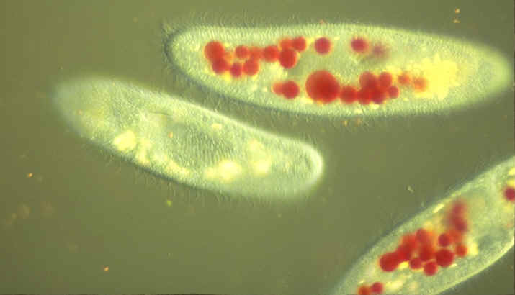  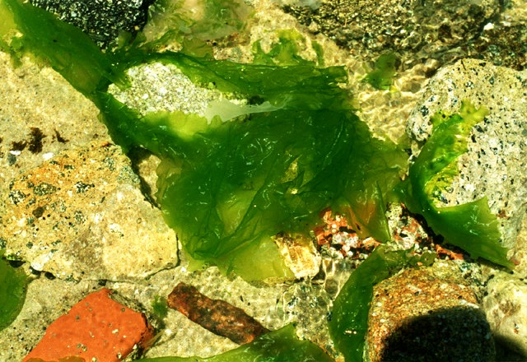 | 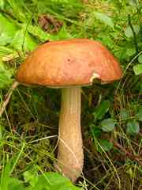 | 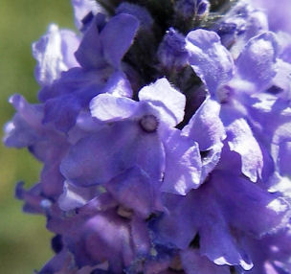 | 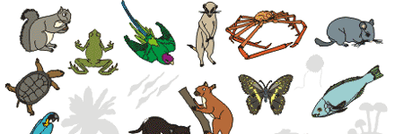  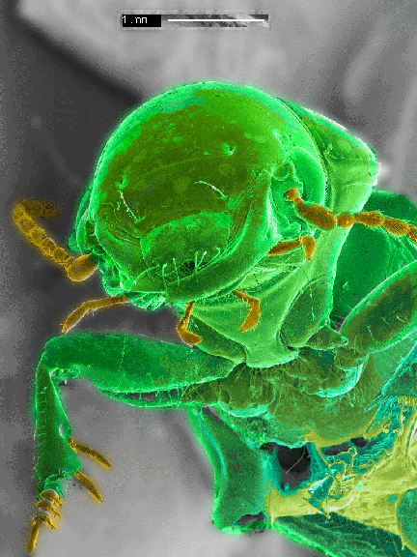
Number of
cells

Example:

Where are they found? |  |  | X | X | X | X
Form of
Nutrition(A/H)

- If you were asked to classify an organism that is multicullular and autotrophic, in which kingdom might you place it?

- If your “mystery organism” is unicellular and prokaryotic, into which two kingdoms might you place it?

- If the “mystery organism” is multicellular, eukaryotic, and, it could belong to which two kingdoms?

- What characteristics would help you determine in which kingdom it belonged?

