Name: ____________________________________ Class: _______________ Date: _______________________

Meiosis Internet Project

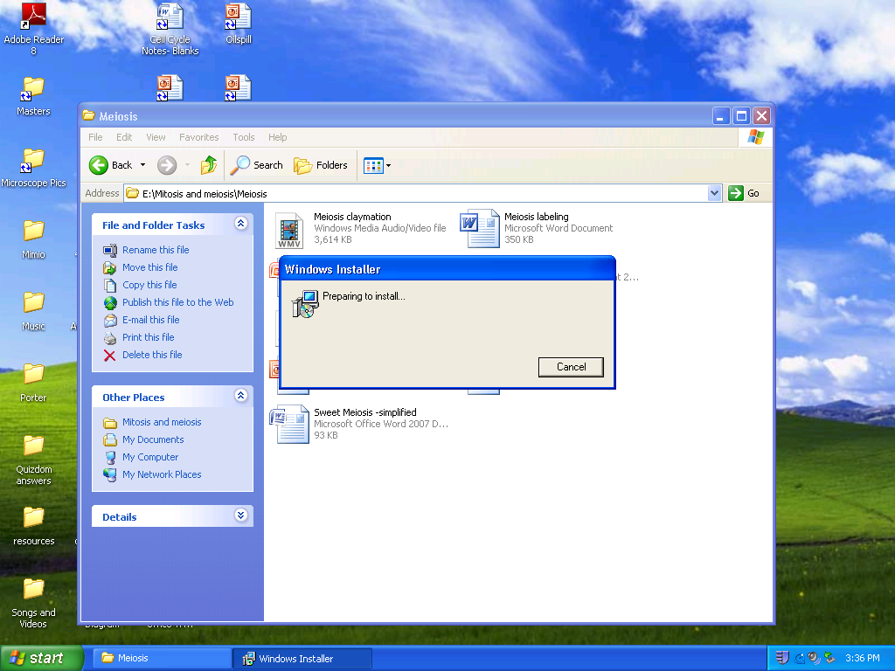
IMPORTANT: When you get to this screen, leave it alone!!! DO NOT CLICK CANCEL or your animations will not work.
-Be patient, it may take a minute or two.
- Download the document by saving it to your server(when you click save, make sure it is under the “my documents” under YOUR NAME.
- Put your name on the top.
- Click CTRL+link or copy/paste the link into your web browser.
- Answer the following questions for each link.
- Save regularly so you don’t lose your work.
- Print out at the end. You may need to install a printer. If so, I will tell you how or ask someone who already knows. →Print to lab C135
- When, and only when, you have your printout handed in, you may turn off your computer.

Site 1 - Lew-Port's Meiosis Page
Go to http://www.lew-port.com/10712041113402793/lib/10712041113402793/animations/meiosis.html

How many chromosomes does the cell in this animation start with?
What type of cells does meiosis form?

What does it mean to replicate?

The homologous pairs are represented by similar:
Copies of chromosomes are held together by the :
Each chromosome finds its:
What is another word for “crossing over?”
How many chromosomes are at each pole of the cell? ___________
Only _________ copy of each chromosome moves toward the poles.
New membranes form around each ____________________________
Each cell divides, forming a total of ______________ cells.
PRINT OUT YOUR WORKSHEET BEFORE YOU CONTINUE. You will need to sketch the images for site 2.
Site 2 - Biology in Motion - Meiosis
Go to http://www.sumanasinc.com/webcontent/anisamples/majorsbiology/meiosis.html
1. Read through the introduction information.
2. Select the “Animation” tab.
3. Select the “Narrated” button and listen to and watch the simulation.
4. When the animation finishes, select “Intro” to return to the start. This time, select “Step through” so that you can fill in the chart below. Follow the prompts to watch each step and read its explanation.
5. Sketch each phase of meiosis on the paper that is handed out:
6. Take the Quiz and fill in your answers below.
- With respect to meiosis, when does DNA replication occur?
  - Before meiosis I only
  - After meiosis I only
  - Before and after meiosis I
  - After meiosis II
- When does crossing over take place in meiosis?
  - Anaphase I
  - Metaphase I
  - Prophase I
  - Telophase I
- Skip this one.
- During which of the following phases of meiosis does the membrane reform around the chromosomes?
  - Prophase I
  - Anaphase II
  - Telophase II
  - Metaphase I

Site 3: Comparing mitosis and meiosis
Go to http://highered.mcgraw-hill.com/olcweb/cgi/pluginpop.cgi?it=swf::535::535::/sites/dl/free/0072437316/120074/bio17.swf::Comparison of Meiosis and Mitosis. Click on play. You can view text at the bottom by clicking text. If you have speakers, you can click audio and it will be read aloud.

After viewing the animation, fill out the chart below, by placing an X in the box or boxes to indicate which the event occurs in (some events might have checks for both mitosis and meiosis).
 | Meiosis | Mitosis
Chromosomes condense and become visible
Two cell divisions
Spindle fibers form
Two cell divisions
Two daughter cells
Four daughter cells
Occurs in asexual reproduction
Occurs in sexual reproduction
Occurs in every cell except sperm/egg
Occurs only in sperm/egg

