Emotional Regulation

An Instructional Design for
Early Childhood

Megan Fantozzi
EDTL 7100
11/05/10

Rationale

Positive social interaction is a fundamental and vital human skill which serves as the basis for success in all venues of life. Knowledge of how to effectively and respectfully speak, listen, negotiate, cooperate, and interact with diverse individuals is vital to one’s educational journey, relationship development, and eventual career path. “Learning to get along with others—adults and peers—is one of the single most important skills acquired in childhood” (Petty, 2009, p.84). Embedded within the knowledge of learning to get along with others is the challenging task of emotional self-regulation. Children must learn how to recognize, accept, and regulate their feelings appropriately if they are to attain healthy, positive social relationships with others. This proposed instructional design will address the issue of positive social interaction through a relevant and contextualized investigation of emotions and emotional regulation.
According to Ann S. Epstein, a director of early childhood at the High/Scope Educational Research Foundation in Ypsilanti, Michigan, social knowledge coordinates development in all other domains of learning. “Social development underlies and affects all other areas of learning and development, and so it is an important part of the early childhood curriculum” (Epstein, 2007, p.69). Epstein breaks the domain of social development/competence into four focused categories: emotional self-regulation, social knowledge and understanding, social skills, and social dispositions (p.69). Thus, this design’s focus on emotional regulation will assist children in developing the skills and knowledge needed to become socially competent individuals capable of developing meaningful, healthy social relationships with others.
The philosophical approach for this instructional design is rooted in the well-established and revered research of Lev Vygotsky and his theory of the ZPD, or the zone of proximal development. Petty (2009) describes the ZPD as an approach in which “an adult or more competent peer provides just the right level and amount of support to help a younger, less capable learner acquire skills and knowledge” (p.81). Throughout this instructional design, educators will assist children in attaining emotional regulation by offering individualized modeling, coaching and support within the context of the classroom learning environment. Authentic classroom issues, situations and problems will be posed and utilized as learning experiences. Children will be encouraged to interact through on-going dialogue and problem-solving methods. These strategies will be used to collaboratively construct understanding regarding emotional regulation and positive social interaction. This instructional approach will facilitate a blend of socio-cultural theory and contextualized teaching and learning theory.
The basic lesson planning model will serve as the chosen model for the instructional planning of this pro-social design. This model was selected due to its relevance and appropriateness for the early childhood setting. Children engaging in this instructional design will most likely be in the three, four or five-year-old age group. These students learn most effectively when information is presented through concrete and concise methods within an appropriate period of time. The basic lesson planning model will most effectively enable the instruction to remain concrete, succinct, and appropriately timed for the developmental levels of the age group, while still thoroughly addressing objectives and content.
The instructional design teaching model chosen for this unit is the social problem-solving meeting model. The content of the unit will be presented within the context of a class meeting, which has been established as a useful method of instruction in the early childhood setting. Class meetings provide the opportunity to build a sense of community and interconnectedness among students and teachers, which are key factors in developmentally appropriate practice. “Children develop best when they have secure, consistent relationships with responsive adults and opportunities for positive relationships with peers” (National Association for the Education of Young Children, 2009, p.13). Since the content of this instructional design is social in nature, the social-problem solving meeting is assuredly an appropriate and natural approach to instruction. In addition, this model assists in facilitating progress toward the goal of positive social interaction. This model will be utilized to pose authentic, contextual social issues and situations to the students for further exploration, discussion, and generation of solutions. In conjunction with the basic lesson planning model, this teaching model will enable each student to investigate several key principles of pro-social behavior, including emotional regulation methods and tools.
The philosophical basis, as well as the planning and teaching models utilized throughout this instructional design, will positively impact classrooms as the elements combine to create a caring and investigative community of learners. The implementation of these approaches will facilitate relevant, appropriate, and contextual learning experiences. These experiences will assist students in accomplishing the objectives of the emotional regulation subunit while simultaneously addressing the issue of positive social interaction.
References
Epstein, A.S. (2007). The intentional teacher: choosing the best strategies for young children’s learning. Washington D.C.: NAEYC.
National Association for the Education of Young Children. (2009). Developmentally appropriate practice in early childhood programs serving children from birth through age eight. Position Statement, 1-32. Retrieved from
http://www.naeyc.org/files/naeyc/file/positions/position%20statement%20Web.pdf.
Petty, K. (2009). Using guided participation to support young children’s social development. Young Children, 64(4), 80-84.
Emotional Regulation Unit Outcomes
- Students will identify the various types of human emotions. (memory/recall)
- Students will identify management and relaxation techniques used to respond to various emotions. (memory/recall)
- Students will identify the cause of human emotions within the context of the classroom and their personal lives. (comprehension)
- Students will recognize that there are many ways to appropriately express one’s feelings. (comprehension)
- Students will acquire and independently demonstrate the effective use of emotional management techniques. (application)
- Students will acquire and demonstrate the effective use of non-aggressive assertion techniques within a social setting. (application)
- Students will analyze both hypothetical and authentic contextual situations for the appropriate use of emotional management techniques, as well as propose alternative responses and solutions to the given situation. (analysis, synthesis)
- Students will formulate a safe and appropriate strategy for reacting to feelings of anger and sadness. (synthesis)

Pre-Assessment
The pre-assessment components for this emotional regulation unit will include both an observational checklist of social/emotional behavior conducted within the classroom setting, as well as a “Feelings Inventory” administered individually to students. These pre-assessments should be conducted one to two weeks prior to the implementation of this unit’s first lesson. The observational checklist of social/emotional behavior will serve as a documentation tool regarding each child’s emotional management techniques within the context of daily social situations and interaction with peers. The “Feelings Inventory” will provide information regarding each child’s recognition and knowledge of the various emotions and their causes. This pre-assessment is two-fold, as the ensuing unit will focus on both emotional recognition and regulation. After administration of the pre-assessment, each component should be reviewed and evaluated by the teacher to determine each child’s level of understanding regarding the unit content. This information will serve as an instructional basis for the teacher, guiding the content and design as needed.

Observational Checklist of Social/Emotional Behavior
Child’s Name: _____________________________________________________
Date of Birth: _____________________________________________________
Observation Date: _______________________________________________

Administrator instructions: Observe the child for the following social/emotional behaviors. Check “yes” or “no” to indicate the presence or absence of each behavior. Provide a brief description of the behavior, as well as the context in which it occurred. If the behavior is not observed, check N/O (not observed).

Behavior | Yes | No | N/O
Verbalizes feelings (i.e., “I’m mad”)
Demonstrates physically aggressive behavior toward other children (i.e., shoving, hitting)
Demonstrates verbally aggressive behavior toward other children (i.e., screaming, shouting)
Utilizes relaxation techniques as method for controlling emotions (i.e., takes a deep breath, removes self from situation)
Demonstrates appropriate, assertive behavior toward other children (i.e., asking for a turn, saying “I am using it, give it back”)

Feelings Inventory
Child’s Name: ________________________________________________________________
Date of Birth: _________________________________________________________________
Date Administered: ___________________________________________________________

Administrator Instructions: Ask the child each question as follows. Record the child’s exact response in the space provided.

- Look at each person’s face. How do you think they are feeling?

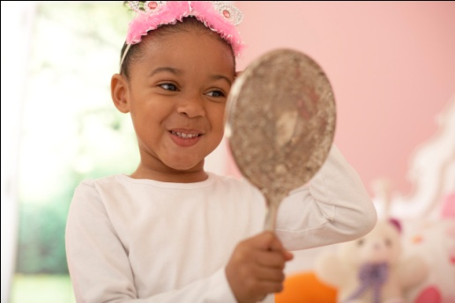  “____________________________________  ____________________________________  ____________________________________” | 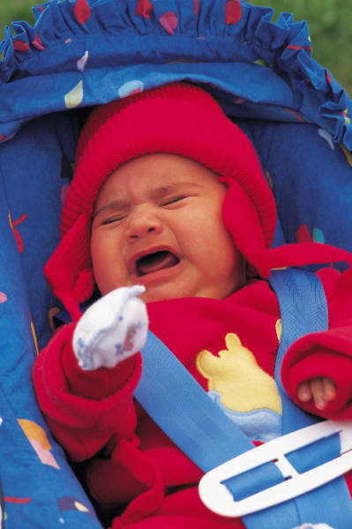  “_____________________________________  _______________________________________  ______________________________________”
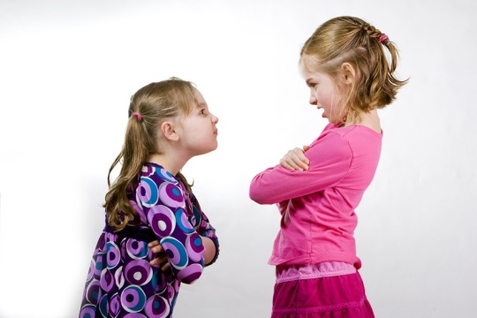  “____________________________________  _____________________________________  ____________________________________” | 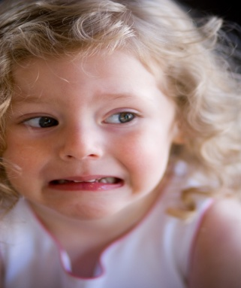  “______________________________________  _______________________________________  ____________________________________
- What makes you feel happy?
“____________________________________________________________________________
___________________________________________________________________________”
- What makes you feel sad?
“____________________________________________________________________________
___________________________________________________________________________”
- What makes you feel mad?
“___________________________________________________________________________
____________________________________________________________________________”
- What makes you feel scared?
“___________________________________________________________________________
___________________________________________________________________________”
- What do you do when you are mad?
“____________________________________________________________________________
___________________________________________________________________________”
- What do you do when you are sad?
“___________________________________________________________________________
___________________________________________________________________________”
- What do you do when you are scared?
“_____________________________________________________________________________
____________________________________________________________________________”

Lesson One
Exploring and recognizing basic emotions

Concept or Skill To Be Learned (Content)
- Basic human emotions
Unit Outcome
- Students will identify the various types of human emotions. (memory/recall)
Lesson Objectives
- Students will be able to recognize the four basic human emotions (happy, sad, angry, and scared) as conveyed through the facial expressions of both self and others.
- Students will be able to classify pictures of children based on the feeling portrayed.
Procedures
- Introductory Activity (10 minutes)
- Assemble students on classroom rug to begin social meeting.
- Introduce social issue utilizing “Mr. Hopper”, the class meeting rabbit mascot/puppet.
  - “Good morning school family! How are all of you feeling today?” Allow time for student responses. Utilize emotion words by asking, “Are any of you feeling happy/sad/angry/scared? How can you tell if someone is feeling happy/sad/angry/scared?” Allow time for discussion of emotion words.
  - “Today I brought a special book to share with you. This book has many different kinds of feelings inside.”
- Read “Glad Monster, Sad Monster” with the children. While reading, utilize questions such as, “How do you think this monster is feeling? How can you tell he is feeling sad? Have you ever felt sad before? What happened to make you feel sad?”
- Developmental Activity (10-15 minutes)
- Show children four small “Feelings Baskets”, each with a different emotion word and visual picture representing the emotion. Ask the children to help you figure out what the word on the basket says.
- Place the four baskets in the middle of the meeting rug.
- Allow each child the opportunity to reach into the “Feelings Bag” and pull out one of the “Four Basic Emotions Pictures”.
- Encourage each child to look at the picture, verbalize the feeling portrayed, and place the picture in the matching “Feelings Basket”.
- Provide support and comprehension by asking questions such as, “How do you think this child is feeling? What does this child’s face look like? I noticed this child has tears in his eyes, what do you think this means?”
- Concluding Activity (5-10 minutes)
- “We have seen what other people look like when they are feeling happy, sad, angry and scared. Now we are going to figure out how our faces look when we are feeling happy, sad, angry and scared.”
- Distribute one small pocket mirror to each child.
- Provide the children with the basic emotion words, one word at a time. Ask, “What does your face look like when you are happy/sad/angry/scared?”
- Encourage children to look in their mirror and notice their facial expressions as they perform each emotion. Provide assistive feedback such as, “I noticed that your face looks sad. Your mouth is turned down like this, and your lip is puffed out like this.”
Assessment/Evaluation Strategy
- Observe students during the developmental activity. Note each child’s ability to identify the emotion portrayed and correctly classify the emotion into the correct basket.
- Observe students during the concluding activity. Note each child’s ability to accurately act out each emotion.
Materials/Resources Needed
- Class meeting puppet/mascot
- “Glad Monster, Sad Monster” by Anne Miranda and Ed Emberly, ISBN # 0316573957
- Four small baskets, each labeled with a different emotion word and picture
- Feelings Bag (shopping bag large enough to contain emotion pictures)
- Four Basic Emotion Pictures (provide enough copies so that each child in the class can choose one from the feelings bag)
- Small pocket mirrors (enough for each child to have their own)
Key Questions
- What are the four basic emotions?
- How do people look when they are feeling happy/sad/angry/scared?
- How do I look when I am feeling happy/sad/angry/scared?
Connection to Classroom Environment
- After the lesson concludes, add the book, feelings bag, emotion pictures, baskets, and several pocket mirrors to the classroom environment in the form of a “Feelings Center”. Encourage children to revisit these materials during center time as a way to extend and enhance skills and concepts.

Four Basic Emotion Pictures

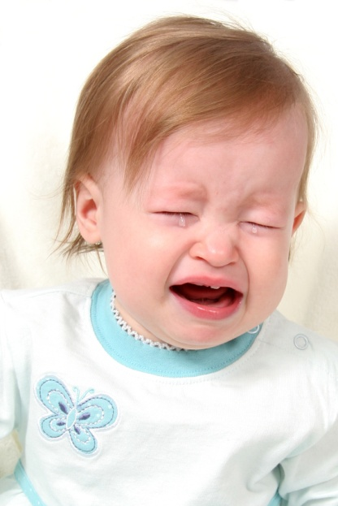
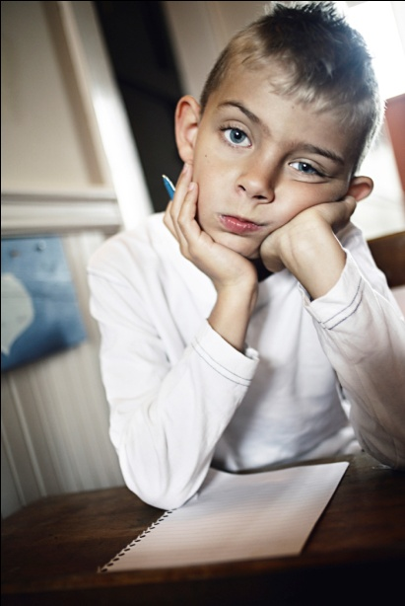
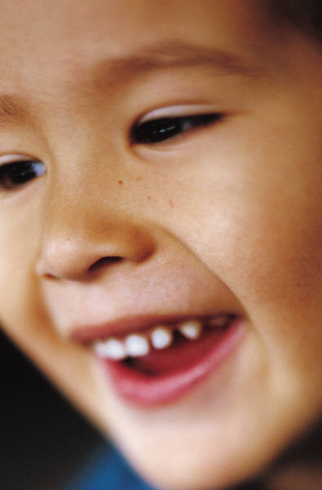

Lesson Two
Exploring causes of emotions

Concept or Skill To Be Learned (Content)
- Causes of various feelings
Unit Outcome
- Students will identify the cause of human emotions within the context of the classroom and their personal lives. (comprehension)
Lesson Objective
- Students will be able to articulate circumstances or situations which cause them to feel happy, sad, angry, or scared.
Procedures
- Introductory Activity (5-10 minutes)
- Assemble students on classroom rug to begin social meeting.
- Introduce social issue utilizing “Mr. Hopper”, the class meeting rabbit mascot/puppet.
  - Gently hold Mr. Hopper close to your shoulder as you quietly explain that he is feeling very sad today.
  - Ask the children, “Why do you think Mr. Hopper is sad? What could have happened?” Allow time to discuss children’s responses.
  - Ask Mr. Hopper if he is willing to share why he is sad. Have Mr. Hopper explain that he is sad because he has lost his favorite toy.
  - Ask the children, “Have any of you ever felt sad like Mr. Hopper is feeling? What makes you feel sad/happy/angry/scared?” Provide assistance by telling children, “I feel happy/sad/angry/scared when…” Allow time for discussion.
- Developmental Activity (20 minutes)
- Transition students to art tables.
- Explain the idea: “Today we are going to make our own feelings puppets. You will decide if you want your puppet to be happy, sad, angry, or scared. You can use any of the materials on your table to make your puppet. When you are finished, we are going to talk about what makes you feel happy, sad, angry, or scared.”
- Show children a teacher example so they have an idea of what a puppet looks like. Explain the emotion depicted and point out facial features which support the emotion.
- Distribute a paper bag to each child. Assist children in writing their names as needed.
- Ask students to decide what kind of puppet they will make (happy, sad, angry, or scared.) Write each child’s emotion on the bottom of their puppet.
- Provide support by asking, “What would a happy puppet look like? How do you look when you are happy? What would a sad/angry/scared puppet look like?” Provide visual support by offering children pictures portraying the emotion they selected.
- Assist children as needed in cutting and gluing the materials to their puppet.
- As children finish their puppets, ask each child to describe circumstances that cause them to feel the emotion portrayed by their puppet. For example, “What makes you feel happy?” Record each child’s responses on the back of their puppet.
- Concluding Activity (5 minutes)
- Regroup at the meeting rug.
- Ask students to share their puppets. Discuss the feelings portrayed, as well as the circumstances which cause various feelings.
Assessment/Evaluation Strategy
- Evaluate each child’s recorded responses to the question “What makes you feel ______?” to assess their understanding of the causes of emotions.
Materials/Resources Needed
- Class meeting puppet/mascot
- Small paper bag for each child
- Pictures depicting four basic emotions
- Sample completed emotion puppet
- Markers, crayons, scissors, glue
- Construction paper, yarn, googly eyes, fabric scraps, etc.
Key Questions
- What makes you feel happy/sad/angry/scared?
Connection to Classroom Environment
- After the lesson concludes, add a small puppet stage to the dramatic play area. Encourage children to use their puppets to act out the various depicted emotions.

Lesson Three
Managing emotions

Concept or Skill To Be Learned (Content)
- Emotion management techniques
- Appropriate expression of emotions
Unit Outcomes
- Students will recognize that there are many ways to appropriately express one’s feelings. (comprehension)
- Students will identify management and relaxation techniques used to respond to various emotions. (memory/recall)
- Students will formulate a safe and appropriate strategy for reacting to feelings of anger and sadness. (synthesis)
Lesson Objective
- Students will be able to identify and practice four safe and appropriate methods of reacting to feelings of anger or sadness (STAR, Balloon, Drain, and Pretzel).
- Students will be able to draw and verbalize one method they will use to help calm their body when feeling angry or sad.
Procedures
- Introductory Activity (5-10 minutes)
- Assemble students on classroom rug to begin social meeting.
- Introduce social issue utilizing “Mr. Hopper”, the class meeting rabbit mascot/puppet.
  - “Over the past few days, we have been talking about feeling sad and angry. Today we are going to learn what to do if we feel sad or angry. What do you think you could do if you felt sad or angry?” Discuss children’s responses.
- Show children the video, “Ernie’s Feelings Game” from the Sesame Street Website (http://www.sesamestreet.org/video_player/-/pgpv/videoplayer/0/8e002053-1551-11dd-8ea8-a3d2ac25b65b/ernie_s_feelings_game).
- After viewing the video, ask the children, “How was Bert feeling in the video? What did Bert do to show that he was angry?” (He screamed, yelled, and ran away.) “Do you think this was a safe choice?”
- Explain: “We all feel angry sometimes. It is okay to feel angry, but screaming and yelling at someone is scary. Let’s talk about some safe ways to calm our bodies if we feel angry or sad.”
- Developmental Activity (20 minutes)
- Show children the STAR icon picture. Tell them, “When you are sad or angry, you can be a STAR. This means you stop, take a deep breath, and relax/blow it out.”
- Model how to be a STAR, verbally repeating each step as you model it.
- Encourage the children to act out the steps of being a STAR.
- Show children the Balloon, Drain, and Pretzel icon pictures. Model the steps to each relaxation technique, and ask the children to act out the steps of each technique.
- Explain that the children can use these techniques in the quiet area of the classroom when they are feeling angry or sad.
- Read the story “When Sophie Gets Angry—Really, Really Angry” by Molly Bang. Pause periodically throughout the story during the points in which Sophie’s anger culminates. Ask the children, “What could Sophie do to calm her body?” As a group, demonstrate the four relaxation techniques that would be helpful to Sophie when she is angry.
- Concluding Activity (10 minutes)
- Transition students to the tables.
- Provide each child with the paper, “When I feel angry or sad, I will be a _______.”
- Ask each child to draw a picture of what they will choose to be when they are sad or angry (STAR, Balloon, Pretzel, or Drain).
- Complete the sentence by writing each child’s response in the blank; encourage older children to write the word independently.
- Ask each child to demonstrate their chosen technique.
- Tell the students, “I am going to use your papers to make a class relaxation book. I will put this book in our feelings center. When you are feeling sad or angry, you can use this book to remind you of a way to relax your body.”
Assessment/Evaluation Strategy
- Observe students during the developmental activity. Note each child’s ability to correctly identify and practice the given relaxation technique.
- Utilize each child’s work sample to assess their ability to identify and verbalize a relaxation technique.
Materials/Resources Needed
- Class meeting puppet/mascot
- Computer with Internet connection
- “Ernie’s Feelings Game” Video (http://www.sesamestreet.org/video_player/-/pgpv/videoplayer/0/8e002053-1551-11dd-8ea8-a3d2ac25b65b/ernie_s_feelings_game
- STAR/Balloon/Drain/Pretzel icon pictures (Available at: http://www.beckybailey.com/documents/Icons.pdf)
- Relaxation Technique Implementation Instructions (Adapted from: http://www.beckybailey.com/)
- “When Sophie Gets Angry—Really, Really Angry” By Molly Bang, ISBN# 0439598451
- “When I Feel Angry” page for each student
- Markers and Crayons
Key Questions
- What can you do when you feel angry or sad?
- What are some safe ways to show your feelings?
Connection to Classroom Environment
- After the lesson concludes, add the class relaxation book to the feelings center. In addition, place the STAR, Balloon, Drain and Pretzel icon pictures in the classroom soft area as a visual cue for students to use when they need to relax.
- Remember to review these techniques each day with the children; they will need practice in order to become comfortable enacting the techniques independently within authentic situations!

When I Feel Angry
Name:

When I feel angry or sad, I will be a

______________________________________________.

Relaxation Technique Implementation Instructions
- Balloon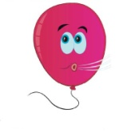
To be a balloon, put both arms up and place your hands on top of your head. Gently blow air out of your mouth. With each breath, raise your arms a little higher away from your head as if you are blowing up a balloon. Once your balloon is full, gently and slowly exhale. As you exhale, slowly lower your arms back down as if you are emptying your balloon.

- STAR
To be a STAR, stop your entire body. Take a deep, slow breath in, raising your arms up with your palms facing the ceiling. When it is time to blow the air out, flip your hands over so your palms are facing the ground. Lower your arms slowly as you slowly exhale.

- Drain 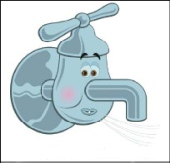

To be a drain, put both arms straight out in front of your body. Close your hands into two tight fists and squeeze, squeeze, squeeze out all of your anger and frustration. Then, open your hands and pretend that you are pouring all of the frustrations down your drain. Lower your hands down slowly as you make the sound, “Whoosh.”

- Pretzel 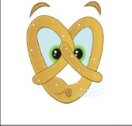

To be a pretzel, place your arms straight out in front of you. Your fingers should be pointing forward with your thumbs up and your palms facing one another. Flip your hands so that your thumbs are pointing down and the tops of your palms are facing each other. Next, cross your arms and link your fingers together. Slowly flip your arms up so that your linked hands are resting on your chest. Take a deep breath and blow it out.

“Safe Place Icons” and instructions adapted from Conscious Discipline Program by Dr. Becky Bailey. Go to http://www.beckybailey.com/ for more information. Loving Guidance, Inc., 1997-2010.

Icons

STAR | Balloon
Drain | Pretzel

“Safe Place Icons” from Conscious Discipline Program by Dr. Becky Bailey. Go to http://www.beckybailey.com/ for more information. Loving Guidance, Inc., 1997-2010.
Lesson Four
Developing a “Big Voice”

Concept or Skill To Be Learned (Content)
- Non-aggressive assertion techniques
- Big Voice
Unit Outcomes
- Students will acquire and demonstrate the effective use of non-aggressive assertion techniques within a social setting. (application)
Lesson Objective
- Students will be able to demonstrate the use of their “big voice” to respond to hypothetical problem situations.
Procedures
- Introductory Activity (5-10 minutes)
- Assemble students on classroom rug to begin social meeting.
- Introduce social issue utilizing “Mr. Hopper”, the class meeting rabbit mascot/puppet.
  - Tell the children, “I have a new book that I am so excited to share with you!” Hold it up to show the children. With your other hand, have Mr. Hopper pull the book away as he says, “I want it!”
  - Enact an ensuing argumentative skit between yourself and Mr. Hopper over the book. As you and Mr. Hopper both pull on the book, shout in both your voice and Mr. Hopper’s, “It’s mine!” and “I want it!” Use your face and tone to convey the hypothetical emotions of anger and frustration.
  - Pause the skit. Ask the children questions such as, “How do you think Mr. Hopper is feeling? How do you think I am feeling? Why are we feeling this way? How did we show our feelings? Was shouting and pulling on the book helpful or hurtful?”
  - Explain that this was pretend. Tell the children, “Sometimes things like this happen, and it can be scary. Let’s read my book to find out what you can do instead of shouting, pushing or pulling.”
- Developmental Activity (20 minutes)
- Read the story, “Shubert’s Big Voice” by Becky Bailey. This book will explain and demonstrate the concept of a big voice (a voice that is calm, firm, and assertive without being aggressive).
- As you read the story, encourage the children to practice using a big voice with the character of Shubert. Use your own voice to model what a big voice sounds like. Point out that their voice should be neither “whispering like this” nor “shouting like this”, but “calm and firm like this”. Provide positive reinforcement as the children practice their big voices.
- Tell the children, “Now that you know what a big voice sounds like, we are going to practice using our own big voices. We are going to listen to some short stories about things that could happen in our classroom. Then I am going to ask you to use your big voice to help finish the story.”
- Explain the Big Voice Scenarios one at a time. After each scenario, ask the children, “What would you say if this happened? (Answers should sound like, “I don’t like it when you take my toy”, “Give it back, I’m using it”, “It’s my turn now”, etc.)
- Ask the children to practice saying the correct words using their big voice.
- Concluding Activity (5 minutes)
- Tell the children you are going to pretend once again that Mr. Hopper took your book away.
- Re-enact Mr. Hopper pulling the book away as he says, “I want it!”
- Tell the children, “This time, I am going to use my big voice to let Mr. Hopper know that I don’t like that.”
- Say, “Mr. Hopper, I don’t like it when you take my book. Give it back, I’m using it.”
- Have Mr. Hopper respond by handing back the book. Emphasize how your big voice helped Mr. Hopper understand while also keeping him safe.
Assessment/Evaluation Strategy
- Observe students during the developmental activity. Note each child’s ability to effectively demonstrate a “big voice” in response to the hypothetical scenarios.
Materials/Resources Needed
- Class meeting puppet/mascot
- “Shubert’s Big Voice” by Dr. Becky Bailey, ISBN# 1889609102
- Big Voice Scenarios
Key Questions
- What is a big voice?
- What does a big voice sound like?
- When can you use a big voice?
Connection to Classroom Environment
- After the lesson concludes, add “Shubert’s Big Voice” to the classroom feelings center. Provide daily opportunities for children to practice their big voice within authentic classroom situations.

Big Voice Scenarios

Provide the children with the following scenarios. Ask the children to determine how they would respond and what they would say in each scenario. Encourage them to use their big voice to practice saying the words.

Imagine that…

- You are in the house area using a baby. You are getting out a bottle to feed the baby, when someone comes over and takes the baby away.

- You are building an awesome tower in the block area. It is very tall and you are almost done. Someone walks by and knocks down your work.

- You sit down to have snack, but forget to wash your hands. You get up, go to the bathroom, wash your hands, and come back to the table. Someone else is sitting in your spot.

- You are working on a puzzle at the table. Someone comes over, takes the puzzle piece out of your hand, and starts to put the puzzle together.

- You are waiting to go out on the playground. The teacher calls your name, so you know that it is your turn to go out. Someone pushes you out of the way and goes out in front of you.

Post Assessment

The post-assessment tools for this emotional regulation unit will be similar in form and structure to the pre-assessment. However, the composition of the post-assessment will be more comprehensive in nature as to ensure a holistic and thorough evaluation of overall student understanding. This assessment will be twofold, incorporating a detailed post-assessment questionnaire as well as a behavioral observation. The questionnaire will be utilized to assess student knowledge and comprehension of unit terms and concepts. The behavioral observation will be utilized to denote each student’s ability to demonstrate and apply unit concepts and principles. After administration of the questionnaire, teachers should follow the instructions included in the “Post Assessment Questionnaire Scoring Guide” to evaluate each child’s performance. Teachers should also review the behavioral observation results as a way to evaluate each child’s ability to demonstrate and apply unit concepts and skills.

Post Assessment Questionnaire
Child’s Name: ____________________________________________________________
Date Administered: ______________________________________________________
Total Score: ___/20 (See scoring guide for evaluation instructions)

Part 1-Recognition of Emotions
Administrator Instructions: Ask the child the following questions. Record the child’s responses in the space provided.

- a. Which of these pictures shows a person who is happy? (Circle A, B, or C to denote response)
A. B. C.

- b. How can you tell they are happy? _____________________________________
______________________________________________________________________________
______________________________________________________________________________

- c. Show me what your face looks like when you are happy. (Describe demonstrated facial expression; i.e., “smile, frown, eyebrows furrowed”)
______________________________________________________________________________
______________________________________________________________________________

- a. Which of these pictures shows a person who is sad? (Circle A, B, or C to denote response)
A. B. C.

- b. How can you tell they are sad? _________________________________________
______________________________________________________________________________
______________________________________________________________________________

- c. Show me what your face looks like when you are sad. (Describe demonstrated facial expression; i.e., “smile, frown, eyebrows furrowed”)
______________________________________________________________________________
______________________________________________________________________________

- a. Which of these pictures shows a person who is scared? (Circle A, B, or C to denote response)
A. B. C.

- b. How can you tell they are scared? _____________________________________
______________________________________________________________________________
______________________________________________________________________________

- c. Show me what your face looks like when you are scared. (Describe demonstrated facial expression; i.e., “smile, frown, eyebrows furrowed”)
______________________________________________________________________________
______________________________________________________________________________

- a. Which of these pictures shows a person who is mad? (Circle A, B, or C to denote response)
A. B. C.

- b. How can you tell they are mad? _______________________________________
______________________________________________________________________________
______________________________________________________________________________

- c. Show me what your face looks like when you are mad. (Describe demonstrated facial expression; i.e., “smile, frown, eyebrows furrowed”)
______________________________________________________________________________
______________________________________________________________________________

Part 2-Causes of Emotions
Administrator Instructions: Ask the child how they would feel in the following scenarios. Record each child’s response in the space provided.

How Would You Feel If…

- You lost your favorite toy? ___________________________________________________
_____________________________________________________________________________

- You got to eat your favorite candy? __________________________________________
_____________________________________________________________________________

- Your friend wouldn’t share their toys with you? _________________________________
______________________________________________________________________________

- There was a big thunderstorm and the lights went out? _________________________
______________________________________________________________________________

Part 3-Regulation of Emotions
Administrator Instructions: Provide the child with crayons or markers. Allow them to draw a response to question 1 in the box provided. Record the child’s response to questions 2, 3, and 4 in the space provided.

- Draw a picture of what you can do when you feel sad or mad.

Verbal description of drawing: __________________________________________________________________________________
__________________________________________________________________________________

- Show me how to be a STAR. (Describe child’s demonstration of technique below)
______________________________________________________________________________
______________________________________________________________________________
______________________________________________________________________________

- What is a big voice?
______________________________________________________________________________
____________________________________________________________________________________________________________________________________________________________

- Use a big voice to show me what you would say if someone took away your toy.
__________________________________________________________________________________________________________________________________________________________________________________________________________________________________________
Post Assessment Questionnaire Answer Key

Part 1
1a-C
1b- The little girl is smiling
1c- Demonstrated behavior = smile, laugh
2a-A
2b-The baby is crying, eyes are shut tight
2c- Demonstrated behavior = pout, mouth turned down, cover face, etc.
3a- B
3b-The girl’s eyes are open wide, mouth is open, eyebrows raised
3c- Demonstrated behavior = eyes open wide, eyebrows raised, etc.
4a- C
4b- The girls have their arms folded, eyebrows scrunched down
4c- Demonstrated behavior = scrunch eyebrows together, mouth turned down, fold arms, squint eyes, etc.

Part 2
1- Sad or mad
2- Happy
3- Sad or mad
4- Scared

Part 3
1- Appropriate drawings include STAR, Balloon, Drain, or Pretzel
2- Child should stop, raise arms up as inhale, lower arms slowly as exhale
3-Possible responses include: a voice you use to help someone understand; a voice that tells someone that you don’t like something; also accept responses in which the child provides an example of using a big voice
4- Child’s voice should be strong, firm, controlled, and audible as they speak. Possible responses include: Give me back my toy; I don’t like it when you take my toy

Post Assessment Questionnaire Scoring Guide

Evaluation Instructions:

Each questionnaire item is worth one point, for a total of 20 possible points. After administering the questionnaire to the child, allot 1 point for each correct response given. Add up the total of correct responses and record this number on the top of Page 1 of the questionnaire. Use the guide below to interpret the score. Target scores should fall within “accomplishing” and “mastering” levels.

Score (Out of  20 points) | Level | Interpretation
0-5 | Beginning | Skills and concepts are in beginning stages
5-10 | Developing | Skills and concepts are being developed
10-15 | Accomplishing | Skills and concepts are being accomplished
15-20 | Mastering | Skills and concepts have been mastered

Post Assessment Behavioral Observation
Child’s Name: _____________________________________________________
Date of Birth: _____________________________________________________
Observation Date: _______________________________________________

Administrator instructions: Observe the child for the following social/emotional behaviors. Check “yes” or “no” to indicate the presence or absence of each behavior. Provide a brief description of the behavior, as well as the context in which it occurred. If the behavior is not observed, check N/O (not observed).

Behavioral Indicator | Yes | No | N/O
Verbalizes feelings and can state the cause of identified feelings within contextual situations
Demonstrates safe and appropriate social interactions with other children in classroom context
(Interactions are verbally and physically non-aggressive)
Identifies and utilizes
relaxation techniques (STAR, Balloon, Pretzel, Drain) to control emotions in contextual situations
Demonstrates appropriate, assertive “Big Voice” as a method to safely resolve conflict in classroom situations

Evaluation Note: Target performance includes checking “Yes” for each behavioral indicator. Any indicator receiving a “No” should be considered for further instruction of content and skills.

