THIRD GRADE INTRODUCTION (Smart Notebook illustration)

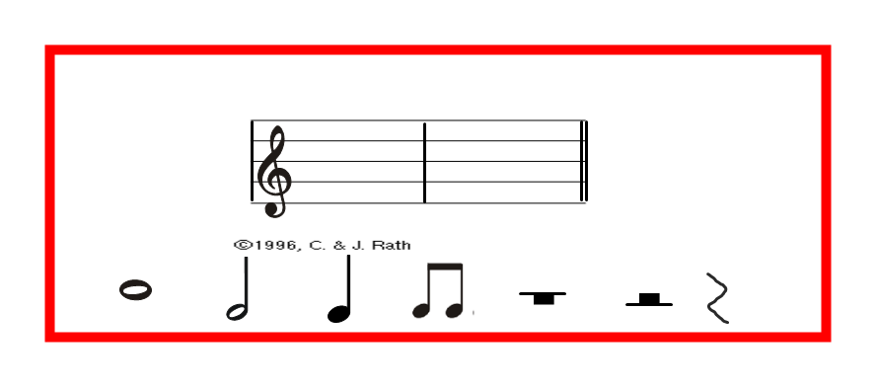
Introduction:
Staff, barline, double barline, measure, treble clef sign, whole note, half note, quarter note, eighth notes, whole rest, half rest, and quarter rest

