Managing Financial Resources
Work and the Paycheck
Anthony A. McCord
Bowling Green State University
EDTL 7100

Rationale
As one spent time researching and observing CBI students for the field experience portion of EDTL 7100, it became clear traditional teaching must be supplemented with some sort of cooperative learning experience.
The focus of the learning experience for this unit is managing financial resources. Students today are faced with complicated financial choices in today’s economy. Young people find themselves in financial hot water in terms of credit card debt and other obligations. Debt tied with a job which is tied to the minimum wage is a formula for financial distress. This combination of debt load and wages are a concern since young people may lack the needed knowledge to successfully navigate financial decisions (Lusardi, 2010).
In order to make wise financial decisions, students must be taught financial literacy. Most researchers agree that many if not most consumers lack the financial literacy necessary to make important financial decisions in their own best interests (Mandell, 2009). This issue has become so important that states have begun to mandate the teaching of financial literacy as part of the core curriculum for all high school students. In fact Ohio in House Bill 1 required all high school students to take a course in financial literacy as part of their high school core curriculum (ODE, 2011).
Some research has to light questioning the value of teaching financial literacy in high school. Students may not utilize the lessons learned in a financial literacy course because: 1) what is learned in a financial literacy class may not be acted upon by the students until later in life when they have the financial resources to utilize what they were taught; 2) students who graduate from high school today come from families who did not live during the Great Depression and therefore never learned from their parents how to save and to live on less. These two reasons coupled with easy-to-get credit cards may have created an environment where students may not understand the necessity of learning financial literacy (Mandell, 2009).
Another factor in teaching how to manage financial resources is the concept of the why’s and how’s of obtaining steady, long-term employment. Many if not most individuals start their careers in part-time situations and eventually end up working full-time. For today’s teenagers, part-time employment has become the norm for not only their high school years, but also for several years as young adults. Part-time workers receive considerably less earnings and benefits as full-time employees (Hirsch, 2005). Linking employability skills with financial literacy must be part of managing financial resources. In other words, one cannot achieve one without the other.
Students learn best when what is being taught in the classroom can be tied to some sort of real-life situation (Techniques, 2008). By teaching students the importance of developing their abilities and tying their interests into a career choice, will assist them in managing their financial resources. Students will find meaning in the lessons and will be able to apply them in their lives. This is why contextualized learning and teaching, CTL, is an important part of this unit. In fact CTL is composed of: connecting content to student experiences; and engages students in active learning (Chiarelott, 2006).
In order to incorporate the concepts of work and the paycheck into the managing financial resources unit, a combination of lesson plans will be utilized. Since cooperative learning is teaches employability skills (McNamara, 2009), this section will be introduced by the Jigsaw Model of Lesson Planning. This model will allow students to not only learn the information, but also be able to teach their peers (Chiarelott, 2006). As the lessons progress, the Basic Lesson Planning Model will be adapted to the lesson. As one learns about a paycheck, there is only one correct answer which is acceptable. As students learn this concept, they will be conditioned that are certain expectations in life they must meet.

References
Chiarelott, L. (2006). Curriculum in context: designing curriculum for teaching and learning in context. Wadsworth: Belmont, CA.
Hirsch, B. T. (2005). Why Do Part-Time Workers Earn Less? The Role of Worker and Job Skills. Industrial and Labor Relations Review, 58 (4), pp. 525-551.
Lusardi, A.. (2010, Jan. 28 ). In Financial Literacy among the Young: Evidence and Implications for Consumer Policy. Retrieved Feb. 14, 2011, from http://www.dartmouth.edu/~alusardi/Papers/Financia
Mandell, L, and L. Klein. (2009). The Impact of Financial Literacy Education on Subsequent Financial Behavior. Journal of Financial Counseling and Planning, 20 (1), pp. 15-24.
McNamara, B. R. (2009). Skill Gap: Will the Future Workplace Become an Abyss. Techniques, 5(84), 24-27.
Ohio Department of Education Teaching. (chap. Graduation RequiremeFinancial Literacy) Retrieved Jan. 21, 2011, from http://education.ohio.gov/GD/Templates/Pages/ODE/O

Section Outcomes

Section 1: Work and the Paycheck

- Students will define human capital and investment in human capital [Memory/Recall]
- Students will identify the impact of abilities and skills on career development (5.1.3) [Comprehension]

- Students will describe various examples of investment of human capital [Memory/Recall]
- Students will compare the relationship between one’s education and one’s income potential [Analysis]

- Students will assess differences in the wages, benefits, annual incomes, cost of living, and job opportunities associated with selected career options (5.2.6) [Evaluation]

- Students will analyze how individuals and households exchange their resources for income in order to bug goods and services (1.9.3) [Analysis]

- Students will interpret a pay stub [Application]

- Students will identify items commonly taken out of gross pay [Comprehension]

- Students will define income, taxes, and wages [Knowledge]

- Students will explain the difference between gross and net pay [Comprehension]

- Students will complete a W-2 and W-4 form [Application]

- Students will calculate gross pay for common pay periods [Analysis]

- Students will calculate net pay [Analysis]

- Students will define straight time, overtime, and double time [Knowledge]

- Students will calculate gross earnings for straight time, overtime, and double time [Analysis]

- Students will calculate the salary per pay period [Analysis]

References
Phillips, M.. (2006, Aug. 22 ). In CBI Course of Study. (chap. Core Integrated TechStrand 6: Managing Resources) Retrieved Feb. 21, 2011, from http://www.ode.state.oh.us/gd/templates/pages/ODE/

Managing Financial Resources QUESTIONNAIRE

(Pre-assessment)
[Career Based Intervention—12th Grade]

Student | DATE | CBI Coordinator
Lab Site |  | Class

Work and the Paycheck:

INSTRUCTIONS
Please complete this form. Please answer all the questions to the best of your ability. You will need to use your last paycheck to answer some of the following questions.

Human Capital
Define “Human Capital”

Skills/Abilities
Define “Skills”
List at list 2 skills you have:

Careers
What is the difference between a job and a career?

Education
Does one’s education determine one’s career?
[ ] Yes | [ ] No

Income
Does income determine purchasing power?
[ ] Yes | [ ] No
Why or Why not?

Income
Define “Income”

Income
List at least 3 things that affect one’s income.

Have you ever worked (and got paid) before?
[ ] Yes [ ] No
If yes, where did you work?

Paycheck
I know which pay is greater.
[ ] Gross | [ ] Net

Paycheck
I can list at least 3 types of taxes which can be taken out of my paycheck.
[ ] Yes | [ ] No
List them:

Paycheck
I can calculate my yearly salary based on my paycheck.
[ ] Yes | [ ] No
My yearly salary is:

You may use this space for calculating your answers:

Lessons
Each lesson is designed for a 45-50 minute class period. The lessons provided are for a 10 day time frame.
Lesson 1 What is Human Capital?
Key Questions to Learn (Concepts):
1. What is Human Capital?
2. What does it mean to invest in Human Capital?
3. What are some examples of investing in Human Capital?
4. What is the relationship between a person’s level of education and income-earning potential?
Learner Outcomes (Objectives): The learner outcomes correspond to the outcomes listed on page 6.
1, 2, 3, 4, 5, 6
Materials:
- Two sheets of light-colored construction paper per student and one sheet for the instructor
- One black marker per student
- Watch with a second hand or timer
- PowerPoint: “School is a Job” (i.e. Dropout vs. Diploma)
- PowerPoint: “Setting Goals”
- Four laptop computers
- Student notebooks and pens/pencils
- Questionnaire (Pre-assessment) for Work and the Paycheck Section
Time Required:
3 days
Procedures:
Day 1: (Part one of the Introductory Activity) Students will be given the Pre-assessment questionnaire. The students will be given approximately 10 min. to complete. This questionnaire will not be graded; rather the questions and answers will be discussed as a class. At the end of the discussion, the students will turn in their questionnaires so the instructor can determine the exact level the class is in terms of the sub-section. This activity will take approx 20-25 min.
(Part two of the Introductory Activity) The students will be divided into four groups. The instructor will tell the groups they will be making name tents for display on their desks for future discussions. The instructor will demonstrate to the groups how to create their name tent by using the following directions:
- Fold the piece of construction paper in half, shorter edges (8 1/2”) together. Crease the center fold. The folded paper should measure 8 ½” x 5 ½”.
- Open the page to 8 ½” x 11”.
- Fold the bottom 8 ½” edge to the middle crease. Crease the fold.
- Open the page to 8 1/2” x 11”.
- Fold the top 8 ½” edge to the middle crease. Crease the fold.
- The paper should now have four sections each measuring approximately 2 ¾” x 8 ½”.
- Starting from one end of the paper, count down three rectangles. Print your first name in large letters in the rectangle.
- Turn your paper upside-down. Again count down three rectangles and print your first name in large letters in the rectangle.
- Fold the paper to create a tent with the name displayed on both sides.
The instructor will explain that each group will now have their own set of rules for folding their name tents. The rules follow:
- Group 1: Each of you will remain seated to produce your own name tent, using only one hand, your non-dominant hand (i.e. the hand with which you do not write) to produce your name tent. You must keep your dominate hand behind your back.

- Group 2: Each of you will remain seated to produce your own name tent, using only one hand, your dominate hand (i.e. the hand with which you write) to produce your name tent. You must keep your non-dominate hand behind your back.

- Group 3: Each of you will remain seated to produce your own name tent, using both hands.

- Group 4: Each of you will produce your own name tent while standing and using only one hand—the non-dominate hand—to produce your name tent. You must keep your dominate hand behind your back. You may not use the desk, table, or chair to assist you.

- None of the groups may begin producing their name tents until the class is told to begin.

- When each student completes his/her tent, they should raise their hand.

- Students will be timed and will have a maximum of two minutes to make the name tent.

The instructor will create a table on the board to tally students who raise their hands upon completing the name tent.
Time | Group 1 | Group 2 | Group 3 | Group 4
30 seconds
60 seconds
90 seconds
120 seconds

The instructor will distribute a piece of construction paper to each student. The students will be reminded to fold their tents according to the rules explained for each separate group. Remind the students to raise their hand as soon as their own individual tent is completed. The students then may begin folding their name tents. As students raise their hands, the instructor records the tallies on the chart next to the appropriate group and time segment.
After two minutes, the instructor tells everybody to stop working on their name tents. The instructor will ask the following questions:
- Did any students find it very difficult to make their tents? Why? (Group 4 should have had the most difficult time)

- Review with each group the difficulties they encountered while producing the name tents.

- In general which group finished most quickly? (Group 3) Why? (able to sit down and use both hands)

- In general, which group took the longest time to finish? (Group 4) Why? (Students could not use dominate hand and had to stand while making tents)

The instructor will explain that Human Capital is the education, abilities, and skills that people possess. One can Invest in Human Capital by going to school, pursue training, and developing skills. There is a strong correlation between the level of Human Capital a person possesses and the amount of income the person earns.
The instructor will explain Group 4 represented those with the smallest investment in human capital—high school dropouts. Group 1 represented those who graduated from high school. Group 2 represented those who pursue additional training following high school (i.e. associate/bachelor’s degree or certification). Group 3 represented those with advanced degrees.
The instructor will ask the class how finishing name tents more quickly in this activity might relate to investment in human capital. (Those with more training/education/skills tend to be more productive)
The instructor will distribute new construction paper to those who need to make a new name tent which will be used later on in this unit.
This second part of the introductory activity will take approx. 25 min.
Day 2: (Developmental Activity) Students will be split into the same four groups as the day before. Groups 1 & 3 will view the PowerPoint, “School is a Job”. Groups 2 & 4 will view the PowerPoint, “Setting Goals”. The instructor will explain the following rules:
- Each group will go to a corner of the classroom with one laptop. Everybody is to bring their notebooks and pen/pencil with them.

- As the group views the PowerPoint, each member of the group is to record what the major point was in each slide. (10 min)

- When the PowerPoint is completed, each group will discuss and choose what the main idea was for each slide. (5 min)

- Each group will choose a secretary. The secretary will write down on a piece of notebook paper what the group decided was the main idea presented on each slide.

- Each group will choose a spokesperson. This spokesperson will review the main ideas of their respected PowerPoint with another group.

- Group 1’s spokesperson will teach Group 4 about their PowerPoint and Group 4’s spokesperson will teach Group 1. (10 min)

- Group 2’s spokesperson will teach Group 3 about their PowerPoint and Group 3’s spokesperson will teach Group 2. (same)

- The spokespersons will have an opportunity to learn about the other PowerPoint by questioning their own group and by participating in the teacher-led review.

This part of the activity will take approx. 25 min.
(Concluding Activity) The instructor will review with the class the major concepts presented in both PowerPoints. It should be noted the concept of “Purchasing Power” and the Learning Outcomes 4 through 6 are covered in the PowerPoints. Students are to participate in the class discussion using the notes they either created or were taught.
(Assessment/Evaluation Strategy) The evaluation of this lesson will occur during the “Jeopardy” session of the unit. Each group will be responsible for their responses at that time. The instructor will collect the student notebooks for review.
Notes:
References

Bachtel, B. (2006). Dropout vs. Diploma (Version 97-2003) [Microsoft Office PowerPoint]. Mentor, OH: Mentor Schools.

Edwards, S. (2007). Setting Goals (Version 97-2003) [Microsoft Office PowerPoint]. Columbus, OH: Career Based Intervention Board of Directors.
Federal Reserve Bank of St. Louis. (chap. Know Your Dough: Invest in Yourself) Retrieved Feb. 10, 2011, from http://www.stlouisfed.org/education

Lesson 2 Income: The Story
Key Questions to Learn (Concepts):
- What is income?
- How does one determine income?
- What is “straight (hourly) time, double time, and overtime?
- What is a pay period?
- What is gross pay?
Learner Outcomes (Objectives): The learner outcomes correspond to the outcomes listed on page 6.
12, 13, 14, 15, 16
Materials:
- Laptop computer
- LED projector
- PowerPoint: “Show Me the Money”
- Text Book: Mathematics with Business Applications 5th ed. pages 92-98
- Student Activity Workbook: Mathematics with Business Applications 5th ed. exercises 1.1-1.3
- Name tents
- Student notebooks, pens, pencils
- Calculators
Time Required:
3 days
Procedures:
Day 1: (Introductory Activity) The instructor will review with the entire class the PowerPoint, “Show Me the Money”. This PowerPoint introduces the concepts of income and how it is determined. Each student will take at least 2 notes in their notebook per PowerPoint slide. During the PowerPoint presentation, students will be encouraged to participate in the teacher-led discussion. This activity will take approx. 25 min.
(Developmental Activity) At the end of the discussion, the instructor will collect the name tents from the class and shuffle them like playing cards. The instructor will then randomly distribute the name tents into three separate piles. Each pile will represent a new group for the students to join. The instructor will then tell the class to sit in the area where their name tents are located. There should be three groups. Each group will be labeled: Group 1, Group 2, and Group 3 respectively. The instructor will then give the directions for each group:
- Group 1 will be responsible for learning all there is to know about “Straight (Hourly) Pay”. Group 1 will find all the information needed from their notes from the PowerPoint and from pages 92-93 in their math text book.

- Group 2 will be responsible for learning all there is to know about “Overtime Pay”. Group 2 will find all the information needed from their notes from the PowerPoint and from pages 94-95 in their math text book.

- Group 3 will be responsible for learning all there is to know about “The Weekly Time Card”. Group 3 will find all the information needed from their notes from the PowerPoint and from pages 96-98 in their math text book.

- Everybody in each group will write down in their notebooks at least ten facts about their chosen topic.

- Each group will choose a secretary to write down at least ten facts which the group believes are the most important facts.

- Each group will choose a spokesperson who will teach their topic to another group.

- Each group will have approx. ten minutes to learn their topic.

- Each spokesperson will have approx. ten minutes to teach another group.

- Each spokesperson will teach the group to their left at the appropriate time.

- The spokespersons will have an opportunity to learn about the other PowerPoint by questioning their own group and by participating in the teacher-led review.

This Developmental Activity will continue into Day 2 of this lesson. Day 1 will end as each group learns about their chosen topic.
Day 2: The instructor will give each group ten minutes to complete their learning session and for the spokesperson to be ready to teach the material to another group. At the end of the ten minutes, the instructor will say “switch” and the spokespersons will go to their assigned group and teach that group. This “switching” will happen twice so that each group is taught the same information in the same time. This activity will take approx. 20 min.
(Concluding Activity) The instructor will review with the class what was taught in each group and answer any questions the students may have about the lesson. This activity will take approx. 15 min.
(Assessment/Evaluation Strategy) Day 3: The instructor will give a workbook assignment which covers the topics taught in this lesson. Each student will be able to use their notebooks and calculator to complete this assignment. This assignment is due at the end of the period. The instructor will also collect notebooks to review student notes. Any topic/concept discussed will also be “fair game” for the Jeopardy Lesson/Post-assessment.
Notes:

The workbook pages (and answers) to be completed are as follows:
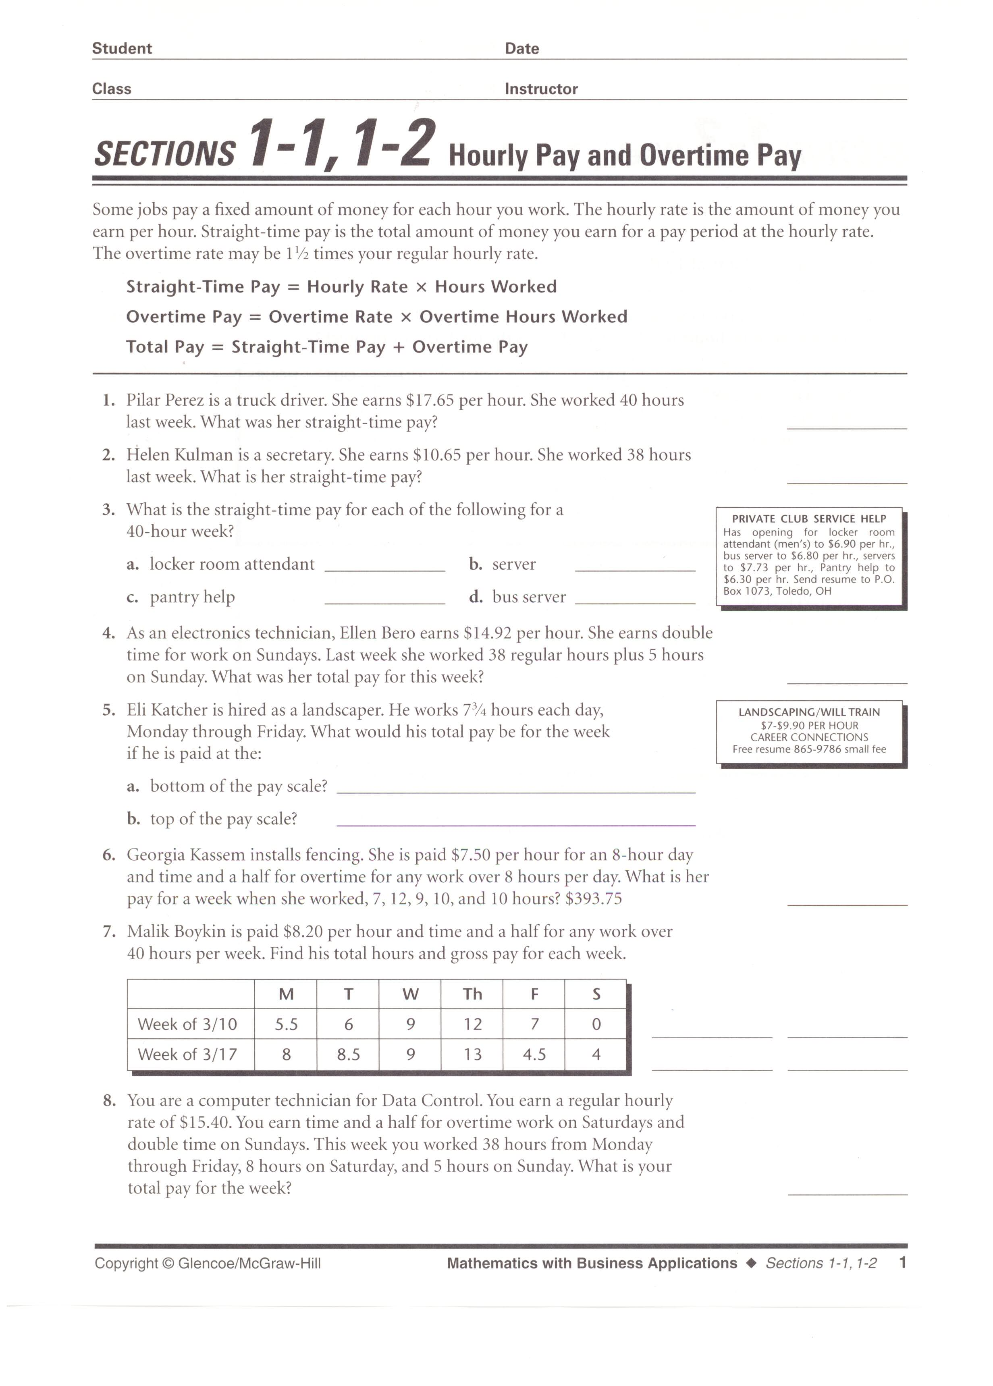
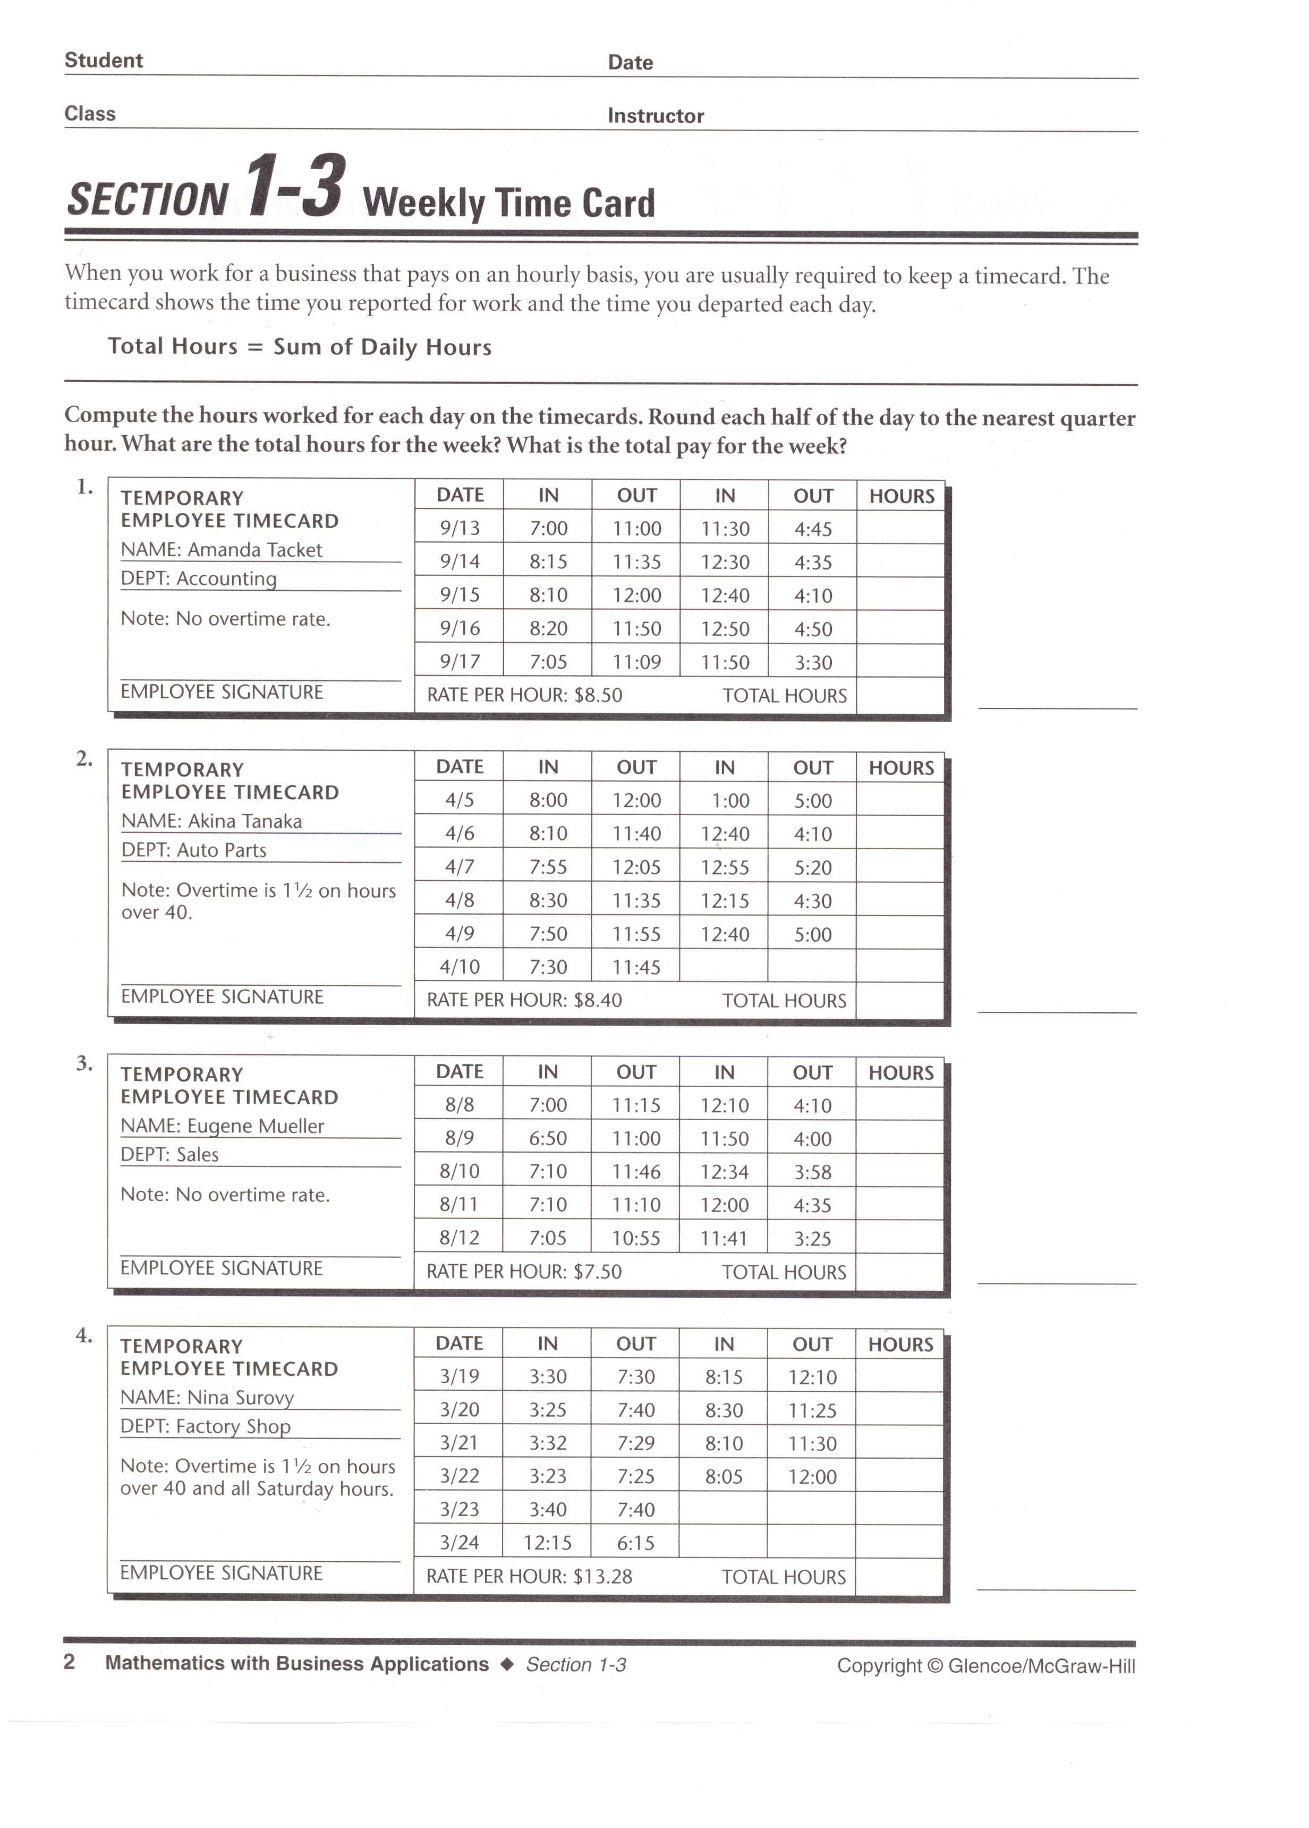
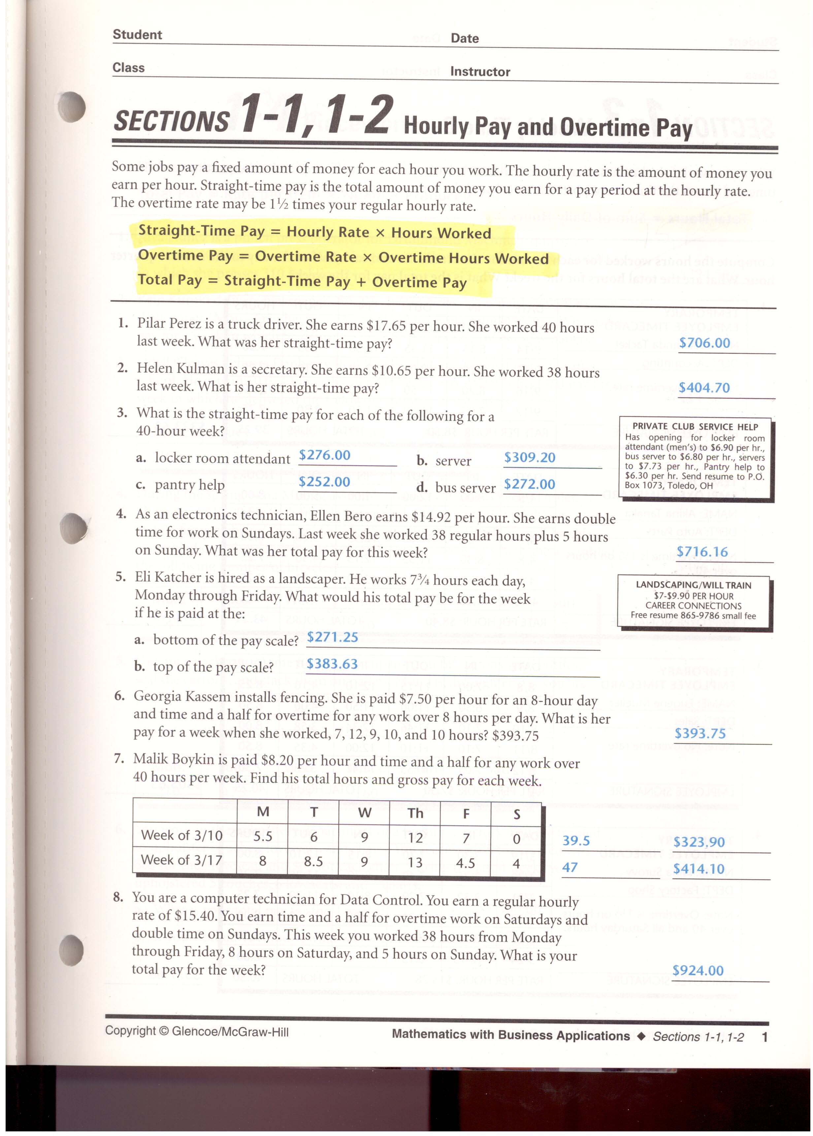

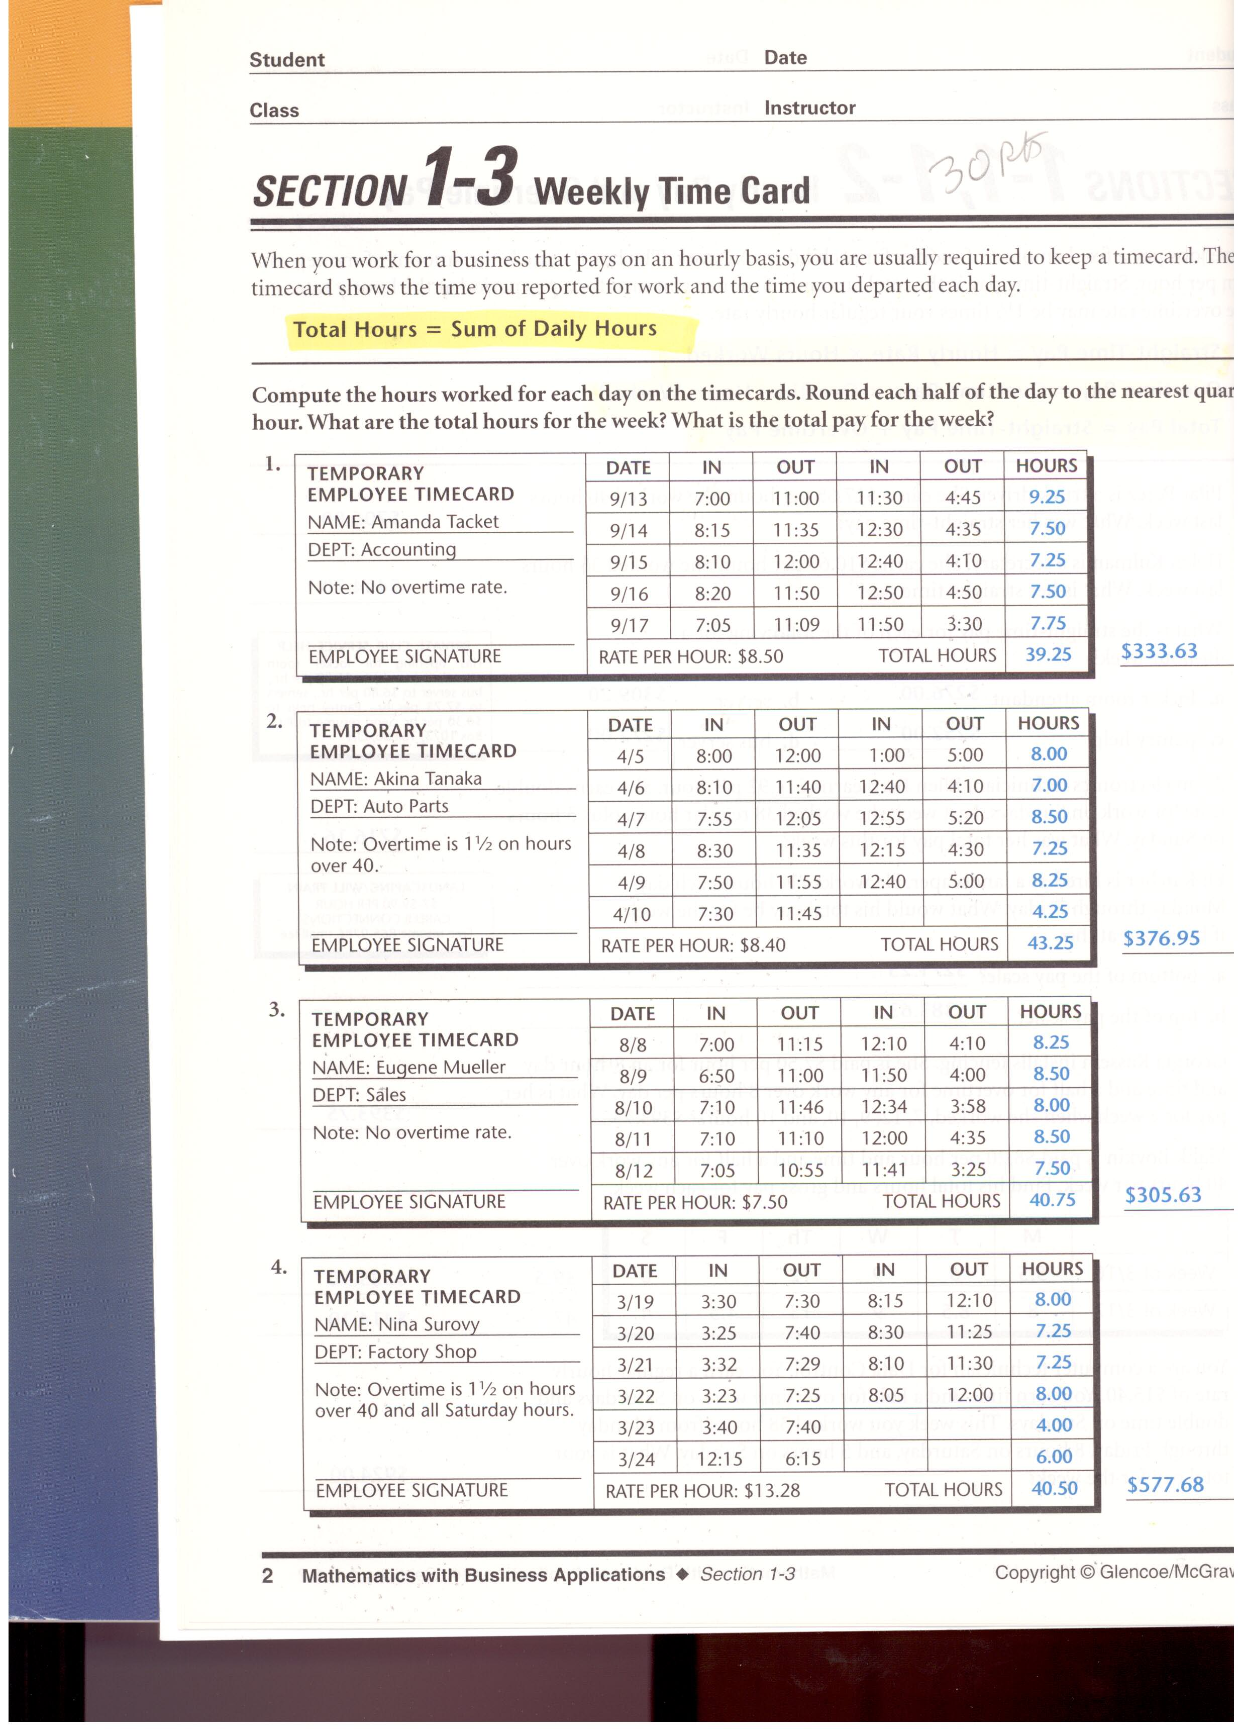

References

Plautz, E. (2006). Show Me the Money (Version 97-2003) [Microsoft Office PowerPoint]. Columbus, OH: Career Based Intervention Board of Directors.
Lange, W. H, & T. Rousos. (2004). Mathematics With Business Applications. (Vol. 5, Diane. Culpepper, Ed.). Woodland Hills, California: Glencoe.

Lesson 3 Analyzing the Pay Stub
Key Questions to Learn (Concepts):
- What are taxes, and wages?
- What do the letters FICA mean and what does it represent?
- What is the difference between gross pay and net pay?
- What is the difference between a W-4 and a W-2?
- What are other items may be deducted from one’s paycheck?
Learner Outcomes (Objectives): The learner outcomes correspond to the outcomes listed on page 6.
7, 8, 9, 10, 11
Materials:
- Laptop computer
- LED projector
- PowerPoint: “The Paycheck and Taxes”
- Name tents
- Student notebooks, pens, pencils
- Handouts of: pay stubs, W-4’s, and W-2’s
- Print outs of explanations of pay stubs, W-4’s, and W-2’
Time Required:
3 days
Procedures:
Day 1: (Introductory Activity) The instructor will review with the entire class the PowerPoint, “The Paycheck and Taxes”. This PowerPoint will be an overview of:
- Why do people work?
- The concepts of wages
- The differences between gross and net pay
- Taxes deducted from wages
  - Why taxes are withheld
  - What do taxes pay for
  - Examples of taxes withheld from one’s pay
- Examples of a W-4 form and a W-2 form
- FICA
Each student will be required to write down at least 2 notes in their notebook per PowerPoint slide. Students will also be encouraged to participate in the teacher-led discussion. This activity will take approx. 25 min.
(Developmental Activity) At the end of the discussion, the instructor will collect the name tents from the class and shuffle them like playing cards. The instructor will then randomly distribute the name tents into three separate piles. Each pile will represent a new group for the students to join. The instructor will tell each group to sit at a different learning station located in the classroom. Each group will be labeled: Group 1, Group 2, and Group 3 respectively. The instructor will then give the directions for each group:
- Each group will begin at one of three “Learning Stations”. These stations are: Pay Stub, W-4, and W-2

- Each learning station will have examples and information about its particular concept

- Each group is to review the information provided and complete the exercises associated with each station

- All group members are to take notes in their notebooks for future reference/study

- All exercises are to be completed and kept with the student notebooks

- Each group will have 15 minutes to review the material and complete their worksheets

- At the end of the 15 minute session, the instructor will say, “switch”. At that time, each group is to go to the learning station to their left

- This rotation will be done until all groups have completed all three stations

This Developmental Activity will continue into Day 2 of this lesson. At the end of Day 1 of the lesson, each group will have completed one learning station.
Day 2: The groups from Day 1 will complete the other two learning stations. This part of the lesson will take approx. 30 minutes.
(Concluding Activity) The last 15-20 minutes of Day 2 will consist of the instructor reviewing the major concepts from all 3 learning stations with the class.
(Assessment/Evaluation Strategy) Day 3: The instructor will hand out examples of a W-4 Form, and a Pay Stub. Each student is to complete the forms and answer the questions associated with each form. The forms and responses will be collected to be graded along with each student notebook for teacher review. As with the other lessons, any topic/concept covered is considered “fair game” for the Jeopardy Lesson/Post-assessment.
Notes:

Below are the exercises (and answers) to be completed:

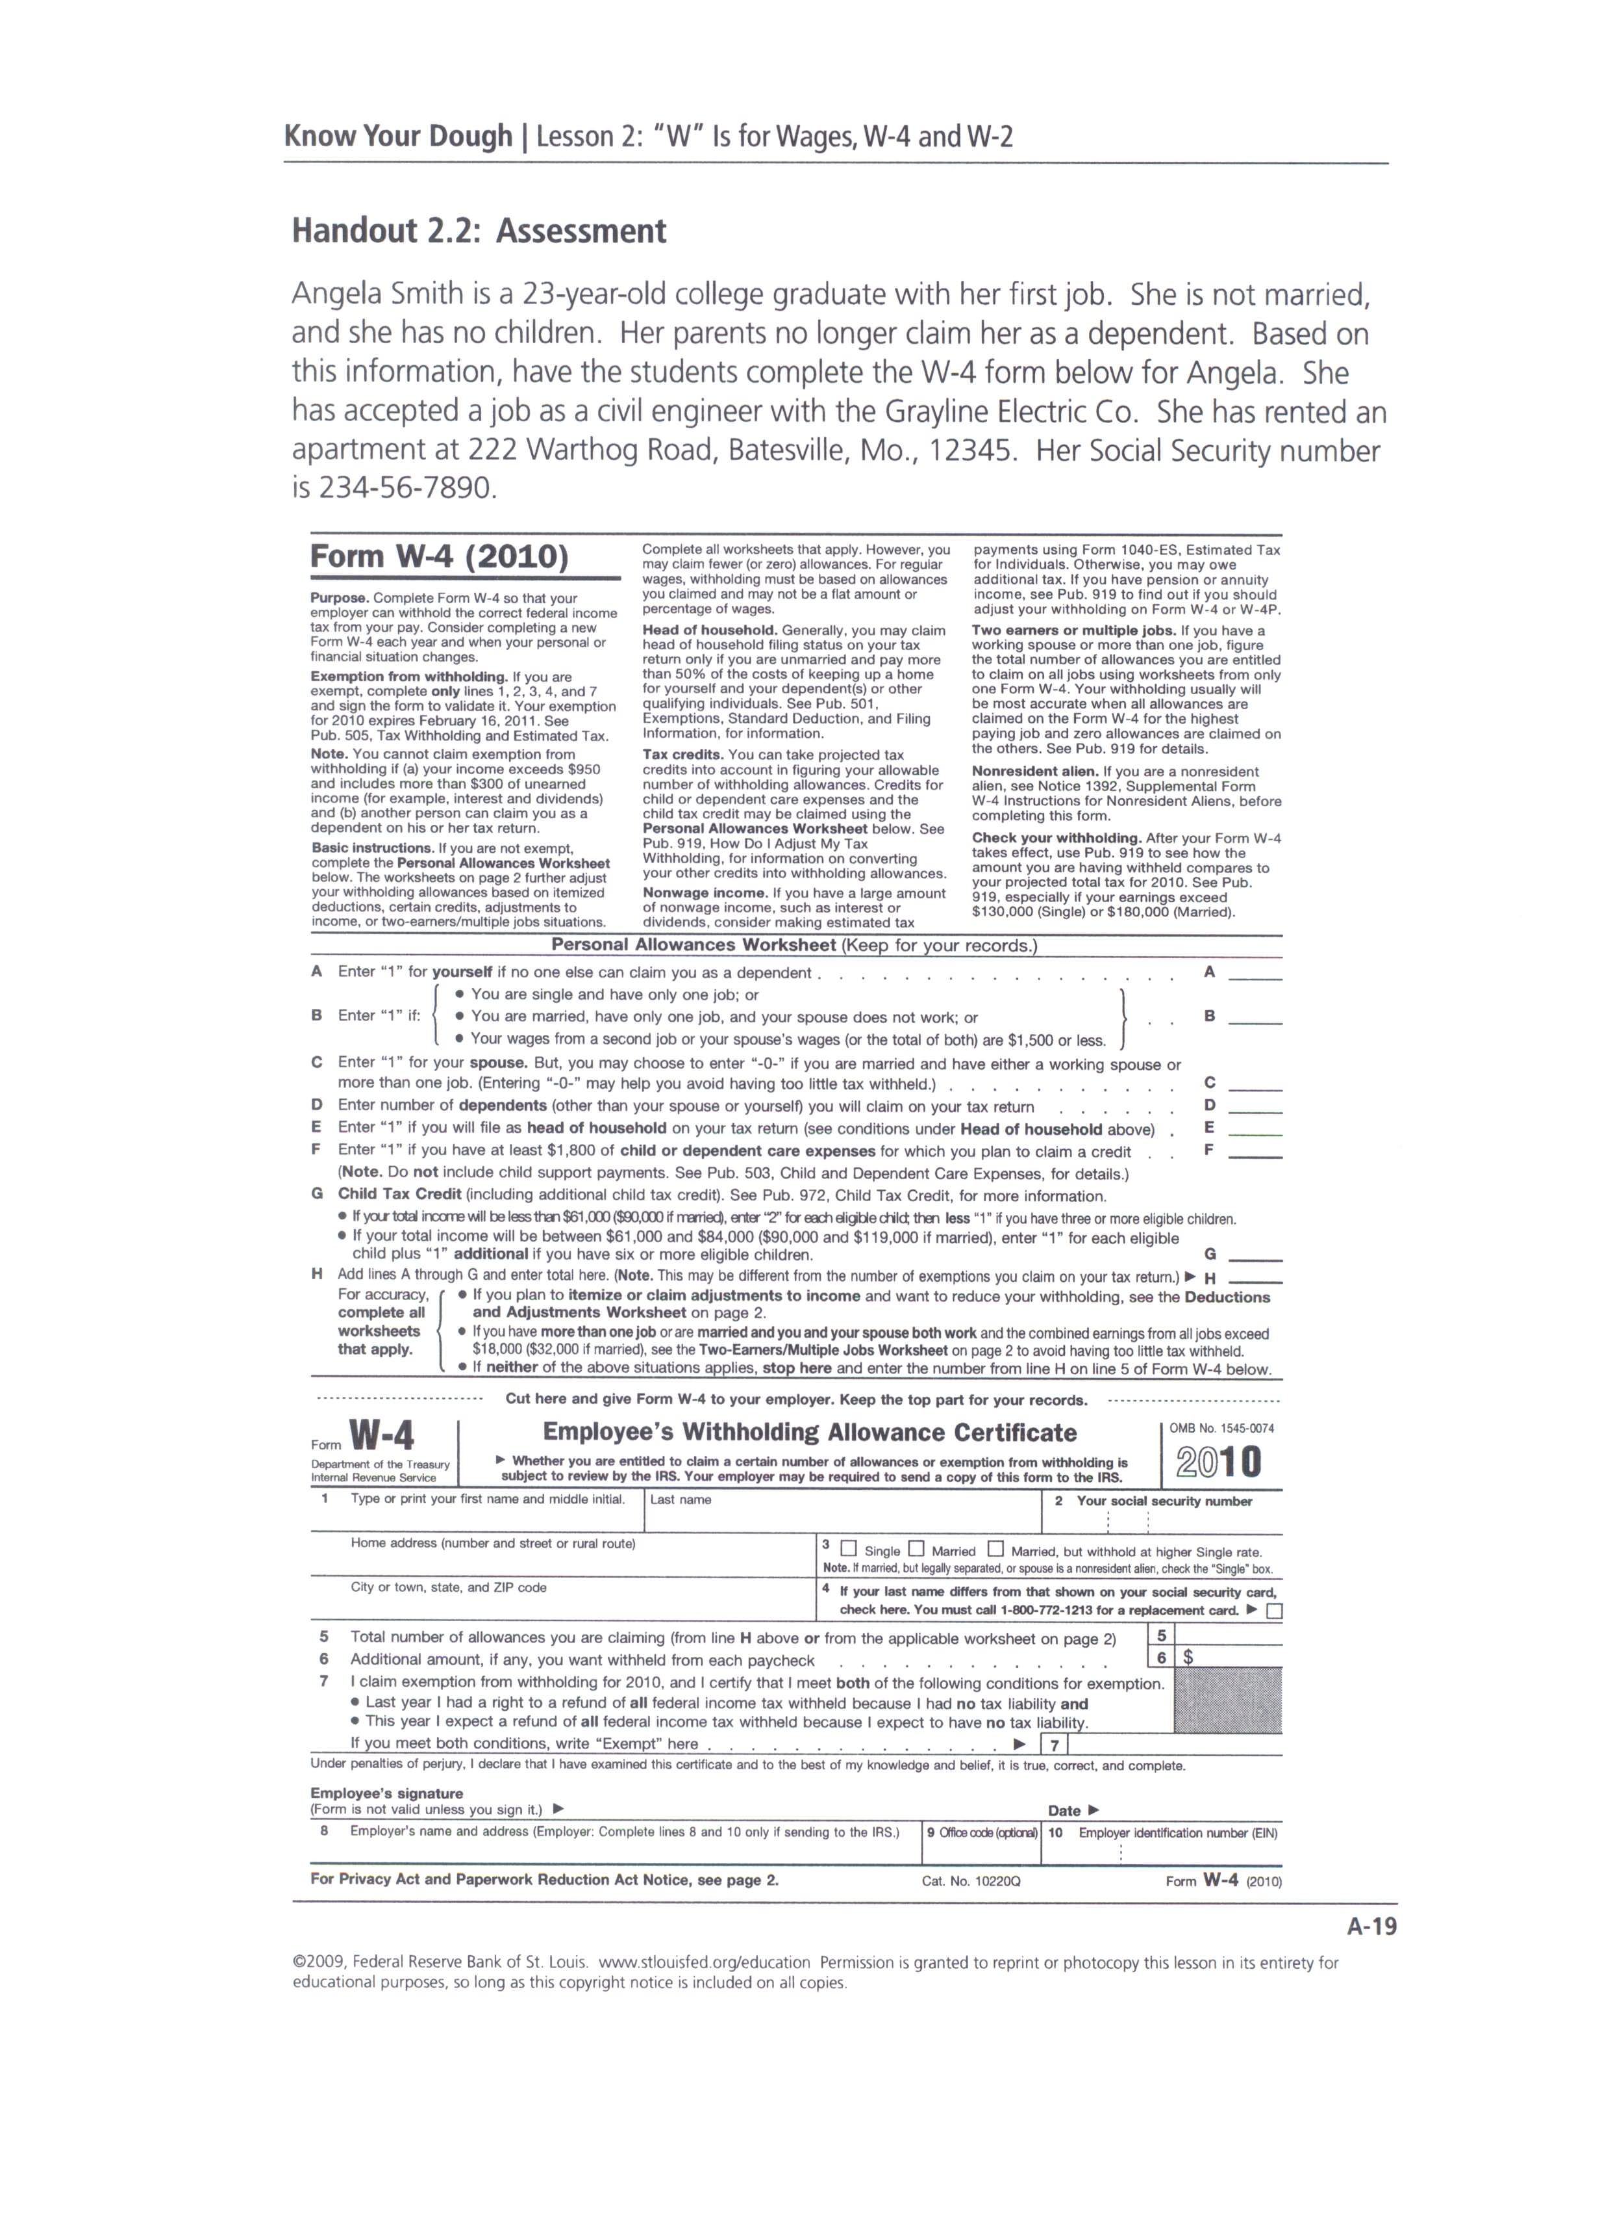
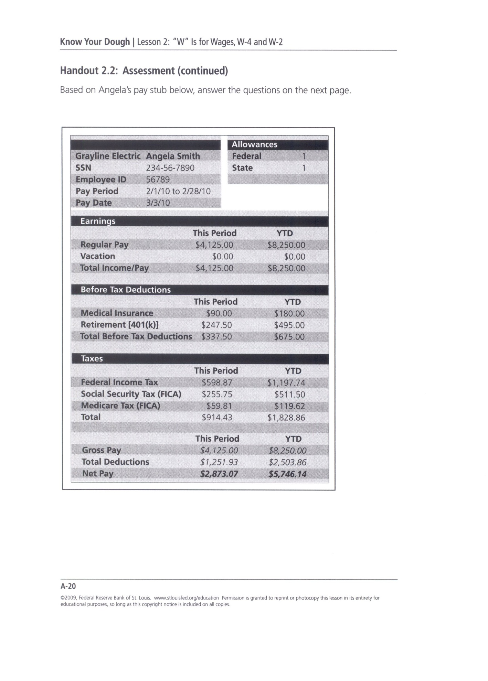
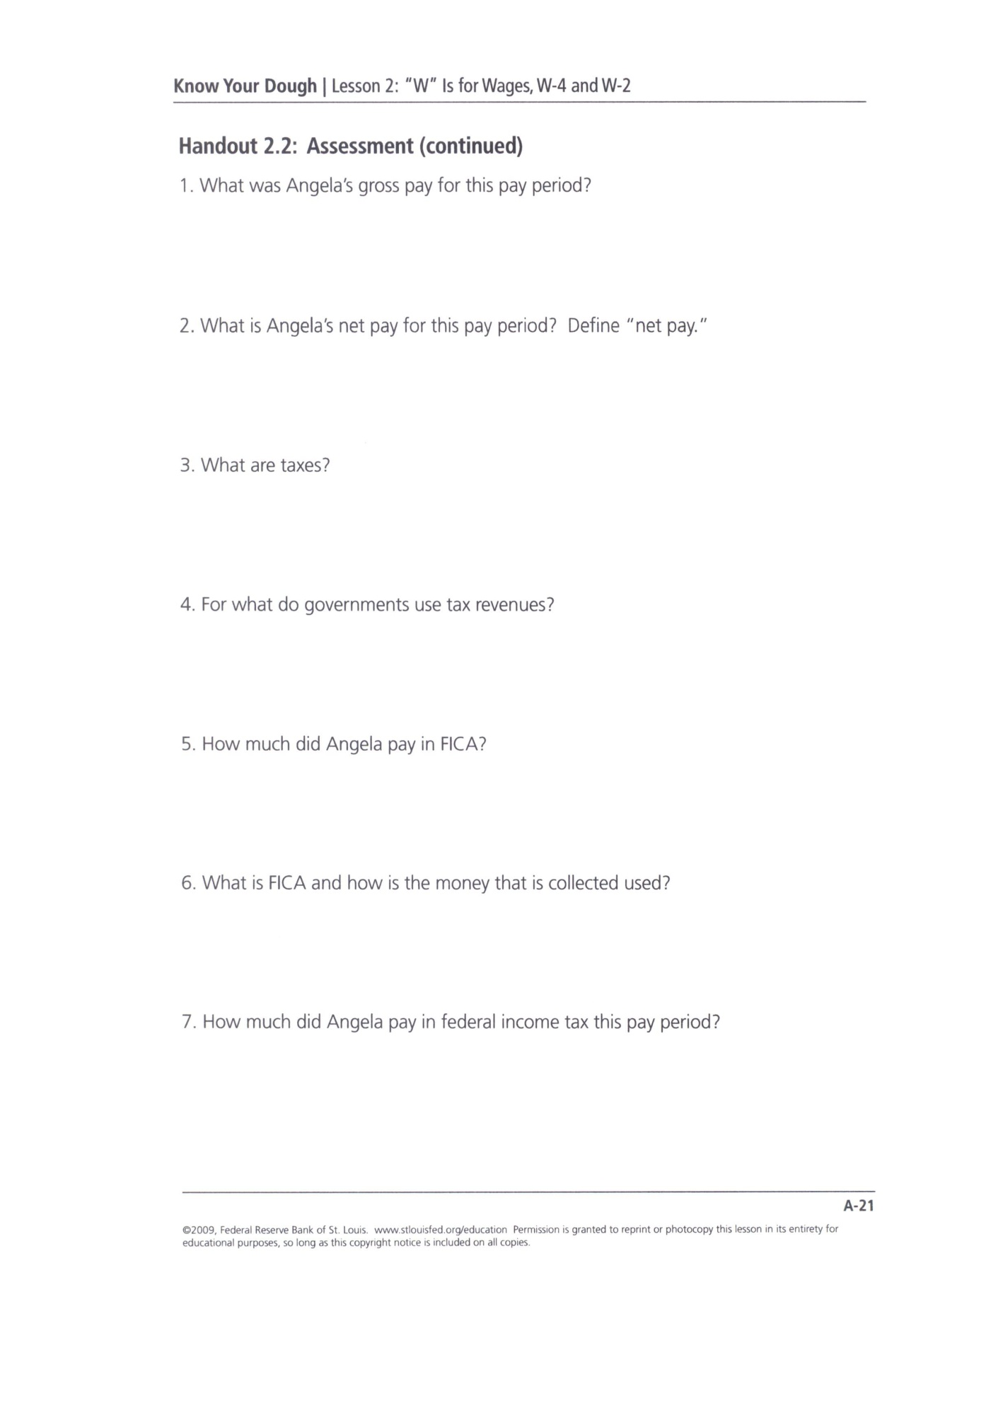
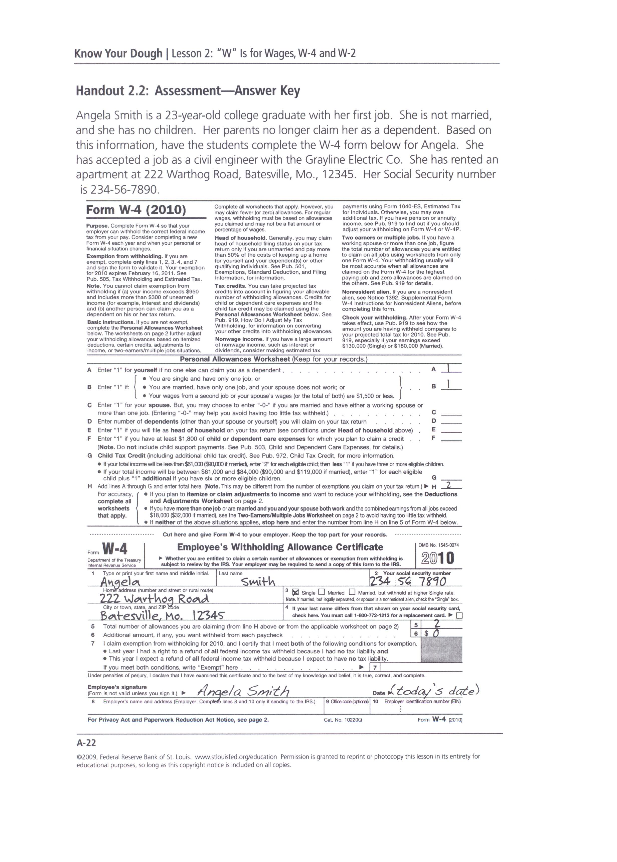
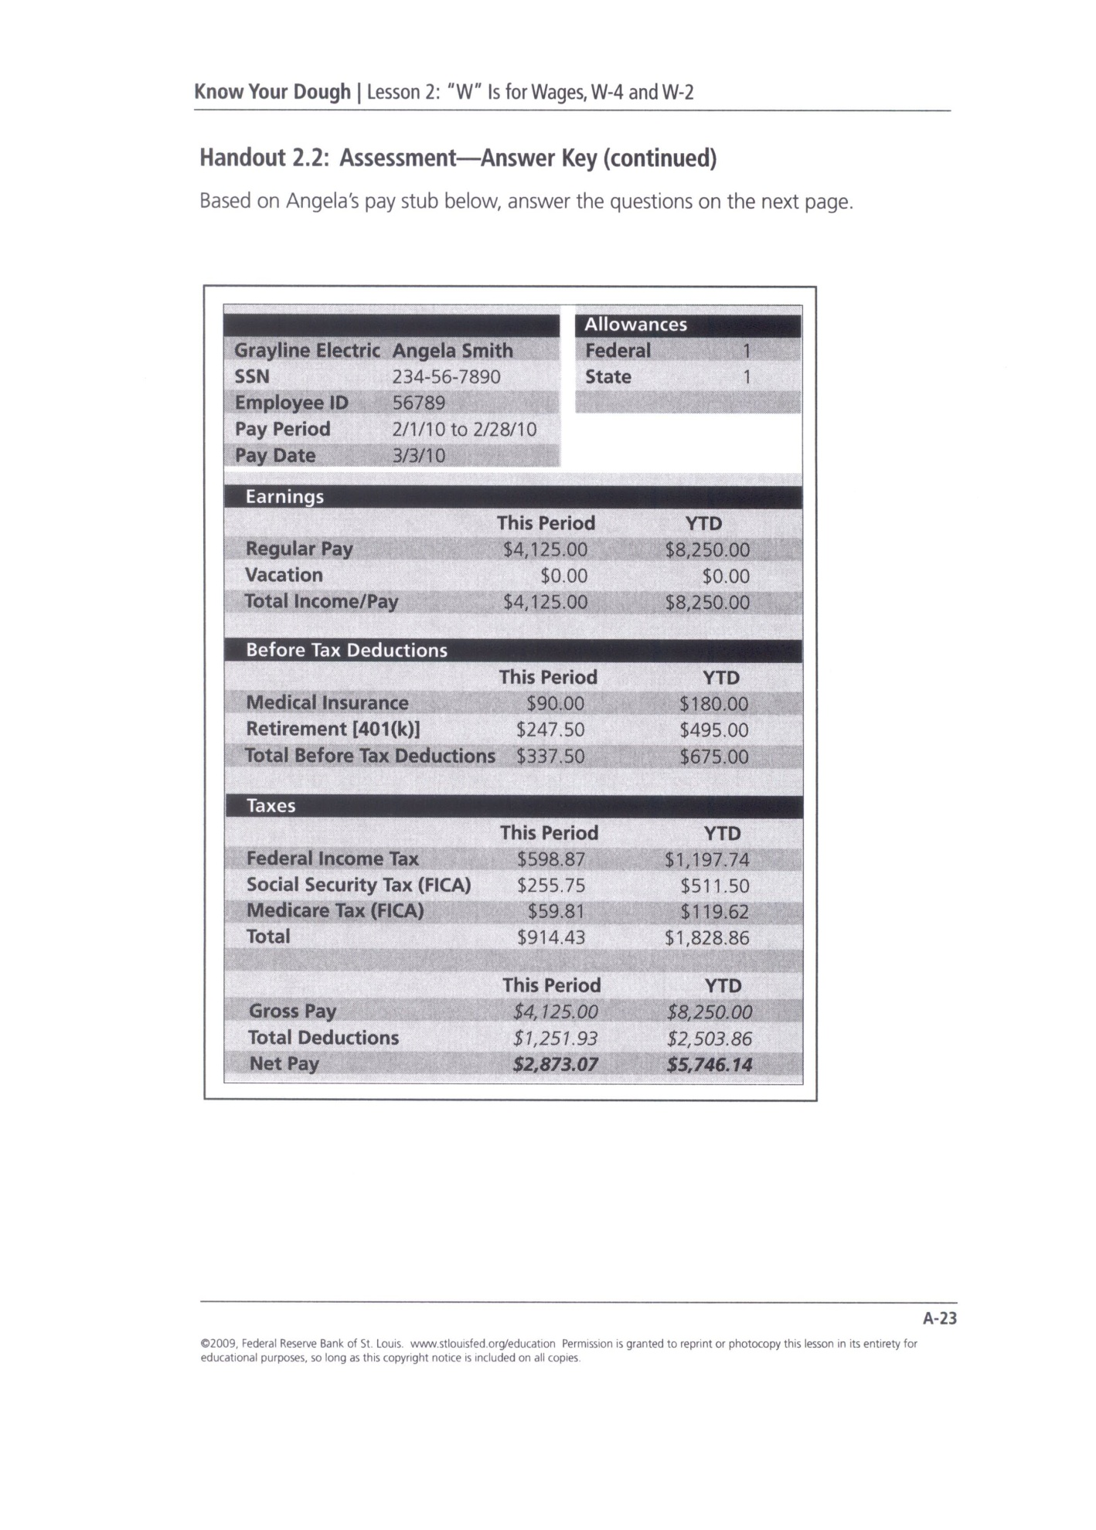
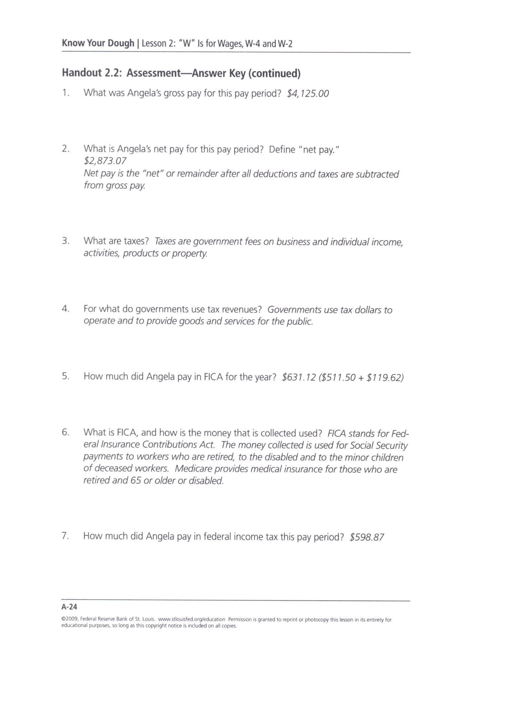
References

Federal Reserve Bank of St. Louis. (chap. Know Your Dough: “W” Is for Wages, W-4 and W-2) Retrieved Feb. 10, 2011, from http://www.stlouisfed.org/education
McKnight, D. (2003). Paycheck and Taxes (Version 97-2003) [Microsoft Office PowerPoint]. Montana State University.

Post-Assessment
Jeopardy: CBI Style
Materials:
- White sheets of copy paper

- Colored sheets of copy paper

- White board or Chalk Board

- Watch with a second hand or a stop watch, or other type of timer

- Calculators

- Black markers

- Score sheets

- Quarter ($.25)

- Name tents

- Pencils

Time Required:

1day

Procedures:
- Instructor will take name tents and shuffle them like playing cards

- Instructor will randomly select name tents and place them in 4 separate piles

- Each pile represents one team

- Students are to sit in the area where their name tents are located

- Each team is to choose a captain and a recorder

- The captain will display the team answers for each question

- The recorder will keep score for their own team

- Each team will receive 50 sheets of white copy paper (for answers) and 20 sheets of colored copy paper (for scrap and figuring out answers) and pencils for figuring; each team will also have one calculator and black marker; the black marker is to be used by the captain to write answers on the white paper; each team will have a score sheet to keep track of number of questions correct and team score

- Each team is located either at a table or in a circle if desks are used instead; each location allows all team members to have a proper view of the game board that is written on either the white or chalk board

- The instructor will give out the directions for participation; These include:

  - A quarter flip will determine which team goes first; afterwards each team will have a turn in choosing a category

  - There will be 5 categories on the board (see diagram); 4 categories from the lessons and 1 “Bonus” category

  - All questions must go in order as listed on the board (i.e. vertically)

  - After a category has been chosen, the instructor will read the question only twice

  - All the teams have 30 seconds to come up with a response—in order to respond to a question, the team captain will write the answer on the white copy paper, fold it in half so nobody can see the answer and be standing up by the end of the 30 seconds. Any captain not standing will not be allowed to offer an answer to the question. Nobody but the captain is allowed to speak for the team or show an answer.

  - If a team has the correct answer, that team recorder may add the number value of the question to their total score. If they miss the question, they simply add a “0” to their score. The job of the recorder is to add up the team’s score, count the total number correct, and to turn in the team’s score sheet to the instructor at the end of the assessment. The score sheet will contain the score and each name of the members of the team. All teams start with “0” points

  - The instructor (or designate) will also be recording team scores to verify accuracy

  - There will be no talking while the question is being read so that all can hear the question

  - Each team will be encouraged to speak in soft voices so that the other teams cannot hear what is being said (i.e. use the colored paper to pass the answer to the captain)

  - The instructor will determine if the answer submitted is correct—no discussion

  - At the end of the game, each team will submit their scores for verification—the winning score gets a prize (up to the instructor)

Grading:
The instructor will simply divide the number of correct answers by the number of questions asked (not including Bonus Questions) during the contest to come up with a percentage. For example, there are 50 questions asked per game, but the instructor will only divide a team’s score by 40 and not 50 to reflect the 10 Bonus Questions.

Sample Jeopardy Board
Work and the Paycheck
Figure My Wage | Parts of a Paycheck | “W” Questions | What Am I | Bonus
10 | 10 | 10 | 10 | 10
30 | 30 | 30 | 30 | 30
50 | 50 | 50 | 50 | 50
20 | 20 | 20 | 20 | 20
40 | 40 | 40 | 40 | 40
60 | 60 | 60 | 60 | 60
80 | 80 | 80 | 80 | 80

Sample Score Sheet
Category Point Value Correct (+) Score
_________________ __________ ___ _____
_________________ __________ ___ _____
_________________ __________ ___ _____
_________________ __________ ___ _____
_________________ __________ ___ _____
_________________ __________ ___ _____
_________________ __________ ___ _____
_________________ __________ ___ _____
_________________ __________ ___ _____
_________________ __________ ___ _____
_________________ __________ ___ _____
_________________ __________ ___ _____
(May make multiple copies for the class)
Sample Questions
Category
Bonus:
1) Name the program that provides benefits to people injured on the job or to dependents of workers killed on the job. (Workers’ Compensation)
2) The ‘spouse’ on a tax return refers to whom? (Husband or Wife)
3) What is the term for a sharp increase in the average price of goods and services? (Inflation)
4) A check that has been cashed is called what? (Cancelled check)
5) What is the term for everything of value that a person owns? (Assets)
6) What is the term for individuals who buy goods and services? (Consumer)
7) What do you call unequal treatment of workers in hiring, employment, pay, or conditions of work because of race, national origin, creed, color, sex, or age? (Discrimination)
8) A work permit which gives minors permission to work may be required for individuals under what age? (18)
9) What is a temporary end to employment due to a lack of business? (Layoff)
10) When filling out a job application, what two colors of ink are acceptable to use? (Black and Blue)
Figure My Wage:
1) Sally makes $7.50 per hour and worked 37 hours that week. What was her gross pay? ($277.50)
2) Johnny worked a total of 59 hours in one week. Of these hours, he was paid 8 at the regular overtime rate of 1.5 times his hourly wage and 11 at double time for holiday pay. Find his gross earnings for the week if his hourly pay is $12.65. ($936.10)
3) Susie works 49 hours in one week and earns $8.45 an hour with time and a half for every hour over 40 hours. Find her gross pay. ($452.08)
4) Peter worked a total of 57 hours in one week. Of these hours, he was paid 8 hours at double time and 9 hours at time and a half. Find his gross earnings for the week if his hourly pay is $15.00. ($1,042.50)
5) Carrie worked 40 hours straight time, 9 hours time and a half, and 12 hours double time. Her hourly rate is $9.25. What is her gross earnings? ($716.88)
6) Ron earns $9.40 per hour and works 40 per week. What is his gross annual salary? ($19,552)
7) Julie’s gross pay for the week was $525.00. She had $15.00 taken out for her dues and another $65.00 taken out for taxes. What was her net pay? ($445.00)
8) If Jane’s net pay was $87.50 and her deductions were $32.50, what was her gross pay? ($120.00)
9) If Peter’s net pay was $182.41 and his gross was $194.00, how much were his deductions? ($11.59)
10) If Mary’s net pay is $448.00 per week, what will her annual net salary be? ($23296.00)

Parts of a Paycheck:
1) YTD stands for: (Year to Date)
2) Regular is another name for: (Straight or hourly)
3) It starts on one day and ends on another (Pay Period)
4) What amount my gross amount is for now (Current)
5) My check has one that goes in order (check number)
6) If it is taken out, it is (Withheld)
7) Straight, over, double are all examples under (Earnings)
8) Add all these up and subtract from the gross (Deductions)
9) ITW means (Income Tax Withheld)
10) When you cash this it is considered (Cancelled)

What Am I:
1) Going to school (Investing)
2) Education, Skills, Abilities (Human Capital)
3) Purchasing Power relies on (Income)
4) The more education relates to (Higher/Greater Income)
5) What is another name for FICA tax? (Social Security)
6) What is the term for income that is disposable income minus essential purchases? It is the money you have after paying your living expenses. (Discretionary Income)
7) Two other taxes besides federal income tax (State, Local, City)
8) The amount one receives on a paycheck after deductions (Net Pay, Take Home Pay)
9) What do the letters IRS stand for? (Internal Revenue Service)
10) What do the letters FICA literally stand for? (Federal Insurance Contributions Act)

“W” Questions:
1) What are wages? (a form of income people receive for the work they do)
2) What is income? (payment people receive for providing resources in the market)
3) What are taxes? (government fees on business and individual income, activities, products, or property—people are required to pay taxes)
4) What is gross pay? (amount people earn in a pay period before any deductions or taxes are taken out)
5) What is net pay? (take home pay; the amount received after taxes and deductions have been taken out)
6) What 2 entities does FICA fund? (Social Security and Medicare)
7) Who pays FICA? (both employee and employer)
8) What is a W-4 form? (filled out by employee and it tells the employer how much income tax to withhold)
9) What is a W-2? (form employers must provide to employee so they can report annual income and withholdings for tax returns)
10) What are union dues and uniform charges considered? (Deductions)

References

Bachtel, B. (2006). Dropout vs. Diploma (Version 97-2003) [Microsoft Office PowerPoint]. Mentor, OH: Mentor Schools.
Burton, S, & N. Shelton. (2005). Practical Math Applications. (Vol. 2, Jack. Calhoun, Ed.). Mason, Ohio: South-Western.
Edwards, S. (2007). Setting Goals (Version 97-2003) [Microsoft Office PowerPoint]. Columbus, OH: Career Based Intervention Board of Directors.
Federal Reserve Bank of St. Louis. (chap. Know Your Dough: Invest in Yourself) Retrieved Feb. 10, 2011, from http://www.stlouisfed.org/education
Federal Reserve Bank of St. Louis. (chap. Know Your Dough: “W” Is for Wages, W-4 and W-2) Retrieved Feb. 10, 2011, from http://www.stlouisfed.org/education
Gerver, R, & R. Sgroi. (2005). Financial Math Review. (Vol. 1, Jack. W. Calhoun, Ed.). Mason, Ohio: South-Western.
Lange, W. H, & T. Rousos. (2004). Mathematics With Business Applications. (Vol. 5, Diane. Culpepper, Ed.). Woodland Hills, California: Glencoe.
McKnight, D. (2003). Paycheck and Taxes (Version 97-2003) [Microsoft Office PowerPoint]. Montana State University.

Plautz, E. (2006). Show Me the Money (Version 97-2003) [Microsoft Office PowerPoint]. Columbus, OH: Career Based Intervention Board of Directors.

