http://blogs.worldbank.org/climatechange/deforestation-disastrous-consequences-climate-and-food-security

Deforestation: Disastrous consequences for the climate and for food security

SUBMITTED BY SHIVA MAKKI ON TUE, 08/25/2009 - 10:40
I grew up in a small village in South-Western India, which is known for evergreen forests, wildlife, and spectacular landscapes. That was in the 1970s and 1980s. My interests in forests began then, as I spent many hours wandering off into the woods on my way back from school. When I was six years old, my father bought five acres of pristine forest land and converted them into a coffee plantation. He wasn’t the only one. In just three decades, much of the forest around where I grew up has been either converted to crop lands or cleared for logging.
This loss grieves me. Although I have worked on a broad range of issues as a professional economist, my concerns for forests and the environment remain high. In a recent note, I’ve tried to show the complex links between deforestation, climate change, and food security with a simple diagram. The note can be easily downloaded and is meant for students.

Deforestation, Climate Change, and Food Security
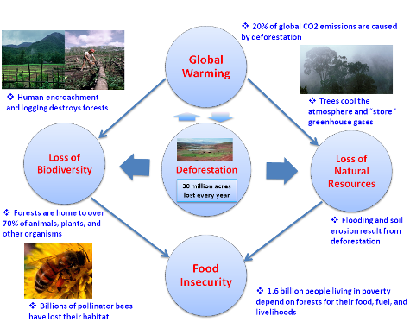
Created by Shiva Makki/World Bank. (See note for a large-scale diagram).
As the diagram shows, forests are not only one of the most valuable natural resources but also crucial to ensure decent conditions for all living organisms. The rate at which our planet is being stripped of its forest cover, however, is alarming. The FAO estimates that over 30 million acres (or 13 million hectares) of forests are destroyed by human activity every year.
Population growth, the expansion of agricultural land use, and indiscriminate logging, are all combining to push many forests to the brink of extinction. If deforestation continues at the current rate, mature natural forests in Papua New Guinea will be gone in 15 years or less, and Indonesia and Myanmar, in about 10 years. The Philippines and Thailand have already logged most of their natural forests.
Deforestation devastates biodiversity and natural habitats and degrades natural resources. In the developing world, 1.6 billion people depend on forests for their food, fuel, and livelihoods. The real economic value of forests is much greater than the short-term benefits of logging or clearing land for agriculture. In the longer run, the loss of biodiversity, habitat, and natural resources will affect food production in both developed and developing countries.
But the most serious consequences of them all may be global warming. Almost 20 percent of all global carbon dioxide emissions are caused by deforestation. This harmful reinforcing sequence of deforestation and climate change not only puts the global food production system at risk but also impedes our ability to maintain a healthy society. Time is fast running out to save tropical and other forests. Only a concerted effort involving scientists, policy makers, and civil society will avoid this dangerous trend.

@@@

