My
Seed
Journal
By:
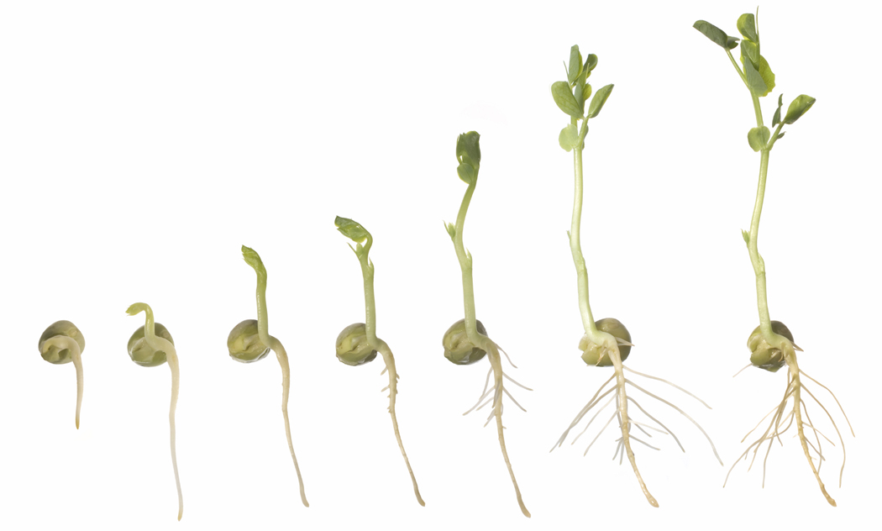

Day One
My seed looks like this:

What I see:

What I did today: watered plant put plant in sunlight
(circle)
Day Two
My seed looks like this:

What I see:

What I did today: watered plant put plant in sunlight
(circle)
Day Three
My seed looks like this:

What I see:

What I did today: watered plant put plant in sunlight
(circle)
Day Four
My seed looks like this:

What I see:

What I did today: watered plant put plant in sunlight
(circle)
Day Five
My seed looks like this:

What I see:

What I did today: watered plant put plant in sunlight
(circle)
After the Weekend
My seed looks like this:

What I see:

What I did today: watered plant put plant in sunlight
(circle)

