Instructional Design
Subunit: Spatial Thinking & Skills
Created and Developed by Cyndy Tilley
Bowling Green State University
June 6, 2011

Rationale - Subunit – Spatial Thinking & Skills

There is a great need to increase the quantity and quality of geography being taught in elementary schools. Elementary students have the ability to learn geographic skills such as observation, map reading, classifying and interpretation. Research by Thornton, Stephen J., and R. Neill Wenger (1989) support that only a small portion of the school day is spent studying geography. Teachers often feel the need to spend more time on more important subjects. In this instructional design I have attempted to emphasize questioning, analyzing and evaluating geographic information, focusing in the spatial thinking skills area. Through the use of books and cross-curricular activities, I have been able to incorporate geography into other educational areas; including reading and language arts.
Teachers need to sequence learning, keeping maturation in mind as well as learning questioning techniques according to Taba, Durkin, Fraenkel, & McNaughton (1963). This method of teaching concepts through inquiry can be used to teach map skills. Although the lessons outlined in this instructional design should last in duration of eight to ten days, the skills should be repeated throughout the geography & social studies course. Students need to transfer information being taught and this may depend on their maturation levels. According to Chiarelott (2006),“The key to successful development and attainment of concepts and skill is the opportunity to have guided practice and timely corrective feedback” (p. 106). I have provided this practice throughout my lessons; however I haven’t taught this unit and the timing may need to be modified and extended. As teachers we must be flexible. While time may need to be modified, as we assess students, lessons may require additional reinforcement.
Both deductive as well as inductive methods will be used in this geography unit. The use of observation will also be used in both methods to teach concepts. Contextualized and essential questioning techniques are also modes that will be utilized throughout the unit, geared toward the learner and society. According to Chiarelott (2006), curriculum designs should place content needs within both the learner and societal needs. This makes the learning relevant to both student and society. Hilda Taba, a curriculum theorist and pioneer in social studies education says humans naturally form concepts from part to whole (as sited in Chiaretlott, 2006, p.114). This instructional design contains objectives that lead to a whole concept; therefore I am using the “inductive model” as a basis for the lessons outlined.
Students will be given informal pre and post assessments for this unit. Formative as well as summative assessments will be used throughout the course. Formative assessments will consist of observations, worksheets and in-class responses. There will also be a summative assessment as well. Instruction will be modified as needed and intervention will be an option.
Through the learning environment, selected models, assessments, contextual and essential techniques, it is my hope students will be engaged in quality geographical instruction that can be transferred in a meaningful way. Geography is a life-long skill and the importance must be stressed in the elementary grades with quality learning targets and teaching strategies.

References

Chiarelott, L. (2006). Curriculum in Context: Designing Curriculum and Instruction for Teaching
and Learning in Context. Bowling Green State University. Vicki Knight publisher.
Buggey, J. and Kracht, J. (1985). “Geographic Learning” In Elementary School Social Studies:
Research As A Guide to Practice, bulletin 79, edited by V>A. Atwood. Washington, D.C.
National council for the Social Studies.
Haas, M.E. (1989-08-00). Teaching Geography in the Elementary School. ERIC Clearinghouse
For Social Studies/Social Science Education Bloomington IN.
Taba, Durkin, Fraenkel, and McNaughton, (1963). David P. Ausabel, The Psychology of
Meaningful Learning, (p.65) (New York: Grune and Stratton).
Thornton’s. & Winger. (1989). Geographic Education in the Elementary School: Current
Practices and the Prospects for Reform. Paper presented at annual meeting of the American
Educational Research Association, San Francisco. Retrieved June 3,2011 from http://www.ericdigests.ort/pre-9212/geography.htm

Unit Learner Outcomes
Grade 4 Geography
Spatial Thinking and Skills
- Use a linear scale to measure the distance between places on a map. (knowledge)
- Use cardinal and intermediate directions to describe the relative location of places. (knowledge/comprehension)
- Describe the location of Ohio relative to other states and countries. (analyze)
- Use maps to identify the location of major physical and human features of Ohio including: a) Lake Erie, b) rivers, c) plains, d) Appalachian Plateau, e) bordering states,
f) The capital city. (knowledge/comprehension)
- Compare and contrast elevations in Ohio. (analysis)
Places and Regions
- Identify manufacturing, agriculture, mining, and forestry regions in Ohio. (knowledge)
- Explain how resources, transportation and location influenced the development of cities and industries in Ohio including major industries such as oil, steel, rubber and glass. (analysis)
Human Systems
- Identify ways people have affected the physical environment of Ohio including wetlands, use of forests, building farms, towns, and transportation systems, using fertilizers, herbicides, pesticides, and building dams. (knowledge/comprehension)
- Analyze patterns of settlement, economic activity and movement. (evaluate/analyze)
- Use natural resources, elevation and road maps to analyze patterns of settlement, economic activity and movement. (analysis)
Preassessment Survey: What I know about Geography
Directions: Read each question and circle yes or no to the best of your ability.
1. A compass rose can be found on a map? Yes No
2. The direction “northeast” is a primary direction? Yes No
3. The north, south, east and west directions on a compass rose
are called cardinal directions? Yes No
4. A star on a map stands for a city? Yes No
5. Our state capital is located in the Great lakes Plains? Yes No
6. An elevation map shows how the height of land changes
in an area. Yes No
7. There are 5 states that border Ohio? Yes No
8. Indiana is east of Ohio? Yes No
9. A map scale gives the actual weight of each city on the map? Yes No
10. Lake Erie was formed by glaciers thousands of years ago? Yes No
11. Describe Ohio’s location. How would you tell someone where Ohio is located?
_______________________________________________________________________
_______________________________________________________________________
_______________________________________________________________________
- What are some things about maps or places you would like to learn about ________________________________________________________________________________________________________________________________________________________________________________________________________________________________
Lesson: Finding Relative Location of Places

Objective: Students will study the relative location of Ohio using cardinal and intermediate directions.
Concepts/Skills: Cardinal directions, intermediate directions, and the use of both to locate places.
Materials: Ohio maps, Ohio Studies Weekly (Vol. 10, issue 1, week 1), “There’s a Map on my Lap” by Tish Rabe, 2002. Materials are attached.
Procedures:
Introductory Activity: (duration: 15 min)
- Tell students we will be learning how to read and use maps.
- Ask students to share what they know about maps.
- Read “There’s a Map on my Lap” to the class. (This book is all about maps)
Developmental Activity: (duration: 20 min)
- (Essential Questioning) Ask where is Ohio? How might you find Ohio on our planet? Has anyone ever heard of a compass rose?
- Tell students to turn to pg. 3 of Ohio Weekly “Compass Rose”. Read and discuss compass rose and intermediate directions. Label cardinal directions on map’s compass, then label intermediate directions.
- Look at the map of Ohio (in the newspaper), “What large city is northeast of Columbus? (Akron).
- Make sure students know every intermediate direction begins with N or S and ends with E or W.
- Activity: Silent Map Relay – give each student a map outline. Students will be placed in groups of four. Rules: The race must be done silently. Everyone must add a map feature to the map in front of them. Move clockwise. Begin by writing the title on own map first. Four minutes will be given to move around to each other’s maps; adding a feature such as a symbol, scale, compass rose, surrounding state, cities etc. Each student may add only one feature to each map. Teams with the most correct entries wins. (This activity will help the teacher assess prior knowledge as well as knowledge learned in class today. He/She will be able to determine misconceptions or lack of understanding.
Concluding Activity: (duration: 5 min)
- Review cardinal/intermediate directions. Ask students “What do you know about cardinal and intermediate directions?” Ask, “Give me intermediate directions from Columbus to: Maumee River, Cincinnati, Akron, Cleveland and Lake Erie.
Assessments: Formative assessments will include teacher observation from both verbal answers and group game. Assign: ws 25 (“Using Intermediate Directions”, 1991, Inst. Fair, Inc., Map Skills). This will be an independent activity and can be used as a grade. A written summative assessment will be given at the end of the geography unit.

Integrated Curriculum: (This lesson can also be incorporated into language arts)
Using formula writing, students will write a paragraph using facts from the Ohio Weekly Newspaper. “Pretend you have a friend who has never seen or used a map. Write a good paragraph to explain to your friend how you use a map. Include a compass rose, cardinal and intermediate directions and a map key.
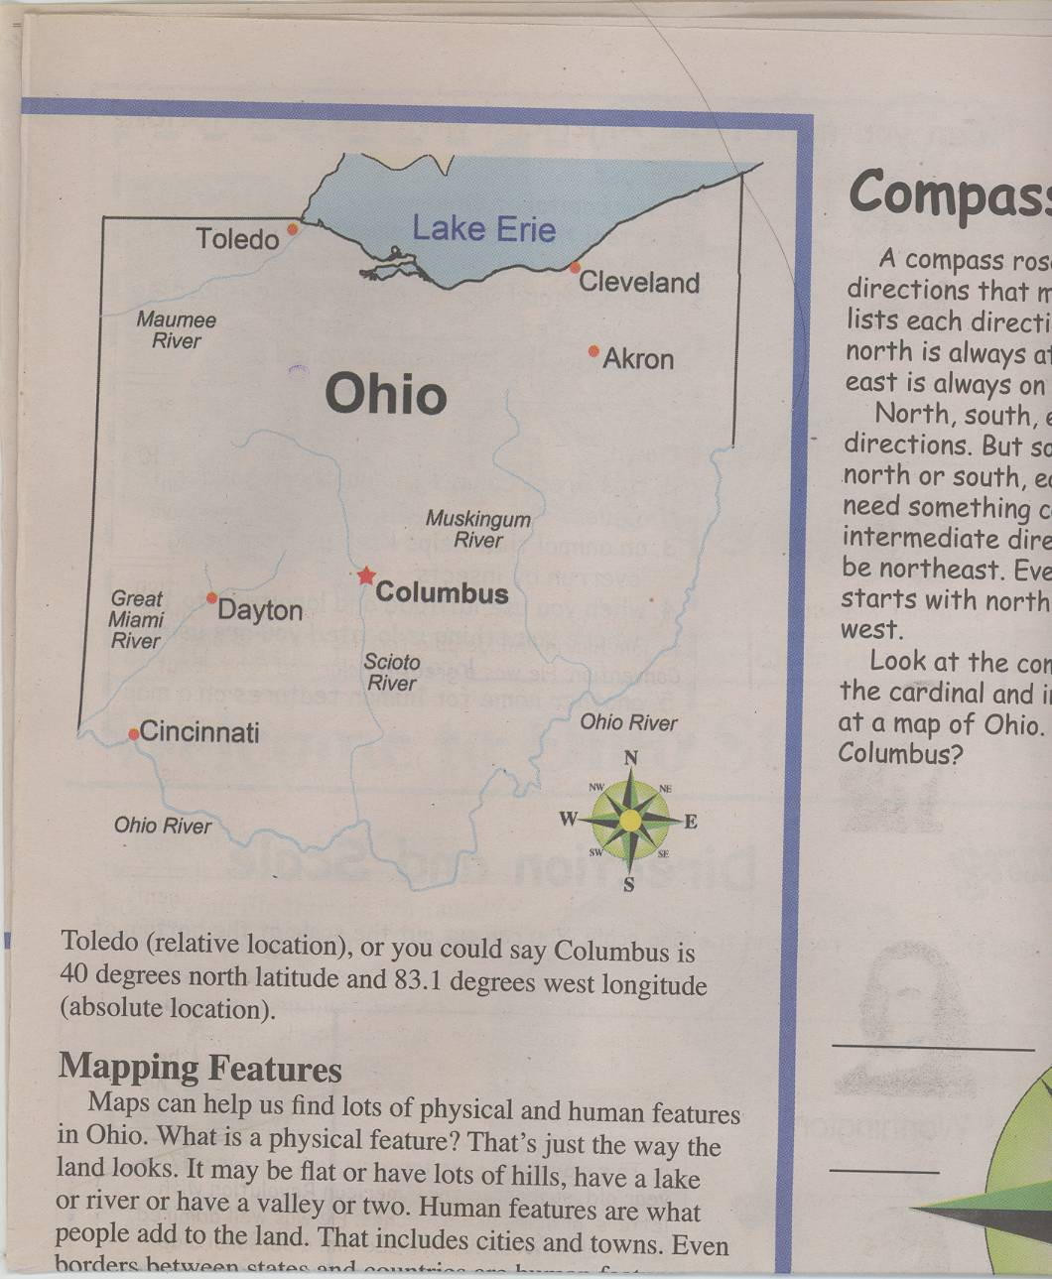
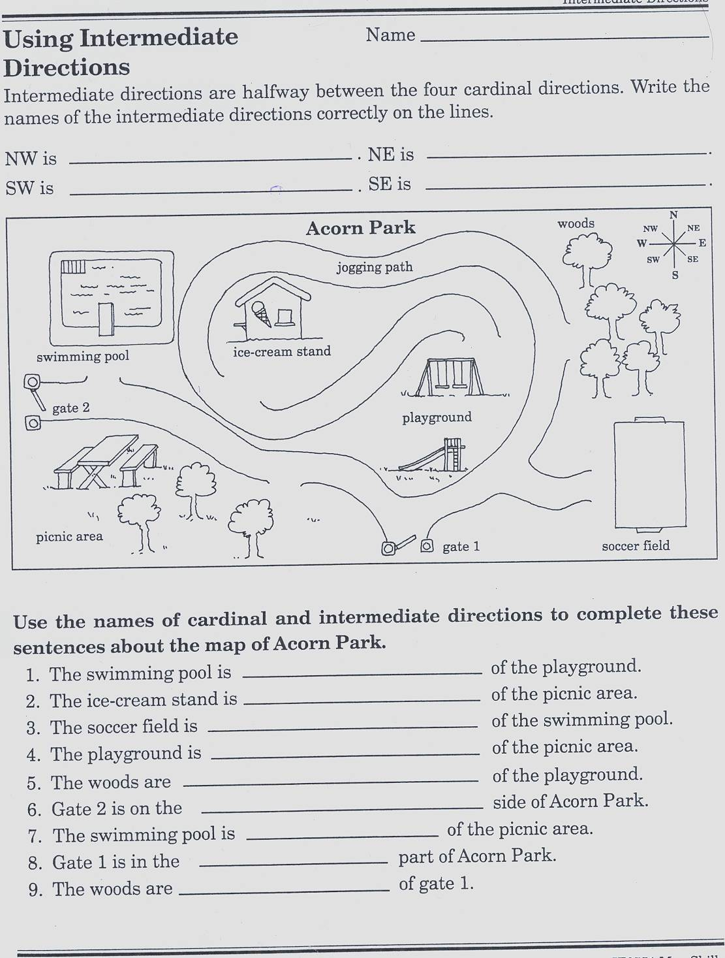
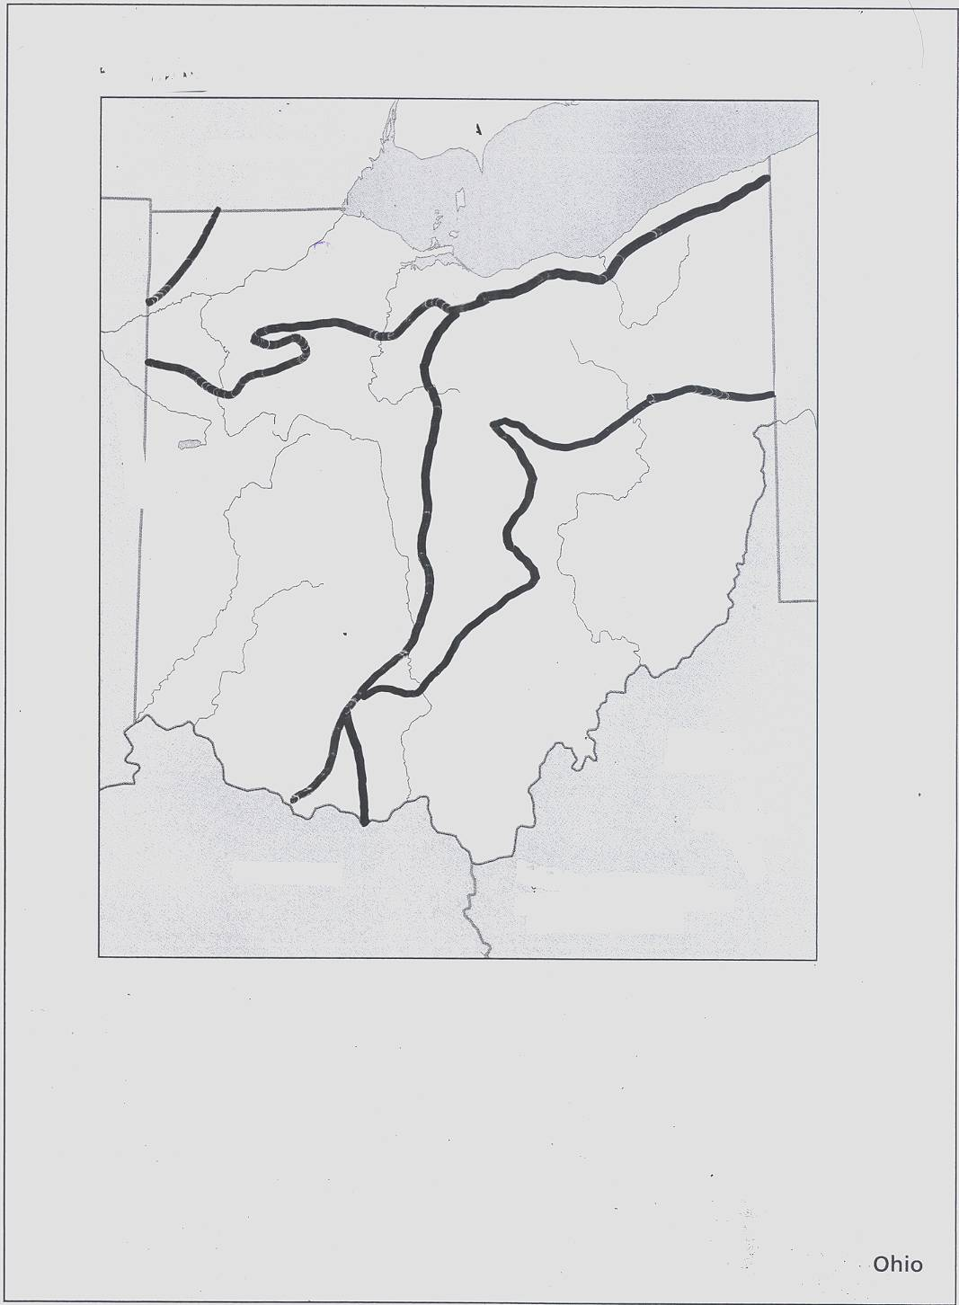
Lesson: Measuring Distance
Objectives: Students will use a linear scale to measure distance between places on a map, including cities and places of interest.
Concepts/Skills: Students will use a road map to figure mileage between at least two places in Ohio.
Materials: Road maps, worksheet- “scale of distance”, teacher copy of p. 2-3 “Using Maps – Weekly Reader – Instructor, 1993. Ohio Studies Weekly, (Vol. 10, issue 1, week 1, pg. 4). Pg. 39 (worksheet – “Camping in Nature Park”) from Instructional Fair, Inc., 1991.
Procedures:
Introductory Activity: Duration: (2 min)
- Read pg. 2-3 “A View from Space” (“Using maps in the United States” (1993) Weekly Reader Instructional Materials) to students.
Developmental: Duration: (25 to 30 min)
- Tell students maps can’t be as large as real places, so map makers draw maps to scale. The map scale shows the relationship between actual size and the size shown on the map.
- Give examples: A road 100 mi. long might be shown by a line 1 inch long on a map. Ask: Then 2 inches would =? mi. (200mi), 3 & 4 would =?
- Give students scales of distance worksheet. Have them cut off bar scale.
- Demonstrate how to use the bar scale to measure from 1 point to another point. The teacher will use the smart board to demonstrate. The students will then be asked to measure distances between places. Partner work: students can work as partners to answer questions regarding map scale and compass rose (review) form pg. 4 of Ohio Studies Weekly.
- Explain to students they could draw a bar scale by tracing the scale on the map to paper. Demonstrate on smart board – how to draw to scale and cut out, then measure. Call students to board to practice measuring with the bar scale.
- Tell students they could also measure using string from point A to point B. (demonstrate).
Concluding Activity: (duration: 10 min)
- Give students maps of Ohio. Ask to point to scale. How many inches = 10 mi? 5 mi?
- Students will be given a list of places to accurately measure from place to place using the map scale.
Assessment: Formative assessments: observations of in-class work. Students should obtain 90 – 100% success on worksheet 39 (Camping in Nature Park, Map Skills, 1991 Instructional Fair, Inc.) A summative assessment will be given at the end of the unit.

Please see attached materials.

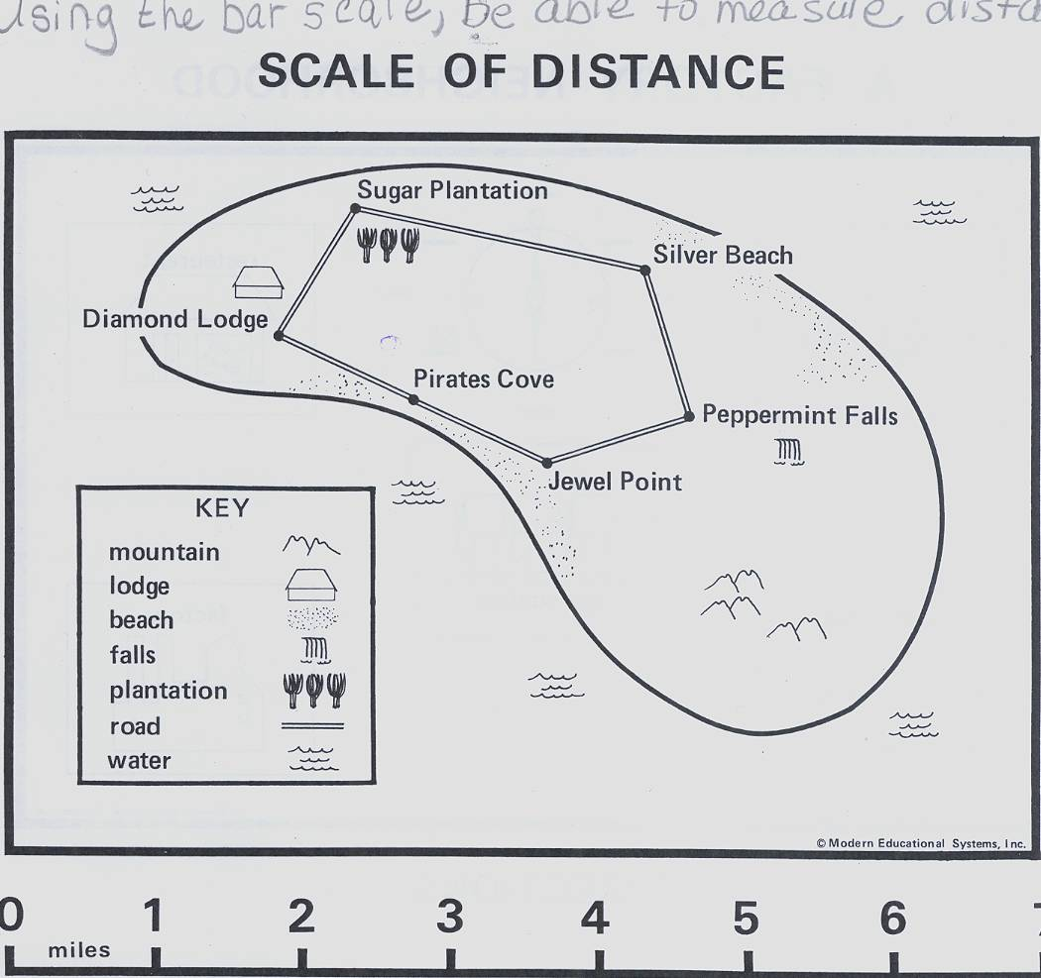
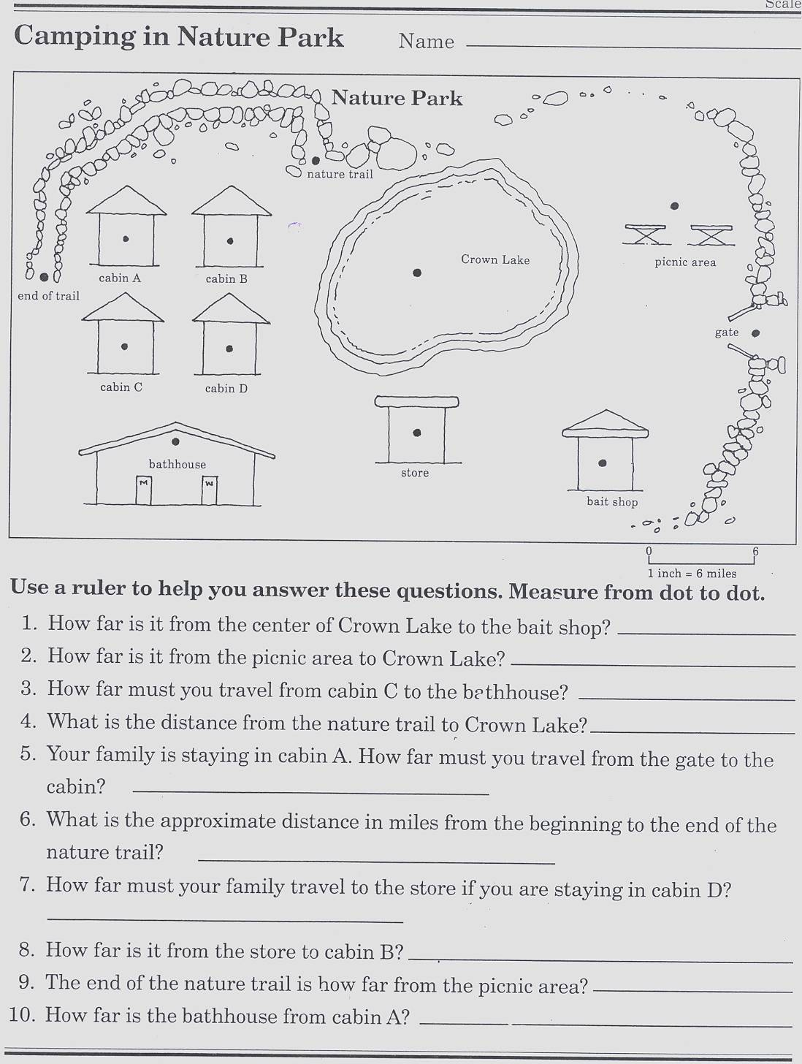

Lesson:
Geography of Ohio

Objective: Describe Ohio’s location relative to other states, countries and bodies of water.
Concepts/Skills: Students will be able to locate Ohio on the North American continent in the United States, just south of Lake Erie. Students will identify Ohio as a Midwest state and close to the Great Lakes.
Materials: blow up globes, an outline of North America (Harcourt Resource Curriculum). “B is for Buckeye” 2000, (by Marcia Schonberg)
Procedures:
Introductory Activity: (duration: 10 min)
- Read “B is for Buckeye pgs. 7-8. Have students take turns stating different ways to describe Ohio’s location. Record responses on smart board.
- Tell students at the end of the lesson we will revisit our responses.
Developmental Activity: (duration: 25 to 30 min)
- Tell students Ohio’s location and physical features are shown on maps and globes. Give each student a globe. Tell students to locate Ohio on the globe.
- Point out that the 5 Great Lakes are Erie, Huron, Ontario, Michigan and Superior.
- Have students use their fingers to trace the shapes of Ohio, U.S., and North America on the globe.
- Tell students to pretend they have a cousin who live in France. She/He wants to know where exactly you live. A) You tell them that Ohio is part of the continent of North America. A continent is one of the 7 largest land areas on Earth. B) Ohio is one of 50 states of the U.S. C) Find the U.S., Canada and Mexico on the globe. Explain they are countries in North America. D) Ohio is south of Lake Erie. Find Lake Erie on the globe). E) Five states surround Ohio. Point to them and name them.
- Give each student an outline of a map of North America. Students will work as partners to label the map. (N. America, U.S., Ohio, 5 Great Lakes, Canada and Mexico). Student may refer to globe as needed.
- As a whole group, display a map on the smart board. Have students come to the smart board and label. Make corrections as needed.
Concluding Activity: (duration: 5 to 10 min)
- Put students’ initial descriptions back up on board. Ask if there is anything they would like to change or add.
- “What did you learn from today’s lesson?” Clear up any misconceptions.
Assessment: formative assessments include, using observations of map work (non-graded), accurate descriptions to the question regarding where Ohio is located. Assign students to write a paragraph describing where Ohio is located. (Take grade – use rubric). Homework: Students will take another outline map of North America home and explain to an adult where North America, Ohio, Canada, Mexico, the 5 Great Lakes and the surrounding states are located. (Non-graded) Summative assessment: A written test will be given at the end of the unit.
*Please see attached materials
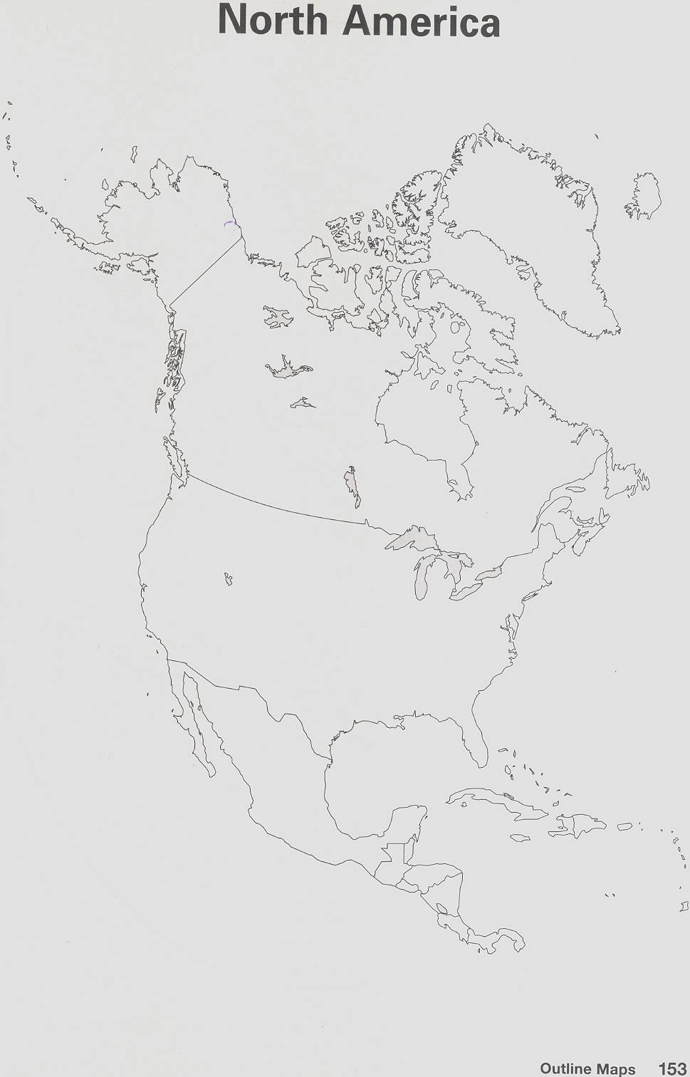
Lesson: Elevations in Ohio
Objectives: Use a map key and scale to identify elevations of places in Ohio. Compare and contrast elevations in Ohio.
Concepts/Skills: Understanding range, use of map key to find ranges of elevations and how to measure elevation.
Materials: Practice worksheet (pg. 2 “Read an Elevation Map”) Homework and Practice Book, Harcourt. Elevation map Transparency (Harcourt), Atlas for each student (Harcourt). White boards, markers, colored pencils, elevation maps.
Procedures:
Introductory Activity: (duration: 10 min)
- Explain to students that elevation maps have many purposes. Ex. Engineers use them when they plan where/when to build roads. Tell students elevation maps show height of land changes in an area. Elevation is always measured relative to sea level and is always 0. Use Ohio Studies Weekly (Vol. 10, issue 1, week 2, pg. 3). Read together.
- Ask students how they might use an elevation map during a camping trip.

Developmental Activity: (duration: may take 1 or 2 class days)
- Display an elevation map of Ohio on the smart board. Tell students to follow these steps to read the map.
- Study the map key (this should be a review from previous lessons). Each color stands for a range of elevations. A range is the highest and lowest places in an area and all elevations in between.
- Look at the shaded areas on the map. Shaded areas show differences in the heights of land in an area.
- Heavy shading shows steep rises and drops in elevation. Light shading shows gentle rises and drops.
- Use an elevation map for atlas (Harcourt) to answer the following questions. (whole class) 1. What is the elevation of Toledo? (328 – 655 ft). 2. What is the highest elevation of the Allegheny Plateau? (above 1,312 ft). 3. Which city has a higher elevation? Portsmouth or Akron? (Akron).
- Students will work as partners to complete elevation map worksheet. Go over answers together as a whole class.
- Imagine that you are planning a trip from Toledo to Dayton. (use Atlas from Harcourt) Write the name and elevation of each city along your route. What is the highest and lowest land you cross along the way? Answers: From Toledo (328-655 ft), moving south elevation increases, Campbell Hill – 1,550 ft., continue south, elevation decreases, Springfield (984 – 1,312 ft), continue south to Dayton (655 -984 ft.).

Concluding Activity: (duration: 10 min)
- Review orally the steps to reading an elevation map. Ask students to explain the steps.
- Give students white boards and markers. Display elevation map on smart board. Ask students to give the range of elevation to various places. After each place given, students will hold up boards. Teacher will observe answers for understanding.
Assessment: Formative assessments – observations during group and individual work. Students will be given an elevation map and asked to use the map key to figure out elevation ranges of various places. This will be an individual graded assessment. Students will draw a map showing the elevations of the region. They will use colored pencils to show each elevation and explain their meanings in a map key. Summative assessment will be given at the end of the unit.

* Please see attached materials.

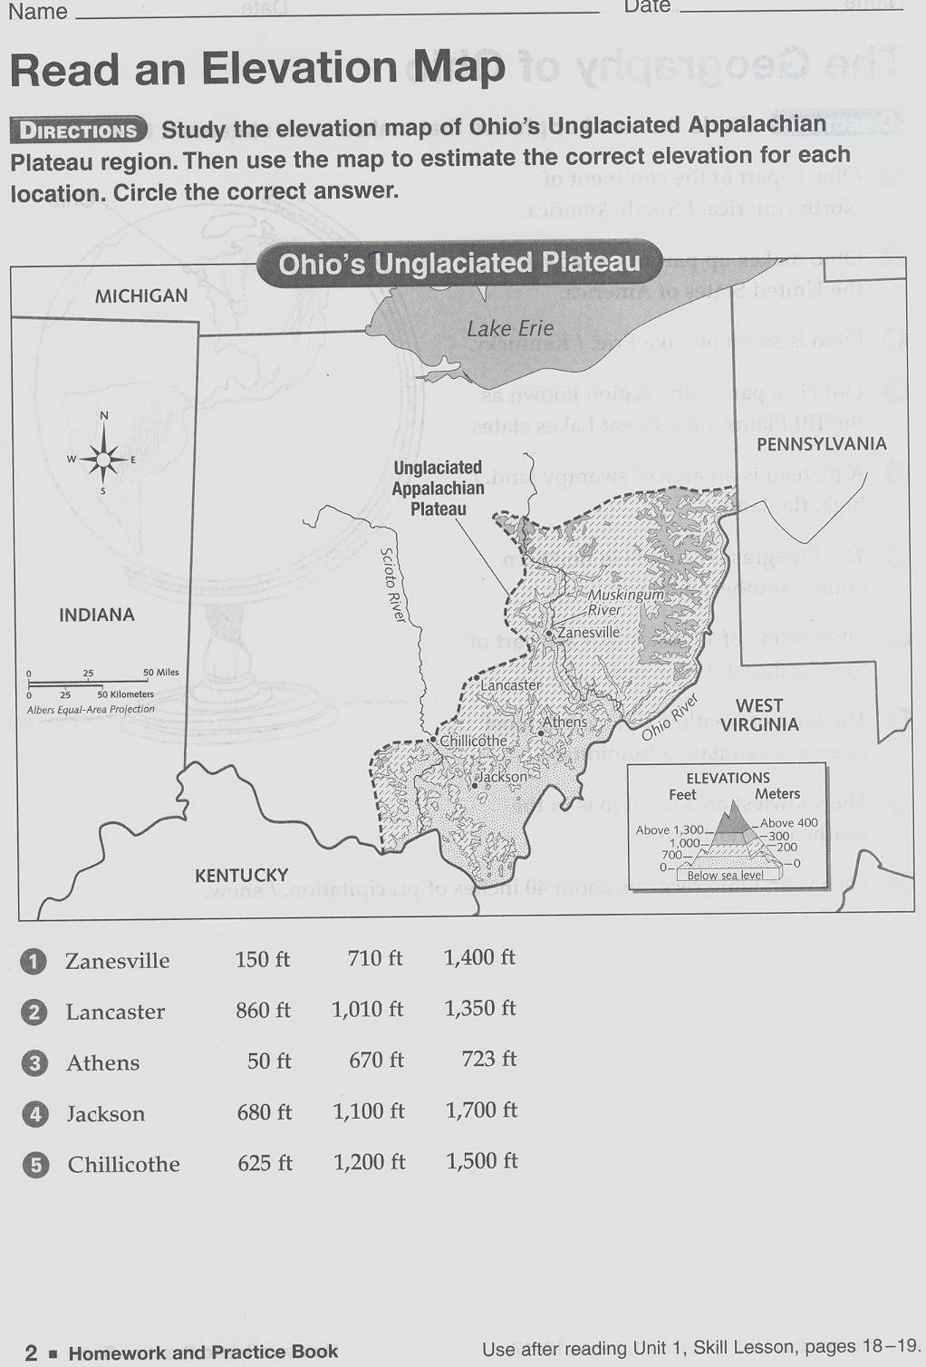
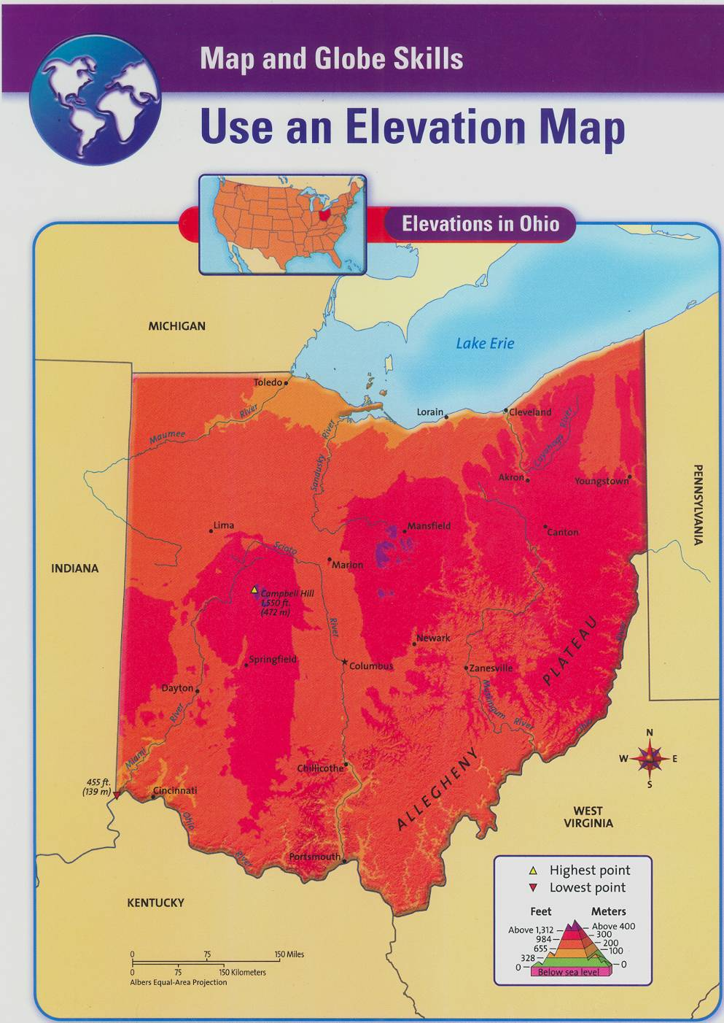
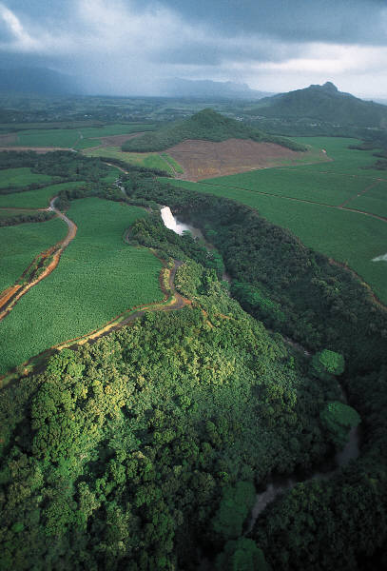
Natural Regions of
Ohio

Objective: Describe the natural features of Ohio.
Concept/Skills: Natural regions of Ohio, glaciers once covered parts of Ohio, plateau, Appalachian Plateau, and plains.
Materials: Harcourt Social Studies Text (4th gr), 2007. “Cardinal Numbers”, “Ohio”. Venn diagram desk mats, dry erase markers.
Procedures:
Introductory Activity: (duration 5 to 10 min)
- Read the sidebar on pg. 5 and 19 form “Cardinal Numbers” (2002) by Marcia Schonberg and pgs. 20, 21 from “Ohio” (2007) by Erin McHugh. This springboard activity discusses Ohio’s lakes, rivers and natural regions.
Developmental Activity: (duration: 2 days)
- Explain a natural region is an area made up of places that share the same natural features. “Ohio’s natural regions formed more than 10,000 years ago. Who knows what covered the land?” (Glaciers). “The ice moved and changed the land. It flattened mountains and carved valleys.” Have students turn to pg. 4-5 in their texts. Explain the map (p 4) shows major landform regions of the U.S. The map on p. 5 shows landforms and natural regions of Ohio. “Using your test, which natural region of the U.S. is Ohio located?” (Central Plains). “Which of Ohio’s natural regions does the Maumee River run?” (Lake Plains). “What major landform lies in the southeast corner of the un-glaciated Appalachian Plateau region?” (Allegheny Plateau).
- Discuss each one of the 5 natural regions.
- Till Plains – When glaciers melted, they left behind till in some regions. Till is clay, sand and rock that makes the soil very rich.
- Bluegrass Region – (north of Kentucky) rolling hills, not well for farming; therefore many endangered plants grow here.
- Lake Plains - formed along Lake Erie in northeast Ohio. Glaciers formed the flat land of this region. In the western part of this region is the Great Black Swamp Area.
- Un-glaciated Appalachian Plateau - Glaciers did not touch the Un-glaciated Appalachian Plateau. This region is in southeastern Ohio. There are deep valleys, high hills and winding streams.
- Glaciated Appalachian Plateau - Huge glaciers moved across northeastern Ohio causing less hilly areas, leaving many lakes. This land is good for growing crops.
- Essential Questions: “What natural region do we live in?” (Lake Plains). “What river runs through our area?” (Maumee).
- Review: “What is a continent?” (One of the seven largest land areas on Earth). “Ohio is located on what continent?” (North America). “What state is east of Ohio? (PA), and to the southeast is? (W.V.), to the south? (Kentucky), and to the west is? (Indiana), northwest of Ohio is?” (Michigan). “Ohio’s capital city is?” (Columbus). “Discuss with elbow partners, how can I tell on a map what the capital city is?” (Star).

Conclusion: (duration: 20 min)
- Use Venn diagram desk mats and ask students to compare and contrast two natural regions of their choice.
Assessment: Formative assessments: observations form oral questioning/essential questioning. The accuracy of the Venn diagram will be used as an intervention assessment. Intervention will be provided as needed. Summative assessment: A unit test will be given.
Across the Curriculum: Language Arts: Students will read “The Great Black Swamp” p. 7 (Harcourt SS text). They will complete a graphic organizer including main idea and details.

Post assessment Survey: What I now know about Geography
Directions: Read each question and circle yes or no to the best of your ability.
1. A compass rose can be found on a map? Yes No
2. The direction “northeast” is a primary direction? Yes No
3. The north, south, east and west directions on a compass rose
are called cardinal directions? Yes No
4. A star on a map stands for a city? Yes No
5. Our state capital is located in the Great Lakes Plains? Yes No
6. An elevation map shows how the height of land changes
in an area. Yes No
7. There are 5 states that border Ohio? Yes No
8. Indiana is east of Ohio? Yes No
9. A map scale gives the actual weight of each city on the map? Yes No
10. Lake Erie was formed by glaciers thousands of years ago? Yes No
11. Describe Ohio’s location. How would you tell someone where Ohio is located?
_______________________________________________________________________
_______________________________________________________________________
_______________________________________________________________________
- What are some other things you might be interested in learning about geography? ________________________________________________________________________________________________________________________________________________________________________________________________________________________________
Unit one – Summative Test Name ____________________________

Multiple Choice:
Directions: Select the letter of the best answer.
1. Which description of Ohio’s location is correct?
A) It is north of Lake Erie
B) It is east of Canada
C) It is bordered by Michigan to the northwest and West Virginia to the southeast.
D) It is bordered by New York to the northeast and Tennessee to the south.

2. Which of the following best describes the Glaciated Appalachian Plateau region?

- flat lands
- deep valleys
- thick forests
- steep hills

- Which of these major U.S. regions includes Ohio?

- the Northeast
- the Southeast
- the Midwest
- the West

- What kind of area do most Ohioans live in?

- rural
- suburban
- urban
- mountainous

- Cardinal directions include?

- north, south, east, west
- northeast, southeast, northwest, southwest
- a star
- northeast, westward, eastern

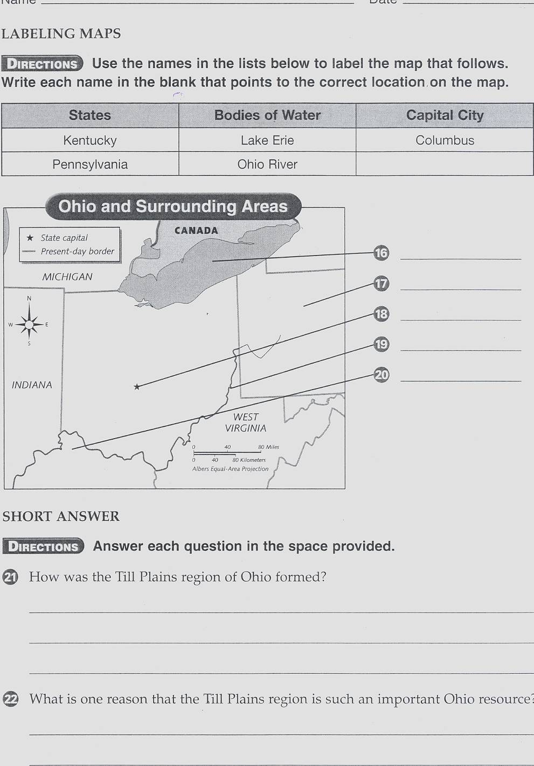
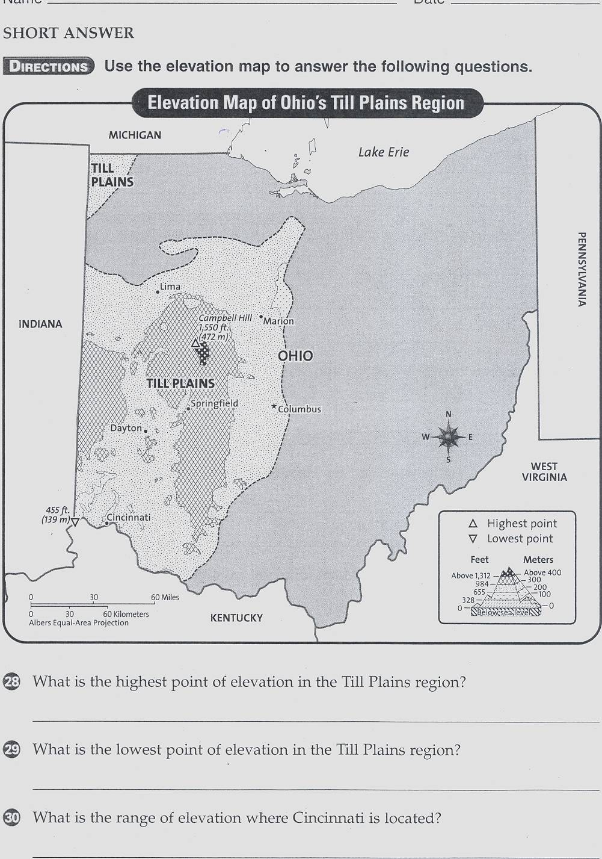

How would you describe the Unglaciated Appalachian Plateau region?

__________________________________________________________________

__________________________________________________________________

__________________________________________________________________

How would you describe the location of Ohio?

___________________________________________________________________

___________________________________________________________________

___________________________________________________________________

___________________________________________________________________

