**Instructional Design Project**

**EDTL 7100**

**Dawn Bryant**

**June 17, 2011**

**Kindergarten Phonemic Awareness**

**Rationale**

“Early literacy plays a key role in enabling the kind of early learning experiences that research shows are linked with academic achievement, reduced grade retention, higher graduation rates and enhanced productivity in adult life” (Strickland & Riley-Ayers, 2006). Learning to read and write is critical for success in school and throughout life. It is important to give students a good solid reading program in early education. Phonemic awareness is a key pre-reading skill. Once a student has phonemic awareness skills, the student learns to use sounds like building blocks that are used to build different words.

In 2000, the National Reading Panel issued the following statement in its [April 13, 2000 press release](http://www.projectpro.com/ICR/Research/Releases/NIH_NRP.htm):

*“In the largest, most comprehensive evidenced-based review ever conducted of research on how children learn reading; a congressionally mandated independent panel has concluded that the most effective way to teach children to read is through instruction that includes a combination of methods. The panel determined that effective reading instruction includes teaching children to break apart and manipulate the sounds in words (phonemic awareness), teaching them that these sounds are represented by letters of the alphabet which can then be blended together to form words (phonics), having them practice what they've learned by reading aloud with guidance and feedback (guided oral reading), and applying reading comprehension strategies to guide and improve reading comprehension.”*

It is important to teach phonemic awareness explicitly. Although there are some children who have an inherent understanding of phonemic awareness, almost all children benefit from explicit instruction. Phonemic awareness is a prerequisite skill for successful phonics instruction. Phonemic awareness involves the ability to hear, identify and manipulate [phonemes](http://en.wikipedia.org/wiki/Phonemes), the smallest units of [sound](http://en.wikipedia.org/wiki/Sound) (Wikipedia). Students may already understand what a dog is, but it requires knowledge of phonemic awareness to understand that the word “dog” is made up of three sounds: /d/, /o/, /g/. The ability to decode words when reading or writing a simple word requires knowledge of phonemic awareness.

Teaching students to read is more important to them than just a reading grade, or a score on a standardized reading test, it affects many areas of learning. Almost all higher level learning requires reading for acquisition of knowledge, whether it’s reading a chapter in a social studies textbook, a question on a test, or instructions to complete a science experiment. A strong grasp of phonemic awareness will help students become proficient readers and successful in school.

Contextualized Teaching and Learning (CTL) involves connecting subject matter to real world situations, connecting to learners’ prior knowledge, and applying it to their lives (Chiarelott, 2006). Incorporating the skills to real life experiences makes learning more meaningful and concrete to students. Using a CTL approach to reading instruction will benefit students. Therefore I plan to use materials that interest the students, choose common themes that the students enjoy and can relate to, and use the students’ own writing and suggestions as examples as often as possible.

My instructional design uses mostly behaviorist teaching strategies, but includes some constructivist strategies as well. The behaviorist approach works well in Kindergarten to get the students off to a strong start and establish the basic skills necessary for reading. I will be using the basic lesson plan model as it lends itself easily to the behaviorist teaching strategy. The instructional design model I follow is the concept attainment model.

**Unit Outcomes**

Phonemic Awareness:

● Student will identify the beginning sound in a word (Knowledge)

●Student will give an example of words that have the same beginning sound (Comprehension)

●Student will demonstrate beginning sounds of words when writing (Application)

● Student will use a kinesthetic approach to tap and say phonemes in c-v-c words (Knowledge)

● Student will identify phonemes in c-v-c words (Knowledge)

● Student will integrate knowledge of phonemes in c-v-c words when writing c-v-c words (Application)

Rhyming Patterns:

● Student will identify whether two words rhyme (Knowledge)

● Student will give an example of a word that rhymes with a word given by the teacher (Comprehension)

● Student will create a family of rhyming words (Application)

Syllables:

●Student will count the number of syllables in a given word by clapping or counting (Comprehension)

●Student will identify the syllables in a word by saying each syllable of the word (Application)

**Pre-Assessment**

1. The Dynamic Indicators of Basic Early Literacy Skills (Dibels) assessment will be used for each student to test letter recognition fluency, initial sound fluency, and nonsense word fluency. This test will be given three times throughout the year and is used to identify at-risk students and allow for progress monitoring for all students. <https://dibels.uoregon.edu>
2. The second assessment is created to be done individually with each student prior to instruction. It should take approximately 10 minutes per student. I adapted parts of assessments from the Yopp-Singer Test of Phoneme Segmentation:

<http://teams.lacoe.edu/documentation/classrooms/patti/k-1/teacher/assessment/tools/yopp.html>

and Dr. Adria Klein’s Phonemic Awareness Assessment Tools:

<http://teams.lacoe.edu/documentation/classrooms/patti/k-1/teacher/assessment/tools/rhyme.html>

This assessment can be used as a pre-assessment, post-assessment, and a progress monitoring tool.

**Name\_\_\_\_\_\_\_\_\_\_\_\_\_\_\_\_\_\_\_\_\_\_\_\_\_\_\_\_\_\_\_\_\_\_\_\_\_\_**

**Phonemic Awareness Assessment – Kindergarten**

For each assessment, give the student an example of a correct response, then record the student’s response.

**Recognizing Rhyming Words**  
***Cat*** and ***fat*** have the same sound at the end so they rhyme. ***Cat*** and ***mop*** do not rhyme because they do not have the same sound at the end. Listen to these sets of words. Thumbs up if they rhyme. Thumbs down if they do not rhyme.

|  |  |  |  |
| --- | --- | --- | --- |
|  | Date: | Date: | Date: |
| fin-win |  |  |  |
| rug-mug |  |  |  |
| hat-dress |  |  |  |
| pan-man |  |  |  |
| bird-book |  |  |  |

**Understanding Rhyming Words**

I am going to give you a word and I want you to tell me a word that rhymes with that word. For example, if I say **big**, you could say **wig**.

|  |  |  |  |
| --- | --- | --- | --- |
|  | Date: | Date: | Date: |
| bat |  |  |  |
| mug |  |  |  |
| hop |  |  |  |
| kit |  |  |  |
| run |  |  |  |

|  |  |  |  |  |  |  |  |  |  |  |  |  |  |  |  |  |  |  |  |  |  |  |  |  |
| --- | --- | --- | --- | --- | --- | --- | --- | --- | --- | --- | --- | --- | --- | --- | --- | --- | --- | --- | --- | --- | --- | --- | --- | --- |
| **Phoneme Isolating-Beginning Sounds**  **hop**: Let’s say the word together: ***hop***. What is the sound at the beginning of ***hop***? I hear a ***/h/*** at the beginning of ***hop.*** Say each word after me and tell me the beginning sound.   |  |  |  |  | | --- | --- | --- | --- | |  | Date: | Date: | Date: | | mouse |  |  |  | | fish |  |  |  | | teeth |  |  |  | | bat |  |  |  | | goat |  |  |  | |

**Phoneme Matching**  
Listen to these words: ***keep, king, jump.*** Two of the words begin with the same sound; ***keep*** begins with the same sound as ***king… /k/.*** Listen to each group of words and tell me which two have the same beginning sound.

|  |  |  |  |
| --- | --- | --- | --- |
|  | Date: | Date: | Date: |
| mouse, pipe, mat |  |  |  |
| teeth, tub, home |  |  |  |
| goat, rat, gum |  |  |  |
| fish, fork, ant |  |  |  |
| bat, duck, bug |  |  |  |

## Phoneme Blending

If I say ***/p/…/i/…/g/*** the word is . . .***pig***. Listen to the sounds and tell me the word those sounds make.

|  |  |  |  |
| --- | --- | --- | --- |
|  | Date: | Date: | Date: |
| /d/ /o/ /g/ |  |  |  |
| /m/ /a/ /n/ |  |  |  |
| /b/ /i/ /g/ |  |  |  |
| /f/ /a/ /n/ |  |  |  |
| /r/ /u/ /n/ |  |  |  |

**Phoneme Segmentation**

I'm going to say a word and I want you to break the word apart. You are going to tell me each sound in the word in order. For example, if I say "old," you should say /o/…/l/.../d/." (Administrator: Be sure to say the sounds, not the letters, in the word.)

|  |  |  |  |
| --- | --- | --- | --- |
|  | Date: | Date: | Date: |
| dog |  |  |  |
| job |  |  |  |
| red |  |  |  |
| sat |  |  |  |
| top |  |  |  |

**Lesson Plans**

**Lesson 1: RHYMING**

**Objective:**

Students will identify rhyming words.

**Lesson Materials**  
• A rhyming picture book. Some great book suggestions:  
     *Brown Bear, Brown Bear, What do you See?* (by Bill Martin Jr.)  
     *The Three Bears Rhyme Book* (by Jane Yolen)  
     *The Cat in the Hat* (by Dr. Seuss)   
• [Rhyming](http://www.instructorweb.com/lesson/rhymetime.asp#LESSON_PRINTABLES) picture cards:

<http://www.kellyskindergarten.com/picturecards/picturecards.htm>

• Pocket chart and index cards

**Opening** (5 minutes)  
Ask students what rhyming words are (words that have the same ending sounds). Tell students to touch their nose when they hear words that rhyme.

Words: (cat, hat) (see, be) (mix, cap) (do, at) (hip, dip)  
**Body** (10 minutes)Do a read aloud with a rhyming picture book. Read the story and encourage students to say the predictable/repetitive phrases with you. Pause at the end of a rhyming stanza to see if students can predict which rhyming word comes next.   
Tell the students that we will read the book once more. Remind students that this picture book has rhyming words in it. Students will be the rhyme detectives and must touch their nose when they hear two or more words that rhyme. When students touch their nose, stop reading and ask students to identify the words that rhyme. Write each of these words on index cards and place them in the pocket chart.   
When you are finished reading the story, you should have plenty of rhyming word cards in the chart. Pull out all of the cards, mix them up and place them back in the chart. Call up students to find the rhyming words and then have them stand in front of the classroom holding their pair of cards.

**Closure** (10 minutes)

Pass out one rhyming card to each student. Have them walk around the room saying their picture card aloud to find the person that has the card that rhymes with their card. Once they found their rhyme, they can sit down. Pairs stand up to say their rhyme aloud, students echo.  
**Assessment** (10 minutes)  
Have students each find one object around the classroom and put it in a basket. Have students sit in a circle on the carpet. Pass the basket around the circle. As each child gets the basket, I say a word (such as “fizzers”) and they pull out the object that rhymes (“scissors”). You can use any object because it doesn’t matter if the rhyming words are real words or nonsense words.

**Extension Activities**  
For the rest of the day, call your classmates by a rhyme of their name, not their real name. For example, you could call John-Bohn, or Suzie-Kluzie.

Cards can be used at Center time for the week for activities such as:

• Students can play Go Fish in pairs to find rhyming matches.

• Students can also write down their rhyming pairs on the Record a Rhyme worksheet to turn in (great evidence of learning).

• Students can play the game like Memory, turning over and mixing up the cards.

|  |  |  |
| --- | --- | --- |
| MCj02289010000[1] | MCPE03019_0000[1] | MCHH00797_0000[1] |
| MCj03244700000[1] | MCj03540470000[1] | MCAN01445_0000[1] |
| MCj02322530000[1] |  |  |
| MCj02909250000[1] | MCSO01746_0000[1] | MCj01512070000[1] |

|  |  |  |
| --- | --- | --- |
| MCj02958330000[1] | MCHM00388_0000[1] | j0378775 |
| MCAN02160_0000[1] | MCj02151460000[1] | MCj03542190000[1] |
| MCAN04330_0000[1] | MCj02902190000[1] | MCj02962260000[1] |
| MCj02100120000[1] | MCj03468910000[1] | hh00316_ |

**Lesson 2: RHYMING**

**Objective:**

Students will identify and complete rhyming patterns.

**Lesson Materials**  
• A nursery rhyme written on sentence strips in a pocket chart (*Row, Row, Row Your Boat*, and *Humpty Dumpty*)   
• index cards

**Opening** (5 minutes)  
Have students name several Nursery Rhymes that they are familiar with and record on smartboard. Sing aloud *Row, Row, Row Your Boat* and *Humpty Dumpty*.  
**Body** (10 minutes)Display the *Humpty Dumpty* Nursery Rhyme pocket chart. Read aloud and have students raise their hand when they hear a rhyme. Read it again and stop at each rhyme, have students identify the rhyming pair. (WALL, FALL) Then ask students to offer a new rhyme for the word WALL. Write the new word (ie. CALL) on an index card and place the word over the word FALL. Reread and substitute the new word for FALL.

Repeat this procedure using the *Row, Row, Row Your Boat* Nursery Rhyme.

**Closure** (10 minutes)

In pairs students will choose a nursery rhyme to “mix up”. Find a quiet spot in the room with your partner and change the rhymes of a nursery rhyme to make a silly new rhyme. Practice a few times. Pairs say new rhyme aloud to group.   
**Assessment** (10 minutes)  
Have students each find one object around the classroom and put it in a basket. Have students sit in a circle on the carpet. Pass the basket around the circle. As each child gets the basket, the student picks an object and gives a word that rhymes with that object. It doesn’t matter if the rhyming words are real words or nonsense words.

**Extension Activities**  
At Centers for the week, use picture dice. Students roll one die, name the picture, then give a rhyme for that word.

**Lesson 3: SYLLABLES**

**Objective:**

Students will identify the number of syllables in a word by counting or clapping

Students will say each syllable in a word

**Lesson Materials**  
• Create a Smartboard template with each student’s name and 5 boxes next to the name

• Index cards

• Suitcase with a variety of objects for counting syllables

**Opening** (5 minutes)  
A syllable is part of a word that contains one vowel sound. Show the students an example of how to count syllables using the word September. Sep- is the first syllable, -tem is the second syllable, and -ber is the third syllable. Have the students say each syllable, clap the word September and count the three syllables in the word. Continue to practice using that week’s theme words or other words the students offer.

**Body** (15 minutes)Read the student names, say each syllable, then clap or count the syllables in each class member's name. Be sure to stress to the students that we are not counting the [letters in their names](http://www.brighthub.com/education/k-12/articles/4946.aspx) (this is a different lesson). Have students come up and color in the correct number of boxes for the syllables in their own name.

Write each child’s name on an index card with the number of syllables. (ie., Suzie 2) Pass the cards out. Continue until all students have a card in hand with the number of syllables in their name. The students have to find all of the people in the class with the same number of syllables in their names and stand together in a group. This is a bit chaotic, but fun to watch how Kindergarteners organize themselves. Once the students have formed the groups, count the number of students in each group (have a student help if you'd like).

**Closure** (10 minutes)

Create a graph to compare the amount of syllables in names. Kindergarteners will understand this practical activity.  
**Assessment** (10 minutes)  
Hold up the suitcase filled with objects common to students. Ask each child to come up and pick an item from the suitcase, say the word aloud broken down into syllables, and count the syllables. (ie., butterfly, but-ter-fly-3)

**Extension Activities**  
Assign the students to write all of their family member's names on a sheet of paper and count the number of syllables in each family member's name. Students really enjoy this activity!

**Lesson 4: BEGINNING SOUNDS**

**Objective:**

Students will identify and write beginning sounds of words.

**Lesson Materials**  
• Beginning sounds tubs (a tub filled with objects for each letter of the alphabet) If these tubs are not available, picture cards can be used

• Create/Download a Smartboard template with pictures and a blank to write beginning sound (any common pictures can be used) Animal beginning sounds template found at Smartexchange:

<http://exchange.smarttech.com/details.html?id=81da7667-f40f-490c-bf33-e685015773c3>

• Dry-erase boards and markers (one for each student)

• Kid-Zone beginning sounds worksheet:

<http://www.kidzone.ws/kindergarten/learning-letters/letters-begin10.htm>

**Opening** (5 minutes)  
Use theme words for the week or name some zoo animals. Ask students to repeat the word. Then say together the beginning sound for that word. (monkey, monkey, /m/…penguin, penguin, /p/)

**Body** (15 minutes)Students sit in a circle on the carpet. Go around the circle and name each child. Students echo name and everyone says beginning sound together. (Suzie, Suzie, /s/)

On Smartboard, name each picture, have one student write beginning sound on line, other students write beginning sound on dry erase board. Repeat for all picures.

**Closure** (10 minutes)

Put objects from beginning sounds tubs (one for every student in the class) in a basket. Have students come up individually, choose an object, name it, and identify the beginning sound.  
**Assessment** (5 minutes)  
Students complete beginning sounds worksheet by writing the letter associated with the beginning sound of the word in the blank.

**Extension**

Sing some Silly Songs**.** First sing a familiar song like “Happy Birthday to You.” Next replace all the beginning sounds in the song with one sound.

Example: *Sappy sirthday so sou, sappy sirthday so sou, Sappy sirthday sear Sally,*

*Sappy sirthday so sou.*

Try with other favorite songs.

[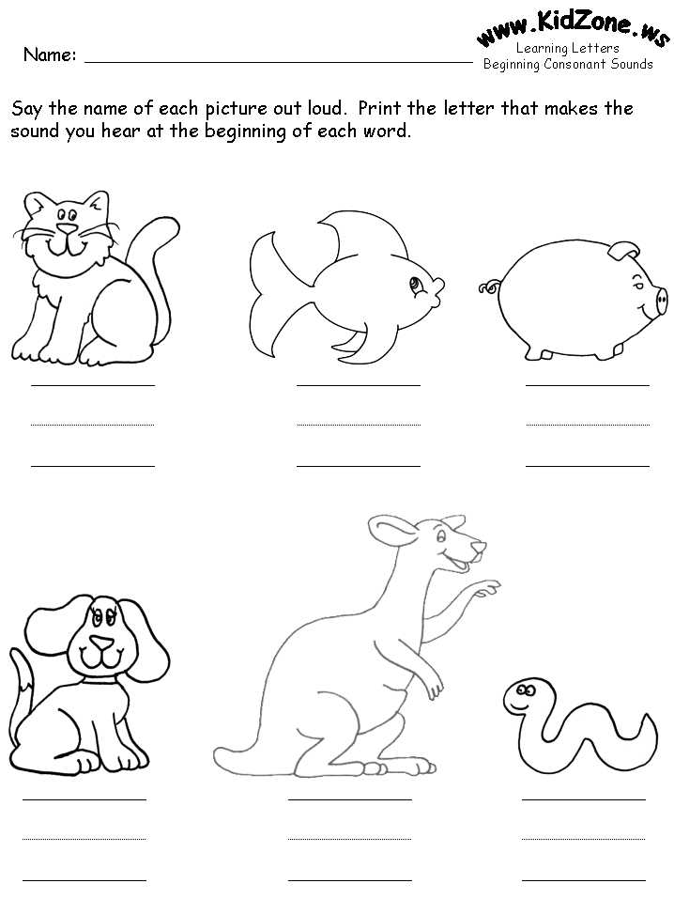](http://www.kidzone.ws/imageschanged/kindergarten/letters-begin10.gif)

**Lesson 4: BEGINNING SOUNDS**

**Lesson 5: BEGINNING SOUNDS**

**Objective:**

Students will identify words that have the same beginning sound.

**Lesson Materials**  
• Beginning sounds tubs (a tub filled with objects for each letter of the alphabet) If these tubs are not available, picture cards can be used

• Create/Download at least ten Smartboard templates with pictures of 3 common objects, two of which have same beginning sound. Template found at Smartexchange:

<http://exchange.smarttech.com/details.html?id=dd979bed-2902-4238-8edb-76f72d7542e2>

**Opening** (5 minutes)  
Say the names of two students that have the same beginning sound. (Suzie and Sara) Tell that they have the same beginning sound (/s/). Then name/). Then name some zoo animals or theme words with the same beginning sounds and ask students to help you name the beginning sound. (penguin, parrot…/p/)

**Body**(10 minutes)Using the common objects Smartboard picture templates, play the game Sound Spy. “I hear two words that begin with the same sound…monkey, dog, mat. Tell me which two have the same beginning sound.”

**Closure** (15 minutes)

Put objects from beginning sounds tubs B, D, M, and S in a basket. Have each student come up and find two objects that begin with the same sound, name the objects and the beginning sound. (dog, doll, /d/)  
**Assessment**  
Observe students during closure.

**Lesson 6: PHONEMES**

**Objective:**

Students will hear, tap, and say phonemes in simple one syllable words.

**Lesson Materials**  
• A tub filled with common objects that are c-v-c words

• Large dry-erase board

**Opening** (5 minutes)

Play **Guess It.** In this activity you orally segment words and have the class try to guess what they are. For example, you might tell children that you are thinking of the names of farm animals. Teacher: "I'm thinking of an animal. It's a /p/.../i/…/g/ What am I thinking of?" Children: "A pig!" Continue with other categories such as zoo animals, classroom objects, numbers, colors, or household items.

**Body** (15 minutes)Using the large dry-erase board, write a common c-v-c word on the board (dog). Color in a dot under each letter. Demonstrate to the students that the word has 3 sounds. Tap your shoulder when you say /d/, tap the middle of your arm when you say /o/, tap your hand when you say /g/. Then start at your shoulder and slide your hand down your arm as you blend the sounds to say “dog”. Repeat with the students copying your movements and sounds /d/ (tap), /o/ (tap), /g/ (tap), “dog” (slide hand down arm)

Repeat this activity using any simple c-v-c words (such as cat, mug, hip, van, bus, mat, sun)

**Closure** (10 minutes)

Each student chooses an item from the tub (ie. hat), says the word, taps and says the phonemes in the word, and blends the phonemes. Students echo. (hat, /h/ (tap), /a/ (tap), /t/ (tap), “hat” (slide hand down)  
**Assessment**  
Observe students during closure. Check journal writing each day for evidence of application of phoneme segmentation when writing.

**Extension**

Have the tub of objects available at Center time. Students choose an object, say and tap out phonemes, then practice writing the sounds of the word.

**Lesson 7: PHONEMES**

**Objective:**

Students will apply their knowledge of breaking words apart into sounds in order to determine the letters needed to represent each segmented sound in words.

**Lesson Materials**  
• A tub filled with common objects that are c-v-c words (hat, pig, dog, cup,…)

• Individual dry-erase boards and markers

• Create/Download a Smartboard template with pictures of c-v-c words and 3 connected boxes under each picture. CVC template found at Smartexchange:

<http://exchange.smarttech.com/details.html?id=c2306916-77c2-40b6-9806-3dc88070fc85>

• Phoneme segmentation worksheet:

<http://bogglesworldesl.com/elkonin_boxes.htm>

**Opening** (5 minutes)  
Using the tub of objects, we will review some c-v-c words we did previously by tapping and blending. Show an object CAT. Demonstrate to the students that the word has 3 sounds and tap your shoulder when you say /c/, tap the middle of your arm when you say /a/, tap your hand when you say /t/. Then start at your shoulder and slide your hand down your arm as you blend the sounds to say “cat”. Repeat with the students copying your movements and sounds /c/ (*tap*), /a/ (*tap*), /t/ (*tap*), “cat” (*slide hand down arm*)

**Body** (10 minutes)Model for students again how we can break words apart into sounds. Model with the word “sit”.

Say this word slowly, and each time that I hear a sound, I will write the letter of the sound in the connected boxes. I will then ask students, "what letter makes the /s/ sound in sit? I will then draw the students' attention to the letters of the alphabet on the chalkboard and say "Oh, now I remember. The letter s makes the /s/ sound in sit. I will then write the letter s underneath the first connected box in which I have my marker. I will then proceed to the middle sound, /i/. I will then look at the alphabet and think aloud, "what letter makes the /i/ sound? I will then say, "I remember that the letter I makes this sound. I will then write the letter I underneath the second connected box with a marker. I will then look at the alphabet and think aloud "what letter makes the /t/ sound in sit? I will then say "Oh, I remember now. The letter t makes this sound!" I will then write this letter underneath the final connected box in which there is a marker.

I will model this skill in the same way as I did with the word sit using the words “mop, cap, and bat.”

**Closure** (10 minutes)

Provide students with a dry erase board and marker. Say the words "top, tin, fin, and pig”. Have students segment these words into phonemes first. Then write the letter that represents each sound heard in these words.   
**Assessment** (5 minutes)  
Students complete phoneme segmentation worksheet. Check journal writing each day for evidence of application of phoneme segmentation when writing.

Name\_\_\_\_\_\_\_\_\_\_\_\_\_\_\_\_\_\_\_\_\_\_\_\_\_\_\_\_\_\_\_\_\_\_\_\_\_\_\_\_\_\_

Name each picture aloud together as a class first. Then complete the worksheet independently.

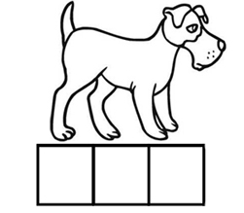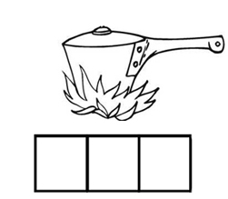

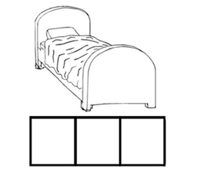 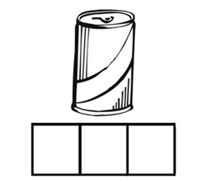

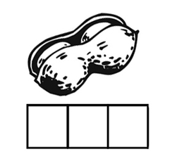 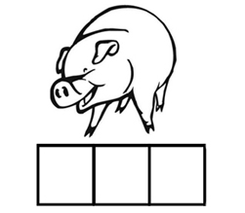

**Post Assessment**

The students will again be tested using the Dibels assessment. I would use the same assessment that I created for the pre-assessment as a post-assessment (and record the post-assessment on the same paper as the pre-assessment to compare results). Comparing the results of the pre-assessment to the post-assessment would show the progress that was made by each student through the use of these lessons. Portfolios including the students’ journals and sentence writing can also be used as post-assessment material.

**Name\_\_\_\_\_\_\_\_\_\_\_\_\_\_\_\_\_\_\_\_\_\_\_\_\_\_\_\_\_\_\_\_\_\_\_\_\_\_**

**Phonemic Awareness Assessment – Kindergarten**

For each assessment, give the student an example of a correct response, then record the student’s response.

**Recognizing Rhyming Words**  
***Cat*** and ***fat*** have the same sound at the end so they rhyme. ***Cat*** and ***mop*** do not rhyme because they do not have the same sound at the end. Listen to these sets of words. Thumbs up if they rhyme. Thumbs down if they do not rhyme.

|  |  |  |  |
| --- | --- | --- | --- |
|  | Date: | Date: | Date: |
| fin-win |  |  |  |
| rug-mug |  |  |  |
| hat-dress |  |  |  |
| pan-man |  |  |  |
| bird-book |  |  |  |

**Understanding Rhyming Words**

I am going to give you a word and I want you to tell me a word that rhymes with that word. For example, if I say **big**, you could say **wig**.

|  |  |  |  |
| --- | --- | --- | --- |
|  | Date: | Date: | Date: |
| bat |  |  |  |
| mug |  |  |  |
| hop |  |  |  |
| kit |  |  |  |
| run |  |  |  |

|  |  |  |  |  |  |  |  |  |  |  |  |  |  |  |  |  |  |  |  |  |  |  |  |  |
| --- | --- | --- | --- | --- | --- | --- | --- | --- | --- | --- | --- | --- | --- | --- | --- | --- | --- | --- | --- | --- | --- | --- | --- | --- |
| **Phoneme Isolating-Beginning Sounds**  **hop**: Let’s say the word together: ***hop***. What is the sound at the beginning of ***hop***? I hear a ***/h/*** at the beginning of ***hop.*** Say each word after me and tell me the beginning sound.   |  |  |  |  | | --- | --- | --- | --- | |  | Date: | Date: | Date: | | mouse |  |  |  | | fish |  |  |  | | teeth |  |  |  | | bat |  |  |  | | goat |  |  |  | |

**Phoneme Matching**  
Listen to these words: ***keep, king, jump.*** Two of the words begin with the same sound; ***keep*** begins with the same sound as ***king… /k/.*** Listen to each group of words and tell me which two have the same beginning sound.

|  |  |  |  |
| --- | --- | --- | --- |
|  | Date: | Date: | Date: |
| mouse, pipe, mat |  |  |  |
| teeth, tub, home |  |  |  |
| goat, rat, gum |  |  |  |
| fish, fork, ant |  |  |  |
| bat, duck, bug |  |  |  |

## Phoneme Blending

If I say ***/p/…/i/…/g/*** the word is . . .***pig***. Listen to the sounds and tell me the word those sounds make.

|  |  |  |  |
| --- | --- | --- | --- |
|  | Date: | Date: | Date: |
| /d/ /o/ /g/ |  |  |  |
| /m/ /a/ /n/ |  |  |  |
| /b/ /i/ /g/ |  |  |  |
| /f/ /a/ /n/ |  |  |  |
| /r/ /u/ /n/ |  |  |  |

**Phoneme Segmentation**

I'm going to say a word and I want you to break the word apart. You are going to tell me each sound in the word in order. For example, if I say "old," you should say /o/…/l/.../d/." (Administrator: Be sure to say the sounds, not the letters, in the word.)

|  |  |  |  |
| --- | --- | --- | --- |
|  | Date: | Date: | Date: |
| dog |  |  |  |
| job |  |  |  |
| red |  |  |  |
| sat |  |  |  |
| top |  |  |  |

**References**

Chiarelott, L. (2006). *Curriculum in Context: Designing Curriculum for Teaching and Learning in Context.* Belmont: Wadsworth.

*Elkonin Boxes Resources*. (2006). Retrieved 06/2011, from Lanternfish: http://bogglesworldesl.com/elkonin\_boxes.htm

Yopp, K. & Singer, H. (n.d.). *Patti's Electronic Classroom.* Retrieved 06/2011, from TEAMS Educational Resources: <http://teams.lacoe.edu/documentation/classrooms/patti/k1/teacher/>

assessment/tools/yopp.html

Klein, A. (n.d.). *Patti's Electronic Classroom.* Retrieved 06/2011, from TEAMS Educational Resources: http://teams.lacoe.edu/documentation/classrooms/patti/k-1/teacher/assessment/tools/tools.html

National Reading Panel (2000, April 13).

*Phonemic Awareness*. (n.d.). Retrieved 06/2011, from Wikipedia: http://en.wikipedia.org/wiki/Phonemic\_awareness

*Picture Cards*. (n.d.). Retrieved 06/2011, from Kelly's Kindergarten: http://www.kellyskindergarten.com/picturecards/picturecards.htm

Riley-Ayers, D. S. (2006). Early Literacy: Policy and Practice in the Preschool Years. *National Institute for Early Education Research* , 12.

*SMARTboard template* (2011). Retrieved 06/2011, from SMART Exchange: http://exchange.smarttech.com/index.html#tab=0