BOOK F CHAPTER 3 SECTION 5 Date: ___________________
Rock and Fossil Record: Time Marches On
Objectives
- Explain how geologic time is recorded in rock layers.
- Identify important dates on the geologic time scale.
- Explain how changes in climate resulted in the extinction of some species.

- Geologic Time
- The Rock Record and Geologic Time Grand Canyon National Park is one of the best places in North America to see Earth’s history recorded in rock layers.
- These rock layers represent almost half, or nearly 2 billion years, of Earth’s history.
    - The Fossil Record and Geologic Time
      - Fossils of plants and animals are common in sedimentary rocks that belong to the Green River formation.
      - These fossils are well preserved.
      - Burial in the fine-grained lake-bed sediments preserved even the most delicate structures.

- The Geologic Time Scale
    - The geologic column represents the 4.6 billion years that have passed since the first rocks formed on the Earth. •
    - To aid in their study, geologists have created the geologic time scale.
    - The geologic time scale is the standard method used to divide the Earth’s long natural history into manageable parts.
    - Divisions of Time
      - Geologists have divided the Earth’s history into sections of time.
      - An eon is the largest division of geologic time.
      - The four eons are the Hadean eon, the Archean eon, the Proterozoic eon, and the Phanerozoic eon.
      - Eons are divided into eras.
      - For example, the Phanerozoic Eon is divided into three eras.
      - Periods are the third-largest divisions of geologic time and are the units into which eras are divided.
      - Periods are divided into epochs the fourth-largest division of geologic time.

The ______________
  - The _________, rigid layer of the Earth is called the
  - The lithosphere is made of two parts—the crust and the rigid upper part of the mantle.
  - The lithosphere is divided into pieces that are called __________ __________.
- B. The ________________.
  - is a plastic layer of the __________ on which the tectonic plates move.
  - made of solid rock that flows very ____________.
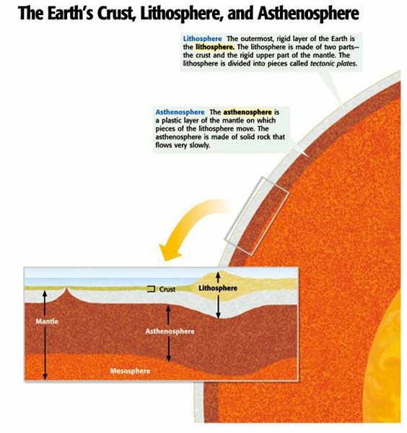
C. The ______________________
  - the strong, lower part of the mantle between the asthenosphere and the outer core.
  - The prefix meso- means “______________.”
D. The ____________ core is
  - the ___________layer of the Earth’s core that lies beneath the mantle.

- The __________ core is
  - the___________, dense center of our planet that extends from the bottom of the outer core to the center of the Earth, about 6,380 km beneath the surface
