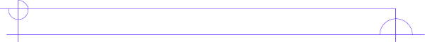
Literature Circle Role Sheet

Travel Tracer
This student researches and shares information about how the physical and cultural settings affect the selection’s characters or conflict. The setting of our novel shifts at various points, so this should be interesting to see how it has impacted our story.

Before you read…
Think about where the story line has gone so far. Write down all of the previous locations so you are familiar with his journey.

_______________________________________________________________

_______________________________________________________________

_______________________________________________________________

While you read…
Keep notes of where he has gone and what he has done in each of these places.

Place: __________________ Notes: __________________________________

_______________________________________________________________

Place: __________________ Notes: _________________________________

_______________________________________________________________

Place: __________________ Notes: _________________________________

_______________________________________________________________

During Literature Circles…
You should provide the discussion with an outline of our character’s journey. Provide some support for your ideas (for example: some type of visual, a picture, or map.)

