The experience of creating an avatar and being able to interact and communicate with others (classmates and teacher) through a virtual world was exciting, interesting and magical because I never thought it would be possible to do a class in a virtual environment instead of the classroom.
Now I’m going to explain all the steps and activities that I followed to have a successful experience.

First step: I created my avatar, then I modified its appearance because I wanted to feel identify with it.
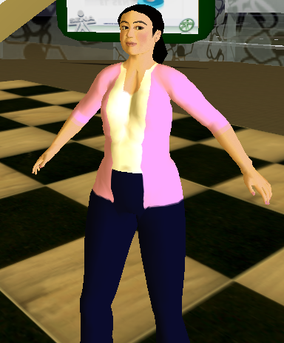
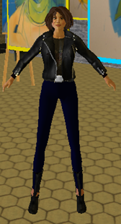
BEFORE NOW

SECOND STEP: I explored Second Life and I followed the tutorials that the teacher sent us.
TUTORIAL 01 TUTORIAL 02
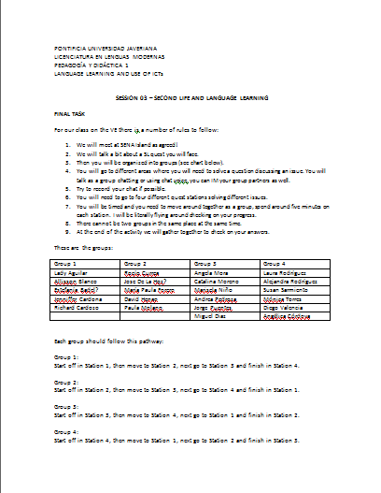
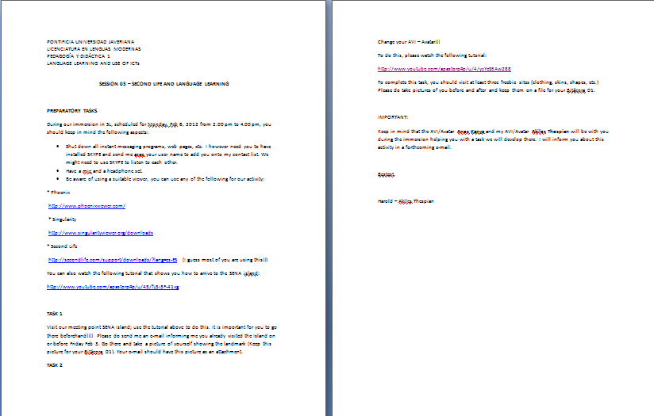

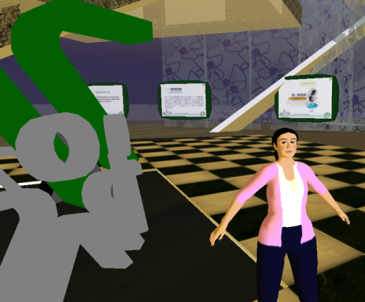
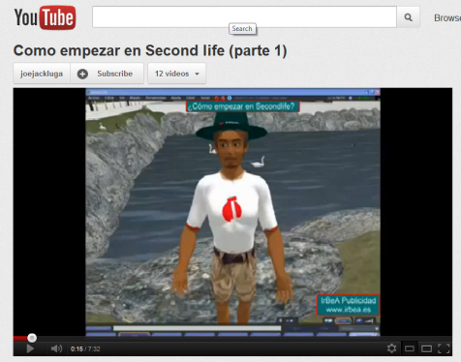

THIRD STEP: The day of our immersion I was online in Second Life at 1:15 pm and I waited until everybody arrived. Then Anes Kanya and Akiles Thespian gave us some instructions.
For example, Anes Kanya gave us some keyboard commands such as Press Esc +f: to fly and Press control+ i: to get the inventory’s window.
Anes Kanya also teleport us to different places, but it was not good because as some people arrived late they were lost and it was not possible to continue with the explanations and tips that she was giving us.
So Akiles Thespian organized new groups and we started with the class and the activity of the four quest stations. As I was in group 3 we began in quest station 3.
In this station we had to answer the following question:
Any advantages or disadvantages for « interaction » when using ICTs in a language classroom?
In the group we discussed and we agreed in the following answers:
ADVANTAGES
- Students can speak and interact with native people and improve their speaking ability.
- Students can interact in real contexts using ICTs.
- Students can communicate with people who are far away in an easy way.
DISADVANTAGES
- Using some ICTs there is a lack of face to face interactions.
- Students can face problems like abuse and harassment through the virtual environments when they interact with other users.

QUEST STATION 03
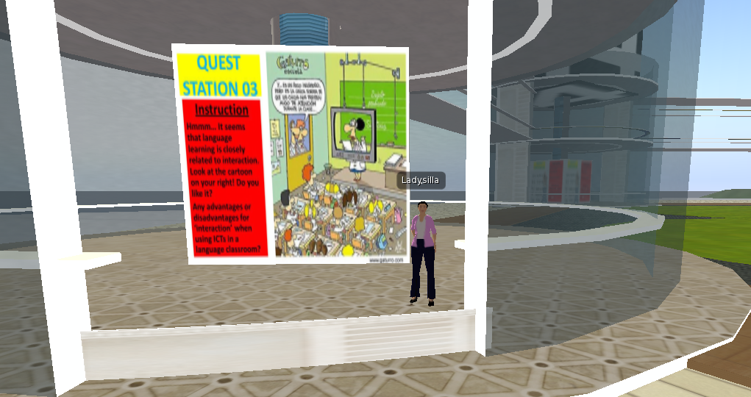

QUEST STATION 04

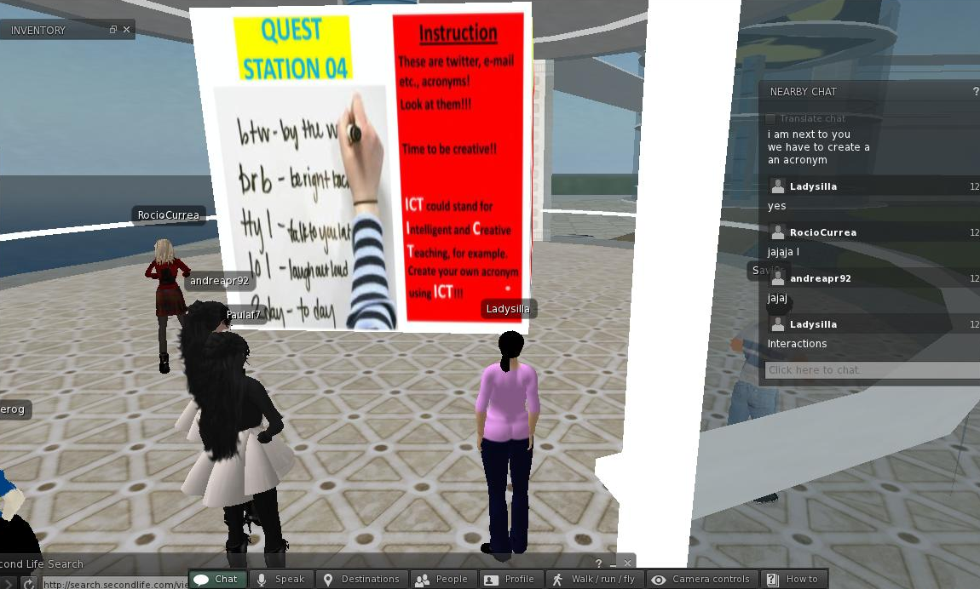

In this station we had to be creative and made an acronym with ICT letters.
In the group there were some proposals, but we chose just one.
PROPOSALS:
- Incredibly Creative Teaching
- Imagination Communicative Teaching
- Intellectual Creative Teaching
- Incredible Communicative Teaching
- Interesting Communicative Teaching
Finally we chose:
Incredible Communicative Teaching

QUEST STATION 01

In this station we had to discuss and give pedagogical reasons about the grammar exercise.
In the group we gave the following reasons:
- If the students make this kind of exercises they would be so passive.

- This exercise defeats the whole purpose of the ICT s because you can easily do this in the classroom.

- This exercise is very structural because the students just have to complete information and that does not motivate students to learn the language.

- The exercise is not in a real context and it is very important the context for the students to know when to use this adjectives in real situations.
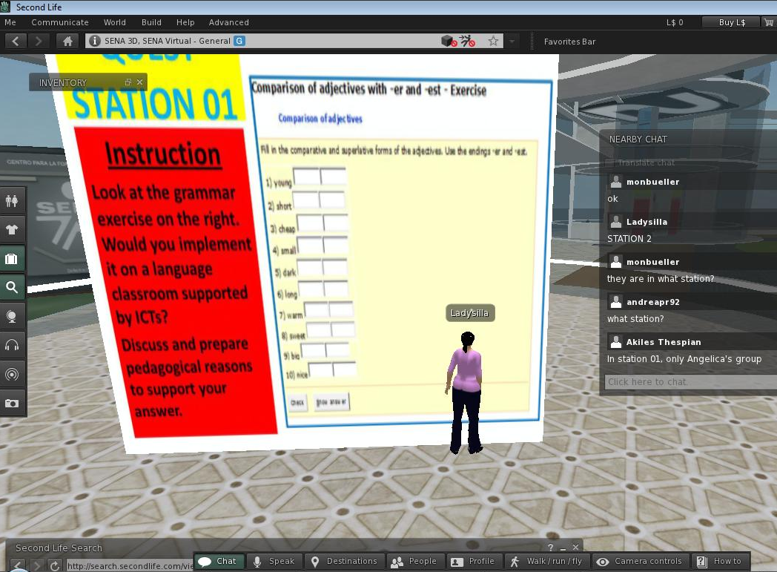

QUEST STATION 02

In this station we had to answer the following question:
In the context of language learning, how would motivation be affected by ICTs?
In the group we gave the following answers:
- It depends on the ICTs that we use because for some people using Second Life and virtual environments will be funny since those are different spaces to learn a language.

- The students will be more motivated to learn because ICTs are new and interesting for them.

- ICTs can motivate in a positive way since they are new, exciting and practical for students.
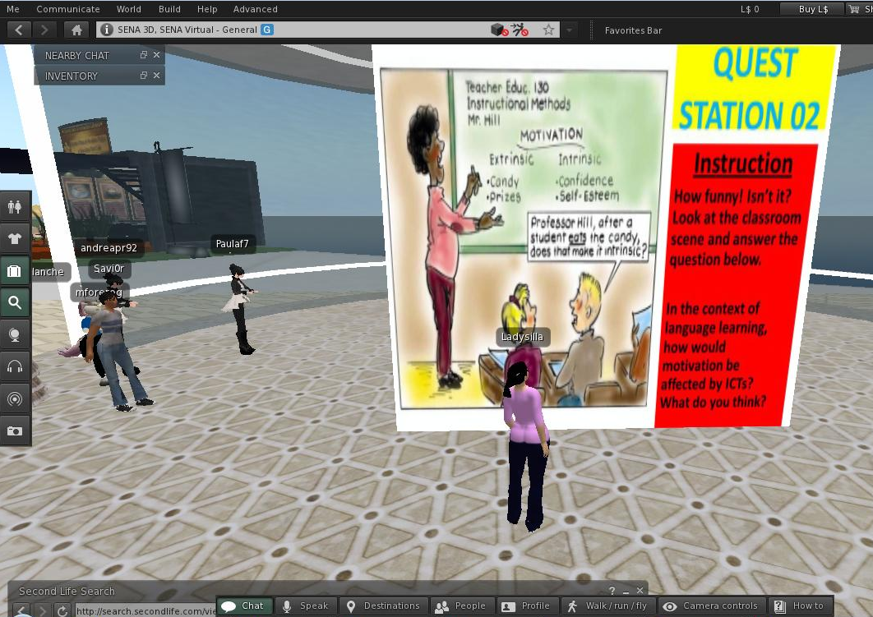

At the end of the activity I was very happy and I enjoy very much the quest stations and the experience of having a virtual class through Second Life.

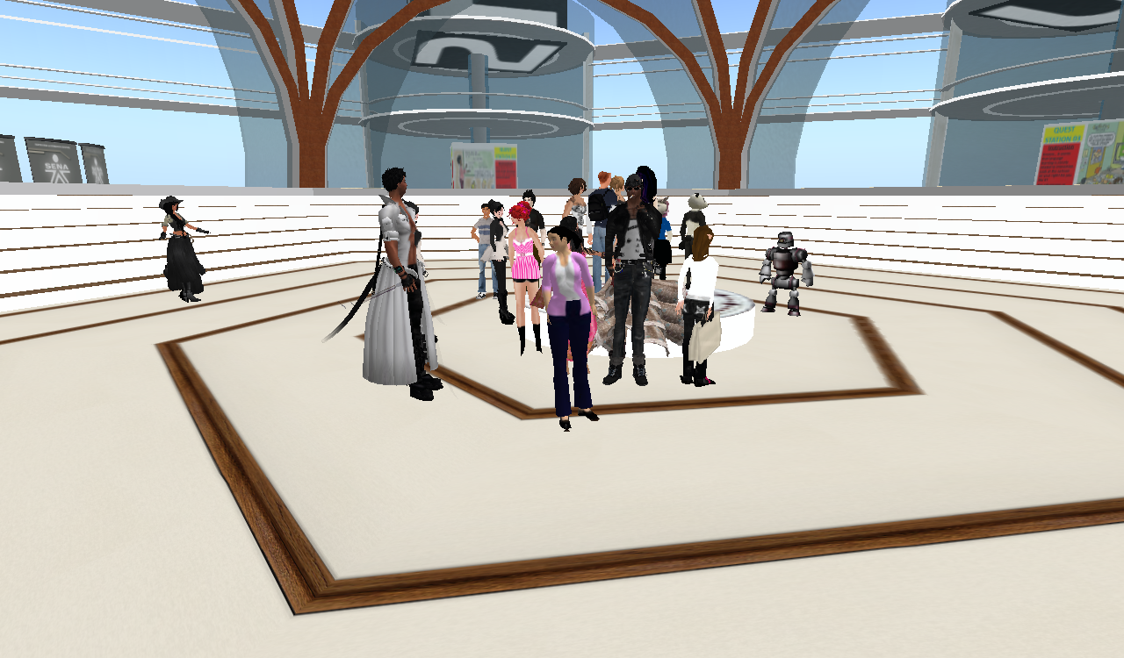

CONCLUSIONS

- Using Second Life and other virtual environments will be useful, interesting and important tools to teach languages because these are new and practical ways to interact between the teacher, the content(s) and the students.

- These virtual environments can improve the speaking and writing level of the students since they can interact, communicate and chat with native people and they also learn new vocabulary. For example, when changing the physical appearance of the avatar.

- Sometimes language teaching is difficult because teachers do not know how get the attention and motivate students to study and learn the language and therefore virtual worlds can be a solution to this problem since these change the routine of the class and open other visions, perspectives and spaces to study and learn a language.

- It is important to follow the tutorials that the teacher purposes because they help to know more about how the virtual environment works so the day of the immersion the students would not feel lost or confused.

- I think that our immersion was very interesting and amazing because it showed me the future. Maybe in a very near future the whole education will be through virtual environments and as teachers of languages we are going to be exposed to these kinds of interactions so this experience is helpful for my own learning and for future experiences.

Lady,
Your final conclusions are so interesting and they truly come from your experience in this activity. Good and great!!!
5.0/5.0
Harold

