BITACORA 0
FIRST LIFE:
SUSAN SARMIENTO
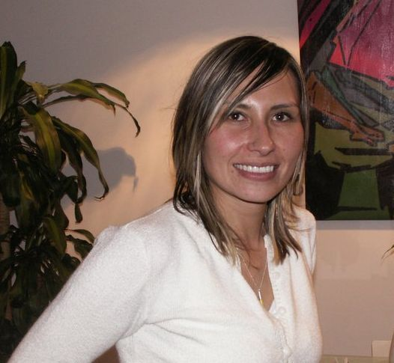

EXPECTATIONS OF THIS CLASS
In this course I expect to learn new things that are going to help me to be a better teacher. I expect to find interesting information, strategies, activities, knowledge I can apply in my own classes with my own students.

EXPERIENCE TEACHING
In the year 2006, I came to Colombia after living in Massachusetts U.S.A. for 4 years. I was looking for a job and someone gave me the opportunity to work as a teacher giving personalized classes. I worked with this person for almost a year and I learnt a lot while I was preparing my classes and while teaching; it was a great experience. After that, I worked in different English institutions and companies in Bogota like Fundacion Universitaria IDEAS, Golden Bridge, Passport and Tucker Energy. Once I started experiencing teaching every day and made a living out of it, I decided to start my program of foreign languages since I knew I needed to learn many more things than those I had already learnt by teaching. I have given personalized and group classes to children and adults. In this moment my first life has change a lot and after teaching straight for 4 years, now I have the opportunity to work as a translator.
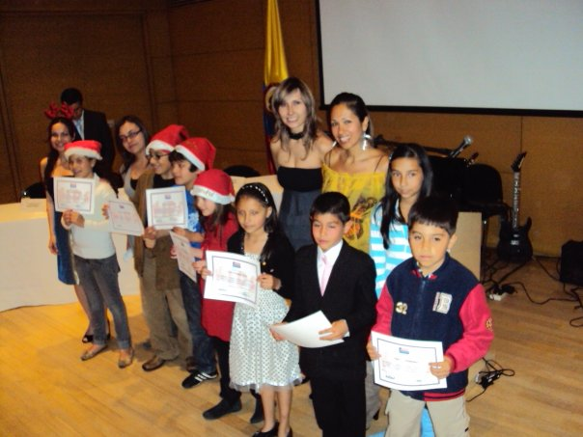
PASSPORT GRADUATION CEREMONY DECEMBER 2010

During my experience as English teacher in the recent years I have learnt that teaching is definitely a talent that implies connecting with the student in a way that he or she feels totally comfortable and receives positively all the new information. It is very important the knowledge of the teacher but it is more important the way the teacher is going to transmit that knowledge. As a teacher it was necessary to read my students and to figure out what was the best way for me to get to them. It is something unique that every teacher needs to discover and develop. The personality of the teacher is really important in the class and the way he behaves, the activities he proposes and the way he develops them, creates the ideal environment for significant learning. I used to do lot of activities with my students involving music, news, podcasts, magazines, movies, board games, role plays, talking games, etc. and I felt they really enjoyed the variety of activities. When you do the same every day for a long time, you become predictable and you need to look for different stuff to surprise students and avoid falling in routine. I also realized they learned more when they had conversations about their real lives because it became something more spontaneous.

TEACHING WITH ICTs
In some of the places I worked, we did not have the technological tools for teaching, so once in a while I would take my computer and we could work in different kinds of activities that required the interaction with English in several ways. In my personalized class I am always using technology. Since I have worked for different institutes I have obtained interesting materials that I use for my classes and they always result motivating for my students. For example, there is one book called interchange and it comes with a CD room with a special software designed to match the contents of the text book. This CD room is quite interesting, my students love it, and it is definitely a great tool.

WHY ICTs SHOULD BE PART OF A LANGUAGE LESSON OR PROGRAM?
There are several reasons why ICTs should be part of a language lesson or program: students need to be familiarized with using and working on computers and generally to manage technology. ICTs offer different ways of learning by games and activities that enable active learning in all senses. It is motivating for students to learn through technology and they can manipulate the machine and interact with people around the world. Students can also have access to anything they need to know since we have Internet and also the feedback from the computers may help students to learn more effectively.

Susan,
This bitácora 0 is so informative and has lots of wonderful ideas and insights!!! Good.
4.5/5.0
Harold

