Jennifer Pleasnick
Instruction Design for Third Grade Economics Unit
Bowling Green State University
Spring 2012
EDTL 7100

Rationale
Economics is an integral part of people’s lives and having an understanding of it allows people to comprehend the modern world and make decisions about the future. It is stated in the Goals 2000 Educate America Act that every student should be able to demonstrate competency in economics to possess knowledge and skills to compete in a global economy (Meszaros, 1998). Therefore, a unit on economics will introduce students to the vocabulary and begin to provide students an understanding of concepts needed to be able understand and compete in the global economy.
According to the research done by Piaget, students in third grade are still at the concrete operational stage of development. Huitt and Hammel (2003) maintain that at this stage, children’s “intelligence is demonstrated through logical and systematic manipulation of symbols related to concrete objects.” Therefore, curriculum at this level needs to be heavily reliant on meeting students at their needs- at the concrete level meaning that activities need to be hands on while incorporating experiences meaningful to the students’ lives. Students in this grade as well as at any stage move through activities and gain understanding of materials at different levels of understanding and at different times depending on their developmental level. In keeping students’ developmental needs in mind when designing curriculum, a variety of levels of understanding must be addressed from the basic skills needed to be successful at functioning in society to those who can gain a deeper understanding.
Through this unit on economics, students will be provided with as much real world experience as possible so that students are able to transfer learning in the classroom to their own lives. As developed by the Ohio Department of Education in the revised Grade Three Academic Content Standards for Social Studies (2011), “Effective economic decision making requires students to be able to reason logically about key economic issues that affect their lives as consumers, producers, savers, investors and citizens.” Interlaced with these key economic issues are the topics of economic scarcity and financial literacy which are also stressed in the Revised Social Studies standards and through the Model Curriculum. This instructional design will aim to help students meet the expectations for learning developed in this literature through a variety of learning strategies and by engaging students in as many real life examples and implications as possible. The lessons in this unit try to utilize the constructivist approach as much as possible but ends up being a blend of behaviorist and constructivist approaches due to level of complexity of content when considering Bloom’s taxonomy. The lessons have direct teaching through discussions and actually telling vocabulary words but also contain hands-on activities, group activities and projects.
Additionally, some of the lessons in this instructional design allow for re-teaching options, modifications for students identified with learning disabilities and to the interests of a specific class. The simpler the plans are and keeping the students in mind while empowering them as being responsible for more of their learning than the teacher makes it a contextualized learning environment.

Learner Outcomes
- Students will define opportunity cost (knowledge)
- Students will describe the opportunity cost of an individual economic decision. (comprehension)
- Students will define consumers and producers (knowledge)
- Students will identify consumers and producers in the local community. (knowledge)
- Students will define markets (knowledge)
- Students will describe markets that exist in the local community. (knowledge)
- Students will define costs and benefits (knowledge)
- Students will evaluate the costs and benefits of an individual economic decision. (evaluate)
- Students will define budget (knowledge)
- Students will explain how using a budget helps individuals make responsible economic decisions. (analysis)
- Students will explain how scarcity impacts price in markets. (analysis)

Please note:
On the Pre-test and post-test these objectives are listed as “I Can” statements, which is the current push from the Ohio Department of Education and in webinar sessions on the Battelle for Kids Ohio Website. It is not stated specifically in the lesson plan but referral to these statements should be made in the flow of conversations or activities as deemed appropriate by the educator.

Pre-Assessment & Post Assessment
Topic:  I can…. | I Can do this without help | I can do this with some help | I need a lot of help to understand this topic | Plan to learn this topic  (filled out with teacher)
Define opportunity costs
Describe opportunity costs of an economic decision
Evaluate the benefits and costs of an economic decision
Define costs and benefits
Evaluate costs and benefits of an individual economic decision
Define a budget

Explain how using a budget helps individuals make responsible economic decisions
Define market

Identify markets in my community
Identify producers and consumers in my community
Define consumers
Define producers

Explain how scarcity affects price

Lesson Plan 1:

Creating Economic Background

Goal:
Through the use of a picture book and engaging students in discussion and activities; teach students economic concepts of opportunity cost, producers, consumers, wants/needs, savings, making a decision.

Subunit objects:
- Students will define opportunity cost. (knowledge)
- Students will describe the opportunity cost of an individual economic decision. (comprehension)
- Students will evaluate the costs and benefits of an individual economic decision. (evaluate)
- Students will define budget. (knowledge)

Materials Needed:
- Book- A Chair for My Mother by Vera B. Williams
- Sticky notes
- Chart paper or Activboard/smart board
- Pencils
- Activity sheets
- Computers for each student
- Dry erase boards, markers & erasers for each student
- Chart with common grocery costs for snacks and 1 meal out of the day

Procedures:

Day 1:

Opening:
- Pass out Pre-Assessment and have students put a smiley face where they feel they are currently with the “I Can” statements. Remind the students that their responses dictate the lessons in which they participate in order to be able to complete all statements independently with mastery. Collect and use with post assessment. (5 minutes)
- Read aloud to class A Chair for My Mother by Vera Williams (7 minutes)

Activity:
- Ask the students the following questions to lead discussion about saving, wants and needs, and opportunity costs: (30 minutes)
- How did the family get money in the story? (the narrator earned money by helping at the restaurant, mom was a waitress and earned her money through tips & pay)
- What were their choices for the money that they earned? (spend, save)
- What did the family save their money for? (a chair)
- Where did the money come from that the family saved? (their jobs- mom’s tips, Grandma’s savings at the grocery store, ½ of the narrator’s earnings from helping at the restaurant)
- What other things would the family have to spend their money on? This is called a budget
- What kinds of things do you do to earn money? (rake leaves, clean snow off of driveways, do chores, etc.) Are there other ways to earn money? (sometimes students will get money for birthdays or holidays)
- Have you ever saved your money?
- What reasons are there to save? (saving to accumulate a larger amount to purchase a planned good or service in the future, to buy a good that people suddenly see or way; to deal with emergencies and unexpected events)
- What did you save your money for? If you have not saved your money for something ever- what would you save your money for? (Pass out a sticky note if no access to an interactive board- record items that students say on sticky note or interactive board)
- Sort the items that students recorded into wants and needs as a review from previous year (if students struggle with this concept there is an attached PowerPoint to use a picture sort. Pictures are: Wants: party, gift, toys (blocks & puzzle pieces), video game, candy; Needs: water, shelter (house), clothes, car (for transportation), food (toast in toaster) )
- Draw students’ attention back to the book- the family saved money by mom’s tips, half of the narrator’s earnings when she worked at the restaurant and any savings Grandma got from grocery shopping (whatever the savings were that week she put into the jar)
- Explain that once a decision is made there are trade-offs. (Use the family decided to save for a chair to have students think of things that the family may have had to trade-off or give up in order to save)
- Have students write a guess on a dry erase board 1 thing that the family had to give up in order to save for the chair. Have them turn over their guess then show all at once after everyone has written something.
- After everyone has written a guess discuss and record those guesses. Some ideas are the following:
  - The little girl: ice cream, gym, candy, toys, time, going to the movies (because it took longer for her to have money to get items)
  - Family: an extra treat from the grocery store because Grandma put the money saved into the jar. The extra treat could be ice cream, etc., going to the movies
  - Mom: some new shoes so her feet wouldn’t hurt; something special, treats, etc.
- Remind students that the trade-offs made or the things or options given up once a decision is made are called the opportunity cost- what is lost or given up based on the decision made.

Closure: (5 minutes)

Have the students restate the lesson objectives in their own words on a piece of paper.

Day 2:

Procedure:
Opening:
Ask the students if they can state any of the lesson objectives or I can statements that they learned the previous day and what the statements mean. This can be done as a whole class or turn to your neighbor tell that person and then randomly select students to share out. Walk around as students are discussing. (8 minutes)
**Review what happened in the story Chair for My mother by having the students watch it from U-tube at the following link: (7 minutes) if necessary depending on class make up and needs http://www.teachertube.com/viewVideo.php?video_id=119490&title=A_Chair_for_My_Mother_by_Vera_Wang
Discuss some of the things the family had to do in order to get their chair. Why couldn’t they just go out and charge the chair? Why should we save? (5 minutes)

Review concepts learned yesterday by this activity:

1. Practice figuring out opportunity cost with the following activity (a trip to the computer lab will need to happen or have enough computers for each student. Flash player is needed to play MAD money game: (Total time 25 minutes)
  - Before the students play the game explain that in the game they will be given a budget, a time frame and a shopping list while trying to save for an item that they would like to purchase
  - Actually go through the following steps on an interactive board to show the students the game 1 time- play it as a class making the decisions (5 minutes)
  - Have students go to http://www.pbs.org/teachers/connect/resources/401/preview/
  - Have them click on the money tab
  - Have them scroll down to the bottom and select MAD money, read the directions together
  - The directions are as follows
    - You’ll get a shopping list of all the items you need to buy this month.
    - You can find them, one by one, by clicking on the shops in town.
    - Spend wisely. A not-so-smart choice will cost you days from your 30-day countdown.
    - Every 7 “Days” you’ll get $15.00 allowance
    - Keep an eye out for the flashing dollar bill. Clicking on it will give you a chance to earn extra money. It may cost you some “days. But it may be worth it!
    - Also beware of some unexpected spending that you didn’t plan for!

They may have to play this a couple of times in order to fully understand the game if not played as a whole class.
  - When the students have finished the game use the following worksheet to have a discussion about the game that they played. Have the students fill it out independently and then discuss as a whole class. (This can be done as the teacher plays the game on an interactive board and the class fills out the worksheet- it depends on class level)
  - Discuss what some of the benefits and cost were to the options in the game. Why buy the three subject notebook vs. the 1 subject; the rechargeable batteries vs. the regular ones for the MP3 player, the gift card for $13 but get $20 vs. one just for $10. Make sure that students are able to tell that benefits are the things earned when making responsible choices in the game they earned a day, costs are the trade-offs for the benefits ex. the rechargeable batteries cost more but will last longer (cost vs. benefit).

Re-teaching activity: (15 minutes) optional

Have students write down what they ate for lunch or their favorite lunch to eat. Then write down their favorite snack food- ice cream, chips, cookies, etc.

Once the students have their list; bring out the poster of typical cost of food at the grocery store. Give the students a dollar amount. It may be $15. Have the students figure out the price of the food that the like to eat for lunch (it can be for the day or for the week- adjust the dollar amount appropriately so that students won’t be able to get their snack or something from their lunch.) Have them figure out if they have enough money or what items that they are going to give up in order to have others on their list.

Closure: (5 minutes)
Have students complete the following exit slip. Define opportunity costs in your own words. Tell why it is important to save. This can be done on a sheet of paper, sticky note, etc.
This is a word version of PowerPoint slide that can be used to reteach wants/needs
Drag the picture to correct position
Wants Needs






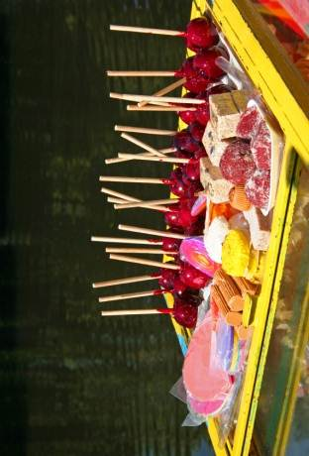




- What item did you select at the beginning of the game?

video game system shoes DVD movie concert ticket

- What choices did you make during the game?
  - Did you do click on the dollar when it popped up? Yes or No
  - What were some of those activities that you had to do? What did you get for doing those activities? _____________________________________________________
________________________________________________________________________________________________________________________________________
  - What did it cost you to do those activities? ____________________________________________________________________
  - What did you gain by doing those activities? ____________________________________________________________________
  - What were some of the choices that you had to make when making your purchases? (Check all of the choices that apply)

_______ Rechargeable batteries vs. regular one

_______ Matinee movie with BFF vs. weekend showing

_______ 5 rides vs. all day pass

_______ Milkshake vs. burger

_______ Designer jeans vs. other brand

_______ 1 subject notebook vs. 3-subject with designer cover

_______ Generic basketball jersey vs. team name

_______ Silver-plated bracelet vs. gold-plated bracelet

_______ Vintage shirt will never wear again vs. shirt will wear to school

_______ Teen terrific magazine vs. local newspaper

_______ Gift card for $10 or $20 gift card special for $13

_______ New video game for $40 or slightly used for $20

_______ Favorite band’s new cd or favorite band’s latest release slightly used

_______ Basic red pet collar or new sparkle collar

_______ Buy as much candy as you can or a certain amount

_______ Give up days in order to make money

- What were your opportunity costs in the game? List them. __________________________________________________________________________________________________________________________________________________________________________________________________________________________________________________________________________________________________________________________________________________________________________________
- How did you save money? ________________________________________________________________________________________________________________________________________________________________________________________________________________________________________________________________________________________________________
- Why should you save money? ________________________________________________________________________________________________________________________________________________________________________________________________________________________________________________________________________________________________________
- What was your budget? __________________________________________________________________________________________________________________________________________________________________________________________________________________________________________________________________________________________________________________________________________________________________________________

Lesson Plan 2:

Goal: Students will be able to identify different markets within their own community.
Objectives:
- Students will define markets (knowledge)
- Students will describe markets that exist in the local community. (knowledge)
- Students will define consumers and producers (knowledge)
- Students will identify consumers and producers in the local community (knowledge)

Materials needed:
- Attached pictures of different markets
- String
- Paper these are materials to make a mobile
- list of products (see attachment for a list)
- Pictures of local businesses
- A variety of products with the location of where they were made labeled on them
- A world map
- Interactive board like a Smart board or Activboard
- Chart paper
- Bag or hat to pull a card out of for mobile
- Sticky notes
- Poster with label: something I can explain to someone else, something I am still learning, I am not sure
- magazines

****Advanced preparation:

Go around the community and take pictures of the different types of markets. Print out on regular paper- have one for every student in the class. Make sure that the pictures are not only pictures of stores- markets are anywhere goods and services are exchanged.

Procedures:

Day 1

Opening

Show the students the pictures that follow this lesson plan on the board and have them describe the pictures. (Take off the names before displaying them-they are there for the purpose of identifying them) Discuss what they students see in the pictures. Lead them to that these are all types of markets around the world and throughout history. (5 minutes)

Activity:
1. Then ask in our community what the different types of markets here are? List them on the board or chart paper. Be specific Lowes not hardware store, Meijer not grocery store. (10 minutes)

2. Pass out a picture of the different markets that are found in the community. Have the students draw a picture of them in front of the market. Have them write a sentence below the picture about one thing they the consumer purchased from the market. (This lesson was adapted from a mailbox book- however I do not have any of the publication information to site it.) (10 minutes)
- Use these pictures to create a bulletin board to remind the students throughout the entire economics unit.

3. Have the students look at a friend’s shirt tag, shoes, or jacket tag to see where it was made. Pull up a world map on the interactive board such as:

http://wallpapersskin.wordpress.com/2011/03/03/printable-world-map-with-countries-labeled/

Put dots or marks on the locations of where the clothes that the students are wearing were produced. Then give students items from the collection of items and place dots on those countries. Make sure to call the people who make the items the producers and those who buy them are the consumers while completing this activity. Can also emphasize that products are made all over the world but we are still able to buy them at our local market. (15 minutes)

Closure: (5 minutes)

Have students write down on separate sticky notes the “I can” statements (or objectives) from the lesson. Then have them place it on a poster under a category of where they would fall- something I can explain to someone else, something I am still learning, and I am not sure.

Day 2:

Procedures:

Opening: (5 minutes)

1. Read aloud For Sale by Shel Silverstein

Ask what is the “good” in the poem? (review from previous year), What is the market?

2. Ask students to explain market, consumers, and producers.

Activity: (20 minutes)
1. Have students select a product from a bag or hat.

2. They are to create a mobile with the product being the first piece and then hanging off of it is 4-5 different markets in which that product can be purchased. They may draw the pictures or cut them out of magazines. Attach these pictures to the product with string. (* This is adapted from a Mailbox magazine but I do not have any of the information to site it)

Closure: (15 minutes)

Have the students share their mobiles and explain the different markets various products can be purchased by consumers as well as why they chose those markets. Then have students rewrite the objectives or “I can” statements of this unit in the own words.

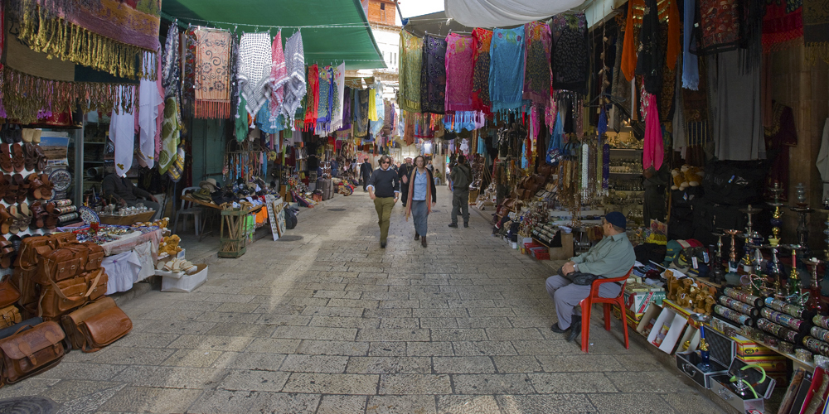

Marketplace in Jerusalem
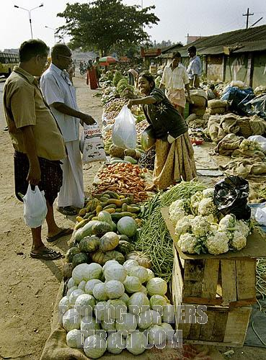
Marketplace in India

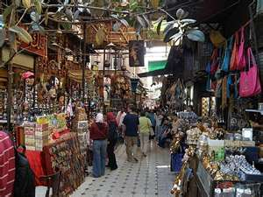
Egypt

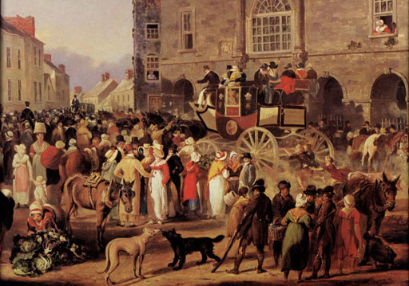
Around 1820 selling off of the stagecoach

Tempe, Arizona today

Grocery store
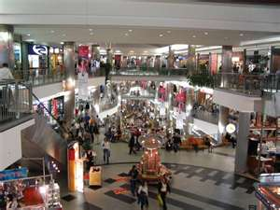
Mall
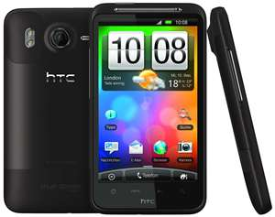
Mail order catalog phone

Note: please don’t forget that trading posts in Colonial times was also a market.

Ideas for making mobile- can be adapted to meet the interest of class
Video Game
Car
Book
Shoes
Dog food
Pet toys
Baseball mitt
DVD movie
music
Can of pop
bicycle

For Sale
By: Shel Silverstein
One sister for sale!
One sister for sale!
One crying and spying young sister for sale!
I’m really not kidding here!
So who will start the bidding?
Do I hear a dollar?
A nickel?
A penny?
Oh, isn’t there, isn’t there, isn’t there any
One kid who will buy this old sister for sale,
This crying and spying young sister for sale?
Lesson Plan 3
Goal: Students will understand supply and demand as well as scarcity and its impact on consumers.
Objectives:
Students will explain how scarcity impacts price in markets. (analysis)
Materials Needed:
- Enough bags of candy to put the class in groups of 4 or 5 make sure that there is not enough candy for everyone in the group
- Worksheet for students to plan and record responses
Procedures:
Opening: (10 minutes)
- Ask the students if they collect anything? (Baseball cards, autographs, etc.) Make a list of those things.
- Ask what makes something valuable?
- Consider this the Ipad 3comes out soon. All of the sudden stores are dropping the price of the Ipad 2 by $100. Why? When Wii systems first came out- they would go for $500 on E-bay especially at Christmas, now they can be purchased for around $120. Why?
- Discuss there is a shortage, or popularity, prices may go up when there is a lot of something, prices may go down.
Activity:
- Play musical chairs with fewer chairs then there are students. (5 minutes) The whole class does not need to play, can just use a small number with 2 less chairs. This all depends on the size of the classroom. What happened when the music stopped? Why? How does this relate to spending and products? What can we say about the value of the chairs when there was not were not enough for each student?
- Put students into random groups of 4 or 5. Pass out a bag of candy and worksheets have them work on how to distribute the candy among its members and a plan. Please tell them that adding candy to the bag is not an option. (15 minutes)
- Bring back groups and discuss worksheet.

Closing: (15 minutes)
Discuss how all of the lessons are related and how this affects us as consumers? Have students fill out post assessment on same sheet as the pre-assessment but, this time make stars instead of smiley faces or use a colored pencil to fill out where they are at the end of the unit.
Group Names __________________________________________________________
- What was in your bag? ________________________________________________
- How much did your bag contain? ________________________________________
- Plan for distribution: ________________________________________________________________________________________________________________________________________________________________________________________________________________________________________________________________________________________________________________________________________________________________________
- What are some problems with the plan for distribution? ________________________________________________________________________________________________________________________________________________________________________________________________________________________________________________________________________________________________________________________________________________________________________
- What are some solutions for distribution? ________________________________________________________________________________________________________________________________________________________________________________________________________________________________________________________________________________________________
- How does activity illustrate scarcity? ________________________________________________________________________________________________________________________________________________
- Define scarcity and its role in markets?
________________________________________________________________________________________________________________________________________________________________________________________________________________________________________________________________________________________________

Works Cited

Chiarelott, Leigh (2006). Curriculum in Context:Designing Curriculum for Teaching and Learning in Context. United State of America: Thomson Wadsworth.

Huitt, W., & Hummel, J. (2003). Piaget's theory of cognitive development. Educational Psychology Interactive. Valdosta, GA: Valdosta State University. Retrieved 2/18/12 from http://www.edpsycinteractive.org/topics/cogsys/piaget.html

Meszaros, Bonnie & Mary Suiter (1998). The Case of Economics in the Elementary. Banking and Policy Issues Magazine, December. Retrieved from http://www.minneapolisfed.org/publications_papers/pub_display.cfm?id=3587

Ohio Department of Education. (2011). Model Curriculum: PK-12 Social Studies. Columbus, OH: Retrieved from http://www.ode.state.oh.us/GD/Templates/Pages/ODE/ODEDetail.aspx?page=3&TopicRelationID=1706&ContentID=76598
Silverstein, Shel/ (1974). Where the Sidewalk Ends. New York: Harper Inc.
Williams, Vera B. (1982) A Chair for My Mother. New York: Scholastic Inc.
Websites utilized in lesson:
http://www.teachertube.com/viewVideo.php?video_id=119490&title=A_Chair_for_My_Mother_by_Vera_Wang

http://www.pbs.org/teachers/connect/resources/401/preview/
http://wallpapersskin.wordpress.com/2011/03/03/printable-world-map-with-countries-labeled/
Mailbox Magazine was used but no publication information was available.

