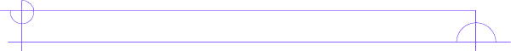
Literature Circle Role Sheet

Literary Luminary
This student helps group members examine AT LEAST two or three passages from the selection that deserve a closer look. Read these passages out loud for the group discussion. For example, one passage might be puzzling, while another might be disturbing or memorable for some reason. A creative way to handle this role would be to team up with the Sketcher and help explain one of the passages they have selected.

Before you read…
Think about the scenes that have shaped the novel so far. If you had to go back and point out important parts, what would they be? Write down some ideas that you think will come up as important parts of your reading.

_______________________________________________________________

_______________________________________________________________

_______________________________________________________________

While you read…
Think about passages that may have stuck out to you and mark it in your book to read for the meeting. Find something that was puzzling or funny, and right down ideas to discuss after you read to the class.

Page #____ Reason you picked this passage __________________________

________________________________________________________________

Page #____ Reason you picked this passage __________________________

________________________________________________________________

Page #____ Reason you picked this passage __________________________

________________________________________________________________

During Literature Circles…
Read one passage to the group and discuss why you picked it. Discuss the other passage(s) with them as well. Tell them why you thought it had an impact on the book or why it was funny.



