Timothy E. Eding
Instructional Design Project
Bowling Green State University
EDTL 7100
March 24, 2012

Rationale
Schools have worked tirelessly in recent years to update curriculum. Two areas of specific focus for administrators include the math and science. Requiring a fourth year of coursework and requiring all students to take at least Algebra II before graduation have bolstered mathematics curriculum. Most schools have gone far beyond that, adding courses in calculus and statistics at the top end of their curriculum. This is all well and good, but I think we are overlooking a very important area: personal financial literacy. Upper-level math skills are wonderful skills for students to have, but we need to make sure our students can function in society. We need to make sure our kids can balance checkbooks, understand loan terms, and make competent financial decisions. Now, more than ever, these skills are important to understand. If our current economic situation has taught us anything, it’s taught us to be prepared and plan for the future—however uncertain that may be.
A well-rounded curriculum in personal finance is essential. Not only do we need to teach our students how education and careers can impact their financial future, we need to teach them the basics of the American Financial System. High School students need to understand how checking and savings accounts work, the pitfalls and dangers of credit cards, how to protect their financial situation, and how to invest and plan for their financial future. According to the National Endowment for Financial Education website, 44 states have adopted personal finance standards for their school curriculum (nefe.org). The NEFE points out, however, that standards are typically very vague and broad, therefore leaving most financial education up to individual teachers. That creates wide variations in how the content is taught from one place to another, depending on the comfort level of individual instructors on financial matters.
As a traditionalist, my lessons that I have included for this unit tend to rely mainly on the expertise of the teacher instructing his/her students. The primary source of information for my lessons will be the textbook, but I will supplement the text with resources on the Internet and other periodicals as necessary. The unit that I have specifically planned for as detailed here includes lessons about investing in the stock market. This is important contextually because of the pivotal role the stock market can play in building personal financial wealth. Day trading has become a major strategy for building long term wealth in the financial plans for many Americans, so exposing my students to the basic concepts necessary to understand the stock market is more critical than ever. It is my belief that high school teachers need to do everything they can to equip students with skills they can and will use after graduation, and that is what this unit is all about.
The National Financial Educators Council believes that “just by providing high school students a personal financial education class, workshop or seminar before they gradate could dramatically improve college graduation rates and get students off on a positive start.” My plan clearly lays out the four broad areas that I believe are necessary for students to understand financial literacy. Financial Decision Making, Income and Careers, Saving and Investing, and Spending and Credit are key components of any financial education plan. For my instructional design, I have included in-depth lessons and activities that would be taught during the “Saving and Investing” component of the course. During this unit I will introduce basic principles of the Stock Market and give students opportunities to demonstrate their ability to build wealth working as day-traders on the stock market.
This unit is designed for high school students on a college preparatory track. The teacher wills serve as an “expert” in the field of personal finance and help to guide students through the content. This unit specifically targets the need for students to understand how the market works and how wealth can be built through the market, therefore hands-on activities like the ones I have included are necessary for higher-level learners that will be taking my course.

Learner Outcomes
Knowledge
- Define appropriate Personal Financial terms
- Identify essential components of a financial plan
- Identify common problems in personal financial plans
Comprehension
- Describe relationship between education and income
- Predict how economic factors can impact your personal financial plan
- Differentiate between different forms of credit
Application
- Solve personal financial problems such as lack of cash flow
- Examine how the use of credit can help build long-term wealth
- Examine how investing can help build long-term wealth
- Experiment with different amounts of liquidity to help manage current cash flow needs balanced with long-term personal financial goals
Analysis
- Analyze different components of personal financial plans
- Classify personal financial goals as short, middle, or long-term goals
- Compare different methods of saving and investing to find what is right for your personal financial plan
- Analyze different approaches to investing and the different levels of risk involved
Synthesis
- Design a personal financial plan that will help achieve personal financial goals
- Explain how paying taxes can impact a personal financial plan
- Anticipate upcoming financial needs and adjust personal financial plan to meet new goals and/or challenges
Evaluation
- Assess personal financial plan and make changes to reflect new or changing financial needs
- Compare the opportunity costs of purchasing decisions with long-term personal financial goals
- Summarize how insurance is an important component of any personal financial plan
- Assess current financial assets and make changes to reflect long-term health of personal financial portfolio

The following pretest would be given to students prior to beginning the unit on saving and investing. My intention would be to get them thinking about different types of investments and gauge what they do and do not know about investments. I chose to leave the responses open-ended in order to encourage a broader range or responses from my students.
Pre-Assessment-Saving and Investing
Name: ________________________________ Period: _______ Date: ____________
Directions: Answer the following questions to the best of your ability.
1. What does it mean to “invest” your money? Why do individuals invest their money?

2. What are some different ways that a person could invest their money?

3. What kind of risk is involved in a person investing their money? Can you think of any specific examples?

4. What are stocks? How do you buy and sell stocks?

5. What causes stocks to go up or down in value?

6. How do investors choose what stock to buy and sell? Where do they get the information to make these decisions?

7. Does investing money in the stock market worry you? Would you be willing to invest your own money in the market, if the opportunity arose? Why or why not?
Lesson Plan-Day 1 and 2
Title: | Introduction to Investing
Lesson Goal: | The goal of this lesson will be to introduce students to the different ways that people can invest money and the reasons for doing so. This lesson will lay the groundwork for other activities that will be conducted during this unit.
Lesson Objectives: | - Define appropriate Personal Financial terms (Knowledge)  - Examine how investing can help build long-term wealth (Application)  - Compare different methods of saving and investing to find what is right for your personal financial plan (Analysis)
Procedures: | - Introductory Activity (5-10 minutes)-You Tube-Two scenes from Seinfeld episode “The Stock Tip”. After watching both clips, I will lead the class in a brief discussion about investing and the anxiousness that people can feel by putting money into the stock market. Videos are found online:  http://www.youtube.com/watch?v=d7eJh36b6rk  http://www.youtube.com/watch?v=IkMdyWJ0-zc  - Developmental Activity (45-60 minutes)-Students will complete an assignment (Reading Guide) in order to prepare for in-class discussion about different methods of investing. Once the assignment was completed, then we would have a discussion (20-30 minutes)-Using the reading guide as the basis of our class discussion, we will go over the different forms of investing that are presented in the text and break down the positives and negatives of both.  - Concluding Activity (5 minutes)-Review the Lesson Objectives orally with the class and ask them to restate in their own words.
Assessment/Evaluation: | Exit slips: Students will be required to write down one thing they already knew from the reading, one thing they learned from the reading, and one thing they want to know more about (will be done at the end of day 2).
Materials Resources Needed (Copies attached when applicable): | Computer with Internet Access  LCD Projector  Textbook  Reading Guide (attached)

Methods of Investing Reading Guide

Name: ____________________________________ Period: _____ Date: _________________

Directions: Read pages 252-264 and answer the following questions.

1. What is an investment?

2. What is the problem with keeping all of your money in less-riskier, highly liquid places like savings accounts and CD’s?

3. What are stocks? Who issues stocks?

4. Why do companies issue and sell stock?

5. What is an IPO? When does and IPO occur and when do you see them?

6. What is the primary market?

7. What is the secondary market?

8. What are some of the more familiar stock exchanges listed in your book?

9. What does it mean when a company is “publicly traded”?

10. When you buy or sell a stock on the NYSE, what is the process?

11. How does the way that the NASDAQ works differ from the NYSE?

12. What are institutional investors?

13. Using figure 14.1, what are some things that can cause stocks to increase in value?

14. Using figure 14.1, what are some things that can cause stocks to decrease in value?

15. What is the difference between a “bull market” and a “bear market”?

16. Who are shareholders and what are dividends?

17. Why do some companies opt out of paying dividends to their stockholders?

18. Are your investments guaranteed like they are in banking accounts?

19. What is the Securities and Exchange Commission? What does it do?

20. What is a brokerage? Why do you have to have an account with one?

21. What is a commission?

22. What is the difference between a full-service brokerage and a discount brokerage? Give examples of each.

23. What is a bond? Who issues bonds?

24. What is a bond’s maturity date? What are typical maturity rates for bonds?

25. What are some different ways that bondholders can make money?

26. What are treasury bonds? Is there a risk involved with treasury bonds? Why or why not?

27. What are federal agency bonds? Who issues them?

28. What are municipal bonds and who issues them?

29. What are corporate bonds and who issues them?

30. How do investors buy bonds?

31. What is a Mutual Fund?

32. Why are mutual funds attractive to some investors?

33. What is diversification? Why is it important to diversify?

34. What kinds of choices do investors have when investing in mutual funds?

35. Where to investors purchase mutual funds?

36. How have millions of Americans used Real Estate as an investment?

37. How can local economic factors have an impact on home prices in the area?

38. In general, what has happened to home prices over the very long run? What other advantages does owning property give an investor?

39. How can a rental property be considered an investment?

40. How can owning a business be considered an investment? What must you consider before investing in a small business?

Lesson Plan-Day 3
Title: | What’s a Stock Symbol?
Lesson Goal: | My goal with this lesson is to give my students some practical skills to help them read and decipher stock market pages in newspapers and on the Internet.
Lesson Objectives: | - Define appropriate Personal Financial terms (Knowledge)  - Predict how economic factors can impact your personal financial plan (Comprehension)  - Compare different methods of saving and investing to find what is right for your personal financial plan (Analysis)  - Analyze different approaches to investing and the different levels of risk involved (Analysis)  - Anticipate upcoming financial needs and adjust personal financial plan to meet new goals and/or challenges (Synthesis)  - Assess current financial assets and make changes to reflect long-term health of personal financial portfolio (Synthesis)
Procedures: | - Introductory Activity (5 minutes): I will have listed stock symbols for a variety of corporations on my board and I will ask students to try and guess what company those symbols represent. Symbols included will be: AEO (American Eagle), ACE (Ace Hardware), HOG (Harley-Davidson), KO (Coca-Cola), WMT (Wal-Mart), MCD (McDonald’s), VZ (Verizon), MSFT (Microsoft), AAPL (Apple), GE (General Electric), BUD (Anheuser-Busch), PEP (Pepsi), YHOO (Yahoo), GOOG (Google), GM (General Motors), F (Ford), BBY (Best Buy), DIS (Disney), BP (British Petroleum), JNJ (Johnson and Johnson).  - Developmental Activity (35 minutes)-I will pass out copies of today’s stock page from The Lima News and explain to the class what the different columns mean. I will then give them copies of the Stock Market Activity (attached) and give them time to answer the questions that are listed. After all students are done, we would then go over the information and discuss how some of the stocks are doing.  - Concluding Activity (5 minutes)-“What local companies are the safest investments? Which ones pay the most dividends?”
Assessment/Evaluation: | Successful completion of the handout that demonstrates they understand the different informational items listed in the paper.
Materials Resources Needed (Copies attached when | Copies of The Lima News  Copies of the Stock Market Activity
Stocks in the Newspaper Activity

Name: ____________________________________ Period: _____ Date: _________________

Directions: Use the photocopy of today’s Lima News Business section to answer the following questions.

1. Write the ticker symbol for the following companies:

Verizon: Fifth-Third Bank:

Bob Evans: Norfolk-Southern:

WalMart: Cooper Tire:

Ford: Harley Davidson:

2. The Last and Close are the same thing. Write the Closing for the following stocks:

McDonalds: Whirlpool:

Valero: Huntington Bank:

General Motors: Cracker Barrel:

CSX: Procter & Gamble:

3. Write the daily or net change for the following stocks:

BP Amoco: Prudential:

Fifth Third: Whirlpool:

Harley Davidson: Andersons:

IBM: JC Penny:

4. Write how much one share of each of the following stocks will pay in dividends:

WalMart: Wendy’s:

Kohl’s: Sprint:

Buckeye Pipeline: American Electric Power:

Heath Care Retirement: Lowe’s:
5. Write is the 52-week high and low of the following stocks:

Citigroup: Viacom:

Chrysler: General Motors:

Ford: McDonald’s:

JPMorgan Chase: The Limited:

6. Which of the stocks listed on the Local Interest Section pays the highest dividend? Lowest?

7. Looking elsewhere on that paper, what companies were the biggest gainers on the NYSE yesterday? What were some of the biggest losers?

8. What was the overall average of the Dow Jones Industrial at closing yesterday? What was the change from the day before?

9. How can the information in the paper be useful to you as an investor?

10. Do you think you’ll make any changes to your portfolio based on what you have seen here today? Why or why not? What changes will you make?

11. Remember, these are stocks of local interest (local companies, local ties, etc). Where could you look for more complete information on all stocks? Do you think you will do this to help your investment portfolio? Why or why not?

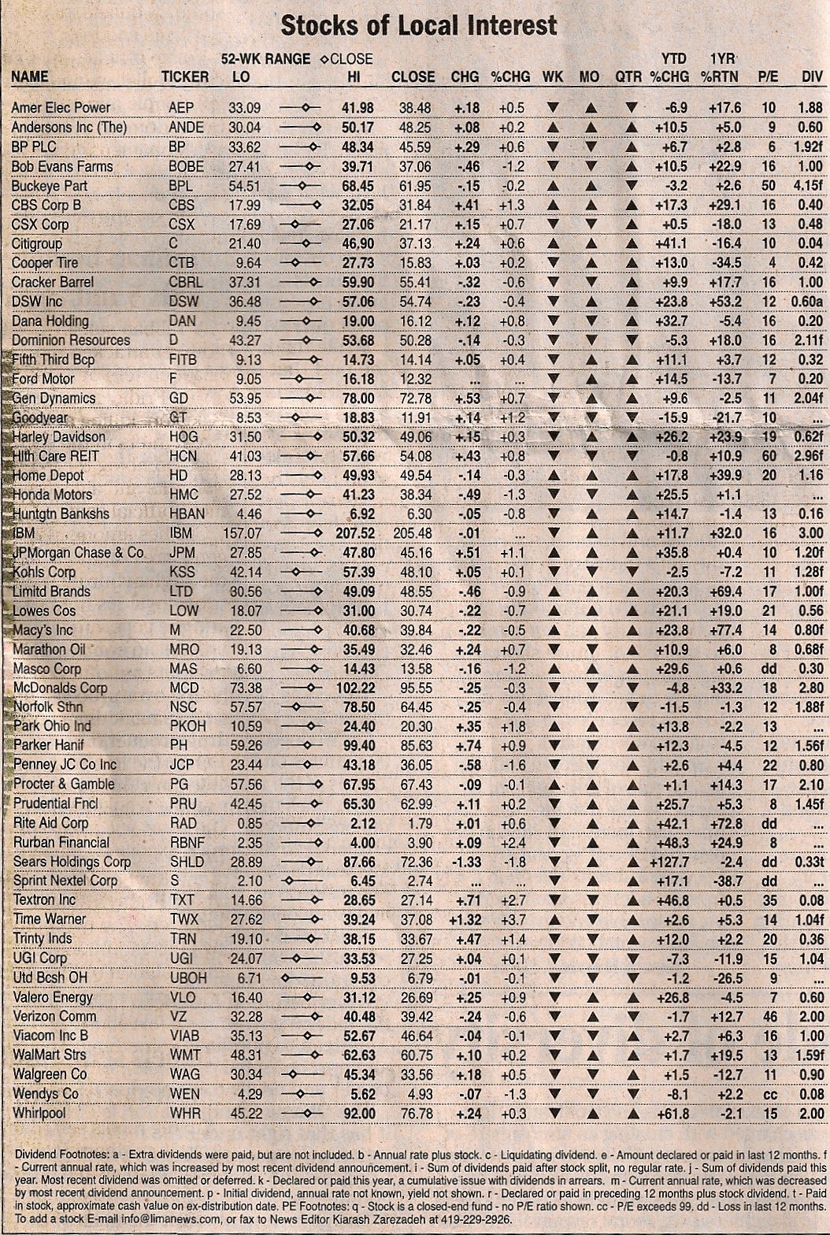
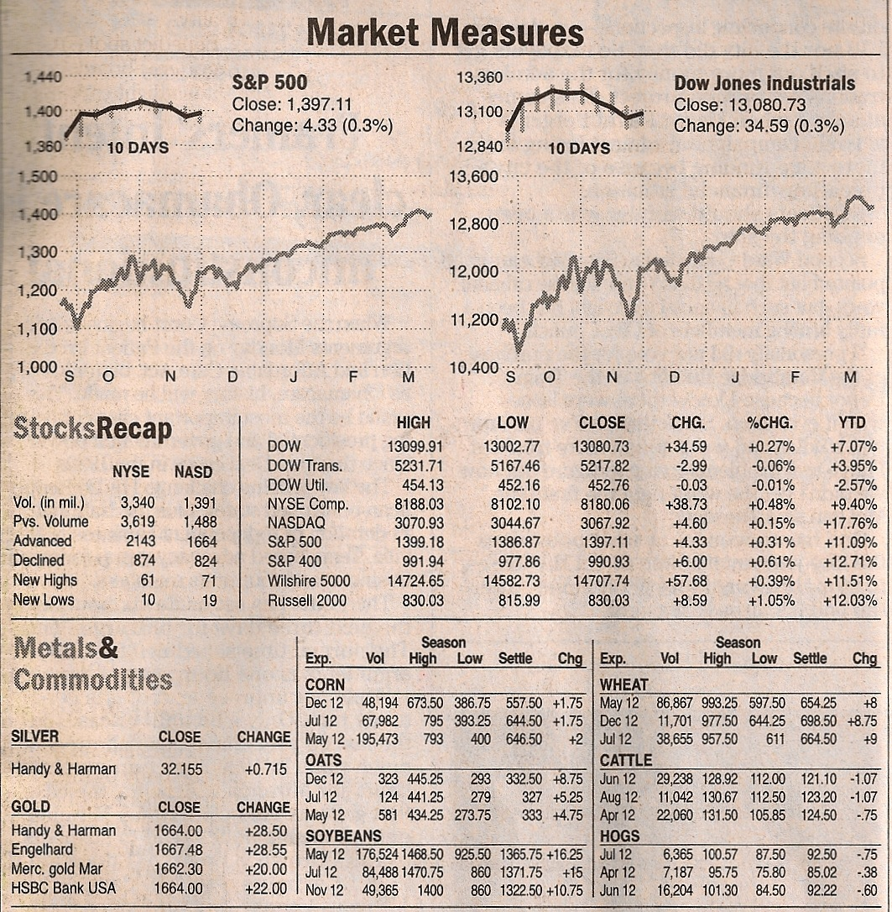
The Lima News-Saturday, March 24, 2012
Lesson Plan-Day 4
Title: | The Stock Market Game
Lesson Goal: | Introduce the Stock Market Game to the class (this is an ongoing lesson that will last for a couple of weeks, maybe longer-I will be introducing the game and all the rules today).
Lesson Objectives: | - Predict how economic factors can impact your personal financial plan (Comprehension)  - Analyze different approaches to investing and the different levels of risk involved (Analysis)  - Anticipate upcoming financial needs and adjust personal financial plan to meet new goals and/or challenges (Synthesis)  - Assess current financial assets and make changes to reflect long-term health of personal financial portfolio (Synthesis)
Procedures: | - Introductory Activity (20 minutes): Explain the assignment and the goals that the students will hopefully accomplish before the game ends.  -Students will be given $100,000 to “invest” any way that they want. See attached handout for specific rules and procedures that will be explained in class.  - Developmental Activity (20 minutes): Computer lab time to set up their portfolios and begin research companies to invest in.  - Concluding Activities (5 minutes): I will ask students if they have any questions or if they need any other information in order to begin the game.
Assessment/Evaluation: | The assessment of this lesson will happen at a much later date. I will set an “end” date for the game. On that date, I will collect all log sheets and printouts of their current financial standing at that time. Those materials will then be used to assign grades.
Materials Resources Needed (Copies attached when applicable): | Computer Lab  Copies of Log Sheets (attached)  Copies of Game Information and Rules (attached)

Stock Market Game
Investment Log
 | Company Name | Symbol | Date of Trade | # of Shares | Total Amount | Profit/Loss | Acct Balance
1
2
3
4
5
6
7
8
9
10
11
12
13
14
15
16
17
18
19
20

Stock Market Game

The purpose of this activity is to help you understand how basic investing in the stock market works as well as other basic economic concepts.

Each person will begin the game with $100,000. With this money, an individual must initially spend at least $50,000 on stocks (including commissions). The remainder may be kept in your cash account, if you choose not to invest it.

All investments and portfolios will be done on the “Virtual Stock Exchange” (www.vse.marketwatch.com).

Each individual must be invested in at least 5 stocks at all times. Penalties will be enforced if this requirement is not met.

Everyone needs to keep a written log of his or her activities on the form that will be provided.

We will keep these portfolios for the remainder of the semester. The top three portfolios (highest cash value) will earn bonus points on the semester exam at the following intervals:
1st Place-10 bonus points
2nd Place-7 bonus points
3rd Place-5 bonus points

Choosing Stocks:
Try to choose stocks or companies that you are familiar with—you know the products that they produce, you have family members that work for them, etc.

The following websites may be useful in helping you decide what to buy:
www.marketwatch.com
www.finance.yahoo.com
www.nyse.com
www.stocks.com
www.money.cnn.com
www.foxbusiness.com
You can also “Google” stocks and see if there are other websites that can help you decide.

Making Trades (Buying and Selling):
To start buying stocks for your portfolio, click the “Make a Trade” link along the left side. Please note, that every trade carries a $9.95 commission price and there is also a 4% interest rate for any credit you use.

Be careful what you spend—the game will allow you to “borrow”…you can easily wind up in debt and actually end the game with a negative balance!

Monitoring your investments:
You should check your portfolio daily. Pay attention to news items or reports that are published about your stocks and make any changes you think are necessary as a result. There are not a “required” number of trades you must make, but remember you want to maximize your profits, so you need to make decisions based on that goal.

Lesson Plan Day 5

Title: | Investing-Math Skills
Lesson Goal: | To give students practice at some typical math “problems” they may encounter when working on investments, especially with stocks, bonds, or the stock market.
Lesson Objectives: | - Assess current financial assets and make changes to reflect long-term health of personal financial portfolio (Synthesis)
Procedures: | - Introductory Activity (5 mins): Follow up on yesterdays lesson and make sure everyone understands the rules of the Stock Market Game.  - Developmental Activity (35 mins): Work on math problems relating to investing (handout attached).  - Concluding Activities (5 mins): Going over the answer they got on the math problems
Assessment/Evaluation: | Correct answers on the handout
Materials Resources Needed (Copies attached when applicable): | Math Skills Handout (attached)  Calculators

Math Skills

Name: ____________________________________ Period: _____ Date: _________________

Directions: Answer the following questions. SHOW ALL WORK!

1. If you owe 500 shares of stock in a company that has 100,000 shares of stock outstanding, what fraction of the firm do you own?

2. What is your profit on the sale of 250 shares of stock for $38 a share if you paid $26 a share 2 years ago (not counting commission)?

3. What is the total value of your stock holdings if you own 50 shares of XYZ valued at $32.50 a share, 90 shares of ABC valued at $54.25 a share, and 125 of DEF valued at $112.12 a share?

4. How much interest will you receive annually on a 7 percent coupon rate bond with a $1,000 face value?

5. What is the total dollar amount you would make on a 9 percent coupon rate bond with a face value of $1000 but for which you paid $1035 and that you held for one year before maturity?

6. Robin sold 35 shares of a stock for $47.50 a share. She bought the stock for $51 a share last year. What was her dollar return (loss), not counting commission?

7. Breanne paid $11.75 a share for stock Y last year. Today, she sold the stock for $14.25 a share. What was her percentage return, not counting commission?

8. How much money did Jeremy receive in interest on a $1000 face value bond that he held for two years and that had a 7 percent coupon rate?

Post-Assessment

Name: ___________________________________ Period: __________ Date: ____________

Directions: Choose the best answer for each of the following questions.

_____ 1. Experts suggest that you should build a cash reserve large enough to pay for _______ worth of your regular bills.
- One Week’s
- One Month’s
- Three to six months
- Six month’s to one year’s

_____ 2. Earnings from which of the following are LEAST likely to outpace inflation over time?
- Stocks
- Bonds
- CDs
- Mutual Funds

_____ 3. With the promise of higher returns on an investment comes ___________.
- Lower taxes
- Lower risk
- Higher risk
- Higher costs

_____ 4. A company receives money for the sale of its stock __________.
- During its IPO
- Whenever its stock is traded
- When shares are purchased in a secondary market
- When shares are privately traded

_____ 5. Your first priority in your financial plan should be to save up cash for non-liquid investments.
- True
- False

_____ 6. The interest paid on many lower-risk investments barely keeps pace with normal levels of inflation.
- True
- False

_____ 7. The stock market has generally produced much higher and more consistent short-term returns than more liquid investments have.
- True
- False

_____ 8. The stock market tends to have major price swings up and down.
- True
- False

_____ 9. If a company in which you have purchased stock goes bankrupt, you may lose your total investment in that company.
- True
- False

_____ 10. IPO stands for ________.
- Initial price offer
- Initial public offering
- Initial principle order
- Initial private ordering

_____ 11. An IPO occurs in the ________.
- Primary market
- Secondary market
- New York Stock Exchange
- NASDAQ

_____ 12. A company is said to be publicly traded when its stocks are _________.
- Sold on the primary market
- Bought and sold in the secondary market
- Sold in an IPO
- Bought and sold by a full-service brokerage

_____ 13. Which of the following is NOT an example of a secondary market?
- SEC
- NASDAQ
- NYCE
- Instinct

_____ 14. Most investors in the stock market are trying to buy a stock at a ______ and sell it later at a _________.
- High price; higher price
- Low price; lower price
- High price; lower price
- Low price; higher price

_____ 15. All companies offer shares of their stock for public sale.
- True
- False

_____ 16. Sara has just submitted an order to sell several stocks through her online broker. Which of the following is most likely to happen next?
- Sara receives confirmation of the sale
- A stock exchange matches Sara’s “sell” order with someone else’s “buy” order for the same stock
- Sara’s online broker contacts a representative at a stock exchange
- The online broker contacts a full-service brokerage

_____ 17. The stock market always goes up, but the rate at which it goes up varies.
- True
- False

_____ 18. All profitable companies give out dividends.
- True
- False

____ 19. Unlike banks, the stock markets do NOT carry insurance on your investments.
- True
- False

_____ 20. Only a very few stocks lose value over a long period of time.
- True
- False

_____ 21. It is generally better to own a number of different stocks than it is to own stocks in just one company.
- True
- False

_____ 22. In financial terms, a bond is ________.
- Security
- Promissory Note
- Commission
- Dividend

_____ 23. Bonds typically have _____ ranging from five to thirty years.
- Coupon Rate
- Interest rates
- Maturity dates
- Value dates

_____ 24. On a bond’s maturity date, the investor is paid _______.
- A dividend
- His or her initial investment
- Compound interest
- A commission
_____ 25. A bond’s coupon rate is its ________.
- Face value
- Interest rate
- Maturity rate
- Dividend

_____ 26. In general, the _____ the bond rating, the ________ the interest rate the bond pays.
- Lower; lower
- Higher; higher
- Lower; higher
- Higher, the more frequent

_____ 27. Which of the following is NOT a factor in a bond’s value moving up or down?
- Investors’ belief in the bond-issuer’s ability to repay a bond
- Whether the bond is sold by a full-service or discount brokerage
- Whether the interest rate goes up
- Whether the interest rate goes down

_____ 28. Using Standard & Poor’s bond rating classes, a medium quality bond would have which of the following ratings?
- AA
- BBB
- B
- CCC

_____ 29. Treasury bonds are used to ________.
- Finance state and local public projects
- Stimulate growth in the economy
- Finance the debt of the United States government
- Reduce owners’ federal taxes

_____ 30. Anything rated below the top four categories of bonds is considered a ________.
- Junk bond
- Corporate bond
- Investment-grade bond
- Municipal bond

_____ 31. Unlike stocks, most bonds do not carry risk.
- True
- False

_____ 32. A bondholder may be able to sell a bond for more than its face value.
- True
- False

_____ 33. Which of the following is a tax-sheltered retirement account?
- A mutual fund
- A municipal bond
- A promissory note
- A 401(k)

_____ 34. Mutual funds vary widely in the fees they charge shareholders, so careful research before investing can save you money.
- True
- False

_____ 35. In general, home prices have increased over the very long run.
- True
- False
Directions: Match each of the following to the organization it describes.

_____ 36. Exchange where traders physically gather to buy and sell stocks in an auction-like environment (B)

_____ 37. The government agency that regulates the stock market (A)

_____ 38. A stock exchange consisting of a network of computer dealers that buy and sell stocks (C)
- SEC
- NYSE
- NASDAQ

Directions: Match each of the following to its corresponding term.

_____ 39. A person who owns stock in a company (A)

_____ 40. A fee for carrying out a transaction (E)

_____ 41. A market that is trending upward (F)

_____ 42. A firm that provides customers access to the stock markets (C)

_____ 43. A distribution of profits to those who own a stock in a company (B)

_____ 44. A market that is trending down (D)
- Shareholder
- Dividend
- Brokerage
- Bear Market
- Commission
- Bull Market

Directions: Answer each of the following questions completely. BE SURE TO SHOW WORK on the math problems.

45. Explain why it is wise to consider riskier investments such as the stock market as long-term investments.

The stock market generally produces much higher long-term returns than more liquid and more guaranteed investments. However, the stock market does not produce steady results. Investments may go up or down unpredictably, with trends in either direction lasting for months or even years. Any money you expect to need in the short-term or mid-term future should be moved to a more stable investment, such as a CD or money market account.

46. Larissa purchased 50 shares of stock for $38 a share in a technology company. Three years later, she sold all of the stock at a price of $53 per share. Not counting commissions, how much did Larissa earn through this investment?

$38 x 50 = $1900

$53 x 50 = $2650

$2650 - $1900 = $750

47. Uri bought 75 shares in a car company at a price of $95 per share. The shares are currently trading for $48. If Uri sold his shares now, how much of his initial investment would he lose (not counting commissions)?

75 x $95 = $7125

75 x $48 = $3600

$7125 - $3600 = Uri would lose $3525

48. Six months ago, Aiden purchased stock in a toy company. He paid $15 per share. Aiden just sold her shares at a price of $22 per share. What percentage return did Aiden make on his stock?

($22 - $15) / $15 = 7/15 = .467 or 46.7%

49. Sara purchased three $1000 bonds at a coupon rate of 8% and a maturity date of five years. How much total interest will Sara’s investment earn over the five years?

$1000 x 0.08 = $80

3 x 5 x $80 = $1,200

50. Clare bought her first home for $135,000 in 2001. In 2006, the value of real estate in her area had increased by 18%. Based on this, how much was Clare’s home worth in 2006?

$135,000 x 1.18 = $159,300

Works Cited

Chiarelott, L. (2006). Curriculum in context. Belmont, CA: Wadsworth Cengage Learning.
Fetterman, Mindy & Hansen, Barbara. Young in Debt: Part I, Struggling with Debt. USA
Today. November 20, 2006
Madura, J., Casey, M., & Roberts, S. (2010). Personal Financial Literacy. (pp. 253-269). Boston:
Pearson Education, Inc.
Market measures. (2012, March 24). The Lima News, p. A5.
National Endowment for Financial Education. Are Teachers Making the Grade in Personal
Finance Education? Retrieved from: http://www.nefe.org/NEFENews/PressRoom/PressRelease/UWMADISONRELEASESSTUDYONTEACHERSCAPABILITY/tabid/835/Default.aspx
National Financial Educators Council. Best Practices in Financial Education. Retrieved from:
http://www.financialeducatorscouncil.org/personal-financial-education.html.

