Instructional Design
Equations (Geometry)

By: Eric Radabaugh



Statement of Purpose/Rationale
Geometry is a course designed to investigate the spacial world that surrounds us as well as develop a strong understanding of how to prove mathematical concepts, called theorems. As per the current Ohio State Standards, Geometry consists of a wide range of mathematical concepts. However, with the adoption of the new Common Core Curriculum, the number of clusters is now numbered to just 15, with one of those being modeling. According to the common core state standards website, “Modeling links classroom mathematics and statistics to everyday life, work, and decision-making” (Common Core, 2010). Real world application is essential to the everyday understanding of students. Without a purpose or motivation to learn, students will not be fully engaged in the learning process, especially in mathematics.
Modeling has always been understood to have a place in the mathematics classroom, but has never been mandated to teach. With the Common Core Standards, that issue is addressed. This unit plans to lessen the gap between the traditional classroom and the new standards of modeling. This unit brings a hands-on approach to using equations and graphing to make real world predictions. Questions such as, “How do engineers design beams to support bridges” and “How much weight can a beam hold” will be answered.
Through a contextualized teaching and learning theory approach, this unit will dive into real world application. According to Elaine Baker, contextualized teaching and learning is defined as the, “Conception of teaching and learning that helps teachers relate subject matter content to real world situations” (Baker, 2009). In my classroom, this is done throughout each unit. Analysis of linear data sets, group discussions, and a group project will guide the modeling approach used in this specific unit.
To help shape the contextualized classroom, I have chosen two instructional models to use in this unit: The behaviorist approach, and the constructivist approach (Chiarelott, 2006). This blended approach will consist of the first two days using a traditional approach to lay a foundation of knowledge and skills. This will be followed by three days of using a constructivist model including hands on learning to guide the lessons. As part of the constructivist approach, I will incorporate a project-based lesson plan. Using a project-based lesson will address the underlying issue of modeling in the classroom. Groups will be working with spaghetti noodles and coins to predict the strength of spaghetti beams, and to gain a strong understanding of how linear models can be used in the real world.
Today’s math and science students need hands-on, minds-on experiences to stimulate and challenge them to think (David, 2011). Tying abstract mathematical concepts into everyday problem solving is a challenge that is addressed with the new common core state standards. This unit is one example where a contextualized teaching and learning approach can meet the modeling curricular need in the traditional geometry classroom.
Resources
Baker, Elaine D. "Contextualized teaching and learning:A faculty primer." Academic
Senate for California Community Colleges Apr. 2009. Print.
National Governors Association Center for Best Practices, Council of Chief State School Officers. (2010). Common core state standards for mathematics. In Common Core State Standard Initiative. Retrieved February 20, 2012

Wetzel, David. Teaching Math and Science. N.p., 6 Dec. 2011. Web. 24 Mar. 2012.
Geometry Learning Outcomes

Congruence

- Students will know precise definitions of angle, circle, perpendicular line, parallel line, and line segment. (knowledge)

- Students will represent transformations in the plane, describe transformations as functions, and compare transformations that preserve distance and angle to those that do not. (comprehension analysis)

- Students will describe rectangles, parallelograms, trapezoids, or regular polygons. (comprehension, analysis)

- Students will develop definitions of rotations, reflections, and translations in terms of angles, circles, perpendicular lines, parallel lines, and line segments. (analysis, synthesis)

- Students will draw a geometric figure after a rotation, reflection, or translation. (application)

- Students will use geometric descriptions of rigid motions to transform figures and to predict the effect of a given rigid motion on a given figure. (synthesis, evaluation)

- Students will use the definition of congruence in terms of rigid motions to show that two triangles are congruent if and only if corresponding pairs of sides and corresponding pairs of angles are congruent. (analysis, synthesis)

- Students will explain how the criteria for triangle congruence follow from the definition. (comprehension, analysis)

- Students will prove theorems about lines and angles, triangles, and parallelograms. (synthesis, evaluation)

- Students will make geometric constructions with a variety of tools and methods. (application)

- Students will construct an equilateral triangle, a square, and a regular hexagon inscribed in a circle. (application)

Similarity

- Students will verify experimentally the properties of dilations given by a center and a scale factor. (application)

- Students will use the definition of similarity in terms of similarity transformations to decide if two figures are similar. (analysis, synthesis)

- Students will use the properties of similarity transformations to establish the AA criterion for two triangles to be similar. (comprehension, application)

- Students will prove theorems about triangles. (synthesis, evaluation)

- Students will use congruence and similarity criteria for triangles to solve problems and to prove relationships in geometric figures. (application)

- Students will discover the definitions of trigonometric ratios. (comprehension)

- Students will explain and use the relationship between the sine and cosine of complementary angles. (analysis)

- Students will use trigonometric ratios and the Pythagorean Theorem to solve right triangles in applied problems. (application)

Circles

- Students will prove that all circles are similar. (synthesis, evaluation)

- Students will identify and describe relationships among inscribed angles, radii, and chords. (comprehension)

- Students will construct the inscribed and circumscribed circles of a triangle, and a tangent line from a point outside a given circle to the circle. (application)

- Students will derive using similarity the fact that the length of the arc intercepted by an angle is proportional to the radius, and define the radian measure of the angle as the constant of proportionality. (analysis, synthesis)

- Students will translate between the geometric description and the equation for a conic section. (application)

Equations

- Students will derive the equation of a circle of given center and radius using the Pythagorean Theorem. (analysis, synthesis)

- Students will derive the equation of a parabola given a focus and directrix. (analysis, synthesis)

- Students will derive the equations of ellipses and hyperbolas given the foci. (analysis, synthesis)

- Students will use coordinates to prove simple geometric theorems algebraically. (synthesis)

- Students will prove the slope criteria for parallel and perpendicular lines and use them to solve geometric problems. (comprehension, application)

- Students will find the point on a directed line segment between two given points that partitions the segment in a given ratio. (application)

- Students will use coordinates to compute perimeters of polygons and areas of triangles and rectangles. (application)

Measurement and Dimensions

- Students will informally prove the formulas for the circumference of a circle, area of a circle, volume of a cylinder, pyramid, and cone. (analysis, synthesis)

- Students will informally prove, using Cavalieri’s principle, the formulas for the volume of a sphere and other solid figures. (analysis)

- Students will use volume formulas for cylinders, pyramids, cones, and spheres to solve problems. (application)

- Students will identify the shapes of two-dimensional cross-sections of three-dimensional objects, and identify three-dimensional objects generated by rotations of two-dimensional objects. (comprehension, application)

Modeling
- Students will use geometric shapes, their measures, and their properties to describe objects. (synthesis)

- Students will apply concepts of density based on area and volume in modeling situations. (evaluation)

- Students will apply geometric methods to solve design problems. (application, analysis, synthesis)

Note: These outcomes are categorized according to Bloom’s Taxonomy

Note: These outcomes are designed to align with the Common Core Standards for Mathematics.
Pre-Assessment
1) In your own words, describe “slope.”

2) True or False: The slope of a vertical line is zero.

3) What is the slope of the following lines?
a) slope = _______ b) slope = _______
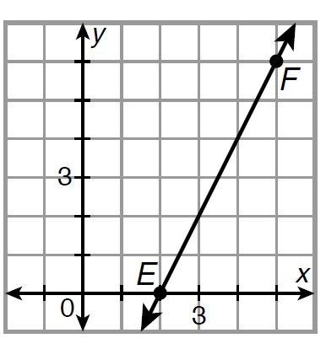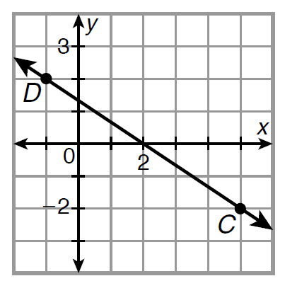

4) The “slope-intercept” form for the equation of a line is _____________________.

5) Solve the following equation for x:
a) 4x + 8 = 24 b) 2 = 2x – 8

6) Evaluate each expression for x:
a) 4x + 9 for x = 31 b) 6x – 16 for x = 43

7) On the following graph, draw two parallel lines, and write the equation of each line.
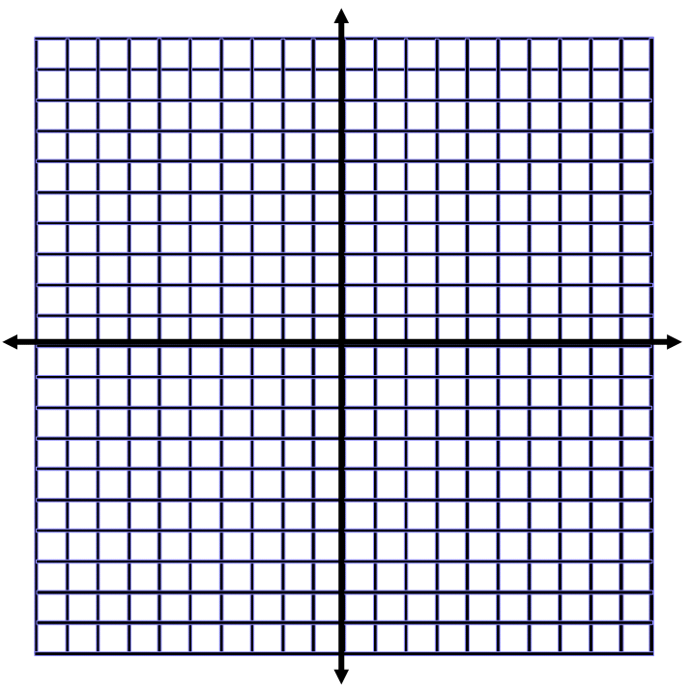
8) On the following graph, draw two perpendicular lines, and write the equation of each line.

LESSON 1 (Day 1)
Objectives:
- The students will be able to find the slope of the line
- The students will be able to use slopes to identify parallel and perpendicular lines

Materials:
- Power Point Presentation
- Worksheet for homework

Lesson Procedure:
Introduction Activity: (5 minutes)
- Put up the first power points slide: the picture of a barn with men working on the roof. Ask, “Which part of the roof would you rather work on?” Why?
- Put up the slide of the barn on a graph. Ask, “How would you find the slope of each section of the barn?”
- Brainstorm with the students ways to find the slope of a line on a graph.
- Also brainstorm other examples when slope can be used.

Developmental Activity: (35 minutes)
- Have the students recall the slope formula: “rise over run” and write it in their notes.
- Discuss with the students how to find the slope of a line. Tell them, “You read a slope like a book. From left to right.”
- Put up the slide of examples. Find the slope of all four lines using the slope formula
- Put up the slide with parallel lines. Ask the students, “What do you notice about the slopes of the lines?” Wait until you hear the students say that they are equal.
- Put up the slide with perpendicular lines. Ask the students, “What do you notice about the slopes of the lines?” What until you hear the students say that they are opposite signs and reciprocals of each other.
- Then put up the slide of example problems. Wait for the students to copy down the problems, and then call on individual students to answer whether the lines are parallel, perpendicular, or neither.
- Next, tell the students, “One reason why we study slope is to make a prediction about something in the future.”
- Put up the problem of Justin driving home from college. Have the students interpret the meaning of the slope, and then make a prediction for when Justin will arrive home.
- Then put up the problem about Tony. Again, have the students interpret the slope, and then predict how far he will have traveled by 6:30 p.m.

Concluding Activity: (10 minutes)
- Ask the students to write in their notes the definition of slope in their own words. Also, have the students write down the definition of parallel and perpendicular lines.
- Have the students turn to a partner and share their definitions. Pick on 3 different groups to share their definitions with the class.
- Then, pass out a worksheet for the students to complete for homework.

Evaluation:
- Informal observations through question and answering during the lesson.
- Glancing at student responses while working on practice problems.
- Conclusion Activity
- Homework Worksheet

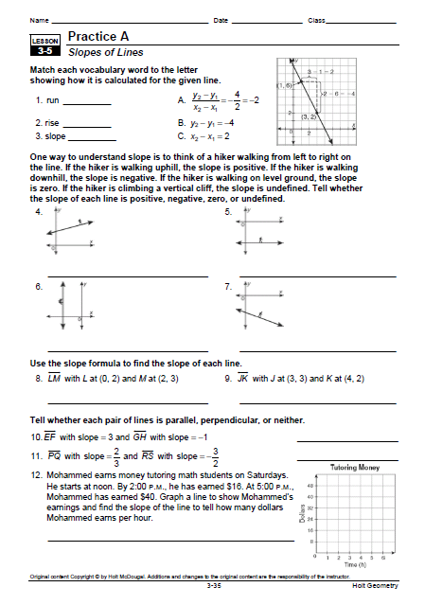
Worksheet taken from HOLT GEOMETRY

LESSON 2 (Day 2)
Objectives:
- The students will be able to graph lines and write their equations in slope-intercept and point slope form.

Materials:
- Power Point Presentation
- Exploration 3-6 Worksheet
- Worksheet for Homework

Lesson Procedure:
Introduction Activity: (10 minutes)
- In order for the students to discover the equation for a line, pass out the “Exploration” Worksheet. Put the students in groups of 4. Have the students work through the three questions at the top of the page together. This should be a good recall from yesterday’s lesson. Then, as a class, discuss the bottom two questions.

Developmental Activity: (30 minutes)
- Have the students copy down the formula they discovered from the Introduction Activity into their notes.
- As a class, go over the six examples dealing with writing equations of lines. This will be the foundation for the rest of class.
- Ask if there are any questions over the examples.
- Put up the graph with the line drawn on it. Ask the class if they remember how to graph lines from Algebra I.
- Discuss the graphing method with the students.
- Then, go over the six examples with the students.

Concluding Activity: (10 minutes)
- Have the students take out a half sheet of paper. The students will complete an “Exit Ticket” for admission out the door.
- Put up 2 questions on the Smart Board:
1) Write the equation of the line through (-1, 3) and (3, -5) in slope-intercept form. Then, graph the equation.
2) Determine whether the lines are parallel, perpendicular, or neither:
2y = 4x + 12, 4x – 2y = 8
- Assign the worksheet for homework

Evaluation:
- Developmental Activity will be used to gain an understanding of prior content knowledge.
- Informal Observations during the lesson.
- Exit Ticket
- Homework

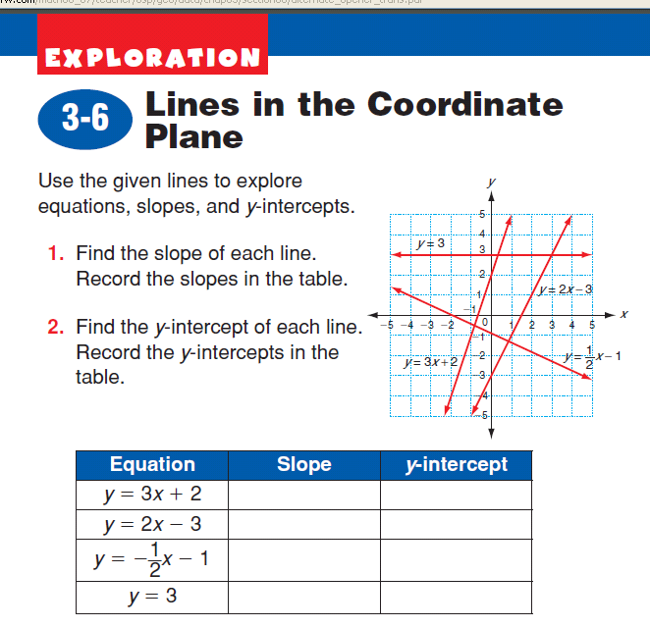
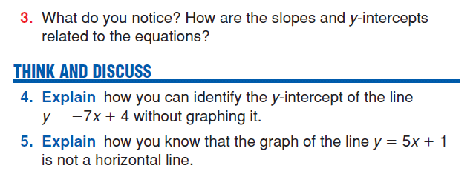

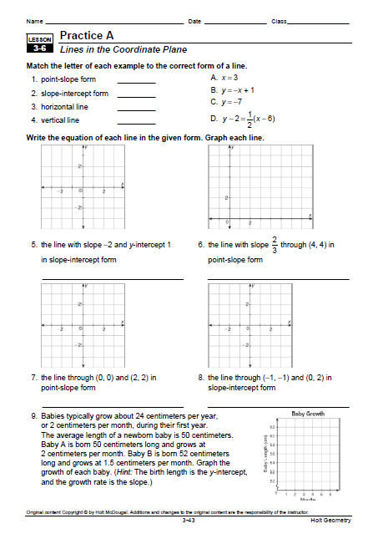

LESSON 3 (Day 3 and 4)
Objectives:
- The students will draw a line that fits or models a set of points
- The students will write an intercept equation that fits a set of real-world data.
- The Students will apply geometric methods to solve design problems.

Materials:
- Spaghetti Project Sheet
- 30 pieces of uncooked spaghetti, 10 inches long
- Several books for each group
- 5-oz plastic cup
- String
- Pennies (100 per group)

Lesson Procedure:
Introduction Activity: (10 minutes)
- Have the students get into groups of 4. Ask the question, “How strong do the beams of a ceiling have to be? How do bridge engineers select beams to support traffic? How can you test the strength of a beam? Would two beams be twice as strong as one beam?
- Tell the students that they will be getting into groups to investigate similar questions using spaghetti noodles. Tell the students they will be investigating the strengths of spaghetti beams using linear equations.

Developmental Activity: (70 minutes)
- Split the class up into groups of 4 students. (Have groups already made)
- Make sure that each group assigns group roles (material collector, someone who will set up the experiment, the tester, and the recorder)
- Pass out the materials to each group.
- Explain that the students will be using data collected from the project to make a linear model to predict the strength of the spaghetti beams.
- Pass out an “Investigation Worksheet” to each group.
- The students will then have the rest of the class to read through the steps in the “Investigation Worksheet” and complete the project.
- While the students are working, the teacher will walk around the classroom and monitor group progress, making sure the groups are on task and answering any questions.
- The students should work as a group to complete steps 1 through 3 and collect all the data for the experiment.

Concluding Activity: (20 minutes)
- Have the students go back to their original seats and individually complete Steps 4 through 7 of the project. (Answers based off of the data collected during the project)

Evaluation:
- Class discussion
- Completed Data Sheet
- Observation of students while completing the concluding activity

Beam Strength Investigation Sheet
Step 1: Make 2 stacks of books of equal height. Punch holes on opposite sides of the cup and tie the string through the holes
Step 2: Follow the procedure note for a beam made from on strand of spaghetti. Record the maximum load (number of pennies) that this beam will support.
Step 3: Repeat step 2 for beams made from 2, 3, 4, 5, and 6 stands of spaghetti.

Step 4: Plot your data on your calculator. Sketch the plot on paper too.
Step 5: Use a strand of spaghetti to visualize a line that you think fits the data on your sketch. Choose 2 points on the line. Calculate the slope of the line between the 2 points.
Step 6: Use the slope to graph the equation on your calculator.
Step 7: Using the spaghetti strand on your sketch, estimate a good y-intercept so that the equations better fits your data.

Data Chart:
Number of Spaghetti Strands | Number of Coins

LESSON 4 (Day 5)
Objectives:
- The students will draw a line that fits or models a set of points
- The students will write an intercept equation that fits a set of real-world data.

Materials:
- Project Data Sheets from yesterday

Lesson Procedure:
Introduction Activity: (10 minutes)
- Have the students get into their groups from yesterday
- Have the students compare their results from steps 4 through 7.
- After the students get a chance to compare, ask “Did everyone end up with the same line? Do you think a line of fit must go through at least two data points? Is any one line better than the others?

Developmental Activity: (35 minutes)
- Then, have the groups write down their answers to the following questions:
  - Explain the real-world meaning of the slope of your line
  - Use your model to predict the number of spaghetti strands needed to support $5 worth of pennies.
  - Use your model to predict the maximum loads for beams made of 10 and 17 strands of spaghetti.
  - Some of your data points may be very close to your line, while others could be described as outliers. What could have caused these outliers?
- Have the groups copy their work (data table and graph) onto an overhead projector.
- When the groups are done, each group will stand up in front of the class and give a brief 3-5 minute summary of their findings. They should discuss their data chart, their method for collecting the data, as well as the math involved in their findings. They should also mention any issues they had with the project.

Concluding Activity: (5 minutes)
- Have the students individually answer the following questions in their binders.
  - Would your results be the same if you moved the books closer or farther apart?
  - Are your results with spread-out spaghetti strands different from those with bunched-up strands?
  - How can this project help answer our original question: How strong do the beams of a ceiling have to be? How do bridge engineers select beams to support traffic? How could they figure this out?
  - What did you like about this project? What is something you should have done different?

Evaluation:
- Informal observations of the group discussions
- Group Presentations
- Conclusion Questions

Post Assessment
Geometry Unit Test Name__________________

I. Identify one example of each of the following: (Correctly label your answers!)
a) Perpendicular segments ________  b) Skew segments _________  c) Parallel segments _________  d) Parallel Planes _________ | 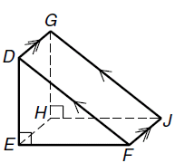

II. Find the value of:
a) x = _________  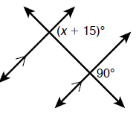 | b) x = _________  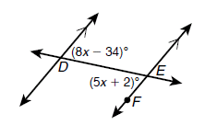 | c) x = __________  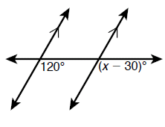

III. Find the shortest segment from the point to the line, then solve an inequality for x.
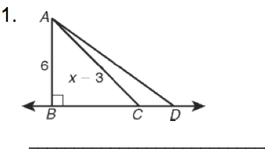

IV. Using the picture to the right, show that lines m and n are parallel. Justify your answer with a theorem or postulate. (Ex: Converse of the alternate interior angles theorem) If the lines are not parallel, write not parallel.
a) m∠3 = 15x + 22, m∠1 = 19x – 10, x = 8  b) m∠2 = 5x + 3, m∠3 = 8x – 5, x = 14 | 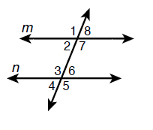

V. Complete the 2-column proof:
Given:
Prove:
Statements | Reasons
1. | 1. Given
2. | 2.
3. | 3. Substitution
4. | 4.

VI. Solve the following
a) A bedroom has sloping ceilings as shown. Marcel is hanging a shelf below a rafter. If m∠1 = (8x – 1), m∠2 = (6x + 7), and x = 4, show that the shelf is parallel to the rafter above it. | 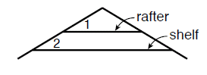

VII. Use the slope formula to find the slope of each line: $m=\frac{y_{2}−y_{1}}{x_{2}−x_{1}}$
a) LM with L at (0,2) and M at (2,3) slope = ______

b) JK with J at (3,-3) and K at (-4,2) slope = ______

d) slope = _______ e) slope = _______ f) slope = _______
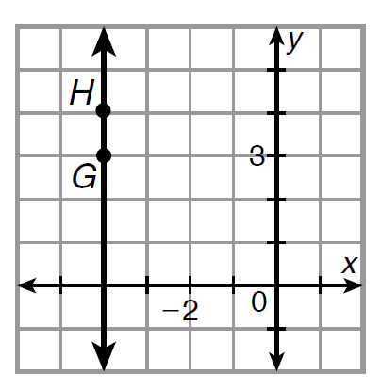

VIII. Find the slope of each line. Then, use the slopes to determine if the lines are parallel, perpendicular, or neither:
a) A(-1,5),B(-3,4) Slope _______
C(3,-1),D(4,-3) Slope _______ Parallel Perpendicular Neither

b) A(4,3),B(-4,-2) Slope _______
C(5,6),D(-3,1) Slope ________ Parallel Perpendicular Neither

IX. Graph each line:
a) $y=\frac{2}{3}x−8$ |  | b) $y=−\frac{1}{4}x+4$
X. Write the equation of each line. Your final answer should be in slope-intercept form.
Slope-Intercept: y = mx + b Point-Slope: y - y₁ = m(x – x₁)

a) The line through (-6,1) and (4,11): __________________

The line represents the distance traveled by an in-line skater traveling at a constant speed. What is the rate of change represented in the graph?
