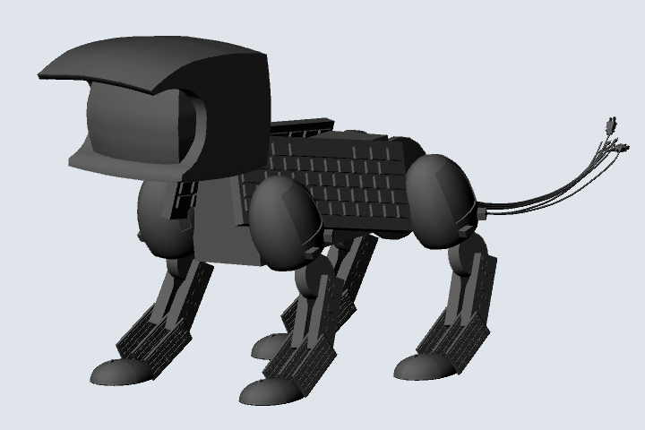

I would like to print models of 3D characters, but I feel I will have to print them in pieces. I will have to investigate joints just like I did with the tectonics project.

If I were simply to put these molds into the printer as an .stl file, there would be so much support material that it would be impossible to cut all of it away. The difficult and research intensive part will be focused on connecting all the pieces. I would want invisible jointing.

Also, as with the pictures above, I’d have to be careful about thin or delicate parts. If a piece is too small, the printer won’t even print it.

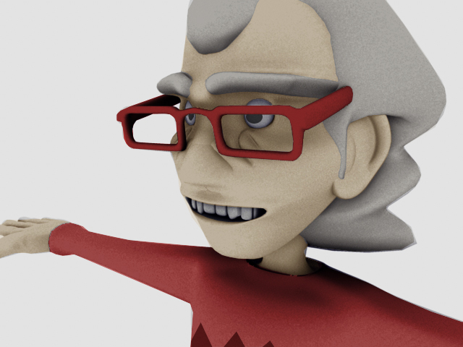

I would like to model more characters than just those shown above, and print and paint them.

I will have to find a hidden way to connect the parts (arms, legs, torso, etc) to make them solid pieces.

Weeks 1 & 2: Due April 3

I would like to refine my telion model and make it printable. I would like to pose it and made sure it’s at a doable scale. Upon completion of this project I’d like a printed, posed model.

Weeks 3 & 4: Due April 17

I would like to refine my Don model and make him printable. I would like to pose him and made sure he’s interesting to look at. Upon completion of this project I’d like a printed, posed model.

Weeks 5 & 6: Due April 30

I’d like to do an entirely new and far more complex character model. As with the others, I’d like him printed, posed, and interesting.