Instructional Design:

The Solar System Subunit

Maura Buckner

Bowling Green State University

EDTL 7100 Summer 2012

Rationale

The fifth grade curriculum explores many facets of Earth and Space Science. The Ohio State Standards emphasizes an understanding or our Solar System and its many parts. The use of videos, Interactive White Board activities and websites to teach 5th grade space concepts are an excellent means to study these concepts. Our students have a variety of learning styles. Some students learn best through auditory or visual senses. Our students are experiencing changes in the way they process information due to their exposure to technology. By using the same methods, we can expand their knowledge of not only science concepts but technology knowledge as well The progressive philosophy suggests that the curriculum be interdisciplinary and the teacher needs to guide students through problem-solving and scientific projects. Dewey sees the teacher as the leader of group activities. It emphasizes activities that encourage how to think, not what to think.(Ornstein & Huskins,2009,p.47). The classroom is an active learning environment opportunities besides using a textbook. The use of technology agrees with Dewey's belief which focuses on cooperation, not competition. There are many other learning that students should be actively engaged participants in learning and share knowledge with each other. (Collins & Halverson,2009 ,p.28).

In this subunit on the Solar System the students will explore the Milky Way Galaxy. They will learn about the various parts of our Solar System. They will learn there are similarities as well as differences between the Earth and the other planets. The will learn that the Sun is at the center of our Solar System and about other stars and constellations. The students will need this knowledge for future study of the Universe. The lessons will involve a variety of models to impart the

knowledge the students will need to learn. The Group Investigation Mode will be used through Interactive White Board lesson. The Project-based model will be used as small groups investigate a particular planet. The 5-E lesson plan will be used study the planets. (Chiarlott,2006)

Resources

Chairelott,L. (2006)*Curriculum in context.* Belmont Ca. :ThomsonWadsworth.

Collins , A. &Halverson, R. (2009) *Rethinking Education in the Age of Technology: The Digital Revolution and Schooling in America.* New York, NY: Teachers College Press

Huskins, F. & Ornstein, A. (2009) *Curriculum: Foundations, Principals, and Issues(5th ed.).*Boston, MA : Pearson.

Learner Outcomes

Subunit Lesson 1

*Students will express what they Know about the Solar System.

*Students will aske questions about What they would like to know

about the solar system.

* Students will be able to identify the Sun and eight planets

*Students will be able to identify Earth as the 3rd planet from the Sun

Subunit Lesson 2

*Students will be able to order the planets

*Students will be able to identify the Inner and Outer Planets

Subunit Lesson 3

*Students will research an object in our Solar System.

*Students will write a short report about their object

*Students will take notes identifying objects in our Solar System.

*Students will share their reports with class.

*Students will create a model of their object from the Solar System.

Subunit Lesson 4

*Students will discuss what they have Learned about the Solar System.

*Students will be assessed on their knowledge of the Solar System.

Subunit Lesson One: The Solar System

|  |
| --- |
| Theme:The Solar System |
| |  |  | | --- | --- | | Science Benchmarks:  Ohio Content Standards 5.1 | Objectives:  *The students will be able to identify the Sun, Earth and other planets  *The students will identify Earth as the third planet from the sun.  . | |
| |  |  | | --- | --- | | Time Requirements: 1 hour and a half block  Computer, Audio-visual connection and white board, Pre-assessment ,Note-taking sheet,Label the Planets worksheet ,Video :*The Magic School Bus Gets Lost in Space.* | Concepts/Skills:  *Access information from video.  *Working in groups | |
| |  |  | | --- | --- | | I will **engage** the students using connections to their prior knowledge. | Explain we will be exploring the Solar System .That we will be doing a K-W-L to start. Ask the students to identify what they **K**now about the Solar System .Next, ask them **W**hat they would like to know. Last, explain that the **L**earned will be completed at the end of the unit.  Assign the Pre-assessment. | | What the students will do to **explore** the concepts and begin to develop vocabulary at the same time. | Students will view the video *The Magic School Bus Gets Lost in Space.* | | What I will do to allow students the opportunity to construct their own **explaination** of the concepts. | Students will complete note-taking worksheet on the planets. | | Opportunities I will give students to **elaborate or** extend their understanding of the concepts. | Each student will generate 5 questions about the order of the planets. They will divide into groups of 4 or 5 and together discuss the answers to the questions. | | How I and the students will **evaluate** his or her learning | Students will complete Label the Planets worksheet. Once completed , they are to circle Earth. Then there will be a class discussion about the order of the planets and where Earth is in the order. | |
| |  |  | | --- | --- | | Teacher Notes: |  | |

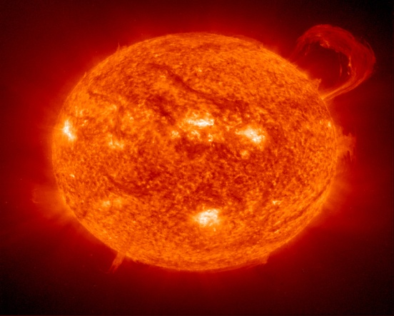 Solar System Pre-assessment

Name____________________________________Date______________________

1. What is the closest star to the Earth?

Milky Way Sun Moon

2. Is the Erath an Inner Planet?

Yes No

3. Which planet is best known for its rings?

Jupiter Saturn Neptune

4. Which planet has a red spot ?

Mars Jupiter Uranus

5. Which is the smallest planet?

Venus Earth Mars

6. What is the 3rd planet from the Sun?

Mars Neptune Earth

7. What is an impression made by an object striking the surface of a planet or moon?

comet constellation crater

8. What is made mostly of ice mixed with bits of rock?

meteor asteroid comet

9. What is a chunk of rock or metal that orbits in space?

asteroid comet moon

10.What is the Milky Way Galaxy?

11. What is a constellation?

12. What are the Inner Planets?

13. What are the Outer Planets?

14. Compare and contrast a star and a planet.

Name__________________________Date___________

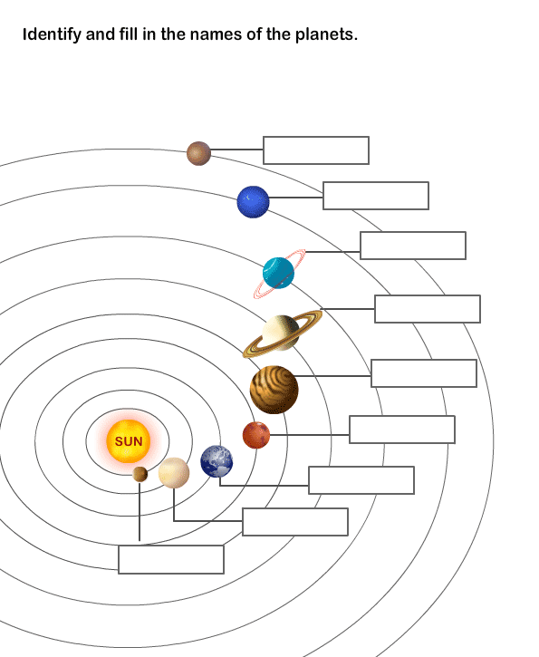

The Magic School Bus Get's Lost In Space

Name_______________________Date______________

*Use this form to take notes about the planets.

M__________________________________________________________________________________________

V__________________________________________________________________________________________

E___________________________________________________________________________________________

M__________________________________________________________________________________________

J___________________________________________________________________________________________

S__________________________________________________________________________________________

U__________________________________________________________________________________________

N__________________________________________________________________________________________

Subunit Lesson Two: Inner and Outer Planets

Objective: The students will identify the inner and outer planets.

Concepts/

Skills: using technology, working in groups

Materials: Interactive White Board, computer, planet name card

Procedures: *Introductory Activity*

Ask students if they are aware of that there are inner and

outer planets. Ask them to identify the planets and guess

which may be inner or outer planets. Explain we will be

using the Interactive White Board for today lesson about

about the planets.

*Developmental Activity*

*Access IWB lessons at [www.exchange.smarttech.com](http://www.exchange.smarttech.com) for

5th Grade Ohio Content Standards for Science.

* Complete lessons titled *The Solar System* and *The*

*Planets*

*\**Distribute planet name cards to 8 students( three

groups).As a group, they are to decide which are the

inner planets, then the outer planets and line up in order

* The teacher will check each group for accuracy.

*Closure*

Review the inner and outer planets during a whole group

discussion.

Planet Name Cards

Mercury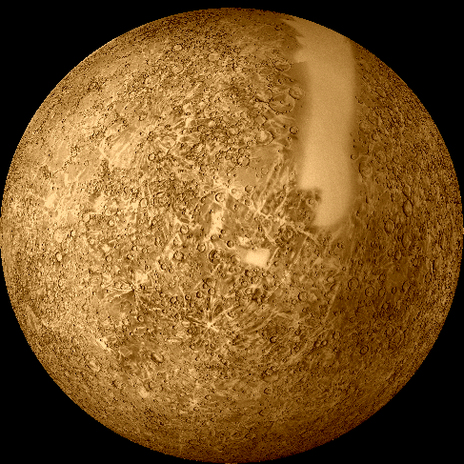

Venus

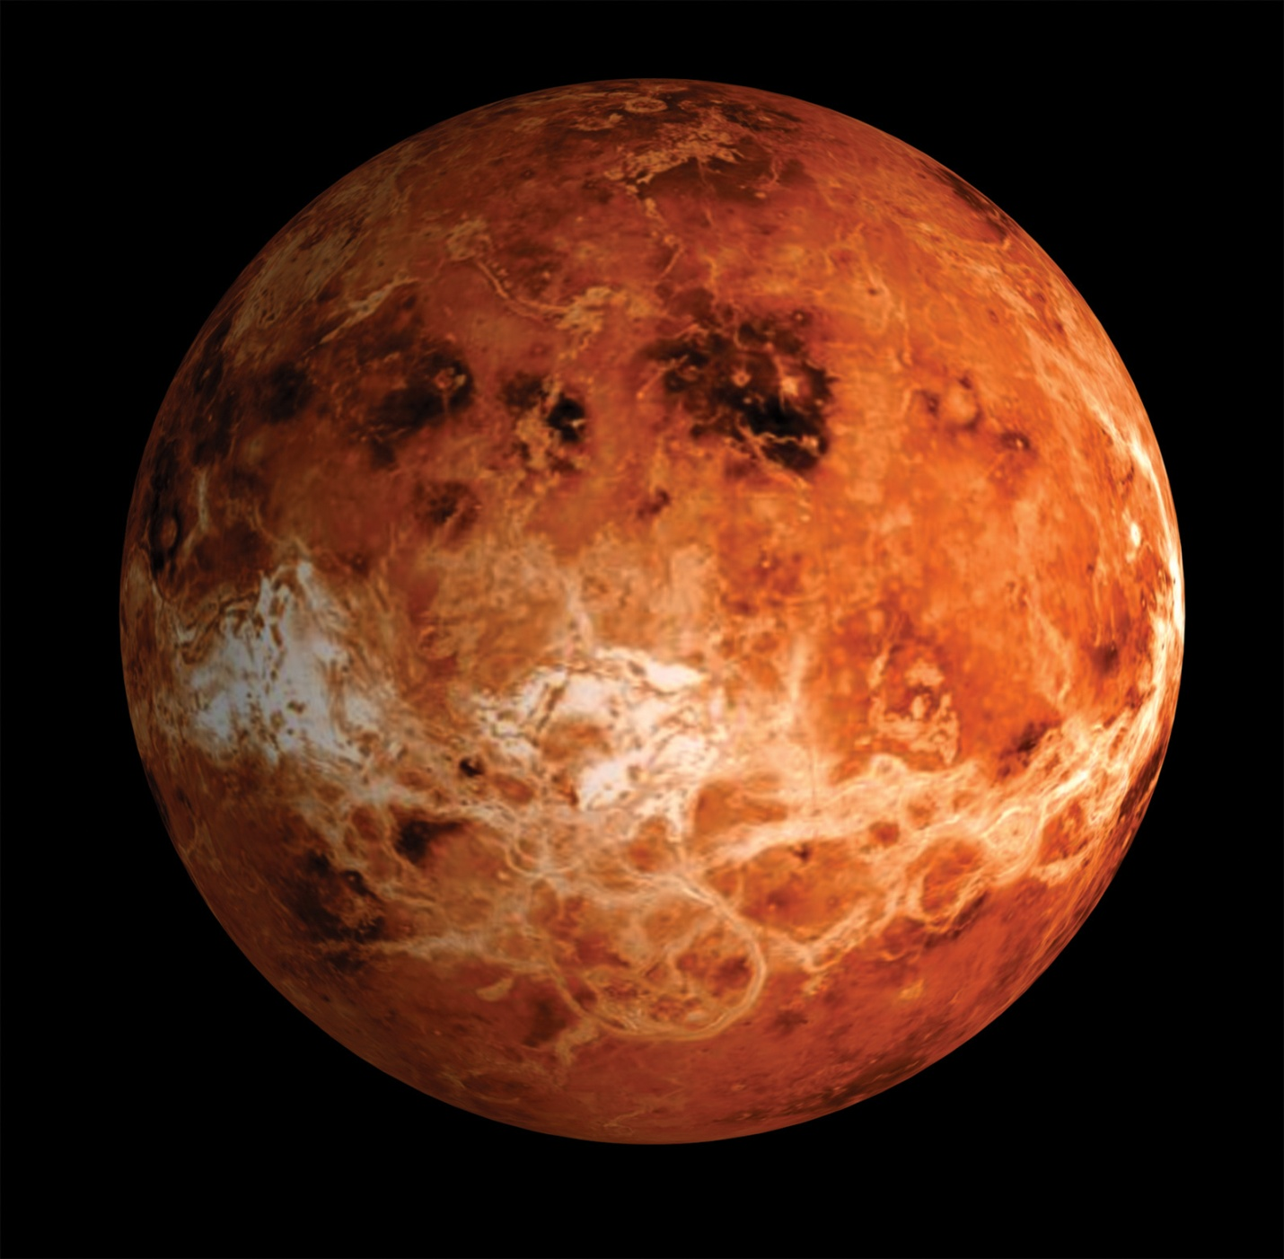

Earth

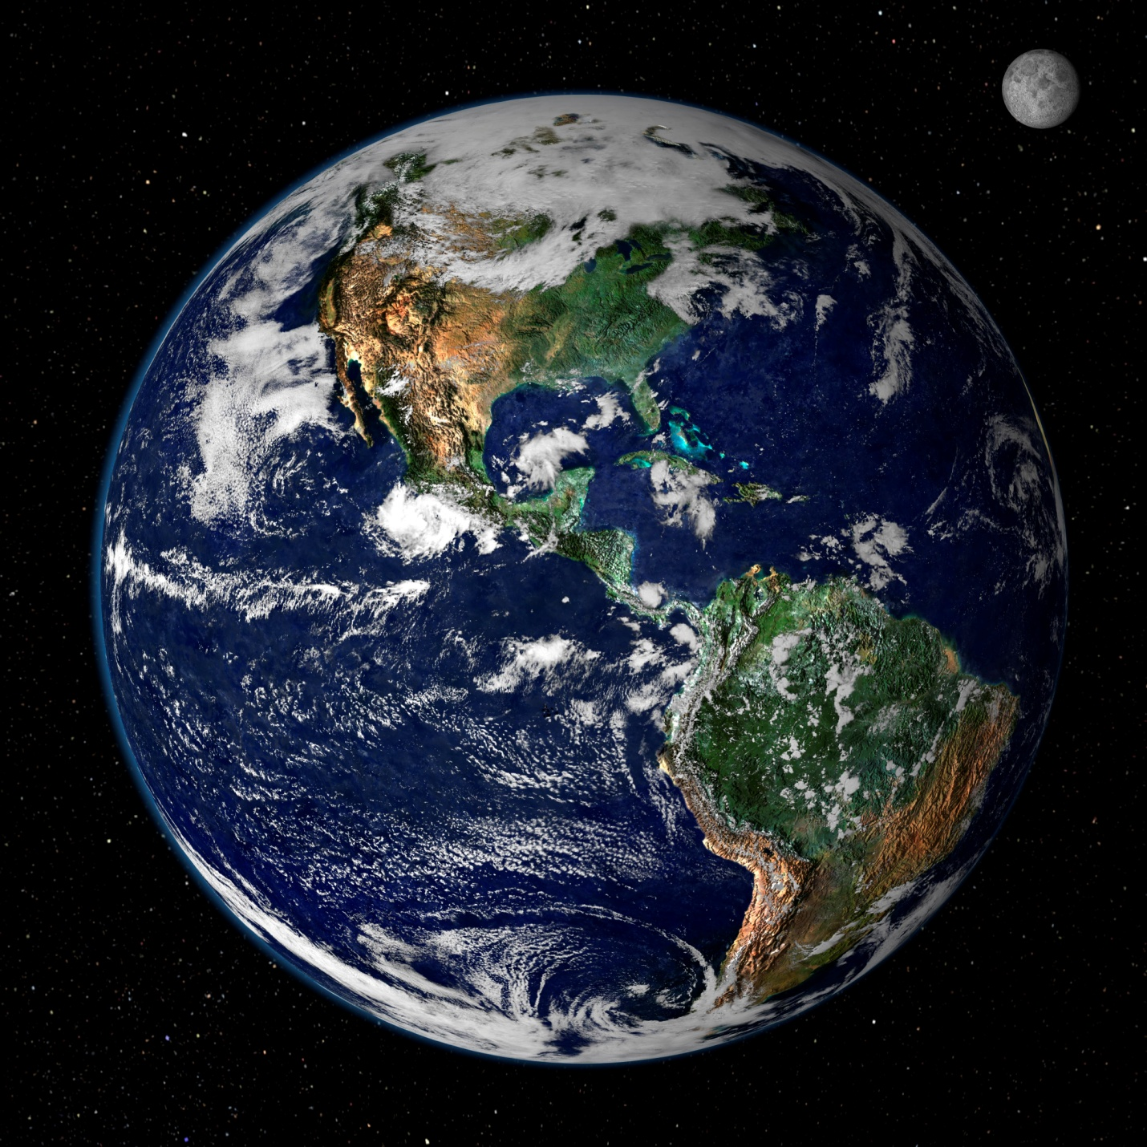

Mars

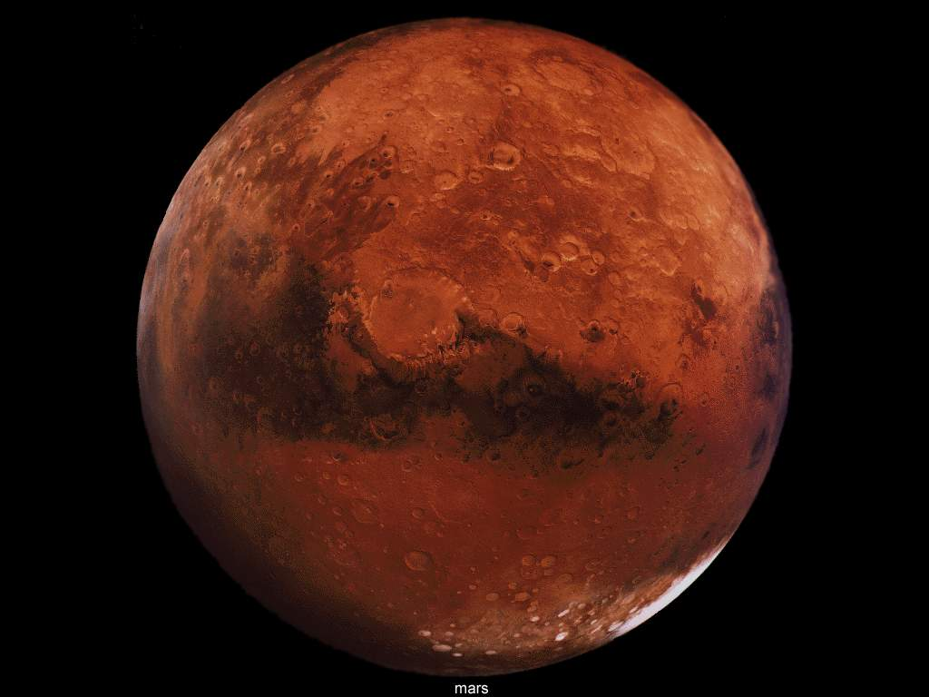

Jupiter

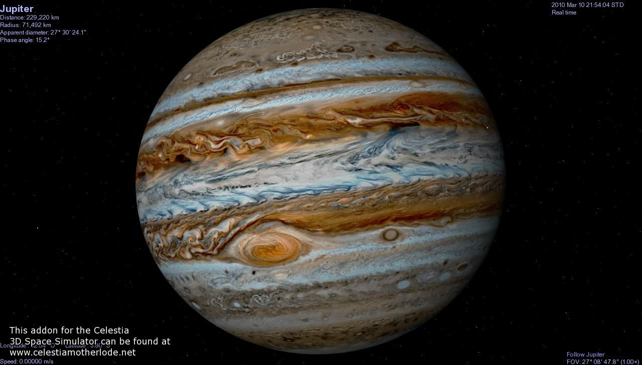

Saturn

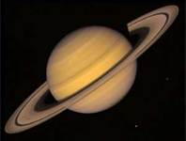

Uranus

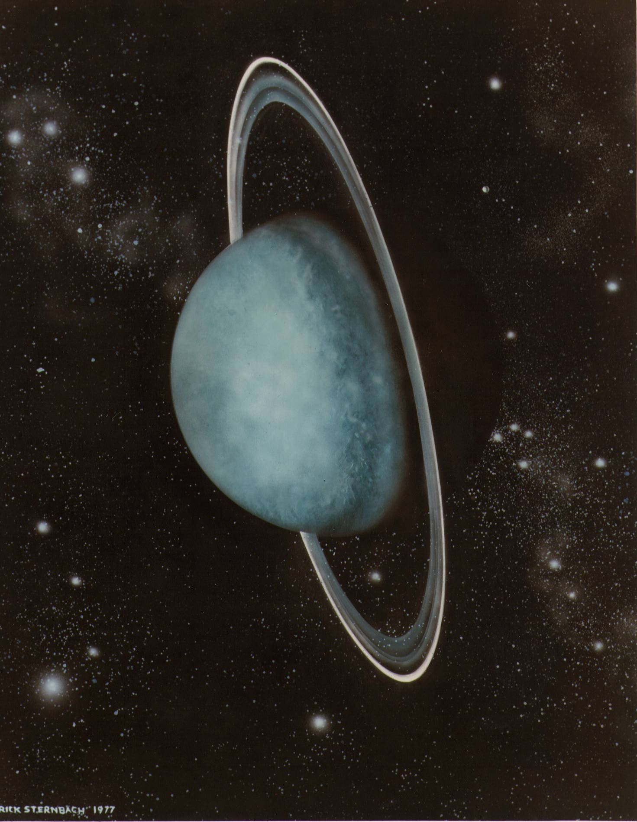

Neptune

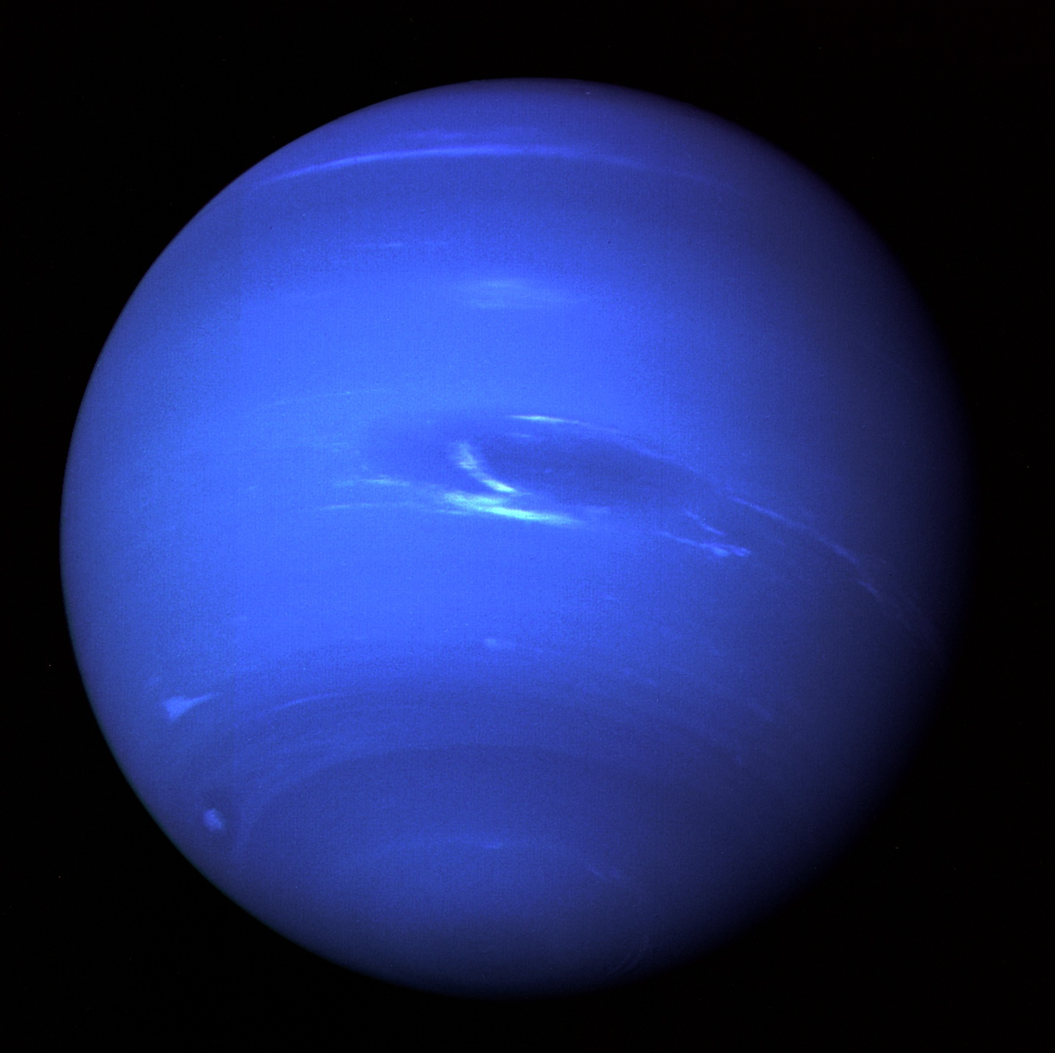

Subunit Lesson 3: The Solar System and Its Parts

Objective: The students will research and report about a part of the

Solar System.

Materials: The Solar System packet, computers, Styrofoam balls, paint,

brushes.

Procedures:1. Divide students into groups of 2 or 3. Distribute The Solar

Day One System packet and assign one of the following:

Sun, One of the eight planets, constellations, meteors, or

asteroids.

2. Explain that each group is responsible for locating infor-

mation about their part of the Solar System. They will

be using the following websites to research their topic:

[www.kidsastronomy.com](http://www.kidsastronomy.com) [www.starchild.nasa.gov](http://www.starchild.nasa.gov)

[www.solarsystem.nasa.gov](http://www.solarsystem.nasa.gov)

3. After completing their research, they will create a model

of their object using paint and Styrofoam balls.

Day Two and Three

4. Student will share their reports with the class. The

students will create an illustration and take notes to

complete the Solar System packets

5. Display models of the objects.

The Solar System

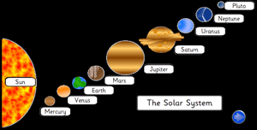

Name

Sun

|  |
| --- |
| Illustration: |

Notes:______________________________________________________________________________________________________________________________________________________________________________________________________________________________________________________________________________________________________________________________________________________________________________________________________________________________________________________________________________________________________________________________________________________________________________________________________________________________________________________________________________________________________________________________________________________________________________________________________________________________________________________________________________________________________________________________________________________________________________________________________________________________________________________________________________________________________________________________________________________________________________________________________________________________ ____

Mercury

|  |
| --- |
| Illustration. |

Notes:_______________________________________________________________________________________________________________________________________________________________________________________________________________________________________________________________________________________________________________________________________________________________________________________________________________________________________________________________________________________________________________________________________________________________________________________________________________________________________________________________________________________________________________________________________________________________________________________________________________________________________________________________________________________________________________________________________________________________________________________________________________________________________________________________________________________________________________________________________________________________________________________________________________________________________________________________________________________________________________________________________________________________________________________________________________________________________________________________________________________________________________________________________________________________________________________________________________

Venus

|  |
| --- |
| Illustration. |

Notes:________________________________________________________________________________________________________________________________________________________________________________________________________________________________________________________________________________________________________________________________________________________________________________________________________________________________________________________________________________________________________________________________________________________________________________________________________________________________________________________________________________________________________________________________________________________________________________________________________________________________________________________________________________________________________________________________________________________________________________________________________________________________________________________________________________________________________________________________________________________________________________________________________________________________________________________________________________________________________________________________________________________________________________________________________________________________________________________________________________________________________________________________________________________________________________________________________________________________________________________________________________________________

Earth

|  |
| --- |
| Illustration. |

Notes:______________________________________________________________________________________________________________________________________________________________________________________________________________________________________________________________________________________________________________________________________________________________________________________________________________________________________________________________________________________________________________________________________________________________________________________________________________________________________________________________________________________________________________________________________________________________________________________________________________________________________________________________________________________________________________________________________________________________________________________________________________________________________________________________________________________________________________________________________________________________________________________________________________________________________________________________________________________________________________________________________________________________________________________________________________________________________________________________________________________________________________________________________________________________________________________________________________________________________________________________________________________________________________________________________________________________________________

Mars

|  |
| --- |
| Illustration. |

Notes:_____________________________________________________________________________________________________________________________________________________________________________________________________________________________________________________________________________________________________________________________________________________________________________________________________________________________________________________________________________________________________________________________________________________________________________________________________________________________________________________________________________________________________________________________________________________________________________________________________________________________________________________________________________________________________________________________________________________________________________________________________________________________________________________________________________________________________________________________________________________________________________________________________________________________________________________________________________________________________________________________________________________________________________________________________________________________________________________________________________________________________________________________________________________________________________________________________________________________________________________________________________________________________________________________________________________________________________

Jupiter

|  |
| --- |
| Illustration. |

Notes:______________________________________________________________________________________________________________________________________________________________________________________________________________________________________________________________________________________________________________________________________________________________________________________________________________________________________________________________________________________________________________________________________________________________________________________________________________________________________________________________________________________________________________________________________________________________________________________________________________________________________________________________________________________________________________________________________________________________________________________________________________________________________________________________________________________________________________________________

________________________________________________________________________________________________________________________________________________________________________________________________________________________________________________________________________________________________________________________________________________________________________________________________________________________________________________________________________________________________________________________________________________________________________________________________________________________________________________________________________________________________________________________________________________________________________________________________________________________________________________________________________________________

Saturn

|  |
| --- |
| Illustration' |

Notes:________________________________________________________________________________________________________________________________________________________________________________________________________________________________________________________________________________________________________________________________________________________________________________________________________________________________________________________________________________________________________________________________________________________________________________________________________________________________________________________________________________________________________________________________________________________________________________________________________________________________________________________________________________________________________________________________________________________________________________________________________________________________________________________________________________________________________________________________________________________________________________________________________________________________________________________________________________________________________________________________________________________________________________________________________________________________________________________________________________________________________________________________________________________________________________________________________________________________________________________________________________________________________________________________________________________________________________________________________________________________________________________________________________________________________________________________________

Uranus

|  |
| --- |
| Illustration. |

Notes:________________________________________________________________________________________________________________________________________________________________________________________________________________________________________________________________________________________________________________________________________________________________________________________________________________________________________________________________________________________________________________________________________________________________________________________________________________________________________________________________________________________________________________________________________________________________________________________________________________________________________________________________________________________________________________________________________________________________________________________________________________________________________________________________________________________________________________________________________________________________________________________________________________________________________________________________________________________________________________________________________________________________________________________________________________________________________________________________________________________________________________________________________________________________________________________________________________________________________________________________________________________________________________________________________________________________________________________________________________________________________________________________________________________________________________________________________________________________________________________________________________________

Neptune

|  |
| --- |
| Illustration. |

Notes:_______________________________________________________________________________________________________________________________________________________________________________________________________________________________________________________________________________________________________________________________________________________________________________________________________________________________________________________________________________________________________________________________________________________________________________________________________________________________________________________________________________________________________________________________________________________________________________________________________________________________________________________________________________________________________________________________________________________________________________________________________________________________________________________________________________________________________________________________________________________________________________________________________________________________________________________________________________________________________________________________________________________________________________________________________________________________________________________________________________________________________________________________________________________________________________________________________________________________________________________________________________________________________________________________________________________________________________________________________________________________________________________________________________________________________________________________________________________________________________________________________________________

Asteroids

|  |
| --- |
| Illustration. |

Notes:___________________________________________________________________________________________________________________________________________________________________________________________________________________________________________________________________________________________________________________________________________________________________________________________________________________________________________________________________________________________________________________________________________________________________________________________________________________________________________________________________________________________________________________________________________________________________________________________________________________________________________________________________________________________________________________________________________________________________________________________________________________________________________________________________________________________________________________________________________________________________________________________________________________________________________________________________________________________________________________________________________________________________________________________________________________________________________________________________________________________________________________________________________________________________________________________________________________________________________________________________________________________________________________________________________________________________________________________________________________________________________________________________________________________________________________________________________________________________________________________________________________

Comets

|  |
| --- |
| Illustration. |

Notes:______________________________________________________________________________________________________________________________________________________________________________________________________________________________________________________________________________________________________________________________________________________________________________________________________________________________________________________________________________________________________________________________________________________________________________________________________________________________________________________________________________________________________________________________________________________________________________________________________________________________________________________________________________________________________________________________________________________________________________________________________________________________________________________________________________________________________________________________________________________________________________________________________________________________________________________________________________________________________________________________________________________________________________________________________________________________________________________________________________________________________________________________________________________________________________________________________________________________________________________________________________________________________________________________________________________________________________________________________________________________________________________________________________________________________________________________________________________________________________________________________________________________________________________________________________________________________

Constellations

|  |
| --- |
| Illustration. |

Notes:________________________________________________________________________________________________________________________________________________________________________________________________________________________________________________________________________________________________________________________________________________________________________________________________________________________________________________________________________________________________________________________________________________________________________________________________________________________________________________________________________________________________________________________________________________________________________________________________________________________________________________________________________________________________________________________________________________________________________________________________________________________________________________________________________________________________________________________________________________________________________________________________________________________________________________________________________________________________________________________________________________________________________________________________________________________________________________________________________________________________________________________________________________________________________________________________________________________________________________________________________________________________________________________________________________________________________________________________________________________________________________________________________________________________________________________________________________________________________________________________________________________

Meteors

|  |
| --- |
| Illustration. |

Notes:______________________________________________________________________________________________________________________________________________________________________________________________________________________________________________________________________________________________________________________________________________________________________________________________________________________________________________________________________________ ________________________________________________________________________________________________________________________________________________________________________________________________________________________________________________________________________________________________________________________________________________________________________________________________________________________________________________________________________________________________________________________________________________________________________________________________________________________________________________________________________________________________________________________________________________________________________________________________________________________________________________________________________________________________________________________________________________________________________________________________________________________________________________________________________________________________________________________________________________________________________________________________________________________________________________________________________________________________

Subunit Lesson 4: The Solar System Post-Assessment

Objective: The students will describe what they have learned about the

the Solar System, They will take a Post-assessment to deter-

mine their personal knowledge of the information they have

discovered about the Solar System.

Materials: K-W-L chart, Post-assessment

Procedures: *The students will be asked what they have learned

about the Solar System. Complete the **L** on the K-W-L

Chart,( 25-30 minutes)

*The students will be given the Post-Assessment.(45-50

minutes)

*Collect and grade assessment.

Solar System Post-AssessmentC:\Program Files (x86)\Microsoft Office\MEDIA\CAGCAT10\j0301076.wmf

Name________________________Date_____________

Multiple choice.

1. What is a pattern of stars?

moons constellations satellites

2. What is at the center of our Solar System?

Moon Earth Sun

3. What is a solid,frozen chunk of rock in outer space?

comet asteroid meteor

4. What is the closet planet to the Sun?

Mercury Venus Mars

5. What is the Sun?

comet star planet

6. What is made up of the Sun, planets, and other ob-

jects?

Solar System Universe Comets

7. What is the 3rd planet from the Sun?

Jupiter Venus Earth

8. Which planets are called the "Gas Giants"?

Inner Planets Asteriod Belt Outer Planets

9. Which planet is best known for its rings?

Jupiter Saturn Mars

10. What planet has a "red eye" which is actually a

storm?

Venus Uranus Jupiter

Short Answer.

1. Compare and contrast an asteroid and a comet.

____________________________________________

__________________________________________________________________________________________________________________________________________________________________________________________________________________________________________________________________________________________________________________________________

2. Why haven't scientists found life on other planets?

__________________________________________________________________________________________________________________________________________________________________________________________________________________________________________________________________________________________________________________________________

Essay. Do you think it is important for people to keep exploring outer space? Why or why not?

__________________________________________________________________________________________________________________________________________________________________________________________________________________________________________________________________________________________________________________________________________________________________________________________________________________________________________________________________________________________________________________________________________________________________________________________________________________________________________________________________________________________________________________