**Instructional Design**

**Unit: Chemical Interactions**

**Subunit: Substances**

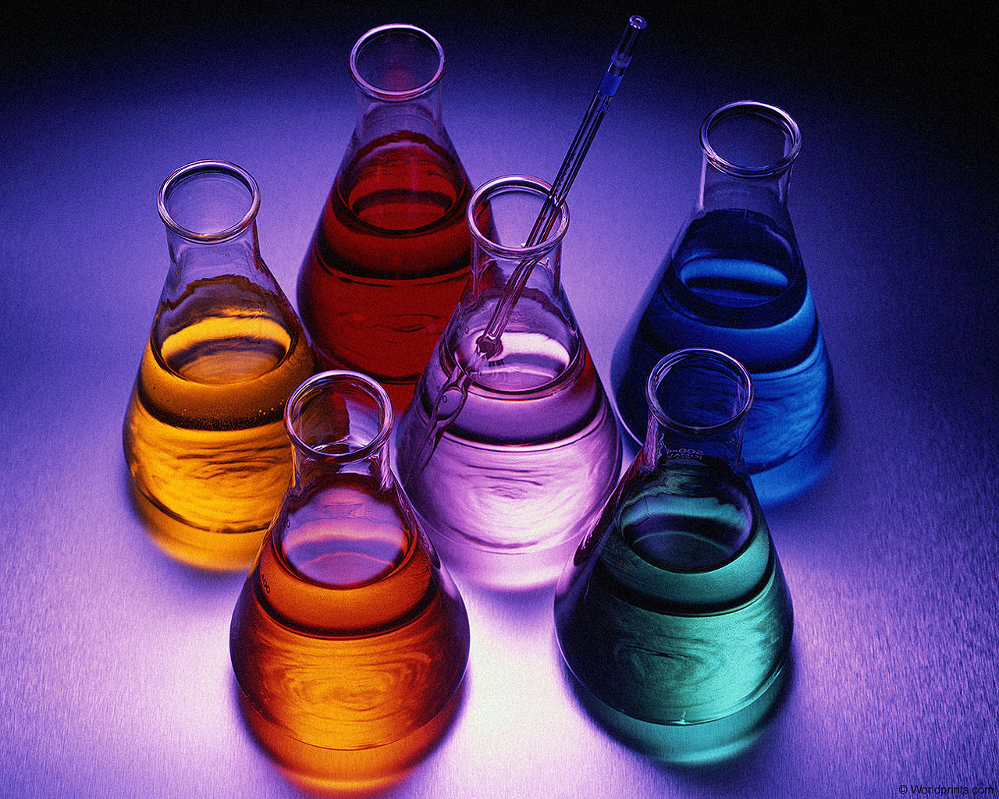

**Designed by Alison MuthigRationale**

In order for students to be prepared both in science content and science skills, they need to have a science education built upon best practices. In order for students to develop deep knowledge, they must immerse themselves in doing science and work collaboratively with others. (Zemelman, Daniels & Hyde, 2005) The chemical interactions unit addresses both of these needs. While the focus of the investigations is guided, students develop their own hypotheses, ways of testing their hypotheses, and develop their own explanations of the concepts studied. Students are always “doing” science. There is room for error and for further exploration based on student needs and personal inquiries. Students are always working with other through the experiences and as a class through discussions.

The subject matter of chemistry is directly related to our energy needs. Students study current events as they work through the unit, making connections between what they are learning and what is happening in the world around them. Beyond the chemistry content, the skills that develop through such a course are important for any student to develop to be successful.

This course is designed not only to develop a deep understanding of basic chemistry, but to also create a connection to issues affecting the world and build skills that will enable students to address global issues in the future. Students will be immersed in a hands-on science experience. Students will develop ideas about science through collaborative work with classmates. Students will discuss the connections between the course and current issues and will discuss what should be done to address these issues.

Lessons are based on the 5-E lesson plan model and group investigation environmental model, which incorporates both the behaviorist and constructivist theories (Chiarelott, p. 116). This model allows students to explore and develop their own thoughts, while the teacher plays a more guiding role once the lessons are introduced. The teacher leads the group in presenting the procedures for the day and reviewing prior experiences. The teacher then takes on a more guiding role (instead of leader) as they class explores with their group. The teacher then takes a more direct role to summarize class findings and provide science vocabulary that meets what students are saying and observing in their own terms.

Zemelman, S., Daniels, H., & Hyde, A. (2005). *Best practice: toda'ys standards for teaching & learning in america's schools*. (3rd ed., pp. 140-169). Portsmouth, NH: Heinemann.

Chiarelott, L. (2006). *Curriculum in Context*. Belmont, CA: Wadsworth.

**Learner Outcomes**

**Unit: Chemical Interactions**

**Subunit: Substances**

* The student will be able to use observation skills to describe what is happening in a chemical reaction. (Memory)
* The student will be able to define chemical reaction. (Memory)
* The student will record observations of white substances to help narrow what they think the mystery mixture could be. (Memory)
* The students will be able to define chemical reaction in their own words. (Comprehension)
* The student will use their definition of chemical reaction to explain how they know a chemical reaction occurred when water was added to the mystery mixture. (Application)
* The student will compare several mixtures with water added to narrow the possibility of what the mystery mixture is based on previous observations. (Analysis)
* The student will create a lab to determine exactly what the mystery mixture is. (Synthesis)
* The student will defend their findings about what they mystery mixture is using evidence from their labs. (Evaluation)

**Preassessment**

**Name: Section:**

**Directions: Answer all of the questions to the best of your ability and as completely as you can.**

1. Quickwrite:

Topic: Chemistry

Tell me everything you can about chemistry. You may write in complete sentences, in notes form, or using illustrations.

1. Quickwrite:

Topic: Chemical Reactions

What makes a change you see a chemical change? How do you know a chemical reaction occurred? Can you give me any examples of a chemical reaction? You may write in complete sentences, in notes form, or using illustrations.

1. Label:

Identify each of the following as chemical or physical change:

* 1. ice cream melting __________________
  2. wood burning __________________
  3. antacids taking away stomach pain __________________
  4. crushing a soda can __________________
  5. iron nail rusting __________________
  6. apple changing color after being sliced __________________
  7. water freezing to ice __________________
  8. exhaling into limewater and it becomes cloudy __________________
  9. mixing baking soda and vinegar (volcano model) __________________
  10. putting an m&m in water and the candy coating dissolves __________________

**Lesson Plans**

***Chemical Interactions***

***Substances***

***Key Questions: What is a chemical reaction? How can we determine what substances are in a mixture?***

***Day One***

**Learner Outcomes:**

The student will be able to use observation skills to describe what is happening in a chemical reaction. (Memory)

The student will be able to define chemical reaction. (Memory)

**Materials**: 150 copies of mystery mixture observation page, post-its, chart paper

**Materials for group investigation:** 1 250 mL cup, hand lens, mystery mixture, water, pipettes, goggles, 5 mL spoon

**Procedure:**

Engagement:

In front of the whole class, show a container containing the mystery mixture (sodium bicarbonate and citric acid). Explain to them that for the next few weeks they are going to be chemists. Their first task is to determine what the mystery mixture is. As this is their first lab with chemicals, take time to review the safety contract all students signed in beginning of the year. (10 minutes)

Part 1:

Exploration:

Before students can begin to explore with they mystery mixture, it is necessary to review physical properties. Have students record the following notes in their science notebooks (5-10 minutes):

*Physical Properties:*

* *can be observed or measured without changing the composition of matter*
* *are used to observe and describe matter*
* *examples: appearance, color, texture, odor, density, boiling point*

Now distribute group materials in lab bins including 4 copies of observation page. Go over science procedures for observing the mixture (emphasizing wear goggles, do not taste or smell directly, how to responsibly transport materials). Give students time to record their observations of the mixture. (10 minutes).

Go over clean up procedures and have students put supplies away. (5 minutes)

Explanation:

Have each group share out two observations they recorded. Record these on chart paper in the front of the room labeled with that classes section number. (5-10 minutes).

Part 2:

Exploration:

Discuss with students other ideas they have about trying to figure out what the mixture is. Typically students will come up with the idea to add water (or at least to add another substance). Use this as the idea to guide the next part of the lab. Go over procedures for students adding water to the mystery mixture. Allow students time in their groups to add water one pipette at a time and record observations (10 minutes).

Explanation:

On the same class chart paper, record observations for each number of pipettes added. Call on students to share out observations they made. Discuss what observations they think are characteristic of chemical reactions. Create a “working” class definition of chemical reaction. (10 minutes).

Extension:

Show students a demonstration of you adding baking soda and vinegar. Ask them to write on a post-it one observation that tells them a chemical reaction occurred. (5 minutes)

Evaluation:

Collect student observation pages. Also be sure to record student compliance with safety procedures during lab.

Student Lab Sheet:

Name: Section:

Part 1. Observe the dry mystery mixture.

1. Put on your goggles.
2. Put one 5-mL spoon of the mystery mixture into a cup.
3. Observe the mystery mixture and record your observations below.

Part 2. Add Water.

1. Add one pipette of water to the mystery mixture in the cup one at a time.
2. Observe. Take turns putting additional pipettes of water into the cup.
3. Record your observations

|  |  |
| --- | --- |
| **# of pipettes of water** | **Observations** |
|  |  |
|  |  |
|  |  |
|  |  |
|  |  |
|  |  |

***Day Two***

**Learner Outcomes:**

The student will record observations of white substances to help narrow what they think the mystery mixture could be. (Memory)

**Materials**: 150 copies of white substance chart, class chart on chart paper that matches their observation chart

**Materials for group investigation:** one set of vials with the following substances: ascorbic acid, calcium carbonate, calcium chloride, citric acid, magnesium sulfate, sodium carbonate, sodium chloride, hand lenses

**Procedure:**

Engagement:

Discuss the observations students made yesterday about the mystery mixture referring to the chart papers. Ask if anyone has any ideas about what the mixture is. Record these on the chart paper as well. (10 minutes)

Exploration:

Students will need the following notes for today’s lab (10 minutes):

Ø***Matter*** *is anything that has mass and takes up space.*

Ø*A substance is a form of* ***matter.***

Ø*Millions of substances on Earth.*

Ø*Each substance is different from every other substance.*

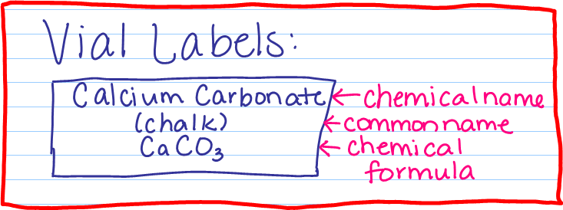

Distribute materials for each group. Tell students to fill in their observation chart using the vials of white substances. Tell them to be as descriptive as possible. (25 minutes)

Explanation:

Have a class size chart on chart paper prepared. Have students share out their observations of each substance. Discuss if students would like to add or delete any of their thoughts about what the mystery mixture is. Have each student write on the back of their chart what they think the mystery mixture is and why. (15 minutes)

Evaluation:

Collect student observation charts to make sure students put the correct information in the right column and that they are being descriptive in their observations.

Student page:

Name: Section:

|  |  |  |  |
| --- | --- | --- | --- |
| **Chemcial Name** | **Chemical Formula** | **Common Name** | **Observations** |
|  |  |  |  |
|  |  |  |  |
|  |  |  |  |
|  |  |  |  |
|  |  |  |  |
|  |  |  |  |
|  |  |  |  |
|  |  |  |  |
|  |  |  |  |

***Day Three***

**Learner Outcomes:**

The student will use their definition of chemical reaction to explain how they know a chemical reaction occurred when water was added to the mystery mixture. (Application)

The student will compare several mixtures with water added to narrow the possibility of what the mystery mixture is based on previous observations. (Analysis)

**Materials**: 150 copies of mystery mixture analysis page

**Materials for group investigation:** one set of vials with the following substances: ascorbic acid, calcium carbonate, calcium chloride, citric acid, magnesium sulfate, sodium carbonate, sodium chloride, hand lenses, well trays, minispoons, water

**Procedure:**

Engagement:

Review what students think the mystery mixture may be based on observations and referring to the chart papers. (5 minutes)

Tell students that during a reaction, starting substances change into new substances. Change is evidence of a reaction. Based on this information, how do they know when we add water to the mystery mixture a chemical reaction occurs? (5 minutes)

Exploration:

Distribute materials. Explain that today; they will have a chance to test their hypotheses about what they think the mystery mixture is. Using the well trays, they will mix different substances (1 minispoon of each) and add water (10 drops) to observe what happens. They will compare these observations to prior lab days to try to narrow their thinking. Give students time to explore. (25 minutes)

Explanation:

Clean up materials. Have each group share out the one or two mixtures they think may possibly be the mystery mixture and justify referring to previous and current observations. (10 minutes)

Extension:

Homework: have students write out a written explanation of what they personally believe the mystery mixture is and why. Give them 5 minutes of class time to work on this.

Evaluation:

Observe students during lab for safe procedures. Scan analysis sheets for completeness; do not collect so students may use these to assist in their homework.

Student page:

Name: Section:

|  |  |  |  |
| --- | --- | --- | --- |
| **Well number** | **Substance 1** | **Substance 2** | **Results** |
| **1** |  |  |  |
| **2** |  |  |  |
| **3** |  |  |  |
| **4** |  |  |  |
| **5** |  |  |  |
| **6** |  |  |  |
| **7** |  |  |  |
| **8** |  |  |  |
| **9** |  |  |  |
| **10** |  |  |  |
| **11** |  |  |  |
| **12** |  |  |  |

***Day Four***

**Learner Outcomes:**

The student will create a lab to determine exactly what the mystery mixture is. (Synthesis)

The student will defend their findings about what they mystery mixture is using evidence from their labs. (Evaluation)

**Materials**: 150 copies of summary chart

**Materials for group investigation:** one set of vials with the following substances: ascorbic acid, calcium carbonate, calcium chloride, citric acid, magnesium sulfate, sodium carbonate, sodium chloride, hand lenses

**Procedure:**

Engagement:

Review previous days hypotheses about the mystery mixture. Explain that today they are to create a lab as a class to determine definitely what it is. Ask the class to brainstorm a list of ideas about what else they could do to determine the mixture. Guide students to come up with evaporation. (10 minutes)

Exploration:

Students will create 7 recipes for the possible mixture and record observations when they add water specific to the fizzing. Students will then leave these to evaporate overnight to observe tomorrow. (remainder of class)

Explanation (next day):

Discuss observations of what students narrowed the possibilities down to when they added water. Then discuss what they think it is after seeing what happens when the water evaporates. Have students write out their conclusion.

Extension:

Have students describe how they could identify if a chemical reaction took place and how to figure out the substances in their own words.

Evaluation:

Summary charts and conclusions.

Student page:

Name: Section:

|  |  |  |  |
| --- | --- | --- | --- |
| Well | Substances | Description of fizzing | Observations |
| 1 |  |  |  |
| 2 |  |  |  |
| 3 |  |  |  |
| 4 |  |  |  |
| 5 |  |  |  |
| 6 |  |  |  |
| 7 |  |  |  |
| 8 | Mystery mixture |  |  |

**Conclusion:**

**Identify the mystery mixtures. Explain how you identified the substances.**

**Postassessment**

Name:

Directions: Select the best response for each question.

Use the data table below to answer question #1.

**Substance Combination Results**

|  |  |
| --- | --- |
| **Substances Combined** | **Observations** |
| Sodium bicarbonate + ascorbic acid | Powders mixed together and stayed a white  powder. No change in odor either. |
| Sodium bicarbonate + ascorbic acid + water | Powders started to bubble when the water was  added together. When the fizzing stopped the  liquid was cloudy. |
| Ascorbic acid + calcium chloride | Powders mixed together and stayed a white  powder. No change in odor either. |
| Ascorbic acid + calcium chloride + water | Powders dissolved in the water. There were no  bubbles or odor. |

1. Which of the following statements is supported by the data collected in the data table above?

A. When ascorbic acid and water are mixed, the solution fizzes.

B. When two powders are mixed and water is added, a chemical reaction takes place.

C. When sodium bicarbonate is mixed with calcium chloride gases are released.

D. When sodium bicarbonate is combined with ascorbic acid and water a new substance is created.

2. A student left a glass of ice water is the sun. When she returns two hours later, there have been some changes. What statement below explains what has occurred?

A. The glass still contains only water because no chemical reaction has taken place.

B. The ice in the glass has melted and is a new substance because a chemical reaction has taken place.

C. There is less water in the glass than there was two hours earlier because a chemical reaction has taken place.

D. The water in the glass is much warmer than it was two hours earlier because a chemical reaction has taken place.

3. Which of the following statements is true of chemical reactions?

A. Chemical reactions always produce new substances that are different from the original substances.

B. When substances undergo chemical reactions they always produce gases.

C. When substances react chemically, there is always a change in color.

D. Chemical reactions always produce new substances that are in a different state.

4. A student is given a mixture of two powders and told to determine the identity of the two substances. Which of the following methods would be most helpful to help him identify the substances?

A. Compare the appearance of the substances in the mixture to the appearance of known substances.

B. Weigh the mixture and compare the mass of the mixture to the mass of known substances.

C. Separate the mixture into the two different substances, add water and compare the results with known substances.

D. Add water to the mixture, let solution evaporate and compare the evaporate to evaporates of known mixtures.

5. Which of the following statements is true?

A. CaCO3 is the chemical formula for calcium carbonate and indicates all the elements found in the chemical.

B. CaCO3 is the common name for calcium carbonate and is used to describe the substance’s properties.

C. CaCO3 is the chemical name for calcium carbonate and can be used to find its location on the periodic table.

D. CaCO3 is the common name for calcium carbonate and it indicates the reactivity of the substance.

Open Response

Below is the data collected by a student during a chemistry investigation. The student recorded what happened in each trial when a mixture of substance A and B was added to water, substance C.

|  |  |  |  |  |
| --- | --- | --- | --- | --- |
| **Trial #** | **Substance A** | **Substance B** | **Substance C** | **Observations** |
| **1** | C6H8O6  Ascorbic acid | CaCO3  Calcium  carbonate | H2O | Powder dissolves in  the water and starts  to fizz and bubble.  The solution feels  warmer. |
| **2** | CaCO3  Calcium  carbonate | MgSO4  Magnesium  sulfate | H2O | The powders dissolve  and the liquid is  cloudy. There are no  bubbles or fizzing. |

Explain whether a chemical reaction has occurred in each trial using evidence from the observations.